Case report

Cutaneous presentation in neonatal lupus: A case report

.
ABSTRACT

Background: Neonatal lupus erythematosus (NLE) is a rare autoimmune condition resulting from the transplacental transfer of maternal autoantibodies, primarily anti-SSA/Ro and anti-SSB/La. The disease can manifest with cutaneous, cardiac, hematologic, and hepatobiliary involvement, with variable prognosis depending on the affected systems.
Case Presentation: We report the case of a 4-month-old female infant who developed erythematous, scaly annular patches on the face, scalp, trunk, and folds. The lesions were asymptomatic and had been present for a month. The infant's mother had a history of systemic lupus erythematosus treated with corticosteroids and hydroxychloroquine. Laboratory investigations revealed elevated anti-SSA and anti-SSB antibodies, while cardiac evaluations were unremarkable. The diagnosis of NLE was established. The skin lesions improved with topical corticosteroids and strict sun protection.
Conclusion: This case highlights the importance of considering NLE in infants presenting with annular cutaneous lesions, especially in the context of maternal autoimmune disease. Early diagnosis, multidisciplinary management, and close monitoring are crucial to prevent complications, particularly cardiac involvement, which significantly affects prognosis.

Keywords: Neonatal lupus erythematosus, Autoantibodies, Cutaneous lesions, Systemic lupus erythematosus, Congenital heart block, Anti-SSA/Ro, Anti-SSB/La

1. INTRODUCTION

Neonatal lupus (NL) is an uncommon passive autoimmune disease resulting from maternal autoantibodies crossing the placenta into the newborn, primarily anti-SSA/Ro, anti-SSB/La and anti-U1-ribonucleoprotein (RNP) antibodies [1]. The pathogenic activity of these autoantibodies may affect various fetal tissues and lead to clinical manifestations, most frequently presenting as skin rashes, hematologic disorders, hepatobiliary involvement and, most severely, congenital heart block (CHB) [2]. Although NL occurs with an approximate frequency of 1 in 20,000 live births, its prevalence may be underestimated due to mild or subclinical presentations [3]. This article presents a case of NL in an infant born to a mother with systemic lupus erythematosus (SLE), followed by a discussion of the current literature on the condition.

2. case presentation

A 4-month-old female infant was brought to the Department of Dermatology at Ibn Sina University Hospital with erythematous, scaly patches on her face that had been present for the past month. The lesions were annular, with erythematous borders and a clear center, extending to the folds, back, abdomen and scalp. The rash was asymptomatic, with no associated pruritus or discomfort reported by the mother.
The infant was born full-term to a 29-year-old mother with a known history of systemic lupus erythematosus (SLE), diagnosed three years earlier and managed with corticosteroids and hydroxychloroquine. The pregnancy was uneventful, with regular prenatal care and no complications reported at birth. Of note, the mother had no history of previous pregnancies or adverse obstetric outcomes.
On physical examination, the infant’s vital signs were within normal limits: temperature 36.8°C, heart rate 120 beats per minute and respiratory rate 30 breaths per minute. Dermatological examination revealed multiple erythematous scaly lesions with central clearing on both sun-exposed and non-exposed areas (Figure 1). No signs of systemic involvement—such as hepatosplenomegaly, jaundice or heart failure—were observed.
Laboratory testing revealed elevated levels of anti-SS-A and anti-SS-B antibodies in the infant’s serum. Complete blood count, liver function tests and metabolic panels were within normal ranges. Electrocardiogram and echocardiography were performed to evaluate for cardiac involvement; both were normal, with no evidence of congenital heart block [4].
A diagnosis of neonatal lupus was made based on the clinical presentation and serological findings. Management included topical corticosteroids and strict sun avoidance. At a six-week follow-up, the skin lesions had improved significantly, and no new systemic symptoms were observed.

3. discussion

Neonatal lupus (NL) is an autoimmune condition that results from the passive transfer of maternal IgG autoantibodies across the placenta, typically during the second trimester [5]. While cutaneous manifestations are the most common, occurring in up to 60% of cases, systemic features such as hematologic abnormalities (anemia, thrombocytopenia, neutropenia), hepatobiliary involvement and cardiac defects—particularly congenital heart block (CHB)—may also occur [6].
The skin is the most frequently affected organ. Although some lesions are present at birth, rashes usually develop within the first few weeks of life. They can appear anywhere but are generally located on the scalp, face and neck. A typical periorbital distribution may resemble a raccoon-eye pattern. The rash often consists of erythematous rings with or without central scaling. In some cases, lesions may present as cystic plaques, urticarial eruptions, ulcerations or blisters [7,8]. Sun exposure is not required for the rash to develop, though ultraviolet light may exacerbate existing lesions and trigger new ones. According to Wisuthsarewong et al., other reported cutaneous findings in neonates with NL include baby-petechiae, persistent cutis marmorata and discoid plaques, as seen in our patient [9].
Newborns diagnosed with NL should be evaluated by a rheumatologist, as systemic involvement often necessitates a multidisciplinary approach. In cases with cardiac involvement, particularly CHB, continuous follow-up with a cardiologist is essential since many affected infants ultimately require pacemaker implantation. To minimize the risk of skin changes and scarring, strict photoprotection is recommended, including the use of sunscreen and protective clothing. Most cutaneous lesions respond well to topical corticosteroids, while systemic immunosuppressive therapy and corticosteroids are rarely needed. However, in more complex cases with hematologic abnormalities, liver dysfunction or neurological complications, systemic immunosuppressants and intravenous immunoglobulin may be necessary [10].
CHB is the most severe complication, affecting approximately 2% of infants born to anti-SSA/Ro-positive mothers. It is typically detected in utero by fetal echocardiography between 18 and 24 weeks of gestation. Unlike cutaneous manifestations, CHB is irreversible and may necessitate permanent pacemaker insertion. Risk factors for CHB include high maternal autoantibody titers and a history of a previous child with NL [11,12].
Other systemic features, such as hematologic and hepatobiliary abnormalities, are usually transient and resolve as maternal antibodies are cleared from the infant’s circulation by six to eight months of age [13]. These manifestations rarely require specific treatment unless complications arise.
The diagnosis of neonatal lupus erythematosus is based on clinical features and the presence of anti-SSA or anti-SSB antibodies in serum samples from either the infant or the mother. A broad differential diagnosis should be considered, as NL can mimic a wide range of dermatologic conditions, including seborrheic dermatitis, atopic dermatitis, neonatal acne, urticaria, tinea corporis, granuloma annulare, erythema multiforme, Langerhans cell histiocytosis and congenital infections such as syphilis [7,10,14].
The prognosis for neonates with NL varies depending on the organs involved. When the disease is limited to cutaneous manifestations, the outlook is highly favorable, with rashes typically resolving by six months as maternal antibodies wane. In contrast, cardiac complications—particularly CHB—pose significant health challenges due to their permanent nature. Reported mortality rates range from 20% to 30%, primarily due to heart failure. Cases involving cytopenias or hepatobiliary disorders generally improve within six months, although close monitoring is necessary to detect potential bleeding or liver-related complications. The recurrence rate in subsequent pregnancies is estimated at 17% to 25%. While children with NL may have an increased susceptibility to developing autoimmune diseases later in life, the exact prevalence remains unclear [9,14,15].

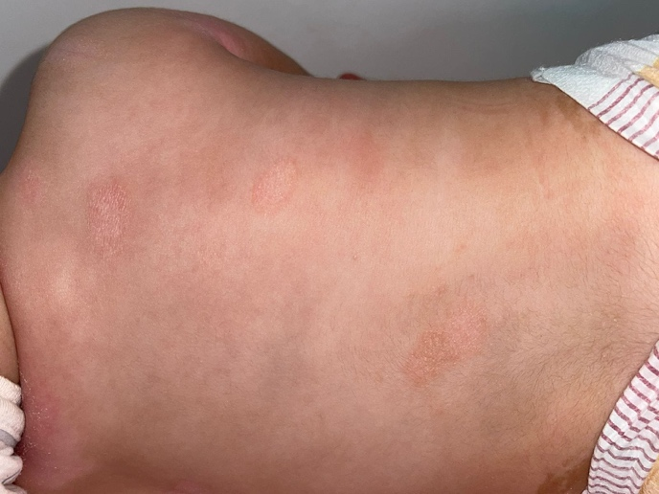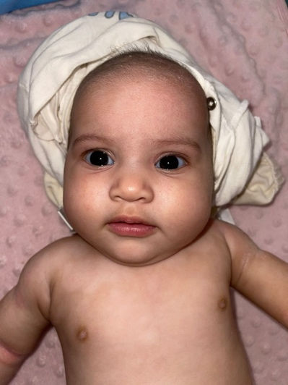

Fig. 1. multiple erythematous scaly lesions with central clearing on the body Mean

4. Conclusion

Neonatal lupus is a relatively rare but potentially serious condition caused by the transplacental transfer of maternal autoantibodies. Early recognition is crucial for timely diagnosis and management, particularly in mothers with autoimmune diseases. Skin manifestations are the most common and typically self-limiting; however, cardiac complications can pose significant risks. The management of affected infants requires a coordinated multidisciplinary approach along with parental counseling.

AcknowledgEments
The authors would like to thank all individuals who contributed to the realization of this work. We are grateful to the clinical staff for their support and to the patient for her cooperation. No external funding was received for the completion of this study. The authors declare that there is no conflict of interest regarding the publication of this article.

Competing interests

Authors have declared that no competing interests exist.

Authors’ Contributions

All authors read and approved the final manuscript.

Consent (where ever applicable)

Authors may use the following wordings for this section: "All authors declare that ‘written informed consent was obtained from the patient (or other approved parties) for publication of this case report and accompanying images. A copy of the written consent is available for review by the Editorial office/Chief Editor/Editorial Board members of this journal."

Ethical approval (where ever applicable)

All authors hereby declare that all experiments have been examined and approved by the appropriate ethics committee and have therefore been performed in accordance with the ethical standards laid down in the 1964 Declaration of Helsinki.

Disclaimer (Artificial intelligence)
Author(s) hereby declares that NO generative AI technologies such as Large Language Models (ChatGPT, COPILOT, etc.) and text-to-image generators have been used during the writing or editing of this manuscript.

References

- Derdulska JM, Rudnicka L, Szykut-Badaczewska A, Mehrholz D, Nowicki RJ, Barańska-Rybak W, Wilkowska A. Neonatal lupus erythematosus – practical guidelines. J Perinat Med. 2021;49(5):529–538. doi:10.1515/jpm-2020-0543. PMID: 33470961.Izmirly PM, Saxena A, Kim MY, et al. Maternal and fetal factors associated with neonatal lupus erythematosus. N Engl J Med. 2011;365(22):2105-2116.
- Chen TH, Tseng YH, Wu YZ. Neonatal lupus. QJM. 2020 Dec 1;113(12):905–906. doi:10.1093/qjmed/hcaa134. PMID: 32311045.
- Cimaz R, Spence DL, Hornberger L, Silverman ED. Incidence and spectrum of neonatal lupus erythematosus: A prospective study of infants born to mothers with anti-Ro autoantibodies. J Pediatr. 2003;142(6):678-683.
- Rivera TL, Izmirly PM, Birnbaum BK, et al. Disease progression and mortality in neonatal lupus: a review of 125 cases. J Autoimmun. 2009;33(1):17-24.
- Ren F. Neonatal lupus erythematosus. J Cutan Med Surg. 2022 Nov-Dec;26(6):650. doi:10.1177/12034754221119492. PMID: 35949184.
- Vanoni F, Lava SA, Fossali EF, et al. Neonatal lupus erythematosus syndrome: a comprehensive review. Clin Rev Allergy Immunol. 2017;53(3):469-476.
- Wisuthsarewong W, Viravan S, Khongkhatithum C, et al. Neonatal lupus erythematosus: clinical spectrum and management. J Dermatol. 2012;39(7):663-670.
- Yokogawa N, Sumitomo N, Miura M, Shibuya K, Nagai H, Goto M, Murashima A. [Neonatal lupus erythematosus]. Nihon Rinsho Meneki Gakkai Kaishi. 2017;40(2):124-130. doi:10.2177/jsci.40.124. PMID: 28603203..
- Neonatal lupus erythematosus. Silverman ED, Laxer RM. Rheum Dis Clin North Am. 1997;23:599–618. doi: 10.1016/s0889-857x(05)70349-5.
- Friedman DM, Kim MY, Copel JA, et al. Utility of cardiac monitoring in fetuses at risk for congenital heart block: the PR Interval and Dexamethasone Evaluation (PRIDE) prospective study. Circulation. 2008;117(4):485-493.
- Llanos C, Friedman DM, Saxena A, et al. Outcome of cardiac neonatal lupus in children: the role of early diagnosis and therapy. Arthritis Rheum. 2009;60(12):4061-4067.
- Diaz-Frias J, Badri T. Neonatal lupus erythematosus. In: StatPearls [Internet]. Treasure Island (FL): StatPearls Publishing; 2025 Jan–. Published 2023 Jun 26. PMID: 30252317.
- Liszewska A, Woźniacka A. Neonatal lupus erythematosus - prevention is better than cure. Postepy Dermatol Alergol. 2022 Dec;39(6):1021-1026. doi:10.5114/ada.2022.122601. PMID: 36686025.
- Hepatobiliary disease in neonatal lupus: prevalence and clinical characteristics in cases enrolled in a national registry. Lee LA, Sokol RJ, Buyon JP. Pediatrics. 2002;109:0. doi: 10.1542/peds.109.1.e11.

