Case report

Recurrent Peripheral Ossifying Fibroma in a Child: A Case Report

ABSTRACT
Peripheral ossifying fibroma (POF) is a reactive, non-neoplastic gingival growth, commonly seen in adolescents and young children, occurring most often in girls. The World Health Organisation (WHO) categorises POF as a fibro-osseous lesion characterised by varied amounts of calcified particles scattered throughout fibrous connective tissue. It often arises in response to local irritants and typically occurs in the anterior maxilla. Although generally benign, POF is known for its potential for recurrence, especially if not completely excised. This is a case study of an eleven-year-old male child who presented with a recurrent, firm, gingival mass in the anterior maxillary region. This case emphasises how crucial the complete surgical removal of the lesion, including the periosteum and involved periodontal ligament, is to minimise the risk of recurrence. It was noted that about 60% of occurrences of this lesion occur in the anterior maxilla, with the incisor-cuspid region accounting for 55–60% of presentations. In clinical terms, POF is a slow-growing gingival lesion that is typically found in the interdental gingiva and is less than 2 cm in size. The study also highlights the need for long-term follow-up, especially in pediatric patients, where recurrence can affect oral development and function.
Keywords: anterior maxillary region, calcified particles, fibro-osseous, gingival growth,
INTRODUCTION
Gingival lesions in children encompass a diverse group of conditions that can be inflammatory, reactive, developmental, or neoplastic in nature. Reactive lesions, such as pyogenic granuloma and peripheral ossifying fibroma, are among the most common gingival growths in pediatric patients. In developed countries, the incidence of gingivitis in children aged 6-11 is around 73%. This rate increases from 6 to 11 years of age (Kulkarni et al., 2023).
Peripheral Ossifying Fibroma (POF) is a non-neoplastic, reactive lesion that originates from the gingival tissue, periosteum, or periodontal ligament. It is a slow-growing mass composed of fibrocellular tissue with areas of mineralisation, such as bone or cementum-like material.¹ The World Health Organisation (WHO) categorises POF as a fibro-osseous lesion characterised by varied amounts of calcified particles scattered throughout fibrous connective tissue.²
POF is microscopically characterised by a highly cellular fibrous connective tissue composed of spindle-shaped and ovoid mesenchymal cells with vesicular nuclei and exhibiting variable amounts of focal or extensive deposition of mature and/or immature bone, cementum-like tissue, and dystrophic calcification (Cavalcante et al., 2022; Godinho et al., 2022). This lesion typically appears as a solitary, firm, nodular mass that may be pedunculated or sessile, commonly found in the interdental papilla. It often has a pink to reddish hue and may present with either a smooth or ulcerated surface​.
POF is comparatively rare in children but remains among the most often observed reactive gingival lesions in pediatric populations. Studies indicate that POF accounts for approximately 3.1% of all oral tumours and 9.6% of all gingival lesions.² It is more frequently observed in young females, particularly in the second and third decades of life.³
The development of this lesion is closely associated with chronic irritation from local factors such as dental plaque, calculus, ill-fitting restorations, and orthodontic appliances. This is a case report of an 11-year-old child who presented with recurrence of gingival swelling in the maxillary anterior region.
CASE PRESENTATION
An 11-year-old male patient reported to the department of Pedodontics with the complaint of swelling and pain of the gingiva in the upper left front tooth region. The child’s parent reported a similar type of growth 6-7 months back, and it was treated in a private clinic, but the parent didn’t have the histopathological report of the lesion.
Intraoral examination revealed a red gingival lesion extending from the mesial surface of the left central incisors to the distal surface of the left lateral incisors and also extending to the palatal surface of 21 & 22. The lesion measured approximately 2cm mesiodistally and 1cm buccopalatally. Inflammation of the gingiva was also seen in the alveolar margin between the two central incisors. The labial and the palatal aspects of the lesion can be appreciated from figures 1 and 2, respectively. On palpation, the lesion was sessile and firm with surfaces of ulceration. On radiographic examination, there were mild interdental bony changes seen. (Fig. 3).

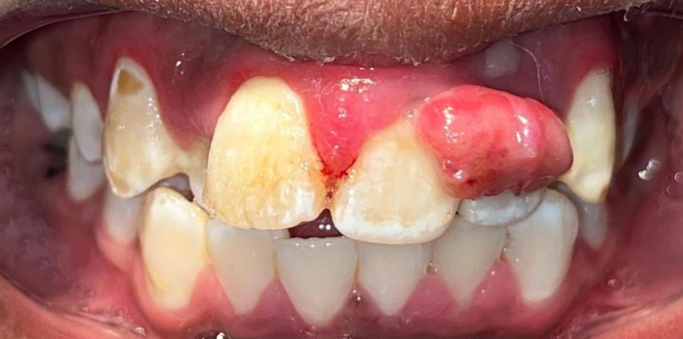
Figure 1: Intraoral Image Showing the Gingival Lesion on the Labial Aspect Between 21 & 22
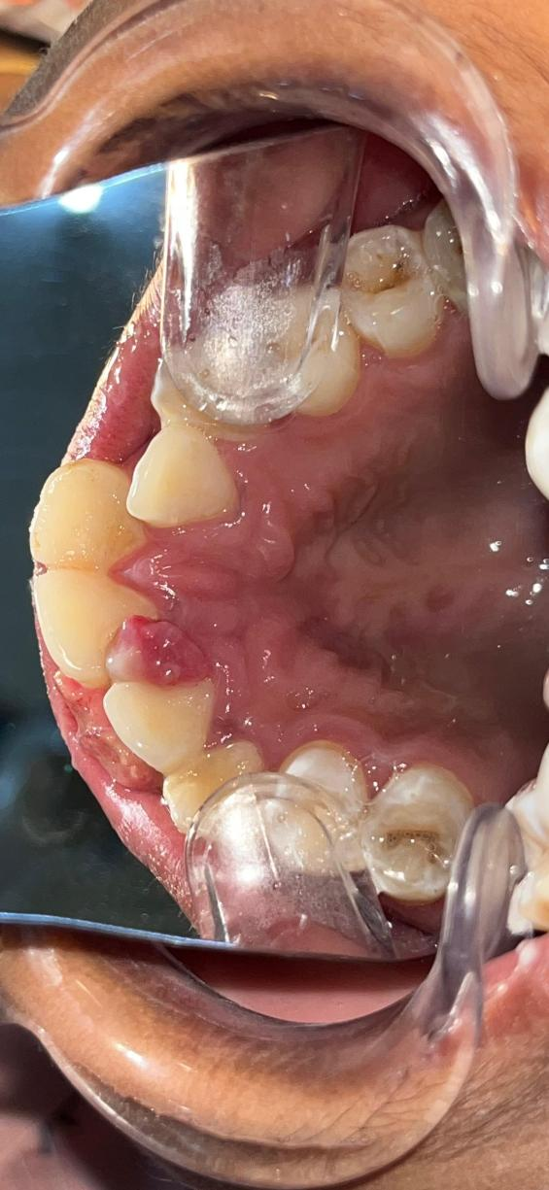
Figure 2: Intraoral Image Showing the Palatal Extension of the Lesion Between 21 & 22
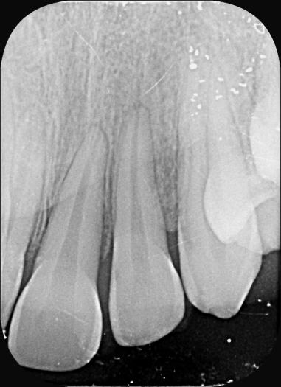
Figure 3: Radiographic Image Showing Interdental Bone Loss Between 21 & 22
The patient had very poor oral hygiene. Considering the recurrence of the previous lesion, the patient was advised to undergo a haematological evaluation, scaling and surgical therapy. Haematological results were normal, and the patient was not under any medications. Oral prophylaxis followed by thorough excision of the lesion and gingival curettage was performed as there was already a recurrence of the lesion (Figs 4 and 5). The patient was prescribed antibiotics and analgesics, and post-operative instructions were given.
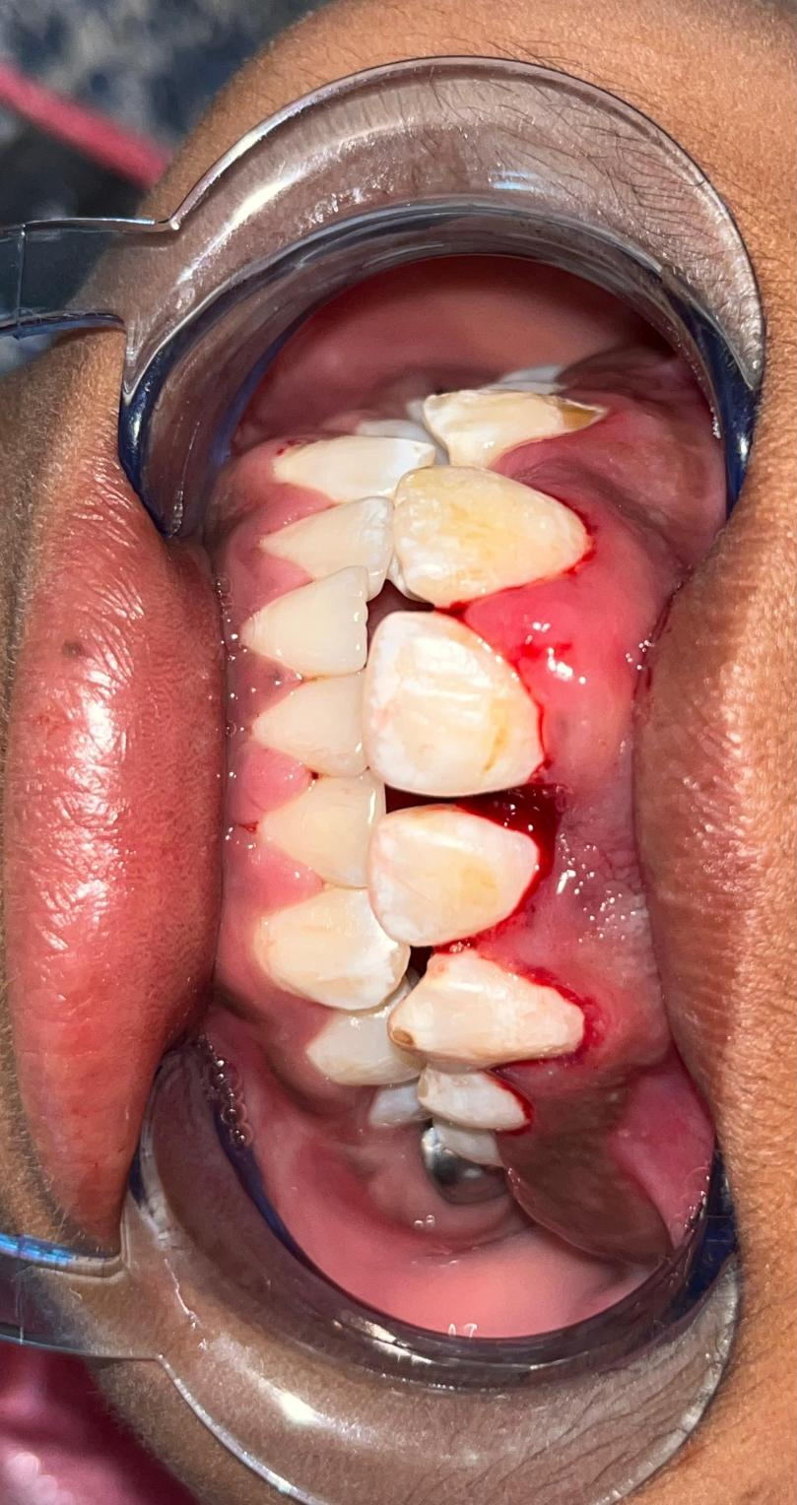
Figure 4: Post-Operative Intraoral Image After Gingivectomy (Labial Aspect)
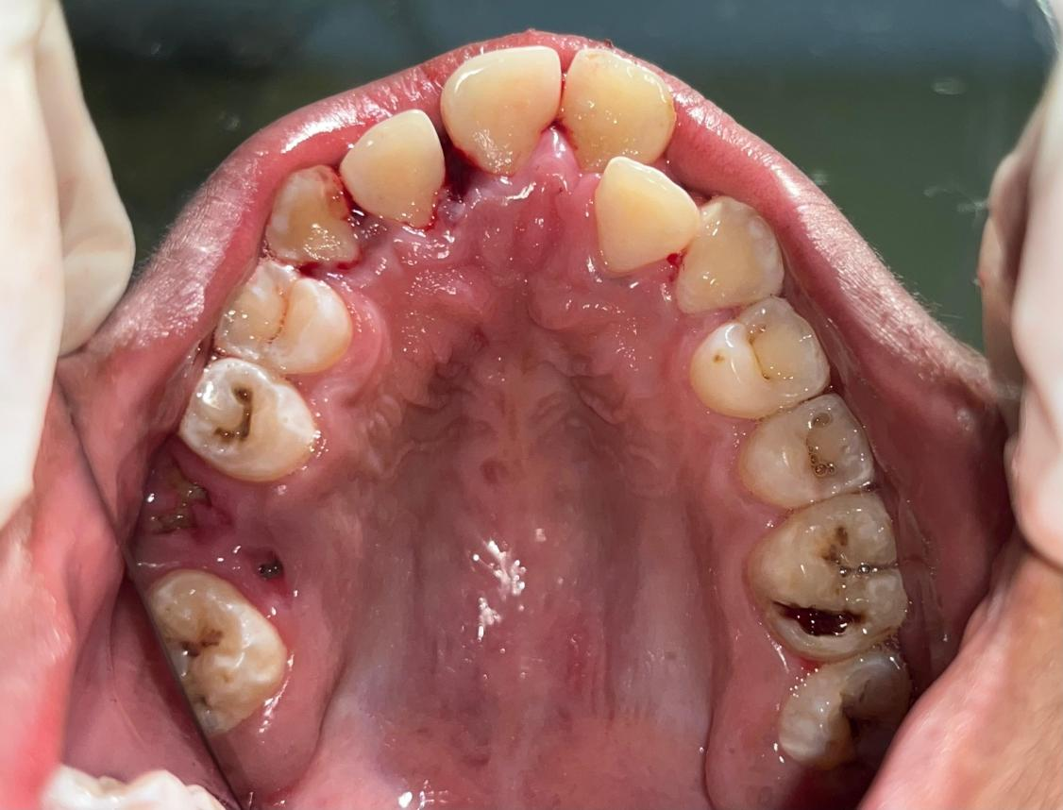
Figure 5: Post-Operative Intraoral Image After Gingivectomy (Palatal Aspect)
The exised lesion was then sent for histopathological report which revealed hyperplastic stratified squamous epithelium with fibrous stroma containing numerous calcifications confirming the features of peripheral ossifying fibroma.
The patient was instructed to practise good dental hygiene and asked to report to the department every three months for a regular follow up, or when any gingival growth occurs (Fig 6).
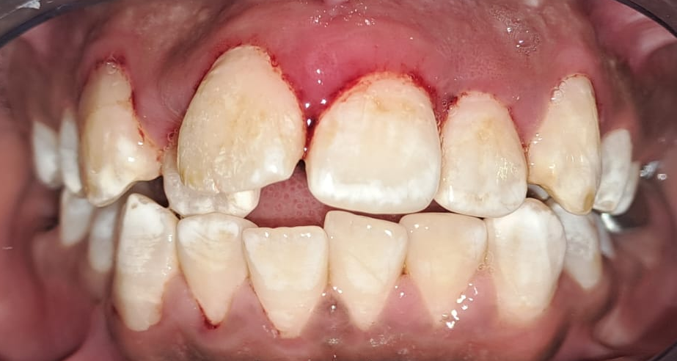
Figure 6: Intraoral Image- 3-Month Follow-Up
DISCUSSION
Ossifying fibromas are benign tumours that fall into two general categories: central and peripheral. While the peripheral type develops in relation to the soft tissues in the jaws' tooth-bearing regions, the central type originates in the endosteum or the periodontal ligament next to the root's apex and, over time, causes the medullary space to expand, resulting in the associated extraoral swelling.⁴ The most common processes at play are reactive hyperplasia and neoplasia. The majority of overgrowths of the oral mucosa are reactive instead of malignant.⁵ It is believed that POF, a prevalent gingival lesion, is likely reactive or aggressive. Although POF is not malignant if treatment is not received, it can have an adverse effect on dental health and cause great discomfort.²
POF is a reactive lesion that is described as "any isolated proliferation on the gingiva" that is anticipated to emerge from the epithelial cells of the PDL. POF only develops in the gingiva (interdental papilla), and due to the close proximity to the PDL and the underlying oxytalan fibres (cellular fibrous connective tissue) in the mineralised matrix of certain lesions may be factors contributing to its appearance in the PDL.⁶ Peripheral ossifying fibroma might be caused by hormone fluctuations, poorly fitting dentures, or poor oral care. Furthermore, its aetiology has been linked to local irritants such as calculus, tooth plaque, and foreign items stuck in the gingiva.⁷
It is especially seen in women within the age of 20-30 years, indicating that hormones play a significant role in these lesions. About 60% of occurrences of this lesion occur in the anterior maxilla, with the incisor-cuspid region accounting for 55–60% of presentations. In clinical terms, POF is a slow-growing gingival lesion that is typically found in the interdental gingiva and is less than 2 cm in size.⁸ It can be pedunculated or sessile, have an ulcerated surface, and be the same colour as the gingiva or somewhat reddish.
Some lesions, although not all of them, may have calcification foci dispersed throughout the lesion's core region on radiography. Radiographs rarely show any underlying bone involvement, but they can occasionally show superficial bone degradation.⁹
Because it is difficult to identify POF solely based on clinical observations, a biopsy specimen must be examined histopathologically for an appropriate diagnosis. The histology of the lesions shows a stratified squamous epithelium covering an incredibly thick mass of connective tissue that includes fibroblasts, fibrillar stroma, and fibrocytes. There are also mineralisation regions and, sometimes, multinucleated giant cells adjacent to it. The mineralisation may contain bone, cementum-like substance, or dystrophic calcifications.¹⁰
Due to its high recurrence rates, POF management includes addressing any aggravating factors that could cause a recurrence as well as removing the lesion entirely, including the periosteum and periodontal ligament.⁴
Conclusion
Given that Cundiff reported a 16% recurrence rate and Eversole and Robin's investigation found a 20% recurrence rate, continuous monitoring is required. The inability to fully extricate the lesion, frequent irritation from injury, or insufficient elimination of the local inflammatory elements are the causes of the recurrence rate, which ranges from 8.9% to 20%.¹¹ The lesion typically recurs for the first time within 12 to 14 months.¹² So, long-term follow-up is mandatory in these types of cases.

Consent
As per international standards, parental written consent has been collected and preserved by the author(s).

Disclaimer (Artificial intelligence)
Option 1:
Author(s) hereby declare that NO generative AI technologies such as Large Language Models (ChatGPT, COPILOT, etc.) and text-to-image generators have been used during the writing or editing of this manuscript.
Option 2:
Author(s) hereby declare that generative AI technologies such as Large Language Models, etc. have been used during the writing or editing of manuscripts. This explanation will include the name, version, model, and source of the generative AI technology and as well as all input prompts provided to the generative AI technology
Details of the AI usage are given below:
1.
2.
3.
REFERENCES
- Pereira T, Shetty S, Babu C, Gotmare SS. Ossifying fibroma: the peripheral variant. Can J Dent Hyg. 2024 Jun 1;58(2):135-139. PMID: 38974824; PMCID: PMC11223634.
- Verma E, Chakki AB, Nagaral SC, Ganji KK. Peripheral cemento-ossifying fibroma: case series literature review. Case Rep Dent. 2013;2013:930870. doi: 10.1155/2013/930870. Epub 2013 Jan 14. Erratum in: Case Rep Dent. 2013;2013:827247. PMID: 23365762; PMCID: PMC3556846.
- Godinho GV, Silva CA, Noronha BR, Silva EJ, Volpato LE. Peripheral Ossifying Fibroma Evolved From Pyogenic Granuloma. Cureus. 2022 Jan 3;14(1):e20904. doi: 10.7759/cureus.20904. PMID: 35145808; PMCID: PMC8807426.
- Chandwani, Manisha & Fernandes, Gabriela. (2018). Peripheral ossifying fibroma: Review and case report. Biomedical Research and Clinical Practice. 3. 10.15761/BRCP.1000168.
- Niranjan B, Shashikiran ND, Dubey A, et al. A Rare Gingival Lesion in Children: Fibroepithelial Hyperplasia. Int J Clin Pediatr Dent 2022;15(4):468–471.
- Bhaskar SN, Jacoway JR. Peripheral fibroma and peripheral fibroma with calcification: report of 376 cases. J Am Dent Assoc. 1966 Dec;73(6):1312-20. doi: 10.14219/jada.archive.1966.0375. PMID: 5223950.
- Gardner DG. The peripheral odontogenic fibroma: an attempt at clarification. Oral Surg Oral Med Oral Pathol. 1982 Jul;54(1):40-8. doi: 10.1016/0030-4220(82)90415-7. PMID: 6750498.
- Shirbhate U, Bajaj P, Meshram M, Durge K. Management of Peripheral Cemento-Ossifying Fibroma Associated With Maxillary Anterior Teeth: A Case Report. Cureus. 2023 Nov 6;15(11):e48410. doi: 10.7759/cureus.48410. PMID: 38073985; PMCID: PMC10701190.
- Guru, Sanjeela & Singh, Sinam & Guru, Rakshith. (2016). Peripheral Cemento-ossifying Fibroma: A Report of Two Cases. Journal of Health Sciences & Research. 7. 71-75. 10.5005/jp-journals-10042-1039.
- Barot VJ, Chandran S, Vishnoi SL. Peripheral ossifying fibroma: A case report. J Indian Soc Periodontol. 2013 Nov;17(6):819-22. doi: 10.4103/0972-124X.124533. PMID: 24554899; PMCID: PMC3917219.
- Krishna VK, Periasamy S, Kumar SP, Bhat SV. Atypical Presentation of Peripheral Ossifying Fibroma in the Mandible. Cureus. 2022 Feb 19;14(2):e22375. doi: 10.7759/cureus.22375. PMID: 35321068; PMCID: PMC8935247.
- Cuisia ZE, Brannon RB. Peripheral ossifying fibroma--a clinical evaluation of 134 pediatric cases. Pediatr Dent. 2001 May-Jun;23(3):245-8. PMID: 11447957.
- Cavalcante, I. L., da Silva Barros, C. C., Cruz, V. M. S., Cunha, J. L. S., Leão, L. C. C., Ribeiro, R. R., ... & Cavalcante, R. B. (2022). Peripheral ossifying fibroma: A 20-year retrospective study with focus on clinical and morphological features. Medicina Oral, Patología Oral y Cirugía Bucal, 27(5), e460.
- Godinho, G. V., Silva, C. A., Noronha, B. R., Silva, E. J., Volpato, L. E., & Silva, C. (2022). Peripheral ossifying fibroma evolved from pyogenic granuloma. Cureus, 14(1).
- Kulkarni, V. K., Dixit, M., Balasubramanian, S., & Jetpurwala, A. (2023). Gingival and periodontal diseases in children. Illustrated pediatric dentistry-part, 2, 264.

