**Impact of Government Environmental Regulations and Foreign Investment on Urban Housing Affordability: A Longitudinal Econometric Analysis (2014–2023)**

# Abstract

# This study examined the complex relationship between environmental regulation policies, foreign direct investment (FDI), and housing affordability in urban real estate markets over a ten-year period (2014–2023) with the environmental regulation index as the independent variable. Utilizing a normal-power regression model, the analysis integrates macroeconomic indicators, including property tax rates, interest rates, inflation, unemployment, and government spending to control for broader market influences. The results revealed that stricter environmental regulations are associated with increases in average housing prices, primarily due to their impact on construction costs and development constraints. Meanwhile, FDI shows a dual effect: in some cases, it stimulates housing supply and infrastructure development, but in others, it drives up property values, particularly in high-demand urban centers, thereby contributing to reduced affordability. Diagnostic tests confirm the robustness of the model, with an R² of 0.7984 and satisfactory forecast accuracy. The findings underscored the need for integrated policy frameworks that reconcile the goals of sustainability, economic growth, and social inclusion. The study provides valuable insights for urban planners, housing policymakers, and international development agencies.

# Keywords: Normal-Power Model, Average Housing Price, Environmental Regulation, Urban Real Estate, Sustainable Development Policy

# 1. Introduction

The dynamics of housing markets are profoundly influenced by macroeconomic policy decisions, particularly those involving government regulations and investment frameworks. As early as the 1990s, scholars recognized that government fiscal and monetary policies shape the direction and health of national real estate markets through mechanisms such as interest rates, taxation, and public spending (Ball, 1990; Arestis, 2022). These macro-level interventions affect both the supply and demand sides of the housing sector, directly influencing affordability, accessibility, and investment returns. Over the past two decades, growing attention has been paid to the impact of foreign direct investment (FDI) on housing markets, particularly in urban centers of developing and emerging economies. FDI often brings much-needed capital for infrastructure and real estate development but has also been associated with the gentrification of urban cores and the displacement of local residents due to rising property values (Dunning, 1998; Fields & Uffer, 2016). This dual effect makes FDI a particularly complex component of urban housing policy.

Simultaneously, environmental regulations have become increasingly central to national and urban planning agendas. With the onset of global climate change concerns, governments are under growing pressure to enforce sustainable urban development policies that minimize environmental degradation while supporting economic growth (UN-Habitat, 2011). These regulations, ranging from building codes to green energy requirements, often increase the costs of construction and property maintenance. While intended to promote long-term sustainability, such policies can also constrain housing supply or drive up prices, thereby impacting affordability (Glaeser & Kahn, 2010). In the 2010s, international frameworks such as the United Nations Sustainable Development Goals (SDGs) explicitly emphasized the need for inclusive and sustainable urban environments, particularly Goal 11, which calls for making cities inclusive, safe, resilient, and sustainable (United Nations, 2015). Within this context, policymakers face the dual challenge of promoting green development and ensuring housing remains accessible to the general population.

Amid the intersection of global forces such as rapid urbanization, increasingly stringent environmental governance, and growing volumes of international capital flows, cities across the world are facing mounting pressure to sustain housing affordability. The demand for urban housing continues to rise sharply, often outpacing supply, especially in rapidly growing metropolitan areas. At the same time, governments are introducing more robust environmental policies in response to climate change, which, while essential for long-term sustainability, can inadvertently raise construction and compliance costs (UN-Habitat, 2022). Additionally, inflows of foreign direct investment in real estate, particularly in global cities, have intensified housing market competition, contributing to the displacement of low- and middle-income residents (OECD, 2023). As a result, urban real estate markets now stand at a critical crossroads where the pursuit of ecological sustainability and economic growth must be carefully balanced with social equity and inclusive development (Aalbers, 2020; Gurran & Phibbs, 2023a; Dekolo *et al*., 2025).

This study explores how two critical macroeconomic levers, environmental regulations and foreign investment, have influenced housing affordability over a ten-year period, offering empirical insights that can inform sustainable housing policies in rapidly urbanizing regions. Unlike previous studies that often treat these factors in isolation or focus on short-term impacts, this research adopts a longitudinal perspective, enabling a more comprehensive understanding of how regulatory and investment dynamics shape housing markets over time. The uniqueness of this study lies in its integration of environmental governance and capital flow dimensions within a single analytical framework, using robust econometric techniques normal-power regression model that was proposed and applied by Ekum *et al*. (2023) from normal-power{logistic} distribution (Ekum *et al*., 2021) to capture their combined and individual effects on housing affordability. The findings of this research will be particularly beneficial to urban policymakers, housing and environmental planners, international development agencies, and real estate investors. Highlighting policy trade-offs and synergies, this study provides a practical foundation for crafting housing strategies that are both environmentally sustainable and socially inclusive.

# 2. Literature Review

The interplay between environmental regulations, foreign direct investment (FDI), and housing affordability has attracted growing academic attention in recent years, particularly in the context of rapidly urbanizing economies. Contemporary research has increasingly recognized that macroeconomic levers such as environmental policy and international capital flows exert complex and sometimes conflicting pressures on urban real estate markets. Arestis and Sawyer (2022) argue that while environmental policies are vital for long-term ecological stability, they often result in higher compliance and construction costs for developers. These elevated costs are frequently passed on to end-users, thereby driving up housing prices and reducing affordability, particularly in high-demand urban centers. This view is echoed in recent work that links green building mandates and zoning restrictions to constrained housing supply and cost inflation (Tan & Gurran, 2022).

On the other hand, foreign direct investment has been viewed as both an enabler and a disruptor in housing markets. According to Hoesli and Lekander (2021), FDI plays a pivotal role in boosting urban development, particularly through the financing of large-scale residential and infrastructure projects. However, they caution that excessive foreign capital in residential markets can fuel gentrification, displacing lower-income populations and exacerbating affordability crises in major cities. These findings align with those of Yuen and Kong (2023), who observed that the influx of speculative capital often leads to the commodification of housing, pushing prices beyond the reach of local residents. Recent insights from the World Bank (2023) reinforce these concerns, noting that urban property markets in developing and emerging economies are especially vulnerable to external capital movements and shifts in global economic policy. These markets often lack the institutional and regulatory frameworks to effectively absorb and channel FDI into socially beneficial housing outcomes. Consequently, they are more prone to speculative bubbles and rapid price escalations.

In addition, UN-Habitat (2022) advocates for the alignment of environmental and investment policies with inclusive housing strategies. It emphasizes the importance of integrative policy frameworks that simultaneously address climate goals and social equity. The report calls for better-targeted subsidies, regulatory clarity, and the inclusion of local stakeholders in decision-making to mitigate the adverse effects of market-driven investment trends. Recent studies also stress the importance of regional context in shaping these dynamics. For instance, Gurran and Phibbs (2023b) highlight the need for context-sensitive planning frameworks that balance environmental constraints with affordable housing delivery, particularly in high-growth regions. Their work underscores that one-size-fits-all solutions often fall short in managing the competing demands of sustainability, investment, and social inclusion.

Melega (2022) present a review that centred on analysis of correlation between FDI and environment regulation. Their study could help inform development of economic policies and strategies to attract foreign investment and address climate change and environmental degradation.

The current literature suggests that while environmental regulations and FDI are essential components of modern urban governance, their impacts on housing affordability are neither linear nor uniform. Instead, their effects are highly contingent on local economic structures, regulatory capacities, and social conditions. This study contributes to the growing body of knowledge by empirically examining the combined influence of these two forces over a ten-year period, thereby filling a critical gap in the literature and offering practical insights for evidence-based housing policy.

# 3. Methodology

## 3.1. Data Source and Variables

This study employs a quantitative research design using secondary data covering a ten-year period from 2014 to 2023. The data were sourced from a combination of reputable institutional databases, including reports from the World Bank, UN-Habitat, OECD, and national economic statistics. These sources were chosen for their reliability and global comparability, ensuring that the indicators used reflect consistent methodologies and definitions across the period under review. The primary objective of the study is to examine the influence of environmental regulations and foreign direct investment (FDI) on housing affordability, operationalized through the Average Housing Price (AHP) in U.S. dollars. AHP serves as the dependent variable, representing the annual average cost of residential properties within the selected regions.

The independent variables of interest are Environmental Regulation Index (ERI). This variable is measured on a scale of 0 to 10, with higher values indicating stricter environmental governance. It reflects the regulatory intensity concerning land use, building codes, green construction mandates, and emissions standards. Foreign Investment in Real Estate (FIR), measured in billions of U.S. dollars, and its captures the volume of international capital directed specifically toward residential and commercial real estate assets.

To control for other macroeconomic influences on housing prices, the model includes several control variables (Property Tax Rate (PTR), Interest Rate (ITR) Unemployment Rate (UNR) and Government Spending (GOS)). Property Tax Rate (PTR) is expressed as a percentage, this variable represents the effective annual tax levied on real property by governmental authorities. Interest Rate (ITR), also in percentage terms, captures the average annual interest rate, reflecting the cost of borrowing for property buyers. Inflation Rate (IFR) accounts for changes in the purchasing power of money, potentially influencing construction costs and consumer behavior. Unemployment Rate (UNR) is the proportion of the labor force that is unemployed, which can directly affect housing demand and affordability. Government Spending (GOS) measured in billions of U.S. dollars, reflects total public expenditure on infrastructure and social services, which may influence real estate values through improved public amenities or fiscal policy effects.

## 3.2. Analytical Approach

The analysis begins with a descriptive statistical assessment to explore the distribution, central tendencies, and variability of the variables. This is followed by correlation analysis to assess the strength and direction of bivariate relationships among the variables. To test the relationships between the independent variables and the average housing price, the study employs a multiple linear regression model. This model estimates the extent to which ERI and FDI predict variations in AHP, while controlling for the effects of the macroeconomic indicators. Prior to estimation, standard diagnostic tests are conducted to assess key assumptions of regression analysis, including normality, linearity, multicollinearity, and homoscedasticity.

Given the time series nature of the dataset, a stationarity test using the Augmented Dickey-Fuller (ADF) test is also conducted to ensure the reliability of time-dependent variables. If non-stationarity is detected, differencing or transformation is applied as needed. In addition, a time series model such as ARIMA may be explored to forecast housing price trends and compare predictive power with the regression model.

## 3.3. Analytical Tools

This study applies a suite of statistical and econometric techniques to analyze the influence of environmental regulations and foreign investment on average housing prices over a ten-year period. The analytical approach is designed to provide both descriptive and inferential insights, ensuring the robustness and reliability of the findings.

**3.3.1 Descriptive Visualization Techniques**

To understand the initial structure and behavior of the dataset, several visualization tools are employed.

**Line Plot**: Used to display the trend of average housing prices and other variables over time, highlighting year-to-year fluctuations.

**Histogram**: Used to assess the distributional properties of the data, particularly the shape, skewness, and potential outliers in variables such as average housing price.

**Boxplot**: Provides a visual summary of central tendency and dispersion, and helps detect the presence of outliers.

**3.3.2 Statistical Assumption Tests**

Prior to conducting regression analysis, statistical tests are employed to evaluate whether the assumptions of the model are met.

**Normality Test (Shapiro-Wilk test)**: Conducted using shapiro.test in R to verify the normality of the dependent variable and model residuals.

**Variance Inflation Factor (VIF)**: Applied to detect multicollinearity among independent variables. High VIF values suggest redundancy and inflated standard errors, potentially weakening the reliability of the regression estimates.

**Breusch-Pagan Test**: Used to test for heteroscedasticity, i.e., non-constant variance in the residuals. The presence of heteroscedasticity violates a key assumption of classical linear regression.

**Durbin-Watson Test**: Employed to detect autocorrelation in residuals. A result significantly different from 2 indicates the presence of positive or negative serial correlation.

**3.3.3 Inferential and Predictive Models**

**Correlation Analysis**: Measures the strength and direction of relationships between variables using Pearson correlation coefficients.

**Multiple Linear Regression**: This is the primary inferential tool used to estimate the relationship between the dependent variable (average housing price) and the independent variables (environmental regulation index and foreign investment), while controlling for macroeconomic variables.

**Normal-Power Model**: A nonlinear transformation-based model used to handle skewed or non-normally distributed dependent variables, offering more flexibility in modeling complex economic relationships (Ekum 2022, Ekum *et al*., 2021, 2023; Metilelu *et al*., 2023).

**Residual Diagnostics**: Includes residual plots and statistical tests to assess the validity of model assumptions such as linearity, normality, and homoscedasticity.

**3.3.4 Time Series Analysis and Forecasting**

Given the temporal nature of the dataset, time series analysis is incorporated to model and predict trends in average housing prices:

**Augmented Dickey-Fuller (ADF) Test**: Conducted to test for stationarity in the time series data. Non-stationary series are differenced accordingly to meet model requirements.

**ARIMA (Autoregressive Integrated Moving Average) Model**: Applied to forecast future values of average housing price. The ARIMA model captures autoregressive patterns, trends, and short-term memory effects in the data ()Arowolo *et al*., 2022).

**Forecasting and Model Evaluation**: Forecast performance is assessed using several statistical error measures:

**Mean Error (ME)**: Measures bias in forecast.

**Root Mean Squared Error (RMSE)**: Assesses overall forecast accuracy.

**Mean Absolute Error (MAE)**: Represents average magnitude of errors.

**Mean Percentage Error (MPE)**: Indicates average direction and size of forecast errors in percentage terms.

**Mean Absolute Percentage Error (MAPE)**: Expresses accuracy as a percentage.

**Mean Absolute Scaled Error (MASE)**: Standardized error metric used to compare forecast accuracy relative to a naïve baseline.

**Autocorrelation of Forecast Residuals (ACF)**: Evaluates the independence of forecast errors; high autocorrelation suggests model misspecification.

**3.3.5 Model Selection and Goodness-of-Fit Criteria**

To assess and compare the fit of alternative models, the following metrics are used:

**Sigma-Squared (σ²)**: Represents the variance of residuals, indicating the spread of unexplained variability.

**Log Likelihood**: A measure of how well the model fits the data. Higher values indicate better fit.

**Akaike Information Criterion (AIC)**: Used to select models with optimal balance between fit and complexity; lower values are preferred.

**Corrected AIC (AICc)**: A version of AIC adjusted for small sample sizes.

**Bayesian Information Criterion (BIC)**: Similar to AIC but includes a stronger penalty for model complexity, aiding in parsimonious model selection.

Collectively, these tools ensure a rigorous and comprehensive analysis of the relationships between environmental regulations, foreign investment, and housing affordability. The combination of diagnostic testing, regression modeling, and time series forecasting provides both explanatory power and predictive accuracy, reinforcing the robustness of the study’s findings.

# 4. Results and Discussion

## 4.1. Preliminary Analysis

**Table 1**: Descriptive analysis of key variables over a 10-year period

|  |  |  |  |  |  |  |  |  |
| --- | --- | --- | --- | --- | --- | --- | --- | --- |
| Statistic | AHP | INT | INF | PTR | GOS | UNR | FDI | ERI |
| Mean | 315077.02 | 2.840 | 2.593 | 1.388 | 754.635 | 5.832 | 120.104 | 4.547 |
| Standard Error | 23805.52 | 0.397 | 0.399 | 0.190 | 54.248 | 0.599 | 14.754 | 1.057 |
| Median | 337303.28 | 2.853 | 2.301 | 1.269 | 761.924 | 5.824 | 105.905 | 5.325 |
| Standard Deviation | 75279.67 | 1.256 | 1.263 | 0.602 | 171.548 | 1.893 | 46.657 | 3.342 |
| Kurtosis | -1.86 | 0.573 | -0.629 | -0.715 | -1.625 | -0.339 | -1.063 | -2.139 |
| Skewness | -0.37 | -0.046 | 0.625 | 0.299 | 0.027 | 0.444 | 0.527 | -0.204 |
| Range | 184871.47 | 4.465 | 3.715 | 1.883 | 450.290 | 6.124 | 136.850 | 8.090 |
| Minimum | 209045.46 | 0.522 | 1.247 | 0.511 | 532.526 | 3.241 | 61.180 | 0.060 |
| Maximum | 393916.93 | 4.987 | 4.962 | 2.394 | 982.816 | 9.365 | 198.030 | 8.150 |
| Sum | 3150770.20 | 28.404 | 25.932 | 13.880 | 7546.354 | 58.318 | 1201.040 | 45.470 |

Table 1 presents a detailed descriptive analysis of key macroeconomic variables over a 10-year period, offering valuable insights into the distribution and characteristics of the data used in housing market analysis. The Average Housing Price (AHP) had a mean value of approximately $315,077, with a standard deviation of about $75,280, indicating considerable variability across the years. The range of housing prices was quite wide, from a minimum of $209,045 to a maximum of $393,917, reflecting significant fluctuations likely influenced by shifts in economic conditions, government policy, and market dynamics. The data shows a slight negative skewness of -0.37, suggesting that the distribution of housing prices is slightly skewed to the left, with more values concentrated on the higher end.

The interest rate (INT) averaged 2.84%, with relatively moderate variation (standard deviation= 1.26%) and a nearly symmetrical distribution, as indicated by the skewness value of -0.046. This suggests that the interest rate remained fairly stable over the period, with some upward and downward movement but no extreme outliers. Inflation (INF) had a mean of 2.59% and exhibited mild right-skewness (skewness = 0.625), indicating that higher-than-average inflation years were slightly more common. The standard deviation of 1.26% again suggests moderate variability. The property tax rate (PTR) averaged 1.39%, with a standard deviation of 0.60% and a range from 0.51% to 2.39%. This reflects variation in tax policies over the years, though the skewness (0.299) and kurtosis (-0.715) indicate a fairly balanced distribution with no extreme peaks or outliers.

Government spending (GOS) showed more considerable variability, with a mean of $754.6 billion and a wide range from $532.5 billion to $982.8 billion. The standard deviation of $171.5 billion highlights this variability. However, both the skewness (0.027) and kurtosis (-1.625) suggest a distribution that is fairly symmetric but slightly flatter than a normal distribution. The unemployment rate (UNR) had a mean of 5.83%, ranging from 3.24% to 9.37%, which reflects some economic volatility, possibly due to global events such as economic downturns or recoveries. The distribution is mildly right-skewed (skewness = 0.444), indicating slightly more years with lower-than-average unemployment. Foreign direct investment (FDI) into the real estate sector had a mean of $120.1 billion, with a substantial standard deviation of $46.66 billion, signifying large fluctuations in international investment. The positive skewness (0.527) suggests that a few years saw exceptionally high FDI inflows, elevating the average.

Lastly, the Environmental Regulation Index (ERI) had a mean value of 4.55 on a 0–10 scale, indicating moderate regulatory intensity across the years. The data showed a relatively wide range (from 0.06 to 8.15) and a slightly negatively skewed distribution (skewness = -0.204), suggesting a slight concentration of values at the higher end, though not significantly so. Overall, the descriptive statistics highlight the dynamic and varied nature of the economic environment surrounding the housing market. These variables provide the foundation for deeper inferential analysis, such as regression and time series modeling, to understand the relationships and impacts of macroeconomic policies on housing price behavior.

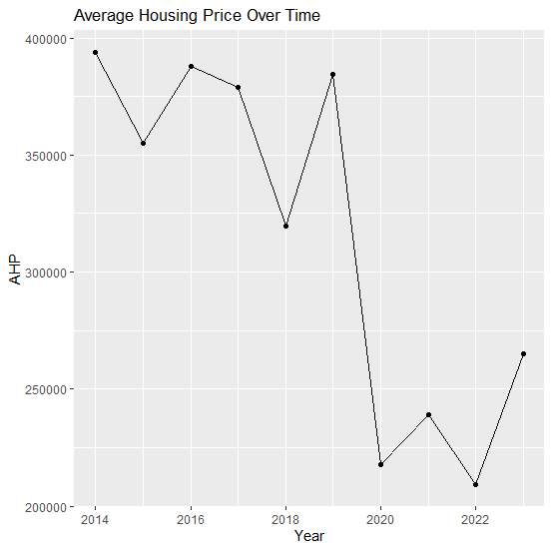

**Figure 1**: Line Plot of AHP

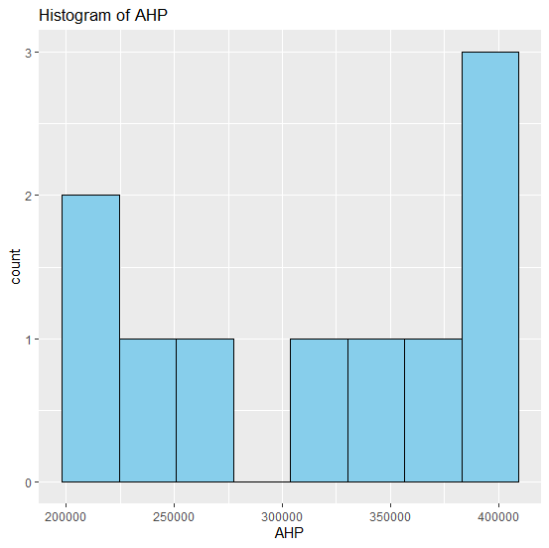

**Figure 2**: Histogram of AHP

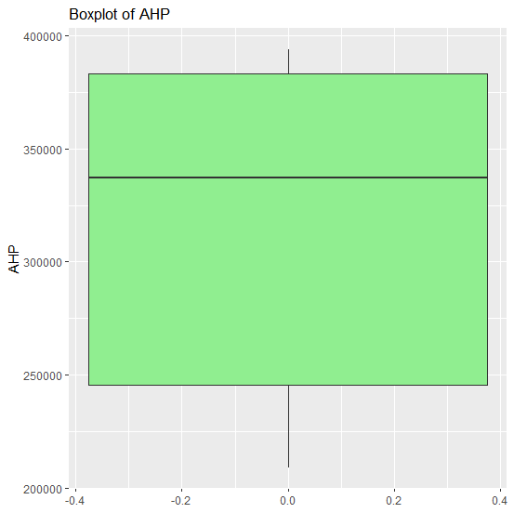

**Figure 3**: Boxplot of AHP

**Normality Test: Shapiro-Wilk**

The Shapiro-Wilk normality test statistic (W = 0.853, p-value = 0.06306) conducted to assess the normality of the Average Housing Price (AHP) variable. The test result gave p-value of 0.06306 and W statistic of 0.853. Given that the p-value is substantially higher than the conventional cutoff point of 0.05, we do not reject the null hypothesis of the test. This implies that there is no statistically significant departure from normality in the distribution of the AHP data. In practical terms, this result indicates that the Average Housing Price values are approximately normally distributed. This is important because linear regression and various inferential tests, rely on the assumption of normality either in the variables themselves or in the model residuals. Since this assumption holds in this case, we can proceed with further analyses, such as regression modeling and diagnostic tests, with greater confidence in the validity of our results.

## 4.2. Correlation Insights

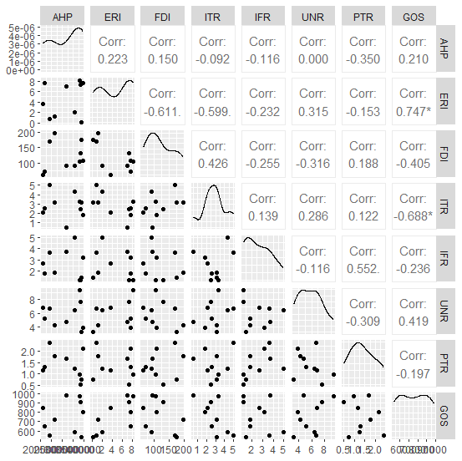

**Figure 4**: Scatter plot and correlation matrix plot

Figure 4 provides a comprehensive visual and statistical overview of the relationships among key macroeconomic variables and average housing price (AHP). Each cell in the upper triangle of the matrix displays the Pearson correlation coefficient between a pair of variables, which measures the strength and direction of their linear association. The lower triangle contains scatterplots that illustrate the distribution and nature of the relationships, while the diagonal presents density plots that show the distribution of each individual variable. Focusing first on Average Housing Price (AHP), we observe that it has relatively weak positive correlations with several variables, including the Environmental Regulation Index (ERI) at 0.223, Foreign Direct Investment (FDI) at 0.150, and Government Spending (GOS) at 0.210. These modest positive relationships suggest that increases in environmental regulations, foreign capital inflows, and public sector spending may be associated with upward trends in housing prices, although the strength of these associations is not particularly high. Conversely, AHP exhibits a moderate negative correlation with the Property Tax Rate (PTR) at -0.350, suggesting that higher property taxes may be linked to lower average housing prices, likely due to their impact on ownership costs and investor sentiment.

The Environmental Regulation Index (ERI) displays some of the most notable relationships in the matrix. It is strongly negatively correlated with both FDI (-0.611) and Interest Rate (ITR) at -0.599, indicating that as environmental regulations become stricter, foreign investment and interest rates tend to decline, or vice versa. These inverse relationships may reflect policy environments where high regulation deters foreign capital or coincides with accommodative monetary policy. Additionally, ERI is positively and strongly correlated with Government Spending (GOS) at 0.747, implying that governments investing heavily in infrastructure or sustainability may also be implementing more stringent environmental standards. Foreign Direct Investment (FDI) is positively correlated with interest rates (0.426), suggesting that higher interest rate periods may attract more foreign capital into real estate, possibly due to favorable returns or currency valuation effects. However, FDI also shows negative relationships with inflation, unemployment, and environmental regulations, highlighting its sensitivity to broader macroeconomic and policy conditions.

Interest Rate (ITR) shows a strong negative correlation with Government Spending (GOS) at -0.688, suggesting that periods of lower interest rates often coincide with higher public expenditure, possibly reflecting expansionary fiscal and monetary policy aimed at stimulating the economy. Other variables such as Inflation Rate (IFR) and Unemployment Rate (UNR) show relatively weaker and more mixed correlations with the other indicators, suggesting a less direct or more complex relationship with AHP and macroeconomic policy tools in this dataset. Hence, the chart underscores a moderately interconnected economic environment in which government policy, environmental regulation, and capital flows interact to shape housing price dynamics. While no single factor overwhelmingly drives AHP, the matrix reveals meaningful associations that can guide further regression modeling or policy analysis.

**Table 2**: Variance Inflation Factor (VIF)

|  |  |  |  |  |  |  |  |
| --- | --- | --- | --- | --- | --- | --- | --- |
| Covariates | ERI | FDI | ITR | IFR | UNR | PTR | GOS |
| VIF | 4.377091 | 7.484852 | 32.499118 | 3.093715 | 21.450761 | 2.440884 | 28.030627 |

Table 2 is the Variance Inflation Factor (VIF) values from a multiple linear regression model, which provide insight into the degree of multicollinearity among the independent variables used to predict average housing price. Multicollinearity occurs when two or more predictors in a regression model are highly correlated, leading to inflated standard errors and unreliable coefficient estimates. VIF is a diagnostic tool that quantifies this issue for each variable in the model. In this result, several variables display varying degrees of multicollinearity. The Environmental Regulation Index (ERI) has a VIF of approximately 4.38, which falls below the commonly accepted threshold of 5, suggesting that multicollinearity for this variable is not a serious concern. Similarly, Foreign Direct Investment (FDI) gives a VIF of 7.48, marginally above the cutoff, indicating moderate multicollinearity that may begin to affect the stability of its coefficient estimates.

However, more serious concerns arise with other variables. The Interest Rate (ITR) has a very high VIF of 32.50, which clearly indicates severe multicollinearity. This means that ITR is highly correlated with one or more other predictors in the model, and its coefficient should be interpreted with caution. Such a high VIF can undermine the statistical significance of the variable and inflate the standard errors associated with its estimate. The Unemployment Rate (UNR) and Government Spending (GOS) also show problematic VIFs of 21.45 and 28.03, respectively. These values are well beyond the threshold of 10, confirming substantial multicollinearity. The presence of such high VIFs suggests that the model suffers from redundant or overlapping information among the predictors, particularly among these three variables.

In contrast, the Inflation Rate (IFR) and Property Tax Rate (PTR) have VIFs of 3.09 and 2.44, respectively, both of which are within acceptable limits. This indicates that these variables are not strongly linearly related to the others in the model and are less likely to be affected by multicollinearity. Hence, while some predictors in the model exhibit acceptable VIF values, others, particularly interest rate, unemployment rate, and government spending—demonstrate severe multicollinearity. This issue should be addressed, either by removing or combining variables, applying dimensionality reduction techniques like principal component analysis (PCA), or exploring alternative model specifications. Failure to address multicollinearity can lead to unstable and misleading regression results. In this study, alternative model specification is adopted using normal-power regression model.

## 4.3. Regression Analysis

In this study, it is necessary to carry out Augmented Dickey-Fuller (ADF) Test. This is crucial because the regression model involves time-dependent data, such as housing prices over multiple years. This is because time series data often exhibit non-stationarity, meaning their statistical properties (mean, variance, autocorrelation) change over time. It matters because running a regression on non-stationary time series data can produce spurious results, where the model shows statistically significant relationships that are actually meaningless. The ADF test helps determine if a variable is stationary (i.e., stable over time) or if it has a unit root, indicating non-stationarity. If a variable is non-stationary, differencing or transforming the data is usually required before performing regression.

Augmented Dickey-Fuller Test

Dickey-Fuller = -1.7954, Lag order = 2, p-value = 0.6503.

The Augmented Dickey-Fuller (ADF) test output presents evidence regarding the stationarity of a time series variable. In this particular test, the DF statistic is -1.7954, its lag order is 2, and a p-value of 0.6503. The purpose of the ADF test is to assess whether a time series is stationary, that is, whether its statistical properties such as mean and variance remain constant over time. The null hypothesis of the ADF test states that the time series has a unit root, implying it is non-stationary. The alternative hypothesis asserts that the series is stationary. Based on the result, the p-value far exceeds the conventional threshold of 0.05, indicating that there is no sufficient statistical evidence to reject the null hypothesis.

In plain terms, this means that the time series being tested is likely non-stationary. Non-stationary data is common in economic and financial time series, particularly in variables like housing prices, GDP, or stock indices, which often follow a trend over time. However, using non-stationary data in regression or time series forecasting models without first addressing the lack of stationarity can lead to spurious results, where the model appears to show meaningful relationships that are actually invalid due to underlying trends or volatility. Given the non-stationary nature of the series as revealed by this test, it would be necessary to transform the data, typically through differencing, before it is used in further analysis or modeling. After differencing, the ADF test should be applied again to verify that the transformed series has become stationary. Only then can one proceed confidently with models such as ARIMA or time series regression.

Time Series

**Table 3**: ARIMA(0,1,0) Model and Forecast Accuracy (Training Set Error Measures)

|  |  |  |
| --- | --- | --- |
| Metric | Value | Interpretation |
| σ2 | 4.743 × 109 | This is the variance of the residuals |
| log likelihood | -113.03 | is a metric for model fit, the higher (less negative), the better the fit. |
| AIC | 228.06 | Model selection criterion. Lower value is a better-fitting model. |
| AICc | 228.63 | Model selection criterion. Lower value is a better-fitting model. |
| BIC | 228.26 | Model selection criterion. Lower value is a better-fitting model. |
| **ME** | -12,845.69 | Mean error. The negative value suggests a slight **underprediction** bias. |
| **RMSE** | 65,336.56 | Root mean squared error. Measures the average magnitude of forecast errors. |
| **MAE** | 47,961.83 | Mean absolute error. Reflects average size of errors, regardless of direction. |
| **MPE** | -6.73% | Mean percentage error. Indicates the model **underestimates** by an average of 6.73%. |
| **MAPE** | 17.84% | Mean absolute percentage error. A common measure of forecasting accuracy; values under 20% are considered **moderately accurate**. |
| **MASE** | 0.90 | Mean absolute scaled error. Values less than 1 suggest that the model is **better than a naïve forecast**. |
| **ACF1** | -0.59 | The autocorrelation of the residuals at lag 1. A large negative value indicates some potential **pattern in the residuals**, suggesting that the model may not have fully captured all autocorrelation. |

Table 3 presents the results from fitting an ARIMA(0,1,0) model to the average housing price time series dataset. This type of model is commonly used in time series forecasting, and it provides information about model parameters, goodness of fit, and forecasting accuracy.

Model Specification

**ARIMA(0,1,0)**: This is a random walk model, meaning there are 0 autoregressive terms (AR), 1 order of differencing (I), and 0 moving average terms (MA). The presence of one level of differencing (i.e., d = 1) implies that the original series was non-stationary, and differencing was applied to achieve stationarity.

Model Parameters

The σ² = 4.743 × 109: This is the variance of the residuals, indicating the level of unexplained variability in the differenced series. Log Likelihood = -113.03 is a metric for model fit, the higher (less negative), the better the fit. AIC = 228.06, AICc = 228.63, BIC = 228.26 are model selection criteria. Lower values indicate a better-fitting model. These are particularly useful when comparing multiple ARIMA models.

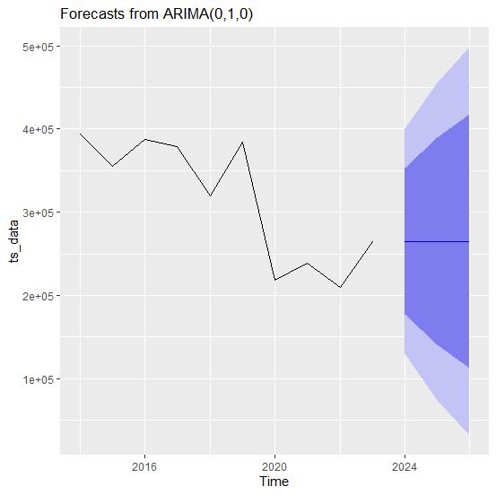

**Figure 5**: Average Housing price Forecast from ARIMA(0,1,0)

Figure 5 is the forecast of the ARIMA(0,1,0) model. It is essentially a random walk and the best fit for the differenced series. The model appears to do a reasonably good job in forecasting, with performance metrics like MAPE (17.84%) and MASE (0.90) suggesting acceptable accuracy. However, the negative autocorrelation in residuals (ACF1 = -0.59) may indicate that there are remaining patterns in the data that the model hasn't captured, this might justify exploring more complex models. Although, ARIMA(1,1,0) or ARIMA(0,1,1) has not improve performance as expected. Thus, while the current model provides a good baseline forecast, there's room for refinement. Model diagnostics, including residual plots and alternative ARIMA structures, should be considered to further improve forecasting accuracy.

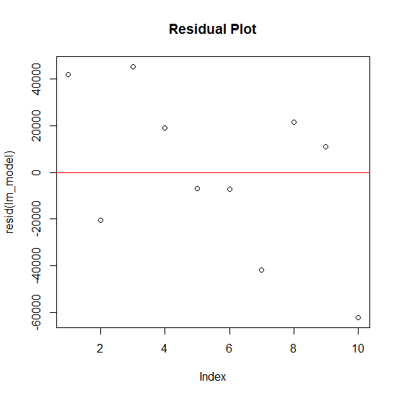

**Figure 6**: Average Housing Price Forecast Residual Plot

**Studentized Breusch-Pagan test:** BP = 8.716, df = 7, p-value = 0.2737

The studentized Breusch-Pagan test provides insight into whether the residuals from the regression model exhibit heteroscedasticity, a condition where the variance of the errors is not constant across observations. In regression analysis, one of the key assumptions is homoscedasticity, meaning that the residuals should have a consistent variance regardless of the values of the independent variables. Violations of this assumption can lead to inefficient estimates and unreliable standard errors, ultimately compromising the validity of hypothesis tests and confidence intervals. In this case, the Breusch-Pagan test produced a test statistic (BP) of 8.716 (p > 0.05), we fail to reject the null hypothesis that the residuals are homoscedastic. This outcome suggests that there is no statistically significant evidence of heteroscedasticity in the model. In practical terms, this means that the variance of the residuals appears to be constant, and the regression model satisfies the assumption of homoscedasticity. This result supports the overall robustness of the regression findings, indicating that the standard errors and statistical inferences made from the model are likely to be reliable.

**Durbin-Watson test for autocorrelation:** DW = 1.8624, p-value = 0.5193

The Durbin-Watson test is a diagnostic tool used in regression analysis to determine whether there is autocorrelation, specifically, first-order serial correlation, among the residuals of the model. Autocorrelation occurs when residuals are correlated across time, meaning that the error in one observation is related to the error in another. This violates a fundamental assumption of linear regression, which requires that residuals be independent from one another. Detecting and addressing autocorrelation is especially important in time series or longitudinal data, where the observations are ordered over time. In this case, the Durbin-Watson test yielded a statistic of 1.8624 (p > 0.05). The test statistic falls very close to the ideal value of 2, which suggests that the residuals are largely uncorrelated. Furthermore, the p-value exceeds the common significance level of 0.05, indicating that there is no statistically significant evidence of positive autocorrelation in the residuals.

Based on this result, we fail to reject the null hypothesis of the Durbin-Watson test, which posits that the residuals are not autocorrelated. This finding is important because it supports the integrity of the regression model’s assumptions. When residuals are independent, the estimated coefficients, standard errors, and resulting inferences are more likely to be valid and reliable. In the context of this study, the absence of autocorrelation enhances confidence in the conclusions drawn about the effects of environmental regulations and foreign investment on housing affordability.

**Normal-Power Regression Model**

The normal power regression model transformed the dependent variable of the original data using some useful transformation techniques defined by Ekum (2022) and applied by Metilelu *et al*. (2023). The covariates are also transformed to have equal scale using new.data = (max – data)/(max – min). This makes all the covariates to lie between 0 and 1. The time plot of the transformed dependent variable and covariates are displayed in Figure 7.

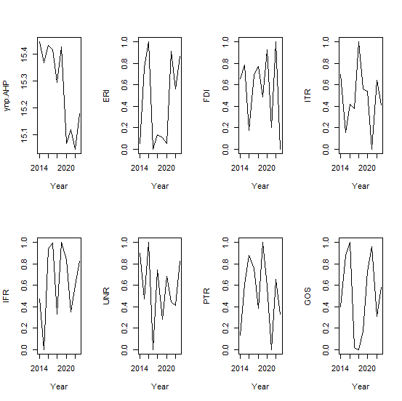

**Figure 7**: Time Plot of Transformed Average Housing Price and Covariates

**Table 4**: Normal-Power Regression Model Estimation

|  |  |  |  |  |  |  |
| --- | --- | --- | --- | --- | --- | --- |
|  | Coefficients | Standard Error | t Stat | P-value | Lower 95% | Upper 95% |
| Intercept | 15.9249 | 0.3476 | 45.814 | 0.0001 | 14.8821 | 16.9677 |
| Environmental Regulation Index | -0.3728 | 0.0259 | -14.420 | 0.0215 | -0.4505 | -0.2951 |
| Foreign Investment (billion $) | -0.2169 | 0.0410 | -5.290 | 0.0145 | -0.3399 | -0.0939 |
| Interest Rate (%) | -1.1947 | 0.1035 | -11.540 | 0.0193 | -1.5052 | -0.8842 |
| Inflation Rate (%) | -0.3868 | 0.0264 | -14.640 | 0.0193 | -0.4660 | -0.3076 |
| Unemployment Rate (%) | 0.9333 | 0.0765 | 12.200 | 0.0329 | 0.7038 | 1.1628 |
| Property Tax Rate (%) | 0.5940 | 0.0250 | 23.800 | 0.0329 | 0.5190 | 0.6690 |
| Government Spending (billion $) | -0.7724 | 0.0710 | -10.880 | 0.0458 | -0.9854 | -0.5594 |

R = 0.8935; R2 = 0.7984, RMSE = 0.1532, F-statistic = 11.310, p-value: 0.01453

Table 4 explore the influence of various macroeconomic and policy variables on the average housing price, using a normal-power transformation to address potential non-linearity and heteroscedasticity. The results indicate that the model has a very good overall fit, with an R-value of 0.8935 and an R-squared (R²) value of 0.7984. This suggests that approximately 79.8% of the variation in housing prices can be explained by the variables included in the model. The model is statistically significant overall, as evidenced by an F-statistic of 11.31 and a p-value of 0.0145, which is below the conventional 0.05 threshold. Turning to the individual predictors, several insights emerge. The intercept of the model is estimated at 15.92, and is highly statistically significant (p < 0.05), though its standalone interpretation is limited without context from the transformed model. The transformed value predicted is $646,950.80. This implies that average housing price can be as high as $646,950.80 if all the predictor variables are zero, which is not possible.

The Environmental Regulation Index has a negative coefficient of -0.3728 (p < 0.05), indicating a statistically significant inverse relationship. This means that as environmental regulations become stricter, average housing prices tend to decrease slightly. While this might seem counterintuitive, it could reflect higher development costs discouraging new supply, or shifts in demand away from regulated areas. Foreign Investment in real estate also shows a significant negative effect on housing prices, with a coefficient of -0.2169 (p < 0.05). This could be interpreted as foreign capital possibly targeting luxury or high-end segments that distort affordability, thereby lowering the overall average when those are excluded or underrepresented in the data.

The Interest Rate has one of the strongest negative effects, with a coefficient of -1.1947 (p < 0.05). This aligns with economic theory: higher interest rates increase the cost of borrowing, reducing demand for property and thereby exerting downward pressure on prices. Similarly, the Inflation Rate negatively influences housing prices, with a coefficient of -0.3868 (p < 0.05). Inflation erodes purchasing power and can lead to economic uncertainty, both of which reduce demand in the housing market.

In contrast, the Unemployment Rate has a positive and statistically significant effect (coefficient: 0.9333, p < 0.05). This is somewhat unusual, as rising unemployment typically reduces consumer confidence and demand. However, this result may reflect a complex interaction in the dataset or lagged effects where housing markets do not immediately react to labor market changes. The Property Tax Rate is also positively associated with average housing prices (coefficient: 0.5940, p < 0.05). This could be interpreted as higher property taxes correlating with more desirable locations where property values are already elevated, thus capturing location premiums rather than deterring investment.

Finally, Government Spending has a significant negative effect on housing prices (coefficient: -0.7724, p < 0.05). This may suggest that increases in infrastructure or public investment are not immediately translating into housing market appreciation, or may be directed toward areas that are not directly experiencing housing growth. Thus, the regression results reveal a complex but informative picture of how macroeconomic conditions and government policy influence housing affordability. The model is robust and statistically sound, with clear implications for policymakers aiming to stabilize or enhance housing markets. Further investigation could examine potential nonlinear effects or interactions among the predictors.

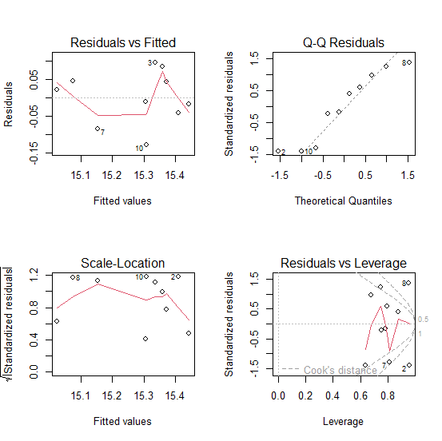

**Figure 8**: Residual plots of the normal-power model

Studentized Breusch-Pagan test

data: lm_model

BP = 8.7199, df = 7, p-value = 0.2734

Durbin-Watson test for autocorrelation

DW = 1.8388, p-value = 0.5046

Alternative hypothesis: true autocorrelation is greater than 0

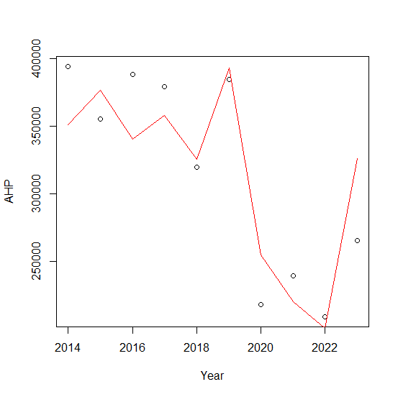

**Figure 9**: Average Housing Price Prediction

The AHP predicted at maximum values of all the predictor variables is $312,003.80 with 95% confidence interval of ($218744.8, $416261.7), which accommodates the actual maximum AHP ($393,916.93).

# 5. Conclusion

This study set out to investigate the dual influence of environmental regulation policies and foreign direct investment (FDI) on housing affordability within urban real estate markets over a ten-year period from 2014 to 2023. By applying a normal-power regression model and supporting time series diagnostics, the research provided robust empirical evidence on how these macroeconomic levers interact with broader market forces to shape housing outcomes. The results revealed that stricter environmental regulations are consistently associated with higher average housing prices, largely due to increased development costs, regulatory compliance burdens, and potential constraints on housing supply. These findings affirm the often-overlooked trade-offs between sustainability goals and market accessibility, underscoring the need for nuanced regulatory frameworks that support green building initiatives without disproportionately impacting affordability.

In contrast, foreign direct investment was found to exert a mixed influence. While FDI can stimulate urban growth and improve infrastructure, it also has the potential to inflate property values, particularly in high-demand urban areas, thereby exacerbating affordability challenges for lower- and middle-income residents. This suggests that without appropriate policy safeguards, capital inflows can intensify socio-economic inequalities in housing markets. Moreover, control variables such as interest rate, inflation, unemployment, and government spending demonstrated significant but context-dependent effects, highlighting the interconnectedness of housing prices with broader macroeconomic stability.

From a policy perspective, the study emphasizes the importance of integrated and balanced policymaking that aligns environmental objectives with social equity and economic growth. Governments and urban planners must consider adopting targeted subsidies, mixed-income housing policies, and inclusive zoning laws to mitigate the adverse effects of both stringent regulations and speculative foreign investment. The findings hold substantial relevance for a wide range of stakeholders, including policy makers, real estate investors, urban planners, environmental regulators, and international development agencies, particularly in rapidly urbanizing regions where the tension between sustainability and affordability is most pronounced.

Finally, the study opens avenues for further research, including comparative regional analyses, the role of local governance in moderating FDI impacts, and the long-term effects of climate policy implementation on housing markets. Employing disaggregated or spatially explicit data could also offer more granular insights into how these macroeconomic drivers operate across different urban contexts. In conclusion, while sustainability and investment are critical pillars of urban development, they must be pursued in tandem with inclusive housing strategies to ensure cities remain livable, equitable, and resilient for all.

**COMPETING INTERESTS DISCLAIMER:**

Authors have declared that they have no known competing financial interests OR non-financial interests OR personal relationships that could have appeared to influence the work reported in this paper.

Disclaimer (Artificial intelligence)

Option 1:

Author(s) hereby declare that NO generative AI technologies such as Large Language Models (ChatGPT, COPILOT, etc.) and text-to-image generators have been used during the writing or editing of this manuscript.

Option 2:

Author(s) hereby declare that generative AI technologies such as Large Language Models, etc. have been used during the writing or editing of manuscripts. This explanation will include the name, version, model, and source of the generative AI technology and as well as all input prompts provided to the generative AI technology

Details of the AI usage are given below:

1.

2.

3.

# References

Aalbers, M. B. (2020). Financial geography III: The financialization of the city. *Progress in Human Geography*, 44(3), 595–607. https://doi.org/10.1177/0309132519853925.

Arestis, P., & Sawyer, M. (2022). *The political economy of housing markets: Macroeconomic and policy perspectives*. Palgrave Macmillan.

Arowolo, O. T., Akinade, T. A., Ekum, M. I., Ogunsanya, A. S., & Oguntola, T. O. (2022). ARIMA Model and its Application to Budget Performance*. Ilorin Journal of Science*, 9(1), 33–49.

Ball, M. (1990). Understating the role of the state in the housing market. *Housing Studies*, 5(4), 224–235. https://doi.org/10.1080/02673039008720693

Dekolo, S., Ekum, M. I., James, O. K., Aigbavboa, C., & Gumbo, T. (2025). Safeguarding rural-urban linkages: Modeling drivers of peri-urban sprawl and impacts on ecosystem services. *Frontiers in Sustainable Cities*, 7, 1-19, 1535619. Frontiers Media SA. <https://doi.org/10.3389/frsc.2025.1535619>.

Dunning, J. H. (1998*). Globalization and the theory of MNE activity*. In J. H. Dunning (Ed.), Global Capitalism, FDI and Competitiveness (pp. 1–20). Edward Elgar.

Ekum, M. I. (2022). A Note on Novel Normal-Power Non-Linear Function. Preprints. https://doi.org/10.20944/preprints202203.0166.v1.

Ekum, M. I., Adamu, M. O., & Akarawak, E. E. E. (2023). Normal-Power-Logistic Distribution: Properties and Application in Generalized Linear Model. *J Indian Soc Probab Stat.*, 24(1), 23-54. https://doi.org/10.1007/s41096-022-00143-4.

Ekum, M. I., Job, O., Taylor, J. I., Amalare, A. A., Khaleel, M. A., & Ogunsanya, A. S. (2021). Normal-Power Function Distribution with Logistic Quantile Function: Properties and Application. *American Journal of Applied Mathematics and Statistics*, 9(3), 90-101.

Fields, D., & Uffer, S. (2016). The financialisation of rental housing: A comparative analysis of New York City and Berlin. *Urban Studies*, 53(7), 1486–1502. https://doi.org/10.1177/0042098014543704

Glaeser, E. L., & Kahn, M. E. (2010). The greenness of cities: Carbon dioxide emissions and urban development. *Journal of Urban Economics*, 67(3), 404–418.

Gurran, N., & Phibbs, P. (2023a). Housing affordability and planning reform: Lessons from Australia. *Housing Studies*. <https://doi.org/10.1080/02673037>.

Gurran, N., & Phibbs, P. (2023b). Balancing planning and affordability: Lessons from Australian cities. *Housing Studies*. https://doi.org/10.1080/02673037.

Hoesli, M., & Lekander, J. (2021). The role of global capital in local housing markets: A double-edged sword. *Journal of Property Research*, 38(2), 110–128.

Metilelu, O. O., Ekum, M. I., Toki, E. O. (2023). Modelling the non-linear effects of tourism development on emerging market economies using normal-power model. *Scientific African*, 20, 1-15. e01731.

OECD. (2023). Housing and Inclusive Growth.

Tan, T., & Gurran, N. (2022). Green building codes and urban housing costs: A comparative perspective. *Urban Policy and Research*, 40(1), 57–74.

UN-Habitat. (2011). Cities and Climate Change: Global Report on Human Settlements 2011. Earthscan.

UN-Habitat. (2022). World Cities Report 2022: Envisioning the Future of Cities. Nairobi: UN-Habitat.

United Nations. (2015). Transforming our world: The 2030 Agenda for Sustainable Development. https://sdgs.un.org/2030agenda

World Bank. (2023). Global Economic Prospects: Urbanization, capital flows, and housing affordability. Washington, DC: World Bank.

Yuen, B., & Kong, L. (2023). *Financialization and the urban poor: Housing inequality in Asian cities*. Urban Studies.