Original Research Article

An Application Of Natural Cubic Spline For The Prediction And Forecasting Of Rainfall In Uttar Pradesh, India

Abstract
Weather and climate have a significant impact on our daily lives. The amount of data available is vast and in order to draw meaningful conclusions from the data one needs to develop appropriate models that can fit the data properly. Several models are available for analyzing and predicting the time series data. The spline-based technique produces an acceptable pattern of time series data that can be used for prediction and modelling. The data for the study is obtained from the Government of India website for the meteorological subdivision of East and West Uttar Pradesh for the past 120 years from 1901 to 2020 on a monthly basis. This study discusses the application of Autoregressive Integrated Moving Average (ARIMA) model and Natural Cubic Spline for the development of a more appropriate model for predicting and forecasting rainfall in Uttar Pradesh. The study focuses on two different approaches of applying the cubic spline. The fitted models are compared by plotting the curves and various matrices like Root Mean Square Error (RMSE), R square, adjusted R square, AIC and BIC. The analysis was performed using R software. From the comparison, the model fitted through Natural Cubic Spline is obtained as more suitable for the prediction and forecasting of Rainfall in Uttar Pradesh. With a better model for forecasting of rainfall, the study will contribute to better decision-making for policymakers, thus eventually contributing to better crop management in the state. The study will also contribute to better water resource management and enhance disaster preparedness. The study can also serve as a foundation for future research on rainfall prediction in UP and other regions and encourage further exploration of different statistical techniques and data sources.
Keywords: ARIMA, CUBIC SPLINE, RMSE, AIC, BIC

Introduction

Accurate prediction and forecasting of rainfall are critical for managing agricultural practices, water resources, and addressing the challenges posed by extreme weather events. In India, the variability of rainfall poses significant challenges, particularly in regions like Uttar Pradesh, where diverse climatic conditions influence the amount, distribution, and timing of precipitation. The monsoon season, which contributes more than 75% of the annual rainfall, varies greatly across different parts of the state. This temporal and spatial variability makes it difficult to predict rainfall accurately, yet it remains essential for effective decision-making in sectors such as agriculture, infrastructure development, and disaster management. Uttar Pradesh, located in northern India, experiences a tropical monsoon climate with three distinct seasons: winter, summer, and the monsoon season. The state’s large geographical expanse and varied topography result in significant regional differences in rainfall, with the eastern parts receiving heavier precipitation compared to the northwest. The challenge of forecasting rainfall is compounded by the irregular and fluctuating nature of weather patterns, which are influenced by factors such as wind patterns, humidity, and temperature. To address these challenges, statistical methods have been increasingly utilized to model and forecast rainfall data. One such method is the natural cubic spline, a powerful technique for creating smooth, flexible models that can handle non-linear relationships in data. Natural cubic splines provide a way to interpolate and smooth time-series data, making them particularly useful for predicting complex and irregular rainfall patterns. This study aims to explore the application of natural cubic splines for predicting and forecasting rainfall in Uttar Pradesh. By utilizing this technique, the research seeks to improve the accuracy of rainfall predictions, contributing to better-informed decision-making in sectors dependent on rainfall data. Through this approach, the study also aims to highlight the potential of natural cubic splines in overcoming the challenges posed by variable and irregular rainfall patterns.

Review of literature
Predicting and forecasting rainfall is critical for agricultural and water management systems in regions with seasonal variations in rainfall patterns. Several statistical models and machine learning techniques have been used to analyze rainfall data and improve forecast accuracy. Early methods of rainfall prediction relied on statistical techniques such as Box- Jenkins ARIMA models (Box & Jenkins, 1976) and have been extensively used for rainfall forecasting. However, these models assume stationarity, which is the limitation of this model. Multiple linear and logistic regression models have been applied in some studies, but they often fail to capture the nonlinearity present in rainfall patterns (Singh et al., 2015). Rainfall during the monsoon (June- September) is essential for the economy of Uttar Pradesh, as the state relies heavily on agriculture. Studies have analyzed seasonal and annual variations using historical data. (Kumar et al.,2018) examined long-term rainfall trends across different districts in UP and found increasing variability, particularly in the eastern and central regions. The study suggested that erratic monsoon patterns contribute to recurrent droughts and floods. Pal et al. (2019) used wavelet transforms to analyze rainfall fluctuations in UP, revealing significant inter-annual variability influenced by global climatic phenomena like ENSO (El Niño–Southern Oscillation). Meixner et al. (2016) highlighted that rainfall in western UP shows declining trends, affecting groundwater recharge and leading to water scarcity issues. In the study conducted by Irham et al. (2018), the effectiveness of different cubic spline methods for interpolating rainfall data was examined. The authors found that both natural and not-a-knot splines provided accurate results for rainfall data in Malaysia.

On the other hand, Kurniawan (2020) explored the performance of the ETS model compared to the ARIMA model for forecasting rainfall in Indonesia, highlighting that the ETS model outperformed ARIMA in both the training and testing sets. While the ARIMA model has been widely used for rainfall forecasting, some studies (e.g., Kurniawan, 2020) suggest that it may not always yield the most accurate results, particularly in tropical climates. In contrast, machine learning models, such as artificial neural networks (ANN), have shown promise in capturing non-linear relationships in rainfall data (Parmar et al., 2017). However, few studies have explored using cubic splines for rainfall forecasting, despite their potential for interpolating irregular data patterns. The literature indicates that while statistical models like ARIMA and machine learning techniques such as ANN are widely used for rainfall forecasting, few studies have explored the application of natural cubic splines. This research aims to fill this gap by applying natural cubic splines to forecast rainfall patterns in Uttar Pradesh, offering a potential improvement in forecast accuracy.

Methodology
The monthly rainfall data for the meteorological subdivision of East and West Uttar Pradesh is obtained from government of India website (data.gov.in) for the past 120 years from January 1901 to December 2020. The analysis was done using R software. Two different models have been used for the analysis of the data namely: Autoregressive Integrated Moving Average and Natural Cubic Spline. The models are fitted using these models and compared with the predicted values and the most suitable model is used for the forecasting. Comparison was done using accuracy measures like AIC, BIC, RMSE, R squared and Adjusted R square.

Autoregressive Integrated Moving Average
The research used the Autoregressive Integrated Moving Average (ARIMA) model. This model encompasses Autoregression (AR) and Moving Average (MA). Additionally, an integrated module was employed when data required differencing to establish stationarity.
The Autoregressive (AR) component postulates that the most recent value is the sum of the immediately previous value and random white noise:
y_{t} = ε_{t} + ϕy_{t-1} | (1)
Here, y_{t} represents the event at time t, ε_{t} is immediate random white noise, y_{t−1} is the event at the previous time, and ϕ is the coefficient.
In the Moving Average (MA) component, the current value is regarded as the sum of the previous value and a specific white noise:
y_{t} = ε_{t} + θε_{t−1} | (2)

The combined AR and MA components yield the Autoregressive Moving Average (ARMA) model:
y_{t} = ϕ₁y_{t−1} + ⋯ + ϕ_{p}y_{t−p} + ε_{t} + θ₁ε_{t−1} + ⋯ + θ_{q}ε_{t−q} | (3)

The ARIMA model is represented as ARIMA (p, d, q)(P, D, Q), where p and P correspond to non-seasonal AR and seasonal AR components respectively, d and D denote the non-seasonal and seasonal integrated orders, and q and Q signify the non-seasonal and seasonal MA lags.
To construct ARIMA models, the Box-Jenkins method was adopted, encompassing four key phases: Identification, Estimation, Diagnostics, and Forecasting.
Finally, the precision of the chosen model was quantified using metrics such as Root Mean Square Error (RMSE) and Mean Absolute Error (MAE).

Natural Cubic Spline
Natural cubic splines are the piecewise cubic polynomials that fits a smooth, flexible curve to the data while maintaining continuity and smoothness. They are piecewise cubic polynomial defined on a set of knots and ensure smooth second-order derivatives at the knots. They are constrained to have a zero second-order derivative at the boundaries. Given a dataset (x_{i}, y_{i}), the function is constructed as:
S(x) = a_{i} + b_{i} (x – x_{i}) + c_{i} (x – x_{i} )² + d_{i} (x – x_{i )}³, x_{i} ≤ x ≤ x_{i+1} | (4)
where the coefficients a_{i,} b_{i,} c_{i} and d_{i} are determined using boundary conditions and smoothness constraints. Here (x – x_{i}) represents the basis function which is zero when x < x_{i}.
the Natural Cubic Splines capture non-linear relationships effectively and provide smooth interpolation between data points. A careful selection of knots needs to be done to balance between overfitting and flexibility.
The first step was the handling of missing values; since no missing values were identified in the dataset, the next phase proceeded without requiring any imputation. Appropriate statistical tests were applied to check for stationarity, ensuring the data was suitable for time series analysis. For model selection and forecasting, the time series data was divided into a training set and a test set. The training set consisted of data from January 1901 to December 2019, while the test set consisted of data from January 2020 to December 2020. The study utilises two different approaches for applying Natural Cubic Spline. The first approach utilizes the Natural Cubic Smoothing Spline model based on penalized least squares regression with a roughness penalty. A smooth curve f(x) is fitted to a set of data points (x_{i}, y_{i} ) by minimizing the objective function
$\sum_{i=1}^{n}{\left(y_{i}-f\left(x_{i}\right)\right)}$² + λ∫(f′′(x))²dx | (5)
where:
- The first term $\sum_{i=1}^{n}{\left(y_{i}-f\left(x_{i}\right)\right)}$² assures that the spline stays close to the data.
- The second term λ∫(f′′(x))²dx controls the smoothness of the data.
- λ is the smoothing parameter.
The smoothing parameter λ determines the roughness penalty. A higher λ may lead to overfitting of the data while a lower λ may lead to underfitting of the data. Hence it is important to select an optimal smoothing parameter that balances the overfitting and underfitting of the data. For this purpose, different smoothing parameters are tested and the one that gives the least RMSE is selected for the model.
The next approach of applying Natural Cubic Spline is generating a spline basis function and fitting a linear model using these transformed variables.
y = β₀ + $\sum_{i=1}^{p}{β_{i}}$B_{i}(x) + ε | (6)
where:
- B_{i}(x) are the spline basis functions
- β_{i} are the corresponding regression coefficients
- ε is the error term.
The number of knots is controlled by the degrees of freedom used in the spline model. A higher degree of freedom implies a greater number of knots that offer more flexibility to the curve which may lead to overfitting of the data. On the other hand, a low degree of freedom ensures a lesser number of knots leading to underfitted data. So, the objective is to use an optimal number of degrees of freedom that gives a smoother curve. A good approach is using cross-validation to select an optimal degree of freedom. The value of RMSE for different degrees of freedom is tested and the one with the least RMSE is selected for the model.

Data Analysis.
Firstly, the spline model for the East U.P. rainfall was constructed using the smooth.spline function. This function requires a smoothing parameter. To get the best smoothing parameter (spar) that results in the best model for our rainfall dataset, a range of spar values from 0.0 to 1.0, in increments of 0.05, was defined for evaluation. A smoothing spline was fitted for each spar value, and predictions were generated on the test data. The RMSE was calculated for each spar value to measure the model’s performance. The best model was selected based on the spar value for the RMSE, which was the least. The graph between the actual and predicted values was plotted using this model. Then, the natural cubic spline was fitted, utilising another approach. The natural cubic spline fitted through the lm() function is the regression spline with knots being placed based on the degrees of freedom instead of directly optimising for smoothness. An iterative method is applied to fit the model for various degrees of freedom, and the optimal model for the dataset is determined by assessing the RMSE. The model was selected using the degrees of freedom with the least RMSE. Using this model, the graph is plotted between the actual and the predicted values. The same procedure is applied to analyse the data of West U.P. and the graph is plotted between the actual and predicted values. For comparing the results ARIMA model is also applied for both datasets. Different accuracy measures are obtained for all the models to get a better understanding of the models.

Results.
Table 1 shows the values of the Root Mean Square Error for different smoothing parameters (spar) for the natural cubic spline using penalized least square regression. The RMSE is least (41.35) for spar 0.35 for East U.P. while RMSE is least (48.37559) for spar 0.30 for West U.P. Table 2 shows the value of Root Mean Square Error for different degrees of freedom for Natural Cubic Spline using linear model lm() for both East and West UP. For East U.P., RMSE is the least (43.95) for 6 degrees of freedom, while for West U.P., RMSE is the least (48.40) for 8 degrees of freedom. So, the best models are selected using these values and the graphs are plotted for the actual and predicted values. Figure 1 to Figure 6 shows the actual vs. predicted values of the data. It is clear from the graphs that the spline model can capture the general trend in the data more effectively than the ARIMA model for both East and West UP. It is evident from the graphs that the model is flexible and adapts well to the local variations. The minor deviation between the actual and the predicted values shows that while the model is good at capturing the trend, it may still struggle slightly with abrupt changes. Accuracy measures are obtained for Natural Cubic Spline using both the approaches and the ARIMA model. From Table 3, it is clear that both approaches to applying the Natural Cubic Splines are capable of giving better results than the ARIMA model. However, for East U.P. smooth.splines is giving the best results, while for West U.P., Natural Cubic Spline using lm() functions is giving the best results.
Discussion:
While it is evident that the Natural Cubic Splines outperforms the ARIMA model for both the meteorological subdivisions of Uttar Pradesh, it still may overfit in some cases. On the other hand, the ARIMA model gives a strong time-series fit, but it still lags in adapting to sudden spikes. Another approach can be explored using a hybrid approach combining Spline smoothing with ARIMA forecasting for improved performance. A further study needs to be done on applying Natural Cubic Splines for predicting rainfall for different datasets. Other spline-based approaches can also be utilized for different time series models, and their efficiency needs to be checked.

Conclusion:
This paper consists of a comparative analysis of Natural Cubic Spline and the traditional ARIMA model for the prediction and forecasting of rainfall in the meteorological subdivisions of East and West Uttar Pradesh. While the traditional models are easy to use, they often lack in capturing the local variations in the data. On the other hand, the Spline method is a more recent approach that not only addresses the local variations in the data but also avoids overfitting of the data and maintains the smoothness of the fit. This study offers valuable insights into the strengths and limitations of the Spline approach to modelling the rainfall data, thus contributing to a more advanced and accurate forecasting of rainfall in the region. However, more research needs to be done on the applicability of the spline model for other datasets. In conclusion, this study provides the applicability of the Natural Cubic Spline for forecasting rainfall in Uttar which is a crucial factor in the agricultural advancements of the state. It will benefit the policymakers and consequently the farmers of the region in making it one of the leading agricultural states in the country.

Disclaimer (Artificial intelligence)
Author(S) hereby declared that no generative AI technologies such as Large Language Models (ChatGPT, COPILOT, etc.) and text-to-image generators have been used during the analysis or editing of this manuscript.

References
Naill, P. E., & Momani, M. (2009). Time series analysis model for rainfall data in Jordan: Case study for using time series analysis. American Journal of Environmental Sciences 5(5)
M. Abbas, A. A. Majid and J. M. Ali. Science Asia, 39, (2013)
T. Young and M. J. Mohlenkamp, Introduction to Numerical Methods and MATLAB
Programming for Engineers, Colombus: Ohio University (2017).
T. Young and M. J. Mohlenkamp, Introduction to Numerical Methods and MATLAB
Programming for Engineers, Colombus: Ohio University (2017).
T. Young and M. J. Mohlenkamp, Introduction to Numerical Methods and MATLAB
Programming for Engineers, Colombus: Ohio University (2017).
Ahmed, I. A., Salam, R., Naikoo, M. W., Rahman, A., Praveen, B., Hoai, P. N., Pham, Q. B., Anh, D. T., Tri, D. Q., & Elkhrachy, I. (2022). Evaluating the variability in long-term rainfall over India with advanced statistical techniques. Acta Geophysica, 70, 801–818.
Kumar, V., Kedam, N., Kisi, O., Alsulamy, S., Khedher, K. M., & Salem, M. A. (2025). A comparative study of machine learning models for daily and weekly rainfall forecasting. Water Resources Management, 39, 271–290.
Gupta, A., & Mishra, A. (2023). Trend analysis and change point detection of annual and seasonal precipitation timeseries over Varanasi District, Uttar Pradesh. In Climate Change and Environmental Impacts: Past, Present and Future Perspective (pp. 267–286). Springer Nature. https://doi.org/10.1007/978-3-031-13119-6_15
Kumar, A., Tripathi, P., Gupta, A., Singh, K. K., Singh, P. K., Singh, R., ... & Tripathi, A. (2018). Rainfall variability analysis of Uttar Pradesh for crop planning and management. Mausam, 69(1), 141-146.
Pal, L., Ojha, C. S. P., Chandniha, S. K., & Kumar, A. (2019). Regional scale analysis of trends in rainfall using nonparametric methods and wavelet transforms over a semi‐arid region in India. International Journal of Climatology, 39(5), 2737-2764.
Meixner, T., Manning, A. H., Stonestrom, D. A., Allen, D. M., Ajami, H., Blasch, K. W., ... & Walvoord, M. A. (2016). Implications of projected climate change for groundwater recharge in the western United States. Journal of Hydrology, 534, 124-138.
Azizan, I., Abdul Karim, S. A. B., & Raju, S. S. K. (2018). Fitting rainfall data by using cubic spline interpolation. MATEC Web of Conferences, 225, 05001. https://doi.org/10.1051/matecconf/201822505001
Kamath, R. S., & Author, A. (2018). Time-series analysis and forecasting of rainfall at Idukki district, Kerala: Machine learning approach. Disaster Advances. https://www.researchgate.net/publication/328495188
James, G., Witten, D., Hastie, T., & Tibshirani, R. (2023). An introduction to statistical learning with applications in R (2nd ed.). Springer.
India Meteorological Department. (2020). Annual report on rainfall and monsoon trends in Uttar Pradesh. Government of India.
Indian Meteorological Department. (2023). Rainfall data for Uttar Pradesh. Retrieved from https://www.imd.gov.in
Morton, R., Kang, E. L., & Henderson, B. L. (2008). Smoothing splines for trend estimation and prediction in time series. Environmetrics, 20(3), 249-259.

Table 1: Value of RMSE for different smoothing parameters for East and West UP for Natural Cubic Spline
S.no. | Smoothing_Parameter | RMSE for East U.P. | RMSE for West U.P.
1 | 0.00 | 45.85295 | 49.16666
2 | 0.05 | 45.78143 | 49.12332
3 | 0.10 | 45.63022 | 49.03636
4 | 0.15 | 45.33256 | 48.88551
5 | 0.20 | 44.79449 | 48.68196
6 | 0.25 | 43.89265 | 48.48909
7 | 0.30 | 42.57933 | 48.37559
8 | 0.35 | 41.35381 | 48.47939
9 | 0.40 | 41.6163 | 49.19701
10 | 0.45 | 44.19284 | 50.54719
11 | 0.50 | 48.16669 | 51.79877
12 | 0.55 | 53.11957 | 52.83642
13 | 0.6 | 59.49489 | 54.16524
14 | 0.65 | 67.41185 | 56.26739
15 | 0.7 | 76.08909 | 59.51857
16 | 0.75 | 83.37733 | 62.97411
17 | 0.8 | 88.01576 | 65.44984
18 | 0.85 | 90.46089 | 66.82718
19 | 0.9 | 91.62479 | 67.49857
20 | 0.95 | 92.15219 | 67.80598
21 | 1 | 92.38587 | 67.9428
Table 2: Value of RMSE for different d.f. for East and West UP for Natural Cubic Spline
S.no. | Degrees_of_Freedom | RMSE for East U.P. | RMSE for West U.P.
1 | 3 | 63.32259 | 63.68311
2 | 4 | 46.9267 | 59.20462
3 | 5 | 45.77298 | 51.51853
4 | 6 | 43.92525 | 53.17538
5 | 7 | 47.43237 | 48.80909
6 | 8 | 44.96232 | 48.40932
7 | 9 | 47.30845 | 48.64503
8 | 10 | 44.48566 | 49.14462
9 | 11 | 45.9109 | 49.20275
10 | 12 | 45.9109 | 49.20275

Table 3: Accuracy measures for all the models
S.no. | Metric | For East U.P. |  |  | For West U.P.
 |  | SmoothSpline | LinearModel | ARIMA | SmoothSpline | LinearModel | ARIMA
1 | AIC | 7872.198583 | 15425.58406 | 16512.46 | 7965.334457 | 15296.68 | 16410.77
2 | BIC | 7908.511858 | 15467.6963 | 16559.83 | 8007.811702 | 15349.32 | 16437.09
3 | RMSE | 41.3538063 | 43.925252 | 78.24 | 48.3755874 | 45.64799 | 70.17
4 | R² | 0.7944212 | 0.786846 | 0.54 | 0.7809257 | 0.751697 | 0.54
5 | Adjusted R² | 0.7935679 | 0.785946 | 0.54 | 0.779835 | 0.7502971 | 0.54

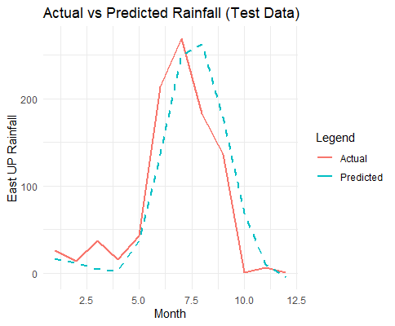  Figure 1: Actual vs predicted graph for East U.P. using smooth.spline function | 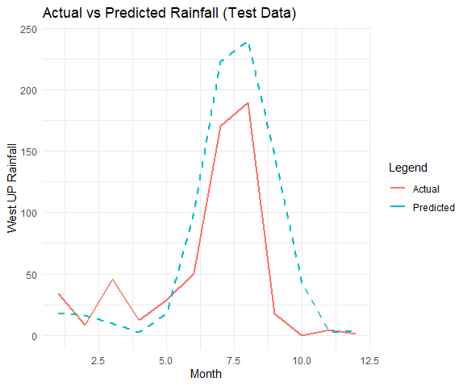  Figure 2: Actual vs predicted graph for West U.P. using smooth.spline function.
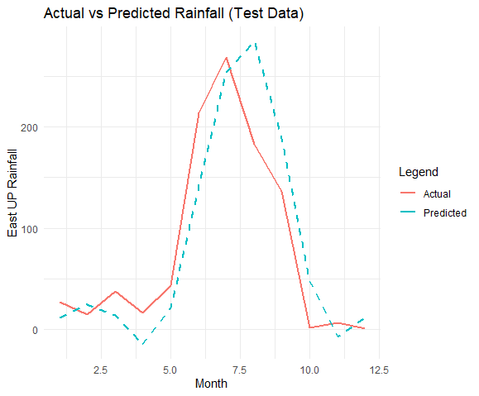  Figure 3: Actual vs predicted graph for East U.P. using lm() function | 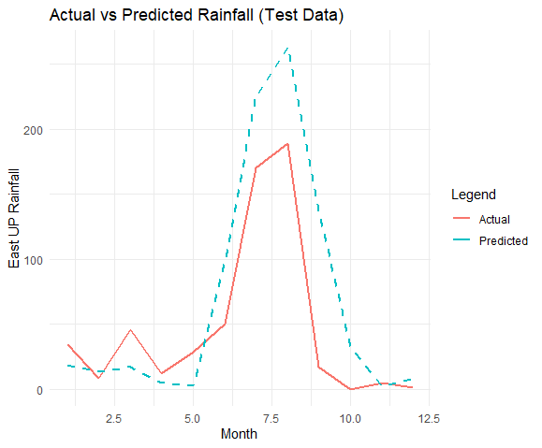  Figure 4: Actual vs predicted graph for West U.P. using lm() function
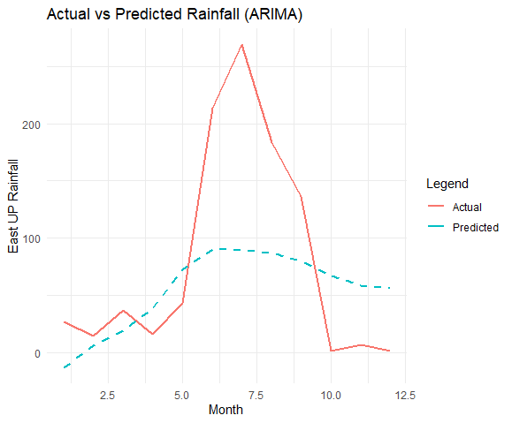 | 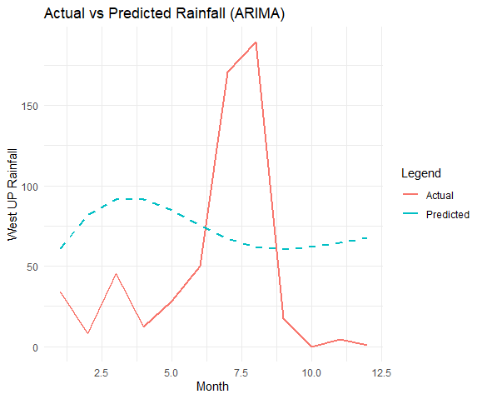
Figure 5: Actual vs predicted graph for East U.P. using auto.arima() function | Figure 6: Actual vs predicted graph for West U.P. using auto.arima() function

