The Marshall-Olkin Inverse Rayleigh Distribution and Applications
ABSTRACT
The Marshall-Olkin Inverse Rayleigh (MOIR) distribution is an extension of the classical Inverse Rayleigh distribution, incorporating Marshall-Olkin shock model that enhances its flexibility and applicability in various fields. This paper presents the derivation of the MOIR distribution and explores its fundamental properties, including moments, reliability measures, and order statistic. Expression for the mean, variance, skewness and kurtosis are also presented. Parameter estimation is addressed through maximum likelihood method, demonstrating its applicability and efficiency through simulation studies. Furthermore, we illustrate the practical utility of the MOIR distribution in modeling real-world data. The results highlight the flexibility and robustness of the MOIR distribution in capturing diverse patterns in lifetime data, offering a valuable tool for statisticians and practitioners in various fields.

Keywords: Inverse Rayleigh distribution; reliability; Marshall-Olkin-G; maximum likelihood estimation; moments

1. INTRODUCTION

Standard models are often inadequate or less representative of real data in a variety of situations. Finding a suitable model for the data is necessary since most classic distributions, such as the Rayleigh, Weibull, and exponential distributions, may not match the real data adequately. Several distributions that are more flexible than the baseline distribution have been proposed in the literature through convolution, generalization, extension, or modification to describe lifetime data. Voda (1972) created the inverse Rayleigh (IR) distribution, which is a crucial distribution for reliability and lifetime research. In particular, it offers a suitable statistical model for unimodal, heavily right-skewed data. The probability functions of the IR distribution are simple and tractable, and its hazard rate function has a unique curvature. It rises to a point, then falls till reaching a state of equilibrium.

A random variable X is said to have an IR distribution if its probability density function (pdf) is given as

$f \left(x\right)=\frac{2λexp\left(-\frac{λ}{x^{2}}\right)}{x^{3}}$ , (1)

the corresponding cumulative distribution function (cdf) is given by
$F(x) = exp\left(-\frac{λ}{x^{2}}\right)$ (2)

respectively, where $λ$ is a scale parameter.

The survival function $\overline{F}(x)$ is given as
$\overline{F}\left(x\right)=1-F\left(x\right)= 1-exp\left(-\frac{λ}{x^{2}}\right)$ (3)

Many extensions of the IR distribution have been produced recently, frequently on the foundation of generic families of distributions and utilizing various mathematical methodologies. Kumaraswamy exponentiated IR (KEIR) distribution by Haq (2016), weighted IR (WIR) distribution by Fatima and Ahmad (2017), odd Fréchet IR (OFIR) distribution by Elgarhy and Alrajhi (2019), type II Topp-Leone IR (TIITLIR) distribution by Mohammed and Yahia (2019), type II Topp-Leone generalized IR (TIITLGIR) distribution by Yahia and Mohammed (2019), exponentiated IR (EIR) distribution by Rao and Mbwambo (2019), Alpha power IR (APIR) by Basheer (2019), Exponential Transformed Inverse Rayleigh Distribution by Banerjee and Bhunia (2022), Exponentiated Weibull Inverse Rayleigh (EWIR) Distribution by Arowolo et al. (2023), Three-parameter inverse Rayleigh distribution that extends the inverse Rayleigh distribution, based on the generalized transmuted family of distributions by Shala and Merovci (2024), and Half logistic exponentiated inverse Rayleigh distribution by Kamnge and Chacko (2025).

This paper introduces the Marshall-Olkin Inverse Rayleigh (MOIR) distribution, a hybrid model that synergizes the strengths of both the Marshall-Olkin and inverse Rayleigh distributions. By integrating the shock model approach with the inverse Rayleigh distribution, the MOIR distribution provides a more comprehensive and flexible tool for lifetime data analysis.

2. methodology

2.1 Marshall-Olkin Inverse Rayleigh Distribution

Let $\overline{F }(x)$ denote the survival function of a continuous random variable X, then the survival function $\overline{G}(x)$ of Marshall-Olkin G family is defined by

$\overline{G}(x) =\frac{θ\overline{F}\left(x\right)}{1-\left(1-θ\right)*\overline{F}\left(x\right)}$ (4)
where $θ˃0$ is the tilt parameter, $\overline{θ}=1-θ$ and -$∞$ $<x < ∞$.

If $g(x)$ and $r(x)$ are the probability density function (pdf) and hazard rate function corresponding to $\overline{G}(x)$, then

$g(x)= \frac{θ f(x)}{{\left(1- \overline{θ}\overline{F }\left(x\right)\right)}^{2}}$ (5)

where $θ˃0$, $\overline{θ}=1-θ$ and -$∞$ $<x < ∞$ and

$r\left(x\right)=\frac{h(x)}{1- \overline{θ}\overline{F }(x)}$ . (6)

where$h(x)$ is the hazard rate corresponding to $f\left(x\right).$

MOIR distribution is derived by injecting equations (1) and (3) in equations (4) and (5). Thus, the survival function of MOIR distribution is

$\overline{G}\left(x\right)=\frac{ θ\left(1-exp\left(-\frac{λ}{x^{2}}\right)\right)}{1-\left(1-θ\right)\left(1-exp\left(-\frac{λ}{x^{2}}\right)\right)} ; x>0, λ>0, θ>0.$ (7)

The cdf

$G\left(x\right)=\frac{exp\left(-\frac{λ}{x^{2}}\right)}{θ-\left(θ-1\right)exp\left(-\frac{λ}{x^{2}}\right)} ; x>0, λ>0, θ>0.$ (8)

and the pdf

$g\left(x\right)=\frac{2θλexp\left(-\frac{λ}{x^{2}}\right)}{x^{3}{\left(θ+\left(1-θ\right)\left(1-exp\left(-\frac{λ}{x^{2}}\right)\right)\right)}^{2}} ; x>0, λ>0, θ>0.$ (9)
The hazard function

$R\left(x\right)=\frac{2exp\left(-\frac{λ}{x^{2}}\right)\left(\left(θ-1\right)exp\left(-\frac{λ}{x^{2}}\right)-θ\right)λ}{x^{3}\left(-1+exp\left(-\frac{λ}{x^{2}}\right)\right){\left(1+\left(θ-1\right)exp\left(-\frac{λ}{x^{2}}\right)\right)}^{2}}$ (10)

Figures 1–4 show various forms of the pdf, cdf, survival, and hazard of MOIR distributions for different parameter values (θ and γ).

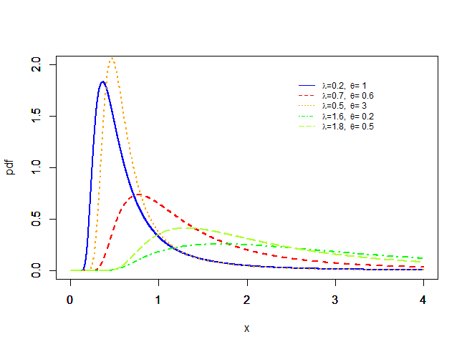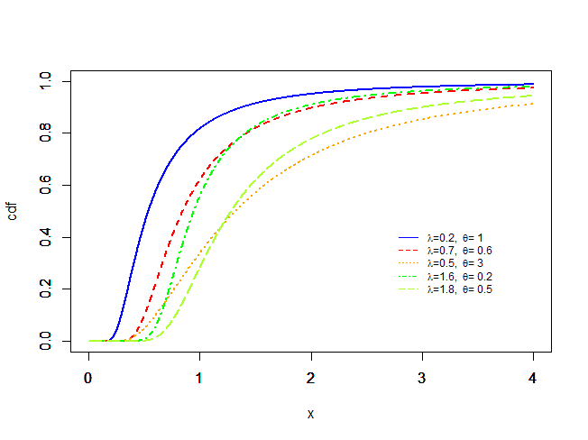
Figure 1: Probability Density Plot of MOIR
Figure 2: Cumulative Distribution Plot of MOIR
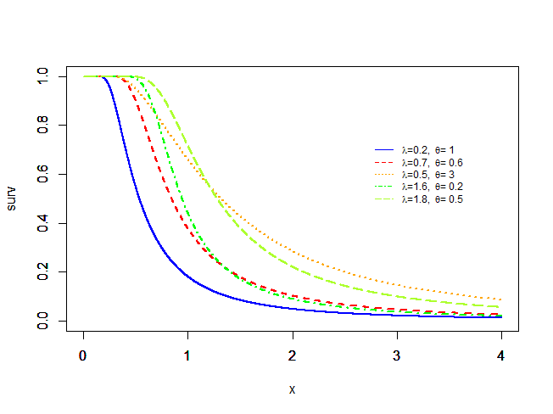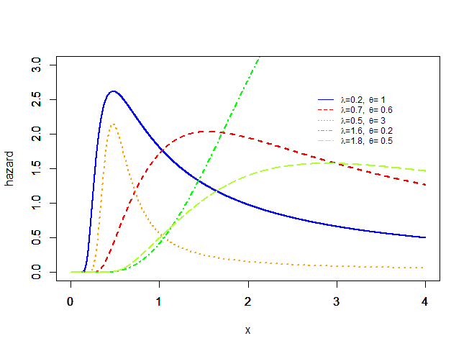
Figure 3: Survival Plot of MOIR
Figure 4: Reliability Plot of MOIR

2.2 Derivation and properties of the MOIR distribution.

2.2.1 Moments
If a random variable $X$ has the MOILLD, the r^{th} non-central moment

$E\left(x^{r}\right)=\int_{0}^{∞}{x^{r}g\left(x\right)dx}$
$=\int_{0}^{∞}{x^{r}\frac{2θλexp\left(-\frac{λ}{x^{2}}\right)}{x^{3}{\left(θ+\left(1-θ\right)\left(1-exp\left(-\frac{λ}{x^{2}}\right)\right)\right)}^{2}} dx}$
$=\int_{0}^{∞}{\frac{2θλexp\left(-\frac{λ}{x^{2}}\right)x^{r-3}}{{\left(θ+\left(1-θ\right)\left(1-exp\left(-\frac{λ}{x^{2}}\right)\right)\right)}^{2}} dx}$
Let
$y=1-exp\left(-\frac{λ}{x^{2}}\right); \frac{dy}{dx}=-λx^{-3}exp\left(-\frac{λ}{x^{2}}\right)⇒dx=\frac{dy}{-λx^{-3}exp\left(-\frac{λ}{x^{2}}\right)} ;x=-λ^{-\frac{1}{2}}{\left(\log\left(1-y\right)\right)}^{-\frac{1}{2}}$
when $x=0, y=1$ and when $x=∞, y=0$.
Substitute in (7) and simplify
$E\left(x^{r}\right)=2θ\int_{1}^{0}{\frac{-λ^{-\frac{r}{2}}{\left(\log\left(1-y\right)\right)}^{-\frac{r}{2}}}{{\left(θ+\left(1-θ\right)y\right)}^{2}}}dy$

$=2θλ^{-\frac{r}{2}}\int_{0}^{1}{\frac{{\left(\log\left(1-y\right)\right)}^{-\frac{r}{2}}}{{\left(θ+\left(1-θ\right)y\right)}^{2}}}dy$

$=2θλ^{-\frac{r}{2}}\int_{0}^{1}{\frac{-\frac{r}{2}\left(\log\left(1-y\right)\right) }{{\left(θ+\left(1-θ\right)y\right)}^{2}}}dy$

$=-θrλ^{-\frac{r}{2}}\int_{0}^{1}{\frac{\left(\log\left(1-y\right)\right) }{{\left(θ+\left(1-θ\right)y\right)}^{2}}}dy$

$=-θrλ^{-\frac{r}{2}}\left.\left(\frac{\ln\left(1+\left(θ-1\right)\left(1-y\right)\right)}{θ-1}-\frac{\ln\left(1-y\right)\left(1-y\right)}{\left(1-y\right)θ+y}\right)\right]\begin{matrix}1 \\ 0\end{matrix}$

$=-rθλ^{-\frac{r}{2}}\left(\frac{-lnθ}{θ-1}\right)$
$=rθλ^{-\frac{r}{2}}\left(\frac{lnθ}{θ-1}\right)$
Therefore,
$E\left(x^{r}\right)=\frac{rθlnθ}{λ^{\frac{r}{2}}\left(θ-1\right)}$ (11)
Hence, the first and the second moments are respectively

$E\left(x\right)=\frac{θlnθ}{λ^{\frac{1}{2}}\left(θ-1\right)}$ (12)
and
$E\left(x^{2}\right)=\frac{2θlnθ}{λ\left(θ-1\right)}$ (13)
and the variance
$Var\left(x\right)=E\left(x^{2}\right)-{\left(E\left(x\right)\right)}^{2}$

$=\frac{2θlnθ}{λ\left(θ-1\right)}$ - ${\left(\frac{θlnθ}{λ^{\frac{1}{2}}\left(θ-1\right)}\right)}^{2}$

$Var\left(x\right)=\frac{θlnθ}{λ}\left(\frac{2}{θ-1}-\frac{1}{{\left(θ-1\right)}^{2}}\right)$ (14)

2.2.2 Quantile and Random Number Generation from MOILLD
Let q be a uniform random variable in the domain (0,1), random number from MOIR distribution can be obtained by inverting the corresponding cdf thus:
Let $G(x) = q$

that is $\frac{exp\left(-\frac{λ}{x^{2}}\right)}{θ-\left(θ-1\right)exp\left(-\frac{λ}{x^{2}}\right)} = q$

After some algebraic manipulations,
$x_{q}={\left(-\frac{λ}{\log\left(\frac{qθ}{1-q\left(θ-1\right)}\right)}\right)}^{\frac{1}{2}}$ (15)

The quantile function may also be used to calculate quartiles, generate values from the MOIR distribution for simulation, and define different metrics of skewness and kurtosis.

2.2.3 Maximum Likelihood Estimates of MOIR

$L=\prod_{i=1}^{n}{g\left(x_{i}\right)}, i = 1, ..., n$
$l = -2nln\left(θ-1+exp\left(\frac{λ}{x_{i}^{2}}\right)\right)+n\left(ln\left(2\right)+\frac{λ}{x_{i}^{2}}\right)+nln\left(λθ\right)-3nln\left(x_{i}\right)$

$diff\left(l, θ\right)=\frac{n\left(-θ-1+exp\left(\frac{λ}{x_{i}^{2}}\right)\right)}{\left(θ-1+exp\left(\frac{λ}{x_{i}^{2}}\right)\right)θ}$ (16)

$diff\left(l, λ\right)=\frac{n\left(\left(x_{i}^{2}-λ\right)exp\left(\frac{λ}{x_{i}^{2}}\right)+\left(x_{i}^{2}+λ\right)\left(θ-1\right)\right)}{x_{i}^{2}λ\left(θ-1+exp\left(\frac{λ}{x_{i}^{2}}\right)\right)}$ (17)

$θ, λ$ are estimated by equating (16) and (17) to zero, and then solve numerically.

3. results and discussion

3.1 Simulation Study
The data for this study were simulated for different sample sizes and parameters on the basis of bias and standard error for MOIR distribution. The algorithms were written in R language to generate $10,000$ samples using the Monte Carlos simulation. ML estimates for $λ$ = 2, $θ$ =1.8; $λ$ =3.5, $θ$ =2.5 and $λ$ = 4.2, $θ$ = 3.4 were calculated. The mean of these estimates for sample sizes 30, $50, 100$, $200$, and $500$ are represented in Table 1.

Table 1: Bias and Standard error of MOIR distribution for different sample sizes and parameters.
Parameters | n | $$λ$$ |  | bias | Std error | $$θ$$ | bias | Std error
$λ$ = 2  $θ$ = 1.8 | 30 | 2 |  | 0.8177 | 0.9744 | 1.8 | 1.0849 | 0.5199
$λ$ = 2  $θ$ = 1.8 | 50 | 2 |  | 0.6245 | 0.7262 | 1.8 | 1.1138 | 0.3571
$λ$ = 2  $θ$ = 1.8 | 100 | 2 |  | 0.4010 | 0.5042 | 1.8 | 1.1789 | 0.2265
$λ$ = 2  $θ$ = 1.8 | 200 | 2 |  | 0.2876 | 0.3516 | 1.8 | 1.2159 | 0.1520
$λ$ = 2  $θ$ = 1.8 | 500 | 2 |  | 0.1806 | 0.2208 | 1.8 | 1.2311 | 0.0940
$λ$ = 3.5  $θ$ = 2.5 | 30 |  | 3.5 | 1.7267 | 1.9783 | 2.5 | 1.8790 | 0.4170
$λ$ = 3.5  $θ$ = 2.5 | 50 |  | 3.5 | 1.2017 | 1.4376 | 2.5 | 1.9985 | 0.2673
$λ$ = 3.5  $θ$ = 2.5 | 100 |  | 3.5 | 0.8075 | 1.0016 | 2.5 | 2.0393 | 0.1754
$λ$ = 3.5  $θ$ = 2.5 | 200 |  | 3.5 | 0.5900 | 0.7022 | 2.5 | 2.0734 | 0.1166
$λ$ = 3.5  $θ$ = 2.5 | 500 |  | 3.5 | 0.3504 | 0.4396 | 2.5 | 2.0932 | 0.0711
$λ$ = 4.2  $θ$ = 3.4 | 30 |  | 4.2 | 2.4872 | 2.7102 | 3.4 | 2.9083 | 0.3373
$λ$ = 4.2  $θ$ = 3.4 | 50 |  | 4.2 | 1.6795 | 2.0030 | 3.4 | 3.0127 | 0.2138
$λ$ = 4.2  $θ$ = 3.4 | 100 |  | 4.2 | 1.1258 | 1.3691 | 3.4 | 3.0644 | 0.1355
$λ$ = 4.2  $θ$ = 3.4 | 200 |  | 4.2 | 0.8020 | 0.9532 | 3.4 | 3.0832 | 0.0918
$λ$ = 4.2  $θ$ = 3.4 | 500 |  | 4.2 | 0.4784 | 0.5978 | 3.4 | 3.0988 | 0.0560

Table 1 presents the simulation study bias and standard error of MOIR distribution for different sample sizes and parameters. The bias and standard error of the distribution decrease as the sample sizes decrease irrespective of the parameters used to simulate the data. Hence, the distribution behaves asymptotical like normal distribution.

3.2 Applications to real-world data

In this section, the performance of the Marshall-Olkin Inverse Rayleigh distribution is compared with Alpha power Inverse Rayleigh, and Inverse Rayleigh distributions on some lifetime data sets in the literature.

Data set I: The data set have been obtained from Rodrigues, et al, (2015) which represents the relief times of twenty patients receiving an analgesic. The data are:
Data Set II: The data represents the strength for the single carbon fibers and impregnated 1000-carbon fiber tows, measured in GPa. It was reported in single carbon fiber tested at gauge length 1mm (Bader and Priest, 1982).
2.247, 2.64, 2.908, 3.099, 3.126, 3.245, 3.328, 3.355, 3.383, 3.572, 3.581, 3.681, 3.726, 3.727,
3.728, 3.783, 3.785, 3.786, 3.896, 3.912, 3.964, 4.05, 4.063, 4.082, 4.111, 4.118, 4.141, 4.246,
4.251, 4.262, 4.326, 4.402, 4.457, 4.466, 4.519, 4.542, 4.555, 4.614, 4.632, 4.634, 4.636, 4.678, 4.698, 4.738, 4.832, 4.924, 5.043, 5.099, 5.134, 5.359, 5.473, 5.571, 5.684, 5.721, 5.998, 6.06.

Data Set III: The data is taken from Leiva et al. (2014) which represents the ball size of wire bonding for an electronic connection from the integrated circuit apparatus to the lead frame.
2.891, 4.035, 4.495, 2.890, 2.312, 3.158, 5.228, 3.334, 5.896, 5.639, 3.842, 1.590, 1.954, 1.842, 0.680, 2.752, 1.301, 2.260, 0.889, 2.381, 0.619, 2.788, 1.050, 3.750, 3.508, 6.123, 6.549, 5.954, 2.207, 4.417, 4.805, 1.516, 2.227, 2.797, 1.636, 1.066, 0.940, 4.101, 4.542, 1.295, 1.770, 3.492, 5.706, 3.722, 6.644, 2.472, 1.383, 4.494, 1.694, 2.892, 2.111, 3.591, 2.093, 3.222, 2.891, 2.582, 0.665, 3.234, 1.102, 1.083, 1.508, 1.811, 2.803, 6.659, 0.923, 6.229, 3.177, 2.333 ,1.311, 4.419,
2.495, 0.921, 4.061, 9.725, 1.600, 4.281, 3.360, 1.131, 1.618, 4.489, 3.696, 1.982, 2.413, 5.480, 1.992, 2.573, 1.845, 4.620, 6.221, 1.694, 4.882, 1.380, 3.982, 2.260, 2.366, 2.899, 3.782, 2.336, 1.175, 3.055.

Table 2: Summary Statistics of real-life data sets
Data set | Min | Median | Mean | Maximum | Skewness | Kurtosis
I | 1.10 | 1.7 | 1.90 | 4.10 | 1.862 | 4.185
II | 2.247 | 4.249 | 4.261 | 6.06 | 0.076 | 2.997
III | 0.619 | 2.77 | 3.036 | 9.725 | 1.014 | 4.251

Table 2 shows the summary statistics of the three data sets, the minimum, median, mean, maximum, skewness and kurtosis of the data sets are presented. Data set I range between 1.10 and 4.10 with unequal mean and median, and high skewness and kurtosis which suggest that the data is not normal and highly skewed. Data set II range between 2.247 and 6.06 with almost same mean and median, and low skewness and kurtosis which suggest that the data is approximately normal. Data set III range between 0.619 and 9.725 with unequal mean and median, and moderate skewness and kurtosis which suggest that the data is not normal and skewed.

Table 3: Parameter estimates, Loglikelihood and AIC of MOIR, APIR and IR.
Data Set | Distribution | $$σ$$ | $$α$$ | LL | AIC
I | MOIR | 8.29 | 16.28 | 15.65 | 35.29
I | APIR | 16191.00 | 0.14 | 257.18 | 518.36
I | IR | 0.83 | NA | 35.28 | 72.56
II | MOIR | 67.02 | 48.51 | 75.88 | 155.77
II | APIR | 743196.33 | 0.20 | 1774.16 | 3552.32
II | IR | 1.20 | NA | 236.56 | 475.11
III | MOIR | 1.47 | 0.25 | 190.01 | 384.01
III | APIR | 166743.55 | 0.03 | 1773.75 | 3551.51
III | IR | 0.40 | NA | 291.29 | 584.58

Table 3 presents the parameter estimates, Loglikelihood and AIC of MOIR, APIR and IR distributions. The MOIR distribution has the lowest loglikelihood and AIC and thereby considered to be the most suitable model for the three data sets. Figure 5, the probability plot of competing models for data set I, II and III corroborate the fact that MOIR distribution is more flexible than the competing distributions.

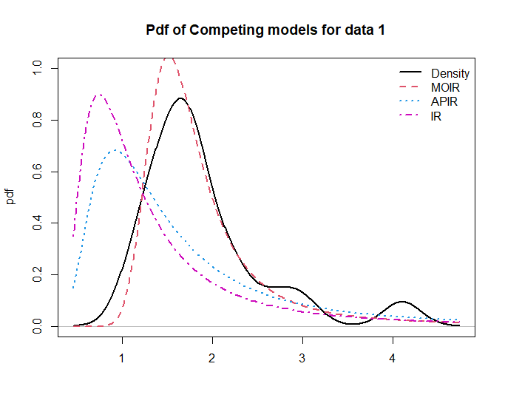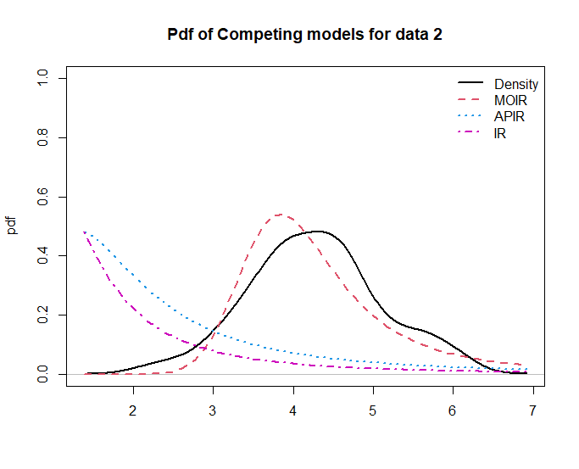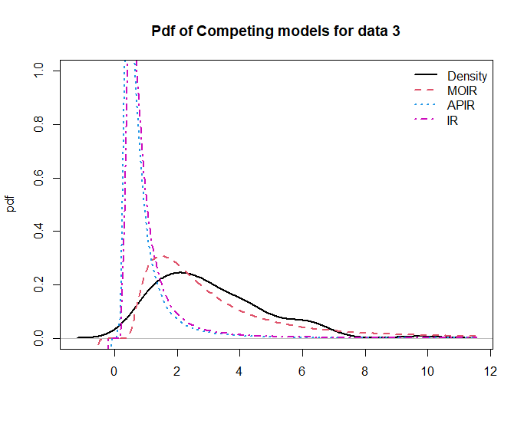
Figure 5: Probability plot of competing models for data set I, II and III

4. Conclusion

Marshall-Olkin Inverse Rayleigh is a novel lifetime model that combines the Marshall-Olkin shock model and the inverse Rayleigh distribution. The study derives the MOIR distribution and investigates its essential properties, including moments, reliability measures, and the Quantile function. Mean, variance, skewness, and kurtosis expressions are also provided. The maximum likelihood approach is used to estimate parameters, and its efficacy is demonstrated by simulation tests. Furthermore, the MOIR distribution's usefulness in representing real-world data is proved by comparing its flexibility to APIR and IR distributions. The MOIR with the lowest loglikelihood and AIC demonstrated greater flexibility when modeling real data. The MOIR distribution provides a complete method to lifetime data analysis, allowing better simulation and evaluation of system lifetimes. It is recommended for modeling skewed data from the industrial and manufacturing sectors.

Disclaimer (Artificial intelligence)
Option 1:
Author(s) hereby declare that NO generative AI technologies such as Large Language Models (ChatGPT, COPILOT, etc.) and text-to-image generators have been used during the writing or editing of this manuscript.

References

Arowolo, O. T., Ogunsanya, A. S., Ekum, M. I., Oguntola, T. O. and Ukam, J. B. (2023). Exponentiated Weibull Inverse Rayleigh Distribution. International Journal of Mathematical Sciences and Optimization: Theory and Applications, 9(1), 104 – 122.

Banerjee, P. and Bhunia, S. (2022). Exponential Transformed Inverse Rayleigh Distribution: Statistical Properties and Different Methods of Estimation. Austrian Journal of Statistics, 51(4), 60–75. Https://Doi.Org/10.17713/Ajs.V51i4.1338

Basheer, A. M. (2019). Alpha power inverse Weibull distribution with reliability application. Journal of Taibah University for Science, 13(1), 423-432.

Elgarhy, M. and Alrajhi, S. (2019). The odd Fréchet inverse Rayleigh distribution: Statistical properties and applications. J. Nonlinear Sci., 12, 291–299.

Fatima, K. and Ahmad, S. P. (2017). Weighted inverse Rayleigh distribution. Int. J. Stat. Syst., 12, 119–137.

Haq, M. A. (2016). Kumaraswamy exponentiated inverse Rayleigh distribution. Math. Theory Model, 6, 93–104. https://doi.org/10.5281/zenodo.8218022

Kamnge, J. S. and Chacko, M. (2025). Half Logistic Exponentiated Inverse Rayleigh Distribution: Properties and Application to Life Time Data. Plos One 20(1): E0310681. Https://Doi.Org/10.1371/Journal.Pone.0310681

Mohammed, H. F. and Yahia, N. (2019). On type II Topp-Leone inverse Rayleigh distribution. Appl. Math. Sci., 13, 607–615.

Rao, G. S. and Mbwambo, S. (2019). Exponentiated inverse Rayleigh distribution and an application to coating weights of iron sheets data. J. Probab. Stat., 7519429.

Shala, M., and Merovci, F. (2024). A New Three-Parameter Inverse Rayleigh Distribution: Simulation and Application to Real Data. Symmetry, 16(5), 634. Https://Doi.Org/10.3390/Sym16050634

Voda, V.G. (1972). On the inverse Rayleigh distributed random variable. Rep. Stat. Appl. Res., 19, 13–21.

Yahia, N. and Mohammed, H. F. (2019). The type II Topp-Leone generalized inverse Rayleigh distribution. Int. J. Contemp. Math. Sci., 14, 113–122.

