**ASSESSING THE EFFECTIVENESS OF ONLINE LEARNINGPLATFORMSAT FEDERAL UNIVERSITY OF LAFIA, NASARAWA STATE, NIGERIA.**

***ABSTRACT***

*An unexamined life is not worth living so said by Socrates(Plato Apology 38a5-6). It is in line with this that we attempt to examine the effectiveness of online learning platforms at federal university of Lafia, Nasarawa state, Nigeria with the aim to implement the result of the findings to other universities, focusing on student’s satisfaction. The growing role of digital tools in education was well emphasized in an attempt to introduce this research. The main aim of every research is to identify a gap and proffer solution to the gap. Identifying a gap, we delve into the challenges and opportunities posed by these platforms. Recognizing a need for clarity, this research addresses the problems surrounding student’s satisfaction with online learning platforms at federal University of Lafia, Nasarawa state, Nigeria. Therefore, our major goal is to understand the factors affecting student satisfaction, measure engagement levels, and propose improvement. Using SPSS, we employed descriptive statistics to analyze data. Surveys and interviews gave insights into student experiences. Findings revealed that students express dissatisfaction with online learning platforms, signaling a need for further investigation. In light of these results, we recommend enhancing platform features, fostering engagement, and promoting a collaborative feedback loop for continuous improvement.*

# 1. INTRODUCTION

* 1. The rapid growth in technology has impacted so much in education sector more than any other sector globally. The landscape of education has witnessed a significant shift with the widespread adoption of online learning platforms in higher institutions. This has forced many institutions to key into this method of learning in order not to be left behind. E-learning, as it is commonly known, refers to the utilization of digital technologies to deliver educational content and facilitate interactive learning experiences. This mode of education has gained immense popularity due to its flexibility, accessibility, and potential to enhance student engagement. The purpose of this study is to analyze the effectiveness of online learning platforms at Federal University of Lafia. By examining the impact and outcomes of e-learning, this research aims to contribute to the existing body of knowledge and provide insights for further improvements in the field [17-20].

The effectiveness of online learning platforms has been a subject of interest and investigation among researchers and educators. Numerous studies have been conducted to explore the benefits and challenges associated with e-learning in higher education. For instance, Smith et al. (2018) conducted a comprehensive study analyzing the impact of online learning platforms on student performance and satisfaction. Their findings indicated a positive correlation between e-learning and academic achievements, highlighting the potential of these platforms to enhance learning outcomes.

Moreover, a meta-analysis conducted by Johnson and Smith (2020) reviewed multiple studies on online learning in higher institutions. The meta-analysis encompassed various variables, including student engagement ,retention rates, and the effectiveness of different instructional strategies employed in online environments. The results demonstrated that e-learning, when designed and implemented effectively, can yield comparable or even superior outcomes in comparison to traditional face-to-face instruction.

Furthermore, the COVID-19 pandemic has further accelerated the adoption of online learning platforms globally. Educational institutions were compelled to transition swiftly to online modalities to ensure continuity in the wake of social distancing measures. Several studies have examined the impact of this abrupt shift to e-learning during the pandemic. For example, Chen et al. (2021) investigated the challenges and opportunities of online learning in the context of higher education institutions during the COVID-19 crisis. Their research shed light on the importance of instructional design, technological infrastructure, and learner support systems in facilitating effective online education.

Building upon these previous studies, our research aims to delve deeper into the specific context of The Federal University Lafia. By conducting a comprehensive analysis of the effectiveness of online learning platforms, considering factors such as student satisfaction, students engagement in class, and learning and assimilating rate and to take notes on areas that requires improvement on the technology applied for their learning to be effective.

**1.1 Justification of the study**

Most policies and programmes of the Government of Nigeria failed not because they are not good enough or for lack of fund and manpower to drive them but failed as a result of lack of feedback mechanism to ascertain the level of success and failure with the aim to improve on it. In May, 2019, former president Muhammudu Buhari introduced the NPOWR programme which was meant to reduce poverty and frustration among Nigeria youths. The original aim was to reduce terrorism through this programme. But it failed woefully due to lack of examination. Many programmes went that way in the past. Therefore, with the introduction of online learning platforms at the federal university of Lafia, the justification to assess this method of learning after two academic sessions of its use cannot be overemphasized. The integration of online learning platforms in The Federal University of Lafia (FuLafia), has presented both opportunities and challenges. However, a significant problem has been observed concerning the satisfaction and effectiveness of the e- learning platform, particularly among the newly admitted hundred level students. Despite the intention to facilitate their learning process, these students have expressed dissatisfaction with the development and implementation of the online learning platform, as it fails to adequately support their educational needs and hinder their ability to learn effectively. The problem arises from the fact that the e-learning platform, introduced to the hundred level students, does not align with their expectations and requirements for successful learning. Many of these students, coming from traditional classroom-based educational backgrounds, faced difficulties in adapting to the online environment. They encounter obstacles such as navigating the platform, accessing course materials, engaging in meaningful interactions, and receiving timely feedback from instructors. Consequently, this lack of satisfaction negatively impacts their learning experience and raises concerns about the overall effectiveness of the online learning platform in facilitating their educational journey.

Furthermore, the dissatisfaction of the newly admitted hundred level students with the e-learning platform suggests potential gaps in instructional design, user experience, and support mechanisms. It is crucial to identify and address these issues to ensure that the online learning platform meets the needs of these students and provides them with an environment conducive to effective learning. By resolving these problems, it is possible to enhance the educational experience and outcomes of the hundred level students, ultimately contributing to the overall success and effectiveness of the online learning initiative at the Federal University Lafia (FuLafia).Theobservedproblemrevolvesaroundthedissatisfactionofnewlyadmittedhundred

level students with the online learning platform introduced at The Federal University of Lafia. The misalignment between their expectations and the platform's functionality, coupled with difficulties in adapting to the online learning environment, hinders their ability to learn effectively. Addressing these issues is crucial to ensure that the e-learning platform aligns with the needs and expectations of the students, fostering a positive and productive learning experience.

##### 1.2 Aim and objectives of the study

The aim of this research is to analyze the effectiveness of the online learning platform implemented at Fulafia and its impact on the educational experiences, outcomes and satisfaction rate of the newly admitted one hundred level students. By examining the strengths, weaknesses, and areas for improvement, this study aims to provide insights into optimizing the online learning environment to better support student learning and enhance overall educational outcomes.

###### 

###### 1.3 Objectives:

* + - * To assess the level of satisfaction among newly admitted hundred level students regarding the online learning platform at FuLafia.
      * To identify the challenges and difficulties faced by students when using the online learning platform.
      * To examine the effectiveness of the online learning platform in facilitating student learning outcomes, such as knowledge acquisition.
      * To propose recommendations and strategies for enhancing the effectiveness of the online learning platform based on the identified challenges and opportunities.

These objectives will guide the research process and provide a clear focus for investigating the effectiveness of the online learning platform at (FuLafia) and addressing the concerns and issues raised by the newly admitted hundred level students. By achieving these objectives, the research aims to contribute to the improvement and enhancement of the online learning experience and outcomes for students.

**1.4 Research scope and limitation:**

This research focuses on analyzing the effectiveness of the online learning platform implemented at FuLafia and its impact on the newly admitted hundred level students. The study aims to gather insights from students and instructors regarding their experiences with the online learning platform and its effectiveness in supporting learning outcomes. It covers aspects such as student satisfaction, engagement and Identifying the various challenges faced by the students. The research will primarily utilize qualitative and quantitative research methods, including surveys, interviews, and analysis of student satisfaction rate data.

**1.5 Research limitations:**

1. ***Sample Size:*** Due to resource and time constraints, the research will be limited to a specific sample size of one hundred level students at FuLafia. While efforts will be made to ensure representative sampling, the findings may not be fully generalized to the entire student population.
2. ***Time Constraints:*** The research will be conducted within a specific time frame, which may limit the ability to capture long-term effects and changes in the online learning platform's effectiveness over time.
3. ***Subjectivity:*** The data collected in this research will rely on self-report measures from students. It is important to acknowledge that subjective perceptions and biases may influence the findings.
4. ***Institutional Context:*** The research will focus on FuLafia as a case study, which meansthefindingsmaybeinfluencedbythespecificcontextandinfrastructureoftheinstitution. The results may not be directly applicable to other higher education institutions.
5. ***Technological Factors:*** The research scope does not specifically investigate the technical aspects and limitations of the online learning platform, such as system reliability or connectivity issues. These factors may have an impact on the overall effectiveness but are not the primary focus of this study.
6. ***External Factors:*** The research does not extensively consider external factors that may influence the effectiveness of the online learning platform, such as students' personal circumstances, internet access, or other external support systems.

##### 1.6 Definition of terms:

**1.6.1 Online Learning:** Online learning refers to a mode of education that takes place primarily or entirely through digital platforms and the internet. It involves the delivery of educational content, interaction with instructors and peers, and assessment of learning outcomes in virtual environments.

**1.6.2 Learning Management System (LMS):** A learning management system is a software application or platform used by educational institutions to deliver online courses and manage various aspects of the learning process. It typically includes features such as content delivery, course management, assessment tools, and communication tools.

**1.6.3 Effectiveness:** In the context of this research, effectiveness refers to the degree to which the online learning platform at (your university) achieves its intended goals and outcomes. It involves assessing how well the platform facilitates student learning, engagement, satisfaction, and overall educational success.

**1.6.4 Satisfaction:** Satisfaction refers to the level of contentment, fulfillment, or approval experienced by students and instructors regarding the online learning platform. It encompasses factors such as user-friendliness, accessibility, course design, interaction opportunities, and support services.

**1.6.5 Engagement:** Engagement refers to the level of active involvement, participation, and interaction exhibited by students in the online learning environment. It includes factors such as active participation in discussions, completion of assignments, interaction with course materials, and collaboration with peers.

**1.6.6 Academic performance:** Academic performance refers to the extent to which students achieve learning outcomes and demonstrate their knowledge, skills, and understanding of the course content. It is typically measured through assessments, examinations, assignments, and other forms of evaluation.

**1.6.7 Instructional design:** Instructional design refers to the systematic planning, development, and organization of learning experiences in order to facilitate effective teaching and learning. It involves the selection of appropriate instructional strategies, resources, and assessments to meet the desired learning objectives.

**1.6.8 User experience (UX):** User experience refers to the overall experience and perception of users, such as students and instructors, while interacting with the online learning platform. It encompasses factors such as ease of use, intuitiveness, accessibility, and the quality of interactions and support.

**2. REVIEW OF RELATED LITERATURE**

Like any other top issue of global discourse, our topic of research is not a virgin one. Some other researchers have attempted to do justice to this research topic in different ways. Some of those efforts made will be X-rayed in attempt to solve this research problem. Technology has touched each and every field in some way or the other. Education through e-learning applications has had open up horizons of learning from distance, efficient methods of learning and added quality to knowledge sharing activities. There has been a significant amount of research by scholars, academicians and technology experts with technology at its prime focus but the effectiveness of e-learning in widely shaping the future of students and adding quality to their thinking and values has not been given much attention. This study therefore reviews the literature that is available on online and offline sources in the form of books, scholarly articles and research writings from peer reviewed journals. The aim of the literature review is to understand the scholarly works on the topic of e-learning both from the technological point of view and for its impact on the students. The research highlights the gaps in the existing literature and marks the areas that the future studies should cover to bridge the existing gaps in the literature available on the topic.

[Shu-ShengLiaw](https://www.researchgate.net/profile/Shu-Sheng_Liaw), in the research study on effectiveness of e-learning investigates the reason for dissatisfaction of some of the e-learning students. There search surveys 424 university studentsfortheirfeedbackoneffectivenessofe-learningforthem.Thefindings of the report suggest that the intention and study focus are the main factors that influence the objectives and usefulness of e-learning. Personal efficiency for the courseworkisalsoadeterminingfactorfortheoutcomes([Shu-ShengLiaw](https://www.researchgate.net/profile/Shu-Sheng_Liaw),2008).

The examination of effectiveness of e-learning is useful for not just the students but also for the trainers as it helps them in refining their methods of teaching. Regular testing of the outcomes of e-learning and efficiency of knowledge transfer guide the teachers to employ techniques that can be more effective in transferring the education. The technocrats are also interested in transforming the e-learning experiencing through effect ICT applications (CommLab, 2015).

E-learning has been used extensively not just for academic purposes for students but also for businesses and corporate employees to impart training on various upcoming industrial revisions (**Judith B. Strother**, 2002). E-learning has contributed to so many different fields such as medicine, health, businesses, industries and pharmacy.

A research study on pharmacy education by M.Sandra highlights that there is little to no evidence for the fact that e-learning in pharmacy has significantly enhanced the knowledge of the practitioners for the long term. The assessment finds that the e-learning is beneficial but at an individual level and has limitations for value addition with quality and sustainability([SandraM. Salter](https://www.ncbi.nlm.nih.gov/pubmed/?term=Salter%20SM%5BAuthor%5D&cauthor=true&cauthor_uid=24850945)etal.,2014).The study however fails to provide any records to prove that limitations with evidence in the form of survey or case study. For health systems also, e-learning has been used explicitly to serve the purpose of both teachers and learners. A study by Kai Ruggeri and others stress on the various forms in which e-learning has benefited in the e-health facilities and learning in the remote places .Digital literacy rate up liftment and need for infrastructure for e-learning has been cited as effective measures to fulfill the objectives of e-learning comprehensively. However, the study does not use any quantitative assessment or analytical tools for proving the findings of the report ([Kai Ruggeri](https://www.ncbi.nlm.nih.gov/pubmed/?term=Ruggeri%20K%5BAuthor%5D&cauthor=true&cauthor_uid=23472702)et al., 2013).

A study conducted in Tehran Alzahra University by R. Safiyeh tried to investigate the relation between the e-learning and motivation for the students. The study uses questionnaire based survey and the university students as respondents, quantitative methods like person correlation was used to understand the survey findings and form a relationship between the dependent and independent variables for the research. The findings suggest that motivation of the students is affected by e-learning significantly. But the study has many limitations as it is based on a single university and uses no interviews; hence, the findings are not supported by corroborative evidence of face to face interviews or a global audience ([Safiyeh R. Harandi](http://www.sciencedirect.com/science/article/pii/S1877042815031985#!), 2015).

Research scholars, Sekiwu Denis &Naluwemba Frances through their research have delved into the various aspects that make e-learning as an effective tool for transferring knowledge. According to the report one of the factors that make e-learning suitable in the changing environment due to dynamic nature of the technological upgrades, especially in the developing world, is the low cost and ease of course adjustment for upgrading the courses quickly. The researches stress that e-learning opportunities are a gate way of growth and prosperity for the developing world. The study lacks the point of view of the students and misses the key point of including the quality of the education provided in a compromise for low cost (Sekiwu Denis &Naluwemba Frances, 2014).

English as an international language is used officially for international trade, businesses, learning and higher education. It is impending on students from non-English speaking countries to be conversant with English in order to smoothly learn and do business with their counter parts in other countries. A study based in Kingdom of Saudi Arabia by Intakhab A. Khan addresses the usefulness of e-learning in English education for Saudi students. It says that the involvement of the learners is an important aspect and e-learning through its innovative methods helps students relate to the techniques with ease. Resource generation, usefulness and effectiveness for students were some of the factors that were highlighted by the study as a mark of success of e-learning in English language for students in Saudi Arabia. The study has limitations of using only a specific country for the research base (Intakhab A. Khan, 2016).

Y. Levy, investigates a different aspect of e-learning for checking its effectiveness by considering reviews from the students. The research work takes into account the view of drop out students and compares them to the successful student. There is found to be a striking difference in their views as drop out find the e-learning as ineffective and useless. The study therefore establishes the fact that the intention, performance and individual approach make e-learning practices suitable for the students. However, the study does not comment on what additional factors are involved for students to drop out from the e-learning courses ([Yair Levy](http://www.sciencedirect.com/science/article/pii/S0360131505000096#!), 2007).

Other than these, interactive videos are a major contributing factor that helps the students in analysis the subjects and evolve a deeper understanding of the study material. The 3D technology, various software and multi dimensional approach have convincingly made e-learning equivalent to the classroom studies, if not better ([Dongsong Zhang](http://www.sciencedirect.com/science/article/pii/S0378720605000170#!) et al., 2006).

A research based on data mining for trends in e-learning establishes the fact that the researches on e-learning are moving their focus from effectiveness of the e-learning to the methods of teaching. Medical education and training has been identifies as the aggressive users of e-learning and present a wide scope for induction of such practice in future. The study remarks that the scope, expectations and applicability for developing and developed courtesies differ significantly (Miklian, 2018). The government policies have major role to play in growing the effectiveness of the e-learning for the students and businesses. However, the limitations of the studies include lack of empirical data to support the views expressed and corroborate the findings (Jui-long Hung, 2010).

##### Findings and analysis

The various sources, academic journals, white paper researches, business related studies and technical paper presentations were reviewed as described above. The findings of the review suggest that e-learning is current topic of discussion for many researches. Online and offline sources are flooded with articles, papers and studies about effectiveness of e- learning. But considering the scope and usefulness of the topic, there is less research on analyzing the applicability or suitability of e-learning for the students. There are gaps to identify the questions like what is it that students find frustrating about e-learning or complain about its shallowness? Some studies suggest that for long term value addition e-learning practices are not good enough, hence, studies can focus on the reasons for the non-sustainability of e-learning as far as value addition for the students is concerned. Studies have addressed e-learning as a compromise solution for a low cost alternate to classroom studies, future studies should make sure to establish this fact and highlight the causes for its ineffectiveness for students. There is also scope to analyze the reason for high dropout rates among e-learning students.

**CONCLUSION**

In conclusion, there are gaps in the existing researches which may be covered through involving the views and perspectives of the students and analyzing the effectiveness of e- learning with respect to adding value to the lives of the students and addressing areas that would possibly contribute to creating a suitable learning with E-learning rather than focusing on just the technological aspects of it.

**METHODOLOGICAL FRAMEWORK**

In this chapter, I outline the methodology used to investigate the effectiveness of online learning platforms in higher education institutions, a case study FuLafia. The methodology encompasses research design, data collection, data framing, variables, measures, methods of data analysis, and a conclusion.

***RESEARCH METHOD***

The method applied in this research was quantitative. To collect data, an online questionnaire was distributed online via a Google form. The software used to analyze the data was SPSS, employing descriptive statistics for analyzing the data. Making Surveys and interviews to gathered insights of student experiences. Which was used to confirm the reliability and validity of the study.Theexaminationofthehypotheseswasconductedbasedonself-initiation.

**DATA COLLECTION**

In this research project, my primary source of data was from the students engaging the online learning platforms, in the Federal University Lafia, Majorly with the 2022/2023 sets. By focusing on the students as my primary source of data, this research aims to provide a comprehensive and students-centric analysis of online learning platforms’ impact on the learning experience, meaning, it takes into account the students strength and weaknesses, and tailors the evaluation process to meet the student’s unique needs.

**SURVEY WITH GOOGLE FORMS:** The survey phase was conducted through Google Forms, an online survey creation and distribution platform. This approach allowed for seamless data collection and the benefit of automated data organization. The survey instrument was carefully designed to include structured questions, particularly Likert-scale items, addressing aspects of the student experience with online learning platforms. The use of Google Forms facilitated easy distribution to a stratified sample of students, ensuring comprehensive data collection.

### Data frame, variables and measures

##### Data frame

Thedataframeincludesbioinformation(name,gender,andacademicdepartment),frequency of platform use, and open-ended responses from interviews.

### Variables and measures

### *Dependent variables:* Includes student engagement, perceived platform effectiveness, satisfaction with online learning

**Independent variables:** includes Frequency of platform use, the effectiveness of the

platforms, the projection of lectures online; the availability of internet resources for the students, the department of the student..

**Control Variables:** gender

## Method of data analysis

**Quantitative Data Analysis:** Quantitative data from surveys will be analyzed using

Statistical software(e.g.SPSS).

The primary aim is to understand the relationship between the DEPENDENT variable (which is the student satisfaction with online learning platforms and the INDEPENDENT variable which is the predictor variables.

###### Yi=BO+B1X1i+B2X2+...+BkXki + ei

Here, *Yi=dependent variables(students satisfaction)*

*B0 is the intercept,B1i,B2i, . . ., Bki are the coefficient for each independent variable X1i, X2i,. . . , Xki, and ei is the error term*

This model allows us to assess the unique on each independent variable while controlling for the influence of others.

*By incorporating a multiple linear regression model, we aim to unveil the nuanced relationship between various factors and students satisfaction, providing a robust statistical foundation for our conclusion.* This part has detailed the methodology employed in the comprehensive investigation of online learning platform effectiveness in higher education institutions. The research design, data collection methods, data framing, variables, measures, and data analysis techniques have been meticulously outlined to ensure the pursuit of our research objectives.

The selection of a mixed-methods approach, which incorporates both quantitative and qualitative data collection, has been designed to provide a holistic understanding of the research topic. This approach recognizes the multidimensional nature of the student experience within online learning platforms.

The data collection phase, employing Google Forms for surveys and semi- structured interviews, was executed with a focus on accuracy and participant convenience.Surveysallowedforstructuredquantitativedatacollection,while interviews enriched the dataset with qualitative insights, capturing the subtleties of students' experiences and perspectives.

As we move forward into the data analysis phase, the combined quantitative and qualitative data will be examined rigorously to provide a profound understanding of the factors influencing the effectiveness of online learning platforms in higher education.

In summary; this meticulously designed methodology serves as the foundation for uncovering the intricate facets of online learning platform effectiveness and student experiences in higher institutions. The use of a mixed-methods approach ensures that our analysis is not limited to surface-level findings but delves deep into the dimensions that contribute to the overall educational landscape.

The subsequent chapters will build upon the groundwork laid in this methodology, leading us closer to a comprehensive understanding of the challenges, benefits, and potential enhancements of online learning platforms in higher education.

**DATA ANALYSIS AND RESULT**

This chapter delves into the heart of our research, employing robust statistical methods facilitated by SPSS to analyze the data collected through the use of goggle forms. The overarching aim is to extract meaningful insights from the amalgamation of quantitative survey responses and qualitative interview data.

### Overview of data

Before delving into specific analyses, let's provide an overview of the dataset. The sample comprises 300 participants from bio details. The quantitative data, collected through surveys, captures numerical feedback on various questions on aspects of online learning platform effectiveness. Concurrently, qualitative data from interviews adds depth and context to our understanding.

### Utilizing SPSS

To navigate the complexities of our dataset, we turn to the statistical prowess of SPSS. This powerful tool enables us to conduct both descriptive and inferential analyses, offering a comprehensive exploration of the multifaceted nature of online learning experiences.

### Structure of analysis

**Descriptive statistics:** Commencing with a descriptive analysis, we present an overview of participant demographics and a summary of survey responses. SPSS facilitates the computation of means, standard deviations, and frequencies to capture the essence of our dataset.

**Data Analysis:** Data for this research were collected by the use of primary method of data collection and were analyzed with the aid of statistical software(SPSS), by carrying out a descriptive statistics, a multiple linear regression model is also applied to examine the simultaneous impact of multiple independent variables on students satisfaction. Following an ANOVA table.

**Test of hypotheses**

H0:The online learning platform has not been effective for the students in federal university Lafia.

H1: The online learning platforms have been effective for students in federal university Lafia.

##### TABLE 1.Data Presentation and interpretation

|  |  |  |  |  |  |
| --- | --- | --- | --- | --- | --- |
| **Sex** | | | | | |
|  | | Frequency | Percent | Valid Percent | Cumulative  Percent |
| Val id | Female | 135 | 45.0 | 45.0 | 45.0 |
| Male | 165 | 55.0 | 55.0 | 100.0 |
| Total | 300 | 100.0 | 100.0 |  |

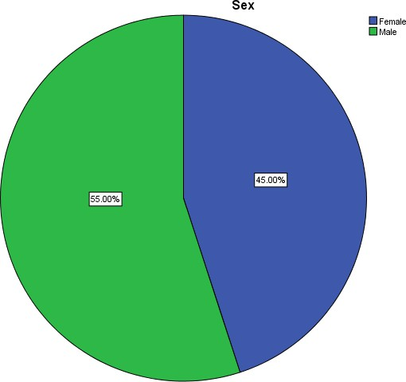

FIG 1. students participated in the survey

The above illustration shows the total number of students that participated in the survey, with a total number of 300, 165 being male and 135 being female.

With a percentage of 55% male and 45% female.

##### TABLE 2 Demographic study

|  |  |  |  |  |  |
| --- | --- | --- | --- | --- | --- |
| **Have you previously used online learning platforms for your education,** | | Frequency | Percent | Valid Percent | Cumulative Percent |
|  | No | 202 | 67.3 | 67.3 | 67.3 |
| Valid | Yes | 98 | 32.7 | 32.7 | 100.0 |
|  | Total | 300 | 100.0 | 100.0 |  |

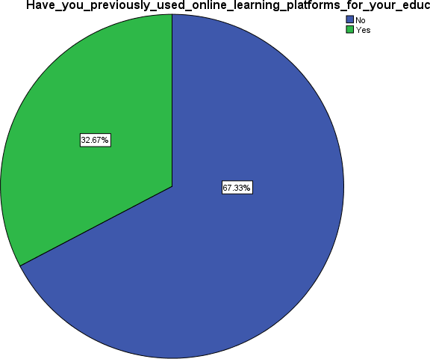**FIG 2. Online learning platforms for education**

The above illustration displays information on the number of students who answered yes to the question of previous experience on online learning to those who answered no.

Given a total of 98 to “Yes ”responses and 202 to “No ”responses Saying YES has 32.67% while NO has 67.33%

##### TABLE 3. Have you been able to adapt to the online learning classes

|  |  |  |  |  |  |
| --- | --- | --- | --- | --- | --- |
|  | | Frequency | Percent | Valid  Percent | Cumulative  Percent |
|  | No | 191 | 63.7 | 63.7 | 63.7 |
| Valid | Yes | 109 | 36.3 | 36.3 | 100.0 |
|  | Total | 300 | 100.0 | 100.0 |  |

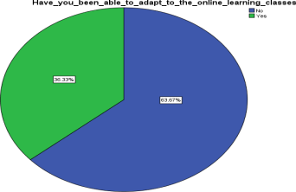

**FIG 3.**Adapt to the online learning classes

The figure above shows that, 109 student agreed to have adapted to the online class while 191 said they have not been able to adapt.

Which gives a percentage of 36.3% YES to 63.7% NO.

##### TABLE 4. Do you feel effectively involved in online learning_ process

|  |  |  |  |  |  |
| --- | --- | --- | --- | --- | --- |
|  | | Frequency | Percent | Valid  Percent | Cumulative  Percent |
| Valid | No | 215 | 71.7 | 71.7 | 71.7 |
| Yes | 85 | 28.3 | 28.3 | 100.0 |

|  |  |  |  |  |  |
| --- | --- | --- | --- | --- | --- |
|  | Total | 300 | 100.0 | 100.0 |  |

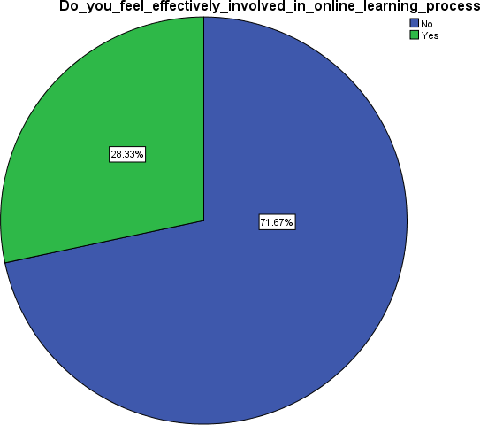

FIG 4.Effectively involved non line learning process

The figure above shows that 85 students feel effectively involved in the online learning process while 215 students do not.

With a percentage of 28.3% YES response and 71.7% NO response

##### TABLE 5. Do you participate in online activities such as discussion or group work

|  |  |  |  |  |  |
| --- | --- | --- | --- | --- | --- |
|  | | Frequency | Percent | Valid  Percent | Cumulative  Percent |
|  | No | 139 | 46.3 | 46.3 | 46.3 |
| Valid | Yes | 161 | 53.7 | 53.7 | 100.0 |
|  | Total | 300 | 100.0 | 100.0 |  |

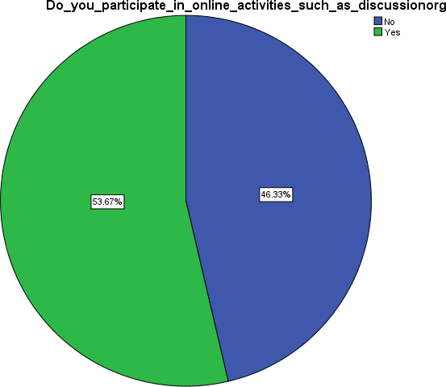

FIG 5.Participate_in_online_activities_(discussion or group work)

The above illustration shows the number of students that participate in online activities such as group discussions to those who do not.

161peoplesaidyeswhile139peoplesaidno.

Whichinpercentageisinterpretedas;53.7%YESand46.3NO.

##### TABLE .6Are there communication channels e.g discussion forums

|  |  |  |  |  |  |
| --- | --- | --- | --- | --- | --- |
|  | | Frequency | Percent | Valid  Percent | Cumulative  Percent |
|  | No | 42 | 14.0 | 14.0 | 14.0 |
| Valid | Yes | 258 | 86.0 | 86.0 | 100.0 |
|  | Total | 300 | 100.0 | 100.0 |  |

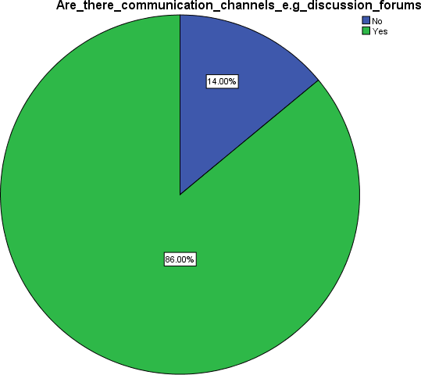

FIG 6.communication channels

The above illustration shows that 258 students answered YES to a the question, that there are communication channels, e.g discussion forums for asking questions and stating concerns while 42 answered NO.

Withapercentageof86%YESresponsesand14%NOresponses.

##### TABLE 7. Are you provided with mediums for assessment and feedbacks

|  |  |  |  |  |  |
| --- | --- | --- | --- | --- | --- |
|  | | Frequency | Percent | Valid  Percent | Cumulative  Percent |
|  | No | 40 | 13.3 | 13.3 | 13.3 |
| Valid | Yes | 260 | 86.7 | 86.7 | 100.0 |
|  | Total | 300 | 100.0 | 100.0 |  |

The figure above shows the number of student that answered YES to the question about being

provided with mediums for assessment where feedback are being taken on a timely basis, to those who answered NO.

Showing 260 YES responses and 40 NO responses. With 86.7% on YES and 13.3% on NO.

##### 

##### FIG 7.mediums for assessment and feedbacks

##### TABLE 8. Do you think you have achieved a good learning experience

|  |  |  |  |  |  |
| --- | --- | --- | --- | --- | --- |
|  | | Frequency | Percent | Valid  Percent | Cumulative  Percent |
|  | No | 211 | 70.3 | 70.3 | 70.3 |
| Valid | Yes | 89 | 29.7 | 29.7 | 100.0 |
|  | Total | 300 | 100.0 | 100.0 |  |

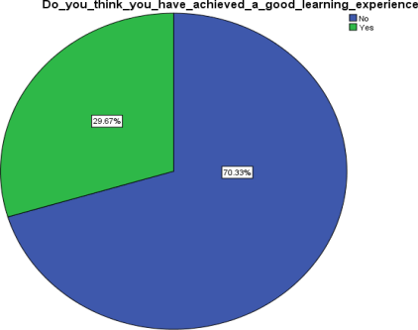

**FIG 8.**learning experience

The figure above gives the output about the students that answered YES in having a good learning experience to those that answered NO.

Which says, 89 YES and 211 NO.

With a percentage of 29.7% YES and 70.3 NO respectively.

##### TABLE 9. Rate your experience so far

|  |  |  |  |  |  |
| --- | --- | --- | --- | --- | --- |
|  | | Frequency | Percent | Valid  Percent | Cumulative  Percent |
| Valid | Fair | 43 | 14.3 | 14.3 | 14.3 |
| Good | 49 | 16.3 | 16.3 | 30.7 |
| Poor | 66 | 22.0 | 22.0 | 52.7 |

|  |  |  |  |  |  |
| --- | --- | --- | --- | --- | --- |
|  | Very  good | 24 | 8.0 | 8.0 | 60.7 |
| Very  poor | 118 | 39.3 | 39.3 | 100.0 |
| Total | 300 | 100.0 | 100.0 |  |

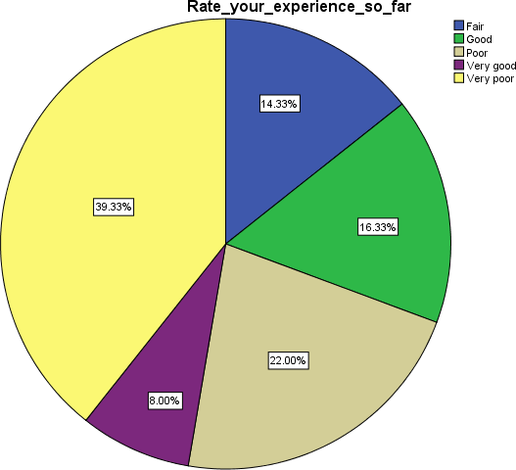

FIG 9.Rating of experience

The figure above displays the response of students rating their learning experience so far with the platform, which shows that majority of the student have had a poor learning experience while only few have had a good learning experience.

### Multiple linear regression for the analysis of the study.

This is the part where we utilized multiple linear regression to dissect factors influencing student satisfaction with online learning platforms. This method assessed individual and combined impacts, offering quantitative insights for targeted improvements.

##### TABLE 10. Model Summary

|  |  |  |  |  |
| --- | --- | --- | --- | --- |
| Model | R | R  Square | Adjusted R  Square | Std. Error of the Estimate |
| 1 | .849a | .720 | .712 | .245 |

**a. predictors;** (Constant), Rate your experience so far, Are there communication channels e.g discussion forums where you.., Do you participate in online activities such as discussion or group.., Have you previously used online learning platforms for your educ…, Are you provided with mediums where assessment and feedbacks are…, Do you feel effectively involved in the online learning process? If yes rate the effectiveness of this medium, Have you been able to adapt to the online learning classes?

|  |  |  |  |  |  |  |  |  |  |  |  |
| --- | --- | --- | --- | --- | --- | --- | --- | --- | --- | --- | --- |
| **TABLE 11.ANOVAa** | | | | | | | | | | | |
| Model | | Sum of  Squares | | Df | | Mean  Square | | F | | Sig. | |
| Regression | | 45.077 | | 8 | | 5.635 | | 93.591 | | .000b | |
| 1 | |  | |  | |  | |
| Residual | | 17.520 | | 291 | | .060 | |
| Total | | 62.597 | | 299 | |  | |

**A .Dependent Variables:** Do you think you have achieved a good learning experience using the online learning platform

**B. Predictors;** (Constant), Rate your experience so far, Are there communication channels e.g discussion forums where yo…, Do you participate in online activities such as discussion or gr.., Have you previously used online learning platforms for your educ…, Are you provided with mediums where assessment and feedback are taken …, Do you feel effectively involved in the online learning process, if yes rate the effectiveness of this medium, Have you been able to adapt to the online learning classes

**Decision rule:** from our analyses in the table above, it is observed that my p value is less than 0.05.

And since p value is less than 0.05,we reject the null hypothesis that states that “the online learning platforms has been effective on the students of federal university Lafia.” hence accept the alternative hypothesis.

##### TABLE 12. Coefficients

|  |  |  |  |  |  |  |
| --- | --- | --- | --- | --- | --- | --- |
| Model | | Unstandardized Coefficients | | Standardize d  Coefficients | t | Sig. |
| B | Std. Error | Beta |
|  | (Constant) | -.267 | .064 |  | -4.155 | .000 |
|  | Previously used platforms | -.024 | .034 | -.024 | -.700 | .484 |
|  | Have you been able to adapt to the online learning classes | .262 | .054 | .276 | 4.902 | .000 |
|  | Do you feel effectively involved in the online learning processes | .309 | .051 | .304 | 6.044 | .000 |
|  | Do you participate in online activities such as discussion | -.014 | .030 | -.016 | -.489 | .625 |
|  | Are the communication channels discussion forums | -.062 | .047 | -.047 | -1.311 | .191 |
|  | Are you provided with mediums where assessment and feed backs are | .127 | .047 | .095 | 2.687 | .008 |
|  | If yes rate the use fullness of this medium | .033 | .022 | .070 | 1.488 | .138 |
|  | Rate your experience so far | .105 | .020 | .310 | 5.287 | .000 |

**Dependent variable:** Do you think you have achieved a good learning experience using the online learning platform?

* 1. **Findings**

##### Lack of motivation

The first phase of online learning was seen with a high level of excitement. However, as the process continued for a couple of weeks, students started to lose motivation. Most students felt as if they were staring at the wall and were hardly motivated every single day to get up and start online classes. One of the major problems faced by students in online classes is that they feel demotivated to sit in front of a screen for hours unless it's something of their interest. To resolve one of these challenges in online learning, the students can be asked to switch on their cameras to inculcate a sense of face-to-face interaction. More activities can be designed where a maximum number of students can participate. Playing games related to the subject can be a win-win to keep the students motivated.

##### Lesser attention span

Most of the time, in online classes, students' concentration deteriorates very easily. It becomes very difficult for the students to concentrate and grasp whatever is taught. This mostly happens because of a lack of interaction between the student and the faculty. If observed, the students are completely attentive in the initial minutes and understand whatever is taught; however, after a certain amount of time, the student does not understandwhatisbeingtaught.Itbecomesdifficultforstudentstoconcentrateandgraspbecause of the receding span of attention. Due to this, students often face difficulties while self-studying or preparing for exams.

##### Abundant distractions

When you're studying in an online learning environment, you're not in the public eye. No one can see or hear you. Such a situation encourages students to start engaging themselves in other things. In many cases, students log in to the meeting but surround themselves with many distractions. They will either play games, listen to music, or watch a movie instead. One of the most common problems faced by students in online classes is they are easily prone to distract themselves and not concentrate on the knowledge they have been provided.

##### Lack of tech facilities

Nowadays, everyone you come across has a smart phone. It doesn't matter if it is a teenager or a grandparent. Everybody has a basic knowledge of how to use it. The only requirement online classes have is a laptop, a desktop or a mobile phone with an internet connection. However, there were still some classes of the economy which couldn't afford these facilities and were not able to benefit from online learning. Lack of tech facilities still continues to be one of the major online learning challenges.

##### Technical issues

The entire population is distributed in rural as well as urban areas. Strong connectivity is not always offered. This creates barriers in the process of online learning. Additionally, sometimes due to overloading on a single site, there are high chances of the website crashing. This delays the classes, and students do not get enough time to cover the syllabus, plus they rarely understand what is going on in the lectures. During online lectures, this is one of the most common online learning challenges faced by students, which causes students to miss their classes.

##### Lack of productivity

One huge drawback of online classes is that students have to sit in one place for hours. This encourages nothing but laziness. The student is tired most of the time and is least interested in taking up another activity. The students may choose to sit in one place, scrolling through their phones rather than doing something productive. Students can take up their hobbies or try finding new interests.

##### Poor time management

Greater and effective time management causes lesser anxiety and results in better academic performance for the student. In reality, many students struggle to manage their studies with their day-to-day lives. For instance, if work is assigned to students, many of them are seen starting the work a day before the submission. This is a very common example of poor time management. This can lead to a poor academic performance as they can face anxiety. It is essential to keep a balance between the two.

##### Increased dependency

In an online environment, it is very easy for students to depend on the internet, artificial intelligence tools, or even an acquaintance from the class to complete their assignments. Students choose to copy work from external sources and submit the assignment. Students are rarely encouraged to do assignments and often go for shortcuts. In order to encourage participation and communication amongst the students, professors assign group assignments. However, this usually happens as students lack creativity and are demotivated to work and become dependent on others to complete the

### Conclusion

In conclusion, the synthesis of our findings leads us to a pivotal realization that the path of

Education is intricately tied to the evolution of online learning platforms. The

Dissatisfaction expressed by students signals a pressing need for transformation and

adaptation. It is clear that merely embracing Technology is not enough.

**Recommendation**

Based on our findings, we recommend that efforts should be made to

Invest in user-friendly interfaces and intuitive navigation. In the same vein, effort should be made to integrate interactive elements to elevate engagement and foster a collaborative environment.

**Disclaimer (Artificial intelligence)**

Author(s) hereby declare that NO generative AI technologies such as Large Language Models and text-to-image generators have been used during the writing or editing of this manuscript.

**REFERENCES**

[1] Plato, Apology Wikipedia (2020);38a 5-6

[2] Smith et al. Wise intervention (2018); 23

[3] Johnson and Smith. The impact of online pedagogical Feedback on Student Motivation and Performance in Mathematics. Journal of Educational Research (2020); 25, 456-470.

[4] Chen et al. New data content and improved web interfaces(2021); 14

[5] Shu – Sheng Liaw Investigating students’ perceived satisfaction, behavioral intention and effectiveness of

e-learning: A case study of the Backboard system(2008); 55

[6] Comm Lab. How to measure the effectiveness of E – learning programs(2015); 34

[7] Judith B. Strother. An Assessment of the Effectiveness of e-learning in Corporate Training Programs(2002);7

[8] Sandra M. Salter etal. Effectiveness of E-learning in Pharmacy Education(2014);9

[9] Kai Ruggeriet et A global model for effective use and evaluation of e-learning health(2013);56

[10] Safiyeh R. Harandi . Effects of e-learning on students’ Motivation(2015);91

[11] Sekiwu Denis and Nluwemba Frances. E-learning for University Effectiveness in the Developing World

(2014);72

[12] Intakhab A. Khan. Effectiveness of E-Learning for the Teaching of English: A study of comparative

strategies (2016);88

[13] Yair Levy. Comparing drop outs and persistence in e-learning courses (2007);43

[14] Dongsong Zhang et at Instructional video in e-learning; Assessing the impact of interactive video on

learning effectiveness (2006);79

[15] MiklianGaming the system, testing the ability of Artificially generate academic citations through

Incentive-based promotion “ social science research network (2018);51

[16] Jui –long Hung. Trends of e-learning research from 2000 to 2008, use of text mining and bibliometrics

2010);9

[17]. Al-Maroof, R. S., Alnazzawi, N., Akour, I. A., Ayoubi, K., Alhumaid, K., AlAhbabi, N. M., ... & Salloum, S. (2021, December). The effectiveness of online platforms after the pandemic: will face-to-face classes affect students’ perception of their Behavioural Intention (BIU) to use online platforms?. In *Informatics* (Vol. 8, No. 4, p. 83). Multidisciplinary Digital Publishing Institute.

[18]. Liu, Z. Y., Lomovtseva, N., & Korobeynikova, E. (2020). Online learning platforms: Reconstructing modern higher education. *International Journal of Emerging Technologies in Learning (iJET)*, *15*(13), 4-21.

[19]. Kim, H., & Kim, M. (2023). Presence and effectiveness of online learning using a metaverse platform: Gather. town. *International Journal of Information and Education Technology*, *13*(4), 690-695.

[20].Matei, A., & Vrabie, C. (2013). E-learning platforms supporting the educational effectiveness of distance learning programmes: a comparative study in administrative sciences. *Procedia-social and Behavioral sciences*, *93*, 526-530.

[21] Jrall R, Kiran. Elements of E-Learning that Facilitate or Hinder Learning Motivation: A Review. Asian J. Educ. Soc. Stud. [Internet]. 2023 Dec. 20 [cited 2025 Apr. 24];49(4):294-305. Available from: https://journalajess.com/index.php/AJESS/article/view/1208