A Case Series on Total Ankle Arthroplasty Following High-Frequency Spinal Cord Stimulation in Peripheral Neuropathy Patients

Abstract:

Introduction: Patients with peripheral neuropathy (PN) who undergo high-frequency spinal cord stimulation (HF SCS) therapy may now benefit from total ankle arthroplasty (TAA). This patient population was previously excluded from eligibility for TAA as PN was an absolute contraindication. Now, risks of PN are reduced through HF SCS therapy, involving the surgical implantation of a device in the patient’s epidural space, ultimately interrupting the central processing of peripheral nerves and providing disease-modifying neurological improvements. These improvements diminish the risks faced by patients with PN, making them eligible to receive TAA. This case report seeks to determine whether TAA is a viable option for patients who have had their PN improved with HF SCS therapy.

Methods: We performed TAA on three patients with PN whose symptoms were previously improved with HF SCS therapy. Radiographic and functional outcome data was collected on these patients for 12-19 months postoperatively.

Results: Functional and radiographic follow-up over 12-19 months showed favorable outcomes with no major postoperative complications, suggesting safety and feasibility.
Conclusion: The results of this case series show that TAA is a viable treatment option for patients with PN who undergo HF SCS therapy to manage their symptoms and should no longer be considered an absolute contraindication for this population. By providing potentially disease-modifying neurological improvement, including motor strength, reflexes and sensation, HF SCS therapy diminishes the risk factors associated with PN and allows for a safe postoperative course following TAA. To our knowledge, there are no reports described in the literature of TAA being performed on this patient population. This case report will add to the evidence in support of expanding the indications for TAA to include individuals with PN being managed with HF SCS therapy.

Level of Evidence: Level IV

Keywords: total ankle arthroplasty; arthritis and joint disease; high frequency spinal cord stimulator; peripheral neuropathy

Introduction:

Ankle arthritis is a progressive disabling condition that occurs when cartilage in the ankle joint breaks down, leading to incongruencies within this joint as well as a decrease in the quality of periarticular bone¹. Previous trauma to the ankle joint is the number one etiology, representing approximately 70% of all cases. Rheumatoid disease is the second leading cause, but it falls far behind, accounting for a mere 12% of cases².

Approximately 1% of adults globally suffer from ankle arthritis^{3,4}. This condition typically presents at approximately 50 years of age, disproportionately affecting a younger population when compared to arthritis of other joints³. Ankle arthritis results in significant pain, chronic disability and diminished quality of life⁵. Individuals with this condition tend to have fewer total steps per day and slower walking speeds when compared to age-matched controls⁵. This limitation on activity may have a deleterious effect when it comes to an individual's ability to perform activities of daily living, their economic productivity as well as their mental health⁶.

Treatment of ankle arthritis depends on the stage of this condition. Conservative methods are typically implemented in the initial stages. These methods involve the use of orthotics and bracing, administration of corticosteroids and NSAIDs, as well as activity modification and physical therapy⁷. Operative management is indicated for those with pain unreceptive to conservative care, particularly those with end-stage arthritis⁵. End-stage arthritis involves cartilage loss and bone-on-bone contact with total or subtotal disappearance or deformation of the joint space⁵. Ankle arthrodesis (AA) and total ankle arthroplasty (TAA) are the two primary surgeries for treatment of end-stage ankle arthritis⁵.

AA has been a common treatment option to manage end-stage ankle arthritis for its reproducible results and longevity⁸. AA, which involves fusion of the tibiotalar articulation, treats pain by eliminating ankle joint motion. Although the relief provided may be long-lasting, it has the risk of nonunion, longer recovery time and altered gait⁹. The eradication of motion in the ankle joint following AA may also alter the biomechanics of adjacent joints, particularly in the hindfoot, leading to the accelerated degeneration of these joints¹⁰. As such, TAA may be better indicated than AA for individuals with preexisting periarticular joint degeneration as it preserves ankle joint mobility, causing less compensatory motion and stress to adjacent joints¹¹.

TAA involves the removal of the ankle joint and replacement with a prosthetic. TAA is an attractive option for its ability to preserve the ankle joint's range of motion. While first-generation implants had a high rate of complications, advances in implant design and technology have led to implants with more favorable outcomes. Unique materials and technologies such as patient-specific instrumentation have led to a more anatomic alignment of the implants as well as decreased intraoperative time and postoperative complication rates^{12,13}. These outcomes are comparable, and in some cases superior, to those of AA, with the added benefit of preservation of motion in the ankle joint, improved gait, shorter recovery time and possible conservation of adjacent joints¹³. There is still a risk of additional or revisional surgery following TAA, even though there is a success rate of greater than 90% at 7-12 years after this surgery¹⁴.

Historically, the ideal candidate for TAA was a reasonably mobile, mid-to-older aged patient with normal body mass index, good bone stock, minimal deformities and no neurovascular impairment to the lower limb¹⁵. Patients who did not fit this criterion had no choice but to proceed with AA^{16,17}. Recent developments have reduced the contraindications for TAA and now allow its use in a broader patient population, including those with peripheral neuropathy (PN).

PN is an umbrella term referring to all disorders that result in injury to nerves within the peripheral nervous system¹⁸. This condition is thought to be multifactorial, with over 100 different causes identified to date^{18,19}. Diabetes is considered the most important risk factor, accounting for 18-49% of all PN cases¹⁹. Other known risk factors include genetics, alcohol abuse, neurotoxic medications, such as chemotherapeutic drugs, and nutritional deficiencies²⁰. PN affects millions of people worldwide, with an estimated prevalence as high as 1-12% of the general population²¹.

PN has a wide array of symptoms and is associated with poor outcomes in patients undergoing foot and ankle surgery^{22,23}. These symptoms range from nuisances, such as numbness and tingling sensations, to the more dire, such as severe chronic pain, insensibility and loss of proprioception. The latter two are particularly perilous as they may be limb-threatening. Individuals with PN have an increased risk of postoperative infection, ulceration, need for revision surgery and may also develop a neuropathic process^{25,26,27}. Due to these risks, PN has long been considered an absolute contraindication for TAA²⁸. But, with the advent of spinal cord stimulation (SCS) therapy, this absolute contraindication is no longer the case.

SCS involves surgically implanting in the epidural space a device that alters the central processing of peripheral nerves. This device reduces PN symptoms through either low or high-frequency electrical pulses²⁹. Originally, only low-frequency SCS (LF SCS) was used to treat chronic pain syndromes and involved delivering low-frequency electrical pulses (40-60Hz) directly to the dorsal column to generate paresthesia along painful areas³⁰. But studies have demonstrated that LF SCS is inferior to high-frequency SCS (HF SCS) in its ability to decrease pain³¹.

HF SCS involves the delivery of high-frequency (10kHz) electrical pulses to the T8 to T11 spinal epidural space³¹. This type of therapy is paresthesia-independent, relieves chronic leg pain and decreases the symptoms of painful PN without the patient experiencing any stimulation-related paresthesia. HF SCS may also provide disease-modifying neurological improvements, as suggested in a recent multicenter randomized controlled trial evaluating the long-term impact of HF SCS³². Participants in this trial who were given HF SCS in addition to their conventional pharmacological management experienced decreased pain and increased foot sensation compared to those who only received pharmacological management, suggesting improved neurological function³².

The HF SCS device’s disease-modifying effects may be attributed to the positive effect this device has on nerve fiber density as well as on the electrophysiologic and neurochemical processing in the spinal cord dorsal horn. Enhanced nerve regeneration as a result of HF SCS therapy has been confirmed via corneal confocal microscopy as well as through intra-epidermal nerve fiber (IENF) density evaluations. A recent study demonstrated an increase in corneal nerve (CN) density and IENF density of 189% and 147%, respectively, from baseline after six months of HF SCS therapy³³. The exact mechanism of how HF SCS initiates CN and IENF regeneration is unknown.

Recent literature has sought to elucidate the underlying mechanism of action of HF SCS through experimentation on rodent models. Wang et al. showed that HF SCS therapy can restore protective sensation by reducing the size of the receptive field in the dorsal horn on diabetic neuropathic rodents^{34,35}. Receptive fields are areas of the body that a sensory nerve fiber innervates. Receptive field reorganization, including enlargement, can occur after damage of peripheral nerves³⁶. An enlarged receptive field is typically encountered in neuropathic patients, which has been correlated with increased pain and decreased spatial acuity^{36,37}. Wang et al.’s rodent model demonstrated a reduction of pain response and hypersensitivity to stimuli as well as a reduced receptive field size after one week of stimulation with HF SCS therapy³⁸. This normalization of the receptive field may partially explain the curative effects beyond pain relief of HF SCS therapy. Alterations in glutamatergic signaling in the dorsal horn have also shown to be associated with neuropathic pain³⁹. In another rodent study, this altered spinal glutamate processing was partially restored following HF SCS therapy, suggesting a normalization of spinal excitability⁴⁰. Together, these findings indicate that HF SCS therapy may not only treat the symptoms of PN but also the underlying cause.

The improvement of neurological function due to HF SCS has opened the door for more patients to receive TAA who previously would’ve been excluded. As HF SCS technology is cutting-edge, more insight is required to understand the effectiveness of TAA on this expanded patient population. This case report seeks to assess outcomes for those who receive TAA while managing their nondiabetic PN with HF SCS therapy by evaluating the success of this surgery for such individuals.

We hypothesize that TAA is a safe and viable option for individuals with end-stage ankle arthritis who have demonstrated improvement of their neurological function due to HF SCS therapy. By providing potentially disease-modifying neurological improvement, including motor strength, reflexes and sensation, HF SCS therapy diminishes the risk factors associated with PN and potentially allows for a safe postoperative course following TAA. As such, PN should no longer be considered an absolute contraindication for this patient population. To our knowledge, there are no reports of TAA being performed on this patient population described in the literature. This case report will add to the evidence in support of expanding the indications for TAA to include individuals with PN being managed with HF SCS therapy.

HF SCS Therapy Overview

As HF SCS therapy is a new technology, we have provided a detailed explanation of how it works in this section.

Appropriateness for HF SCS therapy is primarily determined from the patient’s history as well as through clinical and psychological evaluation. A history of the patient’s symptomatology is taken, where the patient is asked questions such as “How long can you walk before pain limits you?” and “Have you had spine surgery previously?” A pain management provider will then determine whether a patient is a candidate for HF SCS therapy.

Pain management providers may utilize HF SCS therapy as an alternative or complementary approach when pharmacological management is unable to provide adequate pain relief. First-line medical management typically includes gabapentinoids and duloxetine, while second line medical management includes tricyclic antidepressants, tramadol and opioids. If these treatments fail to provide adequate pain relief, then providers may recommend HF SCS therapy.

Once HF SCS therapy is recommended by a pain management provider, candidates undergo a trial period with an external device to determine the short-term response to treatment. The trial lasts anywhere from several days to a week. First, percutaneous stimulation electrodes are placed under fluoroscopy in the posterior epidural space at vertebral levels ranging from T8 to T11. An external HF SCS device is then connected to these leads and taped to the patient’s back, staying there for the length of the trial. The leads and devices are typically removed at the end of the trial period. Patients who report at least 50%³³ pain relief from baseline after the trial period are eligible for the next step in this process, which is permanent implantation.

The HF SCS device is permanently implanted into eligible patients after the trial period. Surgical implantation involves two incisions: one midline at the level of the upper lumbar spine and the other at the intended implantable pulse generator (IPG) site. The leads are then inserted into the epidural space utilizing a 14-gauge Touhy needle under AP fluoroscopic guidance. Similar to the HF SCS trial, the two leads are positioned at the anatomical midline in a staggered fashion in the dorsal epidural space between T8 and T11. These leads are typically placed with one tip at the top of the T8 vertebral body and the second tip at the mid-T9 vertebral body⁴¹. Lateral fluoroscopy is used to confirm the dorsal positioning of these leads. The leads then are sutured to the supraspinous ligament or deep fascial tissue with lead lock anchors and non-absorbable suture. Next, a subcutaneous pocket is created along the flank, above the belt line or in the buttock for placement of the rechargeable IPG⁴¹. Finally, a tunneling device is utilized to route the leads subcutaneously to the pocket site and connect them to the IPG. The electrical integrity of the device is checked with intraoperative impedance testing. The patient remains under anesthesia during the entire procedure as no patient feedback is required. This procedure is generally performed on an outpatient basis. Postoperative protocol prohibits excessive bending, reaching and lifting for the first 6-20 weeks following surgery.

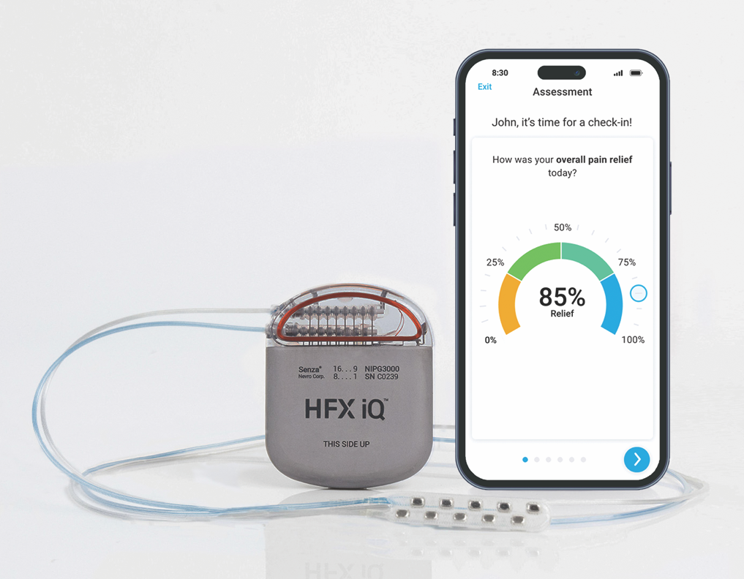
Figure 1. Image depicting Nevro’s HFX iQ device and accompanying mobile app interface.

Programming of the device occurs postoperatively and as needed during routine clinic visits based on the patient’s feedback regarding their pain intensity. The device delivers stimulation at a high frequency of 10 kHz and a short-pulse duration of 30 µsec, with a low amplitude ranging from 1-5 mA⁴². These parameters yield no paresthesia sensations, unlike LF SCS. The pulse amplitude may be adjusted on a case-by-case basis to maximize the individual patient’s pain relief. This adjustment may be made by a provider or automatically with the assistance of AI through an app available to patients through their personal electronic devices.

Complications include implant site pain, infection and lead migration. Lead migration rates range from 2.1-23%⁴², although recently these rates have been comparatively low, likely due to better device technology, implantation techniques and patient selection⁴². No stimulation-related serious adverse events or neurological deficits have been reported in the literature^{32,33, 41,42.}

Case Presentation

We performed TAA on 3 (three) patients who suffered from ankle arthritis as well as PN. All three patients in this case series had nondiabetic PN with etiologies including hereditary, alcohol induced and idiopathic. Each patient attempted medical management with minimal relief of their neuropathic symptomatology. These patients all received HF SCS therapy with the Senza® OmniaTM or HFX iQTM (Nevro, CA) systems prior to their TAA. After starting HF SCS therapy, the patients’ PN symptoms were reduced from baseline, although this level fluctuated from day to day. The percentage of this change was reported periodically by the patients using an app on their mobile devices. The patients’ arthritic ankle pain either remained the same or was aggravated following this decrease in symptoms. After the TAA, clinical and radiographic follow-up examinations exhibited improved ankle motion and joint congruency as well as pain reduction and high patient satisfaction. Only minor complications were present during the postoperative course, including neuralgia and stiffness; no complications typically associated with PN were observed (Table 1).
Table 1: Presentation of Three case details
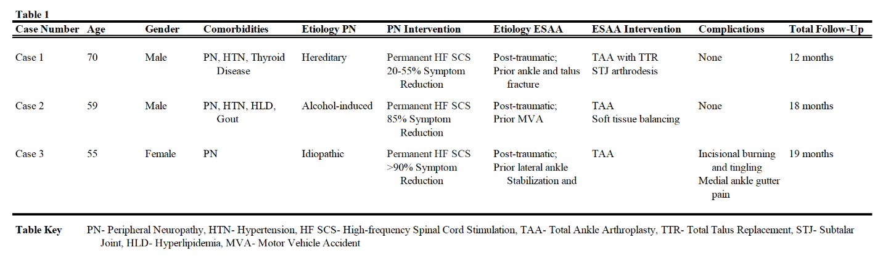

Case 1

A 70-year-old male presented with a history of worsening right ankle pain secondary to post-traumatic arthritis as well as PN symptoms. The patient had a right ankle and talar fracture over 50 years ago, which was managed nonoperatively. He reported debilitating ankle pain leading to extensive discomfort with activity, such as ambulating or standing, at the time of initial presentation. The patient tried and exhausted conservative treatments recommended by a prior provider, including bracing, activity modification, NSAIDs and corticosteroid injections. His comorbidities included hypertension, acid reflux, thyroid disease and PN, likely hereditary in origin.

Physical examination of the patient revealed diminished sensation along with pain and limitation of motion to the right ankle and subtalar joints. There was crepitus with motion of the right ankle joint and persistent point tenderness throughout the joint as well as to the medial and lateral ankle gutters. Light touch sensation and vibratory response were absent at the level of the right ankle along the sural, saphenous, deep/superficial peroneal and tibial nerve distributions.

We evaluated the ankle joint, leg length and hindfoot alignment by reviewing weight-bearing (WB) radiographs as well as a computed tomography (CT) scan of the foot and ankle. This imaging demonstrated extensive degenerative changes, including spur formation, subchondral cysts and sclerosis along the ankle and subtalar joints. Extensive heterotopic ossification was present along the posterior ankle, particularly along the posterior talus, where a very large hypertrophic Stieda process was apparent. Signs of avascular necrosis, including density changes and collapse, were evident throughout the talus. No valgus or varus tilting was noted when comparing the hindfoot to the distal tibia. Right and left limb lengths were found to be within acceptable limits.

The patient was referred to an interventional pain management provider for management of his PN symptoms after our initial consultation. His PN symptoms included numbness and tingling sensations for which pharmacological management offered little relief. The provider determined that the patient was a candidate for HF SCS therapy and enrolled him in a trial, which lasted approximately four weeks. He transitioned to a permanent HF SCS device, the Senza® OmniaTM system (Nevro, CA), once he achieved a 50% reduction of his PN symptoms. By the time of operative intervention, the patient had been undergoing PN management for approximately five months and had demonstrated reduction of his PN symptoms ranging from 20-55%. This reduction made him a candidate to obtain a TAA.

The patient received a TAA with a total talus replacement (TATTR). The decision was made to perform a TATTR with subsequent subtalar arthrodesis given the patient’s extensive ankle and subtalar joint arthritis with talar collapse as a result of avascular necrosis of the talus. A custom talar component (Restor3d, NC) with fully threaded screws to achieve a subtalar joint fusion was utilized along with the ProphecyTM INBONETM total ankle system (Stryker, NJ). The INBONETM system was chosen for its ability to control torsional as well as frontal, transverse and sagittal plane instability through its intramedullary component.

Postoperatively, the patient had no immediate complications. He did not experience any wound dehiscence, infection, deep venous thrombosis or neuritis symptoms. At his final appointment before discharge five months after receiving his TAA, the patient had a nonantalgic gait and no pain when his ankle joint was palpated. He did have some slight stiffness and mild difficulty with dorsiflexion but experienced no limitations on his ability to ambulate or perform daily tasks. Radiographs showed anatomic alignment of the total ankle and total talus components, with no loosening, no cystic formation, and no subtle tilt of the polyethylene implant. This patient made no further reports of complications at the time of writing, twelve months after his TAA.
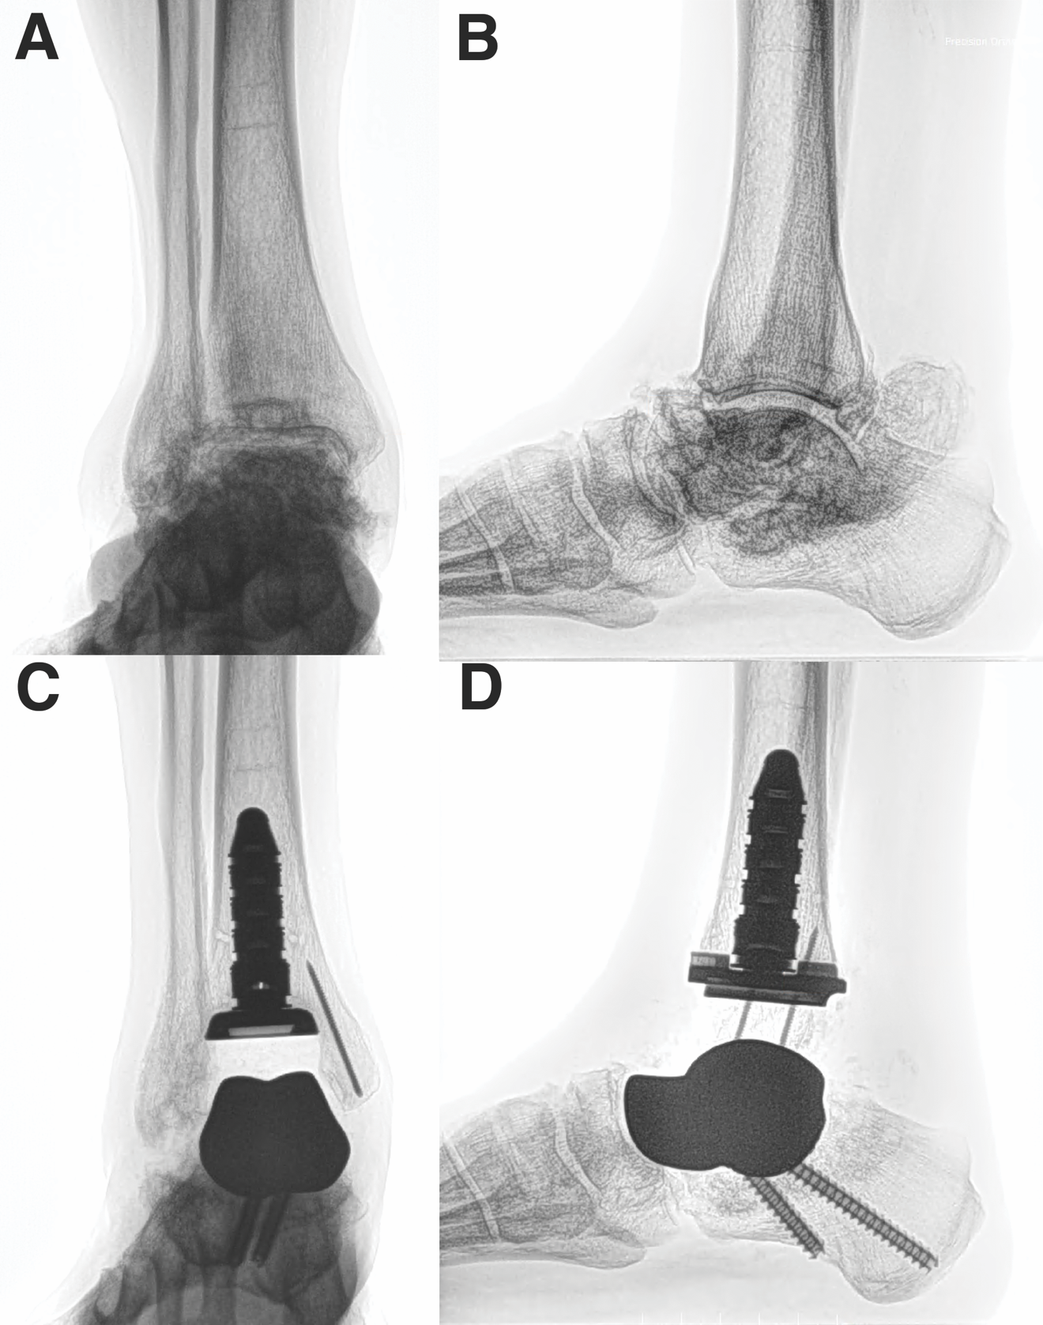
Figure 2. Preoperative radiographs, showing extensive degenerative changes along the ankle and subtalar joint with collapse of the talus and peritalar heterotopic ossifications from the anteroposterior (A) and lateral (B) views. Postoperative radiographs demonstrate insertion of a Inbone tibial component with five stems, a custom talar implant with threaded screws and snap-off pins within the medial malleolus for a medial tibia reinforcement from the anteroposterior (C) and lateral (D) views.

Case 2

A 59-year-old male presented with the chief complaint of chronic right ankle pain as well as numbness and tingling sensations to his bilateral lower extremities. The patient reported a history of a motor vehicle collision 10 years ago, leading to an ankle injury that was managed nonoperatively. In addition, he related a history of multiple ankle sprains while growing up playing sports. The patient stated that his symptoms had progressed to the point where he was no longer able to perform basic tasks, such as ambulating, without severe pain in his right ankle. The patient had attempted physical therapy, NSAIDs, rest and activity modification without alleviation of his symptoms. The patient’s past medical history was significant for alcohol induced PN, cancer, high blood pressure, hypercholesterolemia and gout. His PN had been confirmed with a prior electromyography test, with results suggestive of polyneuropathy.

Physical examination of the patient revealed intact sensations with limitation of motion and tenderness to the right ankle joint. The patient had crepitus and a right ankle range of motion of approximately 7 degrees of dorsiflexion and 20 degrees of plantarflexion. There was also persistent point tenderness to palpation over the anterior, medial and lateral joint. Sensation was intact to the sural, saphenous, deep/superficial peroneal and tibial nerve distributions with intact vibratory and proprioceptive response.

We evaluated the ankle joint, leg length and hindfoot alignment by reviewing WB radiographs as well as a CT scan of the foot and ankle. This imaging showed a non-congruent, arthritic ankle joint with approximately 10 degrees of varus deformity. Bone-on-bone contact was observed along the right ankle joint with osteophyte formation, cystic changes and subchondral sclerosis. Subtle cavus foot type and heel varus were identified in the right foot radiographs. No significant leg length discrepancy was noted.

The patient was referred to an interventional pain management provider for treatment of his PN after our initial consultation. The patient was found to be a candidate for HF SCS therapy and underwent a trial period with an external device. The patient achieved an 85% reduction of his PN symptoms within five days of starting the trial period. A permanent HF SCS device, the Senza® HFX iQTM (Nevro, CA), was implanted several weeks following the initial trial placement. The patient reported an increase in arthritic pain to his right ankle joint as the numbness that masked this pain decreased with HF SCS therapy. Overall, the patient's PN symptoms were reduced by up to 85% in the two months he underwent HF SCS therapy prior to his surgery. The patient did report some days of 0% relief, but this outlier is likely due to human error when reporting.

The reduction of the patient’s PN symptoms made him a candidate for a TAA. The ProphecyTM INFINITYTM tibial component (Stryker, NJ) was utilized as the patient’s tibia was healthy and without significant angular deformity at the level of the ankle. The patient had a varus deformity of 10.9 degrees, which was corrected with tibial and talar resections as delineated by the ProphecyTM system. Concomitant balancing of the ankle ligaments was also performed to achieve optimal alignment of the ankle joint.

The patient had no postoperative complications. He was ambulating in a CAM walker boot and had initiated physical therapy by postoperative week five. By postoperative week eight, the patient was pain-free, active and able to return to work without limitations. This patient made no further reports of complications at the time of writing, 18 months after his TAA.

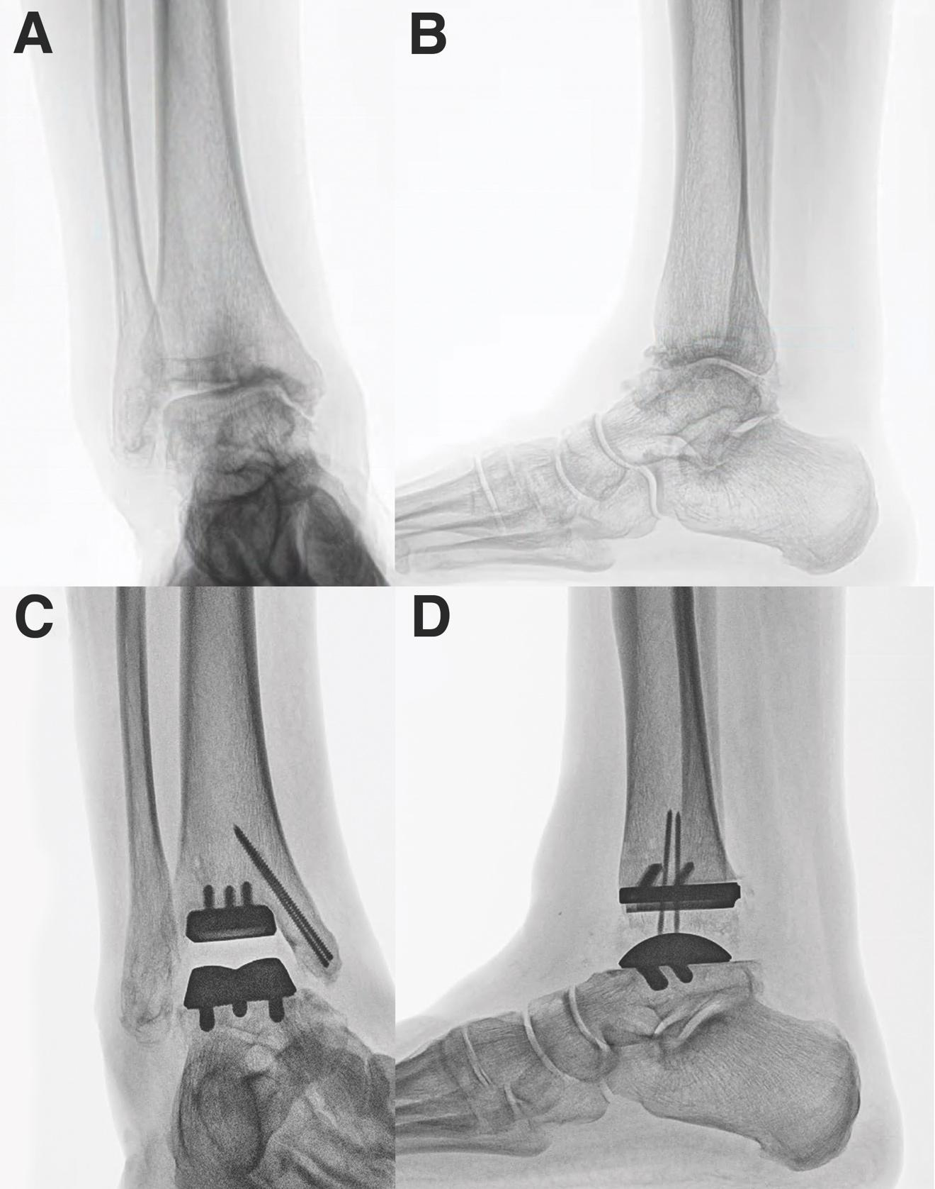
Figure 3. Preoperative radiographs, showing degenerative changes with 10.9 degree varus talar tilt from the anteroposterior (A) and lateral (B) views. Postoperative radiographs demonstrate insertion of an Infinity with Adaptis technology tibial and talar components and snap-off pins within the medial malleolus for a medial tibia reinforcement with correction to neutral talar tilt from the anteroposterior (C) and lateral (D) views.

Case 3

A 55-year-old female presented with a several-year history of right ankle pain aggravated by burning and tingling sensations in the bilateral hindfoot and ankle. The patient had a history of a high ankle sprain to the right ankle, managed operatively with an ankle stabilization and syndesmotic repair with suture button fixation. She had no significant past medical history except for idiopathic neuropathy. Her right ankle symptoms included pain with motion, particularly with ambulation, stiffness and weakness. Conservative treatments were attempted, including activity modification, rest, corticosteroid injections, nonsteroidal anti-inflammatories and narcotic medications, which offered no long-term improvement of her symptoms. At the time of initial presentation, the patient was taking daily narcotics and gabapentin for management of her PN and right ankle pain. The patient also underwent multiple spinal injections, which provided only short-term relief of her PN.

Physical examination of the patient revealed tenderness along the right lateral and medial ankle. The patient had intact sensation, vibratory response and proprioception with a positive Tinel’s sign along the superficial peroneal, saphenous and sural nerves. Positive neuritis was noted along the saphenous nerve distribution, extending along the medial portion of the foot. Range of motion to the right ankle was painful and restricted but without crepitus.

We evaluated the ankle joint, leg length and hindfoot alignment by reviewing WB radiographs, a CT scan of the foot and ankle as well as an electromyography (EMG) test. The imaging showed ankle arthrosis with osteophyte formation as well as joint space narrowing and incongruence. A varus tilt deformity at the level of the ankle joint of approximately 12 degrees was also identified on radiographs. No significant leg length discrepancy was present. The EMG test was positive for mononeuropathy in the right peroneal and sural nerve distribution.

The patient attempted a trial with an external device and saw a 65% symptom reduction along the saphenous nerve distribution within a few days of initiating therapy. A permanent HF SCS device, the Senza® OmniaTM (Nevro, CA), was implanted several weeks following the initial trial placement. The patient reported intensified pain along her right ankle joint as the numbness that obscured this pain decreased with HF SCS therapy. By the time of operative intervention, the patient had been undergoing management of PN for over a year and had demonstrated a greater than 90% reduction of PN symptoms along the saphenous nerve distribution.

The reduction of the patient’s PN symptoms made her a candidate for a TAA. The ProphecyTM INFINITYTM tibial component (Stryker, NJ) was utilized given the mild varus deformity and the adequate bone stock of the tibia. The patient’s mild varus deformity was corrected with tibial and talar resections as delineated by the ProphecyTM system. Proper ankle alignment was achieved without any ancillary procedures.

Postoperatively, the patient had complaints of tingling and burning sensations along the anterior surgical incision site, but these did not affect her quality of life. She also reported pain along the anterior ankle joint and medial gutter. Physical therapy and an ankle corticosteroid injection provided relief from these discomforts. This patient made no further reports of complications at the time of writing, 19 months after her TAA.

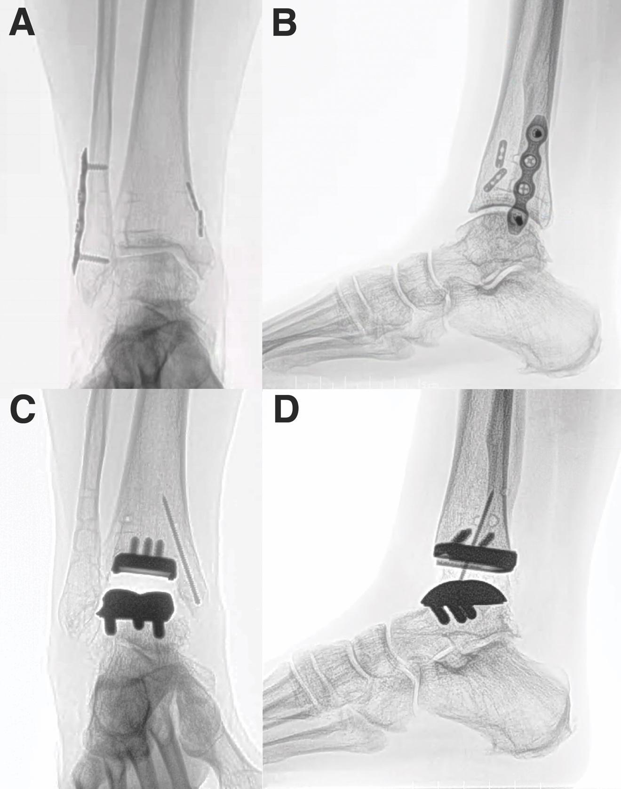
Figure 4. Preoperative radiographs, showing degenerative changes with 12.8 degree varus talar tilt from the anteroposterior (A) and lateral (B) views. Postoperative radiographs demonstrate insertion of an Infinity with Adaptis technology tibial and talar components and a snap-off pin within the medial malleolus for a medial tibia reinforcement with correction to neutral talar tilt from the anteroposterior (C) and lateral (D) views.

Discussion

This case series demonstrates that PN is no longer an absolute contraindication for TAA, especially for patients who have had their PN partially or entirely reversed through HF SCS therapy. None of the major postoperative complications associated with PN in the literature, including infections, wound healing problems or need for revision surgeries, were encountered. These complications are the primary reason PN is considered an absolute contraindication for TAA. In their absence, the prohibition on TAA for individuals with PN undergoing HF SCS therapy needs to be reevaluated.

We believe that HF SCS therapy’s disease-modifying capabilities may decrease the risk of the postoperative complications traditionally associated with PN. PN has been associated with an increased risk of postoperative Charcot neuroarthropathy⁴³, infection, ulceration as well as the need for revisional surgery^{25,26,27}. Wukich et al. showed that, when comparing nondiabetic patients with neuropathy with nondiabetic patients without neuropathy, neuropathic patients had a greater than fourfold increased risk of surgical infection compared with patients without neuropathy^{22,23}. Yet none of our patients experienced any of these complications, even those who did not achieve a consistent reversal of PN symptoms. Advances in the treatment of PN, specifically with HF SCS therapy, now mean the risks that made it an absolute contraindication for TAA are no longer as impactful as they previously were.

Patients whose PN is being managed by HF SCS should have the choice of a potentially superior option to treat their end-stage ankle arthritis. Currently, due to the absolute contraindication of PN for TAA, this patient population is only eligible to receive an AA. Yet TAA has benefits that AA does not. When utilizing methods such as gait analysis, TAA surpasses AA in terms of mobility^{44,45,46,47}. The improvements in mobility equate to superior range of motion, less limp and a better balanced gait when comparing TAA to AA. Similarly, these patients will likely have a lower risk of arthritis in surrounding joints, especially if they have prior ipsilateral hindfoot arthritis^{10,11,48,49,50,51}. Mid- to long-term data on TAA and AA suggest potentially lower incidence and rate of progression of ipsilateral periarticular joint arthritis after TAA⁵⁰. Given these benefits, the paradigm that currently prevents patients with PN from treating their end-stage ankle arthritis with a TAA needs to be reconsidered when they are undergoing HF SCS therapy.

Our case series has limitations, which means any paradigm shift should take a conservative approach. The number of patients studied in this case series is small, although not insignificant. We therefore caution against any extrapolation or unsupported conclusions that TAA would be appropriate for all patients suffering from PN who undergo HF SCS therapy. Instead, this case series only supports the assertion that PN is no longer an absolute contraindication for this patient population. Further study is required to delineate the exact conditions under which TAA is and is not appropriate for patients with PN undergoing HF SCS therapy.

Likewise, the follow-up time for this case series was relatively short. The detrimental effects of PN following foot and ankle surgery appear to be predominantly during the first postoperative weeks; we followed up with the featured patients for 8-19 months, beyond this timeframe. Although none of the complications typically associated with PN appeared during this postoperative period, the time frame may not be long enough to determine with certainty whether these or other complications are completely absent. Further studies are needed that increase the number of patients as well as their postoperative follow-up time to help develop a more accurate understanding of the outcomes and complications of performing a TAA on patients who have partially or completely reversed their PN with HF SCS therapy.

This case series has also laid the foundation for further study into the effect of HF SCS therapy on patients suffering from PN who receive a TAA. For instance, HF SCS therapy is considered reversible³², meaning that a patient’s PN may return if they stop this therapy. Yet there is a paucity of data describing the speed and scale of this return. Discontinuing this therapy, especially early in the postoperative period, may create the risk to the patient of the same complications that made PN an absolute contraindication for TAA. There are many unknowns as this technology is new, but the potential benefit to this patient population warrants a cautious approach and additional research.

More importantly, HF SCS therapy may mean that TAAs may be safely offered to other types of patients who suffer from PN, such as patients whose diabetes is well controlled. This case series focused on patients who had nondiabetic PN. But diabetics compose 18-49% of all PN cases¹⁹. If HF SCS therapy offers the same improvements to this patient type as it does to nondiabetics, then TAA may also be an option for well controlled diabetics with PN. Further study is required as there may be risk factors associated with this patient type, such as cardiovascular complications⁵², which means TAAs still would be unsafe, regardless of the effectiveness of HF SCS therapy. There are many unknowns as this technology is new, but the potential benefit it offers warrants a cautious approach and additional research.

Conclusion

By providing potentially disease-modifying neurological improvement, including motor strength, reflexes and sensation, HF SCS therapy diminishes the risk factors associated with PN and likely allows for a safe postoperative course following TAA. The results of this case series show that TAA is a viable treatment option for patients with PN who undergo HF SCS therapy to manage their symptoms and should no longer be considered an absolute contraindication for this population.

To our knowledge, there are no reports described in the literature of TAA being performed on this patient population. This case report will add to the evidence in support of expanding the indications for TAA to include individuals with PN being managed with HF SCS therapy.

Consent:
Written informed consent was obtained from all the patients.

Competing Interests Disclaimer

Authors have declared that they have no known competing financial interests OR non-financial interests OR personal relationships that could have appeared to influence the work reported in this paper.

Disclaimer (Artificial intelligence)

Author(s) hereby declare that NO generative AI technologies such as Large Language Models (ChatGPT, COPILOT, etc.) and text-to-image generators have been used during the writing or editing of this manuscript.

References

1. Coetzee JC, McGaver RS, Seiffert KJ, Giveans MR. Management of Ankle Arthritis After Severe Ankle Trauma. J Orthop Trauma. 2020;34(1):S26-S31. doi:10.1097/BOT.0000000000001697
2. Saltzman CL, Salamon ML, Blanchard GM, et al. Epidemiology of ankle arthritis: report of a consecutive series of 639 patients from a tertiary orthopaedic center. Iowa Orthop J. 2005;25:44-46.
3. Herrera-Pérez M, Valderrabano V, Godoy-Santos AL, De César Netto C, González-Martín D, Tejero S. Ankle osteoarthritis: comprehensive review and treatment algorithm proposal. EFORT Open Rev. 2022;7(7):448-459. doi:10.1530/EOR-21-0117
4. Kim JS, Amendola A, Barg A, et al. Summary Report of the Arthritis Foundation and the American Orthopaedic Foot & Ankle Society’s Symposium on Targets for Osteoarthritis Research: Part 1: Epidemiology, Pathophysiology, and Current Imaging Approaches. Foot Ankle Orthop. 2022;7(4):24730114221127011. doi:10.1177/24730114221127011
5. Grunfeld R, Aydogan U, Juliano P. Ankle Arthritis. Med Clin North Am. 2014;98(2):267-289. doi:10.1016/j.mcna.2013.10.005
6. Glazebrook M, Daniels T, Younger A, et al. Comparison of Health-Related Quality of Life Between Patients with End-Stage Ankle and Hip Arthrosis: J Bone Jt Surg-Am Vol. 2008;90(3):499-505. doi:10.2106/JBJS.F.01299
7. Grunfeld R, Aydogan U, Juliano P, Bustillo J. Ankle arthritis: Diagnosis and conservative management. OA Musculoskelet Med. 2013;1. doi:10.13172/2052-9287-1-4-997
8. Veljkovic AN, Daniels TR, Glazebrook MA, et al. Outcomes of Total Ankle Replacement, Arthroscopic Ankle Arthrodesis, and Open Ankle Arthrodesis for Isolated Non-Deformed End-Stage Ankle Arthritis. J Bone Jt Surg. 2019;101(17):1523-1529. doi:10.2106/JBJS.18.01012
9. Boc SF, Norem ND. Ankle Arthrodesis. Clin Podiatr Med Surg. 2012;29(1):103-113. doi:10.1016/j.cpm.2011.10.005
10. Ling JS, Smyth NA, Fraser EJ, et al. Investigating the Relationship Between Ankle Arthrodesis and Adjacent-Joint Arthritis in the Hindfoot: A Systematic Review. J Bone Jt Surg. 2015;97(6):513-519. doi:10.2106/JBJS.N.00426
11. Dekker TJ, Walton D, Vinson EN, et al. Hindfoot Arthritis Progression and Arthrodesis Risk After Total Ankle Replacement. Foot Ankle Int. 2017;38(11):1183-1187. doi:10.1177/1071100717723130
12. Onggo JR, Nambiar M, Phan K, Hickey B, Galvin M, Bedi H. Outcome after total ankle arthroplasty with a minimum of five years follow-up: A systematic review and meta-analysis. Foot Ankle Surg. 2020;26(5):556-563. doi:10.1016/j.fas.2019.07.006
13. Lawton CD, Butler BA, Dekker RG, Prescott A, Kadakia AR. Total ankle arthroplasty versus ankle arthrodesis—a comparison of outcomes over the last decade. J Orthop Surg. 2017;12(1):76. doi:10.1186/s13018-017-0576-1
14. Cottom JM, DeVries JG, Hyer CF, McAlister JE, Sorensen MD. Current Techniques in Total Ankle Arthroplasty. Clin Podiatr Med Surg. 2022;39(2):273-293. doi:10.1016/j.cpm.2021.11.012
15. Gougoulias NE, Khanna A, Maffulli N. History and evolution in total ankle arthroplasty. Br Med Bull. 2008;89(1):111-151. doi:10.1093/bmb/ldn039
16. Van Der Plaat L, Haverkamp D. Patient selection for total ankle arthroplasty. Orthop Res Rev. 2017;Volume 9:63-73. doi:10.2147/ORR.S115411
17. Thomas RH, Daniels TR. ANKLE ARTHRITIS: J Bone Jt Surg-Am Vol. 2003;85(5):923-936. doi:10.2106/00004623-200305000-00026
18. Callaghan BC, Price RS, Feldman EL. Distal Symmetric Polyneuropathy: A Review. JAMA. 2015;314(20):2172. doi:10.1001/jama.2015.13611
19. Hanewinckel R, Van Oijen M, Ikram MA, Van Doorn PA. The epidemiology and risk factors of chronic polyneuropathy. Eur J Epidemiol. 2016;31(1):5-20. doi:10.1007/s10654-015-0094-6
20. Freeman R. Not all neuropathy in diabetes is of diabetic etiology: Differential diagnosis of diabetic neuropathy. Curr Diab Rep. 2009;9(6):423-431. doi:10.1007/s11892-009-0069-7
21. Lehmann HC, Wunderlich G, Fink GR, Sommer C. Diagnosis of peripheral neuropathy. Neurol Res Pract. 2020;2(1):20. doi:10.1186/s42466-020-00064-2
22. Miller AG, Margules A, Raikin SM. Risk Factors for Wound Complications After Ankle Fracture Surgery: J Bone Jt Surg-Am Vol. 2012;94(22):2047-2052. doi:10.2106/JBJS.K.01088
23. Wukich DK, Crim BE, Frykberg RG, Rosario BL. Neuropathy and poorly controlled diabetes increase the rate of surgical site infection after foot and ankle surgery. J Bone Joint Surg Am. 2014;96(10):832-839. doi:10.2106/JBJS.L.01302
24. Miller AG, Margules A, Raikin SM. Risk Factors for Wound Complications After Ankle Fracture Surgery: J Bone Jt Surg-Am Vol. 2012;94(22):2047-2052. doi:10.2106/JBJS.K.01088
25. Wukich DK, Lowery NJ, McMillen RL, Frykberg RG. Postoperative Infection Rates in Foot and Ankle Surgery: A Comparison of Patients with and without Diabetes Mellitus. J Bone Jt Surg. 2010;92(2):287-295. doi:10.2106/JBJS.I.00080
26. Wukich DK, Joseph A, Ryan M, Ramirez C, Irrgang JJ. Outcomes of Ankle Fractures in Patients with Uncomplicated versus Complicated Diabetes. Foot Ankle Int. 2011;32(2):120-130. doi:10.3113/FAI.2011.0120
27. Marks RM. Complications of Foot and Ankle Surgery in Patients With Diabetes: Clin Orthop. 2001;391:153-161. doi:10.1097/00003086-200110000-00016
28. Gougoulias NE, Khanna A, Maffulli N. History and evolution in total ankle arthroplasty. Br Med Bull. 2008;89(1):111-151. doi:10.1093/bmb/ldn039
29. Pop-Busui R, Ang L, Boulton A, et al. Diagnosis and Treatment of Painful Diabetic Peripheral Neuropathy. ADA Clin Compend. 2022;2022(1):1-32. doi:10.2337/db2022-01
30. Strand NH, Burkey AR. Neuromodulation in the Treatment of Painful Diabetic Neuropathy: A Review of Evidence for Spinal Cord Stimulation. J Diabetes Sci Technol. 2022;16(2):332-340. doi:10.1177/19322968211060075
31. Kapural L, Yu C, Doust MW, et al. Comparison of 10-kHz High-Frequency and Traditional Low-Frequency Spinal Cord Stimulation for the Treatment of Chronic Back and Leg Pain: 24-Month Results From a Multicenter, Randomized, Controlled Pivotal Trial. Neurosurgery. 2016;79(5):667-677. doi:10.1227/NEU.0000000000001418
32. Petersen EA, Stauss TG, Scowcroft JA, et al. Durability of High-Frequency 10-kHz Spinal Cord Stimulation for Patients With Painful Diabetic Neuropathy Refractory to Conventional Treatments: 12-Month Results From a Randomized Controlled Trial. Diabetes Care. 2022;45(1):e3-e6. doi:10.2337/dc21-1813
33. Chen J, Frizzi K, Zardouz S, et al. High-frequency spinal cord stimulation (10 kHz) alters sensory function and nerve fiber density in painful diabetic neuropathy: a pilot prospective open-label study. Pain Med. 2023;24(Supplement_2):S33-S40. doi:10.1093/pm/pnad096
34. Wang D, Lee KY, Lee D, Kagan ZB, Bradley K. Low-Intensity 10 kHz Spinal Cord Stimulation Reduces Behavioral and Neural Hypersensitivity in a Rat Model of Painful Diabetic Neuropathy. J Pain Res. 2022;Volume 15:1503-1513. doi:10.2147/JPR.S358427
35. Argoff CE, Armstrong DG, Kagan ZB, et al. Improvement in Protective Sensation: Clinical Evidence From a Randomized Controlled Trial for Treatment of Painful Diabetic Neuropathy With 10 kHz Spinal Cord Stimulation. J Diabetes Sci Technol. Published online January 9, 2024:19322968231222271. doi:10.1177/19322968231222271
36. Suzuki R. Enlargement of the Receptive Field Size to Low Intensity Mechanical Stimulation in the Rat Spinal Nerve Ligation Model of Neuropathy. Exp Neurol. 2000;163(2):408-413. doi:10.1006/exnr.2000.7371
37. Tan AM, Samad OA, Dib-Hajj SD, Waxman SG. Virus-Mediated Knockdown of Nav1.3 in Dorsal Root Ganglia of STZ-Induced Diabetic Rats Alleviates Tactile Allodynia. Mol Med. 2015;21(1):544-552. doi:10.2119/molmed.2015.00063
38. Wang D, Lee KY, Lee D, Kagan ZB, Bradley K. Low-Intensity 10 kHz Spinal Cord Stimulation Reduces Behavioral and Neural Hypersensitivity in a Rat Model of Painful Diabetic Neuropathy. J Pain Res. 2022;Volume 15:1503-1513. doi:10.2147/JPR.S358427
39. Inquimbert P, Bartels K, Babaniyi OB, Barrett LB, Tegeder I, Scholz J. Peripheral nerve injury produces a sustained shift in the balance between glutamate release and uptake in the dorsal horn of the spinal cord. Pain. 2012;153(12):2422-2431. doi:10.1016/j.pain.2012.08.011
40. Liao WT, Tseng CC, Chia WT, Lin CR. High-frequency spinal cord stimulation treatment attenuates the increase in spinal glutamate release and spinal miniature excitatory postsynaptic currents in rats with spared nerve injury-induced neuropathic pain. Brain Res Bull. 2020;164:307-313. doi:10.1016/j.brainresbull.2020.09.005
41. Amirdelfan K, Ganesh A, Kapural L. High Frequency (HF-10 Therapy) for the Treatment of Pain in the Rehabilitation Patient. In: Carayannopoulos Do, Mph A, ed. Comprehensive Pain Management in the Rehabilitation Patient. Springer International Publishing; 2017:681-693. doi:10.1007/978-3-319-16784-8_53
42. Kapural L, Yu C, Doust MW, et al. Novel 10-kHz High-frequency Therapy (HF10 Therapy) Is Superior to Traditional Low-frequency Spinal Cord Stimulation for the Treatment of Chronic Back and Leg Pain. Anesthesiology. 2015;123(4):851-860. doi:10.1097/ALN.0000000000000774
43. Fishco WD. Surgically Induced Charcot’s Foot. J Am Podiatr Med Assoc. 2001;91(8):388-393. doi:10.7547/87507315-91-8-388
44. Rouhani H, Favre J, Aminian K, Crevoisier X. Multi-segment foot kinematics after total ankle replacement and ankle arthrodesis during relatively long-distance gait. Gait Posture. 2012;36(3):561-566. doi:10.1016/j.gaitpost.2012.05.010
45. Hahn ME, Wright ES, Segal AD, Orendurff MS, Ledoux WR, Sangeorzan BJ. Comparative Gait Analysis of Ankle Arthrodesis and Arthroplasty: Initial Findings of a Prospective Study. Foot Ankle Int. 2012;33(4):282-289. doi:10.3113/FAI.2012.0282
46. Philippe P, Paul C, Mark M, Jean-Noel C, Delphine P, Thierry J. Ankle Replacement versus Arthrodesis: A Comparative Gait Analysis Study. Foot Ankle Int. 2008;29(1):3-9. doi:10.3113/FAI.2008.0003
47. Chopra S, Rouhani H, Assal M, Aminian K, Crevoisier X. Outcome of unilateral ankle arthrodesis and total ankle replacement in terms of bilateral gait mechanics: OUTCOME OF UNILATERAL ANKLE ARTHRODESIS AND TOTAL ANKLE REPLACEMENT. J Orthop Res. 2014;32(3):377-384. doi:10.1002/jor.22520
48. Morash J, Walton DM, Glazebrook M. Ankle Arthrodesis Versus Total Ankle Arthroplasty. Foot Ankle Clin. 2017;22(2):251-266. doi:10.1016/j.fcl.2017.01.013
49. Coester LM, Saltzman CL, Leupold J, Pontarelli W. Long-Term Results Following Ankle Arthrodesis for Post-Traumatic Arthritis: J Bone Jt Surg-Am Vol. 2001;83(2):219-228. doi:10.2106/00004623-200102000-00009
50. Pasache Lozano RDP, Morash J, O’Neill S, Glazebrook M. Periarticular joint arthritis after ankle replacement vs. ankle arthrodesis. A systematic review. J Foot Ankle. 2023;17(1):63-72. doi:10.30795/jfootankle.2023.v17.1686
51. Queen R. Directing clinical care using lower extremity biomechanics in patients with ankle osteoarthritis and ankle arthroplasty. J Ortho Res. 2017 Nov;35(11):2345-55.
52. Tao LS, MacKenzie CR, Charlson ME. Predictors of postoperative complications in the patient with diabetes mellitus. J Diabetes Complications. 2008;22(1):24-28. doi:10.1016/j.jdiacomp.2007.05.008

