Effects of Grewia bicolor fiber on the thermomechanical properties of Earthen Bricks for sustainable habitat construction

.

ABSTRACT

|  |
| --- |
| The context of sustainable development, which forces humans to protect the planet, imposes in its objectives to move towards the use of locally accessible materials in the field of construction. The objective of the present research work is to study the effect of Grewia bicolor fiber content on the properties of adobes. Specifically, this involves measuring the compressive and flexural strengths, thermal resistance, conductivity and effusivity of adobes. In this regard, we carried out geotechnical, physical, chemical, mineralogical characterization of soils taken from Mayo Kebbi Est region especially from Fianga Lengoua 1, Fianga Lengoua 2, Bongor, Moulkou, and Guelendeng and from Loumia in Chari Baguirmi region. Various methods and means of identification of soils have been used, including geotechnical, chemical and mineralogical analyzes. According to the geotechnical characterization of soils, Fianga Lengoua 1 soil is a sandy-silt-loam with plasticity index of 18%, Fianga Lengoua 2 soil is a clay-sandy with a plasticity index of 26%, Bongor soil is clayey with plasticity index of 23%, Moulkou soil is clay-sandy-loamy with plasticity index of 17% and Guelendeng soil is clay-sandy-loamy with plasticity index of 20%; in Chari Baguirmi, Loumia soil is clay-sand with plasticity index of 17%. These results indicate that the six samples are soils of type A2 except Fianga Lengoua 2 soils of type A3. Physicochemical analysis results show a pH value greater than 6 for the six samples. They are aluminosilicates. Oraganic materials presents in the samples are less than 2%. The results of these characterization indicate that Fianga Lengoua 1 soil is suitable for the formulation of raw earth block which has 36% clay and it is in ideal zone of the soils according to texture triangle but the five others soils are appropriate for hydraulic lam. |

*Keywords:* *Adobes, characterization, Grewia bicolor, stabilization, clay-sandy-loamy, Chad*

1. INTRODUCTION

The Sustainable Development Goals (SDGs) and the socio-economic context of developing countries compel populations to use local resources for local development. In the field of housing, this means that to save the planet, populations must use local materials as an alternative to fossil fuels.

The first local building material is naturally earth, which has been used for thousands of years to build homes around the world. However, although numerous in sub-Saharan Africa, earth houses remain fragile in the face of bad weather due to its poor mechanical and thermal performance. Located in the heart of Africa, Chad is a Sahelian country with a hot climate, with peak temperatures reaching 50°C during the hot season. It experiences a cooler, drier period from December to the end of February.

Building materials and energy consumed for heating and air conditioning are expensive. In order to promote local materials and contribute to reducing construction costs and energy to regulate the temperature of homes in Chad, the use of local composite materials with earth as a matrix and plant fibers as reinforcement is essential in view of their proven performance in the literature [1, 2, 3, 4, 5, 6, 7]. The present study aims to study the effect of Grewia bicolor fiber content on the properties of adobes. Specifically, it involves measuring the compressive and flexural strengths, resistance, thermal conductivity and diffusivity of adobes.

2. material and methods

**2.1. Materials**

***2.1.1. Location of study areas***

The soils come from Mayo Kebbi Est region, specifically from Fianga Lengoua 1 (9°56'1.06'‘ N, 15°7'59.99’' E), Fianga Lengoua 2 (9°55'40.16'' N, 15°8'38. 28'‘ E), Bongor (10°16'28.53ʺN, 15°23'28.22ʺE), Moulkou (10°32'59.5ʺ N, 15°34’ 40.8ʺE) and from Guelendeng (10°54'1.12ʺ N, 15°32'50.89ʺE) ; and Loumia (11°25'51.93ʺ N, 15°19'4.28ʺ E) in the Chari Baguirmi region in Chad. They are selected on the basis of their local availability (Figure 1). They are sampled from their natural states at depths of around 90 cm.

***2.1.2. Soil samples***

The following photographs in figure 1 show the soil samples for this research work.

|  |  |  |
| --- | --- | --- |
|  |  |  |
| 1. Soil from Fianga Lengoua 1 | 1. Soil from Fianga Lengoua 2 | 1. Soil from Guelendeng |
|  |  |  |
| 1. Soil from Bongor | 1. Soil from Moulkou | 1. Soil from Loumia |

Figure 1. Samples of soil

***2.1.3.- Fibers from Grewia bicolor bark***

The Grewia bicolor plants (Figure 2) were collected from Fianga in the Mont Illi Department, in the village of Lagna (9°56'43.7'‘N, 15°6'13.85’' E).

|  |  |  |
| --- | --- | --- |
|  | C:\Users\Temoua Habmon\Downloads\1741943596267.jpg | C:\Users\Temoua Habmon\Downloads\IMG-20250123-WA0001.jpg |
| a) Young Grewia bicolor plant | b) Grewia bicolor Outer bark | c) Fibers from Grewia bicolor bark |
| Figure 2. Fibers from Grewia bicolor bark | | |

**2.2 Methods**

**2.2.1. Geotechnical analysis**

***2.2.1.1. Sample particle size***

Granulometric analyses by wet sieving and sedimentometry were carried out using standards NF P18-560.1978 [8] and NF P94-057.1992 [9] respectively. These tests assess the quantity and quality of the finest granular phases contained in a soil fraction.

***2.2.1.2.*** ***Atterberg limits***

Atterberg limits were determined in accordance with standard NF P94-051.1993 [10]. The liquid limit (WL) was determined using the Casagrande disk method, while the plastic limit (WP) was determined using the roller method.

$IP =WL-WP$ (1)

Where:

IP: plasticity index;

WL: liquidity limit;

WP: plasticity limit.

***2.2.1.3. Methylene Blue (VBS)***

The specific surface was determined by the methylene blue method in accordance with standard NF P 94-068.1993 [11]. It is representative of the clay content of the sample.

***2.2.1.4.*** ***Proctor test***

The optimum water content (W opt) and maximum dry density (δ opt) were determined by the normal Proctor test in accordance with standard NF P94-093 (1999) [12]. This optimum water content is an index that characterizes the behavior of a soil in the presence of water. It is the quantity of water that can lubricate the soil particles, allowing them to move within the mass and occupy as little space as possible.

***2.2.1.5.*** ***Methylene Blue (VBS)***

The specific surface was determined by the methylene blue method in accordance with standard NF P 94-068.1993 [11]. It is representative of the clay content of the sample.

***2.2.1.6.*** ***Physicochemical characteristics***

* **pH measurement**

pH is obtained using a pH meter by suspending 10 g of soil sample in 100 ml of distilled water.

* **Organic matter content**

Organic matter content was determined by etching with hydrogen peroxide [15].

***2.2.2. Preparing adobes***

To obtain the best conditions for mixing, the soil used is ground and dried. The soil is oven-dried for 24 hours at a temperature of 65°C. The mixtures of materials (soil + fibers) are first made dry, then mixed with water using an electric mixer. The dry mixes are homogenized with the fibers for a few minutes. Mixing with water lasts three minutes. The composite material is placed in the mold directly after mixing and homogenization. A block of 3 molds, size 4x4x16 cm3 according to Standard NF P 15-451 [16], was used to make the adobes. It is made of tempered steel. The bricks were densified using a vibrating table (Figure 2).

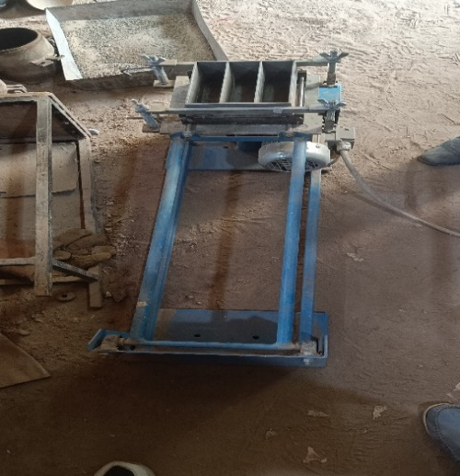

Figure 3. Vibration table with a block of 3 moulds of sizes 4x4x16 cm3

***2.2.2.1. Coding of formulations***

The formulation conditions for earth blocks are specified in Table 1. Four formulations with soil and fiber of Grewia bicolor are selected.

Table 1: Coding of different formulations

|  |  |  |  |  |
| --- | --- | --- | --- | --- |
| Formulation | Soil (%) | Fiber of GB (%) | Codes | Meaning |
| 1 | 100 | 0 | NSO | 100% of sol and 0 of GB fiber |
| 2 | 99,5 | 0,5 | SF1 | 99,5% of soil and 0,5% of GB fiber |
| 3 | 99,25 | 0,75 | SF2 | 99,25% of soil, 0,75% of GB fiber |
| 4 | 99 | 1 | SF3 | 99% of soil and 1% of GB fiber |

***2.2.2.2. Thermomechanical tests***

3-point bending and compression tests were performed in accordance with standards (NF EN 12390 - 5, 2001) [17] and (NF EN 12390 - 3, 2003) [18] respectively, at 28 days curing. Each test was carried out on three specimens of the same formulation.

|  |  |  |
| --- | --- | --- |
| C:\Users\Temoua Habmon\Downloads\IMG-20250221-WA0093.jpg | C:\Users\Temoua Habmon\Downloads\IMG-20250221-WA0092.jpg | |
| 1. 3-point bending test device | 1. Breaking an adobe test piece into two pieces | |
| Figure 4. 3-point bending test | | |
|  |  | |
| 1. Compression testing device | 1. Crushing a piece of adobe test tube | |
| Figure 5. Compression test | | |
|  | | C:\Users\Temoua Habmon\Desktop\THESES 1\1739870007948.jpg |
| Figure 6. Experimental setup for thermal testing | | Figure 7. Briquettes of 4x5x8cm3 |

3. Results and discussions

**3.1.- Geotechnical analysis**

***3.1.1. Grain size***

The grain size curves for soil samples from Fianga Lengoua 1, Fianga Lengoua 2, Bongor, Moulkou, Guelendeng and Loumia shown in figure 8 indicate that they are predominantly fine. They have relatively the same appearance. Table 2 summarizes the percentage constituents of the six soils obtained from the particle size curves.



Figure 8. Complete grading curves for six soil samples.

Table 2 of the particle size compositions of the various soils derived from the particle size curves shows that the Fianga Lengoua 1 soil is sandy-clayey-loamy.

Table 2. Granulometric compositions of the different soils

|  |  |  |  |  |  |
| --- | --- | --- | --- | --- | --- |
| N° | Samples | Sand (%) | Silt (%) | Clay (%) | Nature of soil |
| 1 | Fianga Lengoua1 | 48 | 16 | 36 | Sandy-clay-silty |
| 2 | Fianga Lengoua2 | 40 | 12 | 48 | Sandy-clayey |
| 3 | Bongor | 2 | 3 | 95 | Clayey |
| 4 | Moulkou | 26 | 20 | 54 | Silty-sandy clay |
| 5 | Guelendeng | 34 | 16 | 50 | Silty-sandy clay |
| 6 | Loumia | 38 | 14 | 48 | Sandy-clay |

The Fianga Lengoua 2 soil is clayey-sandy, while the Moulkou and Guelendeng soils are clayey-sandy-loamy. The Loumia soil is clayey-sandy and the Bongor soil contains a very high clay content: it is clayey.

Figure 9 shows the soil classification according to National Institute for Agronomic Research’s (INRA) “texture triangle”

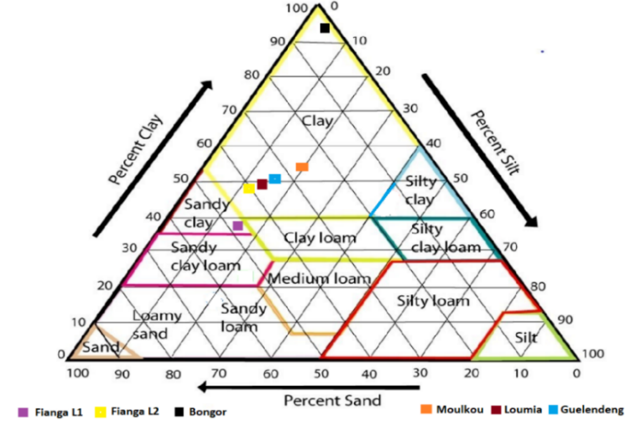

Figure 9. Soil classification according to INRA's “texture triangle”

The lNRA's “texture triangle” classification of the six soils shows that the Fianga Lengoua 1 soil is structurally suitable for making mud bricks. It is also well-suited for stabilization, as it has been established that the soil must possess good natural cohesion after shaping, in other words, the clay content must be sufficiently high: over 10% (this is the case for Fianga Lengoua 1 soil, which has 36% clay); it must also contain a mineral skeleton (sand-gravel).

***3.1.2. Consistency states: Atterberg limits***

Atterberg limits are indicators of a soil's plasticity. Depending on its water content, a soil can have three different consistencies: liquid, plastic and solid.

Table 3. Atterberg limits for six soils

|  |  |  |  |  |  |  |  |  |  |
| --- | --- | --- | --- | --- | --- | --- | --- | --- | --- |
| Atterberg limits | Fianga1 | Fianga2 | Bongor | Moulkou | Loumia | Guelendeng | Boundary zone for compressed earth bricks | Preferred area  For compressed earth bricks | Bibliographical reference |
| LL (%) | 38 | 55 | 52 | 36 | 42 | 41 | 25-50 | 30-35 | (Daot et al. 1991) [19] |
| LP (%) | 20 | 29 | 29 | 19 | 22 | 23 | 10-25 | 12-22 |
| IP (%) | 18 | 26 | 23 | 17 | 20 | 18 | 7-29 | 7-18 |

The Fianga Lengoua 1 soil is sandy-clayey-loamy-plastic, the Fianga Lengoua 2 soil is clayey-sandy-plastic, the Bongor soil is very clayey-plastic, the Moulkou soil is clayey-sandy-loamy-plastic, the Loumia soil is clayey-sandy-plastic and the Guelendeng soil is clayey-sandy-loamy-plastic.

***3.1.2 Methylene Blue Test***

The Methylene Blue values obtained and presented in Table 3 are in line with the Atterberg limits obtained and comply well with standard NF P 11300 [20]. It is revealed that the soils of Fianga Lengoua 1, Bongor, Moulkou, Guelendeng and Loumia are class A2 according to theRoad Earthworks Guide (GTR) classification and A-6, A-7-6 and A-6-7 respectively for the HRB: Highway Research Board (HRB) classification of the same soils. Whereas the Fianga Lengoua 2 soil is class A3 in the GTR classification and A-6 for the HRB classification.

TABLE 4. Soil classification based on Methylene Blue Test

|  |  |  |  |  |
| --- | --- | --- | --- | --- |
| N° | Samples | Methylene Blue Test | Soil classification | |
| HRB | GTR |
| 1 | Fianga Lengoua1 | 1,33 | A-6 | A2 |
| 2 | Fianga Lengoua2 | 1,55 | A-7-6 | A3 |
| 3 | Bongor | 1,00 | A-7-6 | A2 |
| 4 | Moulkou | 1,67 | A-6 | A2 |
| 5 | Guelendeng | 1,33 | A-7-6 | A2 |
| 6 | Loumia | 2, 00 | A-7-6 | A2 |

***3.1.3. Normal Proctor test***

The Proctor test is a geotechnical test used to determine the moisture content required to obtain the maximum dry density of a soil by compaction at a fixed energy (tamper weight, number of blows and standard dimensions). Proctor tests on our soil samples gave the results shown in Table 5. All values are approximately close. Proof that the sites are relatively in the same area.

Table 5. Normal Proctor test results

|  |  |  |  |  |  |  |  |
| --- | --- | --- | --- | --- | --- | --- | --- |
| Normal Proctor |  | Fianga L1 | Fianga L2 | Bongor | Moulkou | Loumia | Guelendeng |
| W opt (%) | 13,4 | 12,8 | 14,4 | 11,3 | 12,2 | 13,4 |
| δ opt (t/m3) | 15,7 | 17,1 | 15,5 | 18,2 | 17,8 | 16,4 |

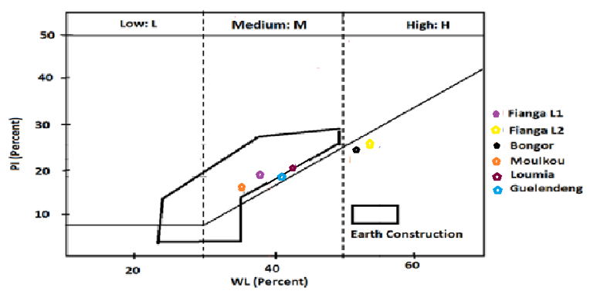

Figure 10. Plasticity diagram for the six soils

The plasticity diagram of the soil samples (Figure 10) shows that the soils of Moulkou, Fianga Lengoua 1, Guelendeng and Loumia are well within the boundary zone of soils eligible for the manufacture of mud bricks. The Bongor soil and the Fianga Lengoua 2 soil are not in the limit zone of eligible soils because they have high liquidity limits.

* 1. **Physicochemical and mineralogical analysis**

***3.2.1. pH measurement***

This was determined using a pH meter on a suspension of 100 grams of soil in 300 mililits of distilled water. Measuring pH can provide valuable information on the predominance of evolved organic matter or carbonates [21]. Soil analyses have shown pH values above 6 (Table 7). According to [22, 23], for a soil to be suitable for stabilization, it must have a pH above 6. If the pH is below 6, soil pre-treatment is essential. Our soils are suitable for stabilization in order to use in eco-construction.

***3.2.2. Chemical and mineralogical analyses***

The six soils are essentially composed of silica and alumina. These compounds reveal the presence of detrital soil minerals such as quartz, feldspars and micas. The majority SiO2 chemical composition of the six soils (Table 6) proves the presence of quartz (SiO2) within them. The presence of quartz is associated with low soil plasticity [24]. The concentration of Al2O3 contributes to good soil plasticity [25]. In third place is calcium oxide for the Fianga Lengoua 2 soil.

The silica/alumina ratio is an indicator of a sample's clay mineral content. These ratios of 4.90 for the Fianga Lengoua 2 sample, 4.96 for the Moulkou sample, 3.71 for the Loumia sample and 2.68 for the Guelendeng sample are comparable with the 2:1 clay mineral ratio of between 2 and 4 [26, 27]. The high sample ratio of 5.18 for the Fianga Lengoua 1 soil reveals the abundant presence of free silica in the sample. The high alumina content, low alkaline element content (K2O) and non-existence of Na2O are indicative of the possibility of using these soils as a base material for refractory products [28, 29]. The low ratio of 1.54 for the Bongor sample is very close to that of pure kaolins (1.1) [30].

TABLE 6. Chemical analysis of the soil samples

|  |  |  |  |  |  |  |
| --- | --- | --- | --- | --- | --- | --- |
| Oxydes (%) | Fianga Lengoua 1 | Fianga Lengoua L2 | Bongor | Moulkou | Loumia | Guelendeng |
| MgO | 0,26 | 0,20 | 0,31 | 0,07 | 0,00 | 0,26 |
| Al2O3 | 15,27 | 15,41 | 35,43 | 15,51 | 19,46 | 25,11 |
| SiO2 | 79,16 | 75,56 | 54,61 | 77,05 | 72,39 | 67,32 |
| P2O5 | 0,00 | 0,05 | 0,00 | 0,01 | 0,01 | 0,00 |
| K2O | 0,28 | 0,42 | 0,35 | 0,37 | 0,37 | 0,33 |
| CaO | 0,03 | 1,08 | 0,00 | 0,52 | 0,51 | 0,00 |
| TiO2 | 0,32 | 0,31 | 0,59 | 0,36 | 0,36 | 0,34 |
| Fe2O3 | 1,25 | 2,62 | 2,47 | 2,70 | 2,55 | 1,93 |
| PF | 3,40 | 4,25 | 7,23 | 3 ;30 | 4,34 | 4,71 |
| Total | 100 | 100 | 100 | 100 | 100 | 100 |
| SiO2/Al2O3 | 5,18 | 4,90 | 1,54 | 4,96 | 3,71 | 2,68 |

***3.2.3. Organic matter levels***

Analyses of the six soils revealed organic matter (OM) levels below 2% (2% is the limit recommended by [31, 32]) (Table 7).

Table 7: Organic matter (OM) content and soil pH

|  |  |  |
| --- | --- | --- |
| Sample | Organic materials (%) | pH |
| Fianga L1 | 1,13 | 6,89 |
| Fianga L2 | 0,15 | 6,45 |
| Bongor | 0,14 | 6,63 |
| Moulkou | 2,31 | 6,52 |
| Loumia | 0,48 | 6,65 |
| Guelendeng | 1,88 | 6,78 |

* 1. **Thermomechanical characterization**

***3.3.1. Effects of GB bark fiber content on the mechanical properties of adobes***

* Effects of GB bark fiber content on the flexural strength of adobes.

Figure 11 show the effect of GB bark fiber content on flexural strength

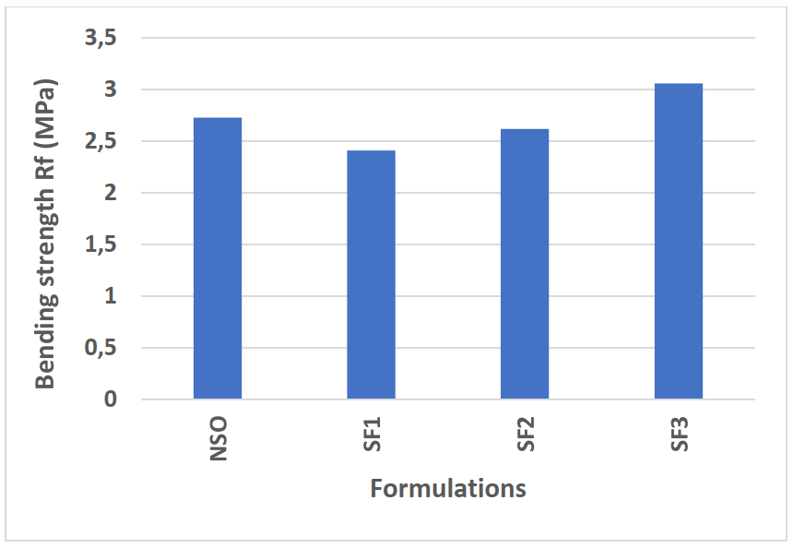

Figure 11: Effect of GB bark fiber content on flexural strength

It can be seen that the flexural strength of fibered specimens increases as the fiber content increases. From 0.6 MPa for adobes without fibers (NSO) to 1.6 MPa for those with 1% fibers (SF3), an increase of almost 130%. This trend has been observed in the authors' work [1, 2, 3]. This is due to the fact that fibers destroy both crack formation and crack propagation.

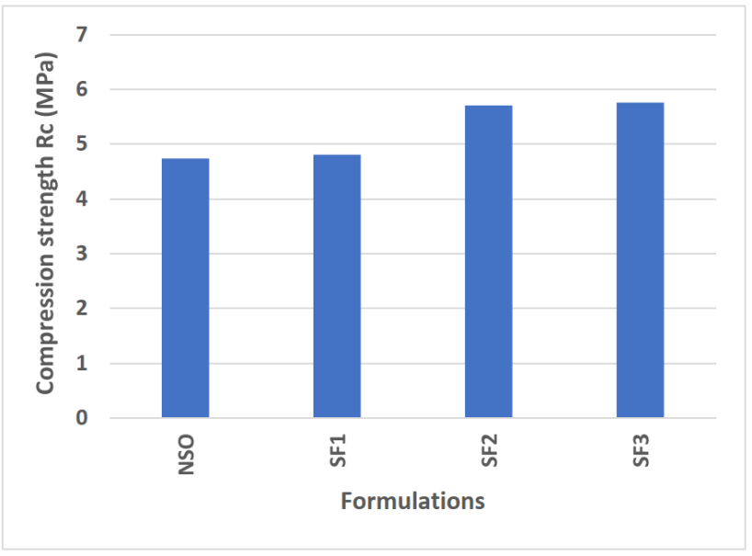

Figure 12: Effect of GB bark fiber content on compress ive strength

Figure 12 shows that compressive strength increases with fiber content. The highest value was obtained with a fiber content of 1%, 5.76 MPa, i.e. an increase of around 53% compared to adobe without fiber. This increase is almost 122%. These results converge with those obtained by some authors [1, 2, 3, 4].

***3.3.2. Effect of GB fiber content on the thermal***

Figure 13 shows the variation in conductivity as a function of the percentage of fibers in the adobes. A linear decrease in thermal conductivity can be observed with increasing fiber content in the specimens.

Figure 13. Effects of GB fiber content on the thermal conductivity of adobes

The presence of fibers creates voids in the bricks, making them porous. This phenomenon improves thermal insulation, reduces conductivity and increases the material's thermal resistance. Heat penetrates the material less easily. This result is in harmony with those of many others [2, 3, 4, 5].

* Effect of GB fiber content on the thermal resistance of adobes.

The Effect of GB fiber content variation on the thermal resistance of adobes is shown figure 14.

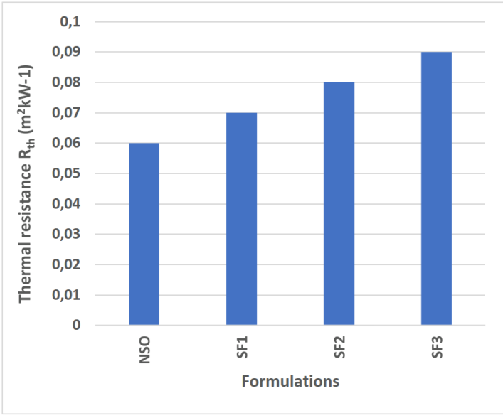  
Figure 14: Variation in thermal resistance of adobe briquettes as a function of fiber content

Figure 14 shows an increase in the thermal resistance of adobe specimens as a function of fiber content. The variation ranges from 0.06 m2kW-1 for the soil without fibers to 0.09 m2kW-1 for the composite with 1% fibers. This increase is in line with results reported in the literature [2, 3, 4, 5].

* Effect of GB fiber content on the thermal effusivity of adobes.

Figure 15 shows variation in thermal effusivity of adobe briquettes as a function of fiber content.

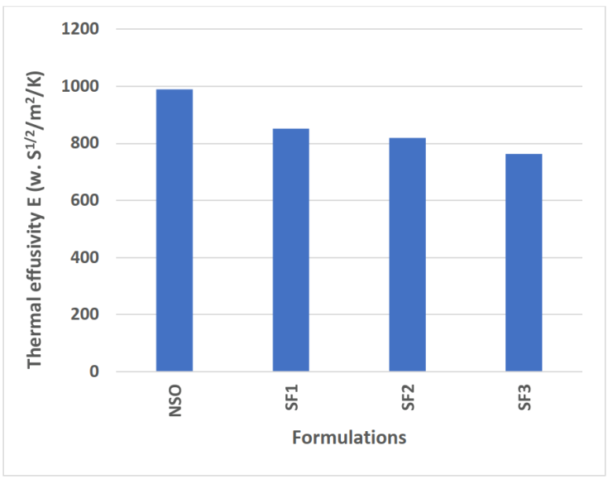

Figure 15. Variation in thermal effusivity of adobe briquettes as a function of fiber content.

Figure 15 shows a decrease in the thermal effusivity of adobe briquettes with increasing fiber content. These values are in line with the authors' results [2, 3, 4, 5, 7]. It varies from 989 to 657 W/S1/2/m2/K respectively from soil without fibers to soil with 1% fibers.

**Conclusion**

The aim of this research is to study the effect of Grewia bicolor fiber content on the properties of adobes. The output responses are the compressive and flexural strengths, thermal conductivity and diffusivity of adobes. Soil samples are from Fianga Lengoua 1, Fianga Lengoua 2, Bongor, Moulkou and Loumia in the Mayo Kebbi Est region; and at Guelendeng in the Cari Baguirmi region, which submitted for characterization. From a geotechnical pointview, the results revealed that the soil in Fianga Lengoua 1 is of class A2 plastic sandy-clayey-loamy, the soil in Fianga Lengoua 2 is of class A3 plastic sandy-clayey, the soil in Bongor is of class A2 plastic clayey, the soil at Moulkou and Guelendeng is of class A2 plastic sandy-clayey-loamy, and the soil at Loumia is class of A2 plastic sandy-clayey. Chemical analyses gave pH values above 6 for all the six soil samples. All the six soils are suitable for stabilization. The six soil samples are aluminosilicates due to their high silica and alumina content. From characterisation finding, the Fianga Lengoua 1 soil, which is eligible for the production of mud bricks, is used to produce adobes measuring 4x4x16cm3 for mechanical tests and 4x5x8cm3 with Grewia bicolor fibers as additives for thermomechanical tests. These tests on adobe briquettes led to the following conclusions:

* Compressive strength of adobes increases from 4.74 to 5.76 MPa with increasing GB fibers, i.e. 122% growth.
* Flexural strength of fiber-reinforced specimens increases from 2.73 to 3.06 MPa with increasing fiber content, i.e. growth of 130%.
* Thermal conductivity decreases from 0.68 to 0.5 W/m.K with increasing fiber content.
* Thermal resistance of fibrous specimens increases from 0.06 to 0.09 m2kW-1 with increasing fiber content, i.e. an increase of 150%.
* Thermal effusivity decreases from 989 to 657 W/S1/2/m2/K with increasing fiber content.

**Acknowledgements**

Our acknowledgements to:

* Building and Public Works Laboratory LBTP), National School of Public Works (ENSTP) for allowing us to carry out tests and analyses.
* Chad geology laboratories and the Chadian Institute of Agricultural Research for Development (ITRAD) for their contributions and for giving us access to their laboratories.

**Disclaimer (Artificial intelligence)**

Option 1:

Author(s) hereby declare that NO generative AI technologies such as Large Language Models (ChatGPT, COPILOT, etc.) and text-to-image generators have been used during the writing or editing of this manuscript.

I declare NO generative AI technologies.

Option 2:

Author(s) hereby declare that generative AI technologies such as Large Language Models, etc. have been used during the writing or editing of manuscripts. This explanation will include the name, version, model, and source of the generative AI technology and as well as all input prompts provided to the generative AI technology

Details of the AI usage are given below:

1.

2.

3.

**REFERENCES**

1. Abakar Ali, 2018. Caractéristiques mécaniques de l’argile de N’Djamena stabilisée par la gomme arabique. Université Henri Poincaré, Laboratoire d’Etudes et de Recherches sur les Matériaux Bois (LERMAB), 54500 Vandœuvre-Lès-Nancy, France.
2. Mbairangone S., Ntamack, G. E., Bianzeube, T., Bozabe, R. K. and O. Kinet, O. (2022). Effect of rice husk on adobes in clay soils. Research Journal of Engineering Sciences, 11(3), 12-21.
3. Togdjim J., Malloum S., Abderahman A. O., Abakar A., Alexis M. N., Danala S. and Michel Q, 2023. Geotechnical and Mineralogical Characterizations of Soil Quarries in Chad with a view to their valorization in Eco-Construction. Journal of Materials and Environmental Science, 14, 255-267.
4. Deepak Gupta, Arun Kumar Chaudhary, Vinay Kumar Singh, Deepak Verma, Kheng Lim Goh, Mohit Sharma, Thermo-mechanical analysis of bhimal fiber (Grewia optiva)-CaCO3/flyash/TiO2 reinforced epoxy bio-composites, Industrial Crops and Products, Volume 204, Part B, 2023.
5. Mahamat Saleh Abdel-khadir et al, 2023. Caractérisation thermophysiques des matériaux locaux d’une localité du Tchad pour une utilisation en écoconstruction. Scientific Research and Academic Publisher.
6. Dadi Mahamat, A., Idriss Hamid, O., Soultan, M., Youssouf Khayal, M., Elhamdouni, Y., Garoun, M. (2015). Effect of Cow’s Dung on Thermophysical Characteristics of Building Materials Based on Clay. Research Journal of Applied Sciences, Engineering and Technology, 10, 464-470.
7. Abderahman Adoum Oumar, 2024. Caractérisation thermomécanique de trois sols d’Abéché au Tchad. Scientific Research and Academic Publisher.
8. Bobet, O and Seynou, M; (2020). Propriétés mécanique, hydrique et thermique de briques en terre crue amendées aux coques d’arachide. Laboratoire de Chimie Moléculaire et de Recherche en Sciences Exactes et Appliquées, Université Joseph KI-ZERBO.
9. NFP18-560. 1978. Analyse granulométrique par tamisage. AFNOR.
10. NFP94-057. 1992. Analyse granulométrique des sols, Méthode par sédimentation. AFNOR.
11. NFP94-051. 1993. Détermination des limites d’Atterberg. AFNOR.
12. NFP94-068. 1993. Mesure de la quantité et de l’activité de la fraction argileuse. Détermination de
13. NFP94-093. 1999. Détermination des références de compactage d’un matériau. AFNOR.
14. Lakhdar MEKKI, Behavior of a strongly overconsolidated expansive clay, PhD thesis, University of Mohamed Boudiaf - M'sila, (2018) 189 p.
15. TAALLAH Bachir, Study of the physico-mechanical behavior of the block of compressed earth with fibers, doctoral thesis, University Mohamed Khider - Biskra, 2014
16. Staljanssens M, Miuy J, Marcoen Fabry J, RasseL A. 1975. Destruction de la matière organique par calcination à basse température en vue de l'analyse minéralogique des sols. Annales de la Société Géologique de Belgique, 98 : 393-403.
17. Norme NF P 15-451. 1989. Dimensions prismatiques.
18. NF EN 12390 - 5, 2001. Essai de flexion trois points.
19. NF EN 12390 - 3, 2003. Essai de compression
20. Daot P, Hays A, Houben H, Matur S, Vitoux F. 1991. Construction en Terre par le CRATerre. Edition Parenthèses.
21. NFP11-300. 1992. Test que bleu de méthylène. AFNOR.
22. Taallah Bachir. Etude du comportement physico-mécanique du bloc de terre comprimée avec fibres, Université de Mohamed Khider Biskra, 2014.
23. Vilenkina N. Utilisation de matériau sol dans la construction des bâtiments ruraux, Mouscou, 1956.
24. Guettala A. Beton de terre stabilisée : amélioration de sa durabilité dans l’eau. Thèse de doctorat, Université de Bskra. 2003.
25. El Fgaier F. 2013. Conception, production et qualification des briques en terre cuite et en terre crue. Thèse de doctorat. Ecole centrale de Lille, 2013.
26. Kornmann. 2005. Matériaux de construction en terre cuite, fabrication et propriétés.
27. Jouennec A. 1990. Traité de céramique et matériaux minéraux. Septima. Editions Septi, à Paris.
28. Konank L. 2006. Interaction entre des matériaux argileux et un milieu basique riche en calcium. Thèse de Doctorat Unique, Université de Limoges, France.
29. Ledoussalh. 1985. Les produits réfractaires. Paris: Société française de céramique.
30. Sagbo E, Laibi A, Senou M, Josse R, Mensah J, Borschneck D, Noack Y. 2015. Physico-Chemical and Mineralogical Characterization of some Clays from Coastal Sedimentary Basin of Benin used in Ceramic. Res.J.chem.sci., 5(12): 1-19.
31. Yah OH, Fripiat JJ. 1979. Data handbook for clay minerals and other non-metallic minerals. Pergamon Press.
32. Doat P, Hays A, Houben H, Matuk S, Vitoux F. Construire en terre. Editions Alternatives et Parallèles, collection an Architecture, Paris, France, 265p, 1979.
33. Vénuat M., Le traitement des sols à la chaux et au ciment. Publié par l'auteur, 66 av. C. Perrière, 92320 Chatillon-sous-Bagneux, 459 Vilenkina N. Utilisation de matériau sol dans la construction des bâtiments ruraux, Moscou, 1956.