Structural and Optical Analysis of Chemically Deposited ZnS Thin Films for optoelectronic devices applications

Abstract: We have produced thin film samples of cubic ZnS by the chemical bath method.
These samples were synthesized using zinc chloride, thiourea, sodium citrate and ammonia solutions at varied deposition time from 24h to 96h.
X-ray diffraction (XRD), transmittance and photoluminescence (PL) analyses provided the physical characteristics of cubic ZnS films with crystal plane orientations (2 0 0) and (2 2 2), lattice parameters of 5.648 Å and an atomic plane distance d=1.412 Å. The grain size calculed are 16.53 nm and 17.12 nm. PL revealed deep defects in the gap with peaks in the visible, with prominent emissions at 430 nm (blue) and 510 nm (green). The measured transmittance of the films is 88.6%.

Keywords: ZnS Thin Films, optoelectronic devices, X-ray diffraction (XRD), transmittance and photoluminescence (PL)

I. Introduction

Semiconductors are essential components for optoelectronics, used in thin layers in photovoltaics, transistors, diodes, etc. Semiconductors have evolved over time in their composition and manufacturing techniques. The most widely used semiconductor today remains silicon (Si). However, due to its low indirect gap, it has drawbacks that can be remedied by using layers synthesized from other materials (binary, ternary, etc.). In this sense, several materials such as II-VI and III-V compounds have been and are still being studied. Zinc sulfide, the subject of our work, is an II-VI type semiconductor material known for its wide direct gap. It has advantages for optoelectronic applications and contributes to protecting the environment [1], [2] due to its non-toxicity. The value of its gap energy Eg is estimated at 3.7 eV (327 nm) at room temperature.
ZnS belong to the large family of large and direct band gap energy. ZnS is a good candidate for solar energy applications as window layer[3], in optoelectronic devices [4] such as Laser, DEL[5], Radiation detector[6] and gas detector[7], [8]. Today,research shows that ZnS has biomedicine applications [6].
To date, several synthesis techniques for this material have been tested and have made it possible to produce good quality ZnS. Among the synthesis techniques, we have: MOCVD [9]⁠, spray pyrolysis [10]⁠, MOPVE, sol gel [11], spin coating [12][13], CBD [14][15].
As part of our work, we synthesized ZnS by the CBD (Chemical Bath Deposition) method.
After the synthesis of the samples, a characterization was carried out using several techniques including X-ray diffraction, photoluminescence (PL) and transmittance to determine their crystallographic and optical properties.

II. Materials and Methods
II.1. Substrate preparation

Microscope glass substrates were used. These substrates underwent ultrasonic cleaning in a bath of acetone, ethanol and distilled water and were then dried before being immersed in the precursor’s solution at room temperature.

II.2. Preparation of the solution
The deposition solution was prepared using zinc acetate (ZnC₄H₆O₄) as a source of Zinc (Zn) and thiourea (SC(NH₂)₂) as a source of sulfur (S). CBD methode use complexing agents to enhance material precipitation and a pH control solution. Sodium citrate was therefore used as a complexing agent and ammonia to control the pH of the solution.
From a starting pH at 6.5, the deposition solution was brought up to a pH of 10.94 (using about 10 ml of ammonia) to allow the growth of film made of in a basic medium.
The proportions of sources used are:
• 160 ml of Thiourea (0.2 M)
• 80 ml of Zinc Acetate (0.2 M)
• 5.12 ml of Sodium Citrate (0.66 M)
• 10 ml of Ammonia
Thus, a total volume of 250 ml with a Zn:S ratio of 1:2 is used.

II.3 reactional Mechanisms
ZnS layers can be obtained in an acidic medium, at low temperature, or in a basic medium (temperature deposition [16]–[18]).
Since the deposition is done in an aqueous medium, zinc and sulfur are in an ionic form according to the following reactions:
For thiourea:
$\begin{matrix}{SH}^{-}\left(aq\right)+{OH}^{-}\left(aq\right)⇆S^{2-}\left(aq\right)+H_{2}O\end{matrix}$ 1

Sulfur is the SH⁻ form instead of S²⁻ .

For zinc:
Zinc (II) tetraamine ions are formed

$\begin{matrix}{{Zn\left({NH}_{3}\right)}_{4}}^{2+}\left(aq\right)⇆ {Zn}^{2+}(aq)+4{NH}_{3}(aq)\end{matrix}$2

HS⁻ ions will dissociate in solution to give S²⁻ ions according to the following equation

${HS}^{-} {+ OH}^{-}⇆ S^{2-}(aq)+H_{2}O$ 3

The released sulfur (II) and zinc (II) ions will thus react to form ZnS according to the following equation:

$\begin{matrix}{Zn}^{2+}(aq)+S^{2-}(aq)⟶{ZnS}_{\left(s\right)}\end{matrix}$ 4

This process is called “the ionic mechanism”.

In this process, formation of zinc hydroxide (Zn(OH)2) is one of the most probable reactions in the absence of complexing agent.

${Zn}^{2+}\left(aq\right)+{2OH}^{-}(aq) ⟶ {Zn\left(OH\right)}_{2\left(s\right)}$ 5

Thus, to limit the formation of zinc oxide (ZnO) or zinc hydroxide, the use of complexing agent seems to be necessary, since its catalytic reaction is significantly faster than that of the formation of ZnS, under the same conditions.With a solubility of ZnS greater than that of ZnO, we can expect a disappearance of ZnS in the solution in favor of ZnO . This is what justifies the use of the complexing agent which limits the formation of ZnO.
In case of deposition temperature, one can observe an aggregates formation of [Zn(OH)₂]_{n}(s), then followed by a slow thermal decomposition of the thiourea.
The reaction can be summarized by the following equation:

$\begin{matrix}{\left[Zn\left(OH\right)2\right]}_{n\left(s\right)}+{nS}^{2-}\left(aq\right)⟶{nZnS}_{\left(s\right)}\end{matrix}$ 6

This process is called the “aggregate mechanism”

A third mechanism of ZnS formation exists also and the process is called “ionic mechanism by decomposition of complexes”.
The ZnS thus obtained through this process is covered with pollutants (ligands) that are eliminated by rinsing using an alkaline solution (distillated water).

III. Apparatus

The samples were deposited under an absorbent host and required laboratory glassware, 250 ml graduated flask, beakers, magnetic stirrers, microscope glass slides, graduated burette, and personal protective equipment (gloves, masks, etc.).
The samples were characterized using a Philips XPERT Panalytical diffractometer with a Cu source, kα1 (1.54056 Å), for structural properties, in θ-2θ configuration from 20° to 70°.
The optical properties were characterized using photoluminescence measurements. We used a cryostat that could go down to 20 K, a TRIAX 550 CCD with a 550 Blaze angle, and a 266 nm wavelength laser with 10 mW power.
Due to accessibility of the equipment, we realized transmittance measurement on one of our samples by using high pressure xenon lamp was used and signal was detected using a Hamamatsu R943 photomultiplier.

IV. Results and Discussions

Four samples were used at room temperature in this experiment based on the duration of the deposit. Depositions ranged from 24 h to 96 h with one sample every 24 hours.
At the end of the experiment, each sample was rinsed with distilled water and then dried, under vacuum, for four (4) hours.

IV.1 Structural properties

Results from structural properties analysis by XRD of the 4 samples are shown in Figure 1 and Figure 2.

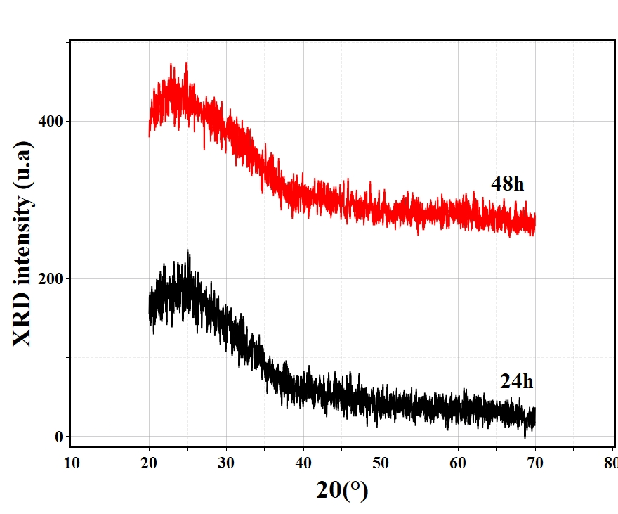

Figure 1: XRD (θ-2θ) patterns of ZnS samples made in 24 h and 48 h by CBD at room temperature
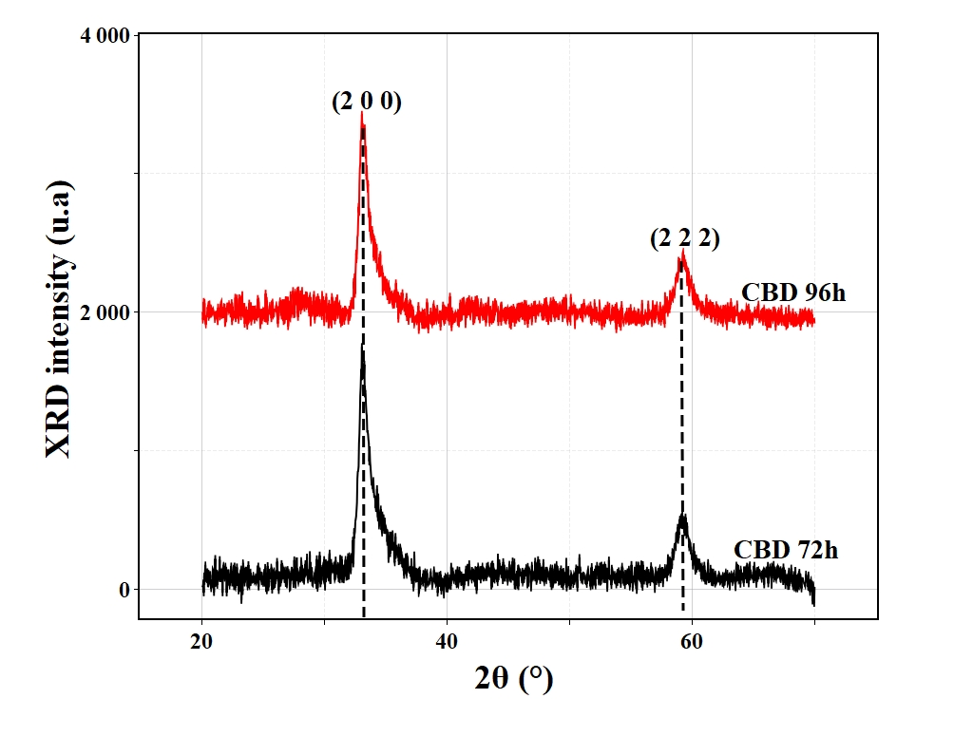
Figure 2: XRD (θ-2θ) of samples made in 72 hours and 96 hours by CBD at room temperature

Results of The XRD (θ-2θ) characterization is given by the first three figures. It can be seen form these curves that, samples made in 24 h and 48 h, curves in Figure 1, do not show any diffraction peaks. This can be explained by the non-crystallization of the layer due to the low ambient temperature (around 14°C) and an insufficient duration time to drive the coalescence process to an ideal level.
The ZnS samples obtained after 72 hours and 96 hours show diffraction peaks at positions 2θ = 33.05° and 59.20°.
According to the AMCSD database [19], [20], these positions correspond to the respective orientations of (2 0 0) and (2 2 2) attributed to the cubic structure of ZnS. Similar results were obtained by Mukta V. Limaye et al. [10]
In the rest of our work, we were only interested in the samples made in 72h and 96h which are the only ones to give a signal in XRD.
Determination of the inter-reticular plane distance can be obtained by using Bragg formula.

2dsinθ = nλ, for order 1, n =1, with:

d=λ/2sinθ (7)
θ: diffraction angle
λ= 1.54056 Å
d=1,412 Å.

The distance between the reticular planes d allowed to calculate the mesh parameters.
These mesh parameters are such that:
a=b=c=5.648 Å.
This value is close to that obtained by La Porta [20].
Using the Debye-Scherrer formula, the grain size was calculated.
D=(0.9λ)/(βcosθ) (8)
With:
D : grain size ;
λ the wavelength used in X-ray (1.54056 Å);
β the FWHM and
θ the diffraction angle.
We find D = 16.53 nm (72h sample) and D = 17,12 nm (96h sample), consistent with those obtained by La Porta et al [20] and Ahmad Al-Diabat et al [21].
According to the literature [22], particle grain size is a quality factor for thin films characterized in XRD.
Indeed, the smaller the particles grains, the greater the possibility of particles grain boundaries, making the thin film unfavorable to good conductivity.
On XRD spectra, this can be seen by broad peaks announcing an amorphous tendency or poor crystallization of the thin film [22].
However, when the particles grains are of adequate size, the diffraction peaks obtained after an XRD measurement are finer. Indeed, the best crystal structure is obtained when the XRD peaks are infinitely thin. These are Bragg peaks. They provide information on the arrangement of atoms on atomic planes (crystalline planes) in almost perfect order.
From this approach, we deduce that the layers obtained after 96 hours of deposition have a better quality.
Indeed, the measurement of the width at half-height of the peaks (FWHM) confirms our result. The size of the seeds obtained by calculation is also in the same direction. It was found that the grains are larger in the 96 h samples than in those of 72 h.
These results can be improved by processes such as heat treatment by annealing.
Several authors [23]–[25] have reported studies on the crystallographic properties of ZnS deposited by various methods. These studies show the influence of the deposition temperature and/or annealing on ZnS films.

IV.2 Optical properties

IV.2.1 Transmittance

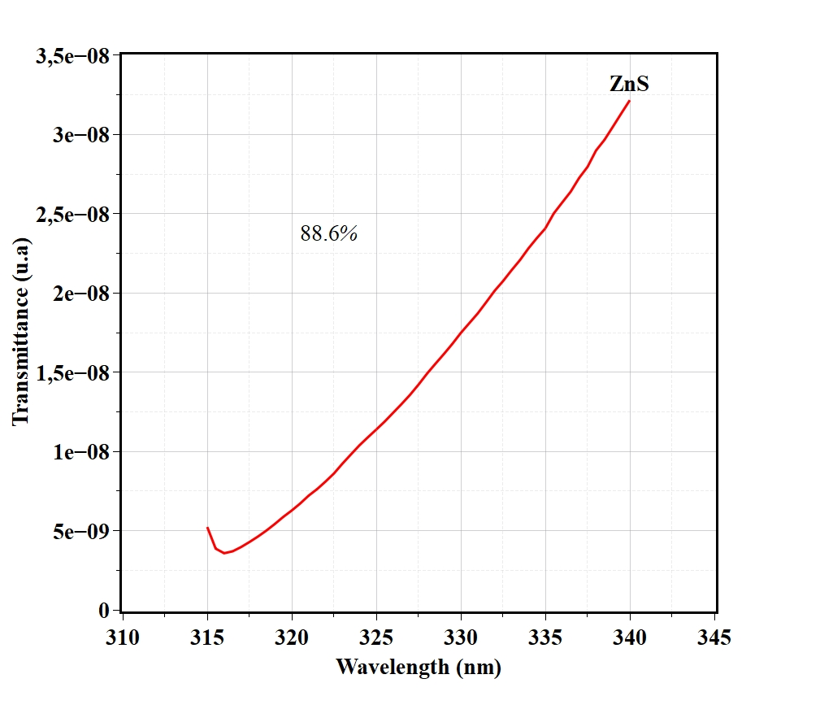
Figure 3: Transmittance of ZnS layer obtained after 72 hours deposition by CBD

Optical transmittance measurements were performed on the ZnS layer obtained in 72 hours covering the ZnS gap band (from 315 to 340 nm).
In the layer obtained in 72 hours, optical transmittance measurements shows that it is 88.6% transparent. This result is similar to the one by Anisuzzaman Sakil et al [4]using CBD to obtain ZnS:Co layers with transmittance between 60 and 80% in the visible. F. Gode et al [16], A. Djelloul et al [26] produced also a ZnS by CBD, at temperature, with a transmittance in the visible (290 nm to 800 nm) between 66 and 87% and 50 to 90% respectively.

IV.2.2 Photoluminescence

The photoluminescence measurements performed on our samples do not concern those produced in 24 hours and 48 hours due to their non-reactivity to XRD. The following results are those obtained on the 72 hours and 96 hours samples.
These results show recombinations around the 430 nm and 510 nm positions. These luminescence bands can be attributed to defects in the material gap [27]⁠. The transition recorded around 430 nm may correspond to a recombination of electrons from the conduction band to a sulfur vacancy close to the valence band as reported by Anisuzzaman Sakil et al [4].
The transition located around 510 nm can be attributed to interstitial defects or impurities incorporated during synthesis. Anisuzzuman et al reported that the presence of dopant (Co²⁺) as a substituent of Zn²⁺ could explain recombinations around 510 nm. P M Parameshwari et al [27]attributed this green transition to sulfur interstitials [25]. Other teams like that of Poornima et al. [10] who attributed this luminescence to zinc or sulfur vacancies corresponding to acceptor and donor levels respectively. Maskaeva et al [28] also reported transitions from V_{zn} sites to V_{S} at wavelengths 410 nm to 430 nm and recombinations between 470 nm and 620 nm corresponding to band-interstitial, acceptor-donor transitions.
The recombination observable around 860 nm can be attributed to the 2nd order of the PL.
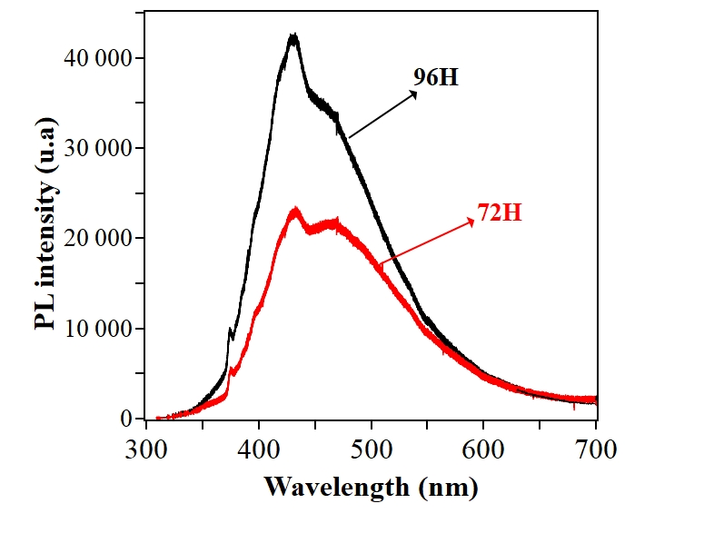

Figure 4 : Photoluminescence measurements of samples made in 72 hours and 96 hours

V. Conclusion

Zinc sulfide was successfully produced by the CBD method, at low temperature and depending on the deposition time from 24h to 96h. The results showed an improvement in the crystallographic and optical qualities of the layers from a deposition time of 72 hours: for an ambient temperature of 14 ° C. The DRX shows a cubic structure with (2 0 0) and (2 2 2) atomics plans orientations, and the PL displays deep defects in the quantum gap of the layers with prominence of blue emission (430 nm) on green one (510 nm). The result of the transmittance analyses of these layers shows that they are transparent in UV and visible, which makes them potential good candidates for applications in solar photovoltaic technology as buffer layers and blue laser dispositive.
Our future works will focus on physicochemical analyses such as stoichiometry, conductivity; the Hall effect and profilometry.

Disclaimer (Artificial intelligence)
Author(s) hereby declare that NO generative AI technologies such as Large Language Models (ChatGPT, COPILOT, etc.) and text-to-image generators have been used during the writing or editing of this manuscript.

Acknowledgments
- French Embassy in Niger which, through a scholarship, allowed us to stay in the L2C-CNRS/UM laboratory in Montpellier (France) for the characterization of the samples
- Silvie Contreras (L2C), UMR 5221 CNRS-Université de Montpellier, Montpellier FR 34095, France
- Bernard Fraisse ICGM, CNRS, Université de Montpellier, ENSCM, Montpellier, France

REFERENCES:

[1] G. Korotcenkov, “Metal oxides for solid-state gas sensors: What determines our choice?,” Mater. Sci. Eng. B, vol. 139, no. 1, pp. 1–23, 2007, doi: 10.1016/j.mseb.2007.01.044.
[2] A. Djelloul et al., “Properties study of ZnS thin films prepared by spray pyrolysis method,” J. Nano- Electron. Phys., vol. 7, no. 4, pp. 4–8, 2015.
[3] A. Derbali et al., “Élaboration et Caractérisations Physico-chimiques des Couches Minces de Sulfure de Zinc ( ZnS ) En Vue d ’ applications Photovoltaïques, thèse de doctorat,” Int. J. Thin Film Sci. Technol., vol. 8, no. 3, pp. 2017–2018, 2019, doi: 10.18576/ijtfst/080301.
[4] M. A. Shakil, S. Das, M. A. Rahman, U. S. Akther, M. K. Hassan, and M. K. Rahman, “A Review on Zinc Sulphide Thin Film Fabrication for Various Applications Based on Doping Elements,” Mater. Sci. Appl., vol. 09, no. 09, pp. 751–778, 2018, doi: 10.4236/msa.2018.99055.
[5] T. S. T. Shobana, T. V. T. Venkatesan, and D. K. D. Kathirvel, “A Comprehensive Review on Zinc Sulphide Thin Film by Chemical Bath Deposition Techniques,” J. Environ. Nanotechnol., vol. 9, no. 1, pp. 50–59, 2020, doi: 10.13074/jent.2020.03.201394.
[6] Yankun Sun, “Research progress of ZnS nanoparticles,” J. Mater. Sci. Res. Rev., vol. 6, no. 4, pp. 871–878, 2023.
[7] H. Gourari, M. Lumbreras, R. Van Landschoot, and J. Schoonman, “Elaboration and characterization of SnO2-Mn2O3 thin layers prepared by electrostatic spray deposition,” Sensors Actuators, B Chem., vol. 47, no. 1–3, pp. 189–193, 1998, doi: 10.1016/S0925-4005(98)00022-7.
[8] S. Roy and S. Basu, “Improved zinc oxide film for gas sensor applications,” Bull. Mater. Sci., vol. 25, no. 6, pp. 513–515, 2002, doi: 10.1007/BF02710540.
[9] A. Abounadi et al., “Reflectivity and photoluminescence measurements in ZnS epilayers grown by metal-organic chemical-vapor deposition.”
[10] N. Poornima, A. Jose, C. S. Kartha, and K. P. Vijayakumar, “Composition and conductivity-type analysis of spray pyrolysed ZnS thin films using photoluminescence,” Energy Procedia, vol. 15, no. 2011, pp. 347–353, 2012, doi: 10.1016/j.egypro.2012.02.042.
[11] U. A. Kalu, O. U. Vincent, O. N. Agatha, and A. Nwode, “Effect of Black Velvet Tamarind Doping on the Optical and Structural Properties of Sol-Gel Grown ZnS Thin Film Crystals,” vol. 9, no. 12, pp. 1–9, 2023.
[12] M. Sahal, B. Hartiti, and A. Ridah, “Résumé,” Afrique Sci. Rev. Int. des Sci. Technol. · January, no. January, 2006.
[13] T. Nimalan and M. R. Begam, “Physical and Chemical Methods: A Review on the Analysis of Deposition Parameters of Thin Film Preparation Methods,” Int. J. Thin Film Sci. Technol., vol. 13, no. 1, pp. 59–66, 2024, doi: 10.18576/ijtfst/130107.
[14] M. H. Khalil, R. Y. Mohammed, and M. A. Ibrahem, “Influence of Post Annealing on CBD Deposited ZnS Thin Films,” AIP Conf. Proc., vol. 2660, no. May, 2022, doi: 10.1063/5.0109757.
[15] T. Ben Nasr, N. Kamoun, M. Kanzari, and R. Bennaceur, “Effect of pH on the properties of ZnS thin films grown by chemical bath deposition,” vol. 500, pp. 4–8, 2006, doi: 10.1016/j.tsf.2005.11.030.
[16] C. G. Gode, F, “Investigations on the physical properties of the polycrystalline ZnS thin films deposited by the chemical bath deposition method,” vol. 299, pp. 136–141, 2007, doi: 10.1016/j.jcrysgro.2006.10.266.
[17] A. Mukherjee and P. Mitra, “Characterization of Sn doped ZnS thin films synthesized by CBD,” Mater. Res., vol. 20, no. 2, pp. 430–435, 2017, doi: 10.1590/1980-5373-MR-2016-0628.
[18] R. Balakarthikeyan et al., “Enhancing the optoelectronic properties of low-cost nebulizer spray pyrolysis (NSP) prepared ZnS thin film through praseodymium doping for photodetector applications,” Mater. Sci. Eng. B Solid-State Mater. Adv. Technol., vol. 289, Mar. 2023, doi: 10.1016/j.mseb.2022.116213.
[19] M. V. Limaye, S. Gokhale, S. A. Acharya, and S. K. Kulkarni, “Template-free ZnS nanorod synthesis by microwave irradiation,” Nanotechnology, vol. 19, no. 41, Oct. 2008, doi: 10.1088/0957-4484/19/41/415602.
[20] F. A. La Porta, J. Andrés, M. S. Li, J. R. Sambrano, J. A. Varela, and E. Longo, “Zinc blende versus wurtzite ZnS nanoparticles: Control of the phase and optical properties by tetrabutylammonium hydroxide,” Phys. Chem. Chem. Phys., vol. 16, no. 37, pp. 20127–20137, 2014, doi: 10.1039/c4cp02611j.
[21] A. M. AL-Diabat, N. M. Ahmed, M. R. Hashim, K. M. Chahrour, and M. Bououdina, “Effect of Deposition Temperature on Structural and Optical Properties of Chemically Sprayed ZnS Thin Films,” Procedia Chem., vol. 19, pp. 485–491, 2016, doi: 10.1016/j.proche.2016.03.042.
[22] M. M. Rose, R. S. Christy, T. A. Benitta, J. T. T. Kumaran, and M. R. Bindhu, “Phase transition in ZnS nanoparticles: electrical, thermal, structural, optical, morphological, antibacterial and photocatalytic properties,” Chalcogenide Lett., vol. 19, no. 11, pp. 855–869, 2022, doi: 10.15251/CL.2022.1911.855.
[23] N. Perret and U. De Sherbrooke, “Propriétés optiques et mécanismes de relaxation de l’énergie des porteurs dans des boîtes quantiques,” 2001.
[24] M. Nasiri Sarvi, P. Esmaili, and S. Asgary, “Effect of annealing on structural and optical properties of indium sulfide thin layers produced by chemical bath deposition method,” Indian J. Phys., vol. 94, no. 10, pp. 1545–1552, 2020, doi: 10.1007/s12648-019-01601-9.
[25] H. Ahn and Y. Um, “Post-annealing effects on ZnS thin films grown by using the CBD method,” J. Korean Phys. Soc., vol. 67, no. 6, pp. 1045–1050, 2015, doi: 10.3938/jkps.67.1045.
[26] A. Djelloul, M. Adnane, Y. Lerbah, T. Sahraoui, and S. Hamzaoui, “Élaboration et Caractérisation des Couches Minces de Sulfure de Zinc ( ZnS ) Préparés par la Technique SILAR ( Successive Ionique Layer Adsorption and Reaction ),” vol. 1, pp. 1–9, 2016.
[27] P. M. Parameshwari, “Spray Deposition and Characterization of Nanocrystalline Cd 1-x Zn x S thin films,” vol. 11, no. 1, pp. 45–58, 2017.
[28] L. N. Maskaeva, O. A. Lipina, V. F. Markov, V. I. Voronin, A. V. Pozdin, and I. A. Anokhina, “Chemical Synthesis, Morphology, and Optical Properties of Manganese-Doped Zinc Sulfide Films,” Russ. J. Phys. Chem. A, vol. 96, no. 11, pp. 2505–2514, 2022, doi: 10.1134/S0036024422100211.

