Recycled Water Use for Irrigation in Nigeria: Reviewing the Socio-economic and Environmental Sustainability

Abstract
In response to increasing water scarcity and the need for sustainable agriculture, this review examines the environmental and socio-economic implications of using recycled water for irrigation in Nigeria. Using a narrative review approach, literature from 2000 to 2024 was sourced from ScienceDirect, Scopus, and Google Scholar. The findings highlight key benefits, such as water conservation, nutrient recycling, drought resilience, and critical risks, including soil salinity, heavy metal buildup, and regulatory gaps. Drawing lessons from countries like Israel, India, Ethiopia, and Australia, the study underscores the importance of policy frameworks, infrastructure, and emerging technologies (e.g., AI and IoT) for safe implementation. With adequate safeguards and public engagement, recycled water offers a viable pathway for improving agricultural sustainability and water management in Nigeria.

Keywords: Water recycling, Irrigation, water security, agricultural productivity

1. Introduction
With the long list of global crises today, water scarcity remains a critical and urgent problem. Water scarcity depicts insufficient freshwater resources to satisfy demand (Caretta et al., 2022). Human beings, animals and other living organisms cannot live without water. Additionally, industrial production, livestock rearing, food production, biodiversity, and environmental conservation depend on water; therefore, water is life (Dhanasekaran, 2019). According to Dhanasekaran (2019), fresh water is the only source for drinking, industrial use, agricultural development, and other purposes. In sub-Saharan Africa and most regions worldwide, agriculture uses over 70 per cent of freshwater. With the growing global population, agricultural production is estimated to increase 50 percent as water withdrawals increases 15 percent (Khokhar, 2017). There is a significant increase in water demand and misuse, which has increased widespread risks of water stress and scarcity (Baker et al., 2016). In developing countries like Nigeria, water scarcity is critical to agricultural productivity and sustainability (FAO, n.d). This issue is particularly pressing in Nigeria, where agriculture accounts for over 70% of water use and supports more than one-third of the population. The combined effects of climate change, poor water infrastructure, and growing demand are worsening water stress, especially in arid northern regions. As freshwater supplies dwindle, exploring recycled water offers a promising, context-specific solution to improve irrigation efficiency, enhance food security, and mitigate environmental degradation. In Nigeria, agriculture is a significant sector of the economy. A study on employment rate in 2020 stated that agriculture accounts for up to 35% of total employment in Nigeria 2020 (Dikeogu-Okoroigwe et al., 2024). According to the FAO, agriculture remains the foundation of the Nigerian economy, providing livelihood for most Nigerians and generating millions of jobs (FAO, 2020).
Nigeria has a growing population that is projected to experience a constant increase in the following decades (Iyanda & Falade, 2019). According to Doris (2023), Nigeria will experience a population growth of over 377 million people by 2050. As the Nigerian population grows, the need and demand for agricultural development also marginally increases, thereby proving the need for improvement in production to match the country's increasing population for sustainable development to be achieved (Aina et al., 2019). With the advent of climate change, disruptions in rainfall patterns and increasing pressure on traditional water sources like groundwater and surface water have resulted in the urgent need to explore alternative solutions to ensure water security and sustainable agricultural practices (Rastogi et al., 2024). As shown in Figure 1, water availability across Nigeria is unevenly distributed, with northern regions facing more severe water stress. This regional disparity highlights the importance of localized solutions such as recycled water irrigation. There are various alternative sources or approaches for alternative water sources for agriculture. However, one promising approach is using recycled water for irrigation (Aishwarya et al., 2022). This approach involves treating wastewater to a quality suitable for reuse as a source of irrigation in agriculture (Drechsel et al., 2010).
Globally, recycled water has been successfully used in agriculture, providing multiple benefits such as water conservation, nutrient recycling and effective wastewater management (Poustie et al., 2020). However, adopting such practices in Nigeria is still in its early stages, with limited implementation and awareness (Adewumi, 2016). This review evaluates the potential environmental impacts of adopting recycled water for irrigation in Nigeria. By examining global practices, current initiatives within the country and relevant case studies, this paper provides a comprehensive understanding of the benefits, risks and necessary measures for successful implementation in Nigeria. The findings will inform policymakers, agricultural practitioners and stakeholders about the feasibility and implications of using recycled water for irrigation and contribute to sustainable water management and agricultural resilience in Nigeria.
Although recycled water presents a promising alternative, its adoption for agricultural irrigation is limited by concerns over water quality and potential health risks, especially in a densely populated and agriculturally intensive country like Nigeria. Lessons from countries such as Israel and Australia demonstrate that successful implementation requires stringent regulatory standards, infrastructure investment and ongoing quality monitoring. By aligning Nigeria's water recycling efforts with global best practices, there is significant potential to mitigate water scarcity, enhance food security and promote sustainable land use, particularly in semi-arid regions facing severe drought conditions.
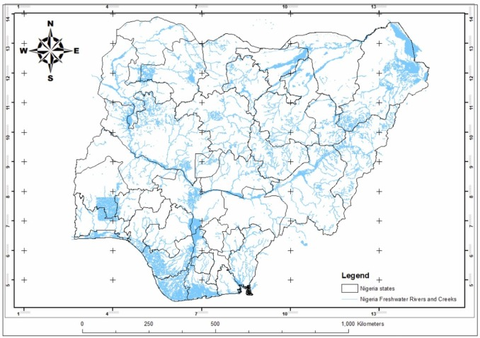
Figure 1: Map of Nigeria showing water distribution across regions (Isukuru et al., 2024)

1.1. Objectives of the Study
The primary objective of this review is to evaluate the environmental impacts, benefits, and risks associated with the use of recycled water for irrigation in Nigeria. Specifically, the study aims to:
- Assess global best practices in agricultural water reuse.
- Identify key environmental concerns such as soil degradation, water pollution, and public health risks.
- Evaluate the applicability of these practices in the Nigerian context, including infrastructural, regulatory, and socio-economic factors.
- Recommend strategies for safe and sustainable adoption of recycled water in Nigerian agriculture.

2. Methodology
This review followed a narrative synthesis methodology guided by thematic analysis. Literature published between 2000 and 2024 was systematically searched using reputable databases, including ScienceDirect, Scopus, and Google Scholar. The following search terms and keyword combinations were used: “recycled water,” “wastewater irrigation,” “Nigeria,” “agriculture,” “environmental impacts,” and “water reuse.”
Studies were included based on the following criteria:
- Focus on recycled water or wastewater reuse in agricultural irrigation
- Relevance to environmental sustainability, public health, or socio-economic outcomes
- Empirical or case study-based contributions from Nigeria or other comparable regions (e.g., Sub-Saharan Africa, Israel, Australia, India)
- Published in English between 2000 and 2024

Articles were excluded if they lacked methodological rigor, did not relate to agricultural use of recycled water, or were duplicate publications.
An initial pool of studies was screened by reviewing abstracts and full texts for relevance. After applying the inclusion and exclusion criteria, 39 sources were selected for critical review and thematic synthesis.
While this review did not involve primary data collection or statistical meta-analysis, several empirical studies included within (e.g., Abegunrin et al., 2016; Rahman et al., 2022) employed quantitative methods such as ANOVA and regression modeling. These findings were then triangulated to identify consensus, contradictions, and knowledge gaps, thereby informing context-specific recommendations.

- Literature Review
3.1 Overview of Water Recycling Practices

Water recycling, also known as water reclamation or reuse, treats wastewater to remove contaminants, making it suitable for various purposes, including agriculture and irrigation (EPA, 2024). The treatment type and degree depend on the intended reuse (I.L. Pepper et al., 2015). Treatment typically involves primary (removal of large solids), secondary (biological treatment for organic matter degradation) and tertiary stages (advanced filtration and disinfection) (Anjaneyulu et al. 2005). The sequence of these treatment stages is visually represented in Figure 2, which illustrates how contaminants are progressively removed to make wastewater suitable for reuse. Globally, recycled water is used in agriculture, industry and landscape irrigation (Wang et al., 2017). Countries like Israel, Spain and Australia have successfully implemented large-scale programs, demonstrating benefits like water conservation, reduced freshwater dependence and enhanced nutrient management (Jimenez & Asano, 2008; Angelakis et al., 2018).

Recent studies affirm that integrating treated wastewater with precision irrigation and smart monitoring systems can significantly enhance water use efficiency while maintaining environmental safety (Rao et al., 2022; Lyu et al., 2022). Advances between 2022 and 2024 have shown that AI-driven irrigation scheduling systems, remote sensing technologies, and real-time water quality monitoring can improve both the productivity and safety of water reuse in agriculture. For instance, Rastogi et al. (2024) reviewed smart irrigation technologies and emphasized the role of AI in forecasting crop water requirements, reducing irrigation losses, and optimizing nutrient delivery. Additionally, Shi et al. (2022) examined contaminants of emerging concern (CECs) in recycled water, highlighting the need for AI-supported models to predict and manage environmental risks.

Studies from China and India have demonstrated the success of sensor-based fertigation systems using recycled water, especially in water-scarce rural zones (Chen et al., 2024). These systems enable site-specific management by integrating IoT sensors with AI algorithms that assess soil moisture, salinity, and crop water needs in real time. In sub-Saharan Africa, similar trials have begun, with pilot projects using AI-enabled irrigation in Kenya and Ghana showing promise for smallholder farmers (Rastogi et al., 2024).

From a treatment perspective, Dunsin and Oladoja (2021) and Mishra et al. (2023) advocate combining conventional treatment with nature-based solutions like constructed wetlands, which are both cost-effective and adaptable to rural areas. These innovations are particularly relevant for Nigeria, where infrastructure is limited and maintenance costs are a concern.
Recent innovations in AI and sustainable technologies are transforming water reuse for agriculture. AI-powered irrigation systems, such as machine learning-based evapotranspiration forecasting, help optimize water delivery based on real-time crop needs, reducing wastage and improving yields (Rastogi et al., 2024). Internet of Things (IoT) devices, including moisture sensors and automated valves, now enable precision fertigation and remote water quality monitoring in real time (Chen et al., 2024). In Kenya and India, sensor-based irrigation has increased water efficiency by over 30%, demonstrating the scalability of such tools for smallholder farmers (Lyu et al., 2022). These technologies not only conserve water but also reduce labor costs and environmental risks, directly benefiting farmers, agricultural cooperatives, and local governments seeking data-driven resource management. Integrating these innovations into Nigeria’s water reuse strategies can enhance stakeholder engagement, economic efficiency, and long-term agricultural resilience.

While water recycling initiatives in Nigeria are limited, with efforts mainly focused on urban wastewater treatment, there is growing discussion around its potential for agricultural reuse. Studies have explored using treated wastewater for irrigation in peri-urban areas of Lagos and Kano (Binns et al., 2003). Despite the benefits, large-scale implementation faces infrastructural, financial and regulatory challenges (Helmecke et al., 2020).

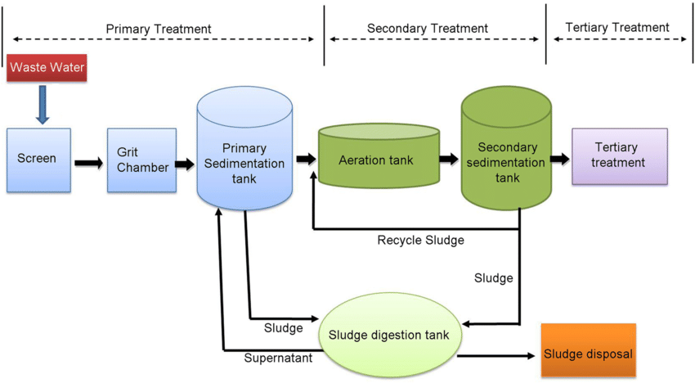

Figure 2: Wastewater treatment process showing primary, secondary and tertiary treatment stages as used in industries to meet discharge standards (Chauhan, J., & Kumar, S., 2020).

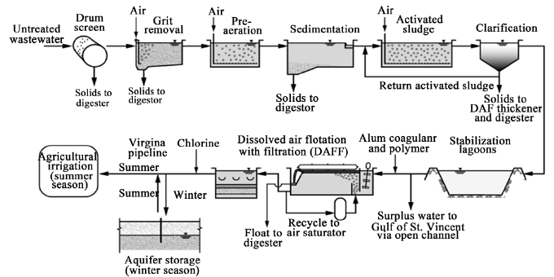

Figure 3: Process flow diagram for the Bolivar sewage treatment facility used in water reuse for unrestricted irrigation.(Ranieri, Leverenz, & Tchobanoglous, 2011)

3.2 Definition and Types of Recycled Water
Recycled water, also known as reclaimed or treated wastewater, is water that has been used and subsequently treated to remove impurities, making it suitable for various purposes, including irrigation. The recycling process involves multiple stages of treatment to ensure that the water meets specific quality standards. These stages typically include primary treatment (removal of large particles), secondary treatment (biological treatment to remove organic matter) and tertiary treatment (advanced filtration and disinfection) (Asano & Levine, 1996).
There are different types of recycled water based on the treatment level and intended use:
- Non-potable Recycled Water: Treated water used for purposes such as irrigation, industrial processes and toilet flushing.
- Indirect Potable Reuse: Treated wastewater that is added to groundwater or surface water sources and eventually used for drinking after further treatment.
- Direct Potable Reuse: Treated wastewater that is directly incorporated into the potable water supply without blending with other sources.
3.3 Global Practices and Success Stories of Recycled Water Use in Agriculture
Globally, recycled water has been successfully integrated into agricultural practices, particularly in water-scarce regions. Countries like Israel, Australia and Spain have pioneered the use of recycled water for irrigation, demonstrating both economic and environmental benefits.
Israel: As highlighted in the introduction, Israel reuses approximately 85% of its treated wastewater for agriculture. This is achieved through advanced treatment technologies and a centralized water management system. The success in Israel is attributed to severe water scarcity, strong government support and advanced technological infrastructure.
Australia: Australia has also made significant strides in using recycled water for irrigation, particularly in the Murray-Darling Basin. This region has implemented various projects that utilize recycled water for irrigating crops like grapes, citrus and vegetables. The Australian experience highlights the importance of stringent water quality regulations and community engagement in the successful adoption of recycled water (Radcliffe, 2004). For example, Figure 3 illustrates the process flow of the Bolivar treatment facility, which has been instrumental in producing high-quality recycled water for unrestricted agricultural irrigation.
Spain: Spain has successfully integrated recycled water into its agricultural sector, with over 400 million cubic meters used annually for irrigation, allowing farmers to maintain crop yields even in water-stressed areas (Jiménez & Asano, 2008).
India: In rural India, decentralized wastewater treatment combined with low-cost irrigation systems has been implemented in water-scarce regions to support smallholder farming (Mishra et al., 2023). These models provide a valuable precedent for Nigeria, where similar economic and agricultural structures prevail. The success of sensor-based fertigation in India, integrated with recycled water, shows the potential for cost-effective and scalable technologies adaptable to Nigerian agro-ecological zones.
Kenya: Kenya has piloted recycled water irrigation systems in peri-urban areas such as Kisumu and Nairobi. These initiatives, driven by NGOs and research institutions, demonstrate how stakeholder collaboration and policy support can enable reuse even in low-resource settings (Rastogi et al., 2024). Such grassroots-level innovations are particularly relevant for Nigeria’s smallholder-dominated agriculture.
Ethiopia: Ethiopia has adopted nature-based wastewater treatment systems such as constructed wetlands for agricultural reuse in rural communities. These systems, due to their low cost and maintenance requirements, are promising models for Nigeria, where access to electricity and high-tech infrastructure remains limited (Dunsin & Oladoja, 2021).
Transferability to the Nigerian Context: Opportunities and Constraints
While these global examples provide valuable insights, the direct transfer of these practices to Nigeria requires careful consideration of the country's unique socio-economic, environmental and regulatory landscape.
Socio-economic Factors: Nigeria's agricultural sector is characterized by a large number of smallholder farmers with limited access to capital and technology. This contrasts with the large-scale, technologically advanced agricultural systems in countries like Israel and Australia. Therefore, the adoption of recycled water in Nigeria must be economically viable for smallholder farmers, potentially through government subsidies or cooperative models (Adewumi, 2016).
Environmental Factors: Nigeria's diverse climate and soil conditions necessitate region-specific approaches to recycled water use. For example, the arid and semi-arid regions of northern Nigeria may benefit from recycled water for irrigation, but careful attention must be paid to soil salinity and sodicity (Rahman et al., 2022). In contrast, the humid regions of Southern Nigeria may face different challenges related to waterlogging and nutrient management.
Regulatory and Institutional Factors: Nigeria lacks a comprehensive regulatory framework for water recycling, which hinders the widespread adoption of this practice. The establishment of clear water quality standards, monitoring protocols and enforcement mechanisms is crucial for ensuring the safe and sustainable use of recycled water in agriculture (Helmecke et al., 2020).
Technological Factors: The choice of appropriate wastewater treatment technologies is critical for the successful implementation of recycled water projects in Nigeria. Technologies should be cost-effective, easy to operate and maintain and capable of removing pathogens and contaminants to levels that meet regulatory standards. Constructed wetlands and other nature-based solutions may be particularly suitable for rural areas with limited access to electricity and technical expertise (Dunsin & Oladoja, 2021).
Public Perception: Public acceptance appears to be an important factor in the success of water recycling projects, particularly in developing countries (Chigor et al., 2020). In Nigeria, there may be cultural or religious concerns about using recycled water for irrigation, particularly for food crops. Therefore, effective public awareness campaigns are needed to educate communities about the benefits and safety of recycled water (Chigor et al., 2020).
By carefully addressing these constraints and leveraging the opportunities, Nigeria can adapt global best practices to develop sustainable and context-appropriate recycled water programs for agriculture. Region-specific guidelines that address local soil conditions, crop requirements and community concerns is critical.

3.4 Current Status of Recycled Water Use in Nigeria
The adoption of recycled water for irrigation in Nigeria remains in its nascent stages, facing a complex web of challenges despite its potential to address water scarcity. While pilot projects and research studies have explored the possibilities, widespread and sustained implementation is lacking. These challenges can be categorized into infrastructural, regulatory, socio-economic and technical barriers:
Infrastructural Deficiencies: A significant impediment is the lack of adequate wastewater treatment infrastructure designed to produce water of suitable quality for agricultural use. Existing treatment plants are often overwhelmed by the demands of growing urban populations and are not specifically designed to remove contaminants of concern for irrigation, such as heavy metals and pathogens. This leads to the use of inadequately treated wastewater, posing risks to soil health and public health (Abegunrin et al., 2016). Urama (2005) observed that land-use intensification without adequate environmental safeguards has contributed significantly to soil degradation in southeastern Nigeria. His study supports the argument for integrating controlled recycled water irrigation as a land management strategy to mitigate erosion and preserve soil health.
Regulatory Gaps and Enforcement: Nigeria lacks comprehensive national guidelines and standards specifically for the use of recycled water in agriculture. The absence of clear regulations regarding water quality, monitoring protocols and enforcement mechanisms creates uncertainty and discourages investment in recycling initiatives. While various environmental regulations exist, their application to recycled water is often ambiguous and inconsistently enforced (Helmecke et al., 2020).
Socio-Economic Factors: Public perception and acceptance of recycled water remain a significant hurdle. Concerns about potential health risks, cultural beliefs and a general lack of awareness about the benefits of recycled water contribute to resistance among farmers and consumers. Additionally, the cost of implementing and maintaining recycling systems can be prohibitive for many farmers, particularly smallholder farmers who constitute a significant portion of the agricultural sector (Akinyemi et al., 2004).
Technical and Research Needs: Further research is needed to assess the long-term impacts of recycled water use on soil health, crop productivity and the accumulation of contaminants in the food chain under Nigerian conditions. There is also a need for locally adapted treatment technologies that are cost-effective and suitable for the specific characteristics of Nigerian wastewater (Sani et al., 2022).
Despite these challenges, there are ongoing policy discussions and initiatives that signal a growing recognition of the potential of recycled water. The Federal Ministry of Water Resources has expressed interest in exploring water reuse as part of its national water resources management strategy. Additionally, some state governments are considering incorporating water recycling into their urban development plans. However, these discussions have yet to translate into concrete policies and large-scale investments.
Moving forward, a coordinated approach involving government agencies, research institutions, the private sector and local communities is essential to overcome these barriers and unlock the potential of recycled water for sustainable agriculture in Nigeria. This includes developing clear regulatory frameworks, investing in appropriate infrastructure, promoting public awareness and fostering research and innovation in water recycling technologies.

3.5 Environmental Benefits of Using Recycled Water
The use of recycled water for irrigation in Nigeria presents several environmental benefits, particularly in the context of the nation's specific ecological challenges.
Reduced Pressure on Freshwater Resources: As the FAO (2016) reports, agriculture in Nigeria accounts for a significant portion of water withdrawals, totaling 5,510 million m3 (44 percent), with 4,549 million m3 used for irrigation. By substituting freshwater with recycled water, the strain on rivers, lakes and groundwater reserves can be significantly reduced, preserving these resources for other critical uses and maintaining ecosystem health (Friedler, 2001). This is particularly important in regions where water scarcity is exacerbated by climate change and population growth.
Addressing Drought and Desertification: In the northern regions of Nigeria, where drought and desertification are major concerns, recycled water can provide a reliable water source for irrigation, enabling agriculture to continue even during dry periods. This helps to combat desertification by maintaining vegetation cover and preventing soil erosion. The integration of drought-resistant crops with recycled water irrigation could further enhance the resilience of agricultural systems in these areas.
Nutrient Recycling and Reduced Fertilizer Use: Recycled water often contains valuable nutrients such as nitrogen and phosphorus. When used for irrigation, these nutrients can act as a natural fertilizer, reducing the need for synthetic fertilizers. This not only lowers the cost for farmers but also minimizes the environmental impacts associated with fertilizer production and runoff, such as eutrophication of water bodies. Studies have shown that the nutrient content in recycled water can improve soil fertility and enhance crop yields, particularly in nutrient-poor soils common in some parts of Nigeria. For instance, a study by Abegunrin et al. (2016) demonstrated that irrigation with wastewater increased soil pH, magnesium, potassium, calcium, total organic carbon, total nitrogen, and cation exchange capacity compared to rainwater irrigation. Additionally, the study found that vegetable growth parameters improved under wastewater irrigation, highlighting the potential of recycled water to enhance soil fertility and support crop production in nutrient-deficient soils.
Mitigation of Water Pollution: Properly treated recycled water can be a safer alternative to the direct use of untreated or poorly treated wastewater for irrigation, a practice that, as noted in studies conducted in Nsukka (Chigor et al., 2020), can lead to the spread of harmful pathogens and antibiotic-resistant bacteria. By ensuring that recycled water meets stringent quality standards, the risk of waterborne diseases and soil contamination can be significantly reduced. Additionally, the controlled treatment and distribution of recycled water can prevent the uncontrolled discharge of pollutants into natural water bodies.
Promotion of Soil Health: The use of recycled water can improve soil health by increasing organic matter content and enhancing soil structure. As Sani et al. (2022) found in their study in the semi-arid tropical zone of Nigeria, treated wastewater improved soil aggregate stability, leading to better water infiltration and permeability. This can enhance the long-term productivity of agricultural lands and reduce the risk of soil degradation.
Economic Benefits: Beyond the direct environmental benefits, the use of recycled water can also provide significant economic advantages. By reducing the need for freshwater extraction and synthetic fertilizers, farmers can lower their operational costs. Additionally, the increased reliability of water supply can lead to more stable crop yields and higher incomes, contributing to the economic resilience of agricultural communities. The development of water recycling infrastructure can also create jobs and stimulate economic growth in related sectors.
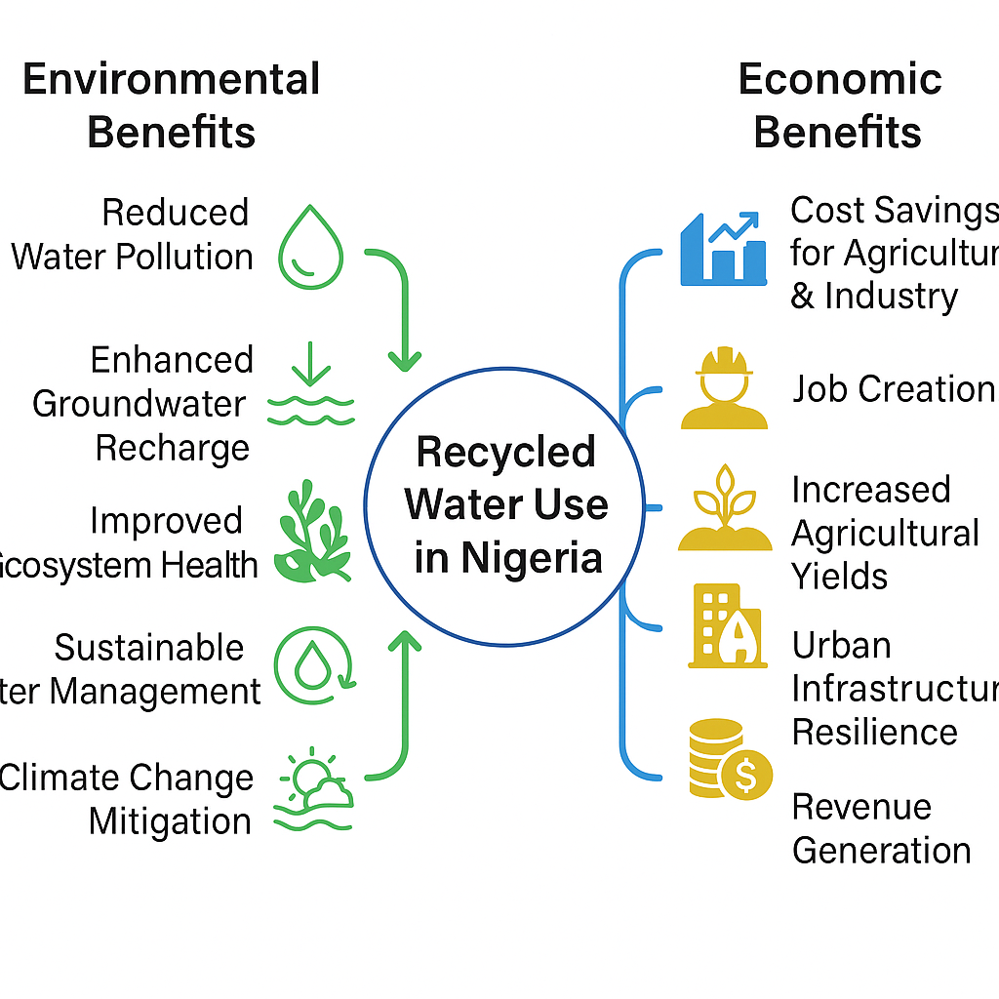
Figure 4: Conceptual Model of the Environmental and Economic Benefits of Recycled Water Use in Nigeria
The environmental and economic benefits discussed above are summarized in Figure 4, which presents a conceptual model linking reduced water stress, improved soil fertility, cost savings, and enhanced agricultural productivity.

3.6 Potential Environmental Risks and Challenges
Despite the various benefits of using recycled water for irrigation in agriculture, if the use of recycled water for irrigation is not properly managed, recycled water can adversely affect crop growth, soil productivity and pose risks to soil health by increasing the salinity and sodicity of the soil, increased heavy metal accumulation and decreased hydraulic conductivity of soil (Rahman et al., 2022). Recycled water may contain salts, heavy metals and other contaminants that can accumulate in the soil over time, potentially leading to soil salinity, toxicity and degradation of soil structure (Sidan et al., 2022). The quality of recycled water is a critical factor in its safe use for irrigation. Contaminants such as pathogens, pharmaceuticals and industrial chemicals can pose risks to human health and the environment if not adequately removed during treatment (Qingyang et al., 2022). Additionally, the use of recycled water can also impact local ecosystems and biodiversity. Changes in water quality and quantity can affect aquatic habitats, flora and fauna, potentially disrupting ecological balance (Xu et al., 2014). Recycled water may also contain contaminants of emerging concern (CECs) such as pharmaceuticals and personal care products, which can accumulate in soil or crops. Shi et al. (2022) emphasized that conventional treatment systems may not effectively eliminate these micro-pollutants, raising concerns about long-term ecosystem health and food safety. This is especially relevant for Nigeria, where wastewater treatment infrastructure often lacks the capacity for advanced filtration.
In a broader assessment, Toze (2006) outlined both the ecological and agricultural benefits of effluent reuse, while cautioning that inadequate quality control and monitoring could result in salinity buildup, pathogen exposure, and soil degradation. These observations underscore the need for regulated treatment and usage protocols tailored to Nigeria’s agricultural systems.
One of the critical considerations in using recycled water for irrigation is the potential accumulation of heavy metals, which can impact soil and crop health. While treatment processes remove most contaminants, trace metals like lead, cadmium and arsenic may remain in low concentrations, especially if industrial effluent is part of the wastewater source. Over time, these metals can build up in the soil, potentially reaching toxic levels that can impair plant health and pose risks to consumers through the food chain. Regular testing and careful management of water sources, including separate treatment standards for industrial wastewater, are essential to minimize these risks. Developing adaptive strategies for monitoring soil and crop health could further mitigate long-term environmental impacts.

3.7 Key Findings and Statistical Basis of Reviewed Studies
This review identifies several key findings regarding the adoption of recycled water for irrigation in Nigeria:
Recycled water presents significant environmental and economic benefits, including reduced freshwater use, nutrient recycling, and improved soil fertility (Abegunrin et al., 2016; Friedler, 2001).
Major challenges include regulatory gaps, public perception, infrastructure deficits, and environmental risks such as heavy metal accumulation and soil salinization (Rahman et al., 2022; Chigor et al., 2020).
Lessons from Israel, Spain, and Australia highlight the importance of strong regulatory frameworks, investment in treatment infrastructure, and public education (Jiménez & Asano, 2008; Radcliffe, 2004).
Although this study did not involve primary statistical analysis, it reviewed several empirical works that employed statistical methods. For instance, Abegunrin et al. (2016) used ANOVA to analyze soil nutrient levels under wastewater irrigation, and Rahman et al. (2022) employed regression models to assess long-term changes in soil salinity. These analyses provided evidence of the measurable impacts of recycled water use on agricultural outcomes, lending credibility to the findings synthesized in this review.

3.8 Comparison with Existing Literature
The findings of this review are consistent with and extend existing literature on the use of recycled water in agriculture. Studies from Israel and Australia (Jiménez & Asano, 2008; Radcliffe, 2004) emphasize the importance of robust infrastructure and regulatory oversight—challenges that are similarly observed in the Nigerian context. Unlike these countries, however, Nigeria faces more acute infrastructural and public perception barriers, aligning with regional studies in sub-Saharan Africa (Chigor et al., 2020; Abegunrin et al., 2016). The review corroborates the conclusions of Rahman et al. (2022), who highlighted soil salinity as a primary environmental risk, while also reinforcing findings from Lyu et al. (2022) and Chen et al. (2024) on the promise of AI and IoT in mitigating such challenges through smart irrigation. Thus, while this review echoes the global literature on the benefits and risks of recycled water, it adds value by contextualizing these within Nigeria’s unique socio-economic and ecological landscape and by identifying region-specific implementation strategies.

4. Conclusion
This review has critically examined the potential of adopting recycled water for irrigation in Nigeria, emphasizing both environmental and economic impacts. In alignment with global literature (e.g., Jiménez & Asano, 2008; Friedler, 2001), the findings confirm that recycled water offers considerable benefits in addressing water scarcity, enhancing soil fertility, and reducing pressure on freshwater resources. However, this review also identifies specific contextual challenges in Nigeria—such as infrastructural deficits, regulatory gaps, and socio-economic constraints—that have received less attention in broader international studies.
While countries like Israel and Australia demonstrate the viability of large-scale recycled water use, their success depends heavily on robust infrastructure, advanced technology, and centralized water governance—conditions not fully present in Nigeria. In contrast, studies from Sub-Saharan Africa (e.g., Abegunrin et al., 2016; Chigor et al., 2020) provide more regionally relevant evidence, highlighting the potential of low-cost treatment systems and the need for public sensitization, which this review builds upon.
New insights offered by this review include:
- The critical need for region-specific implementation strategies that consider Nigeria’s diverse agro-ecological zones.
- The emerging role of AI and IoT technologies for smart irrigation and monitoring, which has not yet been deeply explored in Nigeria’s context.
- An integrated policy and public education model is necessary to ensure the acceptability and safety of recycled water use.
Research gaps and future directions:
- Long-term field studies are needed to assess soil health, crop safety, and contaminant accumulation under Nigerian conditions.
- Socio-cultural research to understand public perceptions and acceptance of recycled water in agriculture.
- Development of affordable AI-based monitoring systems tailored to the realities of smallholder farmers.
Despite the promising benefits, significant challenges remain. Infrastructural deficiencies, regulatory gaps, socio-economic factors, and technical needs hinder the widespread adoption of recycled water in Nigeria. To overcome these challenges, the following recommendations are made:
Establish a Comprehensive Regulatory Framework: Develop clear national guidelines and standards for the use of recycled water in agriculture, including water quality standards, monitoring protocols, and enforcement mechanisms.
Invest in Treatment Infrastructure: Prioritize investments in wastewater treatment infrastructure designed to produce water of suitable quality for agricultural use, incorporating advanced treatment technologies and nature-based solutions.
Promote Public Awareness and Engagement: Implement public awareness campaigns to educate communities about the benefits and safety of recycled water, addressing cultural and religious concerns.
Support Research and Development: Encourage research to assess the long-term impacts of recycled water use on soil health, crop productivity, and the accumulation of contaminants in the food chain under Nigerian conditions.
Foster Collaboration and Partnerships: Promote collaboration among government agencies, research institutions, the private sector, and local communities to ensure a coordinated and integrated approach to water recycling.
By addressing these recommendations, Nigeria can unlock the potential of recycled water for irrigation, contributing to sustainable water management, agricultural resilience, and economic development. Future research should focus on developing region-specific guidelines that address local soil conditions, crop requirements, and community concerns, ensuring the safe and sustainable use of recycled water in agriculture across Nigeria.

Disclaimer (Artificial intelligence)
Author(s) hereby declare that NO generative AI technologies such as Large Language Models (ChatGPT, COPILOT, etc.) and text-to-image generators have been used during the writing or editing of this manuscript.

References
Abegunrin, T. P., Awe, G. O., Idowu, D., & Adejumobi, M. (2016). Impact of wastewater irrigation on soil physico-chemical properties, growth and water use pattern of two indigenous vegetables in southwest Nigeria. Catena, 139, 167-178.
Adewumi, J. (2016). Planning of wastewater reuse programme in Nigeria. Consilience: Journal of Sustainable Development.
Aina, I., Falola, A., Amoussou, J., Oni, M., & Aribisala, T. (2019). The effect of population growth on the agricultural production in Nigeria (1961-2013). Croatian Journal of Food Science and Technology, 11(2), 230-236. https://doi.org/10.17508/CJFST.2019.11.2.12
Akinyemi, J. O., & Souley, S. (2014). Monitoring the Quality of Some Sources of Irrigation Water in Different Parts of Ogun State, Nigeria. IERI Procedia, 9, 123-128.
Akinyemi, J., Kumapayi, O., & Adeokun, O. (2004). Potential use of industrial wastewater in irrigation - case study of Ibadan Metropolis, Nigeria. Journal of Environmental Extension, 4, 37-42.
Angelakis, A. N., & Snyder, S. A. (2015). Wastewater treatment and reuse: Past, present and future. Water, 7(9), 4887-4895. https://doi.org/10.3390/w7094887
Anjaneyulu, Y., Sreedhara Chary, N., & Samuel Suman Raj, D. (2005). Decolourization of industrial effluents – available methods and emerging technologies – a review. Reviews in Environmental Science and Biotechnology, 4(4), 245-273. https://doi.org/10.1007/s11157-005-1246-z
Baker, B., & Aldridge, C., & Omer, A. (2016). Water: Availability and use. Mississippi State University Extension. 2016. p3011.
Binns, J. A., Maconachie, R., & Tanko, A. (2003). Water, land and health in urban and peri-urban food production: The case of Kano, Nigeria. Land Degradation & Development, 14(5), 431-444. https://doi.org/10.1002/ldr.571
Caretta, M. A., Mukherji, A., Arfanuzzaman, M., Betts, R. A., Gelfan, A., Hirabayashi, Y., Lissner, T. K., Liu, J., Lopez Gunn, E., Morgan, R., Mwanga, S., & Supratid, S. (2022). Chapter 4: Water. In H.-O. Pörtner, D. C. Roberts, M. Tignor, E. S. Poloczanska, K. Mintenbeck, A. Alegría, M. Craig, S. Langsdorf, S. Löschke, V. Möller, A. Okem, & B. Rama (Eds.), Climate Change 2022: Impacts, Adaptation and Vulnerability. Contribution of Working Group II to the Sixth Assessment Report of the Intergovernmental Panel on Climate Change (pp. 551–712). Cambridge University Press. https://doi.org/10.1017/9781009325844.006
Chen, L., Chen, Z., Liu, Y., Lichtfouse, E., Jiang, Y., Hua, J., Osman, A., Farghali, M., Huang, L., Zhang, Y., & Rooney, D., & Yap, P. S. (2024). Benefits and limitations of recycled water systems in the building sector: A review. Environmental Chemistry Letters, 22(1), 75-87. https://doi.org/10.1007/s10311-023-01683-2
Chauhan, J., & Kumar, S. (2020). Wastewater ferti‑irrigation: An eco‑technology for sustainable agriculture. *Sustainable Water Resources Management, 6*(10). https://doi.org/10.1007/s40899-020-00389-5
Chigor, V. N., Ibangha, I. I., Chigor, C. B., & Titilawo, Y. (2020). Treated wastewater used in fresh produce irrigation in Nsukka, Southeast Nigeria is a reservoir of enterotoxigenic and multidrug-resistant Escherichia coli. Heliyon, 6(1), e04095.
Dhanasekaran, N. C. (2019). Water scarcity - Challenging the future. International Journal of Agriculture Environment and Biotechnology, 12(2), 221-228. https://doi.org/10.30954/0974-1712.08.2019.2
Dikeogu-Okoroigwe, C., & Okonkwo, O. (2024). Agricultural sector productivity and employment generation in Nigeria. International Journal of Agriculture Environment and Biotechnology, 14(2), 126-141.
Drechsel, P., Scott, A., Sally, R., Redwood, M., & Bachir, A. (2010). Wastewater irrigation and health: Assessing and mitigating risk in low-income countries. International Water Management Institute. Earthscan.
Dunsin, T. S., & Oladoja, N. (2021). Nutrient recovery from wastewater and reuse in agriculture: A review. Environmental Chemistry Letters, 19(2), 675-689. https://doi.org/10.1007/s10311-020-01159-7
FAO. (2016). AQUASTAT country profile – Nigeria. Food and Agriculture Organization of the United Nations (FAO). Rome, Italy.
Food and Agriculture Organization of the United Nations. (2020, November 24). Nigeria at a glance. FAO. http://www.fao.org/nigeria-at-a-glance
Food and Agriculture Organization of the United Nations. (n.d.). Water scarcity: One of the greatest challenges of our time. FAO. https://www.fao.org/newsroom/story/Water-Scarcity-One-of-the-greatest-challenges-of-our-time/en
Friedler, E. (2001). Water reuse: An integral part of water resources management: Israel as a case study. Water Policy, 3(1), 29-39.
Hamilton, A. J., Stagnitti, F., Premier, R., Boland, A. M., & Hale, G. (2007). Quantitative microbial risk assessment models for consumption of raw vegetables irrigated with reclaimed water. Applied and Environmental Microbiology, 73(10), 3285-3290. https://doi.org/10.1128/AEM.00036-07
Helmecke, M., Fries, E., & Schulte, C. (2020). Regulating water reuse for agricultural irrigation: Risks related to organic micro-contaminants. Environmental Sciences Europe, 32(1), 4. https://doi.org/10.1186/s12302-019-0283-0
Isukuru, E. J., Opha, J. O., Isaiah, O. W., Orovwighose, B., & Emmanuel, S. S. (2024). Nigeria's water crisis: Abundant water, polluted reality. *Cleaner Water, 2*, 100026. https://doi.org/10.1016/j.clwat.2024.100026
Iyanda, F. (2019). On mathematical projection of Nigeria population using numerical techniques. Journal of Science and Technology, 5(2), 176-182.
Jiménez, B., & Asano, T. (2008). Water reclamation and reuse around the world.
Kasbohm, J., Grothe, S., Steingrube, W., Lai, L., Hong, N., & Huong, N. (2009). Integrated water resources management (IWRM) - An introduction. Journal of Geology, Series B, 3-14.
Khokhar, T. (2017, March 22). Chart: Globally, 70% of freshwater is used for agriculture. World Development Indicators. The World Bank Group. https://blogs.worldbank.org/opendata/chart-globally-70-freshwater-used-agriculture
Lyu, S., Wu, L., Wen, X., Wang, J., & Chen, W. (2022). Effects of reclaimed wastewater irrigation on soil-crop systems in China: A review. Science of The Total Environment, 813, 152531. https://doi.org/10.1016/j.scitotenv.2021.152531
Mishra, S., Kumar, R., & Kumar, M. (2023). Use of treated sewage or wastewater as an irrigation water for agricultural purposes - Environmental, health and economic impacts. Total Environment Research Themes, 6, 100051. https://doi.org/10.1016/j.totert.2023.100051
Mojekeh, M., & Eze, P. (2011). The Environmental Impact of Production and Sales of Sachet Water in Nigeria. African Research Review, 5.
Pepper, I. L., Gerba, C. P., & Gentry, T. J. (2015). Environmental microbiology (3rd ed.). Elsevier. https://doi.org/10.1016/B978-0-12-394626-3.00027-2
Poustie, A., Yang, Y., Verburg, P., Pagilla, K., & Hanigan, D. (2020). Reclaimed wastewater as a viable water source for agricultural irrigation: A review of food crop growth inhibition and promotion in the context of environmental change. Science of The Total Environment, 739, 139756. https://doi.org/10.1016/j.scitotenv.2020.139756
Rahman, M., Aghajani Shahrivar, A., Hagare, D., & Maheshwari, B. (2022). Impact of recycled water irrigation on soil salinity and its remediation. Soil Systems, 6(1), 13. https://doi.org/10.3390/soilsystems6010013
Ranieri, E., Leverenz, H., & Tchobanoglous, G. (2011). An examination of the factors involved in agricultural reuse: Technologies, regulatory and social aspects. *Journal of Water Resource and Protection, 3*(5), 115–125. https://doi.org/10.4236/jwarp.2011.35038
Rao, A. P., Patel, J., & Pradhan, A. K. (2022). Application of alternative sources of water in agricultural food production: Current trends and future prospects. Current Opinion in Food Science, 47, 100877. https://doi.org/10.1016/j.cofs.2022.100877
Rastogi, M., Kolur, S. M., Burud, A., Sadineni, T., Sekhar, M., Kumar, R., & Rajput, A. (2024). Advancing water conservation techniques in agriculture for sustainable resource management: A review. Journal of Geography, Environment and Earth Science International, 28(3), 41-53. https://doi.org/10.9734/jgeesi/2024/v28i3755
Sani, A., Adamu, U., Hayatu, B., Adam, I., Aliyu, R., Garba, M., Aliyu, J., Almu, H., & Abdulkadir, N. (2022). Treated wastewater irrigation effects on aggregate stability of Sandy loam soils in Semi-arid Tropical Zone of Nigeria. Global Journal of Agricultural Research. • Chigor, V., Ibangha, I. I., Chigor, C., & Titilawo, Y. (2020). Treated wastewater used in fresh produce irrigation in Nsukka, Southeast Nigeria is a reservoir of enterotoxigenic and multidrug-resistant Escherichia coli. Heliyon, 6.
Shi, Q., Xiong, Y., Kaur, P., Sy, N. D., & Gan, J. (2022). Contaminants of emerging concerns in recycled water: Fate and risks in agroecosystems. Science of The Total Environment, 814, 152527. https://doi.org/10.1016/j.scitotenv.2021.152527
Toze, S. (2006). Reuse of effluent water-benefits and risks. Agricultural Water Management, 80(1-3), 147-159. https://doi.org/10.1016/j.agwat.2005.07.010
Urama, K. (2005). Land-use intensification and environmental degradation: empirical evidence from irrigated and rain-fed farms in south eastern Nigeria. Journal of Environmental Management, 75(3), 199-217.
Wang, Z., Li, J., & Li, Y. (2017). Using reclaimed water for agricultural and landscape irrigation in China: A review. Irrigation and Drainage, 66(2), 259-274. https://doi.org/10.1002/ird.2129
Xu, M., Wang, Z., Duan, X., & Pan, B. (2014). Effects of pollution on aquatic ecology and water quality bio-assessment. Hydrobiologia, 729, 33-45. https://doi.org/10.1007/s10750-013-1504-y

