Hydrodesulfurization of Mixed FCC Gasoil, CDU Gasoil, and Heavy Gasoline Feedstocks at the SORAZ Refinery

**ABSTRACT**

This paper presents a set of equipment and methods for processing (hydrotreating) gas oil from the fluidized catalytic cracking (FCC) unit and the atmospheric distillation unit. However, all the results obtained from this treatment are also presented. Since the main objective was to assess the quality of the finished diesel to determine whether it meets ECOWAS and international standards, we focused more on the physico-chemical characteristics of the product. These include average sulfur content (0.0385%), water (0.0300%), residual carbon (0.0200%), sediments (0%), ..., a cetane number of 54.25, copper strip corrosion of 1b, and many other parameters determined during this study. The desulfurization rate achieved was 89.45 %. This shows that SORAZ refinig's DHT (hydrotreating) unit was fully capable of hydrodesulfurizing diesel fuel, an essential process for improving fuel quality and reducing pollutant emissions.

**Keywords:** Hydrotreating; Gasoil; Cetane number; Desulfurization rate; Residual carbon.

1. **Introduction**

The efficiency, performance, simplicity and complexity of a refinery are linked to the number of units and sub-units for upgrading the products it produces. Consequently, the performance of a unit processing the hydrotreatment or hydrodesulfurization of a petroleum feedstock (e.g. FCC diesel) is also linked to the unit's operating variables and the quality of the resulting products. In refineries around the world, diesel oil is processed or upgraded by hydrodesulphurization or hydrotreatment.

Hydrogen pressure desulphurization of liquid petroleum fractions (hydrotreatment) is a well-known and widely used process for improving the quality and properties of these fractions. In particular, these processes convert organic compounds containing heteroatoms, mainly sulfur and nitrogen, into hydrocarbons and inorganic compounds such as hydrogen sulfide (H2S) and ammonia (NH3). These mineral compounds can then be separated, usually by steam stripping (distillation) and water washing [1]. Other than compounds containing sulfur and nitrogen, hydrotreating processes aim to remove impurities such as oxygen and metals from petroleum hydrocarbons [2,19,20].

As with other petroleum cuts, the desulphurization or hydrotreatment of diesel oil involves the elimination of undesirable compounds (see above) considered as impurities, in the presence of a catalyst under hydrogen pressure.

Hydroprocessing processes mainly help to protect the environment by reducing the content of these undesirable compounds [1], [2], [3]. These impurities must be eliminated not only because they represent air pollutants, but also because they are considered poisons for industrial catalysts.

After hydrogen and carbon, sulfur is the third most important component in a petroleum cut. Its content in petroleum products varies (0.1-8%) according to their origin [2]. Following the combustion of sulfur-containing products, sulfur is generally eliminated in the form of sulfur dioxide (SO2), a compound responsible for acid rain when combined with water and atmospheric hydrogen [2], [4], [5], [6], [7], [8] [17]. [18].

Depending on the impurity molecules targeted during hydrotreatment, the reactions that take place can be of several types, such as the hydrogenation (HYD) of unsaturated compounds (aromatics), olefins), hydrodesulphurization (HDS), hydrodenitrogenation (HDN), hydrodemetallation (HDM) or hydrodeoxygenation (HDO) [2], [5], [9], [10], [11], [12], [13].

In this study, diesel hydrotreating will be studied under operating conditions (temperature, reactor pressure, hydrogen pressure, catalyst/charge ratio, catalyst space velocity, VVH, etc.) taken on an industrial scale. In this way, we will evaluate the efficiency of the unit, the rate of desulfurization and the conformity of the finished diesel oil to national and international requirements, in order to gain a clear and succinct view of the entire hydrotreating process and therefore of the various reactions involved.

1. **Materials and methods**
   1. **Feed streams and products**

Hydrotreating diesel oil can generally be done in two basic ways. The first option is to hydrotreat a feedstock (diesel) in a laboratory-scale pilot process when we wish to test and validate its industrial-scale configuration under well-defined operating conditions. The second option is to treat a well-defined feedstock in a hydrotreating unit at a refinery, with the aim of obtaining finished diesel fuel that meets marketing and environmental requirements. In the case of this study, the hydrotreating process of the Zinder refining company (SORAZ) was used to process diesel as a feedstock (see figures 1 and 2).

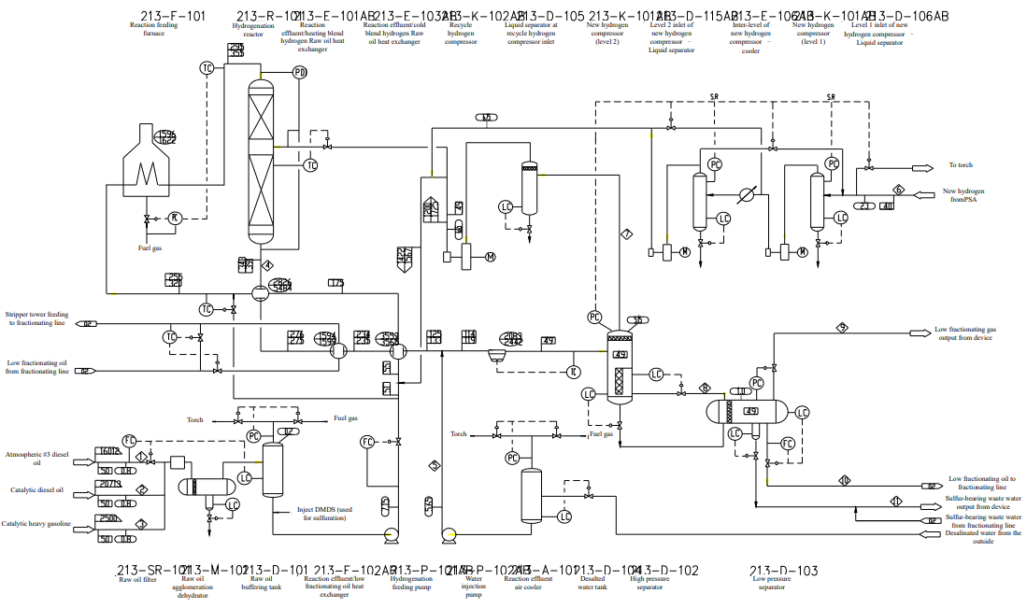

$Figure 1: simplified diagram of the hydrotreating process reaction section$ [14]

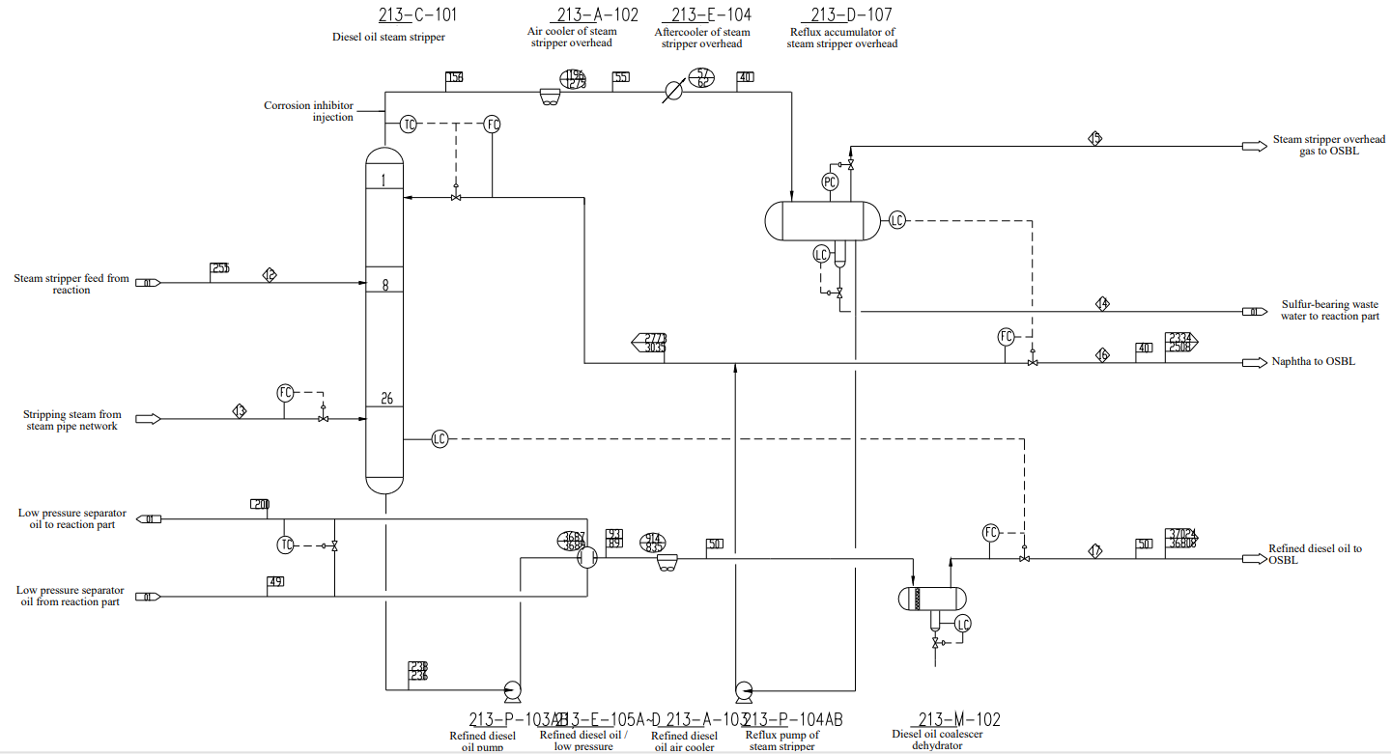

$$Figure 2: Simplified diagram of diesel hydrotreating process, product separation section[14]$$

Figures 1 and 2 show a simplified diagram of the diesel hydrotreating unit. The operating mode or description of the treatment process is summarized as follows.

The feedstock (Figure 1) is a mixture of diesel oil from the atmospheric distillation unit, diesel oil from the catalytic cracking unit and recycled oil. The three oils making up the charge are first sent to the filter (SR101), where particles with a diameter greater than 25 µm are removed; the filtered charge is then sent to the dehydrator-coalescer (M101), then to the buffer tank (D101). Once drawn from the bottom of the latter, the mixture of these oils begins the hydrogenation process, passing through the pump (P101 A/B) where the pressure is increased. Then, by flow control, these oils are mixed with hydrogen, and the combination (oils + hydrogen) forms the mixed feedstock for the hydrotreating unit. This mixed feedstock passes through the cold reaction product/feedstock + hydrogen heat exchanger (E103 AB), then into the furnace (F101), where it is heated to the required temperature.

The mixed mixture is then sent to the hydrogenation reactor (R101), where it undergoes desulfurization, denitrification, alkene saturation and aromatic hydrocarbon saturation reactions, in the presence of a catalyst.

The products from this hydrogenation reactor progressively pass through the products + hot hydrogen heat exchanger (E101AB), the reaction products/low-pressure fractionated oils heat exchanger (E102AB), the reaction products/feedstock +cold hydrogen heat exchanger (E103AB), to exchange heat with the feedstock + hot hydrogen mixture ; low-pressure fractionated oils, cold hydrogen mixture feedstock, and then passes to the reaction product air-cooling exchanger (A101), to be cooled to 49°C, and then passes to the high-pressure separator (D102). Salt water is injected upstream of the reaction product air-cooling exchanger (A101) and into the outlet lines of the reaction product heat exchanger/low-pressure fractionated oil heat exchanger (E102AB), to avoid the accumulation of ammonium salts and dissolve them in the products formed during the various reactions.

These cooled products are then separated into three phases (gas, oil and water) in the high-pressure separator (D102). As for the fractionated gases (circulating hydrogen), they begin the separation phase through the phase separation pot at the circulating hydrogen compressor inlet (D105), then pass into the circulating hydrogen compressor (K102AB) where the pressure is raised to 6,65 MPa and are split into two streams, one of which flows into the reactor as quench hydrogen, while the other is mixed with the newly pressurized hydrogen, which is then mixed with the charge oil as a mixed feedstock for the unit. The pressure of the liquids drawn off by the high-pressure separator (D102) is reduced, and they are then sent to the low-pressure separator (D103) where the three-phase separation (gas, oil and water) continues. The sulfur-containing water drawn off at the bottom of the high-pressure separator (D102) is sent to the low-pressure separator (D103) after pressure reduction, and is finally sent to the desulfurization unit for overall treatment. Fractionated gases also containing sulfur, by flash distillation from the low-pressure separator (D103), are sent to the desulfurization unit. As for the sulfur-containing water withdrawn from the bottom of the low-pressure separator (D103), its pressure is reduced, then mixed with the sulfur-containing water withdrawn from the reflux tank at the head of the diesel vapor withdrawal column (D108) and sent to the steam-acid water withdrawal unit for overall treatment.

As for the low-pressure fractionated oils, they pass through a heat exchanger train, the refined diesel/low-pressure fractionated oils heat exchanger (E105A-D), the product/low-pressure fractionated oils heat exchanger (E102AB) and are stored in the diesel steam extraction column (C101).

As for the newly-formed hydrogen, it passes through the separation pot (D106AB) where it is separated from the liquid, then sent to the new hydrogen compressor (K101AB) where its pressure is increased to 6.75 MPa by double compression and mixed with the circulating hydrogen.

As for the reaction product fractionation section (figure 2), the fractionation process is detailed as follows:

The oils are previously stored in a column (C101) with 26 valve plates and a storage temperature of 255°C. The withdrawal steam is injected at the bottom of the column, and the oil vapors withdrawn at the top of the column are sent to the air-cooled exchanger (A102) and the intercooler at the top of the steam withdrawal column (E104) to be cooled to 40°C. The cooled vapours are then passed to the reflux tank at the top of the column (D108) for separation of gas, oil and water. Exhaust gases from flash distillation are sent to the fluid catalytic cracking unit for overall treatment. The high-sulfur exhaust water mixed with that from the low-pressure separator (D103) is sent for treatment to the steam-acid water extraction unit. The oil stream is drawn off by the reflux pump at the top of the extraction column (P104AB) to increase its pressure. Part of it is returned as reflux to the head of the diesel steam extraction column, while the other part is used as feedstock for the catalytic reforming unit.

A corrosion inhibitor is injected at the top of the column to prevent hydrogen sulfide from corroding heat exchanger pipes and tubes.

After the pressure of the diesel bottoms has been increased by the refined diesel pump (P103AB), the oils first pass through the refined diesel/low-pressure fractionated oils (E105A-D) to exchange heat with the low-pressure fractionated oils from the reaction section, then pass through the refined diesel air-cooling exchanger (A103) to be cooled to 50°C. They are then dewatered by the diesel coalescer dehydrator (M102), and finally sent to the finished products storage area as refined/finished diesel.

The characteristics of the catalyst used are given in Table I below:

$Table I: Catalyst characteristics$

|  |  |  |  |  |
| --- | --- | --- | --- | --- |
| Characteristics | | | RG-1 | RS-1000 |
| Physics | Specific area, m2/g | | ≤180 | ≤150 |
| Resistance to soiling, N/mm | | ≤12 | ≤20 |
| Pore volume, ml/g | | ≤0.6 | ≤0.20 |
| Apparent density, kg/m3 | | 550 | 950 |
| Forme | | Clover | Papillon |
| Chemicals, %wt | | WO3 | … | ≤26.0 |
| NiO | ≤1.0 | ≤2.6 |
| MoO3 | ≤5.5 | ≤130 |

It is important to justify the choice of catalyst and operating parameters for the hydrodesulphurisation unit. The hydrotreating catalyst used at SORAZ is highly efficient, economically viable, has a life of at least 12 years and is adapted to the operating conditions and configuration of the unit. These are the main reasons for choosing this catalyst. Although one of the important parameters (sulphur content, for example) does not comply with international specification standards.

One of the main reasons for choosing a hydrotreating catalyst is that it is the most widely used catalyst in the oil industry (for hydrotreating diesel), not only because it contains group VIII and VIB metals such as nickel (Ni), tungsten (W) and molybdenum (Mo), but also because it has a high hydrogenating power. These latter reasons were put forward when choosing a catalyst for the hydrotreatment and hydroisomerisation of biomass feedstocks in which the effluent to be hydrotreated and the hydrogen stream contain a limited carbon monoxide content by Nicolas et al. (2015)[12]. Except that this type of highly hydrogenating catalyst has one major drawback, which is that it is rapidly deactivated by the metals present in the feed or the coke deposited on the catalytic surfaces when operating at high temperatures[15].

As for the unit's operating parameters, they were chosen on the basis of the values determined during the simulation prior to installation of the unit.

As for the unit's operating parameters, they were chosen on the basis of the values determined during the simulation prior to installation of the unit.

* 1. **Physico-chemical characterization**

All the physico-chemical characteristics of the feedstock and of the products (gaseous and liquid) from the hydrotreating unit were determined using the equipment available at the petroleum products analysis laboratory of the Société de Raffinage de Zinder (SORAZ).

The physico-chemical analyses essentially determined are :

* Density using a densimeter and ASTM D 4052-1289, IP-160, IP-365 ISO-3675;
* Moisture content according to SH/T0246, a Chinese standard;
* Distillation according to ASTM D 86;
* Sulfur content as per ASTM D 7039;
* Color according to ASTM D1500;
* Copper strip corrosion as per ASTM D 130;
* Ash content as per ASTM D482;
* Sediment content as per ASTM D 1796;
* Viscosity, CST at 37.8°c, as per ASTM D 445, ISO-3104, IP-71;
* Flash point by ASTM D 93, IP-34, EN-2719;
* Cetane number by ASTM D 976-4737.

All the characteristics determined for finished diesel are detailed in section 3.

As for the hydrogen used in this study, its composition was determined by the chromatographic method most commonly used in refineries worldwide. This is gas chromatography.

Like the catalyst, hydrogen was used to treat the feedstock. However, it is important to note the composition of this hydrogen, given that it is of fairly high purity (around 99.96). Table II below illustrates the chemical composition, as well as the mass percentage of each constituent of said hydrogen.

***Table II:*** *composition of hydrogen used*

|  |  |  |  |  |  |
| --- | --- | --- | --- | --- | --- |
| Components | H2 | Cl | N2 | N2+CO2 | Total |
| V (%) | 99.9 | 0.09 | 0.01 | ≤20 mµg/g | 100.0 |

This composition varies from one period to another, and also from one refinery to another, i.e. from one crude source to another.

However, it is important to note that the desulfurization rate, although not a physico-chemical characteristic for either the feed or the products, is a very important parameter in assessing the performance of the hydrotreating unit or the efficiency of the desulfurization operation. It is determined using the following equation (1):

$T \left(\%\right)=\frac{Tse-Tss}{Tse}×100$ (Eq 1)

Where Tse and Tss are the sulfur content of the feedstock at the inlet and outlet of the hydrotreating unit respectively.

1. **Results and discussion**

The results obtained from hydrotreating catalyzed diesel are presented and discussed in the following paragraphs.

* 1. **SORAZ finished diesel specifications**

SORAZ/national finished diesel specifications are shown in Table III below.

$Table III: Finished diesel specifications$

|  |  |  |  |
| --- | --- | --- | --- |
| Designations | | Specifications nationales | Test methods |
| Densitéy(15°C), kg/m3, min-max | | 820-880 | ASTM : D-4052, D-1289 IP-160, IP-365 ISO-3675 |
| Color, max | | 3.0 | ASTM D-1500 |
| Distillation | 50% (vol) recovery temperature, °c, max | 300 | ASTM D-86  ISO-3405, IP-123 |
| 90% (vol) recovery temperature, °c, max | 355 |
| 95% (vol) recovery temperature, °c, max | 365 |
| Viscosity, CST à 37.8°c, min-max | | 1.6-6 | ASTM D-445, ISO-3104, IP-71 |
| Copper blade corrosion, (50°C, 3h), max | | 1b | ASTM D-130 ISO-2160 |
| Sulfur content, % (mass), max | | 0.05 | ASTM D-5453, D-2622, D-4294 |
| Water content, % (vol) ; max | | 0.05 | ASTM D-95 ISO-3733 |
| Flash point, °c, min-max | | 60-120 | ASTM D-93 |
| Calculated cetane number, min | | 48 | ASTM D-976, D-4737 |
| Cetane number, min | | 49 | ASTM D-976, D-4737 |
| Ash content, %-mass, max | | 0.01 | ASTM D-482, ISO-6245 |
| Total acidity, mgKOH/g, max | | 1 | ASTM D-974, ISO-6618, IP-139 |
| Conradson carbon on residue 10%, %-mass, max | | 0.15 | ASTM D-189, D-4530, ISO-10370, |
| Point of disturbance, °C, max | | +7 | ASTM D-2500, ISO-3015 |
| Sediment contents, %-mass, max | | 0.01 | ASTM D-473, ISO-3735, IP-53 |
| Lubrification, Microns; max | | 460 | ISO-121561, CEC-F06-A-96 |
| Fatty acid methyl ester,FAME, % (vol), max | | 7 | ASTM D-7371 |

* 1. **Feed characterization**

Table IV shows the results of physico-chemical analysis of the feedstock and the end product (hydrotreated diesel) produced over 15 successive days.

$Table IV: Charge characteristics$

|  |  |  |  |  |
| --- | --- | --- | --- | --- |
| *Days (D)* | *Density at 15°C*  en kg/m3 | *Sulfur content*  *in ppm* | *water content* | *color* |
| *D1* | *856.20* | *1591* | *368* | *1.0* |
| *D2* | *854.20* | *1679* | *377* | *1.0* |
| *D3* | *853.20* | *1668* | *367* | *1.0* |
| *D4* | *853.5* | *1665* | *328* | *1.0* |
| *D5* | *851.7* | *1705* | *357* | *1.0* |
| *D6* | *852.0* | *1554* | *350* | *1.0* |
| *D7* | *849.5* | *1490* | *486* | *1.0* |
| *D8* | *848.3* | *1616* | *538* | *1.0* |
| *D9* | *849.0* | *1670* | *314* | *1.0* |
| *D10* | *848.7* | *1573* | *327* | *1.0* |
| *D11* | *848.9* | *1458* | *463* | *1.0* |
| *D12* | *849.5* | *1570* | *337* | *1.0* |
| *D13* | *848.3* | *1485* | *304* | *1.0* |
| *D14* | *847.5* | *1043* | *305* | *1.0* |
| *D15* | *849.5* | *1578* | *478* | *1.0* |

Figure 3 gives more details on the variations of these parameters as a function of day and the interaction between them.

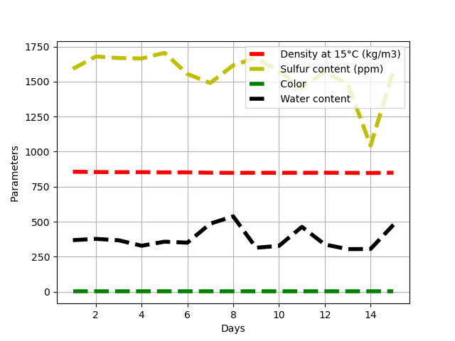 ***$Figure 3: Variation in charge physicochemical properties as a function of$***

$treatment day$

It can be seen that the sulfur content of the charge is high, exceeding 1500 ppm. This is due to the fact that, initially, the untreated charge contains many of the same impurities as the finished products. This high content may also be linked to the nature of the crude oil making up the feedstock, which is mainly distilled in the atmospheric distillation tower. This is due to the fact that impurities are concentrated in high-boiling products during the first fractionation operations. Similarly, this table illustrates the variation in sulfur content as a function of density at 15°C. The higher the density, the higher the sulfur content. Unlike water content, which varies almost constantly, the variation is linked to the quantity processed per day.

An analysis of the graph (Figure 3) shows that there is no interaction between density and color, density and copper strip corrosion, density and water content, sulfur content and flash point. However, it should be noted that all these characteristics, except density and sulfur content, can be easily modified (increased or decreased) according to various situations, for example, contamination during transport or storage prior to processing. Indeed, different variations are evident from day to day as far as the charge is concerned, since it may come from different crudes or at least from several storage tanks prior to the first crude fractionation operation.

* 1. **Refined/finished diesel characteristics**

Table V below contains other characteristics that were not determined for the feedstock, as they are important for a clear view of the quality of the finished product.

For finished diesel oil (Table V, Figure 4), we note that the density at 15° varies slightly from that of the feedstock. Product density values are slightly higher than those of the charge. This is because the product has a lower boiling point than the feedstock.

|  |  |  |  |  |  |  |
| --- | --- | --- | --- | --- | --- | --- |
| *Days (D)* | *Density at 15°C*  en kg/m3 | *Sulfur conten in*  *ppm* | *Color* | *Copper blade corrosion* | *Flash point (°C)* | *Cloudy point (°C)* |
| *D1* | *860.90* | *269* | *0.50* | *1a* | *90.0* | *18* |
| *D2* | *858.40* | *265* | *0.50* | *1a* | *89.0* | *17* |
| *D3* | *858.10* | *235* | *0.50* | *1a* | *86.5* | *18* |
| *D4* | *858.20* | *172* | *0.50* | *1a* | *85.5* | *15* |
| *D5* | *858.40* | *178* | *0.50* | *1a* | *86.5* | *16* |
| *D6* | *857.30* | *176* | *0.50* | *1a* | *86.5* | *16* |
| *D7* | *857.70* | *113* | *0.50* | *1a* | *86.0* | *16* |
| *D8* | *856.90* | *136* | *0.50* | *1a* | *86.0* | *16* |
| *D9* | *856.00* | *130* | *0.50* | *1a* | *85.0* | *16* |
| *D10* | *856.40* | *133* | *0.50* | *1a* | *85.0* | *16* |
| *D11* | *856.70* | *140* | *0.50* | *1a* | *85.0* | *16* |
| *D12* | *856.20* | *115* | *0.50* | *1a* | *82.0* | *16* |
| *D13* | *856.80* | *111* | *0.50* | *1a* | *82.0* | *15* |
| *D14* | *856.90* | *142* | *0.50* | *1a* | *84.5* | *15* |
| *D15* | *855.90* | *148* | *0.50* | *1a* | *85.0* | *15* |

$Table V: physico-chemical characteristics of the product$

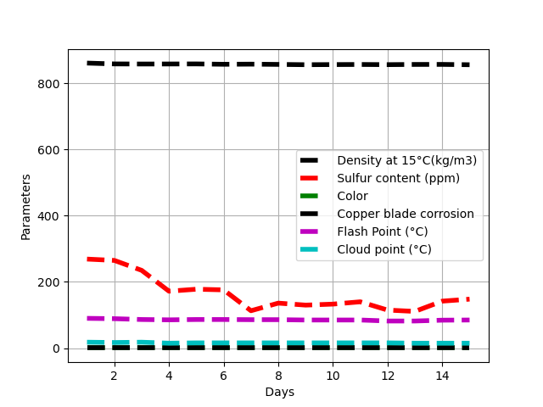

$$Figure 4: Variation in physicochemical properties of finished diesel as a function$$

$of processing day$

In contrast to the slight increase in product density, the sulfur content of the product dropped considerably. This may be due to the various hydrotreating reactions taking place in the reactor in the presence of the catalyst used, particularly the hydrodesulfurization reactions during which sulfur is removed from the feedstock in the form of dihydrogen sulfide according to the following generalized reaction[8], [10], [14]:



These may include dissulfide and thioether desulfurization reactions according to the following reactions:



This reduction in the sulfur content of finished diesel may also be due to the following desulfurization reactions (hydrogenation of thiophene and tetrahydrothiophene):





As for the color of the product (with a constant value of 0.5), it is obvious, and indeed to be expected, that it is better than that of the charge (with a constant value of 1). This change in color is due to all the purification reactions, such as denitrification, deoxygenation and demetallization of the charge, during which most of the impurities giving the charge its dark color have been eliminated. This enables the treated product to have an acceptable color according to specification standards. Similarly, flash and cloud points are in line with national or even WECAO requirements, and are also linked to product purity.

To assess the overall efficiency of the hydrodesulfurization unit, it is important to determine the rate of desulfurization of the feedstock.

Calculation of desulfurization rate :

As mentioned in section 2.2, the desulfurization rate is defined by the following equation 1.

Using this equation, the various desulfurization rates are determined and illustrated in Table VI below:

|  |  |  |  |  |  |  |  |  |  |  |  |  |  |  |  |
| --- | --- | --- | --- | --- | --- | --- | --- | --- | --- | --- | --- | --- | --- | --- | --- |
| Days | D1 | D2 | D3 | D4 | D5 | D6 | D7 | D8 | D9 | D10 | D11 | D12 | D13 | D14 | D15 |
| T (%) | 83,09 | 84,22 | 85,91 | 89,66 | 89,56 | 88,67 | 92,42 | 91,58 | 92,22 | 91,54 | 90,40 | 92,67 | 92,50 | 86,38 | 90,62 |

$Table VI: Desulfurization rates$

The average desulfurization rate (Tm) is determined by equation 2 below:

$Tm \left(\%\right)=\frac{\sum{T(\%)}}{15}$ (Eq.2)

On a $Tm \left(\%\right)=89,43$

The desulfurization rate can also be determined by adding up all the sulfur content values of the feedstock and those of the product, applying the following equation 3:

$Tm \left(\%\right)=\frac{Tmsc-Tmsp}{Tmse}×100$ (Eq.3)

With :

Tmsc the average sulfur content of the charge for 15 days. It is determined by the following formula:

$T_{scm}=\frac{\sum{T_{se}}}{15}$ (Eq.4)

Applying this formula to the load, we find : $T_{msc}=\frac{23345}{15}=1556,33$ ppm

And the average sulfur content of the product is determined using equation 5:

$T_{msp}=\frac{\sum{T_{msp}}}{15}$ (Eq.5)

So, $T_{msp}=\frac{2463}{15}=164,20$ ppm

And we find : $Tm \left(\%\right)=\frac{1556,33-164,2}{1556,33}×100=89,45$

The values for the desulfurization rate determined using the average of the desulfurization rates, and for the sulfur content of the feed and product, are 89.43% and 89.45% respectively. These values are roughly equal. As a result, the unit's desulfurization rate is approximately 89.45%. This value appears to be acceptable, based on the different values found per day. From the values found (Table VI), we can conclude that the rate of desulphurization varies from day to day, and depends not only on the content of sulphur and other impurities in the feedstock, but also on the quality of the treatment, i.e. the operating conditions of the unit, and the type of catalyst used. But, the value 89,45% of the unit's desulfurization rate is not equal or the same to the value that was predicte by the unit. Beacause of the most difference between the values of sulfur content after desulfurization of unit for experimentation and the values of specification, 164,2 and 140ppm respectively. Moreover, this sulphur removal rate is significantly lower than that obtained by Frédéric and his colleagues (2015)[16] which was 99.95% with sulphur contents at the reactor inlet and outlet of 9013 and 80ppm respectively. This considerable difference could be justified by the severity of the treatment and, above all, the hydrogen/charge ratio. This needs to be reviewed in the case of SORAZ.

Generally speaking, the results of the characterization of the finished diesel, i.e. after hydrotreatment, are illustrated in Tables VII and VIII below. The parameters illustrated in these tables are used exclusively to draw conclusions about the quality of the diesel supplied by SORAZ, and also about the efficiency of the hydrotreating process or unit. It is important to note that these results represent the average of five successive days' analysis results.

$Table VII: Physicochemical parameters of finished diesel fuel$

|  |  |  |  |  |  |  |  |  |
| --- | --- | --- | --- | --- | --- | --- | --- | --- |
| Parameters | Density at 15°C  (Kg/m3)  820≤D15≤880 | Density at 20°C  (Kg/m3) | Color | Distillation | | | Kinematic Viscosity (37,8°C) in mm2 | Copper blade corrosion (50°C, 3h) (1a, 1b) |
| R50%, ≤300 °C | R90%, ≤355 °C | R95%, ≤365 °C |
| Standards | ASTM D4052 | ASTM D4052 | ASTM D1500 | ASTM D86 | ASTM D86 | ASTM D86 | ASTM D445 | ASTM D130 |
| Values | 838,81 | 835,26 | 1,0 | 282,95 | 351,85 | 364,70 | 3,4255 | 1b |

|  |  |  |  |  |  |  |  |  |  |  |
| --- | --- | --- | --- | --- | --- | --- | --- | --- | --- | --- |
| Parameters | Sulfur content ≤0,05 | Water content ≤0,05 | Point flash (PF)  60≤PF≤120  (°C) | Calculated cetane number ≥40 | Ash content ≤0,01 | Total number of acids (mgKOH/g) ≤1.0 | 10% distillation residual carbon ≤0,15 | Cold point ≤7 in °C | Sediment content ≤0,01 | Lubricity  ≤460µm |
| Standards | ASTM D5453 | ASTM D95 | ASTM D93 | ASTM D976 | ASTM D482 | ASTM D474 | ASTM D4530 | ASTM D2500 | ASTM D473 | ASTM D6079 |
| Values | 0,0385 | 0,03 | 76,8 | 54,25 | 0,002 | 0,04 | 0,02 | 5,8 | 0 | 391 |

In addition to the above parameters, there is the parameter (mechanical impurities) which is not shown in the table, but whose values were practically zero in all five analyses.

However, all the values of the various parameters found meet the specification standards for finished diesel consumed in Niger, as well as in neighboring countries such as Nigeria, Mali, Côte D'Ivoire, Chad and Burkina Fasso. However, it is important to mention the non-conformity of certain parameters, such as sulphur content, with international specifications.

1. **Conclusion**

Diesel oil, one of the most widely consumed petroleum products in Niger, must therefore meet a certain number of national and ECOWAS consumption standards or specifications, for a number of objectives such as preserving the environment, satisfying consumers' needs, contributing to the country's economy, and so on. Generally speaking, the diesel produced by the Zinder refining company (SORAZ) complies with national and ECOWAS marketing standards (standards in force before 2025 where the sulfur content of diesel, for example, must be ≤50ppm). However, the quality of this diesel still needs to be improved, whether in line with ECOWAS specifications (sulfur content ≤50ppm by January 1, 2025 at the latest) or those of the international community.

However, it is important to mention the limitations of this study, which extends to the study of desulfurisation reactions, the rate of desulfurisation and many other parameters. Thus, it would be important to carry out several laboratory tests by varying the operating conditions and the cat/charge ratio in order to optimise the desulfurisation rate of the said unit.

It would also be important in the future to think about optimising this unit, studying the distribution of the charge and that of the catalyst along the hydrotreatment reactor, studying the reaction mechanism more closely in order to gain a better understanding of it, and finally thinking about doing some kinetic modelling of the hydrodesulfurisation reactor.

Disclaimer (Artificial intelligence)

Option 1:

Author(s) hereby declare that NO generative AI technologies such as Large Language Models (ChatGPT, COPILOT, etc.) and text-to-image generators have been used during the writing or editing of this manuscript.

**I've never used AI anywhere.**

**Références**

[1] Christian, S., Fabrice, L., & Christian, B.(1999). Process and unit for the hydrotreatment of a petroleum feedstock comprising the cracking of ammonia and the recycling of hydrogen into the unit. European patent application, EP 0 899 320 A1.

http://patentimages.storage.googleapis.com/pdfs/1f15ec0c7cd63ad549e6/EP0899320A1.pdf

[2] Conventional hydrotreatment process and associated reactions (consulted online on 24/09/2024). https://mcours.net/cours/pdf/yass3/yass3cli372.pdf

[3] Jean Paul, S., & Chantal, L.(2002). Process for desulphurising a hydrocarbon mixture. Patent application, FR2821350A1. https://patents.google.com/patent/FR2821350A1/fr

[4] Advantage of desulfurized fuels (consulted online on 24/09/2024).

https://www.newsd.admin.ch/newsd/message/attachments/1091.pdf

[5] Lucie Palais.(2017).Thesis " Double promoted Mo/Al2O3 hydrotreating catalysts

prepared from Anderson heteropolyanions: Sulphidation monitoring by Quick-EXAFS".

https://pepite-depot.univ-lille.fr/LIBRE/EDSMRE/2017/50376-2017-Plais.pdf

[6] Vincent, M., César,V., Gildas, M., Laurent, M., & Michel, H.(2008). Method for the hydro-processing of a gas oil feedstock, hydro-processing unit for implementing said method, and corresponding hydro-refining unit. International application published under the Patent Cooperation Treaty (PCT). N° WO 2008/ 087279 A2.

https://patentimages.storage.googleapis.com/0c/61/66/5d0e8c635fc114/WO2008087279A2.pdf

[7] Diesel hydrotreatment (consulted online on 25/09/2024).

http://www.mcours.net/cours/pdf/hascl1/hasssbcla750.pdf

[8] Guermat, S.(2005). Master's thesis "Dimensionnement d'une unité d'hydrodésulfuration du gasoil de la raffinerie de Skikda".

https://repository.enp.edu.dz/jspui/bitstream/123456789/5479/1/GUERMAT.Sofiane.pdf

[9] Kahina, B.(2008). Magister "Modelling the diesel hydrotreatment process using artificial neural networks". https://core.ac.uk/download/55514080.pdf

[10] ". Boursier, L. M.(2014). Thesis "Characterization and reactivity in hydrotreatment of heteroatomic compounds present in petroleum vacuum distillates.

https://theses.hal.science/tel-00987560/file/these_archivage_NA_3071192.pdf

[11] Jacques, D., Jean-Paul, G., & Laurent, M.(1986). Process for hydrotreating hydrocarbon feedstocks and catalyst for carrying out this process. European patent application. N° EP0175605A1. https://patents.google.com/patent/EP0175605A1/fr

[12] Nicolas, A., Nathalie, D., Thierry, C.(2015). Process for hydrotreatment and hydroisomerization of feedstocks resulting from biomass in which the effluent to be hydrotreated and the hydrogen stream contain a limited carbon monoxide content. European patent leaflet. N° EP2880126B1.

https://patentimages.storage.googleapis.com/b6/d3/6e/f78daadca9faf9/EP2880126B1.pdf

[13] Gas oil hydrotreatment (consulted online on 24/09/2024).

[14] SORAZ.(2010). " Manual for diesel hydrotreating operations ". Access only to those present at the Zinder refinery (SORAZ).

[15] Pierre,R.(1991). Process for hydrotreating a petroleum residue or heavy oil in order to refine it and convert it into lighter fractions. European patent leaflet. N° 0 450 997 B1.

[16] Fréderic, B., Luis, P., Matthieu, D., & Anne Claire, L.(2015). Method for hydrotreating diesel fuel in reactors in series, comprising hydrogen recirculation. Brevets (PCT). N°WO 2015078674 A1. <https://patents.google.com/patent/WO2015078675A1/en>

17. Song, C. (2003). An overview of new approaches to deep desulfurization for ultra-clean gasoline, diesel fuel and jet fuel. *Catalysis today*, *86*(1-4), 211-263.

18. Zhao, R., Yin, C., Zhao, H., & Liu, C. (2003). Synthesis, characterization, and application of hydotalcites in hydrodesulfurization of FCC gasoline. *Fuel Processing Technology*, *81*(3), 201-209.

19. Brunet, S., Mey, D., Pérot, G., Bouchy, C., & Diehl, F. (2005). On the hydrodesulfurization of FCC gasoline: a review. *Applied Catalysis A: General*, *278*(2), 143-172.

20. Chandak, N., George, A., Hamadi, A., Dakhan, M., Chaudhry, A., Singaravel, G., & Morin, S. (2019). Impact of processing different blends of heavy gas oil and light cycle oil in a mild hydrocracker unit. *Catalysis Today*, *329*, 116-124.