Phytochemistry of Yam Bean (*Pachyrhizus Erosus)* and its Potential on Folliculogenesis in Female Rats Ovaries

.

ABSTRACT

|  |
| --- |
| **Aims:** Menopause is a natural phase that occurs due to the decline of the oestrogen hormone, and is characterised by physical and psychological decline. Hormone replacement therapy (HRT) is a widely utilised treatment for the management of menopausal symptoms. The utilisation of natural ingredients, particularly yam beans, in the management of menopause symptoms is minimal. The objective of the present study was to examine the effect of yam bean on ovarian follicles in preclinical studies of female rats  **Study design:** The research design employed a laboratory experimental design. The test material employed was yam bean, which was utilised to produce a 96% ethanol extract for the purpose of GC-MS method analysis. The experimental animals utilised were premenopausal female Sprague Dawley rats.  **Place and Duration of Study:** The research was conducted at two locations: the Pharmaceutical Chemistry Laboratory for GCMS analysis and the Animal Physiology Laboratory of PGRI Madiun University. The research was conducted over the period from February to August 2020.  **Methodology:** The present study employs an experimental approach as a research method. An experiment was conducted in which phytoestrogen compounds present in a 96% ethanol extract of yam bean powder were analysed using a gas chromatography-mass spectrometry (GC-MS) method. Female Sprague-Dawley rats aged between 12 and 13 months, with a body weight range of 170-200 grams. The experiment involved 24 rats, which were grouped into three distinct treatment groups. The control group (P0) received a placebo, while the treatment groups (P1 and P2) received 2 g/kg and 2.8 g/kg of yam bean powder, respectively. The subject was administered powder for a period of 36 days. On the 37th day, dislocation surgery was performed, and the ovary was removed. The ovary was then subjected to HE staining. The analysis of data was conducted on the basis of the results of gas chromatography-mass spectrometry (GCMS) chromatograms of isoflavone compounds and alterations in ovarian tissue structure, which were carried out using an optileb microscope.  **Results:** The results of the gas chromatography-mass spectrometry (GCMS) analysis of yam bean powder revealed the presence of isoflavone compounds, specifically daidzein, genistein, and quercetin. The administration of 2.8 g/kg of yam bean powder (P2) resulted in the observation of folliculogenesis in the ovaries. The presence of tertiary follicles was identified, and granulosa cells that exhibited responsiveness to follicular fluid production were observed, filling the follicle antrum.  **Conclusion:** The conclusion drawn from the present study is that yam bean powder contains phytochemicals daidzein, genistein and quercetine, which have been demonstrated to be capable of increasing ovarian folliculogenesis in female rats. |

*Keywords:* folliculogenesis, ovary, phytoestrogen yam bean, Menopause

1. INTRODUCTION

Menopause is a natural phase in a woman's life which is characterised by the permanent cessation of the menstrual cycle due to decreased ovarian function and oestrogen hormone production (Bagga et al., 2025; Santoro et al., 2021; Timmana et al., 2021). This condition arises due to diminished oogenesis, resulting in a decline of female reproductive hormones (Burger et al., 2008; Das et al., 2023; Ma et al., 2023)**.** In Indonesia, this phase typically manifests in women aged 45-55 years (Anggraini et al., 2024)**.** The onset of menopause frequently precipitates a plethora of physical and psychological symptoms, including hot flushes (sudden hot sensations), sleep disturbances, mood swings, and decreased bone mass (osteopenia/osteoporosis). These symptoms are associated with an elevated risk of cardiovascular disease (Banin et al., 2017; Duralde et al., 2023; Sharma, S., Krishnan, A., Mukherjee, A., & Kumar, 2025). This menopausal condition has been demonstrated to exert an impact on reproductive health and quality of life (Cea García et al., 2022; Sun et al., 2018).

Concurrent with the advancement of science and technology, a range of methodologies have emerged to address the adverse effects of menopause, including hormone therapy (Hormone Replacement Therapy)(De Franciscis et al., 2019; Genazzani et al., 2021; Vrachnis et al., 2021)**.** The utilisation of synthetic hormones can be readily obtained at a minimal cost. A substantial corpus of research has been published on the subject of the long-term side effects of synthetic hormones, including an increased risk of breast cancer and cardiovascular disease (Hill et al., 2016; Okwuosa et al., 2021; Shufelt & Manson, 2021; Ugras & Layeequr Rahman, 2021).

The present study investigates the increasing use of hormone therapy and the side effects it causes. It also examines the current development of natural ingredients as hormones by the pharmaceutical industry. The utilisation of natural ingredients as hormone therapy constitutes a safer, more effective and efficient alternative (Al-Baldawy et al., 2023; Johnson et al., 2019; Pan et al., 2022)**.** One of the natural ingredients that has been posited as an alternative to hormone therapy is yam bean (*Pachyrhizus erosus*) (Ardela et al., 2025; Primiani, 2015).

Yam bean (*Pachyrhizus erosus*) is a local plant in Indonesia with the local name bengkuang (Mahmood et al., 2015; NURSHILLAH et al., 2022). This plant is indigenous to tropical regions and is extensively cultivated in Central Java, East Java, and West Sumatra. Bengkuang is a versatile ingredient in the beauty industry, where it is employed in various forms, including body lotion, masks, and powders. In addition to its use in beauty products, it is also consumed as a fresh food, commonly found in dishes such as rujak and pickles.

Yam bean (*Pachyrhizus erosus*) is a plant that belongs to the Leguminoceae family. Research results have indicated that this family is frequently referred to as a phytoestrogen, due to the presence of phytochemical components that exhibit a structural similarity to the hormone estrogen (Chavda et al., 2024; Dias et al., 2021; Whitten, P. L., Kudo, S., & Okubo, 2020), certain groups of phytoestrogen compounds include isoflavones, lignans, coumestans and stilbenoids and protein (Inyang et al., 2018). The chemical structure of this group of phytoestrogen compounds has been shown to resemble the estrogen hormone (17β-estradiol) (Kiyama, 2023), and therefore, these phytoestrogen compounds have been found to exhibit physiological properties similar to the estrogen hormone (Fuentes, N., & Silveyra, 2019; Kiyama, 2023; Whitten, P. L., Kudo, S., & Okubo, 2020)**.**

Genistein and daidzein are isoflavone compounds that have been identified in the Leguminoceae family (Chavda et al., 2024)**.** Research findings demonstrate the affinity of isoflavones for estrogen receptors within the body **(**(Fuentes, N., & Silveyra, 2019; Křížová et al., 2019)**.** This receptor affinity has been demonstrated to engender oestrogenic effects, thereby aiding in the alleviation of menopausal symptoms and the maintenance of physiological function (Fuentes, N., & Silveyra, 2019)**.** As demonstrated by several studies, the consumption of phytoestrogens has been shown to selectively stimulate endogenous hormone activity, with the potential to extend the fertile period or delay the onset of menopause when administered appropriately before or during the premenopausal phase (Canivenc-Lavier & Bennetau-Pelissero, 2023; Kiyama, 2023; Whitten, P. L., Kudo, S., & Okubo, 2020)**.**

Research results have been published that demonstrate the extensive utilisation of yam beans in the cosmetics industry. The development and consumption of hand body products, lotions and facial masks has been extensively embraced by the public (Krisnawati et al., 2018; Kusnandar, M. R., Wibowo, I., & Barlian, 2025; Lee et al., 2017). These cosmetic products are formulated for topical application on external body parts. The development of natural cosmetic products derived from the yam bean has been limited. The potential of yam bean as an oral natural oestrogenic agent for the detection of oestrogenic effects on the ovaries has not been extensively explored. The present study is predicated on the hypothesis that yam bean, a natural hormone therapy, exerts an effect on the development of follicles in the ovaries, thereby counteracting the adverse effects of menopause. The objective of the present study was to examine the effect of yam bean on ovarian follicles in preclinical studies of female rats.

2. material and methods

Yam bean species were obtained from yam bean plantations in Kediri, East Java, Indonesia. The identification of the specimen was conducted using the reference number 00119/Taxo-Plant/Biology/III/2020.

**2.1. Yam bean powder production**

The quantity of yam beans required is 1000 grams. The skin should be left intact, and the beans should be washed, sliced into a fine gauge, and dried in an incubator at a temperature of 50-60°C for a period of 3-4 days. Following this, the beans should be ground using a blender, and then a 60-mesh sieve should be used to separate the fragments.

**2.2. Yam bean extract preparation**

A quantity of 1000 grams of yam bean powder was dissolved in 96% ethanol. The solution was then homogenised using a vortex for a period of 10-15 minutes. Following this, the solution was left in a container for 30 minutes. Thereafter, the solution was filtered using filter paper, and the filtrate was collected. This process was repeated on three occasions. The filtrate is then concentrated using a rotary vacuum evaporator at a temperature of 50°C at a speed of 60 rpm. Subsequently, the extract should be subjected to a heating process in an oven at a temperature of 50°C for a period of 10 days with a view to achieving a thickening of the extract. The yield of this extract can be continued for Gas Chromatography Mass Spectrometry (GCMS) testing.

**2.3. GCMS analysis of yam bean**

Conditions for GCMS testing of yam bean extract with stages: The procedure is initiated with the preparation of the sample, followed by derivatisation. The next step involves the injection of the sample into the system, which is then separated using gas chromatography (GC). The mass spectrometer (MS) detector is then utilised for detection. The column oven temperature is set at 70.0°C, the injection mode is set to split, the flow control mode is pressure-based, and the total flow rate is determined. 80.5 millilitres per minute; column flow: The flow rate was 0.6 mL/min, the split ratio was 127.5, the ion source temperature was 2500°C, the interface temperature was 3000°C, the solvent cut time was 2 min, the detector gain mode was relative, the detector gain was 0.00 kW, the SCO mode was scan, the start m/z was 40.00, the end m/z was 600, and the sample unit was GC.

**2.4. Grouping of experimental animals**

Female rats were divided into three distinct treatment groups. The first group was designated as the control (P0), the second group (P1) was treated with 2 g/kg yam bean powder, and the third group (P2) was treated with 2.8 g/kg yam bean powder.

**2.5. Experimental animal treatment**

Female white Sprague-Dawley rats, aged between 12 and 13 months and thus premenopausal, were obtained from the Animal Breeding Unit in Blitar, East Java. The rats were initially weighed and found to range from 170 to 200 grams. The animals were then housed in group cages in the Animal Physiology Laboratory at Universitas PGRI Madiun. The rat cage is placed in a room with a temperature of approximately 27-29°C, a humidity level of 55-60%, 12 hours of manual lighting, and standard feed given every morning at 07:00 and afternoon at 16:00. Water for drinking is given ad libitum.The cage was cleaned and the husks replaced on a daily basis. The induction of the Yam bean powder was achieved through the utilisation of a sonde (gavage tube) in a morning feeding routine, administered over a period of 36 days. On the 37th day of the experiment, the surgical procedure and removal of the ovary were conducted.

**2.6. Preparation of histological preparations for HE staining**

The stages of preparation and HE staining are conducted in accordance with standard procedures (Feldman & Wolfe, 2014; Sampedro-Carrillo, 2022).

**2.7. Data analysis**

The data obtained were in the form of a mass spectrum of yam bean isoflavone phytochemistry from GC-MS tests and data on changes in ovarian tissue structure, including the development of primary follicles, secondary follicles, and Graff follicles. The subsequent histopathological data analysis was conducted on the basis of the observations made using the optilab microscope.

3. results and discussion

The analysis of yam bean powder by gas chromatography-mass spectrometry (GC-MS) has revealed the presence of isoflavone compounds daidzein, genistein and quercetin (Table 1).

**Table 1. Results of GCMS analysis of yam bean powder**

|  |  |  |  |  |
| --- | --- | --- | --- | --- |
| Name | Formula | RT (min) | MW (g/mol) | Molecule structure |
| Daidzein | C15H10O4 | 81,227 | 254,23 |  |
| Genistein | C15H10O5 | 85,289 | 270,24 |  |
| Quercetin | C15H10O7 | 100,228 | 302,24 |  |

Visualization of mass spectrum of daidzein, genistein and quercetine in Figure 1

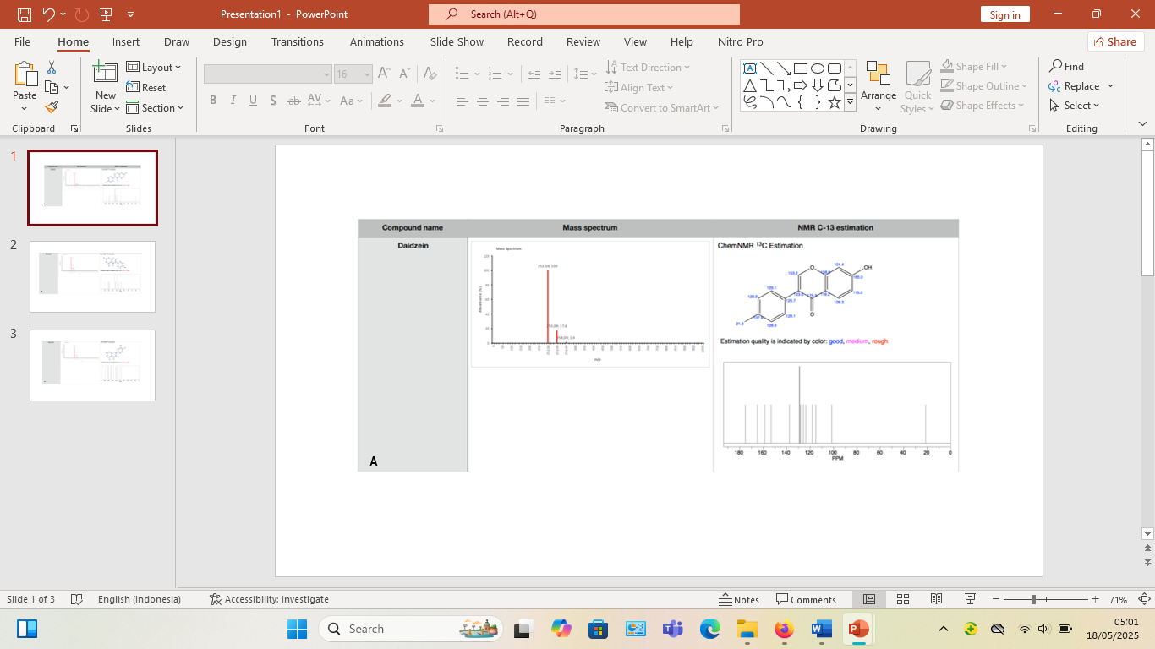

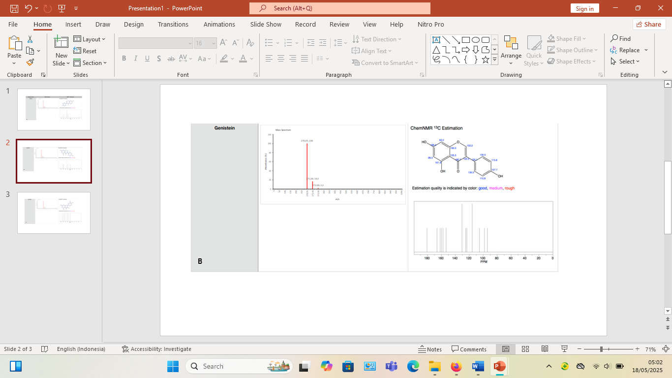

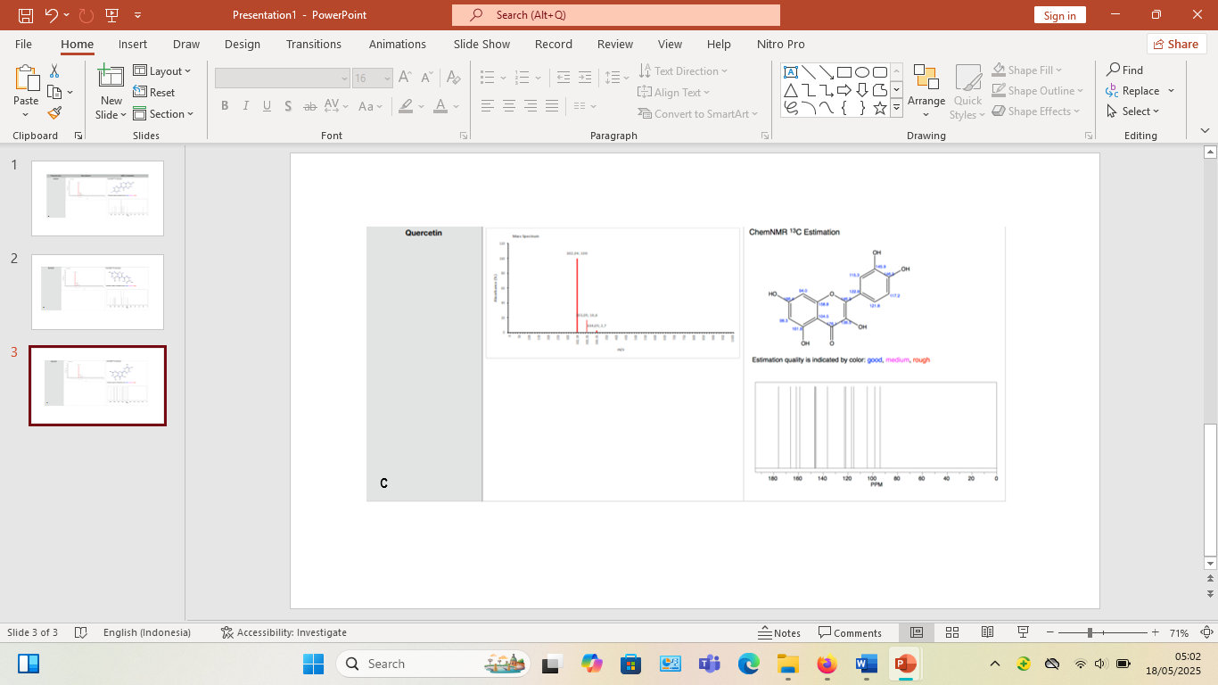

**Figure 1. Mass spectrum and molecular structure of (A) daidzein, (B) genistein and (C) quercetine**

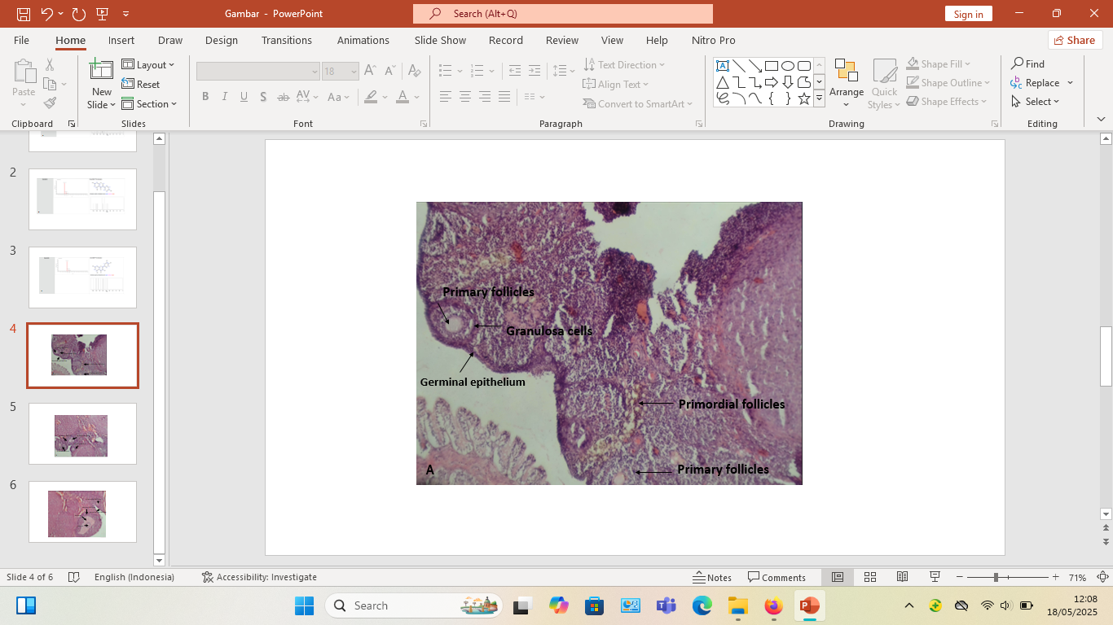 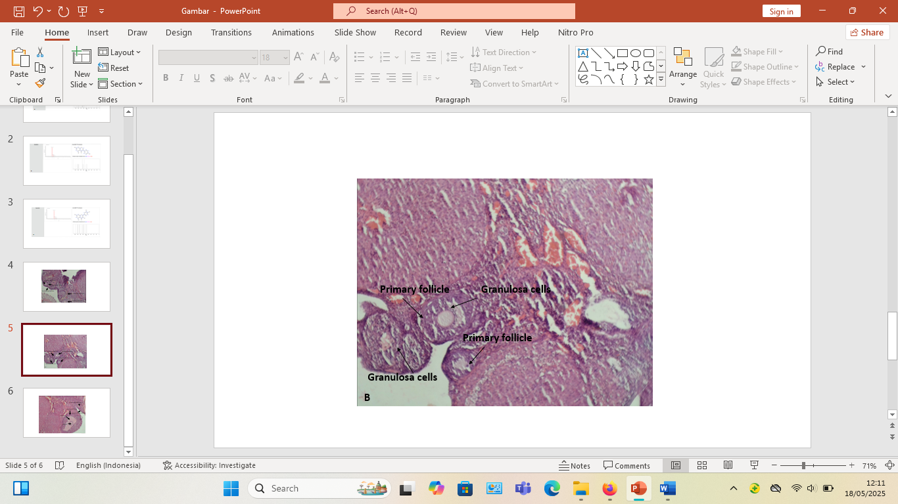 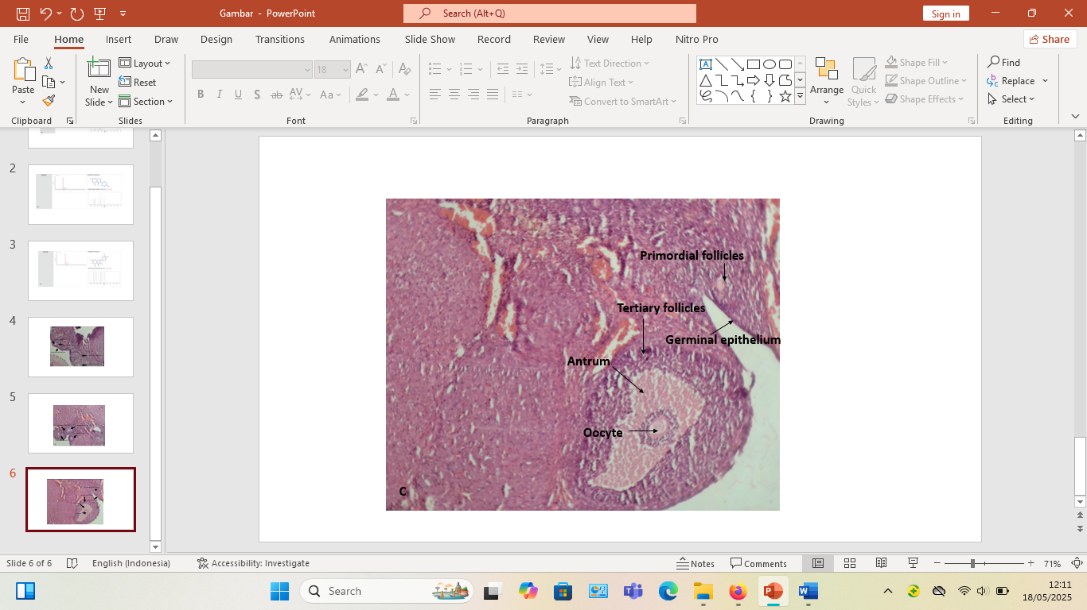

**Figure 2. Development of ovarian follicles in mice treated with P0, P1, and P2, the use of HE staining at 100X magnification**

1. **The ovaries exhibit the presence of primordial and primary follicles, in addition to flat granulosa cells classified (P0)**
2. **The development of primary follicles and cuboidal granuloma cells is indicated here (P1)**
3. **The presence of tertiary follicles is indicated. Granulosa cells are responsible for the production of follicular fluid, which fills the antrum, and oocytes are present (P2)**

The results of the gas chromatography-mass spectrometry (GCMS) analysis of yam bean powder demonstrated the presence of daidzein, genistein and quercetine compounds. These three compounds are classified as isoflavone groups. Isoflavones exhibit a molecular structure that is analogous to that of 17β-estradiol (Chavda et al., 2024). This phenomenon is frequently designated as 'estrogen-like molecules (Kiyama, 2023)**.** Yam bean powder phytoestrogens (Table 1) have been demonstrated to bind to estrogen receptors (ER-α and ER-β), thereby mimicking or modulating the activity of the body's natural estrogen hormones. Consequently, these three compounds have been shown to provide estrogen hormone-like activity (Fuentes, N., & Silveyra, 2019; Kang & Park, 2019). This phenomenon is exemplified by the observation of ovarian follicle development, the presence of tertiary follicles, and the maturation of granulosa cells that secrete follicular fluid at P2 (Figure 2).

Yam bean phytoestrogens possess a molecular structure analogous to that of estrogen, thereby inducing biological stimulation within the reproductive system, specifically through the activation of primordial follicles into primary follicles via estrogen-like mechanisms (Ardela et al., 2025; Chavda et al., 2024; Lin et al., 2021; Primiani, 2015)**.** Yam bean phytoestrogens have been hypothesised to enhance the expression of Follicle Stimulating Hormone (FSH) receptors in granulosa cells, thus accelerating the growth of early follicles and increasing the number of growing follicles (Ardela et al., 2025; Ogunlakin et al., 2023).

4. Conclusion

Yam bean powder has been found to contain phytochemicals, including daidzein, genistein and quercetine, which are classified as phytoestrogen compounds due to their molecular structure, which is similar to 17β-estradiol. The administration of yam bean powder over a period of 36 days has been observed to result in an augmentation of folliculogenesis within the ovaries of Sprague Dawley rats.

**DISCLAIMER (ARTIFICIAL INTELLIGENCE)**

Author(s) hereby declare that NO generative AI technologies such as Large Language Models (ChatGPT, COPILOT, etc) and text-to-image generators have been used during writing or editing of manuscripts.

References

Al-Baldawy, M. S. M., Matloob, A. A. A. H., & Almammory, M. K. N. (2023). The Importance of Nitrogen-Fixing Bacteria Azotobacter chroococcum in Biological Control to Root Rot Pathogens (Review). *IOP Conference Series: Earth and Environmental Science*, *1259*(1). https://doi.org/10.1088/1755-1315/1259/1/012110

Anggraini, N., Sari, R., Hartiningsih, S., Maria, N., Dewi, Y., Octavia, V., Anggraeni, A., & Riyanti, R. (2024). *Factors Affecting Menopause Quality of Life in the 45-55 Years Age Group in Indonesia*. *10*(12), 9926–9937. https://doi.org/10.29303/jppipa.v10i12.8782

Ardela, M. P., Fitriasnani, M. E., & Kulistiyani, P. E. (2025). *Bengkuang as an Alternative for Hypoestrogen Problems in the Reproductive System*. *8*(2), 282–291.

Bagga, S. S., Tayade, S., Lohiya, N., Tyagi, A., & Chauhan, D. (2025). Menopause dynamics: From symptoms to quality of life, unraveling the complexities of the hormonal shift. *Multidisciplinary Reviews*, *8*(2). https://doi.org/10.31893/MULTIREV.2025057

Banin, R. M., de Andrade, I. S., Cerutti, S. M., Oyama, L. M., Telles, M. M., & Ribeiro, E. B. (2017). Ginkgo biloba Extract (GbE) stimulates the hypothalamic serotonergic system and attenuates obesity in ovariectomized rats. *Frontiers in Pharmacology*, *8*(SEP), 10–11. https://doi.org/10.3389/fphar.2017.00605

Burger, H. G., Hale, G. E., Dennerstein, L., & Robertson, D. M. (2008). Cycle and hormone changes during perimenopause: the key role of ovarian function. *Menopause*, *15*(4), 603–612.

Canivenc-Lavier, M. C., & Bennetau-Pelissero, C. (2023). Phytoestrogens and Health Effects. *Nutrients*, *15*(2), 1–44. https://doi.org/10.3390/nu15020317

Cea García, J., Márquez Maraver, F., & Rubio Rodríguez, M. C. (2022). Cross-sectional study on the impact of age, menopause and quality of life on female sexual function. *Journal of Obstetrics and Gynaecology*, *42*(5), 1225–1232.

Chavda, V. P., Chaudhari, A. Z., Balar, P. C., Gholap, A., & Vora, L. K. (2024). Phytoestrogens: Chemistry, potential health benefits, and their medicinal importance. *Phytotherapy Research*, *38*(6), 3060–3079. https://doi.org/10.1002/ptr.8196

Das, P. K., Mukherjee, J., & Banerjee, D. (2023). Female reproductive physiology. In *Textbook of veterinary physiology* (pp. 513–568).

De Franciscis, P., Colacurci, N., Riemma, G., Conte, A., Pittana, E., Guida, M., & Schiattarella, A. (2019). A nutraceutical approach to menopausal complaints. *Medicina (Lithuania)*, *55*(9), 16–18. https://doi.org/10.3390/medicina55090544

Dias, M. C., Pinto, D. C. G. A., & Silva, A. M. S. (2021). Plant Flavonoids: Chemical Characteristics and Biological Activity. *Flavonoids from Plants to Foods: From Green Extraction to Healthy Food Ingredient*, *26*(17), 5377.

Duralde, E. R., Sobel, T. H., & Manson, J. A. E. (2023). Management of perimenopausal and menopausal symptoms. *Bmj*. https://doi.org/10.1136/bmj-2022-072612

Feldman, A. T., & Wolfe, D. (2014). Chapter 3. Tissue Processing and Hematoxylin and Eosin Staining. In *Methods in Molecular Biology* (Vol. 1180, pp. 31–43). https://doi.org/10.1007/978-1-4939-1050-2

Fuentes, N., & Silveyra, P. (2019). Estrogen receptor signaling mechanisms. In *Advances in protein chemistry and structural biology* (pp. 135–170).

Genazzani, A. R., Monteleone, P., Giannini, A., & Simoncini, T. (2021). Hormone therapy in the postmenopausal years: Considering benefits and risks in clinical practice. *Human Reproduction Update*, *27*(6), 1115–1150. https://doi.org/10.1093/humupd/dmab026

Hill, A., Crider, M., & Hill, S. (2016). Hormone therapy and other treatments for symptoms of menopause: Discovery Service for Endeavour College of Natural Health Library. *American Family Physician*, *94*(11), 884–889. https://www.aafp.org/afp/2016/1201/p884.html

Inyang, U., Ibanga, U., & Enidiok, S. (2018). Changes in Amino Acids, Anti-Nutrients and Functional Properties of African Yam Bean Flour Caused by Variation in Steeping Time Prior to Autoclaving. *Asian Journal of Biotechnology and Bioresource Technology, 3 (1)*, 1-10. <https://doi.org/10.9734/AJB2T/2018/39747>

Johnson, A., Roberts, L., & Elkins, G. (2019). Complementary and Alternative Medicine for Menopause. *Journal of Evidence-Based Integrative Medicine*, *24*, 1–14. https://doi.org/10.1177/2515690X19829380

Kang, S. C., & Park, D. W. (2019). Pharmaceutical Composition for Preventing and Treating Alpha Herpes Virus Infection, Containing, As Active Ingredient, Elaeocarpus Sylvestris Extract or Fraction Thereof. *Patent Application Publication*, *1*, 1–12.

Kiyama, R. (2023). Estrogenic flavonoids and their molecular mechanisms of action. *Journal of Nutritional Biochemistry*, *114*, 109250. https://doi.org/10.1016/j.jnutbio.2022.109250

Krisnawati, A., Sutrisno, & Adien, M. M. (2018). Diversity in Tuber Characteristics of Local Cultivars of Yam Bean (Pachyrhizus erosus) in Indonesia. *Biosaintifika*, *10*(2), 267–274. https://doi.org/10.15294/biosaintifika.v10i2.14272

Křížová, L., Dadáková, K., Kašparovská, J., & Kašparovský, T. (2019). Isoflavones. *Molecules*, *24*(6). https://doi.org/10.3390/molecules24061076

Kusnandar, M. R., Wibowo, I., & Barlian, A. (2025). Characterizing Nanoparticle Isolated by Yam Bean (Pachyrhizus erosus) as a Potential Agent for Nanocosmetics: An in vitro and in vivo Approaches. *Pharmaceutical Nanotechnology*, *13*(2), 341–357.

Lee, A. R., Kim, H.-O., Song, W. J., Min, Y.-H., & Roh, S.-S. (2017). Effects of Mask Pack Containing Yam Bean (Pachyrhizus erosus) Extracts on Skin Improvement. *Asian Journal of Beauty and Cosmetology*, *15*(2), 180–190. https://doi.org/10.20402/ajbc.2016.0123

Lin, J., Wu, D., Jia, L., Liang, M., Liu, S., Qin, Z., Zhang, J., Han, Y., Liu, S., & Zhang, Y. (2021). The Treatment of Complementary and Alternative Medicine on Premature Ovarian Failure. *Evidence-Based Complementary and Alternative Medicine*, *2021*. https://doi.org/10.1155/2021/6677767

Ma, L., Shen, W., Zhang, J., Ma, L., Shen, W., Shen, W., & Zhang, J. (2023). The life cycle of the ovary. In *Ovarian aging* (pp. 7–33).

Mahmood, K., Zia, K. M., Zuber, M., Salman, M., & Anjum, M. N. (2015). Recent developments in curcumin and curcumin based polymeric materials for biomedical applications: A review. *International Journal of Biological Macromolecules*, *81*(1), 877–890.

NURSHILLAH, C., ANGGOROWATI, D., PUTRI, E. R., BALGIS, M., NURWULANDARI, M., MURTININGSIH, M., AGUSTINA, N., WULANDARI, P., LIZA, N., HIMAWAN, W., & SETYAWAN, A. D. (2022). Diversity of edible plants traded in Legi Traditional Market, Surakarta, Indonesia. *Asian Journal of Ethnobiology*, *5*(1), 52–61. https://doi.org/10.13057/asianjethnobiol/y050106

Ogunlakin, A. D., Sonibare, M. A., & Ojo, O. A. (2023). Review on Effect of Medicinal Plants on Female Reproductive System. *Tropical Journal of Natural Product Research*, *7*(3), 2473–2483. https://doi.org/10.26538/tjnpr/v7i3.1

Okwuosa, T. M., Morgans, A., Rhee, J. W., Reding, K. W., Maliski, S., Plana, J. C., Volgman, A. S., Moseley, K. F., Porter, C. B., & Ismail-Khan, R. (2021). Impact of Hormonal Therapies for Treatment of Hormone-Dependent Cancers (Breast and Prostate) on the Cardiovascular System: Effects and Modifications: A Scientific Statement From the American Heart Association. *Circulation: Genomic and Precision Medicine*, *14*(3), E000082. https://doi.org/10.1161/HCG.0000000000000082

Pan, M., Pan, X., Zhou, J., Wang, J., Qi, Q., & Wang, L. (2022). Update on hormone therapy for the management of postmenopausal women. *BioScience Trends*, *16*(1), 46–57. https://doi.org/10.5582/bst.2021.01418

Primiani, C. N. (2015). The phytoestrogenic potential of yam bean (Pachyrhizus erosus) on ovarian and uterine tissue structure of premenopausal mice. *Biology, Medicine, & Natural Product Chemistry*, *4*(1), 5–9.

Sampedro-Carrillo, E. A. (2022). Sample preparation and fixation for histology and pathology. *Immunohistochemistry and Immunocytochemistry: Methods and Protocols*, 33–45.

Santoro, N., Roeca, C., Peters, B. A., & Neal-Perry, G. (2021). The Menopause Transition: Signs, Symptoms, and Management Options. *Journal of Clinical Endocrinology and Metabolism*, *106*(1), 1–15. https://doi.org/10.1210/clinem/dgaa764

Sharma, S., Krishnan, A., Mukherjee, A., & Kumar, V. (2025). Menopause and Oral Health. *Management of Menopause: A Guide for Practitioners*, 73–88.

Shufelt, C. L., & Manson, J. A. E. (2021). Menopausal Hormone Therapy and Cardiovascular Disease: The Role of Formulation, Dose, and Route of Delivery. *Journal of Clinical Endocrinology and Metabolism*, *106*(5), 1245–1254. https://doi.org/10.1210/clinem/dgab042

Sun, N., Xing, J., Li, L., Han, X. Y., Man, J., Wang, H. Y., & Lv, D. M. (2018). Impact of menopause on quality of life in community-based women in china: 1 year follow-up. *Archives of Psychiatric Nursing*, *32*(2), 224–228.

Timmana, V. S. G., Mattapalli, G., Gujju, E., & Boddu, P. (2021). Understanding menopause-postmenopausal complications, management and quality of life. *International Journal of Pharmaceutics and Drug Analysis*, 109–125. https://doi.org/10.47957/ijpda.v9i2.473

Ugras, S. K., & Layeequr Rahman, R. (2021). Hormone replacement therapy after breast cancer: Yes, No or maybe? *Molecular and Cellular Endocrinology*, *525*(January), 111180. https://doi.org/10.1016/j.mce.2021.111180

Vrachnis, N., Zygouris, D., Vrachnis, D., Antonakopoulos, N., Fotiou, A., Panagopoulos, P., Kolialexi, A., Pappa, K., Mastorakos, G., & Iliodromiti, Z. (2021). Effects of hormone therapy and flavonoids capable on reversal of menopausal immune senescence. *Nutrients*, *13*(7), 1–13. https://doi.org/10.3390/nu13072363

Whitten, P. L., Kudo, S., & Okubo, K. K. (2020). Isoflavonoids. In *Handbook of plant and fungal toxicants* (pp. 117–137).