Generic Addition to The Freshwater Red Algal Flora from Arunachal Pradesh, India

ABSTRACT

This study was conducted to investigate the diversity and distribution of freshwater red algae (FWRA) in Arunachal Pradesh, contributing to a broader understanding of Indian algal flora. A review of available literature revealed no existing records of FWRA from this region, prompting an extensive survey in April 2024. Algal samples were collected from various habitats, and microscopic and morphological characteristics were examined using standard monographs and research articles. The survey identified three genera belonging to three families such as Audouinellaceae, Thoreaceae, and Compsopogonaceae. While Audouinellaceae and Compsopogonaceae have been recorded from multiple locations across India, Thoreaceae has comparatively fewer reports. Significantly, Nemalionopsis Skuja from the family Thoreaceae is reported for the first time in the algal flora of India from Arunachal Pradesh. Additionally, the genera Audouinella Bory and Compsopogon Montagne are newly recorded to algal flora of Arunachal Pradesh. These findings highlight the rich yet previously undocumented diversity of red algae in Arunachal Pradesh, contributing valuable data to the broader understanding of algal distribution across India. This study provides detailed descriptions of all identified species, supplemented with photomicrographs and a distribution map.

Keywords: Arunachal Pradesh; Audouinella; Compsopogon; Nemalionopsis; Northeast India; Rhodophyta; Taxonomy.

1. INTRODUCTION

Red algae are eukaryotic and characterized by their red pigment phycoerythrin (major chlorophylls a & d). Their vegetative organization varies from unicellular forms to complex pseudo-parenchymatous thalli. The presence of unique pit connections facilitates cell communication and nutrient exchange. Sexual reproduction is oogamous, involving female carpogonium and male spermatium, with no flagellated cells present. Asexual reproduction occurs via endospores (monospores, bi-spores, tetraspores, polyspores) within sporangia. Red algae have complex life cycles with two independent phases: gametophyte and sporophyte, which can be morphologically similar or distinct. An asexually reproducing carposporophyte phase may also develop on the gametophyte (Desikachary et al., 1990).
Red algae are predominantly marine organisms, thriving in diverse habitats ranging from the intertidal zone to the deep sea. While most species are marine, a few freshwater and terrestrial forms also exist. Freshwater red algae represent only about 3–5% of the species diversity (Sheath, 1984). Despite their limited presence, freshwater red algae exhibit significant taxonomic diversity, encompassing members across nine orders (Kumano, 2002, Saunders and Hommersand, 2004) and recent data shows fourteen orders i.e. Bangiales (Bangiophyceae); Compsopogonales (Compsopogonophyceae); Cyanidiales (Cyanidiophyceae); Acrochaetiales, Balbianiales, Balliales, Batrachospermales, Ceramiales, Hildenbrandiales, Nemaliales, Thoreales, Gigartinales, Ottiales (Florideophyceae); Porphyridiales (Porphyridiophyceae); Stylonematales (Stylonematophyceae), with freshwater red algal members (Guiry, 2024).
The freshwater red algal flora of India is least studied compared to marine red algae, and no study on freshwater red algae of Arunachal Pradesh was done earlier. Arunachal Pradesh features rugged terrain with parallel or opposing hill ridges and valleys. The hills rise from south to north, oriented east-west, with elevations ranging from 200 m in the Siwalik formations to 7750 m near the Tibet-China border. The state is crisscrossed by numerous streams and rivers that flow from the west-north to the east-south direction. The main watershed system is made up of eleven rivers (Kameng, Subansiri, Siang, Lohit, Tirap, Dibang, Kamlang, Sissini, Kamala, Dikrong, Ranga, Noa-Dihing, and Namphuk (Buri-Dihing)), which are fed by rainwater or melting snow at their sources. These rivers collect water from various streams and rivulets and eventually drain into the Brahmaputra River. These rivers shape the landscape and support the ecosystem of the region (Hajra et al., 1996). Earlier studies reported various algae from different habitats including members of Charophyta, Chlorophyta, Cyanophyta, Euglenophyta, and Heterokontophyta from Arunachal Pradesh (Reddy et al., 1986; Singh et al., 1997; Devi et al., 2010; Oinam et al., 2010; Das and Adhikary, 2012; Bhakta and Adhikary, 2014). The lack of studies on Rhodophyta members from Arunachal Pradesh is evident and this article delves into some of the interesting freshwater Rhodophyta members observed in the region for the first time.

2. material and methods

Samples were collected and preserved in 4% formaldehyde, enriched with 10% glycerol, and stored in properly labelled containers. Fresh thalli of macroalgae were also preserved as herbarium specimens (specimens are housed at CAL). Field data, including Field Number, GPS coordinates, Altitude and collection locations are listed in Table 1., and ecological details such as temperature (water and environment), light intensity, and water pH, were documented during collection and listed in Table 2. Slides were prepared using 50% glycerol and appropriately stained (Elaya Perumal et al., 2015; Elaya Perumal and Sundararaj, 2019, 2020). Slides were sealed using the DPX mounting medium and stored for further studies. Microphotography documentation and morphological and morphometric observations were done using Nikon Advance research Microscope (Nikon Eclipse Ni Series: H600L), and NIS-Elements Software. Organisms were identified using standard monographs and various research articles (Desikachary et al., 1990; Desikachary et al., 1998; Kumano, 2002; Necchi et al., 2016; Elaya Perumal and Sundararaj, 2023). Sampling sites of the identified species have been plotted on the geographic map using Arc GIS Software (ArcMap desktop version 10.2.2.)
Table 1. Collection Location’s geographical details and habitat type
Field Number | Date of Collection | Coordinates | Altitude (m above MSL) | Habitat | Location
BSI-CNH-97856 | 14.04.2024 | 27°40'03.0"N 95°51'07.2"E | 167 m | Stream | Namsai gaon,  Namsai District,  Arunachal Pradesh
BSI-CNH-97857 | 15.04.2024 | 27°38'22.1"N 95°47'45.6"E | 165 m | Stream | Dirak,  Namsai District,  Arunachal Pradesh
BSI-CNH-97860 | 16.04.2024 | 27°50'45.0"N 95°13'59.3"E | 153 m | Stream | Ruksin  East Siang district,  Arunachal Pradesh
BSI-CNH-97863 | 16.04.2024 | 27°53'17.3"N 95°18'44.4"E | 165 m | Stagnant water of Stream | Oyan Village  East Siang District,  Arunachal Pradesh
BSI-CNH-97864 | 16.04.2024 | 27°53'43.6"N 95°18'23.6"E | 163 m | Stream | Sile  East Siang District,  Arunachal Pradesh
BSI-CNH-97865 | 17.04.2024 | 27°06'55.0"N 93°49'15.6"E | 129 m | River | Dikrong River, Banderdawa  Papum Pare District  Arunachal Pradesh

Table 2: Environmental characteristics of collection locations
Field Number | pH | Water Temperature ℃ | Environmental Temperature ℃ | Light Intensity (µmol m⁻² s⁻¹) | Total Dissolved solids (ppm) | Electrical conductivity (µs/cm)
BSI-CNH-97856 | 7.6 | 28 | 30 | 703 | 42 | 84
BSI-CNH-97857 | 7.6 | 30 | 32 | 795.5 | 38 | 76
BSI-CNH-97860 | 7.5 | 33 | 34 | 610.5 | 22 | 44
BSI-CNH-97863 | 8 | 35 | 36 | 592 | 51 | 102
BSI-CNH-97864 | 7.6 | 34 | 36 | 666 | 38 | 76
BSI-CNH-97865 | 7.5 | 30 | 32 | 610.5 | 22 | 44

Map 1. Geographic map showing collection locations of all the collected species from Arunachal Pradesh.
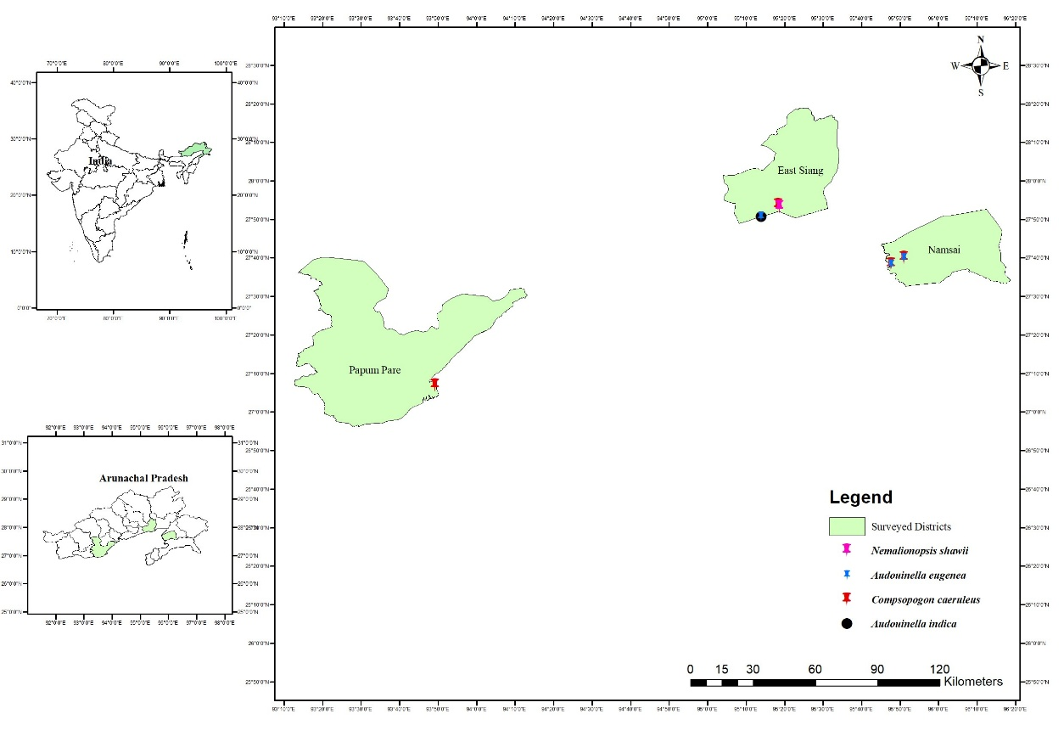

3. results and discussion

The survey identified four different freshwater red algal species belonging to two different classes namely Compsopogonophyceae and Florideophyceae. Compsopogonophyceae is represented by a single species Compsopogon caeruleus (Balbis ex C.Agardh) Montagne from Arunachal Pradesh. Within the class Florideophyceae, three species were identified under two distinct orders such as Acrochaetiales and Thoreales. Notably, the identification of Nemalionopsis shawii Skuja in Arunachal Pradesh marks the first recorded occurrence of this genus in India, as Nemalionopsis had never been documented in the country before. Including this discovery, all species identified from Arunachal Pradesh are being reported for the first time in this region. Furthermore, three genera i.e. Audouinella Bory, Compsopogon Montagne, and Nemalionopsis Skuja, are now added to Arunachal Pradesh's biodiversity represented by four species which are Audouinella eugenea (Skuja) Jao, Audouinella indica (S.K.S.Raikwar) Garbary, Compsopogon caeruleus (Balbis ex C.Agardh) Montagne, and Nemalionopsis shawii Skuja. This article stands the first report on freshwater red algae of Arunachal Pradesh.
3.1. Systematic Treatment
Compsopogonophyceae G.W.Saunders & Hommersand
Compsopogonales Skuja
Compsopogonaceae F.Schmitz
Compsopogon Montagne
Compsopogon caeruleus (Balbis ex C.Agardh) Montagne, Sciences physiques. Botanique. Cryptogamie. 1:154. 1846; Conferva caerulea Balbis ex C.Agardh, 122. Systema algarum, Berlin. 1824; Compsopogon aeruginosus (J.Agardh) Kützing. Spec. alg. 433. 1849; Compsopogon chalybeus Kützing, Spec. Alg. 432. 1849; Nagendran, Journal of Mysore University, India. 26: 136, fig. 1-4. 1973; Compsopogon hookeri Montagne, Botanique Cryptogamie 1:156, pl. 46: fig. 3; pl. 47: fig. 1. 1946; Compsopogon lividus De Toni, Sylloge algarum omnium hucusque cognitarum. Vol. IV. Florideae. Sectio I: 29. 1897. Compsopogon indicus Das, Proc. Nat. Inst. Sci. Ind. – Sect. B 29B: 242, fig. 1-3. 1963; Compsopogon iyengarii Krishnamurthy, Phytomorph. 7: 402. 1958; Composopogon prolificus Yadava & Kumano. Jap. J. Phycol. 33: p. 14, fig. 1–31. 1985; Compsopogonopsis japonica Chihara, Jap. J. Bot. 51:289, fig. 1, 2 A-I. 1976; Compsopogon corinaldii (Meneghini) Kutzing, Abbildungen der Tange. (VII). 35. 1857; Compsopogon sparsus S.L.Xie & Y.J.Ling, Acta Phytotaxonomica Sinica. 36: 81, pl. 2: fig. 1-9. 1998.
Thallus free-floating or attached on aquatic plants (Vallisneria sp.) at stagnant water bodies or on moderately flowing streams and on river. Thallus blue-green to olivaceous green, 3-20 cm high and 0.5-2 mm in diameter. Basal discs attached to the aquatic plants and many erect thalli grow from a single disc. Thallus distinctly constricted and attenuated towards the tip and base. Branches alternate, sparsely branched proximal, abundantly branched distally and branch angled upto 90º∆. Thallus gradually attenuated towards the tips and sometimes abruptly constricted at the apex. Axial cells 44.50 to 309.95 µm in height and 91 to 450.95 µm in breadth. The older thallus devoid of axial cells and looks like a hollow-tube. Apical cells depressed spherical and 12-14 µm in diameter. Thallus corticated with a single layer of cortical cells. Cortical cells 15.55 to 46.10 µm in length and 17.5 to 26.20 µm in breadth. Cortical cells divide and forms monosporangia and size ranges between 9.25 to 31.60 µm in diameter. The monospore enlarges and divides to form new thalli initiation.
The morphology of the collected specimens from Arunachal Pradesh closely resembles Compsopogon sparsus S.L.Xie & Y.J.Ling an ecophene of Compsopogon caeruleus (Balbis ex C.Agardh) Montagne. This specimen has a single cortication layer as described by Xie and Ling (1998) along with similarities in several other morphological characteristics. However, this specimen is considered as Compsopogon caeruleus (Balbis ex C.Agardh) Montagne because Compsopogon sparsus have been synonymized under Compsopogon caeruleus considering its less genetic variation (Necchi et al., 2013).
Distribution: India-Arunachal Pradesh, Assam, Bihar, Gujarat, Jammu & Kashmir, Jharkhand, Karnataka, Kerala, Maharashtra, Madhya Pradesh, New Delhi, Odisha, Rajasthan, Tamil Nadu, Uttarakhand, Uttar Pradesh, West Bengal. Global - Austria, Britain, Ireland, Croatia, Czech Republic Czechia, France, Germany, Italy, Malta, Poland, Arkansas, Florida, Louisiana, Mexico, New Mexico, North Carolina, Cuba, Lesser Antilles, Martinique, W. Atlantic, Argentina, Brazil, Paraguay, Algeria, Mauritius, Egypt, Iraq, Bangladesh, India, Khandesh, Indonesia, Malaysia, Thailand, Viet Nam, China, Japan, Taiwan, Australia, New South Wales, New Zealand, Queensland, Australia, Hawaiian Islands, Vanuatu.
Specimen Examined: India - Arunachal Pradesh, Namsai District, Namsai, Stream, 14-04-2024, U Elaya Perumal, BSI-CNH-97856 (CAL); Namsai District, Dirak Stream, 15-04-2024, U Elaya Perumal, BSI-CNH-97857 (CAL); East Siang District Oyan Village, non-flowing stream, 16-04-2024, U Elaya Perumal, BSI-CNH-97863 (CAL); Banderdawa Papum Pare District, Dikrong River, 16-04-2024, U Elaya Perumal, BSI-CNH-97865 (CAL).
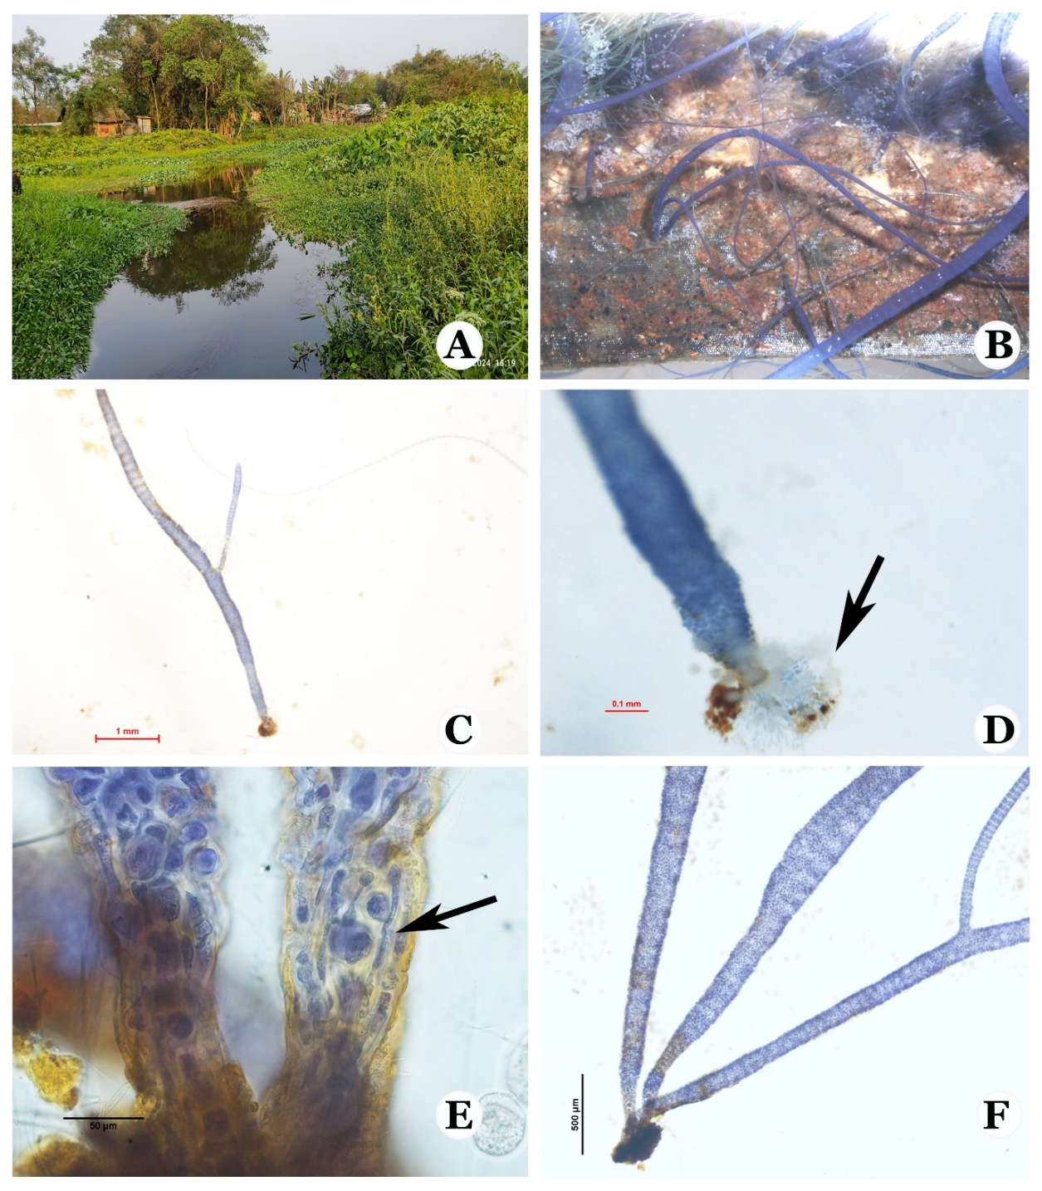
Fig 1. A. Stream near Namsai village, Namsai district, Arunachal Pradesh, Compsopogon caeruleus habitat; B. alga showing epiphytic growth; C. Thallus with branch and basal disc; D. Enlarged view of hold fast /basal disc (arrow); E. Rhizoidal growth; F. Basal portion of thallus.
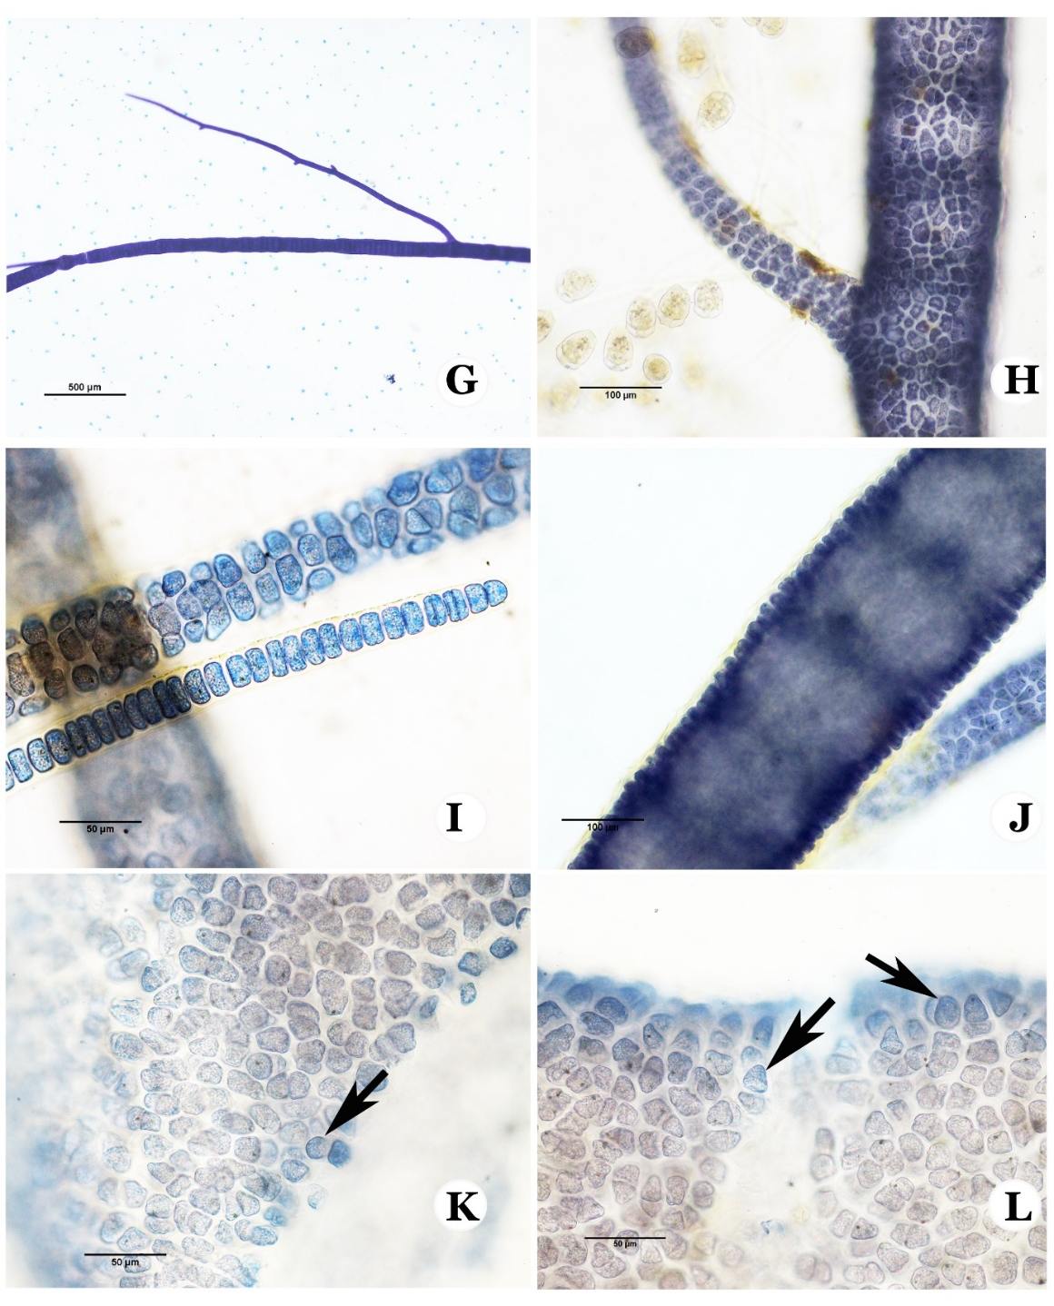
Fig 2. G: Branch and apical portion of thallus;. H: thallus portion enlarged to show the cortical cells;. I: Apical cell and tip of thallus; J: Axial cell and single layered cortical cells; . K&L: Monospore (arrows).

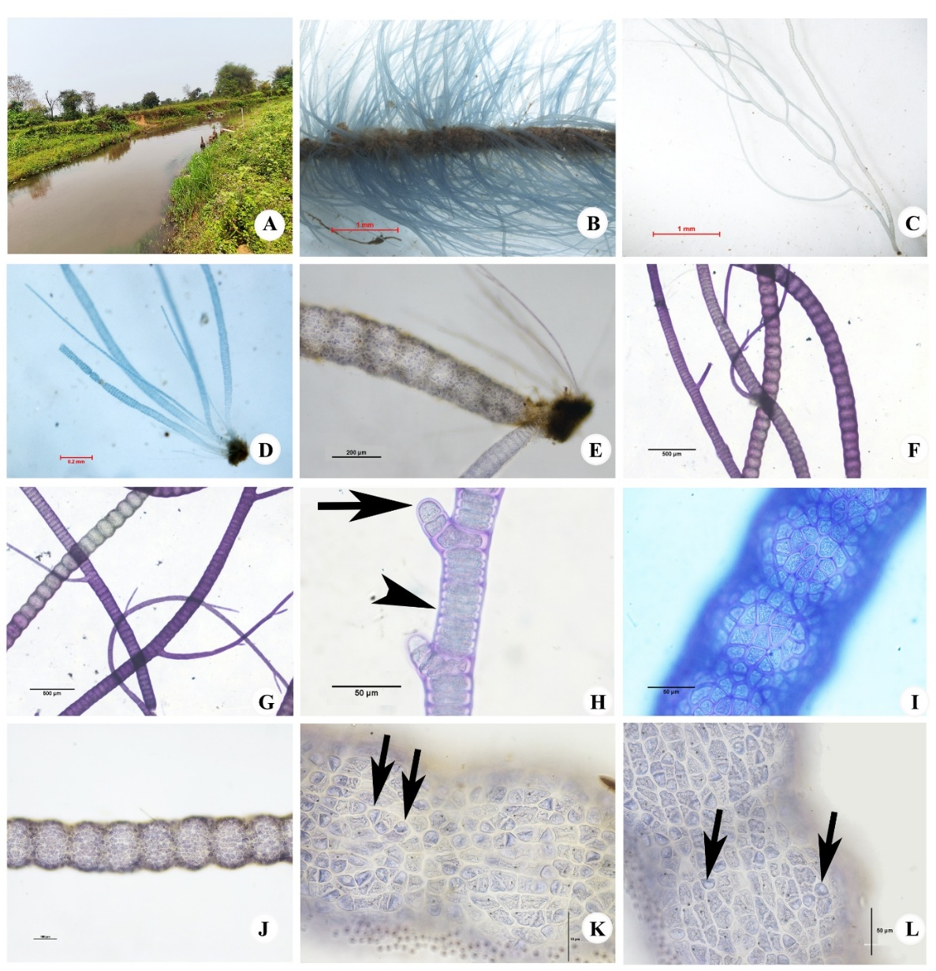
Fig 3 A: Compsopogon caeruleus (Balbis ex C.Agardh) Montagne Collection location, stream near Dirak, Namsai District, Arunachal Pradesh; . B: image showing highly abundant growth of Compsopogon on an aquatic plant;. C: thallus view- showing holdfast and branching pattern; . D: thallus magnified to show the basal part; . E: thallus magnified to show the holdfast; . F: main axis showing axial cells and branches; . G: young branches; . H: apical cells & undivided axial cells;. I: A layer of cortical cells; . J: Axial cells and cortical layer view;. K&L: cortical cells and monosporangia (arrows).
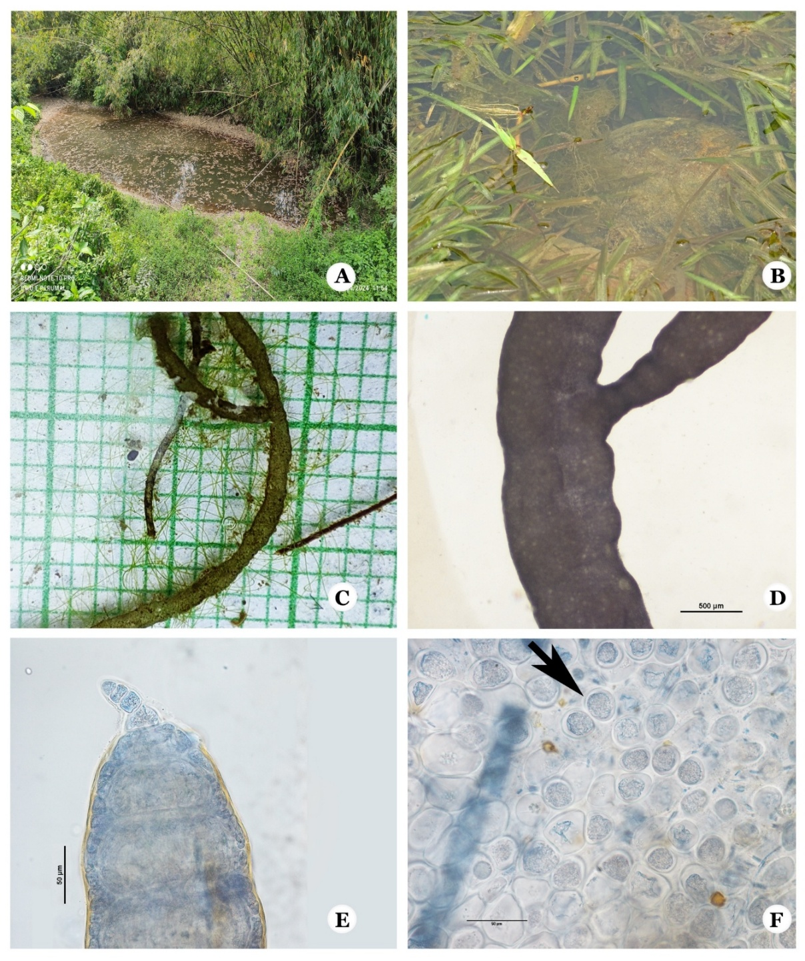
Fig 4 - A: non flowing stream water, near sile, Arunachal Pradesh; . B: free floating Compsopogon caeruleus (Balbis ex C.Agardh) Montagne; . C: Portion of thallus showing branch; . D: thallus portion magnified to show constrictions and branch; . E: Apical portion, apical cell and Axial cell with single layer of cortical cells; . F: Monospore.

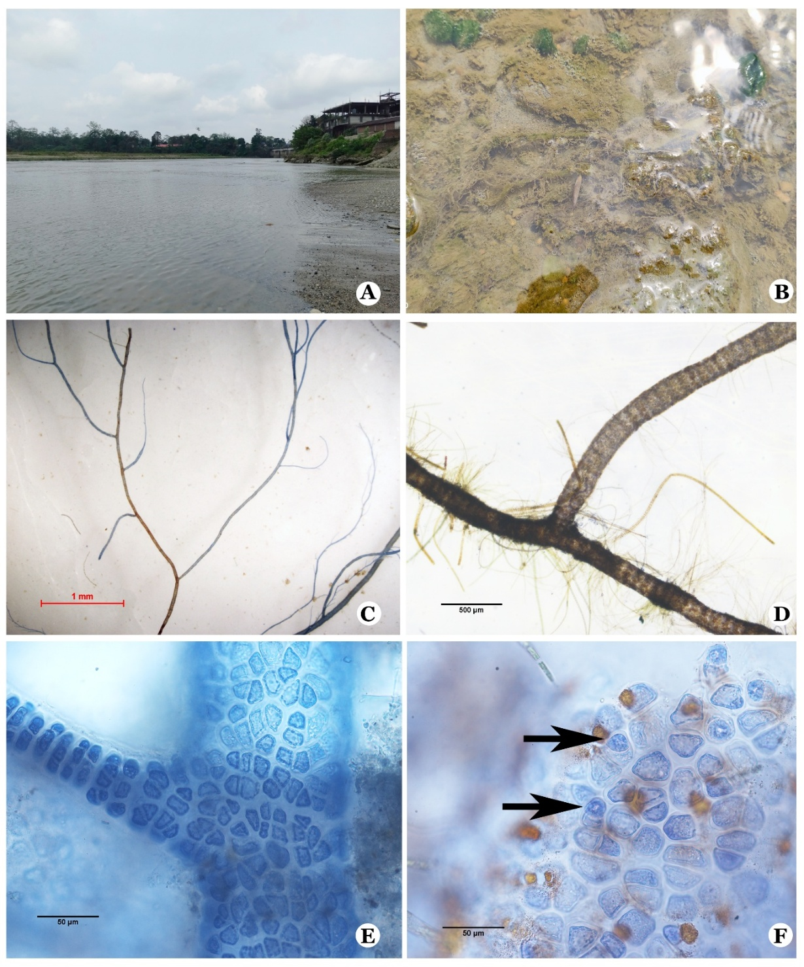
Fig 5 A: River near Banderdewa, Arunachal Pradesh; . B: habit with habitat; . C: thallus showing branches; . D: thallus enlarged to show axial cells and branching; . E: cortical cell layer; . F: monospore (arrow).

Florideophyceae Cronquist
Acrochaetiales Feldmann
Audouinellaceae J.Feldmann
Audouinella Bory
Audouinella eugenea (Skuja) Jao, Sinensia. 11: 243, pls 1-7. 1940; Chantransia eugenea Skuja, Beihefte zum Botanische Centralblatt 52B:177, 179, pl. 1: figs 3-5. 1935; Elaya Perumal and Sundararaj, 12-13. Pl. III: Fig 1-8. Some Interesting Freshwater Red Algae from Southern India. Annakkili Amma Research Institute AARI. Chennai. 2023.
Plants 1-3 mm high, growing along with Compsopogon sp. on aquatic angiosperms (i.e. Vallisneria L.) growing on slow-flowing forest stream. Thallus made of monosiphonous erect and pseudoparenchymatous prostrate system. Many erect filaments grow from the crust and they branched alternatively in different planes. Axial cells without cortication with parietal lobed chloroplast and older axial cells tend to show spiral-like chloroplast and 42.25 to 81.15 µm long and 9.15 to 13.95 µm broad. The axial cell’s mucilaginous sheath transparent and 0.80 to 2.10 µm in diameter. The monospore produced terminal on 2-7 celled special branches and obovate shaped. The length of the monospore ranges between 12.65 to 22.55 µm and breadth ranges between 9.05 to 14.70 µm. Tetraspores rare and terminal on special branches, and their length range between 14.90 to 19 µm and breadth ranges between 10.25 – 15.20 µm.
The current specimen closely resembles the previously described species Audouinella eugenea (Skuja) Jao (Jao, 1941; Kumano, 2002). Its axial cell characteristics, thallus height, the dimensions & shapes of monosporangia and absence of hairs align with earlier descriptions. Given these similarities, it is identified as Audouinella eugenea (Skuja) Jao.
Distribution: India - Arunachal Pradesh, Assam, Karnataka. Global – Mexico, India, China, Queensland, Hawaiian Islands.
Specimen Examined: India, Arunachal Pradesh, Namsai District, Namsai Epiphytic on aquatic plants, on slow flowing Stream, 14-04-2024, U Elaya Perumal, BSI-CNH-97856 (CAL); Namsai District Dirak, Epiphytic on aquatic plants in slow flowing Stream, 15-04-2024, U Elaya Perumal, BSI-CNH-97857 (CAL).
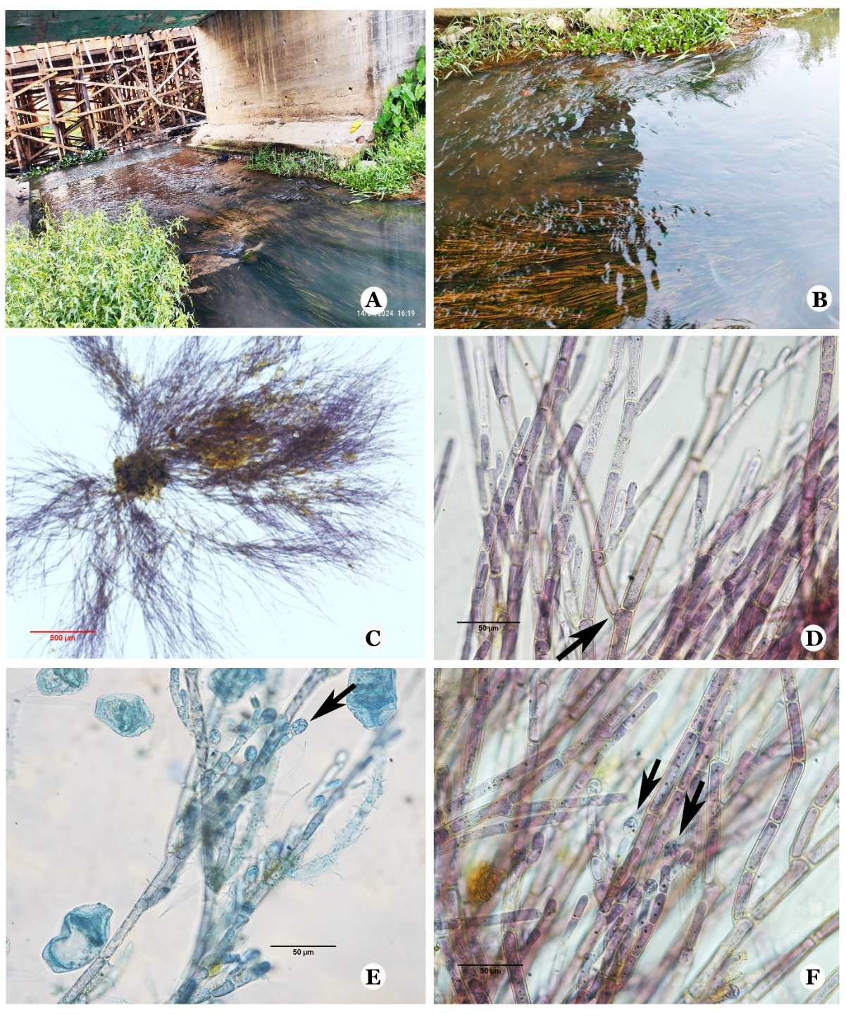
Fig 6 A: Stream near Namsai, Arunachal Pradesh;. B: Aquatic plants with algal growth; C: Habit of Audouinella eugenea (Skuja) Jao; . D: Axial cells and branches;. E & F: Monosporangia (arrows).

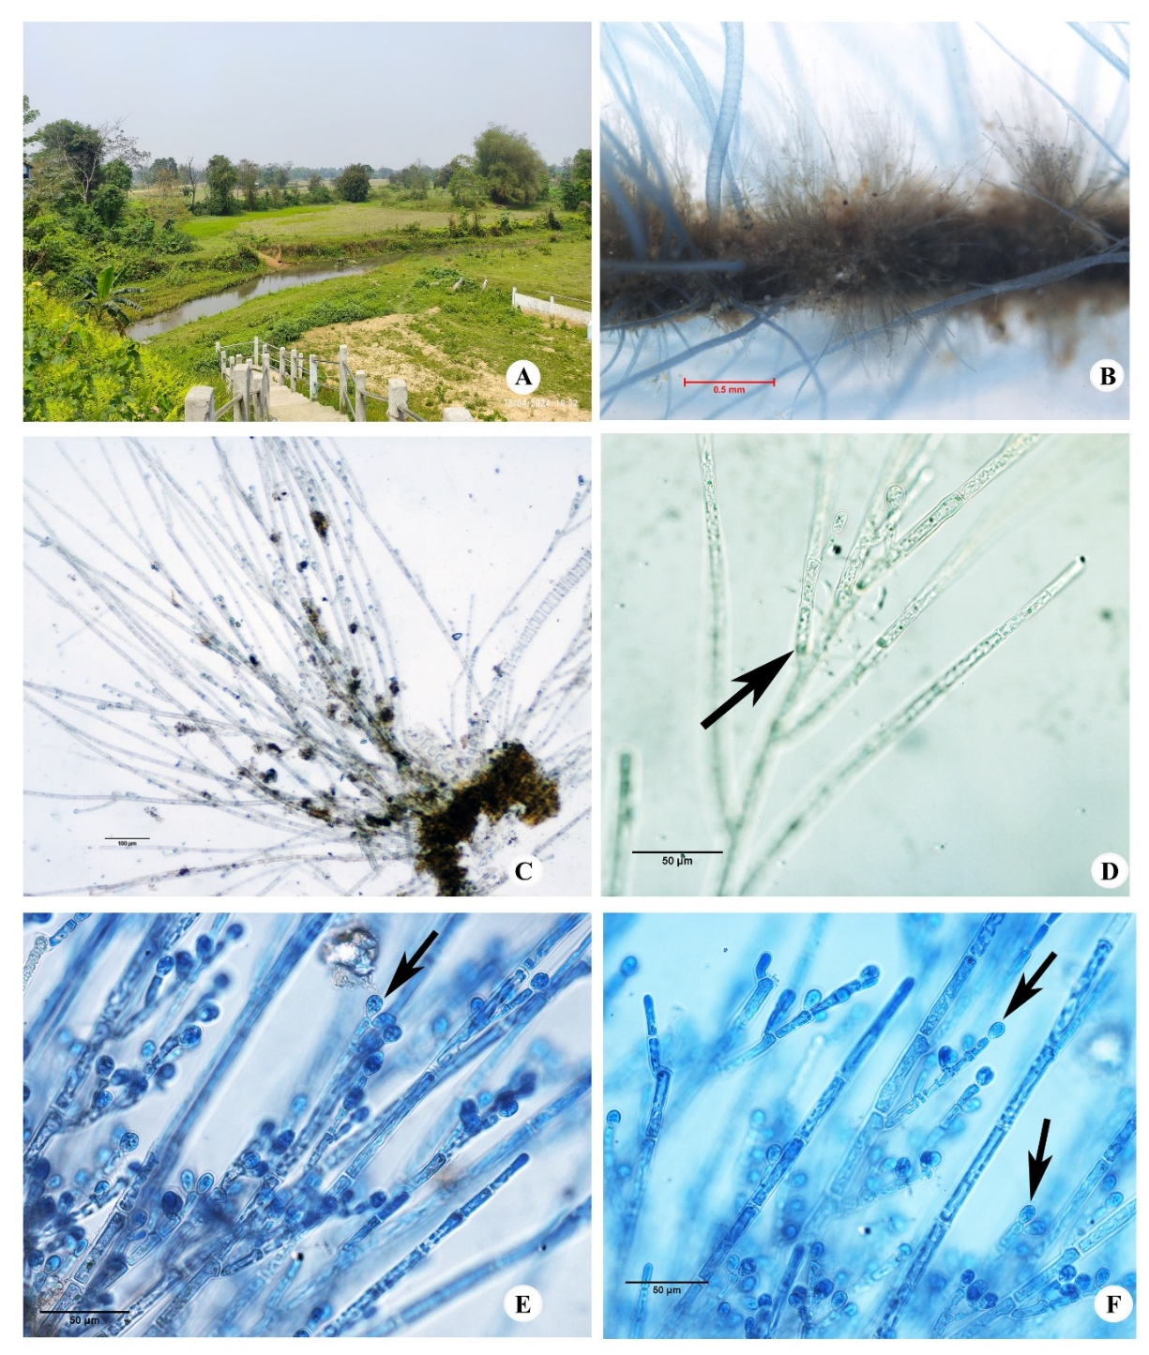
Fig 7 A: Stream near Dirak Gate, Arunachal Pradesh;. B: epiphytic growth of Audouinella eugenea (Skuja) Jao along with Compsopogon species; . C: thallus view; . D: thallus with branches at different planes (arrow); . E&F: Monosporangia (arrows).

Audouinella indica (S.K.S.Raikwar) Garbary, Bibliotheca Phycologica. 77: 92. 1987; Acrochaetium indica S.K.S.Raikwar. Revue Algologique, Nouvelle Serie 6: 102. figs 1-18. 1962; Pseudochantransia indica (Raikwar) Ott, Handbook of the Taxonomic Names Associated with the Nonmarine Rhodophycophyta 378. 2009.
Thallus macroscopic, 5-10 mm high, and dark brownish in colour. Thallus heterotrichous made of monosiphonous erect and pseudoparenchymatous prostrate system. Many erect filaments grow from the crust and they branched alternatively in different planes. Axial cells without cortication with parietal lobed chloroplast and 29.05 to 82.10 µm long and 7.50 to 15.20 µm broad. The axial cell’s mucilaginous sheath transparent and 0.75 to 2.50 µm in diameter. The monospore produced on 2-5 celled special branches and obovate to oblong shape. The length of the monospore ranges between 11 to 22.90 µm and breadth ranges between 8.75 to 14.30 µm. Tetraspores and no sexual reproductive parts were observed.
The specimen collected from Arunachal Pradesh exhibited morphological similarities to Audouinella indica (Raikwar) Garbary. While its thallus height was smaller than that of the holotype, other morphological characteristics of the thalli remained consistent. The monospore, axial cells, and specialized branch morphology were more or less comparable to those of the type specimen (Raikwar, 1962; Kumano, 2002). Based on these similarities, the specimen was identified as Audouinella indica (Raikwar) Garbary.
Distribution: India- Arunachal Pradesh, Madhya Pradesh, Uttar Pradesh, Tamil Nadu. Endemic to India.
Specimen Examined: India, Arunachal Pradesh, East Siang District, Ruksin, Stream, 16-04-2024, U Elaya Perumal, BSI-CNH-97860 (CAL).
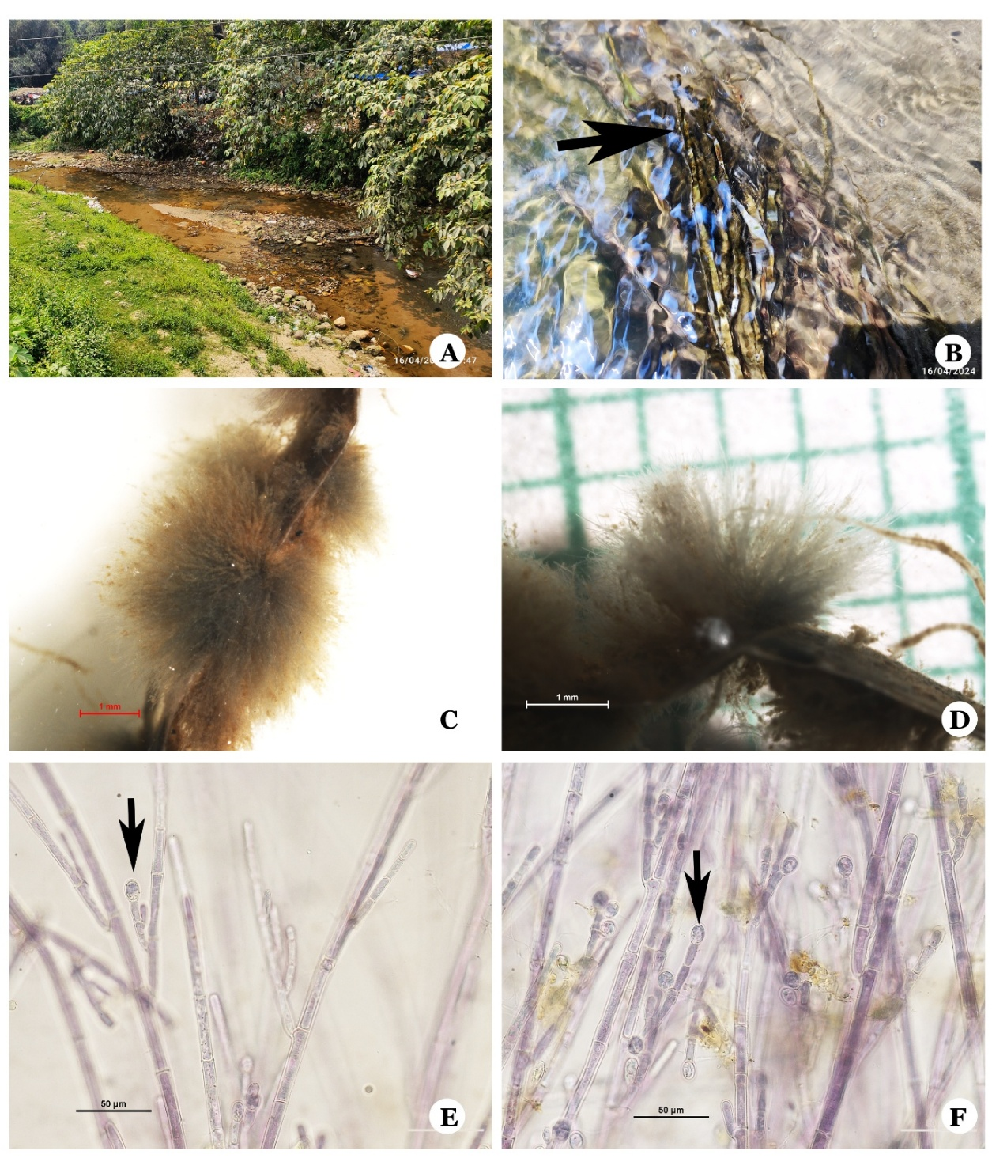
Fig 8. A: Stream, Ruksin, East Siang district, Arunachal Pradesh; . B: Alga growing on plastic materials submerged in water; . C & D: Thallus of Audouinella indica (S.K.S.Raikwar) Garbary; . E &F: Monosporangia (arrows).

Florideophyceae Cronquist
Thoreales K.M.Müller, Sheath, A.R.Sherwood & Pueschel
Thoreaceae Hassall
Nemalionopsis Skuja
Nemalionopsis shawii Skuja, Beihefte zum Botanische Centralblatt 52B:191, Pl. 4 f. 1-9. 1934.
Specimen collected from small, slow flowing, clear transparent stream shaded by bamboo bushes; alga was growing attached to submerged black pebbles or rocks. Thalli monoecious, moderately mucilaginous, Pinkish, 15–25 cm in length, 621.60–1137.25 μm in diameter moderately to abundantly branched, multiaxial, attached to substrata by flat strap-like basal system. Central medulla with interwoven branched and twisted yellowish filaments with cylindrical short to elongate cells and cortex with assimilatory filaments in an outer whorl. Medulla 247.2–854.7 μm in diameter. Assimilatory filaments densely arranged at the distal portion, composed of 13–20 cells, 4.45–19.0 μm in length, 4.25–6.25 μm diameter; proximal cells cylindrical short to elongate or elliptical; distal cells short cylindrical or barrel-shaped. Each cell appears to have a single chloroplast without pyrenoid. Spermatangia arising from terminal or sub-terminal cells of assimilatory filaments, in pairs or single, sub-spherical or elliptical, with a homogeneous content, 8.95– 12.85 μm in length, 7.2–10.0 μm in diameter, spermatangia wall persistent; carpogonium not observed. Gonimoblast filaments somewhat elliptical shaped and 8.40 to 17.80 μm in length and 3.75 to 6.55 μm in breadth. Carposporangia in clusters, near the plant surface, obovoid, 9.20–15.50 μm in length, 6.55–9.75 μm in diameter. Basal system composed of creeping filaments, developing from the medulla or the basal portion of assimilatory filaments, composed of cylindrical cells, 19.5–59.5 μm in length, 3.9–7.3 μm diameter; monosporangia obovoid, sub-spherical or elliptical, 11.0–15.5 μm in length, 8.0–11.5 μm diameter.
Thorea is the only genus within the family Thoreaceae recorded from India, and exhibits distinct morphological variations compared to the current specimen (Singh 1960; Pandey & Chaturvedi 1979; Desikachary et al., 1990; Dhanalakshmi et al., 2009; Bhat et al., 2011; Necchi et al., 2015; Ganesan et al., 2018). The presence of tightly packed multiaxial medulla clearly indicates that this specimen belongs to the genus Nemalionopsis Skuja. This genus has only two members Nemalionopsis shawii Skuja and Nemalionopsis parkeri E.T.Johnston & Vis. Notably, Nemalionopsis parkeri E.T. Johnston is only recognized in its Chantransia stage, as its gametophyte remains undescribed (Johnston et al., 2018). The thallus morphology and reproductive characteristics of current specimen closely resemble Nemalionopsis shawii Skuja, leading to its identification as Nemalionopsis shawii Skuja.
Distribution: India-Arunachal Pradesh. Global- Louisiana, North Carolina, Indonesia, Philippines, China, Japan, Nepal, Hawaiian Islands.
Specimen examined: India, Arunachal Pradesh, East Siang District, Stream near Sile, 16-04-2024, U Elaya Perumal, BSI-CNH-97864 (CAL).
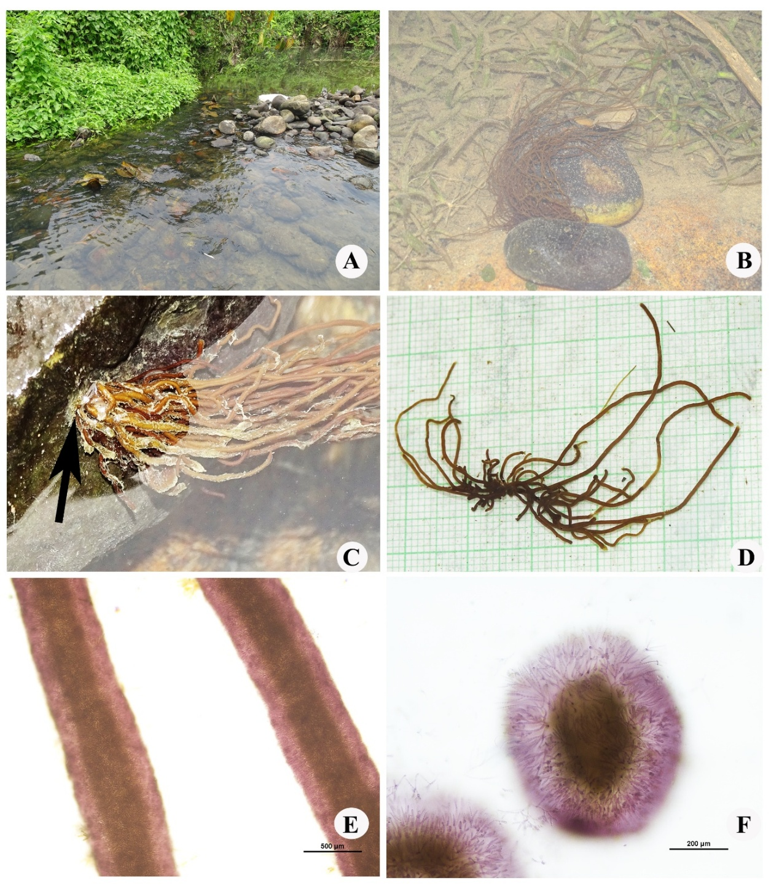
Fig 9 A: Stream near Sile village, Arunachal Pradesh;. B: Epilithic growth of Nemalionopsis shawii Skuja; . C: Thallus attachment on rock pebbles; . D: thallus view; E: Thallus magnified to show compactly packed medulla & cortex;. F: TS of thallus showing tightly packed medulla and outer cortex layer.
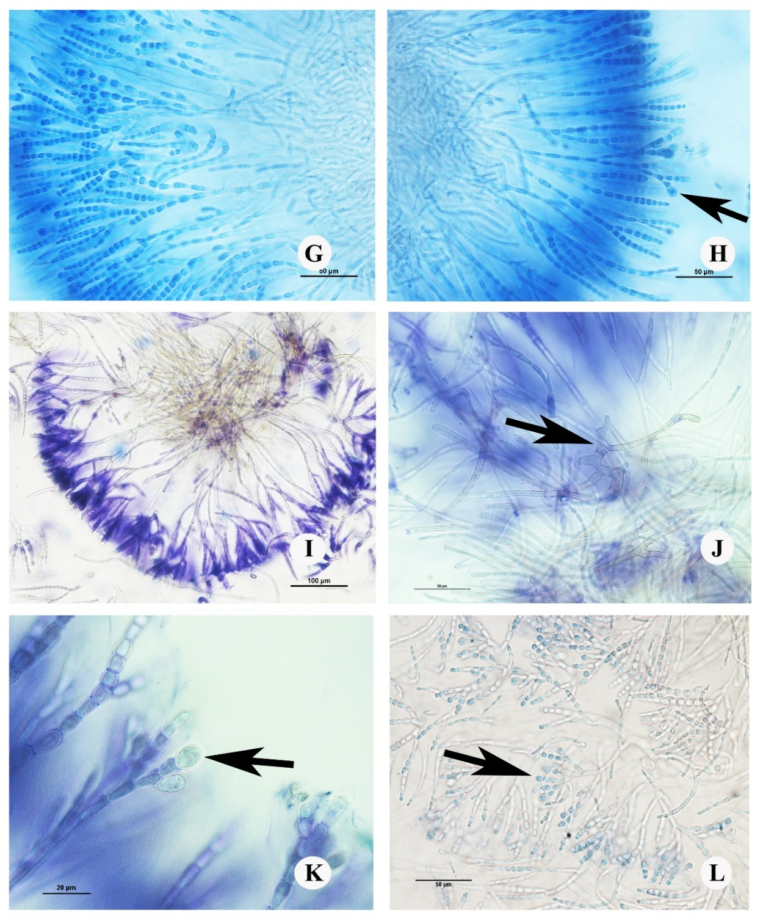
Fig 10 – G: Assimilatory filaments; H: Assimilatory filaments with Monosporangia at the tip;. I: Assimilatory filaments; . J: Medulla with branched medullary filaments; . K: Spermatangia;. L: Carposporangia in cluster

4. Conclusion

Nemalionopsis shawii Skuja, is reported for the first time to Indian algal flora. The freshwater algal flora of Arunachal Pradesh is updated with four freshwater red algal species such as Audouinella eugenea (Skuja) Jao, Audouinella indica (S.K.S.Raikwar) Garbary, Compsopogon caeruleus (Balbis ex C.Agardh) Montagne, and Nemalionopsis shawii Skuja. All the collected species have been described with their morphological characters and geographical distribution. Nemalionopsis shawii Skuja, and Audouinella indica (S.K.S.Raikwar) Garbary, are reported from East Siang District, Arunachal Pradesh and Audouinella eugenea (Skuja) Jao, is being reported from Namsai District, Arunachal Pradesh. Compsopogon caeruleus (Balbis ex C.Agardh) Montagne is being reported from East Siang District, Namsai District and Papum Pare District of Arunachal Pradesh. These findings indicate a high potential for discovering additional freshwater red algae in other regions of Arunachal Pradesh. Given that the current study covered only a limited area, yet similar habitats exist throughout the state, a comprehensive survey could potentially uncover unique freshwater red algal species.

Disclaimer (Artificial intelligence)
Authors hereby declare that NO generative AI technologies such as Large Language Models (ChatGPT, COPILOT, etc.) and text-to-image generators have been used during the writing or editing of this manuscript.
References

Agardh, C.A. (1824). Systema algarum. pp. [i]-xxxvii, [1]-312. Lundae [Lund]: Literis Berlingianis [Berling].
Bhakta, S. & Adhikary, S. P. (2014). Algal Diversity in the Streams and Waterfalls of Eastern and North-Eastern Region of India. Nelumbo, 56, 291–341. https://doi.org/10.20324/nelumbo/v56/2014/86674
Bhat, F.A.Yousuf, A.R.Aftab, A., Arshid, J., Mahdi, M.D. & Balkhi, M.H. (2011). Ecology and biodiversity in Pangong Tso (lake) and its inlet stream in Ladakh, India. International Journal of Biodiversity and Conservation, 3, 501–511.
Biswas, K. (1949). Common fresh and brackish water algal flora of India and Burma.vol. 2. Records of the Botanical Survey of India. 15, 1–106.
Brühl, P. & Biswas, K. (1923). Commentiones Algologicas III. On a species of Compsopogon growing in Bengal. Journal of the Department of Science, University of Calcutta, 5, 1–6.
Brühl, P. & Biswas, K. (1927). Commentiones Algologicas IV. Compsopogon lividus (Hooker) De Toni. Journal of the Department of Science, University of Calcutta, 8, 8–13.
Chakraborty, T., Mukhopadhyay, M. & Pal, R. (2010). Micro algal diversity of Kolkata, West Bengal, India. Indian Hydrobiology, 12, 204–224.
Chihara, M. (1976). Compsopogonopsis japonica, a new species of fresh water red algae. Japanese Journal of Botany, 51, 289-294.
Das S.K. & Adhikary S.P. (2012). Diversity of Freshwater Algae In Arunachal Pradesh and Their Distribution in Different Altitudes. Journal of the Indian Botanical Society, 91(1-3),160-182.
Das, C.R. (1963). The Compsopogonales in India (A Systematic account of the Indian representatives of the order). Proceedings of the National Institute of Sciences of India, 29B, 239–243.
De Toni, G.B. (1897). Sylloge Algarum. vol. IV, Section (1), Patavii.
Desikachary, T.V., Krishnamurthy, V. & Balakrishnan, M.S. (1990). Rhodophyta. vol. 1. Madras Science Foundation, Madras.
Desikachary, T.V., Krishnamurthy, V. & Balakrishnan, M.S. (1998). Rhodophyta, vol. II. Madras Science Foundation, Madras.
Devi S.D., Indrama T & Tiwari O.N. (2010). Biodiversity analysis & reproductive / cultural behaviour of Cyanobacteria of north eastern region of India having acidic properties. The International Journal of Plant Reproductive Biology, 2, 127 -135.
Dhanalakshmi, K., Babu, B., Nicodemus, A., Nagarajan, B. & Baluswami, M. (2009). Thorea hispida (Thore) Desvaux Emend. Sheath, Vis et Cole from Little Andaman, India. In: Proceedings of the International Conference on Algal Biomass, Resources and Utilization. p. 35–42.
Elaya Perumal U., & Sundararaj R. (2019). Studies on Batrachospermum szechwanense (Batrachospermales, Rhodophyta) from Kerala State, India. Indian Hydrobiology, 18 (1 & 2), 138–145.
Elaya Perumal U., & Sundararaj R. (2020). Preliminary studies on Kumanoa zeylanica (Batrachospermales, Batrachospermaceae) reported from the Western Ghats of India. Environmental and Experimental Biology, 18(1), 21-27.
Elaya Perumal, U. & Sundararaj. R. (2023). Some Interesting Freshwater Red Algae of Southern India. Annakkili Amma Research Institute (AARI), Chennai.
Elaya Perumal, U., Uma Rani, V., & Chaugule, B.B. (2015). Studies on a red alga Sirodotia huillensis (Batrachospermaceae) from Orissa State, India. Journal of Theoretical and Experimental Biology, 11, 45–50.
Ganesan, E.K., John A. West & Orlando Necchi Jr. (2018). A catalogue and bibliography of non-marine (freshwater and estuarine) Rhodophyta (red algae) of India. Phytotaxa, 364(1), 001–048. https://doi.org/10.11646/phytotaxa.364.1.1
Garbary, D.J. (1987). The Acrochaetiaceae (Rhodophyta): an annotated bibliography. Bibliotheca Phycologica, 77, 1-267.
Guiry M.D. in Guiry, M.D. & Guiry, G.M. (2024). AlgaeBase. World-wide electronic publication, National University of Ireland, Galway. https://www.algaebase.org; searched on 17 December 2024.
Guiry M. D. (2024). How many species of algae are there? A reprise. Four kingdoms, 14 phyla, 63 classes and still growing. Journal of Phycology, 60, 214–228. DOI:10.1111/jpy.13431.
Gupta, R.K. & Ambarish, K. (2004). Freshwater red algae from Dehradun, Uttaranchal, India. Phytotaxonomy, 4, 135–137.
Gupta, R.K. (2005). Algal flora of Dehradun district, Uttaranchal. Botanical Survey of India, Kolkata.
Gupta, R.K. (2021). Algal Flora of Jharkhand. Botanical Survey of India. Kolkata.
Hajra P.K., D.M. Verma & Giri, G.S. (1996). Materials for The Flora of Arunachal Pradesh Volume 1 (Ranunculaceae Dipsacaceae) in Flora of India Series 2. The Director, Botanical Survey of India, Kolkatta, India.
Jackson, A. & Panikkar, N. M. V. (2015). Species diversity in the freshwater algae of Pathanamthitta District of Kerala and DNA barcoding and bioprospecting of selected Taxa. Mahatma Gandhi University, Kottayam. p.417. http://hdl.handle.net/10603/160893
Jaiswal, A.G. & Pathak, R.R. (2005). Red algae- Compsopogon aeruginosus J. Ag. Kützing var. catenatum Yadav & Pandey from Sakri, District Dhule, Maharashtra. Proceedings of the National Conference on Plant Diversity and Biotechnology, 42–44.
Jao, C.C. (1940). Studies on the freshwater algae of China IV. Subaerial and aquatic algae from Nanyoh, Hunan. Part II. Sinensia, 11, 241-361.
John, J. & Francis, M.S. (2007). Investigation in the algal flora of Thodupuzha taluk, Kerala. Indian Hydrobiology, 10, 79–86.
Johnston, E. T., Lim, P.E., Buhari, N., Keil, E. J., Djawad, M. I. & Vis, M. L. (2014). Diversity of freshwater red algae (Rhodophyta) in Malaysia and Indonesia from morphological and molecular data. Phycologia, 53(4),329–341. doi:10.2216/13-223.1
Johnston, E.T., Dixon, K.R., West, J.A., Buhari, N. & Vis, M.L. (2018). Three gene phylogeny of the Thoreales (Rhodophyta) reveals high species diversity (Bold Award). Journal of Phycology, 54(2), 159-170.
Jose J. & Francis, M.S. (2013). Investigation of the Algal Flora of Idukki District, Mahatma Ghandi University, Kottayam. http://hdl.handle.net/10603/7126
Kant, S. & Vora, S. (1999). Algal flora of J & K State. Journal of the Indian Botanical Society, 78, 51–64.
Kathiresan, K. & Qasim, S.Z. (2005). Biodiversity of Mangrove Ecosystems. Hindusthan Publishing Corporation, New Delhi.
Khan, M. (1970). On two freshwater red algae from Dehra Dun. Hydrobiologia, 35, 249–253. https://doi.org/10.1007/BF00181730
Khan, M. (1985). Algal flora of Sultanpur (U.P.) India. Phykos, 24, 52–57.
Krishna S. R. & Chandan S. (2018). Studies on some aspects of taxonomy and ecology of fresh water algae of Hooghly District West Bengal. University of Kalyani. Kalyani. http://hdl.handle.net/10603/210090
Krishnamurthy, V. (1953). On the structure and reproduction of a Compsopogon from Madras. Phytomorphology, 3, 369–376.
Krishnamurthy, V. (1957). The early stages of development in four species of Compsopogon. Phytomorphology, 7, 398–403.
Krishnamurthy, V. (1961). A note on Compsopogon leptoclados Montagne. Revue Algologique, 5, 260–265.
Krishnamurthy, V. (1962a). The morphology and taxonomy of the genus Compsopogon Montagne. Botanical Journal of the Linnean Society, 58, 207–222.
Krishnamurthy, V. (1962b). The formation of “microaplanospores” in Compsopogon coeruleus (Balbis) Montagne. Current Science, 31, 99–100.
Kumano, S. (2002). Freshwater Red Algae of the World. Biopress, Bristol, UK.
Kützing, F.T. (1849). Species algarum. pp. [i]-vi, [1]-922. Lipsiae [Leipzig]: F.A. Brockhaus.
Martens, G. Von (1869a). Beitrag zur Algen-flora Indiens. No. I. Flora, 52, 233–238.
Misra, J.N. & Dey, A.K. (1959). Studies on the freshwater Rhodophyceae (Red Algae) of Uttar Pradesh. Vijyana Parishad Anusandhan Patrika, 2, 123–134.
Montagne, C. (1846). Flore d’Algérie. Ordo I. Phyceae Fries. In: Exploration scientifique de l’Algérie pendant les années 1840, 1841, 1842. Durieu De Maisonneuve, M. C. Sciences physiques. Botanique Cryptogamie, 1, 1–197.
Nagendran, C.R. (1973). Occurrence of Compsopogon chalybeus Kützing in India. Journal of Mysore University, India, 26, 136–137.
Necchi, O. Jr, Paiano M.O., West, J.A., Ganesan, E.K., & Loiseaux-de Goër S. (2015). Thorea indica sp. nov. (Thoreales, Rhodophyta) from Uttar Pradesh, India. Algae, 30, 265–274. https://doi.org/10.11646/phytotaxa.364.1.1
Necchi, O. Jr, West, J.A., Rai, S.K., Ganesan, E.K., Rossignolo, N.L., & Loiseaux de Goër S. (2016). Phylogeny and morphology of the freshwater red alga Nemalionopsis shawii (Rhodophyta, Thoreales) from Nepal. Phycological Research, 64, 11–18. https://doi.org/10.1111/pre.12116
Necchi, O. Jr., Fo, A.S.G. Salomaki, E.D., West, J. A., Aboal, M. & Vis, M.L. (2013). Global sampling reveals low genetic diversity within Compsopogon (Compsopogonales, Rhodophyta). European Journal of Phycology, 48(2), 152-162.
Oinam, G., Singh K.O., & Tiwari O.N. (2010). An account of Ehrenberg (Euglenophyta) from semi-arid region of some heterocystous Cyanobacteria (Nostocalean) of NE region of India falling under Indo-Burma biodiversity hot spots. Bioscience Biotechnology Research Communications, 3, 26-32.
West W, West G.S., & Carter N. (1923). A Monograph of the British Desmidiaceae. The Ray Society London.
Ott, F.D. (2009). Handbook of the taxonomic names associated with the non-marine Rhodophycophyta. J. Cramer, Germany.
Pal, U.C., Naskar, K.R. & Santra, S.C. (1988) A check-list of algal flora of Sundarban Delta of West Bengal, India. Phykos, 27, 48–53.
Palanivel S. & V. Umarani. (2019). Studies on the Freshwater Algal Diversity In Tamil Nadu India. University of Madras, Chennai. http://hdl.handle.net/10603/238409.
Pandey, R.S., Tiwari, G.L. & Pandey, D.C. (1973). Note on two forms of Compsopogon Montagne from the river Yamuna. Current Science, 42, 800.
Pandey, R.S., Tiwari, G.L. & Pandey, D.C. (1976). Observations on Compsopogon iyengarii Krishnamurthy (Rhodophyceae). Hydrobiologia, 49, 239–244. https://doi.org/10.1007/BF00014517
Pandey, U.C. & Chaturvedi, U.K. (1979), Algae of Rohilkand division, U.P., India-V. Phykos, 18, 37–43.
Pandey, U.C. (1978). A note on record of Compsopogon coeruleus in Rohilkhand Division, Uttar Pradesh. Proceedings of the 65th Indian Science Congress, 6.
Pandey, U.C. (1983). On a species of Compsopogon growing in Bareilly, Uttar Pradesh, India. Algae of the Indian subcontinent: a collection of papers. Bibliotheca Phycological, 66, 241–246.
Patel, R.J. & Francis, M.A. (1970). Some interesting observations on Compsopogon aeruginosus (J.Ag.) Kützing, a species new to India. Phykos, 8, 46–52.
Patel, R.J. (1965). Compsopogon iyengarii Krishnamurthy from Gujarat. Current Science, 34, 644–645.
Pillay, T.V.R., Vijayaraghavan, M.R. & Thakurta, S.C. (1962) An ecological study of benthic flora in brakishwater bheris. Proceedings of the National Institute of Sciences of India, 28B, 417–431.
Pingle, S. D. & Balakrishnan, M. S., (2017). Studies on the algae of impoundments and streams in Maharashtra. SPPU. Pune. http://hdl.handle.net/10603/145921
Raikwar, S.K.S., (1962) A new freshwater species of Acrochaetium (A. indica sp. nov.). Revue Algologique, Nouvelle Serie, 6, 98-104.
Rao, C.S.P. (1966). Observations on the cytology of Compsopogon coeruleus Mont. Phykos, (M.O.P. Iyengar Memorial Volume), 5, 91–94.
Rath, J. & Adhikary, S.P. (2005). Algal flora of Chilika Lake. Daya Publishing House, New Delhi.
Rath, J. & Adhikary, S.P. (2006). Marine macroalgae of Orissa, east coast of India. Algae, 21, 49–59. https://doi.org/10.4490/ALGAE.2006.21.1.049
Ratha, S.K., Jena, M., Rath, J. & Adhikary, S.P. (2007). Three ecotypes of Compsopogon coeruleus (Rhodophyta) from Orissa state, east coast of India (Note). Algae, 22, 87–93. https://doi.org/10.4490/ALGAE.2007.22.2.087.
Reddy, P.M., Yumnam, D.D. & Imchen, T.Y., (1986). Investigations on the blue green algae of North East India: Distribution and Habitat preferences. Phykos, 25, 148-158.
Renu P.B. & Parukutty B., (2016). Studies on the algal flora of Assam. Gauhati University, Guwahati. http://hdl.handle.net/10603/69597
Salve, A. & Chaugule, B.B. (2001). Note on the occurrence of Compsopogonopsis (Mont.) Krishnamurthy from India. Indian Hydrobiology, 4, 37–38.
Sangita & Jha, (2016). Studies on fresh water algal flora of Sivasagar district Assam. Gauhati University, Guwahati. http://hdl.handle.net/10603/114329
Santra, S.C. & Pal, U.C. (2003). An annotated list of the brackish water algae of Chilika Lake, Orissa (India). In: Phycology, Nature & Nurture (Verma, B.N., Kargupta, A.N. & Yadav, R.N., editors), 59–91, Kalyani Publisher, Ludhiana.
Satpati, S.S., Barman, N. & Pal, R., (2012). Morphotaxonomic account of some common seaweeds from Indian Sundarbans mangrove forest and inner island area. Journal of Algal Biomass Utilization, 3: 45–51.
Saunders, G. W., & Hommersand, M. H. (2004). Assessing red algal supraordinal diversity and taxonomy in the context of contemporary systematic data. American journal of botany, 91(10), 1494-1507.
Sen, N. & Naskar, K. (2003). Algal flora of Sunderbans mangals. Daya Publishing House, Delhi.
Seto, R., Yadava, R.N. & Kumano, S., (1991). Development of short spinous branchlets of Compsopogon aeruginosus var. catenatum (Compsopogonaceae, Rhodophyta). Japanese Journal of Phycology, 39, 369–373.
Shaikh, A.A. & Vaidya, B.S. (1972). Some observations on algae from Gujarat. Phykos, 11, 64–66.
Shukla, B.K. & Shukla, A.C., (1987). A contribution to the algal flora of Kanpur. Phykos, 26, 82–85.
Shyam, R. & Sarma, Y.S.R.K. (1980). Cultural observations on the morphology, reproduction and cytology of a freshwater red alga Compsopogon Mont. from India. Nova Hedwigia, 32, 745–765.
Singh N.I., Singh N.S., Devi G.A. & Singh S.M., (1997). Blue green algae from rice growing areas of Arunachal Pradesh. Phykos, 36, 21-26.
Singh, J.D. (1960). Occurrence of Thorea ramosissima Bory in India. Current Science, 29:490.
Singh, M. (1964). Morphology and reproduction of a form of Compsopogon hookeri Montagne, from Delhi (India). Phykos, 3, 37–40.
Singh, N.B. & Pandey, D.C. (1986). A new form of Compsopogon aeruginosus (J. Ag.) Kützing. Phykos, 25, 84–87.
Singh, S.P. Tiwari, G.L. & Pandey, D.C. (1983). Certain observations on Acrochaetium indica Raikwar. Bibliotheca Phycologica, 66, 203–218.
Sinha, B.D. & Srivatsava, N.K. (1978). Compsopogon iyengarii Krishnamurthy var. nov., a new record for Bihar. Phykos, 7, 93–96.
Sinha, B.D. & Srivatsava, N.K. (1979). Taxonomy and biology of the freshwater red alga Compsopogon in Bihar, India. Beihefte Nova Hedwigia, 63, 71–76.
Skuja, H., (1935). Untersuchungen über die Rhodophyceen des Süßwassers. IV. Zwei neue Chantransia-Arten. V. Nothocladus, eine neue Gattung der Batrachospermaceen. VI. Nemalionopsis Shawi, eine neue Gattung und Art der Helminthocladiaceen. Beihefte zum Botanische Centralblatt, 52B, 173-192.
Suseela, M.R. & Toppo, K., (2015). Contribution to the knowledge of fresh water red algae (Rhodophyta) of India. Journal of the Indian Botanical Society, 94, 136–140.
Tiwari, S.K. & Pandey, D.C. (1983). Certain observations on Acrochaetium indica Raikwar. Bibliotheca Phycologica, 66, 203–218.
Vaidya, B.S. (1968). A note on record of Compsopogon coeruleus Mont. from Gujarat. Current Science, 37, 144.
Xie, S.L. & Ling, Y.J. (1998). Two new species of Compsopogon (Rhodophyta) from Shanxi and Guangxi, China. Acta Phytotaxonomica Sinica, 36, 81-83.
Yadava, R.N. & Kumano, S. (1985) Compsopogon prolificus sp. nov. (Compsopogonaceae, Rhodophyta) from Allahabad, Uttar Pradesh in India. Japanese Journal of Phycology, 33, 13–20.
Yadava, R.N. & Pandey, D.C. 1977, An interesting observation on a Compsopogon growing in Allahabad. Current Science, 46, 713– 714.
Yadava, R.N. & Pandey, D.C. 1980. Observations on a new variety of Compsopogon (C. aeruginosus (J.Ag.) Kützing var. catenatum var. nov.). Phykos, 19, 15–22.
Yadava, R.N. & Yadav, B.P. (1998). Studies on Compsopogon, a freshwater red alga. In: Roy, A.K., Dogra, J.V.V. & Sarma, S.K. (Eds.) Phytodiversification and Human Welfare. M.D. Publications, New Delhi.
Yadava, R.N. (1988). Observations on Compsopogon prolificus. Biological Bulletin India, 10, 127–131.
Yadava, R.N. (1991). Monospore study of Compsopogon prolificus in culture. Geobios New Report, 10, 72–74.

