Fate of a Snake Bitten Cross Breed Goat: A Case Report

Abstract:
Snake bite is an important and common cause of accidental death in domestic and wild animals of India. The most affected farmers are from the rural region where they encounter with venomous snake where it is very commonly found and access to the antivenom is very limited. We came across such a case of two-year-old cross bred male (Sirohi x Assam Hill Goat) kept at Instructional Livestock Farm Complex, Lakhimpur College of Veterinary Science, Assam Agricultural University Assam. The reproductive organ area of the snake bitten goat was swollen with edematous with whitish discharge. The skin of the animal was discoloured and it appeared to be bluish in colour and the pupil was dilated. Fang marks were observed after retraction of skin at the biting near the jaw where sero-sanguineous fluid with blood clots accumulated. The victim of the snake bite had multiple fang marks. Cobra snakes has a habit of multiple biting in the course of its attack. The mark of multiple bite observed in the carcass may also be due to the defensive actions of the animal. An amount of about 200–500 mg of venom on an average can be delivered by the snakes of Cobra species and their bites are more common in the morning and evening hours than that of night which happened in this reported case as well. One of the most effective methods of controlling snake numbers is to reduce their food supply (rodents) and shelter. Concerned forest officials should be contacted immediately if snakes are found in farms or near to human habitat.
Keywords: Snake bite, antivenom, male crossbred goat, sero sanguineous fluid
Introduction:
In India, snake bites are a significant and frequent source of unintentional death for both domestic and wild animals. The most affected farmers are from the rural region where they encounter with venomous snake where it is very commonly found and access to the antivenom is very limited. India records highest number of snake bite cases in the world which is 1.4 to 2.8 million and about 46000 fatalities of humans occurs every year (Mohapatra et al,2011, Kabir 2022). However, “accurate data on snake bite in livestock in India is not available. Out of the many snakes two commonly available snakes having nueurotoxic venoms are two sub–species of cobras found in India, the Indian or spectacled cobra (Naja naja) and the monocled cobra (Naja kaouthia). The size and shape of both the sub-species of cobras are same with an average length of about 1.9 meters and maximum length up to 2.4 meters. Body colours of both these species are yellow to dark brown and black in both the sexes. Female snakes are lighter in colour and generally longer in comparison to male due to their long tail. The Indian Cobra inhabits in water lodged areas, such as paddy fields, swamps, and mangroves, but can also be found in grasslands, shrublands, and forests. The species is also found in agricultural land and nearby to human settlements including cities but are mostly commonly found in rural areas. These snakes belong to elapidae family. Venom of Indian Cobra predominantly contains neurotoxins, but it also contains cardiotoxin” (Behler, 1989). Proteins and polypeptides are main toxic constituents (Roy et al., 2010). This clinical article reports a case of cobra envenomation in a male crossbred goat.
Case presentation:
Death of two-year-old cross bred male (Sirohi x Assam Hill Goat) kept at Instructional Livestock Farm Complex (ILFC), Lakhimpur College of Veterinary Science, Assam Agricultural University Assam was reported at around 4.55 PM during summer season in the year 2024 (Figure 1). The goat was healthy with no previous history of any clinical illness. The goat was free ranged in the vicinity of ILFC. The goat had reached the farm around 4.05 PM and started showing nervine symptoms of stretching legs, progressive weakness and flaccid paralysis with discharge from mouth. The tongue became cyanotic within 5-10 minutes. Heavy respiratory distress gradually developed in the animal and animal died. On superficial examination, multiple snake bite marks were observed on right side of the mouth region. The reproductive organ area of the goat was swollen with edematous whitish discharges. The skin of the animal was discoloured and it appeared to be bluish in colour; the pupil was dilated. Fang marks were observed after retraction of skin at the site of biting with accumulation of sero sanguineous fluid and blood clots. Post mortem examination of the carcass was carried out after death of the animal and revealed no abnormalities except congestion in heart with dilatation of the right chamber and oedematous condition of the right lobe of heart with frothy discharges. The intestines appeared to be normal and liver had no any changes. The thorough examination of the kidneys showed little discolouration with inflammation. The post mortem examination showed no other gross lesions. On the manifestation of clinical signs, postmortem lesions, fang marks and history, it was concluded that the animal died of snake bite.
Discussion:
Non-specific clinical and post-mortem findings with respiratory distress, neurological symptoms and cyanotic colouration of tongue and presence of multiple fangs marking and sudden death of the goat was indicative of snake bite. Snakes including cobra have been observed in grazing fields especially during the spring monsoon season in and around ILFC as well as in whole campus of Lakhimpur College of Veterinary Science. The victim of the snake bite had multiple fang marks which may be due to the multiple biting habit of cobra snake and it it also has the capability of delivering multiple bites in a single attack. Similar observation was reported by Carswell, 2010. The occurrence of several fang marks on the carcass may also be due to the defensive movements of the animal. An amount of about 200–500 mg of venom on an average can be delivered by the snakes of Cobra species (Shea, 2005) and their bites are very common in the morning and evening than during night (Punde, 2008, Kabir 2018) which happened in this reported case as well. “The composition of snake venom is highly complex containing many proteins, enzymes and strongly basic polypeptides” (Jiminez Porras, 1968). “The snakes’ venoms are often characterized as either neurotoxic, hemotoxic, or both” (Jiminez–Porras, 1968; Greene, 1997). “Neurotoxins are rich in basic amino acids (Lee, 1972) and disrupt neuromuscular junctions” (Jiminez–Porras, 1968; Greene, 1997). Neurotoxins present in the snake venom attack the central nervous system and results in cardiovascular collapse of the victim. Death soon follows due to respiratory failure. Oedema, erythema, haemolytic anemia, hemoglobinuria, and swelling of facial and laryngeal tissues, cardiac irregularities, and fall in blood pressure, shock and neurotoxicity occurs which is caused due to the presence of phosphodiesterase, hyaluronidase and peptidase in cobra venom (Chauhan, 2010). Similar observation was made in this case on post–mortem examination. Plant poisoning, allergic reaction and other venomous insect bites also shows respiratory distress and restlessness which leads complication in diagnosis with snake bite (Anyika et al, 2024). However, in this case, “the history and presence of snake bite marks (Figure 2) with respiratory distress, restlessness and sudden death were clearly indicative of snake bite” (Farooq et al, 2014, Kabir 2013).
Conclusion:
Based on the animal's history and necropsy results, it was determined that the cause of death was due to snake bite, which is commonly not identified or reported. It is suggested that some precautionary measures should be adopted to control the snake population near animal sheds. One of the most effective methods of controlling snake numbers is to reduce their food supply (rodents) and shelter. Concerned forest officials should be contacted if snakes are found in farms or human households. If live snakes are captured then they should be rehabilated in areas away from human habitats or should be handed over to forest officials.

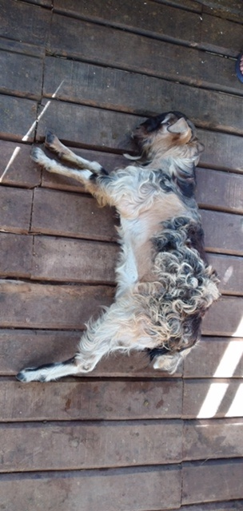
Figure 1: Dead cross bred Goat (vicitim)
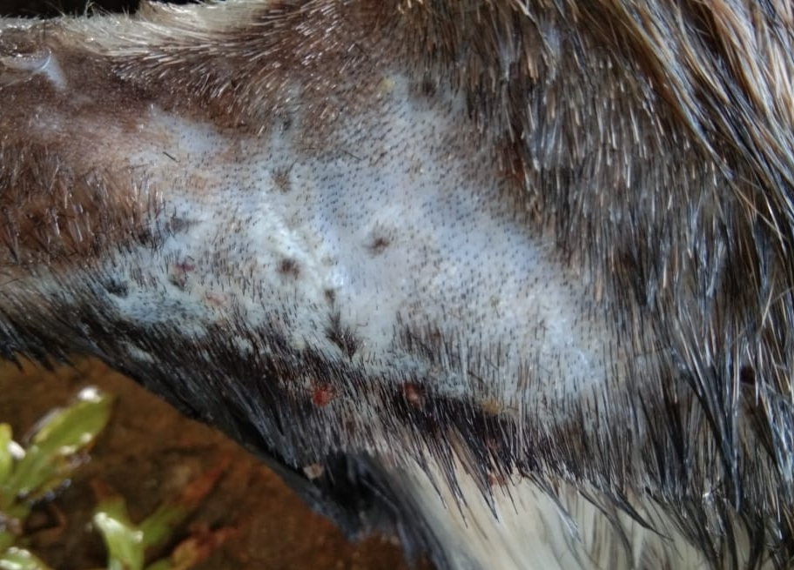
Figure 2: Spot of snake bite in the Cross bred Goat
Disclaimer (Artificial intelligence)
Option 1:
Author(s) hereby declare that NO generative AI technologies such as Large Language Models (ChatGPT, COPILOT, etc.) and text-to-image generators have been used during the writing or editing of this manuscript.
Option 2:
Author(s) hereby declare that generative AI technologies such as Large Language Models, etc. have been used during the writing or editing of manuscripts. This explanation will include the name, version, model, and source of the generative AI technology and as well as all input prompts provided to the generative AI technology
Details of the AI usage are given below:
1.
2.
3.

Reference
Mohapatra B, Warrell DA, Suraweera W, Bhatia P, Dhingra N, Jotkar RM ,Rodriguez PS, Mishra K, Whitaker R, Jha P. Snakebite mortality in India: A nationally representative mortality survey : PLoSNegl. Trop. Dis. 5, e1018; 2011.
Kabir A, Fathy W. Thoughts on Snake Species, Their Bites As Well As Management: 7 (7); 2022
Behler CM. Simon and Schuster's guide to reptiles and amphibians of the world :Simon and Schuster fireside Publishers, New York, 256 ;1989.
Roy A, Zhou XD, Chong MZ, Foo CS, Rajagopalan N, Nirthanam S, Bertrand D, Sivaraman J, Kini RM. Structural and functional characterisation of a novel homodimeric 3–finger neurotoxin from the venom of Ophiophagushannah(King Cobra): J. Biol. Chem, 285: 8302–8315; 2010.
Carswell D King Cobras can be found in many places in Thailand, majority being in the Khaosok: Cited in http://www.articlesalley.com; 2010.
Shea MO. Venomous snakes of the world: Princeton University Press. New Jersey, 160; 2005.
Punde DP. Snake bite (perspective of elapidae bites in rural Maharashtra) :Proceedings of SNA–CON 2008 at Little Flower Hospital, Angamaly Kerala ;2008.
Kabir A. Biography of a snake charmer in Saidpur, Bangladesh :MOJ Biol Med;3(4):151‒152, 2018
Greene HW. Snakes: The Evolution of Mystery in Nature: Berkeley, California: University of Berkeley Press. 351;1997.
Jiminez–Porras JM. Pharmacology of peptides and proteins in snake venoms: Annual Review of Pharmacology, 8: 299–318; 1968.
Lee CY. Chemistry and pharmacology of polypeptide toxins in snake venoms : Annu Rev Pharmacol, 12: 265–286;1972.
Chauhan RS: Textbook of Veterinary Pathology. IBDC publishers. Lucknow, 651;2010.
Farooq U, Irshad H, Ullah RW, Ullah A, Afzal M, Latif A, Zahur AB.. Snake Bite in Jersey Cattle; a Case Report: Research Journal for Veterinary Practitioners, 2 (5): 82 – 83; 2014.
Anyika KC, Govwang F, Omoniwa DO, Adah EJ. A Case of Snake Bite in a One-Year-Old Cross-breed Cow – A Case Report. Res Vet Sci Med. 4: 5 ;2024.
Kabir A. Snakes’ Availability and its Biting Record in Rangpur Carmichael College, Bangladesh: J. Biol. Chem. Research; 30 (1): 319-328; 2013.

