Ecological Assessment and QGIS-Based Resource Mapping of Nypa fruticans (Nipa) (Wurmb, 1779) in Catarman, Northern Samar, Philippines

ABSTRACT
In Catarman, Northern Samar, approximately 15 typhoons enter the region annually, intensifying the importance of resilient coastal vegetation. Nypa fruticans (Wurmb, 1779) supports biodiversity by providing habitat for various species and plays a crucial role in stabilising coastlines. This study assessed the ecological function and resilience of Nypa fruticans to the physicochemical properties of its environment. QGIS mapping was used for the interpretation of the Nipa population distribution by determining the total area of the study site and the number of Nipa trees by spacing distance per square meter area. It involved the evaluation of nipa population distribution, water quality parameters (DO, pH, salinity, temperature, TDS, TSS, turbidity), soil characteristics (moisture, pH, porosity, temperature, and soil type), the presence of macrofauna, and anthropogenic activities in the area. Identification of Macrofauna was done through direct observation, collection of the macrofauna, and photo documentation in the study site during the morning and survey during the afternoon. QGIS-based spatial analysis identified a dense Nipa population in Map A, covering 7,275 ft² with 354 groups per acre across all three sampling sites. These findings indicate a robust habitat that supports active species propagation and dispersal. Most water quality indicators complied with the DENR 2016 standards, except for DO and TSS, which exceeded the allowable limits. Soil moisture, pH, porosity, and temperature remained within acceptable ranges, and the dominant soil types were classified as dark brown and silt clay loam. However, low nitrogen, moderate phosphorus, and low potassium levels were observed, potentially limiting nipa growth and affecting leaf, root, and overall plant resilience. Macrofauna species exhibited tolerance to environmental fluctuations but showed sensitivity to pollution, which may lead to increased mortality and reduced biodiversity. Additionally, anthropogenic disturbances such as pollution and habitat destruction pose further threats to the local ecosystem. The study showed that the study area requires environmental impact assessment, sustainable resource management, public health, and Nipa palm seedlings had a higher survival rate than mangrove propagules. This study underscores the intricate balance between Nypa fruticans’ ecological contributions, environmental quality, and human activity, highlighting the need for informed conservation and management strategies.

Keywords: QGIS, physicochemical, macronutrients, Nipa, macrofauna, anthropogenic

1. INTRODUCTION
“Nypa fruticans (Nipa) palm is a kind of estuarine plant distributed from Africa, South Asia, and Indonesia to the West Pacific. It is an important mangrove palm species, but it is understudied due to a lack of information on genetic patterns within its distribution range” (Mantiquilla et al.,2022; Prasetyo et al.,2025). It grows up to 10 meters tall, depending on the habitat's fertility. It produces many propagules that are dispersed by ocean currents. In the Niger Delta, it invades deforested and exposed mudflats and forms dense monospecific stands which outcompete native mangrove species. “Mangrove forests currently occupy 14,650,000 ha of coastline globally, with an economic value on the order of 200,000–900,000 USD” (Alongi,2008).

Numerous areas in Northern Samar are occupied by Nipa palm (Lim et al., 2020). These species are more at risk of erosion, destabilising foreshores, and increased water turbidity. The lack of pneumatophores in the Nipa may also affect sedimentation processes. “Nipa palm, a species of palm that grows along the coastlines and habitats, can be one possible solution to the problem of the food crisis that the country will soon be facing, according to the World Agroforestry Center Philippines” (Dagalea et al.,2022; Mateo et al.,2022).”This mangrove palm species, with origins dating back to the Late Cretaceous period, is a unique species for investigating long-term adaptation strategies to intertidal environments and the early evolution of palms” (Wu et al.,2024; Choi et al.,2022). In the study area, Nipa palm serves as the first line of defense against the impacts of tsunamis and cyclones that reduce the damages in coastal zones, especially since the study site, barangay Bangkerohan, Catarman Northern Samar has about 15 typhoons enter the region each year. “Large numbers of coastal ecosystems globally are subjected to concurrent hypoxic and acidified conditions that will likely intensify and expand with continued climate change” (Tomasetti et al., 2018). Nipa palm has also been used as a food packaging material (Cu et al., 2024) and a precursor for the biosynthesis of zinc oxide nanoparticles (Lim et al., 2020).

A high water quality with sufficient nutrient availability and salinity enables the species to maintain continuous growth and a healthy population. However, there has been a significant increase in the natural levels of heavy metals in the aquatic ecosystems because of industrial activities and urban development. At certain levels, any chemical elements in water can be dangerous to hydrophyte plants like Nypa fruticans. Therefore, a study on water properties is needed to detect the levels of heavy metals, major metals, trace elements, and nutrients in water, and determine their effects, since this species is constantly inundated.
In the selected areas of Mindanao, the Philippines, Mantiquilla et al. (2020) underscored that “Nipa is a potential source of biofuel, which requires an understanding of the palm’s nutrition to increase sap yield. Initial baseline data on the nutrient levels of Nipa were determined from its natural habitats in Mindanao using foliar analysis. Results revealed that nipa palms thrived in various soils from clayey, loamy, to sandy clay loam types”. “Newly developed shoots are to be used as a vermicide. Ash from the Nipa palm is an analgesic against tooth pain and headache. Dry leaves, petioles, stem wood, fruit residues, etc., are used as fuel. In fishing, rhizomes of Nipa palm are extensively used, facilitating the fishing net to float over the water surface. Farmers also report that the Nipa palm in the river or sea attracts deep-water fish” (Hossain, 2015). Elemental variations were observed across sampling sites owing to their locations in the estuaries, human activities, and soil pH. Nutrient levels of nipa palm were observed in selected sites of Mindanao. Initially, nutrient analysis was conducted using leaf rank 2 supplemented with the physicochemical properties from topsoil and subsoil, grown on nipa palms. Generally, nipa palms are found to be growing in clay to sandy clay loam soils in Mindanao. Particularly, the Talomo stands in Davao City occurred in sandy clay loam to clay loam soils characterised by pH 4.9 to 6.1 with high organic matter content and cation exchange capacity. Soil chemical analysis revealed that sodium and chlorine concentrations were high both in topsoil and subsoil, ascribed to the regular flooding of brackish water in the estuary.

This work assesses the ecological function and resilience of Nypa fruticans in response to physicochemical variabilities in Barangay Bangkerohan, Catarman, Northern Samar. QGIS mapping was used for the interpretation of the Nipa population distribution by determining the total area of the study site and the number of Nipa trees by spacing distance per square meter area. Physicochemical properties of water include (DO, pH, salinity, temperature, TDS, turbidity, TSS, and turbidity) soil parameters include (color, macronutrients, moisture content, pH, soil porosity, temperature, and type of soil), the macrofauna present in the area, and anthropogenic activities in the study area.

2. METHODOLOGY
2.1 Assessment of the Nipa population distribution
In assessing the Nipa population, QGIS mapping was used for the interpretation of its distribution by determining the total area of the study site and the number of Nipa trees by spacing distance per square meter area.

2.2 Estimated number of trees per square meter
The total area through QGIS mapping / [ (spacing of trees in meters for direction 1) x (spacing of trees in meters for direction 2) ].

2.3 Determination of the physicochemical properties of water samples

pH
An on-site digital pH meter was placed in the water sample after the collection. After 1 minute, the registered pH was recorded. This is done in three (3) trials.

Temperature
The temperature of the water sample was determined using a digital thermometer. The thermometer was submerged immediately below the water surface for 5 minutes.

Salinity
The salinity of the water sample was also tested on-site after the collection of the water sample. A drop of the water sample was placed on the glass side of the refractometer.

Dissolved Oxygen (DO)
The dissolved oxygen of water was determined by the use of a Dissolved Oxygen (DO) meter. A 400 mL water sample was poured into the beaker, and the DO meter was placed in the beaker with the water sample.

Total Dissolved Solids (TDS)
The Total Dissolved Solids of water were determined by the use of a TDS meter.

Total Suspended Solids (TSS)
Place the filter paper in the filter flask. Mix the water sample well and pour it into a graduated cylinder to the selected volume. Then apply suction to the filter flask and seat the filter with a small amount of distilled water. Pour the selected volume into the filtration apparatus, then draw the sample through the filter into the filter flask. Rinse the graduated cylinder into the filtration apparatus with three successive 10 mL portions of distilled water, allowing complete drainage between each rinsing. Then, continue suction for three minutes after the filtration of the final rinse is completed. Finally, dry the filter in an oven at 80° for at least 1 hour, then weigh it on the analytical balance for the final weight of the filter paper.

TSS=$\frac{(A-B) X 1,000}{sample volume,mL}$
where:
A = weight of filter + dried residue, (g), and
B = weight of filter, (g).

Turbidity
The turbidity was measured using a turbidity meter to determine the vertical transparency of the river water.

Soil Sample Preparation And Analysis
The soil samples were air-dried in a ventilated room. The samples were then ground using a ceramic mortar and passed through a 2 mm sieve. Portions of the samples were oven-dried at 105° C for the moisture correction factors.

Soil Collection for Moisture Content Determination
The gravimetric method was used to determine moisture content. Here, an empty metal tin of weight is driven into the soil.

Classifying the Type of soil
In determining the type of soil, we used ocular, direct inspection on the study site, and soil texture during laboratory experiments in determining soil properties.

Determination of Soil Temperature
Soil temperature was determined by selecting an appropriate site, a pilot hole was made to a depth of 5 cm, and the temperature probe was inserted and read after 2–3 minutes.

Determination Of The Colour of The Soil
The determination of the colour of the soil was through the Munsell soil colour chart.

Soil Nutrients (macronutrients)
A soil sample testing tool kit was used for the identification of soil macronutrients from the Bureau of Soil and Water Management office in Manila, Quezon City. Analysis by the SOIL TEST KIT (SKT) is a quick method of evaluating the fertility status of soil. This involves chemical analyses that measure the amount of nutrients in the soil that are available to the plant. Results are interpreted and used as a basis for making a recommendation on what kind of nutrients the soil needs.

Moisture Content
Weigh both of the aluminium dishes. Aliquot approximately 50 g of moist soil into each aluminium dish and reweigh the dishes. Hence, the moist weight of the soil sample is now known. Dry the soil overnight at 105 °C in the oven for 24 hours. Remove the dishes from the oven and allow them to cool. Reweigh the dishes plus the oven-dry soil. Now the weight of the dry soil is known.

Calculate the soil moisture content for each of the replicate samples using the following equation.

${\% Moisture content= \frac{weight of moist soil \left(M\right)-weight of dry soil \left(D\right)}{weight of dry soil \left(D\right)}}_{}^{}$
Porosity

To measure porosity, a commonly employed laboratory method involves determining the volume of void space within a sample of soil and rock using the Water Displacement Method.

$$N=\frac{V void}{V total} x 100$$

where:
V void – pore space volume
V total – total volume.

$$N=\frac{ volume of water}{ total volume of material} x 100$$

Identification of Macrofauna Species Present In The Study Site
Identification of Macrofauna was done through direct observation, collection of the macrofauna, and photo documentation in the study site during the morning and survey during the afternoon.

Identify the Anthropogenic Activities That Affect The Area
Identification of anthropogenic activities in the study area was done through direct observation and photo documentation at the study site.

3. RESULTS and Discussion:
Findings revealed that among the three Map locations, Map A, with a total area of 7275 feet, has the highest Nipa population, followed by Map B, at 562 feet, and Map C, at 2754 feet. The Nipa with the biggest population (Map A) had the largest contribution to Nipa’s distribution and dispersal.

Table 1. Approximate number of groups of Nipa per acre based upon the distance in feet in a square grid pattern.

AREA | TOTAL AREA | SPACING (FEET) | NUMBER OF TREES/ACRE
MAP A | 7275 ft. | 5×4 | 364
MAP B | 562 ft. | 5×4 | 28
MAP C | 2754 ft. | 5×4 | 138

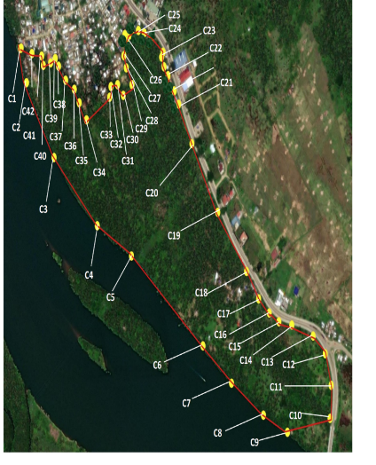
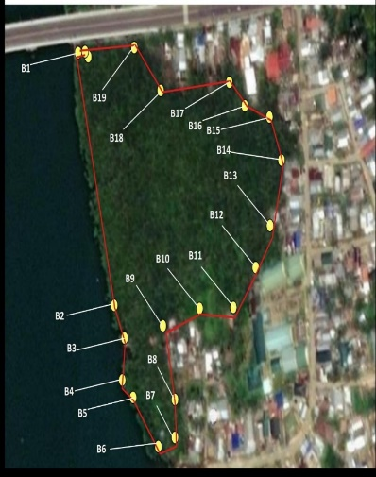
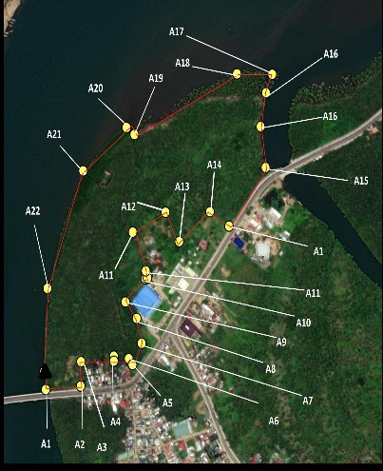

MAP C
MAP B
MAP A

Figure 1. Summary of the Total Number of Groups of Nipa per acre Based Upon the Distance in Feet in a Square Grid Pattern in Barangay Bangkerohan.

Table 2. Summary of the Environmental Parameters of Water in the Study Site, Barangay, Bangkerohan, Catarman, Northern Samar.

Physicochemical Properties of Water | Average | DENR Standard of 2016 | Interpretation
DO | 12.54 mg/L | 5–8 mg/L | Above the permissible limit of DENR Standard 2016
pH | 7.7 pH | 6.0–9.0 pH | Within the permissible limit of DENR Standard 2016
Salinity | 26.573 ppt | 1ppt-33pt | Within the permissible limit of DENR Standard 2016
Temperature | 30.2° C | 20°C–35° C | Within the permissible limit of DENR Standard 2016
Total Dissolved Solids  (TDS) | 8602 ppm | 1,000–10,000 mg/L | Within the permissible limit of DENR Standard 2016
Total Suspended Solids (TSS) | 327.7 mg/L | 110 mg/L | Above the permissible limit of DENR Standard 2016
Turbidity | 1.9 NTU | 2.5 NTU | Within the permissible limit of DENR Standard 2016

Table 3. Summary of the Environmental Parameters of Soil in the Study Site, Barangay, Bangkerohan, Catarman, Northern Samar.

Physicochemical Properties of Soil | Average | DENR Standard of 2016 | Interpretation
Color | Dark brown | - | Dark brown
Moisture Content | 53% | 35% – 65 % | Within the permissible limit of DENR Standard 2016
pH | 5.7 pH | 5.0 pH – 7.0 pH | Within the permissible limit of DENR Standard 2016
Soil Porosity | 35% - 60 % | 53% | Within the permissible limit of DENR Standard 2016
Temperature | 29.8° C | 28–32° C | Within the permissible limit of DENR Standard 2016
Type of Soil | Silt clay loam | - | Silt clay loam

Table 4. Summary of the Environmental Parameters (Macronutrients) of Soil in the Study Site, Barangay, Bangkerohan, Catarman, Northern Samar.

Macronutrients | BSWM Standard of 2022 | Result | Interpretation
Nitrogen (N) | Very High  (> 4.5)  High  (3.6 to 4.5)  Medium  (3.1 to 3.5)  Low  (0 to 2) | Low  (0 to 2) | Within the permissible limit of BSWM Standard of 2022
Phosphorus (P) | Moderately Low  (7 to 10 ppm)  Low  (0 to 6ppm)  High (16 to 20ppm)  Moderately High (11 to 15ppm)  Very High (More than 20ppm) | Moderately High (11 to 15 ppm) | Within the permissible limit of BSWM Standard of 2022
Potassium (K) | Sufficient +  Sufficient  Low  Sufficient +++  Sufficient ++ | Low | Within the permissible limit of BSWM Standard of 2022

Table 5. Macrofauna Species in Barangay, Bangkerohan.
FAMILY NAME | SCIENTIFIC NAME | ENGLISH NAME | LOCAL NAME
Family Carangidae | Caranx Ignobilis | Giant Trevally | Talakitok, Mamsa
Family Gerredae | Gerres abbreviatus | Deep-body Silverbelly | Amorok
Family Haemulidae | Plectorhinchus gibosus | Sweetlips | Gulyabaw
Family Leiognathidae | Leiognathus equulus | Common Ponyfish | Sapsap
Family Leiognathidae | Gazza dentex | Ponyfish, Slipmouth | Sapsap
Family Lutjanidae | Lujanus spp. | white snapper | mayamaya/agu ot
Family Mugilidae | Valamugil buchanani | Longarm Mullet | Balanak
Family Oxudericidae | Periophthalmus sp. | Mudskipper | Tambalo
Family Sesarmidae | Armes sp. | Square-back crab | Talangka
Family Siganidae | Siganus vermiculatus | Vermiculate | Samaral
Family Sphyraenidae | Sphyraena jello | Pickhandle Barracuda | Rumpi, Torsiyo
Family Terapontidae | Terapon jarbua | Terapon | Bagaong, Gonggong

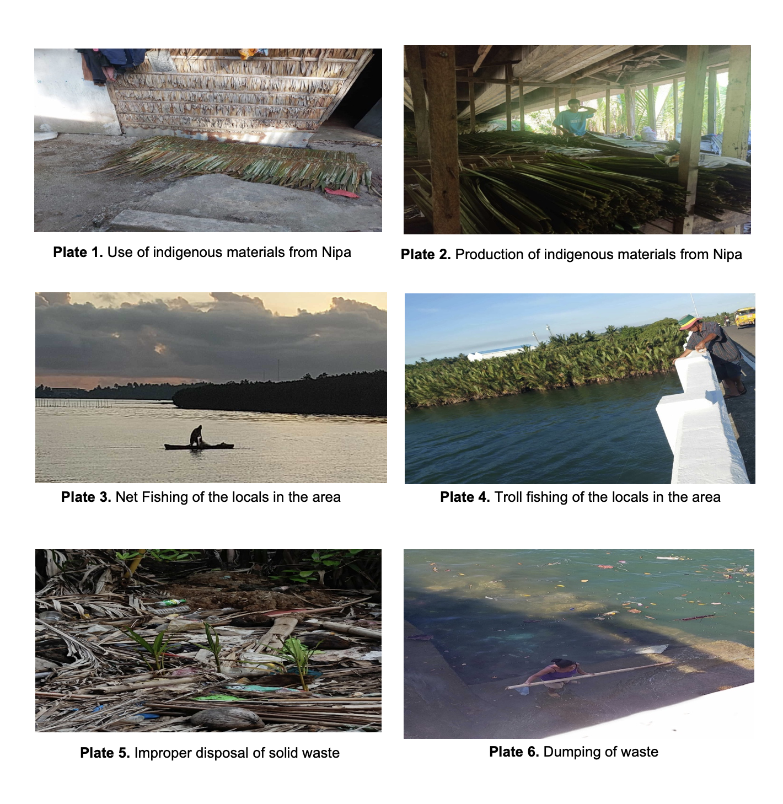

Table 1 and Figure 1, using QGIS (2024), show that Map A, with a total area of 7275 feet, has the highest Nipa population, According to our findings, among the three Map locations, Map A has the largest Nipa population, followed by Map C, at 2754 feet, and Map B, at 562 feet. The largest Nipa population (Map A) also had the largest contribution to Nipa’s population distribution and dispersal, and could supply valuable plant items for food, traditional herbal medicine, and other forest and wood goods. The saltwater and freshwater environments that mangroves cross are both protected by them. The silt and sediment that rivers and tides bring out to sea are collected by nipa roots. The trees prevent erosion by stabilising shorelines through retaining dirt in situ. All mangrove species have laterally spreading roots with attached vertical anchor roots that act as the first line of defence in coastal areas (NOAA, 2024).

The physicochemical properties in the water (i.e., pH, salinity, temperature, total dissolved solids, total suspended solids, and turbidity) or in the soil (i.e., color, moisture content, pH, macronutrients, soil porosity, temperature, and type of soil) play a vital role in determining the resilience of ecosystems, including those inhabiting the Nipa area. For the physicochemical properties of water (Table 2), pH, Salinity, Temperature, Total Dissolved Solids, and Turbidity are within permissible limits of the standard, while Dissolved Oxygen and Total Suspended Solids were above the permissible limit.

On the other hand, the physicochemical properties of soil, including Moisture Content, pH, Soil Porosity, and Temperature, are all within the permissible limit of the standard. Thus, excess organic material in lakes and rivers can cause eutrophic conditions, which is an oxygen-deficient situation that can cause a water body to "die” (U.S. Geological Survey, 2018). Water quality and soil texture appear to be highly significant factors for the growth of Nypa fruticans, with growth determined by: Ca, Fe, Al, As, chloride, sulphate, and nitrate; salinity in water; and silt and clay fractions in soil (Zakaria et al., 2017).

Tables 3 and 4 show how Macronutrients in the soil, such as Nitrogen and Phosphorus, appear to be low, while potassium is moderately high. The type of soil was silt loamy clay in the study area. Understanding these factors in conserving and managing Nipa palm populations for optimal growth, especially in the face of environmental changes and human activities that have a massive impact, that affect estuarine and coastal conditions, is vital.

The twelve 12 macrofauna species (Table 5)be found in the study area are mostly organisms that can tolerate and thrive within these environmental conditions, within the permissible limit of these physicochemical parameters. The physicochemical properties of water and soil are critically important for these species that can be found in the study area because they directly affect their survival, health, and reproductive success. Macroinvertebrates in the coastal areas are also very important to aquatic ecosystems. They are food for vertebrates, and their biodiversity serves as a testament to the quality of their habitats (Kabata et al., 2019). Soil temperature varies seasonally and daily, which may result from changes in radiant energy and energy changes taking place through the soil surface. It governs the soil's physicochemical and biological processes and also influences the interspheric processes of gas exchange between the atmosphere and the soil (Onwuka, 2016). Soil conditions were considered to affect nipa height; therefore, principal component analysis (PCA) has been used to elucidate the relationships among soil properties. As a result, three factors were extracted (Matsui 2016). The importance of humans and a variety of coastal organisms has been well documented (Polidoro, 2010).

Regarding anthropogenic activities (Plates 1 –6) in the study area, we included 9 nine human activities that caused harm and disruption in the environment. This shows that the study area requires environmental impact assessment, sustainable resource management, public health, and Nipa palm seedlings had a higher survival rate than mangrove propagules. Mangrove propagules in lowly polluted soil showed a higher survival rate than propagules in highly polluted soil, thus, pollution had an effect on seedling growth within species. Pollution also had an effect on species’ safety, regulatory compliance measures, and community engagement (Numbere and Camilo, 2016).

CONCLUSION

QGIS mapping determined Map A having the largest total area and, therefore, the approximate population group from all 3 three sites for Nipa. This confers Map A to contribute most to their propagation and dispersal. These areas serve as nurseries for marine life and provide food and shelter for diverse fauna, promoting higher biodiversity. The physicochemical properties of water from the sampling sites are characterized by pH, salinity, temperature, TDS, and turbidity within the permissible limit of the DENR (2016), which contribute to the growth and diversity of flora and fauna, while DO and TSS were above the permissible limit, affirming that flora and fauna species can tolerate such conditions that lead to stress. The physicochemical properties of soil, including moisture content, pH, soil porosity, and temperature were all within the permissible limit of the DENR standard of 2016. The soil colour was dark brown, affirming the presence of organic matter. The soil type was silt clay loam, making the soil more stable, reducing erosion, and providing a solid base for Nipa’s roots to anchor. This specifies that soil parameters contribute to Nypa fruticans and associated fauna in the area of its optimal growth and reproduction efficiently and tolerate environmental changes. Soil macronutrients show low Nitrogen, which affects poor leaf development, moderately high Phosphorus, which affects root development and plant strength, and low Potassium, which weakens plant resilience to other factors. Macrofauna species in the study area can tolerate certain changes in the environment, allowing them to reproduce and take shelter in Nipa, but they are at risk of pollution in coastal environments, contributing to mortality and diminishing biodiversity. Anthropogenic activities in the study area contribute to the mortality and diminishing growth of the site's flora and fauna, contributing to habitat destruction, pollution, and climate change.

Disclaimer (Artificial intelligence)
Option 1:
Author(s) hereby declare that NO generative AI technologies such as Large Language Models (ChatGPT, COPILOT, etc.) and text-to-image generators have been used during the writing or editing of this manuscript.
Option 2:
Author(s) hereby declare that generative AI technologies such as Large Language Models, etc. have been used during the writing or editing of manuscripts. This explanation will include the name, version, model, and source of the generative AI technology and as well as all input prompts provided to the generative AI technology
Details of the AI usage are given below:
1.
2.
3.

REFERENCES

Brysiewicz, A., Kowalska, A., & Kuczyńska-Kippen, N. (2022). Characterisation of benthic macroinvertebrate communities in small watercourses of the European Central Plains ecoregion and the effect of different environmental factors. Animals, 12(5), 606. https://doi.org/10.3390/ani12050606
Cu, Mae Ann A., Jessie T. Gento, Janeca L. Lagrimas, Flyndon Mark S. Dagalea, and Karina Milagros C. Lim. 2024. “Biodegradable Nypa Fruticans (Nipa) Starch-PVA Biocomposite Films for Food Packaging”. Asian Journal of Applied Chemistry Research 15 (4):26-33. https://doi.org/10.9734/ajacr/2024/v15i4294.
DENR (2016) Water and Soil Quality Guidelines and General Effluent Standard of2016
Hossain, M. F., & Islam, M. A. (2015). Utilization of mangrove forest plant: Nipa palm (Nypa fruticans Wurmb.). American Journal of Agriculture and Forestry, 3(4), 156–160. https://doi.org/10.11648/j.ajaf.20150304.16
Hossain, M. M., Noman, A. S., Begum, M. M., Warka, W. A., Hossain, M. M., & Musa Miah, A. S. (2023). Exploring Bangladesh’s Soil Moisture Dynamics via Multispectral Remote Sensing Satellite Image. European Journal of Environment and Earth Sciences, 4(5), 10–16. https://doi.org/10.24018/ejgeo.2023.4.5.415
Benkő, Z., Modi, I., & Tarkó, K. (Eds.). (2017). Leisure, health and well-being: A holistic approach. Palgrave Macmillan.https://doi.org/10.1007/978-3-319-58004-9:contentReference[oaicite:7]{index=7}
Numbere, A. O., & Camilo, G. R. (2016). Reciprocal transplant of mangrove (Rhizophora racemosa) and Nypa palm (Nypa fruticans) seedlings in soils with different levels of pollution in the Niger River Delta, Nigeria. Global Journal of Environmental Research, 10(1), 6–13.
https://idosi.org/gjer/gjer10(1)16/2.pdf
Department of Environment and Natural Resources – Environmental Management Bureau. (2016). DENR Administrative Order No. 2016-08: Water Quality Guidelines and General Effluent Standards of 2016. https://emb.gov.ph/wp-content/uploads/2019/04/DAO-2016-08_WATER-QUALITY-GUIDELINES-AND-GENERAL-EFFLUENT-STANDARDS.pdf
QGIS Development Team. (2024). QGIS Geographic Information System (Version 3.34) [Computer software]. Open Source Geospatial Foundation.
https://qgis.org/
Kabata, C., Charzyński, P., & Chodorowski, J. (2019). Polish Soil Classification, 6th edition – principles, classification scheme and correlations. Soil Science Annual, 70(2), 71–97. https://doi.org/10.37501/SSA.2019.70.2.09
Lim, K. M. R. C.-., Brensis, J. A. H., Dagalea, F. M. S., Bangco, M. J. M., Castillo, M. R., Pulga, H. G., Cruz, M. G. M., Erivera, J. L., Chiquito, F. M., Abobo, T. J. L., Madario, M. J., & Ultra, C. I. (2020). Extraction of Ethanol from Nypa fruticans (Nipa) Palm Fruit. Asian Journal of Physical and Chemical Sciences, 8(4), 41–45. https://doi.org/10.9734/ajopacs/2020/v8i430125
Lim, K. M. R. C.-., Dagalea, F. M. S., Adora, N. M., & Ultra, C. I. (2021). Antimicrobial Activity of Nypa fruticans (Nipa) Palm Starch and Zinc Oxide Nanoparticles (ZnONps) in Textile: Solving the Scarcity Using Local Resources. Journal of Pharmaceutical Research International, 32(38), 84–89. https://doi.org/10.9734/jpri/2020/v32i3831016
Mantiquilla, J. A., Salmasan, S. F. D., Obelidhon, M. K. A., & Abad, R. G. (2020). Nutrient status of Nipa (Nypa fruticans Wurmb.) in selected areas of Mindanao, the Philippines. BANWA B, 14, Article 12. https://doi.org/10.13057/babwa/b14012
Marcovecchio, J. E. (2017). Heavy metals, major metals, trace elements, and nutrients in estuarine ecosystems. Springer.
Matsui, N., & Takahashi, F. (2016). Determination of soil-related factors controlling initial Nipa (Nypa fruticans Wurmb.) growth in an abandoned shrimp pond. Environment and Natural Resources Research, 6(1), 125–135. https://doi.org/10.5539/enrr.v6n1p125
Numbere, A. O., & Camilo, G. R. (2016). Reciprocal transplant of mangrove (Rhizophora racemosa) and Nypa palm seedlings in soils with different levels of pollution in the Niger River Delta, Nigeria. Global Journal of Environmental Research, 10(1), 14–21.
Onwuka, B. M. (2016). Effects of soil temperature on some soil properties and plant growth. International Journal of Agriculture and Biology, 18(1), 125–130.
Polidoro, B. A., Carpenter, K. E., Collins, L., Duke, N. C., Ellison, A. M., & Lovelock, C. E. (2010). The loss of species: Mangrove extinction risk and geographic areas of global concern. PLOS ONE, 5(4), e10095. https://doi.org/10.1371/journal.pone.0010095
Tomasetti, S. J., Morrell, B. K., Merlo, L. R., & Gobler, C. J. (2018). Individual and combined effects of low dissolved oxygen and low pH on survival of early-stage larval blue crabs, Callinectes sapidus. PLOS ONE, 13(12), e0208629. https://doi.org/10.1371/journal.pone.0208629
U.S. Geological Survey. (2018). Dissolved oxygen and water. Water Science School. https://www.usgs.gov/special-topics/water-science-school/science/dissolved-oxygen-and-water
Zakaria, R.M., Aslezaeim N., and Sofawi, A.B. (2017). Effects of water properties and soil texture on the growth of a mangrove palm: Nypa fruticans on Carey island, Malaysia. Pak. J. Bot., 49(1):33-39. http://www.pakbs.org/pjbot/PDFs/49(1)/5.pdf

Dagalea, F. M. S., Flores Jr, A. A. U., Cortez,F.E., & Lim, K. M. C. (2022). Secondary Metabolite Screening of Extracted Oil from Nypa fruticans Wurmb.(Nipa Palm). AsianPlantResearch Journal, 9(3), 17-24.

Mateo, N. E. R., Ulep, R. A., Rosario, J. I., Lucas, M. P., Agrupis, S. C., Sagadraca, J. M., & Baga, C. C. (2022, April). Nipa Sap (Nypa fruitican) as Supplementary Feedstock for Bioethanol Production in the Philippines: The Pamplona Experience. In International Conference on Advances in Environment Research (pp. 19-28). Cham: Springer International Publishing.

Mantiquilla, J. A., Shiao, M. S., Lu, H. Y., Sridith, K., Sidique, S. N. M., Liyanage, W. K., ... & Chiang, Y. C. (2022). Deep structured populations of geographically isolated nipa (Nypa fruticans Wurmb.) in the Indo-West Pacific revealed using microsatellite markers. Frontiers in Plant Science, 13, 1038998.
Prasetyo, C. P., Effendi, A. J., & Chaerul, M. (2025). A journey toward sustainable biofuel: Unlocking the renewable energy potential of Nipa (Nypa fruticans) from mangrove forests in Indonesia.

Wu, W., Feng, X., Wang, N., Shao, S., Liu, M., Si, F., ... & He, Z. (2024). Genomic analysis of Nypa fruticans elucidates its intertidal adaptations and early palm evolution. Journal of Integrative Plant Biology, 66(4), 824-843.
Choi, H. J., Naznin, M., Alam, M. B., Javed, A., Alshammari, F. H., Kim, S., & Lee, S. H. (2022). Optimization of the extraction conditions of Nypa fruticans Wurmb. using response surface methodology and artificial neural network. Food Chemistry, 381, 132086.

Alongi, D. M. (2008). Mangrove forests: resilience, protection from tsunamis, and responses to global climate change. Estuarine,
coastal and shelf science, 76(1), 1-13.

