EGFR in Oncology: A Narrative Review of Mutations, Overexpression and Treatment Strategies

ABSTRACT
The epidermal growth factor receptor (EGFR) was the first member of a broad family of growth factor receptors with intrinsic tyrosine kinase activity. While lung cancer commonly exhibits point mutations and minor insertions within the kinase domain, brain tumours typically exhibit high abundance of EGFR and massive internal deletions. These factors led to the widespread use of EGFR and HER2/ERBB2 as targets for anti-cancer treatments. The association between EGFR expression and cancer prognosis is investigated in this review paper. EGFR, when activated by a ligand, starts a sequence of time-dependent molecular switches that govern genes that determine phenotype. These switches include up-regulation of freshly synthesised mRNAs, down-regulation of a large cohort of microRNAs, and covalent protein changes. Long non-coding RNAs and circular RNAs, in addition to microRNAs, are essential for EGFR signalling. EGFR is a multifaceted driver of metastasis, in addition to driver mutations. Targeted therapies against EGFR, including tyrosine kinase inhibitors and monoclonal antibodies, have significantly improved treatment outcomes in cancers such as non-small cell lung cancer and colorectal cancer. In this review, we discussed about how EGFR overexpression and mutations affect different types of human malignancies. Finally, we evaluated all anti-cancer medications that have received clinical approval that target EGFR and discuss recent advancements in therapy as well as in future possibilities.

KEYWORDS: Cancer, Epithelial growth factor receptor, Reverse transcriptase, Monoclonal Antibodies.

INTRODUCTION
Cancer and its causes
Cancer is a disease where uncontrollable cells grow and spread to other parts of the body. Cell division is the normal process of cell growth and multiplying to form new cells as needed. When abnormal or damaged cells proliferate, they may develop into tumors, which can either be malignant or benign. Malignant tumors invade surrounding tissues and have the potential to metastasize, spreading to distant sites and creating new tumors. While many cancers result in solid tumors, blood cancers such as leukemia typically do not. Cancer is also associated with aging, reflecting patterns seen in non-malignant diseases. Elderly patients diagnosed with cancer frequently have additional chronic and complex health issues that necessitate continuous care. The use of multiple medications can complicate cancer treatment and may require collaboration with various medical specialties. (1).
Cancer could arise from mutations in DNA within cells, affecting the cell's functions and growth. Errors in these instructions can lead to cell death, affecting the tissue’s overall health. “The International Agency for Research on Cancer (IARC) has identified several human viruses as carcinogenic, including human T-cell lymphotropic virus, human immunodeficiency virus, hepatitis B, C, papillomavirus, Epstein-Barr virus, and human herpes virus. Various factors contributing to cancer encompass sunlight exposure, tobacco use, pharmaceuticals, hormonal influences, alcohol consumption, parasites, fungi, bacteria, salted fish, wood dust, and certain herbs. Moreover, the World Cancer Research Fund and the American Institute for Cancer Research have recognized additional contributors, such as beta carotene, red meat, processed meats, diets low in fiber, obesity, and a lack of physical activity” (2).
Cancer Statistics
Cancer incidence increases with age, from 500 in 100,000 to 2000-4000 in 100,000, with patients living longer and potentially having chronic illnesses. The 5-year survival rate for many cancer sites exceeds 50%, indicating a growing prevalence of cancer in the aging population (3). In 2020, breast and lung cancers were the most common cancers worldwide, accounting for 12.5% and 12.2% of new cases, respectively. Colorectal cancer was the third most common cancer, with 1.9 million new cases, accounting for 10.7% of new cases. Lung cancer was the most common cancer in men, accounting for 15.4% of new cases, while breast cancer was the most common cancer in women, accounting for 25.8%. The top three cancers, breast, colorectal, and lung cancers, contributed 44.5% of all cancers, excluding non-melanoma skin cancer.

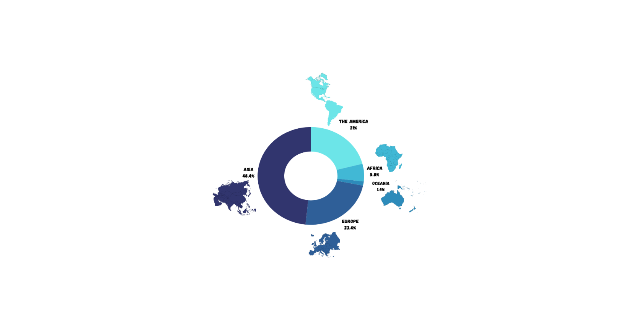
Figure 1: Global Cancer incidence

Cervical cancer was the fourth most common cancer in women, accounting for 6.9% of the total number of new cases diagnosed. Other common cancers contributing more than 5% were stomach and liver. Non-Hodgkin lymphoma, pancreas, leukaemia, oesophagus, kidney, melanoma of skin, brain, central nervous system, bladder, lip, oral cavity, multiple myeloma, gallbladder, vulva, nasopharynx, Hodgkin lymphoma, lynx, salivary glands, oropharynx, vagina, pharynx, Kaposi sarcoma, and mesothelioma was also prevalent. The top three cancers, lung, prostate, and colorectal cancers, contributed 41.9% of all cancers, excluding non-melanoma skin cancer. In the figure 1, global cancer incidence has been illustrated, continent-wise.

CANCER AND ITS GENETICS
Cells are the building blocks of the body, with each cell carrying a copy of its genes, which act as an instruction manual for protein production. Cancer can be caused by genetic changes in genes, which carry instructions for proteins or specialized RNA. These changes can raise or lower protein levels, or stop proteins that tell cells to self-destruct when damaged. Scientists believe that for a healthy cell to become cancerous, multiple DNA changes must occur. People with inherited cancer-related genetic changes may need fewer additional changes to develop cancer, but they may never develop these changes. Cancer cells acquire more DNA changes over time, and each person with cancer has a unique combination of these changes. In essence, cancer is a genetic condition that can be inherited or developed. While most genetic changes aren't harmful, an accumulation over time can turn healthy cells into cancerous ones. While cancer itself and genetic changes in tumor cells can't be passed down, a genetic change that increases the risk of cancer can be inherited if present in a parent's egg or sperm cells. For example, if a parent passes a mutated BRCA1 or BRCA2 gene to their child, the child will have a higher risk of developing breast and other cancers.
Cancer is a genetic disease affecting somatic cells, with tumor karyotypes often showing multiple abnormalities. The concept of cancer was first established through studies of tumor-specific translocations in leukemias and lymphomas, highlighting the role of oncogenes and gene transcription regulation. Hereditary cancer, where the autosomal dominant type is dominant, has led to the cloning of over 30 mutant genes. Penetrance to cancer depends on additional mutations, with most tumor suppressor genes regulating transcription or signal transduction pathways involved in cell birth, differentiation, and death. (4).
CANCER AND EGFR
Epidermal Growth Factor Receptor
By examining tumour tissue under a microscope, doctors can determine the forms of cancer and pinpoint DNA alterations that may contribute to tumour growth. These alterations, also known as molecular markers or biomarkers, are compared to a cell's instruction manual. A DNA mistake can cause cells to develop into cancer. Identification of possible candidates for targeted therapy is aided by biomarker testing. For example, a biomarker for non-small cell lung cancer is a mutation in the EGFR gene. Growth factors are hormone-like substances that can encourage the division and migration of healthy cells; however, cancer has discovered the underlying processes that allow tumour growth and metastasis to occur. We now go into the regulation of epithelial cells, which are the progenitors of all carcinomas, by the epidermal growth factor (EGF) and its corresponding cell surface receptor, known as EGFR. Together with the overproduction of EGF and its family members, tumours also overproduce EGFR, and certain malignancies of the brain, lung, and other organs are specific to mutant hyper-active versions of EGFR. (5).
EGF, originally 'tooth-lid factor', was discovered in 1962 by Stanley Cohen as a protein from the mouse submaxillary gland that accelerated incisor eruption and eyelid opening. It was later renamed EGF due to its ability to stimulate epithelial cell proliferation. “The amino acid sequence of EGF was determined in 1972, and its specific binding site, the EGF receptor (EGFR), was confirmed in 1975. EGFR is expressed in a wide range of human tumours, including those of the lung, head and neck, colon, pancreas, breast, ovary, bladder, and kidney, as well as gliomas” (6). EGFR (epidermal growth factor receptor) is a protein found on cells that aids in their proliferation. An overgrowth of the EGFR gene due to a mutation might result in cancer. Different kinds of EGFR mutations exist. The epidermal growth factor receptor (EGFR) is a member of the ErbB family of receptor tyrosine kinases (RTK) that activates trans-membrane proteins after binding with EGF-family proteins. “Amplification of the EGFR gene and mutations in the EGFR tyrosine kinase domain have been found in carcinoma patients, indicating a high likelihood of response to anti-EGFR agents. The interactions between ErbB proteins and ligands influence the type and duration of intracellular signals” (7).
Structure of EGFR
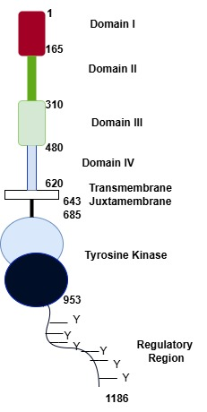
“The EGFR family of RTKs is made up of four members (together known as the ErbB or HER family): EGFR, ErbB2 (HER2/Neu), ErbB3 (HER3), and ErbB4 (HER4). Each ErbB receptor, like all RTKs, is composed of a sizable extracellular region, an intracellular juxtamembrane (JM) region, a single spanning transmembrane (TM) domain, a tyrosine kinase domain, and a C-terminal regulatory region” (8).

Figure 2: Structure of EGFR
“The extracellular region of EGFR consists of four domains: I-IV, also known as L1, CR1, L2 and CR2, or L1, S1, L2 and S2. Domains I and III share 37% sequence identity, while domains II and IV are cystine-rich. The N-lobe is light blue, while the C-lobe is darker blue. Amino acid numbers are noted for each domain boundary, with the conventional numbering system assuming amino acid one of EGFR as the first amino acid of the mature protein. In some recent papers, alternative numbering is used, including the signal peptide of EGFR. The cartoons depict the domains of EGFR, which are arranged in a β-helix fold, with domain I from pdb id 1YY9, and domains II and IV adopting extended structures with disulfide-bonded modules. There are two types of disulfide-bonded modules: one with a single disulfide bond and a bow-like arrangement, and the other with two disulfide bonds with consecutive cysteines linked in the Cys1–Cys3 and Cys2–Cys4 patterns. The inactive kinase is shown with the ATP analogue (AMP-PNP) in stick representation” (8). The overall structure of the EGFR has been described in figure 2.
Chromosome Location
“EGFR is found on the short arm of chromosome 7 (7p11.2), spans about 200 kb, has 28 exons, and encodes a 1210 amino acid protein. The control of EGFR expression is still not fully known, and a number of variables have been suggested to be involved. Specifically, "TATA" and "CAAT" sequences, which are regulatory elements for binding transcription factors, are present in the majority of eukaryotes and are situated 30–80 bp upstream of the start transcription site. The 5′ region of EGFRs is different from the 5′ area of most eukaryotes because it has more GC in the promoter region and less regulatory elements, which provide various start sites for the initiation of RNA transcription” (9).
SIGNALLING PATHWAYS
One of the most significant signalling routes in mammalian cells is the EGFR pathway, which controls a number of critical processes such as intercellular communication during development and proliferation, migration, differentiation, and death. The most well-studied EGFR functions occur in the context of ligand- and kinase-dependent activation, i.e. the 'canonical' EGFR signalling pathway (10). A mutation in one of this pathway's components will result in cancer in humans. Therefore, it has been regarded as the perfect therapeutic target. “Tyrosine residues in the intrinsic kinase domain of one receptor cross-phosphorylate particular residues in the C-terminal tail of the partnering receptor, which creates a scaffold for the recruitment of effector proteins and initiates EGFR signalling. This process is initiated by ligand-induced receptor dimerization” (11). Multiple signalling pathways have been described in the figure 3.
Figure 3: A heterodimer of EGFR and HER2 is schematically depicted, along with a few general signalling pathways that include adaptors.

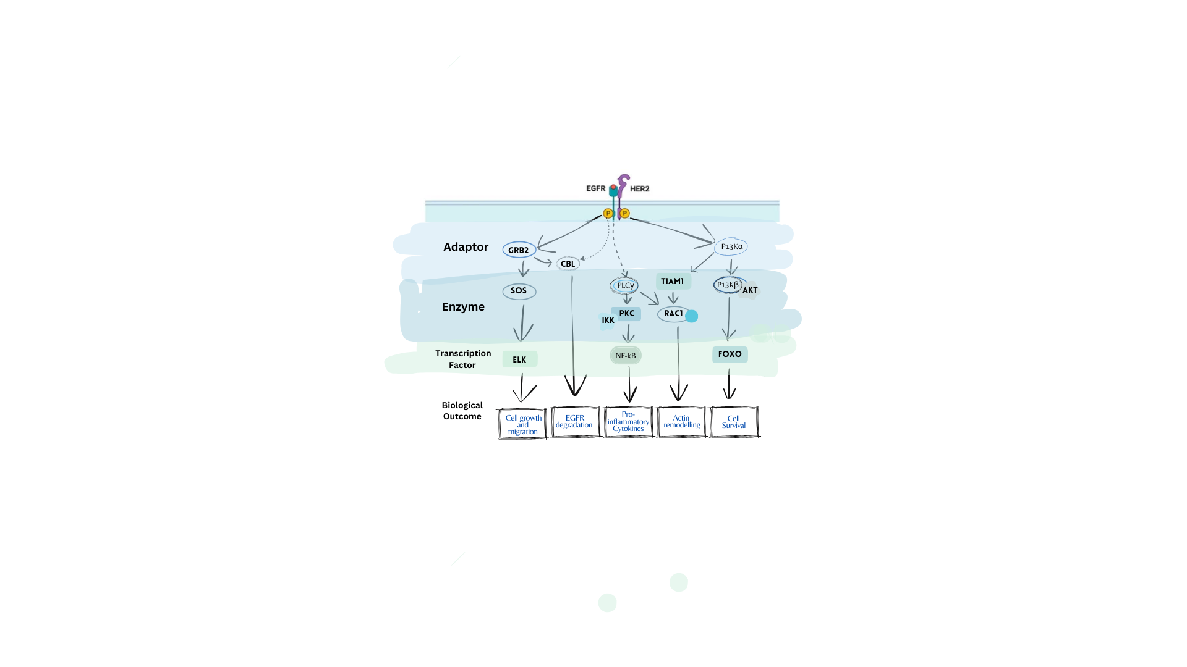

Fig 3. Multiple signalling pathways

Signaling proteins that possess src homology-2 (SH2) or phosphotyrosine binding (PTB) domains are capable of interacting with members of the EGFR family following their tyrosine phosphorylation. The p52 SH2 domain, which includes the α2 collagen-related protein (Shc), serves as an adaptor protein that binds to tyrosine-phosphorylated EGFR family members. Another adaptor protein, Growth Factor Receptor Binding Protein-2 (Grb2), can also associate with tyrosine-phosphorylated Shc and EGFR family members. Grb2 contains two src homology-3 (SH3) domains that interact with proline-rich PXXP motifs, establishing a connection with carboxy-terminal PXXP motifs in Sos-1, a member of the son of sevenless (Sos) family of guanine nucleotide exchange factors (GEFs). Sos-1 is recruited to the activated EGFR, positioning it near the p21 Ras family of guanine nucleotide-binding proteins. The isoforms of the p21 Ras family are activated upon binding to GTP, allowing Sos-1 to facilitate their activation by replacing GDP bound to these proteins with GTP. Once activated, the p21 Ras family members stimulate the Raf family of kinases, which subsequently activate the mitogen-activated extracellular signal-regulated kinase (ERK) activating kinase (MEK) family through the phosphorylation of regulatory residues. After dissociation, the active effector and adaptor proteins initiate their own signaling pathways, including phosphoinositide 3-kinase (PI3K), the KRAS-BRAF-MEK-ERK pathway, the anti-apoptotic AKT kinase pathway, the phospholipase C gamma pathway, and the STAT signaling system, all of which contribute to processes such as angiogenesis, migration, adhesion, and cell proliferation (12). Due to various mutations in different genes involved in these pathways, these biological functions are often disrupted in cancer cells
Discussion:
MUTATIONS IN EGFR FOR CERTAIN CANCERS
The EGFR protein, situated in the cell membrane, operates like a lock that permits the binding of other proteins. These proteins transmit signals to the cell, instructing it to grow and replicate. The EGFR gene acts as a blueprint for the protein, with mutations representing errors in this blueprint. Certain mutations, such as deletions or insertions, remove or add letters or words, whereas point mutations alter just a single letter. These alterations trigger EGFR's "grow and divide" signal, resulting in unregulated cell division, which may lead to cancer. Various types of cancers are linked to distinct mutations in the EGFR gene.
Lung Cancer
Lung cancer, primarily small-cell and non-small cell lung cancer (NSCLC), is a common form. Approximately 32% of NSCLC cases worldwide involve an EGFR mutation, with adenocarcinoma being the most common subtype. There are over 70 types of EGFR mutations, grouped into four types: classical EGFR mutations, which include common deletions and insertions, exon 20 insertions, T790M-like mutations, and P-loop αC-helix compression (PACC) mutations, accounting for nearly 90% of all EGFR mutations. Mutations in the EGFR gene are classified into three types based on their nucleotide changes. Class I mutations involve short in-frame deletions that result in the loss of four to six amino acids (E746 to S752) encoded by exon 19, while Class II mutations involve single-nucleotide substitutions that may occur throughout exons 18 to 21 and Class III mutations involve in-frame duplications and/or insertions that occur mostly in exon 20 (Figure 4). Exon 20 mutations might also be present in patients who test positive for an EGFR mutation. Exon 20 is more prevalent in Asian people and non-smokers, and it can account for up to 1 in 30 cases of lung cancer.
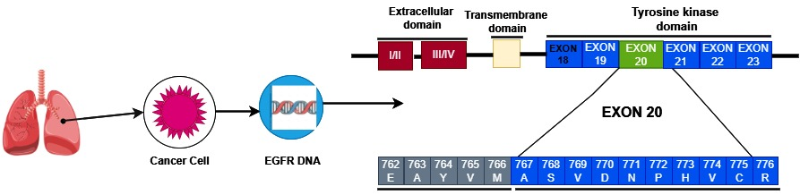

Figure 4: Exon 20 in EGFR DNA

“Among all TK domain mutations, 85-90% are exon 19 class I deletions and exon 21 L858R mutations. While initial reports suggested an almost equal distribution, recent clinical trials suggest a slightly higher frequency of deletions versus point mutations. A rare exon 22 mutation (E884K) has been reported that may confer differential sensitivity to different EGFR small-molecule inhibitors. The standard method to detect mutations is through direct sequencing of PCR-amplified genomic DNA corresponding to exons 18-22 of the EGFR gene. Samples with lower tumor cellularity should be enriched by micro- or macro-dissection of tumor cell-rich areas” (13).
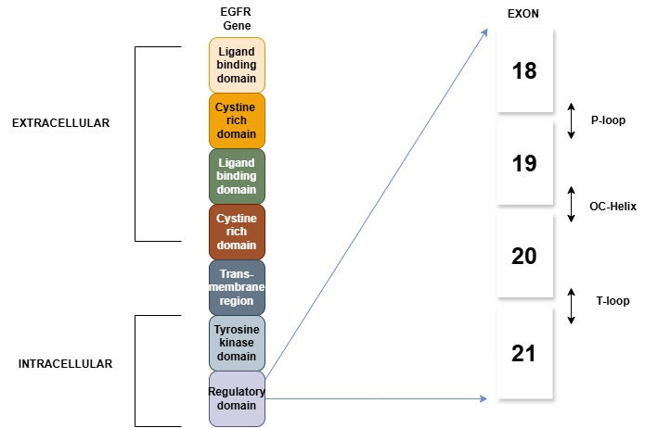
Table 1: Mutation type vs Frequency
MUTATION TYPE | FREQUENCY
Exon 18 | ~2%
Exon 19: deletions | 45-46%
Exon 20: S7681 T790M  Insertions | <1%  4%  ~1%
Exon 21: L858R  L861Q | 38-35%  1%

In figure 5, different types of extracellular and intracellular
Figure 5: Types of mutations in EGFR

mutations have been described and in the table 1, mutation types and their frequencies have been mentioned in detail.

Glioblastomas and Colorectal Cancer
A study examined the DNA of 59 glioblastomas and 293 colorectal tumours for changes in the EGFR kinase domain (exons 17–24) (14). These tumours were selected for analysis because EGFR signalling has been associated with them: glioblastomas have been reported to exhibit structural alterations of the EGFR gene (amplifications and rearrangements), and EGFR-targeted antibodies (cetuximab) have been approved for use in patients with colorectal cancer. All of the glioblastomas and only one colorectal carcinoma, according to our research, lacked a mutation. The one and only mutation was a G-to-S substitution at amino acid 719, the same activating mutation that has been linked to lung tumours in the past. Findings demonstrated that glioblastomas and colorectal tumours have relatively low frequencies of EGFR mutations.

Head and Neck Squamous Cell Carcinoma (HNSCC)
“EGFR mutations in head and neck squamous cell carcinoma (HNSCC) are rare when compared to instances of overexpression. Research focusing on resistance to cetuximab (CTX) in a patient identified a missense mutation in the extracellular domain (ECD) of EGFR at position 465th, which modified the interaction of CTX with domain III of the ECD, resulting in resistance. Additionally, other non-synonymous mutations within the ECD of EGFR, such as G33S and N56K, have been documented in an HNSCC cell line that was selected for CTX resistance. These mutations caused a reduced affinity for EGF binding, led to the constitutive activation of EGFR, decreased internalization for degradation, and maintained EGFR in an open, extended conformation, thereby obstructing CTX from reaching its binding site on domain III. Comparable mechanisms have been noted with EGFR ECD mutations in glioblastoma, where missense mutations at the interface between domains I and II resulted in the spontaneous release of the self-inhibitory tether, promoting oncogenic activity. The A289T mutation has been observed in glioblastoma multiforme, anaplastic astrocytoma, and lung adenocarcinoma, facilitating a ligand-independent transition to the active state. ECD mutations in EGFR across various tumors appear to exhibit a shared mechanism that circumvents steric inhibition, leading to unregulated signaling and the development of a resistant phenotype by hindering the binding of monoclonal antibodies to EGFR” (15).
OVEREXPRESSION OF EGFR IN DIFFERENT CANCERS
The EGFR protein is found to be overexpressed across a wide range of cancer types, and this overexpression is often associated with a negative prognosis. Numerous malignancies exhibit mutations in the EGFR gene, which typically lead to increased levels of the EGFR protein. High EGFR expression is significantly linked to unfavorable outcomes in patients with head and neck, ovarian, cervical, bladder, and esophageal cancers. In a review of 74 studies, 70% indicated that increased EGFR expression correlates with decreased rates of recurrence-free survival or overall survival. However, this association is less pronounced in gastric, breast, endometrial, and colorectal cancers, where only 52% of studies found a connection between elevated EGFR levels and poor survival rates, compared to over 70% in other cancer types. Additionally, in these cancers, EGFR levels were related to other clinically relevant factors. (16).
Lung Cancer
Epidermal growth factor receptor (EGFR) and HER2 are receptor tyrosine kinases located on the cell surface that initiate growth signals through dimerization with other members of the HER family. The overexpression of both EGFR and HER2 is associated with aggressive tumor cell proliferation. Gefitinib and erlotinib are EGFR tyrosine kinase inhibitors that demonstrate antitumor efficacy in 8-18% of patients with advanced non-small-cell lung cancer (NSCLC). These EGFR TK inhibitors may serve as prognostic and predictive tools for identifying patients who are likely to benefit from treatment. EGFR plays a crucial role in tumor development and is notably expressed in various human tumors, including NSCLC (17). Overexpression of EGFR has been observed in 40-80% of patients with non-small cell lung cancer, as well as in both premalignant and malignant lesions (18). This overexpression is primarily attributed to epigenetic mechanisms such as transcriptional activation, although gene amplification and oncogenic viruses may also contribute. Within tumors, the EGFR signaling pathway activates several networks, including MAPK, PLCg, PI3K/AKT, STAT, proto-oncogene transcription factors, and zinc-finger-containing transcription factors (19).
Head and Neck Squamous Cell Carcinoma (HNSCC)
The expression of EGFR in normal cells typically ranges from 40,000 to 100,000 receptors per cell. In head and neck squamous cell carcinoma (HNSCC), approximately 80–90% of cases exhibit overexpression of both EGFR and its ligand, TGF-α, with increases of 1.7-fold (P = 0.005) and 1.9-fold (P = 0.006), respectively, when compared to control samples. The observed protein overexpression is believed to result from enhanced transcription, as there is no significant change in mRNA stability, and instances of gene amplification are reported less frequently (20). TGF-α is involved in an autocrine signaling pathway in transformed mucosal epithelial cells, but this pathway is absent in normal mucosal epithelial cells. Antisense oligonucleotides that target the translation initiation site of TGF-α mRNA can reduce TGF-α protein levels by as much as 93% and decrease cell proliferation in human cell lines by an average of 76% (21). Notably, EGFR overexpression is already detectable in the "healthy" mucosa of cancer patients, a phenomenon known as field cancerization, even before the onset of cancer. This overexpression tends to escalate alongside the emergence of histological changes, including hyperplasia, invasive carcinoma, dysplasia, and in situ carcinoma. Thus, EGFR overexpression is recognized as an early event in the carcinogenic process of HNSCC (22).
Glioblastoma
“EGFR overexpression is prevalent in 60% of primary glioblastomas, a characteristic of aggressive glioblastoma phenotypes. This overexpression can be attributed to enhanced autocrine expression of cognate ligands. Deregulated EGFR expression and signaling are crucial in the origin of human cancers. This led to the development of EGFR-targeted monoclonal antibodies (mAB), such as mAB C225 69 and mAB 528. These mAbs compete with cognate ligands for binding, down-regulating receptor expression and inhibiting cell growth. Initially, mAB C225, dubbed cetuximab, showed promising antitumor effects in cell cultures and xenograft models, leading to its implementation as a therapeutic agent” (23).
Colorectal Cancer
The role of EGFR gene amplification and its elevated copy number in colorectal cancer remains ambiguous. Some research indicates that EGFR gene amplification is rare, while other studies report modest increases in copy number in as many as 50% of cases. Nevertheless, heightened expression of the EGFR protein does not necessarily indicate an increase in EGFR gene dosage. For instance, only a small percentage of EGFR-positive colorectal carcinomas identified through immunohistochemistry were linked to EGFR gene amplification. The predictive value of EGFR gene amplification is also uncertain. One investigation revealed that gains in EGFR gene copy number did not correlate with objective response rates, disease control rates, progression-free survival, or overall survival. In contrast, another study indicated that EGFR amplification or increased EGFR copy number was associated with a response to anti-EGFR therapy in 17.7% of patients. These contradictory findings may stem from the absence of established guidelines for assessing EGFR gene amplification, resulting in the infrequent testing for this amplification in colorectal cancer cases (24).
Breast Cancer
Breast cancer is a common form of cancer among women, with an increased risk of development linked to a family history of the disease, especially if a close relative was diagnosed before reaching menopause. In 2012, Europe reported around 494,000 new breast cancer cases, while the global total reached approximately 1.67 million. Projections indicate that by 2030, the worldwide incidence may rise to 2.3 million cases, although mortality rates in Western nations are decreasing due to advancements in early detection and treatment methods. Genetic factors account for roughly 5% of all breast cancer cases, with about 25% diagnosed at an early age, specifically before 30. Disruptions in various signaling pathways, including the dysregulation of the human epidermal growth factor receptor (HER) family, have been linked to the onset of breast cancer. The overexpression of HER1 and HER2, which are key partners in dimerization, correlates with a poorer clinical outcome and a diminished response to endocrine therapy (25).
Ovarian, Bladder and Oesophageal Cancer
Amplification and activating mutations of the epithelial growth factor receptor (EGFR) have been identified in a small percentage of ovarian cancer cases, specifically 4-22% and 4%, respectively. The rates of EGFR overexpression vary significantly, ranging from 9% to 62%, depending on the assay method, cutoff criteria, and antibodies utilized (26). Higher levels of EGFR expression are associated with poorer patient outcomes. In terms of treatment, several small molecule inhibitors that block EGFR kinase activity, such as gefitinib and erlotinib, have been explored. A novel therapeutic approach is being developed that leverages the overexpression of EGFR in bladder cancer cells alongside the strong cytotoxic effects of alpha-particles emitted from alpha-emitters. As previously noted, small molecule tyrosine kinase inhibitors specifically target EGFR (ErbB1), effectively binding to both the overexpressed wild-type EGFR and various mutant forms (27). The EGFR gene, situated on chromosome 7p12, encodes a membrane glycoprotein that activates its intrinsic kinase upon binding with specific ligands, such as EGF. Enhanced EGFR signaling is associated with multiple tumors, contributing to processes like invasion and metastasis. EGFR was initially isolated from the human squamous cell carcinoma cell line A431, which exhibits a 2-100 fold overexpression. Since then, numerous epithelial cancers, including esophageal cancers, have demonstrated elevated levels of EGFR on their cell membranes (28).
THERAPEUTIC ADVANCES
Conventional chemotherapy has limitations due to high toxicity and low tumor specificity, making EGFR an important target. Monoclonal antibodies like cetuximab, panitumumab, nimotuzumab, and necitumumab are approved for cancer treatment. Two main strategies are antibody-drug conjugates (ADCs) and antibody-nanoparticle conjugates (ANCs). ADCs are antibodies covalently linked to the cytotoxic drug, causing chemical and enzymatic reactions leading to drug release and accumulation.
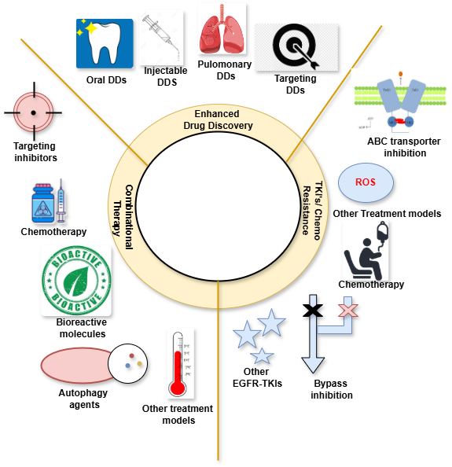
“ANCs are nanotechnology-based formulations that protect the drug against inactivation, allowing controlled release and passive accumulation in tumor tissues. They also undergo active targeting through EGFR receptor-mediated endocytosis, forming lysosomes and drug release into the cytosol” (29).

Figure 6: Cancer Therapy

Tyrosine kinase inhibitors (TKIs), antibody-based therapies, immunotherapy, and pre-clinical RNA therapy trials represent four approaches to targeting EGFR. Among these, TKIs are the most developed form of EGFR-targeting treatment. Antibody-based therapies utilize monoclonal antibodies to block signaling pathways and conjugated antibodies to specifically target certain cells. For EGFRvIII, immunotherapy employs an intradermal vaccine known as CDX-110 along with granulocyte macrophage-colony stimulating factor (GM-CSF). RNA therapies focus on designing antisense oligonucleotides or siRNA that are complementary to clinically relevant regions for silencing purposes (30, 31). Cancer treatment strategies are illustrated in Figure 6.
Tyrosine kinase inhibitors targeting EGFR
“Epidermal growth factor receptor (TKI) inhibitors gefitinib and erlotinib have been shown to significantly increase progression-free survival in non-small cell lung carcinoma (NSCLC) patients. A meta-analysis reported 42.9% of patients receiving TKI therapy reaching at least one year of progression-free survival compared to 9.7% with chemotherapy. Gefitinib has also been used as palliative therapy for patients with brain metastases from NSCLC, with 45% of patients experiencing symptom improvement. Combining gefitinib and erlotinib has shown response rates of up to 70%. Lapatanib, another tyrosine kinase inhibitor, was found to increase progression-free survival to 8.4 months when used in combination with capecitabine. However, lapatinib has not yet been shown to have activity against recurrent GBM in clinical trials. Pre-clinical results show that TKIs can inhibit tumor cell growth, angiogenesis, survival, and proliferation in various EGFR transfected GBM cell lines. However, response rates in GBM patients are disappointing for many inhibitors, possibly due to their efficacy targeting tumor cells that express mutations in exons 19 and 21 of the EGFR kinase domain” (31).
FUTURE PROSPECTS
Research suggests that factors within the tumor microenvironment, such as signals that promote fibroblast survival and inadequate blood vessel formation, can enable cancer cells to endure treatment with EGFR-TKI monotherapy. Clinical trials have demonstrated that combining angiogenesis inhibitors with EGFR-TKIs can extend progression-free survival (PFS). However, there is insufficient evidence to suggest that this approach improves the overall cure rate. The RELAY study reported no significant differences in the detection of T790M mutations during disease progression. Additionally, the use of angiogenesis inhibitors was associated with an increase in hypertension, affecting 23% of patients with CTCAE grade 3 or higher. Further research is required to elucidate the mechanisms underlying resistance and the factors contributing to resistance against angiogenesis inhibitors. A phase II trial that compared single-agent osimertinib to a combination of osimertinib and bevacizumab found no advantage in extending PFS for the combination group. Consequently, identifying a biomarker may be essential for stratifying patients who could benefit from combination therapy involving angiogenesis inhibitors (32-34).
NLR (Neutrophil-to-lymphocyte ratio) and CRP (C-reactive protein) serve as prognostic indicators in head and neck cancer. The use of immunosuppressive agents, specifically immune checkpoint inhibitors (ICIs), alters the tumor's micro-immune environment, thereby enhancing their role as prognostic biomarkers. Although the response rate in advanced cancer cases is relatively modest, the tumor suppression effect tends to be prolonged in patients with stable disease, attributed to the mechanisms of the host immune system. The CheckMate-141 trial demonstrates a significant advantage in treatment continuation while preserving the quality of life. Additionally, liquid biopsy tests have emerged as valuable tools for identifying microsatellite instability and tumor mutational burden, which may help predict responses to ICIs. ICI therapy presents a compelling treatment avenue for patients with head and neck squamous cell carcinoma (HNSCC). Looking ahead, there is potential for combining ICIs with molecular targeted therapies, such as VEGF inhibitors or anti-PD-L1 agents, which have received approval for other malignancies. Clinical strategies may involve the concurrent use of anti-PD-1 and anti-cytotoxic T-lymphocyte antigen-4 (anti-CTLA-4) antibody therapies. In summary, ICI therapy continues to be a promising option for patients with HNSCC (35).
Combination therapy is emerging as a significant approach in the development of treatments for patients with EGFR ex20ins mutations. Established medications such as mobocertinib, amivantamab, poziotinib, and furmonertinib are currently under investigation. At present, platinum-based chemotherapy is the predominant first-line treatment for EGFR ex20ins non-small cell lung cancer (NSCLC), yet existing therapies have proven inadequate. Ongoing clinical trials are assessing the safety and effectiveness of various combination therapies, including osimertinib with bevacizumab, afatinib in conjunction with cetuximab, and amivantamab paired with chemotherapy. Nevertheless, treating patients with EGFR ex20ins mutations poses significant challenges, primarily due to low detection rates stemming from the diverse and complex nature of insertions. Most approved indications and clinical trials have focused on second-line treatments, highlighting a considerable unmet need for effective first-line options. Further comprehensive research is required to address targeted drug resistance mechanisms, manage adverse events, and explore treatment alternatives following drug resistance (36).
CONCLUSION
The EGFR, a receptor prototype for receptor-tissue metalloproteinases (RTKs), has been the focus of extensive research on signal transduction cascades and receptor endocytosis, recycling, and degradation. However, new functions continue to emerge, some linked to unrecognized subcellular localizations. This could be exploited for cancer treatment by studying how membrane trafficking influences EGFR-targeted therapies, potentially increasing efficacy and preventing resistance to treatments. Simultaneous targeting of driver mutations and basic cellular processes has been proposed as a promising therapeutic approach (37, 38). EGFR, a key player in cancer progression, is linked to human malignancies and plays a crucial role in sustaining cell proliferation and promoting metastasis through paracrine loops. Non-coding RNAs, such as microRNAs, ln cRNAs, and circular RNAs, play complex regulatory functions in EGFR signalling. The response to EGFR activation is highly ordered and time-dependent, with wave-like epigenetic events preceding long-term commitments to specific cell fates. EGFR is seen as the axis of a layered network, acting with parallel networks and routes like NF-kB, hedgehog, and the Hippo pathway. The number of antibodies and kinase inhibitory drugs targeting EGFR is increasing, but resistance often develops in patients who initially respond to anti-EGFR drugs. Resolving drug resistance mechanisms can lead to higher granularity maps of signalling pathways and potentially prolong patient response (5).

Abbreviations:
EGFR – Epithelial growth factor receptor
RTKs – Receptor tyrosine kinases
mABs – Monoclonal Antibodies
ADCs – Antibody-drug conjugates
ANCs – Antibody-nanoparticle conjugates
HER – Human epidermal growth factor receptor

Disclaimer (Artificial intelligence)
Option 2: Artificial Intelligence (AI) was used only to correct grammatical & typological errors. No AI was used to write or improve the overall content.
Author(s) hereby declare that generative AI technologies such as Large Language Models, etc. have been used during the writing or editing of manuscripts. This explanation will include the name, version, model, and source of the generative AI technology and as well as all input prompts provided to the generative AI technology
Details of the AI usage are given below:
1. Grammarly - used only to correct grammatical & typological errors. No AI was used to write or improve the overall content
2.
3.

REFERENCES
1. Phillips JL, Currow DC. Cancer as a chronic disease. Collegian. 2010;17(2):47-50. doi: 10.1016/j.colegn.2010.04.007, PMID 20738055.
2. Blackadar CB. Historical review of the causes of cancer. World J Clin Oncol. 2016;7(1):54-86. doi: 10.5306/wjco.v7.i1.54, PMID 26862491.
3. Gerber LH. Cancer rehabilitation into the future. Cancer. 2001;92(4);Suppl:975-9. doi: 10.1002/1097-0142(20010815)92:4+<975::aid-cncr1409>3.0.co;2-b, PMID 11519023.
4. Knudson AG. Cancer genetics. Am J Med Genet. 2002;111(1):96-102. doi: 10.1002/ajmg.10320, PMID 12124744.
5. Uribe ML, Marrocco I, Yarden Y. EGFR in cancer: signaling mechanisms, drugs, and acquired resistance. Cancers. 2021;13(11):2748. doi: 10.3390/cancers13112748, PMID 34206026.
6. Mitsudomi T, Yatabe Y. Epidermal growth factor receptor in relation to tumor development: EGFR gene and cancer. FEBS Journal. 2010;277(2):301-8. doi: 10.1111/j.1742-4658.2009.07448.x, PMID 19922469.
7. Normanno N, De Luca A, Bianco C, Strizzi L, Mancino M, Maiello MR et al. Epidermal growth factor receptor (EGFR) signaling in cancer. Gene. 2006;366(1):2-16. doi: 10.1016/j.gene.2005.10.018, PMID 16377102.
8. Ferguson KM. Structure-based view of epidermal growth factor receptor regulation. Annu Rev Biophys. 2008;37:353-73. doi: 10.1146/annurev.biophys.37.032807.125829, PMID 18573086.
9. Jurišić V, Obradovic J, Pavlović S, Djordjevic N. Epidermal growth factor receptor gene in non-small-cell lung cancer: the importance of promoter polymorphism investigation. Anal Cell Pathol (Amst). 2018;2018:6192187. doi: 10.1155/2018/6192187, PMID 30406002.
10. Lemmon MA, Schlessinger J. Cell signaling by receptor tyrosine kinases. Cell. 2010;141(7):1117-34. doi: 10.1016/j.cell.2010.06.011, PMID 20602996.
11. Siwak DR, Carey M, Hennessy BT, Nguyen CT, McGahren Murray MJ, Nolden L et al. Targeting the epidermal growth factor receptor in epithelial ovarian cancer: current knowledge and future challenges. J Oncol. 2010;2010:568938. doi: 10.1155/2010/568938, PMID 20037743.
12. Yarden Y, Sliwkowski MX. Untangling the ErbB signalling network. Nat Rev Mol Cell Biol. 2001;2(2):127-37. doi: 10.1038/35052073, PMID 11252954.
13. Da Cunha Santos G, Shepherd FA, Tsao MS. EGFR mutations and lung cancer. Annu Rev Pathol. 2011;6(1):49-69. doi: 10.1146/annurev-pathol-011110-130206, PMID 20887192.
14. Barber TD, Vogelstein B, Kinzler KW, Velculescu VE. Somatic mutations of EGFR in colorectal cancers and glioblastomas. N Engl J Med. 2004;351(27):2883-. doi: 10.1056/NEJM200412303512724, PMID 15625347.
15. Nair S, Bonner JA, Bredel M. EGFR mutations in head and neck squamous cell carcinoma. Int J Mol Sci. 2022;23(7):3818. doi: 10.3390/ijms23073818, PMID 35409179.
16. Nicholson RI, Gee JMW, Harper ME. EGFR and cancer prognosis. Eur J Cancer. 2001;37:9-15. doi: 10.1016/S0959-8049(01)00231-3.
17. Hirsch FR, Varella-Garcia M, Cappuzzo F. Predictive value of EGFR and HER2 overexpression in advanced non-small-cell lung cancer. Oncogene. 2009;28;Suppl 1:S32-7. doi: 10.1038/onc.2009.199, PMID 19680294.
18. Merrick DT, Kittelson J, Winterhalder R, Kotantoulas G, Ingeberg S, Keith RL et al. Analysis of c-ErbB1/epidermal growth factor receptor and c-ErbB2/HER-2 expression in bronchial dysplasia: evaluation of potential targets for chemoprevention of lung cancer. Clin Cancer Res. 2006;12(7 Pt 1):2281-8. doi: 10.1158/1078-0432.CCR-05-2291, PMID 16609045.
19. Grandis JR, Sok JC. Signaling through the epidermal growth factor receptor during the development of malignancy. Pharmacol Ther. 2004;102(1):37-46. doi: 10.1016/j.pharmthera.2004.01.002, PMID 15056497.
20. Grandis JR, Tweardy DJ. Elevated levels of transforming growth factor alpha and epidermal growth factor receptor messenger RNA are early markers of carcinogenesis in head and neck cancer. Cancer Res. 1993;53(15):3579-84. PMID 8339264.
21. Grandis JR, Chakraborty A, Zeng Q, Melhem MF, Tweardy DJ. Downmodulation of TGF-alpha protein expression with antisense oligonucleotides inhibits proliferation of head and neck squamous carcinoma but not normal mucosal epithelial cells. J Cell Biochem. 1998;69(1):55-62. doi: 10.1002/(SICI)1097-4644(19980401)69:1<55::AID-JCB6>3.0.CO;2-U, PMID 9513046.
22. Rubin Grandis J, Melhem MF, Barnes EL, Tweardy DJ. Quantitative immunohistochemical analysis of transforming growth factor-alpha and epidermal growth factor receptor in patients with squamous cell carcinoma of the head and neck. Cancer. 1996;78(6):1284-92. doi: 10.1002/(SICI)1097-0142(19960915)78:6<1284::AID-CNCR17>3.0.CO;2-X, PMID 8826952.
23. Xu H, Zong H, Ma C, Ming X, Shang M, Li K et al. Epidermal growth factor receptor in glioblastoma [review]. Oncol Lett. 2017;14(1):512-6. doi: 10.3892/ol.2017.6221, PMID 28693199.
24. Krasinskas AM. EGFR signaling in colorectal carcinoma. Patholog Res Int. 2011;2011:932932. doi: 10.4061/2011/932932, PMID 21403829.
25. Alanazi IO, Khan Z. Understanding EGFR signaling in breast cancer and breast cancer stem cells: overexpression and therapeutic implications. Asian Pac J Cancer Prev. 2016;17(2):445-53. doi: 10.7314/APJCP.2016.17.2.445, PMID 26925626.
26. Sheng Q, Liu J. The therapeutic potential of targeting the EGFR family in epithelial ovarian cancer. Br J Cancer. 2011;104(8):1241-5. doi: 10.1038/bjc.2011.62, PMID 21364581.
27. Seidl C. Targets for therapy of bladder cancer. Semin Nucl Med. 2020;50(2):162-70. doi: 10.1053/j.semnuclmed.2020.02.006, PMID 32172801.
28. Hanawa M, Suzuki S, Dobashi Y, Yamane T, Kono K, Enomoto N et al. EGFR protein overexpression and gene amplification in squamous cell carcinomas of the esophagus. Int J Cancer. 2006;118(5):1173-80. doi: 10.1002/ijc.21454, PMID 16161046.
29. Santos E da S, Nogueira KAB, Fernandes LCC, Martins JRP, Reis AVF, Neto J de BV, et al. EGFR targeting for cancer therapy: Pharmacology and immunoconjugates with drugs and nanoparticles. International Journal of Pharmaceutics. 2021 Jan;592:120082.
30. Pan Q, Lu Y, Xie L, Wu D, Liu R, Gao W et al. Recent advances in boosting EGFR tyrosine kinase inhibitors-based cancer therapy. Mol Pharm. 2023 ;20(2):829-52. doi: 10.1021/acs.molpharmaceut.2c00792, PMID 36588471
31. Padfield E, Ellis HP, Kurian KM. Current therapeutic advances targeting EGFR and EGFRvIII in glioblastoma. Front Oncol. 2015;5:5. doi: 10.3389/fonc.2015.00005, PMID 25688333.
32. Tsubata Y, Tanino R, Isobe T. Current therapeutic strategies and prospects for EGFR mutation-positive lung cancer based on the mechanisms underlying drug resistance. Cells. 2021;10(11):3192. doi: 10.3390/cells10113192, PMID 34831415.
33. Soria JC, Ohe Y, Vansteenkiste J, Reungwetwattana T, Chewaskulyong B, Lee KH, Dechaphunkul A, Imamura F, Nogami N, Kurata T, Okamoto I, Zhou C, Cho BC, Cheng Y, Cho EK, Voon PJ, Planchard D, Su WC, Gray JE, Lee SM, Hodge R, Marotti M, Rukazenkov Y, Ramalingam SS; FLAURA Investigators. Osimertinib in Untreated EGFR-Mutated Advanced Non-Small-Cell Lung Cancer. N Engl J Med. 2018 Jan 11;378(2):113-125. doi: 10.1056/NEJMoa1713137. Epub 2017 Nov 18. PMID: 29151359.
34. Ramalingam SS, Vansteenkiste J, Planchard D, Cho BC, Gray JE, Ohe Y, Zhou C, Reungwetwattana T, Cheng Y, Chewaskulyong B, Shah R, Cobo M, Lee KH, Cheema P, Tiseo M, John T, Lin MC, Imamura F, Kurata T, Todd A, Hodge R, Saggese M, Rukazenkov Y, Soria JC; FLAURA Investigators. Overall Survival with Osimertinib in Untreated, EGFR-Mutated Advanced NSCLC. N Engl J Med. 2020 Jan 2;382(1):41-50. doi: 10.1056/NEJMoa1913662. Epub 2019 Nov 21. PMID: 31751012.
35. Kitamura N, Sento S, Yoshizawa Y, Sasabe E, Kudo Y, Yamamoto T. Current trends and future prospects of molecular targeted therapy in head and neck squamous cell carcinoma. Int J Mol Sci. 2020;22(1):240. doi: 10.3390/ijms22010240, PMID 33383632.
36. Hou J, Li H, Ma S, He Z, Yang S, Hao L et al. EGFR exon 20 insertion mutations in advanced non-small-cell lung cancer: current status and perspectives. Biomark Res. 2022;10(1):21. doi: 10.1186/s40364-022-00372-6, PMID 35418149.
37. Nagel R, Semenova EA, Berns A. Drugging the addict: non-oncogene addiction as a target for cancer therapy. EMBO Rep. 2016;17(11):1516-31. doi: 10.15252/embr.201643030, PMID 27702988.
38. Krishnasamy G, Parthasarathy S, Rajasekaran S, Raja TW, Andrea SG, Tharumasivam SV. Evaluation of Potential EGFR Inhibitors for Non-small Cell Lung Cancer: A Structure-based Virtual Screening and Molecular Dynamics Study. J. Pharm. Res. Int. [Internet]. 2024 Nov. 11 [cited 2025 Apr. 30];36(11):253-6. Available from: https://www.journaljpri.com/index.php/JPRI/article/view/7617

