Antiproliferative and acute toxicity assay of hydroethanolic extract of Smilax kraussiana as an ethnomedicinal plant

Abstract
This study investigated the antiproliferative and acute toxicity of the hydroethanolic extract of Smilax kraussiana using Allium cepa (onion) as a model, a very common plant in the Southern part of Nigeria, hence with unreported ethnomedicinal benefits. Phytochemical screening revealed the presence of bioactive compounds, including flavonoids, saponins, tannins, cardiac glycosides, steroids, and alkaloids, while anthraquinones were absent. Acute toxicity tests in mice yielded an LD₅₀ of 774.5 mg/kg, with severe toxicity observed at concentrations ≥1000 mg/kg. In the Allium cepa assay, the extract exhibited dose-dependent root growth inhibition, with near-complete suppression at 16 mg/ml, indicating potent phytotoxic (herbicidal) effects. Morphological changes, including root discoloration and reduced mitotic activity, were observed, with mitotic inhibition ranging from 7.29% (1 mg/ml) to 62.5% (16 mg/ml). Chromosomal aberrations and reduced cell division suggested genotoxic and antiproliferative properties, potentially linked to the bioactive compounds-mediated interference with cell signaling pathways. Thin-layer and column chromatography identified a steroidal component in the dichloromethane fraction, warranting further isolation. The results demonstrate the cytotoxic properties of S. kraussiana, reinforcing its ethnomedicinal applications while stressing the importance of controlled dosing given its toxicity at elevated levels. The observed antiproliferative activity indicates the potential ability of the plant extract to inhibit cell growth, which is a unique feature of anticancer agents, although additional in vivo research is necessary to confirm its safety profile and mode of action. These findings reveal the plant's dual functionality, thus serving as both a medicinal resource and a source of bioactive compounds with phytotoxic effects, offering valuable insights for pharmaceutical and agricultural applications.
Keywords: antiproliferative, cancer, phytochemicals, Smilax kraussiana, Allium cepa

Introduction
Smilax kraussiana Meisn., a member of the Smilacaceae family, is one of approximately 300-350 species within the Smilax genus distributed across temperate, tropical, and subtropical regions globally. This climbing flowering plant, also referred to as West African sarsaparilla (synonymous with Smilax anceps Willd.), thrives in savannas and forests of western tropical Africa and South Africa. Characterized by its robust, prickly stems reaching 5 meters in length, the vine features hooked thorns and coiled tendrils at leaf bases. Its alternate leaves (4–14 cm long) exhibit an ovate to nearly circular shape with leathery texture, prominent venation, and a mildly sweet-acidic taste. The plant produces unisexual flowers (3–5 mm) with greenish-white to brownish perianths, followed by purplish-black globose berries (8–10 mm) upon ripening (Adegoke et al., 1968; Sanjib et al., 2018).
Sarsaparilla (Smilax kraussiana) serves multiple therapeutic roles in traditional medicine, functioning as a tonic to enhance vitality, a diaphoretic to promote sweating, and diuretic to increase urine output. Its stimulant properties are known to boost metabolic activity and support glandular function. Additionally, Smilax species are traditionally employed to combat infections and inflammation, particularly those involving the skin and gastrointestinal tract (Tashnova et al., 2012).
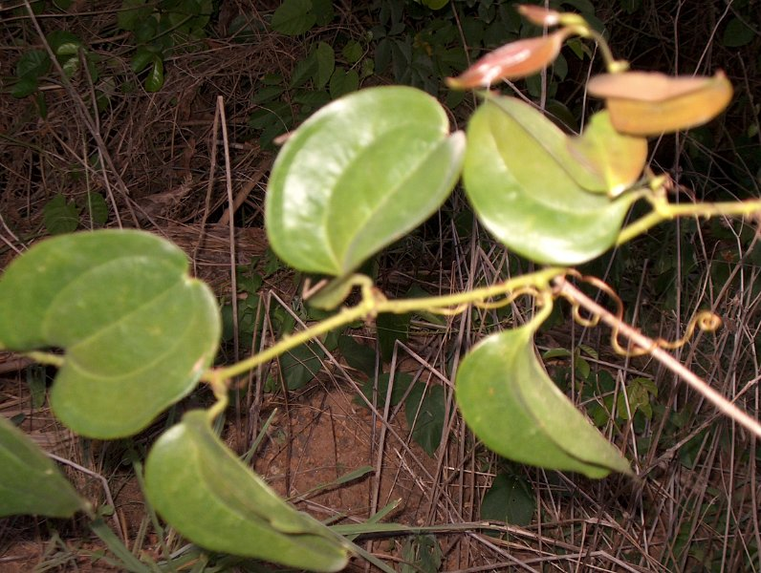
Figure 1. Leaves of Smilax kraussiana.

Across diverse cultures, the plant has been utilized to address a wide range of ailments, including gout, arthritis, fever, digestive issues, skin conditions (e.g., eczema, ulcers), venereal diseases (e.g., gonorrhea, syphilis), reproductive health concerns (e.g., infertility, menopause), and inflammatory disorders like rheumatism and psoriasis. Beyond medicinal applications, sarsaparilla is valued in the food industry as a flavoring and foaming agent in products such as root beer, candies, and dairy desserts (Espinoza-Pérez et al., 2021), as well as a taste-masking agent in pharmaceuticals (Coupland & Hayes, 2014). The plant's bioactive constituents, including parillin (smilacin), alkaloids, flavonoids, saponins (e.g., sarsaponin), glycosides, and steroids, underlie its pharmacological effects. This study specifically evaluated the median lethal dose (LD50), general toxicity, and cytotoxic/genotoxic potential of S. kraussiana extracts on Allium cepa root meristem cells.

Methodology:
Collection of plant material and sample preparation
Dried plants of Smilax kraussiana were bought from Olosha herbal medicine market, Olosha Mushin, Lagos state. The plants were identified and authenticated by Mr. O.V. Akintola, retired agronomist at the Agrochemical division, National Oil and Chemical Marketing Company, now Con Oil. Debris was removed from the dried plants, and the plant was cut into smaller pieces. They were then placed in the oven at 40◦c for 24 hours for complete drying. The plants were then pulverized into powder using a kitchen blender.

Extraction and fractionation of the plant material
700g of powdered plant material was macerated in 4 liters of 30:70 aqueous-methanol solvent for seven days. The mixture underwent sequential filtration through cotton wool, followed by Whatman No.1 filter paper. The resulting extract was concentrated at 40°C in a water bath, yielding 66.853g of a dark brown, viscous residue. From this crude extract, 25g was aqueous-suspended and sequentially partitioned with n-hexane, dichloromethane, ethyl acetate, and butanol to obtain four fractions: n-hexane (1.476g), dichloromethane (2.088g), ethyl acetate (1.544g), and butanol (1.094g). The crude methanol extract was used for phytochemical screening, acute toxicity testing, and general toxicity/genotoxicity testing using Allium cepa. Thin layer chromatography was carried out on the crude extract and the different fractions to determine the components that are present. A further column chromatography was carried out on the dichloromethane fraction to separate the components into single spots.

Phytochemical screening of Smilax kraussiana
The methanolic extract of S. kraussiana was analyzed for secondary metabolites using established protocols (Odebiyi et al., 1978; Sofowora, 1993; Trease and Evans, 1989) with modifications from recent studies (Ogechukwu et al., 2021; Chukwuemerie et al., 2022; Nwankwo et al., 2022; Bunu et al., 2022, 2023a). Steroids/triterpenes were identified through two tests: (1) Salkowski test (reddish-brown precipitate at chloroform-sulfuric acid interface) and (2) Lieberman Burchard test (color transition from violet to blue-green). Anthraquinones were detected by ammonium-induced pink/violet coloration in the benzene layer. Saponins showed persistent frothing in aqueous solution, while cardiac glycosides produced a characteristic violet ring in the Keller-Killiani test.
Tannins were confirmed through: (1) Ferric chloride test (blue-black precipitate) and (2) bromine water discoloration. Alkaloid screening involved four precipitation tests: Mayer's (creamy), Dragendorff's (reddish-brown), Wagner's (reddish-brown), and Hager's (yellow). Flavonoids were identified by (1) sodium hydroxide-induced yellow coloration (reversible with HCl) and (2) Shinoda test (pink/red color with magnesium and HCl). These comprehensive tests confirmed the presence of diverse bioactive compounds in the extract.

Chromatography
The separation and isolation of the components of the extract was carried out using thin-layer chromatography (TLC) and column chromatographic methods.
Analytical thin layer chromatography
The phytochemical components were separated and analyzed using analytical thin layer chromatography (TLC). Methanol-reconstituted samples (crude extract and fractions) were carefully spotted 2 cm from the base of a TLC plate using capillary tubes, with 1 cm spacing between applications. After air-drying, the plate was transferred to a pre-cleaned chromatographic tank pre-saturated for 1 hour with N-hexane:ethyl acetate (2:1 v/v) mobile phase
The chromatographic separation was performed in a closed system with the plate positioned vertically, ensuring the sample origins remained above the solvent front. Component migration occurred through differential partitioning between the stationary phase and mobile phase, resulting in distinct bands. Post-development, separated components were visualized under UV light (254 nm and 356 nm) and by chemical staining (10% sulfuric acid spray followed by oven drying). The resolved spots were marked, counted, and their migration patterns recorded for further analysis.

Column Chromatography
The wet packing method was used in packing the silica gel into the column. Flash column chromatography was used for the chromatographic process. The dichloromethane fraction was mixed with some amount of silica gel using methanol in a beaker, the mixture was allowed to dry. 40g of silica was mixed with methanol to form a slurry, which was then introduced into the column, and the column was then stabilized. The dried mixture of dichloromethane fraction mixed with silica gel was gradually introduced into the column. On introduction of the sample into the column, the eluent was continuously added to the top of the column to avoid cracks that might form within the silica gel column if it dries up, making the components fall down the cracks instead of positioning between the mobile and stationary phases. Elution commenced with N-hexane (100%), followed by gradient elution with the introduction of ethyl acetate as summarized in Table 1. A total of 67 fractions were collected in test tubes. The different fractions obtained were spotted on TLC plates developed in the chromatographic tank and viewed under UV light at absorbance of 254 nm and 365 nm to determine the number of spots in each fraction.

Table 1. Column chromatography of the DCM fraction of Smilax kraussiana.
S/No. | Solvent system | Volume used | Fractions
1  2  3  4  5 | N-hexane 100%  N-Hex-ETA (97:3)  N-HEX-ETA (95:5)  N-HEX-ETA (90:10)  N-HEX-ETA (80:20) | 200ml  100ml  200ml  200ml  200ml | 0-1  2-5  6-12  13-20  21-29
6  7  8  9 | N-HEX-ETA (70:30)  N-HEX-ETA (60:40)  N-HEX-ETA (50:50)  N-HEX-ETA (30:70) | 200ml  200ml  200ml  400ml | 30-38  39-46  47-54  55-67
Note: N-HEX = N-Hexane, ETA = Ethyl acetate.

Fractions 5-30 were monitored by thin layer chromatography using the solvent system N-hexane: ethyl acetate (4:1). The fractions were pooled together based on their similarities observed on the TLC plates, and were further separated using Sephadex L-20.

Gel Filtration of Fraction 5-30
Sephadex L-20 was soaked in methanol for 5 hours, stirred to form a slurry, and then poured carefully into a column. Fractions 5-30, weighing 0.243g, were then fractionized with Sephadex and eluted with pure methanol, collecting 3 ml of the aliquot each. In all, 30 fractions were collected and attention was drawn to 20, 21,22,23,24, and 25 after being monitored by thin layer chromatography based on the prominent spot observed using N-hexane and ethyl acetate (9:1) as solvent system. A further analysis using nuclear magnetic resonance (NMR) and UV/VIS spectroscopy will be carried out in a further spectral study.

Lethal toxicity determination
The median lethal dose (LD₅₀) was determined following Lorke's method. Ten (10) animal groups, each comprising three mice, were established after an overnight fasting period. Test subjects received intraperitoneal injections of S. kraussiana extract at graduated doses ranging from 0.5 to 4.5 g/kg body weight, with administration volumes between 0.06 mL and 0.7 mL. Following treatment, all animals were monitored continuously for 24 hours to document mortality and observable toxicological symptoms. The resultant mortality data served as the basis for LD50 computation through established toxicological calculations.

Allium cepa bioassay
Following an adapted protocol from Rank and Nielsen (1993), uniform onion bulbs (84-90g, 4.5-5.0cm diameter) were prepared by removing outer scales and root plates while preserving root primordia. After 24-hour hydration in distilled water at 25°C in darkness, bulbs with 1-1.7cm roots were selected and randomly allocated to six treatment groups (n=2 bulbs/group). The control group (Group 1) received distilled water, while experimental groups (Groups 2-6) were exposed to serial dilutions (1-16 mg/mL) of S. kraussiana methanolic extract for 96 hours under identical conditions. Root growth parameters (length and number) were quantitatively measured to determine EC50 values. For cytological analysis, four roots per bulb were fixed in ethanol:acetic acid (3:1 ratio), stored in 70% ethanol, then hydrolyzed (1N HCl, 50°C) and stained (2% orcein). Cellular examination involved squash preparation microscopy (40×) with manual counting of 200 cells per slide using four slides per treatment.

Experimental Result
Percentage yield of the extract and the different fractions
The percentage yield was calculated using the formula:
%yield = Total weight of methanol extract× 100
Total weight of powdered plant
= 66.853 × 100
700
= 9.550%
N-hexane fraction: %yield= 1.476÷25*100 = 5.90%, DCM fraction: %yield = 2.088÷25*100 = 8.35%, Ethyl acetate fraction: %yield = 1.544 ÷ 25*100 =6.18%, Butanol fraction: %yield = 1.094 ÷ 25*100 = 4.38%

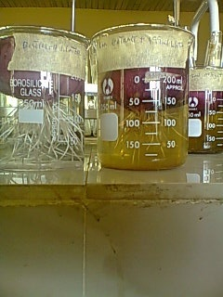
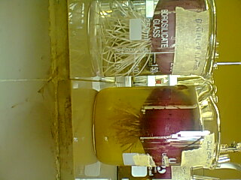
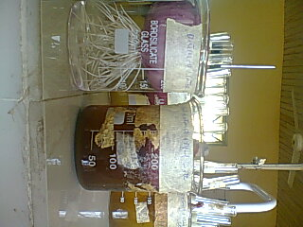
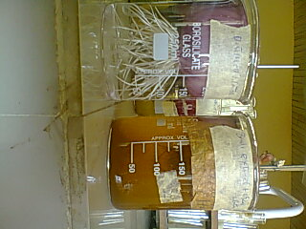
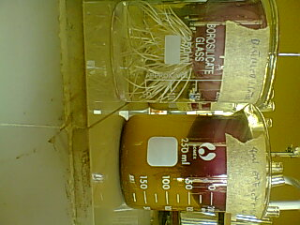
A
B
D
C
E

Figure 2. Plant concentrations (A) control and 1mg/ml concentration. (B) Control and 2mg/ml concentration. (C) control and 4mg/ml concentration. (D) control and 8mg/ml concentration. (E) Control and 16mg/ml concentration.

TLC analysis of the Sephadex fraction
Rf value = Distance moved by the substance (Ds)/Distance moved by the solvent front (Df).

Table 2. Rf value of the Sephadex LH20 fraction of TLC
Sample Tubes | Ds  (cm) | Df  (cm) | Rf value
6 (2 spots) | 2.0  1.4 | 3.4  3.4 | 0.59  0.41
7-9 (3 spots) | 3.3  2.0  1.4 | 3.4  3.4  3.4 | 0.97  0.59  0.41
10-15 (5 spots) | 3.1  2.8  2.2  1.2  0.7 | 3.2  3.2  3.2  3.2  3.2 | 0.97  0.88  0.68  0.38  0.22
16 (4 spots) | 3.1  2.8  2.2  1.2 | 3.2  3.2  3.2  3.2 | 0.97  0.88  0.68  0.38
17-20 (2 spots) | 3.1  2.2 | 3.2  3.2 | 0.97  0.68
21-25 (1spot) | 3.2 | 3.4 | 0.94

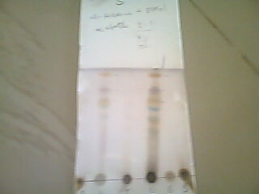

Figure 3. TLC of the plant extract and the different fractions

Phytochemical screening
Phytochemical screening carried out on the methanol extract shows the following phyto-constituents as summarized in Table 3.
Table 3. Phytochemical screening of the Methanol extract of Smilax kraussiana
Test | Observation | Inference | Result
Test for carbohydrate/starch. Molisch’s test. | Two layers were formed. The acid layer below the test solution, on shaking, a dark brown-green colour was observed. | Carbohydrate/starch present | +
Test for phenols | A green-black (dark) colouration was observed. | Phenol present | +
Test for flavonoids | A brick-red colouration was observed. | Flavonoid present | +
Test for saponins | Persistent Frothing on warming. | Saponin present | +
Test for tannins.  - Ferric chloride test.  - Bromine test. | A blue-black precipitate was observed.  Discolouration of the solution was observed. | Tannin present  Tannin present | +  +
Test for cardiac glycosides. | A violet ring was observed at the interface. | Cardiac glycoside present | +
Test for anthraquinones | No colour change was observed. | Anthraquinone absent | -
Test for steroidal/triterpene.  - Salkowski test. | A reddish-brown colouration was observed at the interface. | Steroidal/triterpene present | +
Test for alkaloids  - Dragendorf reagent  - Wagner’s reagent  - Hagger’s reagent  - Mayer’s reagent | A red precipitate was observed.  A turbid precipitate was observed.  A yellow precipitate was observed | Alkaloid present  Alkaloid present  Alkaloid present | +  +  +
+ = positive, - = negative

Acute toxicity test result
The toxicity test result shows that at 600 mg/ml concentration, no animal died, and at 1000mg/ml concentration, all animals died. The physical signs of toxicity range from decreased motor activity with intermittent stretching, increased respiratory rate, restlessness, gasping, and death.
Figure 4. Acute toxicity test. LD₅₀ = (1000 x 600)^{1/2} = 774.5mg/kg. Calculation of doses: Lowest dose = 1/20 * 774.5=38.7 mg/kg. Middle dose = 1/10 * 774.5 = 77.5 mg/kg. Highest dose = 1/5 * 774.5 = 154.9 mg/kg.

The acute toxicity test results demonstrate a clear dose-dependent increase in lethality for the tested substance over 24 hours. In the control group (0 = distilled water), no mortality (0/3) was observed, confirming the absence of toxicity from the solvent alone. Doses of 500 and 600 mg/ml also resulted in no deaths (0/3), indicating these concentrations were below the toxic threshold. At 800 mg/ml, one out of three subjects died (33% mortality), while 900 mg/ml caused two deaths (67% mortality), marking the onset of significant toxicity. All doses from 1000 to 4500 mg/ml resulted in 100% mortality (3/3), indicating severe acute toxicity at these levels. The LD₅₀ is estimated to lie between 800 - 900 mg/ml, and the highest non-lethal dose (MTD) appears to be 600 mg/ml. These findings suggest that the plant extract is highly toxic at concentrations of 1000 mg/ml and above, warranting further investigation for safety assessment (Figure 4).

Allium cepa bioassay
The study found that S. kraussiana extract significantly inhibited Allium cepa root growth in a dose-dependent manner, with higher concentrations (up to 16 mg/ml) causing near-complete suppression. The results suggest potential phytotoxic effects, indicating possible herbicidal or allelopathic applications (Figure 5).
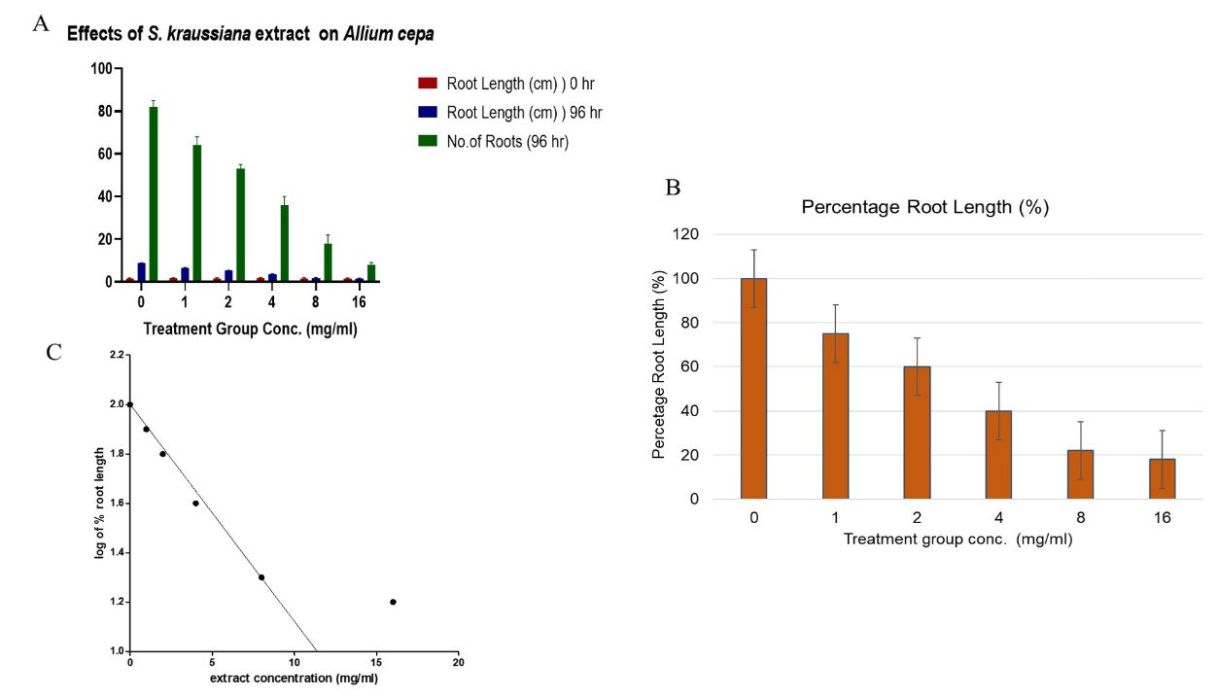
Figure 5. Effect of S. kraussiana extract at different concentrations on root length of Allium cepa after 96 hours of exposure (A). Percentage root length (B). Percentage (%) root length = mean root length of treated group ÷ mean root length of control x 100. Effect of Smilax kraussiana extract at different concentrations on Allium cepa root growth after 96 h exposure (C).

Table 4. Morphological effect of S. kraussiana at different concentrations on Allium cepa root tip cells after 96 hr exposure.
Treatment group conc. | Shape of the root tip |  |  |  | Colour of root tip
 | Straight | Crochet hooks | Bulbs | Broken tips | White | Pale brown | Dark brown
Control | Yes | No | No | No | Yes | No | No
S. kraussiana
1mg/ml  2mg/ml  4mg/ml  8mg/ml  16mg/ml | Yes  Yes  Yes  Yes  Yes | No  No  No  No  No | No  No  No  No  No | No  No  No  No  No | Yes  No  No  No  No | No  Yes  Yes  No  No | No  No  No  Yes  Yes

Table 5. Antiproliferative activity due to S. kraussiana extract at different concentrations on Allium cepa meristematic cells after 96 hr exposure.
Conc. | No. of cells examined | No. of dividing cells | Mitotic index (MI) | % mitotic inhibition | Aberrant cells | Frequency of aberrant cells (%)
Distilled water | 800 | 77 | 9.6 | 0.0 | 0 | 0
S. kraussiana
1mg/ml  2mg/ml  4mg/ml  8mg/ml  16mg/ml | 800  800  800  800  800 | 71  65  58  39  29 | 8.9  8.1  7.3  4.9  3.6 | 7.29  15.6  23.95  48.95  62.5 | 20  24  24  30  25 | 2.5  3.4  3.4  3.8  3.1
Frequency of aberrant cells = (No. of aberrant cells ÷ No. of cells examined) * 100, MI = (No. of dividing cells ÷ No. of cells examined) * 100, Mitotic inhibition = (MI of control – MI of treated group ÷ MI of control) *100.

Discussion
Extraction is a separation process consisting of the separation of a substance from a mixture. It is the crucial step in the analysis of medicinal plants. It is necessary to extract the desired chemical components from plant materials for further separation and characterization. From the extraction carried out, the percentage yield of the methanolic extract of Smilax kraussiana obtained was 9.550%. The partitioned n-hexane, dichloromethane, ethylacetate, and butanol fractions gave yields of 5.90% n-hexane fraction, 8.35% dichloromethane fraction, 6.18% ethylacetate fraction, and 4.38% butanol fraction, respectively. This indicates that the methanol extract of Smilax kraussiana contains mainly semi-polar and non-polar components. The Thin Layer Chromatography carried out on the methanol extract and the various partitioned fractions showed that the dichloromethane and n-hexane fractions have more components with different colours than the others. This indicates that many of the constituents in the plant are non-polar. The TLC carried out on the Sephadex fraction of the DCM fraction indicates the presence of many components. a single component with blue colouration when sprayed with 10% sulphuric acid was isolated, which indicates the presence of a steroidal component (Sasidharan et al., 2011).
Phytochemical analysis revealed that S. kraussiana contains several bioactive compounds, including carbohydrates/starch, saponins, tannins, flavonoids, cardiac glycosides, steroids/triterpenes, phenols, and alkaloids, though anthraquinones were not detected. These findings are consistent with earlier reports by Nwafor et al. (2004).
Acute toxicity refers to harmful effects occurring within 24 hours from either a single exposure or multiple short-term exposures (IUPAC, 1997; MSDS Hyperglossary, 2006). In our evaluation of S. kraussiana, complete mortality occurred at 1000 mg/kg while 600 mg/kg showed no lethality, yielding an LD₅₀ of 774.5 mg/kg. Based on this value, we established three test doses: 38.7 mg/kg (low), 77.5 mg/kg (medium), and 154.9 mg/kg (high). These findings align with Allium cepa assays showing minimal cytotoxicity at 200 mg/mL, suggesting that therapeutic potential exists below cytotoxic thresholds.
Current scientific investigations of medicinal plants with established pharmacological properties and health benefits, particularly for chronic conditions requiring extended treatment durations, are increasingly examining their potential mutagenic and carcinogenic effects in humans. This focus stems from the fact that these plants contain bioactive secondary metabolites that serve protective functions but may exhibit varying degrees of toxicity when purified. The findings of this research demonstrate that S. kraussiana's methanolic extract induces dose-dependent suppression of root development (affecting both length and quantity), alters root morphology, and exhibits anti-mitotic properties in Allium cepa assays. The extract's inhibitory effect on onion root growth manifested at an EC50 value of 9.49 mg/ml, confirming its cytotoxic action on root cells - a phenomenon similarly documented for other traditional Nigerian medicinal plants, including M. lucida, C. citratus, O. gratissimum, A. indica, C. papaya, M. indica, and R. vomitoria (Oyedare et al., 2009; Akinboro & Bakare, 2007; Bunu et al., 2023b).
The experimental results revealed consistent growth inhibition across all tested extract concentrations relative to the aqueous control. This inhibitory effect intensified progressively with concentration, as evidenced by complete growth arrest at 8-16 mg/ml doses, while 1 mg/ml produced results comparable to controls. Morphological analysis showed concentration-dependent root discoloration (from white at 1 mg/ml to dark brown at higher doses) and maintained straight root morphology (indicating non-carcinogenicity). Cellular examinations demonstrated progressively reduced mitotic activity across concentrations (8.9-3.6% mitotic index reduction from 1-16 mg/ml), suggesting interference with normal cell cycle progression. This mito-depressive effect (Badr & Ibrahim, 1987) likely results from multiple mechanisms, including: G1/G2 phase cell cycle blockade, impaired DNA/protein synthesis, disrupted microtubule assembly, and insufficient ATP production for proper spindle function and chromosome segregation (Majewska et al., 2003). The dark root discoloration at elevated concentrations corresponds with cellular necrosis, while the preserved root morphology confirms the absence of tumorigenic potential.
The elongation of roots in Allium cepa, consistent with other plant species, results primarily from cellular expansion within the root tip's elongation zone, where critical differentiation processes occur (Cordoba-Pedrosa et al., 2004). This cellular expansion mechanism involves multiple coordinated biological activities: absorption of water, translocation of nitrogen compounds, enhanced carbohydrate biosynthesis, and increased plasticity of both plasma and vacuolar membranes (Gonzalez-Reyes et al., 1999). Key regulatory molecules in these processes include ascorbate metabolites and enzymatic factors like asparagine synthase and membrane-bound ATPases (Yuan et al., 2024). When these fundamental processes are disrupted, whether by plant-derived compounds or environmental toxins, the consequences include diminished cell wall extensibility, dysregulation of vacuolar homeostasis (the vacuole being a membrane-bound organelle containing aqueous solutions of nutrients and waste products), cytotoxic damage, cellular necrosis, and consequent root growth suppression (Gonzalez-Reyes et al., 1999). These mechanistic insights suggest that S. kraussiana's inhibitory effects on root elongation and branching observed in our study likely involve interference with one or more of these essential cellular expansion and differentiation pathways operating in the root's elongation zone.
Cellular systems possess sophisticated response mechanisms to various stressors, mediated through signal transduction pathways that control critical processes including growth, multiplication, and programmed cell death. Central to these pathways are kinase enzymes that regulate protein activity through targeted phosphorylation events. Notably, flavonoid compounds can modulate these pathways by either preventing phosphorylation of growth factor receptors or competitively inhibiting their ligand binding (Hou et al., 2004; William et al., 2004; Lambert et al., 2003). Through their anti-inflammatory properties, flavonoids additionally suppress the generation of reactive oxygen species by inflammatory enzymes and mediators that normally stimulate cell proliferation and blood vessel formation while preventing apoptosis. Therefore, flavonoids exert triple actions: inhibiting cell multiplication, blocking angiogenesis, and promoting apoptotic pathways (Cho et al., 2003; O'Leary et al., 2004; Steele et al., 2003). The assessment of chromosomal abnormalities and meristematic cell division defects in onion root tips serves as an important biosafety indicator for evaluating potential product toxicity (Vicentini et al., 2001).

Conclusion
From the experiment carried out and the results obtained, it can be concluded that S. kraussiana has many components, and a single steroidal component; the weight obtained was not enough to carry out further analysis. The cytotoxic and genotoxic activity is concentration-dependent. The study suggests that, though S. kraussiana has a beneficial effect as a medicinal herb, there is a need for safe dose administration for short periods in human phytomedicine. Thus, further analysis should be carried out for the identification of the various components, and a large amount of the extract should be used in the fractionation to obtain enough yield. The cytotoxic effect of the plant suggests that the plant may have a potential anticancer effect, since it has an antiproliferative effect; hence, the need to conduct further in vivo genotoxic tests.

COMPETING INTERESTS DISCLAIMER:
Authors have declared that they have no known competing financial interests OR non-financial interests, OR personal relationships that could have appeared to influence the work reported in this paper.

Disclaimer (Artificial intelligence)
Author(s) hereby declare that NO generative AI technologies such as Large Language Models (ChatGPT, COPILOT, etc.) and text-to-image generators have been used during the writing or editing of this manuscript.

References
Adegoke, E.A., Akinsanya, A. and Naquir, S.H.Z. (1968). Studies of Nigerian medicinal plants I. A preliminary survey of plant alkaloids. J. West Africa Sci. Assoc., 13: 13-33,
Akinboro A. and Bakare A.A, (2007). Cytotoxic and Genotoxic effects of aqueous Extract of five medicinal plants on Allium cepa (Linn) J. Ethnopharmacol., 112:470-475.
Badr, A. and Ibrahim, A.G., (1987). Effect of herbicide Glean on mitosis, chromosomes and nucleic acids in Allium cepa and Vicia faba root meristems. Cytol., 52:293-302.
Bunu SJ, O Miediegha, ADC Owaba, Martins OO & Ogechukwu CL (2022). Phytochemicals quantification, TLC, and antimicrobial assessment of leaves and fruit extracts of Lasimorpha senegalensis (Schott) Araceae. Journal of Chemical Research Advances, 03 (02):14-20.
Bunu SJ, Alfred-Ugbenbo D, Kogoro AC, Adesegun KJ, Vaikosen EN, Chukwuemerie OL, Ebeshi BU (2023a). Quantification of secondary metabolites and chromatographic analysis of Allium cepa, Liliaceae ethanolic extract. IOSR Journal of Pharmacy and Biological Sciences, 18 (2); 16-22.
Bunu SJ, Okei OJ, Miediegha O, Ebeshi BU, Chukwuemerie OL (2023b). Assessment of Secondary Metabolites and Thin-Layer Chromatographic Analysis of Carica papaya (Caricaceae) Leaves Ethanolic Extract. Journal of Pharmaceutical Research International, 35(36); 21-28.
Cho, S.Y.; Park, S.J; Kwon, M.J., (2003). Quercetin suppresses proinflammatory cytokines production through MAP kinases and NF-kappaB pathway in lipopolysaccharide-stimulated macrophages. Mol Cell Biochem. 243(1-2):153-160. (PubMed).
Chukwuemerie OL, SJ Bunu, Iloh ES, Ogujiuba CU, Obasi J, Onwuzuluigbo CC & Okeke CO (2022). Evaluation of the anthelmintic property of the endophytic extract of Senna alata in mice model. Journal of Medicinal Plants Studies; 10(3): 52-54.
Cordoba-Pedrosa, M.D.C., Vilalba, J.M., Cordoba, F. and Gonzalez-Reyes, J.A., (2004). Changes in intracellular and apoplastic peroxidase activity, ascorbate redox status, and root elongation induced by ascorbate content in Allium cepa L. J. Experimental Botany, 56:685-694.
Coupland, J. N., & Hayes, J. E. (2014). Physical approaches to masking bitter taste: lessons from food and pharmaceuticals. Pharmaceutical research, 31(11), 2921–2939. https://doi.org/10.1007/s11095-014-1480-6.
Espinoza-Pérez, J., Reyes, C., Hernández-Ruíz, J., Díaz-Bautista, M., Ramos-López, F., Espinoza-Gómez, A., & Pérez-García, O. (2021). Uses, abundance perception, and potential geographical distribution of Smilax aristolochiifolia Mill (SMILACACEAE) on the Totonacapan Region of Puebla, Mexico. Journal of ethnobiology and ethnomedicine, 17(1), 52. https://doi.org/10.1186/s13002-021-00477-6.
Gonzalez-Reyes, J.A.; Alcain F.J., Caler; J.A., Serrano, A. Cordoba, F. and Nevas P., (1999). Stimulation of onion root elongation by ascorbate and ascorbate free radical in Allium cepa L. protoplasma. 184:31-35.
Hou, Z.; Lambert, J.D; Chin K.V and Yang C.S. (2004). Effects of tea polyphenols on signal transduction pathways related to cancer chemoprevention. Mutat Res. 555(1-2): 3-19.
IUPAC, Compendium of Chemical Terminology, 2nd Ed. (the ‘Gold Book’) 1997. Online corrected version (2006). ‘Acute toxicity.
Lambert, J.D. and Yang, C.S. (2003). Mechanism of cancer prevention by tea constituents. J. Nutr. 133(10):3262S-3267S.
Majewska, A.E.; Wolska, E; Sliwinka, M; Furmanowa, N; Ubranska A; Pietrosiuk, A; Zobel A; and Kuras M. (2003). Antimitotic effect, G2/M accumulation, chromosomal and ultra-structure changes in meristematic cells of Allium cepa L. root tips treated with extract from Rhadiola rosa roots. Caryol. 56:337-351.
Nwafor, P.A.; Jacks, T.W. and Longe, O.O. 2004. Acute toxicity study of methanolic extract of Asparagus pubescens L. rooys in rats. Afr. J. Biomed, Res. 7: 19-21.
Nwankwo OL, Bunu SJ, Miediegha O, Iloh ES, Adione NM, Onwuzuligbo N, Dash AK, Okoye FBC, (2022). Usefulness of herbal medicines in the prevention and management of coronavirus disease-2019 (COVID-19) and its symptoms: A review. Journal of Pharmacognosy and Phytochemistry; 11 (2):68-78.
O’Leary K.A.; de Pascual-Tereasa S.; Needs P.W.; Bao Y.P.; O’Brien N.M. and Williamson G. (2004). Effects of flavonoids and vitamin E on cyclooxygenase-2 (COX-2) transcription. Mutat Res. 551(1-2): 245-254.
Odebiyi, O.O. and Sofowora, A. (1978). Phytochemical screening of Nigerian medicinal plants, Lloydis 41: 234-235.
Ogechukwu LN, Onwuzuluigbo CC, Okeke OC, SJ Bunu, Josephat CO, Ezinne SI, Emmanuel ON (2021) Quantitative phytochemical analysis of the fungus endophytic extracts isolated from Azadirachta indica using gas chromatography flame ionization detector. Journal of Drug Delivery and Therapeutics; 11(5):80-83.
Oyedare, B.M., Bakare, A.A. and Akinboro, A., (2009). Genotoxicity of water extracts of Ocimum gratissimum, Morinda lucida, and Citrus medica using the Allium cepa assay. Boletin Latinoamericano y del Caribe de plantas Medicinales Aromaticas. 8:97-103.
Rank, J. and Neilsen M.H.A. 1993. A modified Allium test as a tool in the screening of genotoxicity of complex mixtures. Hereditas. Vol. 118. P. 49-53.
Sanjib B., Jatindra S. and Sachin KB (2018) Smilax sailenii (Smilacaceae) - a new species from Assam, North East India. Taiwania 63(1): 32-36.
Sasidharan, S., Chen, Y., Saravanan, D., Sundram, K. M., & Yoga Latha, L. (2011). Extraction, isolation, and characterization of bioactive compounds from plant extracts. African journal of traditional, complementary, and alternative medicines: AJTCAM, 8(1), 1–10.
Sofowora, A. 1993. Screening plants for bioactive agents: Medicinal plants and traditional medicine in Africa. 2nd Edn., Spectrum Books Ltd., Sunshine House, Ibandan, Nigeria, ISBN-13:987-0471103677, pp. 134-156.
Steele V.E., Hawk E.T., Viner J.L., and Lubet R.A. (2003). Mechanisms and Applications of non-steroidal anti-inflammatory drugs in the chemo prevention of cancer. Mutat Res. 523-524: 137-144.
Tashnova B.A., Bengir-al-labib, M.A., Marjina A.K., A.B.M., Anwarul B, Mohammed R., (2012). Evaluation of antihyperglycemic activity of Smilax perfoliata Lour. (Smilacaceae) leaves in Swiss albino mice. Advances in Natural and Applied Sciences, 6(6): 711-714.
The MSDS HyperGlossary: Acute toxicity. Safety Emporium. Archived from the original on 16th October 2006. Retrieved 2006-11-15.
Trease, G.E. and C.W. Evans, 1989. A textbook of pharcognosy. 15th Edn., ELBS Bailiere Tindall, London. pp. 378-386.
Vicentini V.E.P, Camparoto M.L, Teixeira R.O, Matovani M.S (2001). Averrhoa carabola L., Syzgium cumini L. Skeels, and Cissus sicyoides L.: medicinal herbal tea effects on vegetal and test systems. Acta Scientiarum 23:593-598.
Williams R.J, Spencer J.P and Rice-Evans C. (2004). Flavonoids: Antioxidants or Signalling molecules? Free Radic. Biol Med. 36(7):838-849.
Yuan, Q., Yin, L., He, J., Zeng, Q., Liang, Y., Shen, Y., & Zu, X. (2024). Metabolism of asparagine in the physiological state and cancer. Cell communication and signaling: CCS, 22(1), 163. https://doi.org/10.1186/s12964-024-01540-x.

