Original Research Article
The Role of AI in Epidemiological Research: Applications, Benefits, and Risks in Modern Public Health

ABSTRACT
The integration of Artificial Intelligence (AI) into epidemiological research and practice is reshaping the landscape of public health decision-making, disease surveillance, and predictive modeling. This study provides a comprehensive investigation into how AI technologies are being utilized across five key epidemiological functions: disease surveillance and outbreak prediction, risk factor identification, diagnosis and treatment, data management and analysis, and causal inference. Through an in-depth literature review, the study identifies both the technical and functional benefits of AI, including accuracy enhancement, real-time insights, and resource optimization, while also critically addressing the ethical and operational risks such as data ownership, model transparency, algorithmic bias, and challenges in informed consent. To guide future applications, the study introduces three strategic frameworks: the Loop-Oriented Table of AI Applications, which categorizes AI use cases across epidemiological loops; the AI Overloop Table, which highlights cross-functional synergies of AI implementations; and the AI Risk loop Table, which maps domain-specific risks back to the type of AI deployment. These models provide a systems-level understanding of AI's capabilities and constraints within public health ecosystems. Based on these frameworks, the study offers practical recommendations for integrating AI responsibly and effectively in epidemiological workflows, with an emphasis on transparency, scalability, and equity. Future research should explore the operationalization of these recommendations in real-world settings to validate their feasibility and societal impact.
Keywords: AI, Epidemiology, Public Health, Health Decision-Making, Disease Surveillance
1. INTRODUCTION
The integration of Artificial Intelligence (AI) in epidemiology has introduced transformative possibilities in disease detection, prediction, analysis, and management. This literature review is organized into three sub-sections: (1) Use of AI in Epidemiological Research, (2) Benefits of AI in Epidemiological Research, and (3) Risk of AI in Epidemiology. Each section synthesizes existing applications, evidences of value addition, and critical concerns observed in scholarly and applied contexts. By reviewing AI through these lenses, we aim to frame its multidimensional role within modern epidemiological research and practice.

1.1 Use of AI in Epidemiological Research
AI has been widely adopted across multiple functions in epidemiology. In Disease Surveillance and Outbreak Prediction, AI models such as natural language processing (NLP) and deep learning are employed in Social Monitoring and Note Mining, utilizing data from social media and clinical texts to detect anomalies and potential outbreaks (Rim et al., 2021). Record Screening leverages electronic health records (EHRs) to identify case surges, while Trend Forecasting and Hotspot Mapping apply machine learning and geospatial analytics for predictive modeling and spatial visualization. In Risk Factor Identification, AI contributes by recognizing complex interactions between environment, genetics, and behaviors (Patra et al., 2021). Exposure Mapping enables pattern recognition across behavioral and ecological data, while Genomic Linking identifies genetic risk factors. Omics Integration combines various biological datasets (genomics, proteomics, etc.) to enhance prediction, whereas Outcome Modeling and Cluster Detection help isolate subpopulation risks and understand exposure-outcome relationships (Zeng, Cao, & Neill, 2020).
The use of AI in Diagnosis and Treatment includes Image Diagnosis through computer vision, enhancing analysis of radiological images like MRIs and X-rays (Smit et al., 2020). Symptom Extraction via NLP tools assists in parsing unstructured clinical text. Treatment Support systems such as Clinical Decision Support Systems (CDSS) provide context-aware recommendations, while Triage Assistance and Chatbot Screening automate patient interaction and stratification in both clinical and public health settings. In Data Management and Analysis, AI simplifies large dataset operations. Data Cleaning, Source Integration, and Gap Imputation improve the reliability and usability of epidemiological datasets. Live Dashboards help visualize disease metrics in real time, and Literature Mining supports automated reviews and meta-analyses using NLP and machine learning.
Finally, Causal Inference remains an emerging domain for AI in epidemiology. Techniques like Causal Discovery use algorithms to explore potential causality, while Counterfactual Analysis models hypothetical scenarios. Hybrid Inference merges machine learning with traditional statistical methods, and Instrumental Estimation and Robust Simulation are used to enhance the validity of observational studies.
1.2 Benefits of AI in Epidemiological Research
One of the primary advantages of AI in epidemiology is Accuracy Enhancement. AI algorithms outperform traditional approaches in detecting subtle data patterns, leading to Improved Diagnostic Precision and Reduced Human Error (Park et al., 2024). They facilitate Efficient Data Processing by managing large datasets quickly and accurately, and offer Scalability by adapting to extensive population-level data with minimal additional effort. AI also provides Real-Time Insights that enable dynamic and continuous monitoring. Continuous Data Monitoring allows systems to operate on live streams, such as social media and EHRs, generating Early Outbreak Detection. These systems support a Faster Public Health Response and enable Adaptive Learning, continuously refining prediction models with new data. A third major benefit is Resource Optimization. AI's role in Automated Surveillance reduces manual labor, while Smart Resource Allocation ensures targeted deployment of public health resources like vaccines or medical staff (Bengtsson et al., 2015). AI models can also facilitate Reduced Testing Burden by prioritizing high-risk cases and improve Operational Efficiency by integrating and processing data across systems seamlessly.
1.3 Risk of AI in Epidemiology
Despite its many benefits, AI adoption in epidemiology carries significant risks. Data Ownership and Control is a persistent concern, particularly regarding privacy and data sovereignty when large, sensitive datasets are used without clear governance mechanisms (Gao et al., 2023). Ensuring ethical data use requires strict access control and transparent data-sharing policies. Transparency and Interpretability issues arise when using complex AI models—often termed "black boxes"—which make it difficult for researchers and policymakers to understand how decisions are derived. This lack of interpretability challenges accountability and trust in AI-derived outcomes. The risk of Bias in AI Algorithms is also critical (Wiens & Shenoy, 2018). AI models trained on biased or incomplete data can perpetuate or even exacerbate existing health inequities, leading to unfair or misleading conclusions about certain populations. This calls for careful dataset curation and ongoing fairness assessments.
Finally, Informed Consent becomes complex in AI-based research. Participants may not fully understand how their data will be processed or used, especially when secondary uses or predictive modeling is involved. Addressing this challenge requires new frameworks for transparent communication and ethical consent protocols tailored to AI use. This comprehensive literature review sets the stage for understanding the transformative potential, measurable benefits, and ethical complexities of AI integration into epidemiological practice. Together, these insights inform the recommendations and frameworks proposed in the later sections of this research.
2. LITERATURE REVIEW
The integration of Artificial Intelligence (AI) into epidemiological research has transformed how public health data is collected, analyzed, and interpreted (Tang et al., 2024) (Muley et al., 2023). As this interdisciplinary field evolves, it becomes essential to synthesize existing knowledge to better understand the breadth of AI applications, the tangible benefits it brings, and the potential risks it poses. This literature review is structured into three main sections to provide a comprehensive overview: the first explores the diverse uses of AI in epidemiological research, detailing its application across key domains such as disease surveillance, risk identification, and causal inference. The second section highlights the benefits of AI, focusing on its role in enhancing accuracy, enabling real-time insights, and optimizing resource use. Lastly, the review addresses the risks of AI in epidemiology, examining critical concerns including data privacy, algorithmic transparency, and ethical considerations. Together, these sections offer a balanced and nuanced perspective on the role of AI in modern epidemiological practice.

2.1 Use of AI in Epidemiological Research
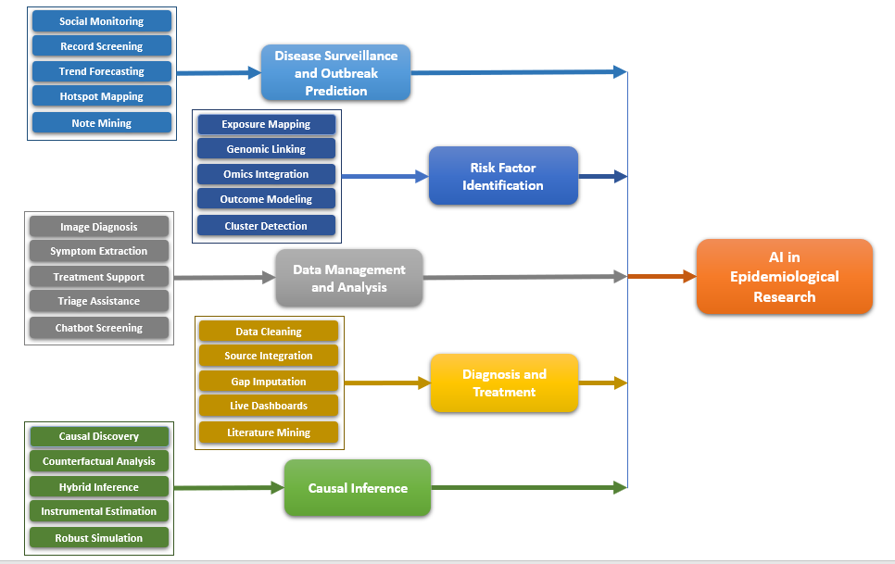
Fig. 1. AI Application in Epidemiological Research
The integration of artificial intelligence (AI) into epidemiological research has transformed how public health data is captured, analyzed, and interpreted. AI has enabled a transition from reactive health surveillance systems to proactive, data-driven forecasting and intervention tools. This section reviews the current landscape of AI applications in epidemiology, structured across five major domains: Disease Surveillance and Outbreak Prediction, Risk Factor Identification, Diagnosis and Treatment, Data Management and Analysis, and Causal Inference.
2.1.1. Disease Surveillance and Outbreak Prediction
AI plays a pivotal role in revolutionizing disease surveillance through real-time data ingestion and prediction mechanisms. Social Monitoring tools analyze data from social media platforms and news feeds to detect unusual patterns that may signal an emerging public health threat. Record Screening techniques, which leverage electronic health records (EHRs), facilitate early outbreak detection by identifying abnormal spikes in clinical visits or symptom patterns (Rajkomar et al., 2018). Additionally, Trend Forecasting utilizes time-series AI models to predict the trajectory of disease spread, enhancing preparedness and response. Hotspot Mapping with geospatial AI tools allows public health officials to visualize emerging clusters in real time, while Note Mining applies natural language processing (NLP) to extract syndromic signals from unstructured clinical notes. These advancements have significantly improved outbreak prediction, offering a granular and timely understanding of epidemiological trends.

2.1.2. Risk Factor Identification
AI enables more nuanced and scalable identification of risk factors by analyzing diverse and complex datasets (Muley et al., 2021). Exposure Mapping applies machine learning to assess lifestyle, environmental, and occupational exposures that may contribute to disease incidence. Genomic Linking uses AI algorithms to identify associations between genetic or epigenetic markers and disease susceptibility, while Omics Integration combines multiple biological data layers—such as genomics, proteomics, and metabolomics—to enhance predictive accuracy (Lu et al., 2021). Moreover, Outcome Modeling leverages deep learning to model non-linear exposure-outcome relationships, generating more precise estimates of risk. Cluster Detection, a powerful tool in population health analytics, uses unsupervised learning to detect patterns and subgroups within populations, revealing hidden vulnerabilities or protective factors. Together, these tools broaden our understanding of disease etiology and population heterogeneity (Kim, Kim, & Jo, 2024).
2.1.3. Diagnosis and Treatment
AI-powered systems have emerged as critical enablers of more accurate and efficient clinical decision-making. In the domain of Image Diagnosis, convolutional neural networks and other image recognition techniques are used to interpret radiological scans such as X-rays, MRIs, and CTs, often matching or surpassing human diagnostic performance. Symptom Extraction tools apply NLP to mine EHRs and clinical notes for structured symptom data, streamlining triage and diagnosis (Grueso & Viejo-Sobera, 2021). Treatment Support is facilitated by clinical decision support systems (CDSS) that recommend personalized treatment plans based on real-time patient data and evidence-based guidelines (Bi et al., 2019) (Littmann et al., 2024). Triage Assistance systems, often used in emergency or high-demand settings, help prioritize patients by severity using predictive models. Chatbot Screening, driven by AI virtual assistants, enables preliminary assessments and follow-up support through natural conversations, enhancing accessibility and efficiency in patient care workflows.
2.1.4. Data Management and Analysis
The growing volume and complexity of health data necessitate robust data management solutions, an area where AI excels. Data Cleaning automates the preprocessing of datasets, including error detection and normalization, thereby improving data quality. Source Integration allows for the merging of heterogeneous data sources—such as wearable devices, EHRs, and public health registries—into unified analytic environments. Gap Imputation employs AI models to infer missing data points, reducing biases and improving model reliability (McCrary, Galambus, & Chen, 2024). Live Dashboards, powered by AI, provide interactive, real-time visualizations that support situational awareness and policy planning (Muzumdar et al., 2023). Additionally, Literature Mining uses text mining algorithms to automate the synthesis of published studies for meta-analyses, systematic reviews, and guideline development. These capabilities significantly reduce the time and human resources required for high-quality epidemiological research (Glicksberg et al., 2024).

2.1.5. Causal Inference
AI is increasingly being applied beyond predictive analytics to explore and validate causal relationships, a traditionally challenging area in epidemiology. Causal Discovery algorithms can autonomously infer causal graphs from observational data, offering new insights into disease mechanisms. Counterfactual Analysis allows researchers to model "what-if" scenarios—such as the potential impact of a public health intervention not yet implemented—by comparing actual outcomes with hypothetical alternatives (Eisbach, Mai, & Hertel, 2024). Hybrid Inference approaches merge machine learning with classical statistical methods to leverage the strengths of both disciplines, improving robustness and interpretability. In economic and social epidemiology, Instrumental Estimation methods powered by AI are used to identify valid instruments in complex datasets, facilitating quasi-experimental designs. Finally, Robust Simulation enables stress-testing of causal models under varied assumptions and data perturbations, supporting more confident and transparent decision-making in public health policy (London, 2022).
2.2 Benefits of AI in Epidemiological Research
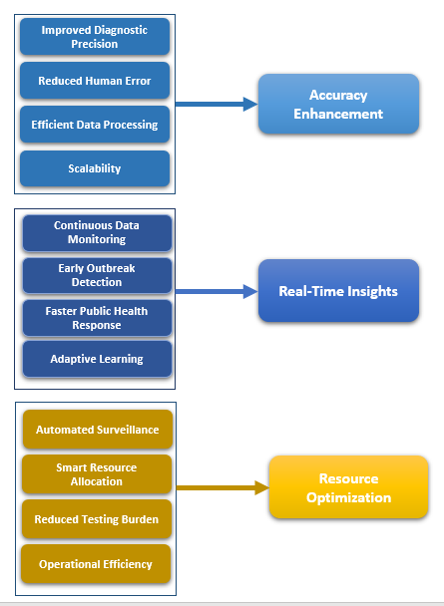
Fig. 2. Benefits of AI in Epidemiological Research
The adoption of Artificial Intelligence (AI) in epidemiological research has introduced substantial benefits across various facets of public health operations. While the technology continues to evolve, current implementations demonstrate tangible improvements in diagnostic precision, surveillance speed, and resource efficiency (Ellison, 2020). These benefits span across accuracy enhancement, real-time insight generation, and resource optimization—three pillars that collectively strengthen the foundations of modern epidemiology.
2.2.1. Accuracy Enhancement
One of the most prominent advantages of AI in epidemiology is its capacity for accuracy enhancement. Traditional statistical methods, while robust, often fall short in handling complex, high-dimensional datasets. In contrast, AI models—especially machine learning and deep learning algorithms—excel at uncovering subtle, nonlinear patterns that may be overlooked by conventional techniques (Matthay et al., 2025). This results in improved diagnostic precision, particularly in analyzing large-scale datasets such as radiological images or genomic data. Furthermore, the reduction in human error is a key strength of AI systems; automation limits subjective biases and inconsistency in data interpretation (Zhang, Shi, & Wang, 2023). The efficiency of data processing is equally notable, as AI tools can parse and interpret terabytes of data in significantly less time, accelerating the cycle from data collection to actionable insights. Additionally, the scalability of AI solutions enables their deployment across national or global surveillance systems without necessitating a proportional increase in manpower, making AI particularly valuable in resource-limited or high-demand scenarios.
2.2.2. Real-Time Insights
Another critical benefit lies in AI's ability to generate real-time insights, transforming epidemiology from a reactive to a proactive discipline. Unlike traditional surveillance systems, which often rely on periodic or retrospective data, AI enables continuous data monitoring across multiple data streams—ranging from electronic health records (EHRs) to social media chatter and mobile health applications. This round-the-clock surveillance allows for early outbreak detection, as machine learning algorithms can swiftly identify anomalies or emerging patterns indicative of potential health threats. The timeliness of these alerts supports a faster public health response, facilitating earlier deployment of containment strategies such as targeted testing, vaccination campaigns, or mobility restrictions. Moreover, AI’s adaptive learning capabilities enable models to evolve based on newly collected data, thereby refining predictive accuracy and maintaining relevance in dynamic public health landscapes (Ahmad, Stoyanov, & Lovat, 2020).
2.2.3. Resource Optimization
AI also contributes significantly to resource optimization, a pressing concern in public health systems often constrained by financial and human capital. Automated surveillance systems reduce the need for labor-intensive manual processes, thus lowering operational costs. Additionally, AI-driven smart resource allocation models enable the efficient distribution of critical resources—such as vaccines, test kits, or medical personnel—to high-risk areas, maximizing impact and minimizing waste. In testing strategies, reduced testing burden is achieved through AI-based risk stratification, which prioritizes individuals with a higher probability of disease, thus reducing unnecessary tests and focusing efforts where they are most needed. Finally, AI enhances operational efficiency by streamlining data integration, harmonization, and analysis workflows, which traditionally required multiple levels of human oversight (Swanson et al., 2023). These improvements not only save time and money but also free up skilled professionals to focus on higher-order decision-making and strategic planning.
2.3 Risk of AI in Epidemiology
While the application of Artificial Intelligence (AI) in epidemiology offers transformative potential, it also introduces a range of critical risks and ethical dilemmas. These concerns span issues of data governance, model transparency, bias, and consent, all of which have significant implications for public trust, scientific rigor, and equity in health outcomes. Understanding these risks is essential to ensuring responsible development and deployment of AI systems in epidemiological settings (Su et al., 2020).
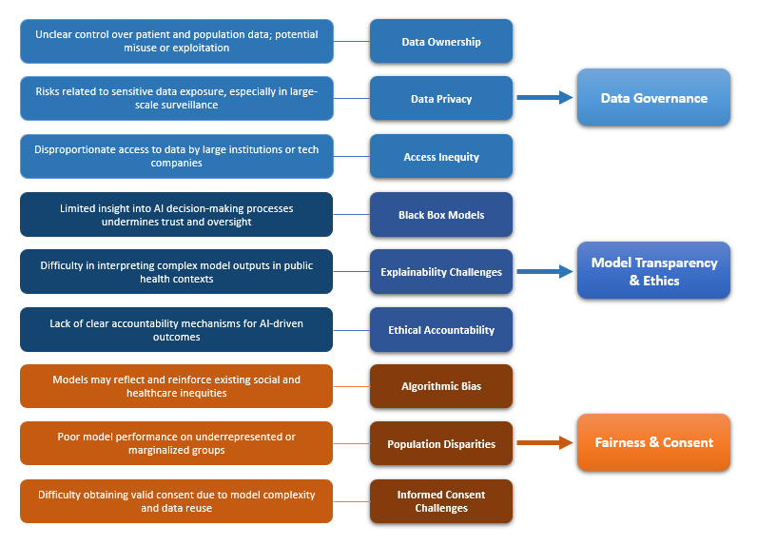
Fig. 3. Risk of AI in Epidemiological Research
2.3.1. Data Ownership and Control
A central challenge in the use of AI for epidemiology is data ownership and control. AI models often require access to large, sensitive datasets, including personal health records, social media activity, and mobile tracking information (Goldust et al., 2023). This creates substantial data privacy concerns, particularly when data is collected without explicit user consent or when it is aggregated across systems without robust anonymization protocols. The question of who owns the data—patients, institutions, governments, or tech companies—remains unresolved in many jurisdictions, and the lack of clear governance frameworks can hinder both data sharing and accountability. Furthermore, inequitable access to data may create power asymmetries, favoring well-resourced organizations while excluding underrepresented communities from the benefits of AI-enhanced public health insights.
2.3.2. Transparency and Interpretability
Another pressing issue is the transparency and interpretability of AI models. Many advanced machine learning systems, particularly deep learning architectures, function as “black boxes”—producing outputs without clear explanations of the decision-making process (Waljee et al., 2022). In epidemiology, where decisions can influence public health policies and clinical recommendations, this lack of clarity undermines trust and can hinder expert review or peer validation. Explainable AI (XAI) methods are being developed to address this problem, but adoption remains limited, and many tools still fall short of offering actionable transparency to end-users such as public health officials or clinicians. This opacity also complicates legal and ethical evaluations, especially when AI outputs influence high-stakes decisions such as outbreak declarations or triage prioritization.
2.3.3. Bias in AI Algorithms
AI systems are only as unbiased as the data on which they are trained, making algorithmic bias a persistent and systemic risk. Historical and structural inequities—whether based on race, gender, geography, or socioeconomic status—can become embedded in datasets, leading AI models to reproduce or even exacerbate these disparities (Murdoch et al., 2019). In epidemiological contexts, this may result in unequal risk predictions, underdiagnosis in minority populations, or inaccurate resource allocation. For example, a model trained predominantly on data from urban hospitals may perform poorly in rural or underserved settings, reinforcing the digital divide. Identifying and mitigating such biases is crucial, but it requires not only technical solutions (such as bias audits and fairness metrics) but also interdisciplinary oversight from ethicists, epidemiologists, and affected communities (Lee et al., 2021).
2.3.4. Informed Consent
Lastly, the integration of AI in epidemiological research raises complex questions about informed consent. Traditional consent models are often inadequate for AI applications, where data may be reused across different studies or combined with external datasets for secondary analysis. Moreover, the opacity of AI systems makes it difficult for participants to fully understand how their data will be used, undermining the ethical foundation of consent. In public health surveillance, where opt-out options are limited or non-existent, the ethical tension intensifies. Innovative consent frameworks—such as dynamic consent models or community-based consent mechanisms—are being explored, but implementation remains inconsistent and resource-intensive (Esteva et al., 2017).

3. RECOMMENDATION
3.1 Loop-Oriented Benefits Table of AI Applications in Epidemiology
Table 1. Loop-Oriented Benefits Table of AI Applications in Epidemiology
Major AI Use Area | Loop (Direct Benefit) | AI Application
Disease Surveillance & Outbreak Prediction | Early Warning | Social Media Mining
Disease Surveillance & Outbreak Prediction | Trend Prediction | Time Series Forecasting
Disease Surveillance & Outbreak Prediction | Hotspot Identification | Geospatial AI (GeoAI)
Disease Surveillance & Outbreak Prediction | Signal Detection | NLP on News Reports
Disease Surveillance & Outbreak Prediction | Behavior Monitoring | Wearable Sensor Integration
Disease Surveillance & Outbreak Prediction | Public Engagement | Chatbots for Symptom Reporting
Disease Surveillance & Outbreak Prediction | Continuous Monitoring | Real-time Dashboards
Risk Factor Identification | Pattern Recognition | Machine Learning on EHRs
 | Risk Stratification | Clustering & Classification
 | Data Extraction | NLP on Medical Literature
 | Gene–Environment Mapping | Genomic AI (Omics Integration)
 | High-Risk Population Detection | Predictive Modeling
Diagnosis and Treatment | Clinical Diagnosis | Radiology AI (Image Recognition)
 | Treatment Guidance | AI Clinical Decision Support Systems
 | Information Structuring | NLP in Diagnostic Reports
 | Tailored Therapeutics | Personalized AI Models
 | Adaptive Treatment Optimization | Reinforcement Learning for Therapy Plans
Data Management and Analysis | Structured Dataset Generation | NLP for Data Extraction
 | Quality Improvement | Data Cleaning Algorithms
 | Interoperability | Automated Integration Systems
 | Data Availability | Synthetic Data Generation
 | Interpretability | Visualization AI
 | Structured Dataset Generation | NLP for Data Extraction
Causal Inference | Causal Attribution | Counterfactual Modeling
 | Probabilistic Inference | Bayesian Networks
 | Scenario Simulation | Reinforcement Learning in Policy Testing
 | Confounder Adjustment | AI-enhanced Mediation Analysis
 | Dynamic Causal Discovery | Time-Series Causal AI Models

The Loop-Oriented Table of AI Applications in Epidemiology was developed to systematically categorize how specific artificial intelligence tools are directly contributing to core functional domains within the field. By organizing the table around the concept of "loops"—that is, the direct benefit or output generated by an AI application—we clarify the immediate value each technology offers to epidemiological practice. These loops, such as early warning, pattern recognition, or treatment guidance, represent high-leverage outcomes that directly address pressing challenges in disease surveillance, diagnosis, and risk identification. This framework reveals that AI does not operate in isolated silos but rather provides targeted benefits that align with specific public health goals. It underscores the importance of adopting AI not just as a blanket solution, but in a strategic, benefit-oriented manner. For example, geospatial AI technologies yielding “hotspot identification” loops are best suited to disease surveillance, while reinforcement learning tools generating “adaptive treatment optimization” loops are most valuable in the domain of diagnosis and treatment. The structure of this table is intended to guide public health agencies, policymakers, and research institutions in prioritizing AI deployments that align with their most urgent epidemiological needs.
Our primary recommendation is to use this table as a strategic implementation guide—a planning tool for integrating AI based on the intended benefit and domain relevance. Public health organizations should map their operational goals (e.g., real-time monitoring, high-risk population detection) to the corresponding loops and invest in the AI technologies that fulfill those needs most directly. Additionally, this table can serve as a training and evaluation framework, helping researchers and program managers assess whether current AI deployments are aligned with their intended epidemiological impact. We further recommend expanding this table into a living framework that evolves with AI innovations and emerging epidemiological challenges, enabling its continued relevance in shaping adaptive, data-driven public health systems. Beyond identifying immediate benefits, the Loop-Oriented Table also provides insight into how AI technologies can be tailored to local, national, or global epidemiological contexts. For example, low- and middle-income countries (LMICs) may benefit most from AI loops like cost-effective surveillance, real-time dashboards, and risk stratification due to limited public health infrastructure. In contrast, high-income countries might focus on tailored therapeutics or reinforcement learning for policy testing, which require more advanced data ecosystems. By aligning AI applications with region-specific epidemiological priorities and available resources, this table facilitates a context-sensitive approach to AI adoption in public health.
Another important recommendation derived from this table is the promotion of interdisciplinary collaboration between AI developers, epidemiologists, and policy analysts. The loop framework encourages AI designers to build tools with a clear understanding of epidemiological outcomes, thereby improving the usability and relevance of AI applications. Conversely, public health professionals can better articulate their needs by referencing these loops during AI project planning and procurement. This table could serve as a shared language and decision-making framework, reducing the communication gap between technical experts and public health stakeholders. Finally, the table can guide ethical and regulatory considerations by helping identify where human oversight is most critical. For example, loops such as clinical diagnosis or personalized treatment planning carry significant patient-level consequences and should involve stringent validation, explainability, and accountability measures. Conversely, loops like signal detection or geospatial modeling may tolerate greater automation. Policymakers can use this framework to calibrate risk and regulation based on the nature of the loop and its proximity to individual or public health decisions. Thus, the Loop-Oriented Table is not just a technical reference—it is a foundational tool for promoting safe, effective, and contextually grounded AI integration in epidemiological research and practice.

3.2 AI Overloop Oriented Benefits Table: Cross-Functional Benefits Across Epidemiology Domains
Table 2. AI Overloop Oriented Benefits Table: Cross-Functional Benefits Across Epidemiology Domains
Primary AI Use Area | Benefit Generated (Loop Output) | Secondary AI Area Enhanced (Overloop Impact) | Description of Interconnection
Disease Surveillance & Outbreak Prediction | Early Warning | Risk Factor Identification | Early signals help target which exposures or populations to analyze for associated risk factors.
Risk Factor Identification | High-Risk Population Detection | Disease Surveillance & Outbreak Prediction | Identifying vulnerable populations refines surveillance focus and resource targeting.
Diagnosis and Treatment | Clinical Diagnosis | Data Management and Analysis | Diagnosed case data feeds structured databases for analysis and future modeling.
Data Management and Analysis | Data Quality Improvement | Causal Inference | Clean, structured, and complete datasets are essential for accurate causal modeling.
Causal Inference | Causal Attribution | Risk Factor Identification | Validated causal links support the prioritization of meaningful risk factors.
Diagnosis and Treatment | Tailored Therapeutics | Surveillance & Outbreak Prediction | Personalized treatment outcomes can indicate emerging resistance or treatment failure trends.
Risk Factor Identification | Pattern Recognition | Diagnosis and Treatment | Helps refine diagnostic decision-making models based on known risk exposures.
Data Management and Analysis | Interoperability | All Other Areas | Unified data infrastructure supports seamless insights across surveillance, diagnosis, etc.
Causal Inference | Scenario Simulation | Policy Decision-Making (Cross-cutting) | Simulation outcomes influence public health interventions beyond a single AI use area.
Disease Surveillance & Outbreak Prediction | Behavior Monitoring | Diagnosis and Treatment | Real-time behavior data informs treatment personalization or triage prioritization.

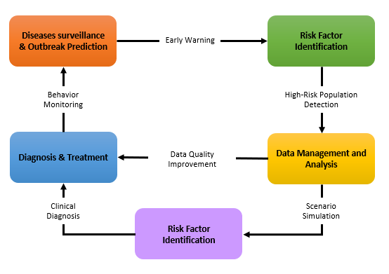
Fig. 4. AI Overloop Oriented Benefits: Cross-Functional Benefits Across Epidemiology Domains
The AI Overloop Table is a conceptual extension of the Loop-Oriented Table, designed to illustrate how the benefits generated in one domain of AI application can catalyze or amplify outcomes in another. While loop benefits represent direct, localized outputs of AI (such as early warning or real-time monitoring), overloops refer to cross-functional synergies—instances where an AI-driven insight in one area strengthens analytical, predictive, or operational capacity in another. These overloops reveal the interconnected architecture of AI ecosystems in epidemiology, promoting a shift from fragmented implementation toward holistic, systems-level planning. For instance, the overloop between disease surveillance and risk factor identification is one of the most vital in modern public health practice. AI systems that detect emerging outbreaks early can prompt targeted analyses of social, environmental, or behavioral risk factors. This supports deeper causal insight and informs more tailored interventions. Conversely, identifying high-risk populations through AI models enriches surveillance efforts by guiding data collection to priority groups, enhancing sensitivity and specificity of future outbreak detection. These mutually reinforcing benefits highlight the strategic value of coordinating AI systems across domains.
The overloop between diagnosis and data management demonstrates how individual-level clinical insights can enhance broader data infrastructure. Diagnostic AI tools generate large volumes of labeled medical data, which can be standardized and fed into data lakes that support population-level analysis and modeling. Improved data structure and completeness, in turn, benefits causal inference models, as these require well-organized, high-quality data to generate valid conclusions. This creates a multi-directional flow of benefit, in which every AI function enriches the ecosystem's overall intelligence and reliability. The Overloop Table also underscores the importance of building interoperable AI platforms in epidemiology. When AI tools are designed in isolation, their insights remain siloed. But if outputs such as hotspot detection, risk mapping, or treatment effectiveness are designed to interact with other models, the benefits multiply. For example, simulation tools used in causal inference can be strengthened with real-world treatment data from diagnostic tools, enabling policymakers to test more accurate “what-if” scenarios. This fosters a continuous learning system, where one domain’s insight leads to better decisions across multiple others.
A critical recommendation emerging from this framework is that AI implementation strategies should be co-designed with overloop potential in mind. Public health agencies and research institutions should ask not only “what can this AI tool solve?” but also “what other domains can this output enrich?” Overloop analysis encourages shared data pipelines, joint modeling infrastructure, and cross-domain validation, allowing systems to evolve into truly intelligent epidemiological platforms. By institutionalizing overloop thinking, we avoid redundant investments and promote scalable, adaptable solutions. Finally, the Overloop Table provides a new lens for prioritizing public health AI research funding. Grants and policy efforts should give preference to initiatives that promise multi-domain impact, especially those that integrate AI across surveillance, diagnosis, and causal modeling. These high-impact areas will yield faster returns in outbreak response, population risk mitigation, and public trust. In sum, the Overloop Table is not just a conceptual tool—it is a strategic framework for designing, deploying, and governing AI in epidemiology in a way that maximizes collective intelligence, minimizes duplication, and builds a smarter, more responsive public health future.
3.3 AI Use Risk Loop Table: Mapping Risks Across Epidemiological Applications
Table 3. Intersection of AI Use Cases and Associated Risks in Epidemiology
Use of AI in Epidemiology | Associated Risks
1. Disease Surveillance & Outbreak Prediction | - Data Privacy & Ownership: Continuous monitoring from sources like social media and EHRs raises privacy concerns.  - Informed Consent: Real-time surveillance may use data without individuals’ explicit consent.  - Bias in Algorithms: Outbreak detection tools may favor urban, tech-savvy populations and miss vulnerable groups.
2. Risk Factor Identification | - Bias in Data: Unequal data representation can lead to skewed conclusions on risk factors.  - Transparency Issues: Complex feature extraction and modeling may obscure causal interpretations.  - Ethical Accountability: Using genetic or lifestyle data requires careful consideration of ethical boundaries.
3. Diagnosis and Treatment
  - Model Explainability: AI used in clinical decision-making may act as a black box, challenging trust among clinicians.
  - Bias & Disparities: Diagnostic tools trained on biased datasets may misdiagnose or undertreat certain populations.
  - Consent Challenges: Patients may be unaware of AI-assisted diagnosis or virtual screening.
4. Data Management and Analysis | - Data Ownership & Access Inequity: Integration of data from multiple stakeholders may spark disputes over who controls or benefits from it.  - Robustness & Accuracy Risks: Automated preprocessing and imputation can introduce unnoticed errors if not carefully validated.  - Transparency in Meta-analysis: AI-based literature mining may lack transparent criteria or reproducibility.
5. Causal Inference | - Black Box Causality: Machine learning used for discovering causal relationships may lack interpretability.  - Instrumental Validity Concerns: AI-generated instruments may be weak or unverified in statistical terms.  - Ethical Risk in Simulation: Simulating counterfactuals involves assumptions that might be ethically sensitive in public health contexts.

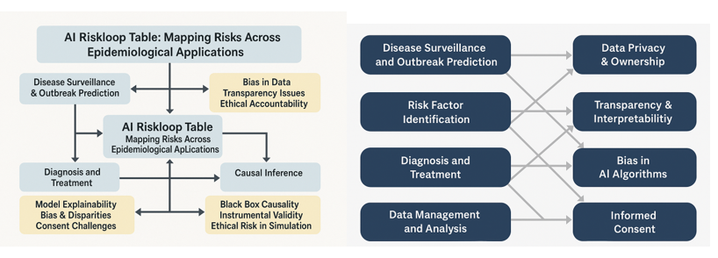
Fig. 5. Intersection of AI Use Cases and Associated Risks in Epidemiology
The AI Risk loop Table presents a structured framework that connects major applications of artificial intelligence in epidemiology with the risks inherently associated with their deployment. While AI has shown transformative potential across areas such as disease surveillance, diagnosis, and causal inference, each use case carries specific ethical, operational, or technical vulnerabilities. This table serves as a diagnostic lens to not only assess risk exposure by application type but also to identify preventive strategies that can be embedded early in the design and implementation of AI systems. In the domain of Disease Surveillance and Outbreak Prediction, AI applications such as social media monitoring and hotspot mapping raise legitimate concerns about data privacy, consent, and bias. Real-time tools often rely on personal or location-based data scraped from unregulated sources, where ownership is ambiguous and informed consent is practically unfeasible. Moreover, such models tend to underrepresent marginalized populations, potentially perpetuating health disparities. Therefore, the table recommends robust privacy protocols, demographic data audits, and stakeholder consent mechanisms at the data collection stage.
For Risk Factor Identification, the use of AI in genomic linking or omics integration brings forth challenges of data sensitivity and potential misuse. Models built on historical or incomplete data may also reinforce societal biases, affecting conclusions drawn about vulnerable groups. The Risk loop table suggests adopting explainable AI (XAI) models and integrating ethics committees into research workflows to mitigate biased interpretations of environmental or genetic risk factors. In Diagnosis and Treatment, risks associated with AI systems functioning as opaque decision-makers are particularly concerning. Black-box models, when involved in clinical decision-making, may alienate practitioners and raise legal concerns if adverse outcomes occur. Additionally, patients are often unaware that their medical images or histories are being processed by automated systems. The Risk loop framework advocates for model transparency, clinician override options, and patient education to ensure informed trust in AI-augmented diagnoses and treatments.
Under Data Management and Analysis, issues such as data ownership conflicts, automated error propagation, and inconsistent metadata standards surface as significant obstacles. These tools often consolidate data from varied and decentralized systems without clear accountability, leading to both ethical and functional ambiguity. As per the Risk loop recommendations, institutions should develop interoperable data governance frameworks, mandate validation checkpoints, and ensure traceability in AI-driven data transformation pipelines. Lastly, in the realm of Causal Inference, AI-driven simulations, counterfactual models, and instrumental variable estimations can raise questions about validity and transparency. As causal relationships influence high-impact policy decisions, it is imperative that the logic and assumptions underlying these models are made explicit. The Risk loop approach encourages the use of hybrid causal frameworks, cross-validation with traditional methods, and documentation of causal assumptions to maintain epistemic rigor.
In conclusion, the AI Risk loop Table is not merely a risk registry, but a strategic tool aimed at encouraging responsible AI design and governance in epidemiology. By mapping specific AI applications to their corresponding vulnerabilities, this framework empowers researchers, developers, and public health institutions to proactively integrate risk mitigation strategies. It reinforces the idea that ethical and technical foresight must co-evolve with innovation to harness AI's full potential without compromising public trust, equity, or safety.
4. CONCLUSION
This study offers a comprehensive examination of how Artificial Intelligence (AI) is shaping the field of epidemiology, providing valuable insights into its applications, benefits, and associated risks. By structuring the literature review into three focused areas—uses, benefits, and risks—this paper establishes a well-rounded understanding of the multifaceted role of AI in epidemiological research and practice. As AI continues to evolve, its ability to process complex datasets, identify hidden patterns, and support real-time decision-making has demonstrated immense potential in enhancing public health outcomes. However, these advantages must be weighed against ethical and operational challenges that arise from its deployment. To bridge the gap between opportunity and responsibility, this study introduces three strategic recommendations. The first, Loop-Oriented Benefits of AI Applications in Epidemiology, emphasizes creating structured feedback loops within each domain of AI application—from disease surveillance to causal inference. These loops align specific AI functionalities with their corresponding benefits, reinforcing efficiency, precision, and responsiveness in epidemiological workflows.
The second recommendation, AI Overloop Oriented Benefits: Cross-Functional Benefits Across Epidemiology Domains, highlights the interconnected nature of AI applications across different public health functions. AI tools that enhance data integration, for example, not only benefit analysis but also improve disease prediction and treatment planning. Recognizing and leveraging these cross-functional or “overloop” advantages can amplify the overall impact of AI in epidemiology by encouraging integrated, system-wide implementations rather than isolated solutions. The third and final recommendation, AI Use Risk Loop: Mapping Risks Across Epidemiological Applications, calls for a proactive framework to address the ethical and practical risks associated with AI. By systematically connecting specific AI applications with their inherent risks—such as data privacy concerns in disease surveillance or algorithmic bias in risk factor modeling—public health practitioners and policymakers can implement targeted safeguards. This risk-aware approach ensures that AI’s adoption in epidemiology remains transparent, equitable, and ethically grounded.
In summary, the responsible and strategic use of AI in epidemiology holds transformative potential. By embracing loop-oriented structures, recognizing overloop synergies, and mapping risks through well-defined frameworks, the public health community can harness the full value of AI while minimizing its unintended consequences. These recommendations lay the groundwork for future research, policy development, and real-world implementation that center both technological innovation and ethical stewardship.
5. FUTURE RESEARCH
Future research should focus on translating the recommendations proposed in this study into practical, real-world applications within epidemiological practice and public health systems. Specifically, researchers and public health agencies can explore the operationalization of the Loop-Oriented Benefits by developing modular AI tools tailored to distinct epidemiological functions, such as outbreak detection or exposure modeling. The AI Overloop Oriented Benefits framework encourages the design of interoperable AI systems that serve multiple functions simultaneously, promoting resource efficiency and systemic resilience. Additionally, implementing the AI Use Risk Loop in policy and system design can guide the creation of ethical AI governance models that address transparency, consent, and bias mitigation. Pilot studies, cross-sector collaborations, and simulation-based evaluations will be essential to refine these models, ensuring that AI applications in epidemiology are not only innovative and efficient but also equitable, secure, and socially responsible.
DISCLAIMER (ARTIFICIAL INTELLEGENCE)
Author(s) hereby declare(s) that NO generative AI technologies such as Large Language Models (ChatGPT, COPILOT, etc.) and text-to-image generators have been used during the writing or editing of this manuscript.
CONSENT
As per international standards or university standards, respondents’ written consent has been collected and preserved by the author(s).
ETHICAL APPROVAL
It is not applicable.

REFERENCES
Ahmad, O. F., Stoyanov, D., & Lovat, L. B. (2020). Barriers and pitfalls for artificial intelligence in gastroenterology: Ethical and regulatory issues. Techniques and Innovations in Gastrointestinal Endoscopy, 22(2), 80–84.
Bengtsson, L., Gaudart, J., Lu, X., Moore, S., Wetter, E., Sallah, K., Rebaudet, S., & Piarroux, R. (2015). Using mobile phone data to predict the spatial spread of cholera. Scientific Reports, 5, 8923.
Bi, Q., Goodman, K. E., Kaminsky, J., & Lessler, J. (2019). What is machine learning? A primer for the epidemiologist. American Journal of Epidemiology, 188(12), 2222–2239.
Eisbach, S., Mai, O., & Hertel, G. (2024). Combining theoretical modelling and machine learning approaches: The case of teamwork effects on individual effort expenditure. New Ideas in Psychology, 73, 101077.
Esteva, A., Kuprel, B., Novoa, R. A., Ko, J., Swetter, S. M., Blau, H. M., & Thrun, S. (2017). Dermatologist-level classification of skin cancer with deep neural networks. Nature, 542(7639), 115–118.
Ellison, G. T. (2020). COVID-19 and the epistemology of epidemiological models at the dawn of AI. Annals of Human Biology, 47(6), 506–513.
Gao, X. R., Chiariglione, M., Qin, K., Nuytemans, K., Scharre, D. W., & Li, Y. J., Martin, E. R. (2023). Explainable machine learning aggregates polygenic risk scores and electronic health records for Alzheimer’s disease prediction. Scientific Reports, 13(1), 450.
Glicksberg, B. S., Timsina, P., Patel, D., Sawant, A., Vaid, A., Raut, G., Charney, A. W., Apakama, D., Carr, B. G., & Freeman, R., et al. (2024). Evaluating the accuracy of a state-of-the-art large language model for prediction of admissions from the emergency room. Journal of the American Medical Informatics Association, 31, 1921–1928.
Goldust, Y., Sameem, F., Mearaj, S., Gupta, A., Patil, A., & Goldust, M. (2023). COVID-19 and artificial intelligence: Experts and dermatologists perspective. Journal of Cosmetic Dermatology, 22, 11–15.
Grueso, S., & Viejo-Sobera, R. (2021). Machine learning methods for predicting progression from mild cognitive impairment to Alzheimer’s disease dementia: A systematic review. Alzheimer’s Research & Therapy, 13(1), 162.
Kim, S., Kim, K., & Jo, W. (2024). Accuracy of a large language model in distinguishing anti- and pro-vaccination messages on social media: The case of human papillomavirus vaccination. Preventive Medicine Reports, 42, 102723.
Lee, E. Y., Maloney, N. J., Cheng, K., & Bach, D. Q. (2021). Machine learning for precision dermatology: Advances, opportunities, and outlook. Journal of the American Academy of Dermatology, 84(5), 1458–1459.
London, A. J. (2022). Artificial intelligence in medicine: Overcoming or recapitulating structural challenges to improving patient care? Cell Reports Medicine, 3(5), 100622.
Lu, L., Dercle, L., Zhao, B., & Schwartz, L. H. (2021). Deep learning for the prediction of early on-treatment response in metastatic colorectal cancer from serial medical imaging. Nature Communications, 12(1), 6654.
Littmann, M., Selig, K., Cohen-Lavi, L., Frank, Y., Hönigschmid, P., Kataka, E., Mösch, A., Qian, K., Ron, A., & Schmid, S., et al. (2024). Validity of machine learning in Chen et al. BMC Medicine, 22, 354.
Matthay, E. C., Neill, D. B., Titus, A. R., Desai, S., Troxel, A. B., Cerdá, M., Díaz, I., Santacatterina, M., & Thorpe, L. E. (2025). Integrating artificial intelligence into causal research in epidemiology. Current Epidemiology Reports, 12(1), 6.
McCrary, M. R., Galambus, J., & Chen, W. S. (2024). Evaluating the diagnostic performance of a large language model-powered chatbot for providing immunohistochemistry recommendations in dermatopathology. Journal of Cutaneous Pathology, 51, 689–695.
Murdoch, W. J., Singh, C., Kumbier, K., Abbasi-Asl, R., & Yu, B. (2019). Definitions, methods, and applications in interpretable machine learning. Proceedings of the National Academy of Sciences, 116(44), 22071–22080.
Muley, A., Cheemalapati, S., Kurian, G., Muzumdar, P., & Singh, K. (2023). Critical factors influencing electronic health record adoption in U.S. hospitals: An empirical analysis using the technology-organization environment framework. Asian Journal of Advanced Research and Reports, 19(3), 11–19.
Muley, A., Muzumdar, P., Kurian, G., & Basyal, G. P. (2021). Risk of AI in healthcare: A comprehensive literature review and study framework. Asian Journal of Medicine and Health, 21(10), 276–291.
Muzumdar, P., Muley, A., Singh, K., & Cheemalapati, S. (2023). Ethical AI in the healthcare sector: Investigating key drivers of adoption through the multi-dimensional ethical AI adoption model (MEAAM). Asian Journal of Medicine and Health, 23(5), 95–115.
Naudé, W. (2020). Artificial intelligence vs COVID-19: Limitations, constraints and pitfalls. AI & Society, 35, 761–765.
Park, Y. J., Pillai, A., Deng, J., Guo, E., Gupta, M., Paget, M., & Naugler, C. (2024). Assessing the research landscape and clinical utility of large language models: A scoping review. BMC Medical Informatics and Decision Making, 24(1), 72.
Patra, B. G., Sharma, M. M., Vekaria, V., Adekkanattu, P., Patterson, O. V., Glicksberg, B., Lepow, L. A., Ryu, E., Biernacka, J. M., & Furmanchuk, A., et al. (2021). Extracting social determinants of health from electronic health records using natural language processing: A systematic review. Journal of the American Medical Informatics Association, 28(12), 2716–2727.
Rajkomar, A., Hardt, M., Howell, M. D., Corrado, G., & Chin, M. H. (2018). Ensuring fairness in machine learning to advance health equity. Annals of Internal Medicine, 169(12), 866–872.
Rim, T. H., Lee, C. J., Tham, Y. C., Cheung, N., Yu, M., Lee, G., Kim, Y., Ting, D. S. W., Chong, C. C. Y., & Choi, Y. S., et al. (2021). Deep-learning-based cardiovascular risk stratification using coronary artery calcium scores predicted from retinal photographs. The Lancet Digital Health, 3(5).
Sharma, D., Gotlieb, N., Farkouh, M. E., Patel, K., Xu, W., & Bhat, M. (2022). Machine learning approach to classify cardiovascular disease in patients with nonalcoholic fatty liver disease in the UK Biobank cohort. Journal of the American Heart Association, 11(1).
Smit, L. C., Dikken, J., Schuurmans, M. J., de Wit, N. J., & Bleijenberg, N. (2020). Value of social network analysis for developing and evaluating complex healthcare interventions: A scoping review. BMJ Open, 10(11), e039681.
Su, C., Xu, Z., Pathak, J., & Wang, F. (2020). Deep learning in mental health outcome research: A scoping review. Translational Psychiatry, 10(1), 116.
Swanson, K., Wu, E., Zhang, A., Alizadeh, A. A., & Zou, J. (2023). From patterns to patients: Advances in clinical machine learning for cancer diagnosis, prognosis, and treatment. Cell, 186(8), 1772–1791.
Tang, A. S., Rankin, K. P., Cerono, G., Miramontes, S., Mills, H., Roger, J., Zeng, B., Nelson, C., Soman, K., & Woldemariam, S., et al. (2024). Leveraging electronic health records and knowledge networks for Alzheimer’s disease prediction and sex-specific biological insights. Nature Aging, 4(3), 379–395.
Tran, K. A., Kondrashova, O., Bradley, A., Williams, E. D., Pearson, J. V., & Waddell, N. (2021). Deep learning in cancer diagnosis, prognosis and treatment selection. Genome Medicine, 13(1), 152.
Waljee, A. K., Weinheimer-Haus, E. M., Abubakar, A., Ngugi, A. K., Siwo, G. H., Kwakye, G., Singal, A. G., Rao, A., Saini, S. D., & Read, A. J., et al. (2022). Artificial intelligence and machine learning for early detection and diagnosis of colorectal cancer in sub-Saharan Africa. Gut, 71(7), 1259–1265.
Weng, S. F., Reps, J., Kai, J., Garibaldi, J. M., & Qureshi, N. (2017). Can machine-learning improve cardiovascular risk prediction using routine clinical data? PLOS ONE, 12(4).
Wiens, J., & Shenoy, E. S. (2018). Machine learning for healthcare: On the verge of a major shift in healthcare epidemiology. Clinical Infectious Diseases, 66(1), 149–153.
Williams, C. Y. K., Zack, T., Miao, B. Y., Sushil, M., Wang, M., Kornblith, A. E., & Butte, A. J. (2024). Use of a large language model to assess clinical acuity of adults in the emergency department. JAMA Network Open, 7(5), e248895.
Zeng, D., Cao, Z., & Neill, D. B. (2020). Artificial intelligence–enabled public health surveillance—From local detection to global epidemic monitoring and control. In Artificial Intelligence in Medicine (pp. 437–453). Academic Press.
Zhang, B., Shi, H., & Wang, H. (2023). Machine learning and AI in cancer prognosis, prediction, and treatment selection: A critical approach. Journal of Multidisciplinary Healthcare, 16, 1779–1791.

