**IN VIVO CELL TRACKING AND SIGNALLING WITH VARIOUS IMAGING MODALITIES**

ABSTRACT

Advancements in imaging technologies have revolutionised the field of immunology by enabling the visualisation of immune cell behaviour and signalling pathways at unprecedented spatial and temporal resolutions. This is a comprehensive review based on various imaging modalities in immunology. It explores various modern imaging techniques, including fluorescence, confocal, TIRF microscopy, SRM, TEM, AFM, etc. Each method offers unique insights into immune processes, from antigen presentation and immunological synapse formation to cell activation and migration. The integration of 3D imaging models, SMI, and multimodal approaches has further enhanced our understanding of immune cell dynamics in both in vivo and in vitro contexts. Applications extended to the study of dendritic cells, T and B cells, neutrophils, and their interactions in health and disease. Furthermore, the development of non-invasive molecular imaging modalities like MRI, PET allows real-time tracking of immune tolerance and therapeutic strategies and shaping the future of personalised immune medicine.

Keywords: Immune cell imaging, TIRF Microscopy, Flow cytometry, Immune tolerance, DNA FISH, Multimodal imaging (MRI, PET, CT, SPECT), 3D imaging

INTRODUCTION

The cell imaging techniques have enabled a better &advanced understanding of the cellular structures and functions. It has become the basis of all cellular discoveries and is playing a major role in immunology. This has helped in knowing how various immune reactions are initiated and controlled in the human body, leading to proper diagnosis and treatment of various diseases. Various imaging techniques with various resolutions and sensitivity of detection, along with the presence of a vast variety of fluorescent molecules, have greatly improved the analysis method. Immune signalling processes occur in two types – spatial and temporal scales. Spatial scale includes large micron-sized clusters to small micro and nanoclusters that are below the resolution of light microscopy, like cytokine and chemokine-based signalling, and inflammatory reactions. Etc. Temporal scale includes events ranging from microseconds to stable cell-cell interactions lasting for a few seconds to minutes. So, a single imaging technique cannot identify all these different interactions; hence, various imaging techniques with varied resolutions are used to study the cellular interactions and various biological signalling pathways. In this review, we shall discuss the various imaging techniques and their role in highlighting the various molecular mechanisms of immune cell signalling and other interactions [1].

OVERVIEW OF IMAGING TECHNIQUES

Molecular imaging techniques allow real-time observation and evaluation of immune mechanism changes in living organisms, leading to the formulation of new approaches to early disease diagnosis and adequate therapy and treatment. Different biological phenomena like the migration, differentiation, proliferation and metabolic alterations of immune cells can be traced. Another use of these methods is preclinical assessment of novel drugs on molecular targets within live cells.

Advanced microscopic methods like fluorescence and confocal microscopy visualise specific cellular proteins, structure and behaviour of immune cells in real time. Fluorescence microscopy plays an important role in studying cellular processes like antigen presentation and immune cell activation.

Two-photon microscopy, a deep tissue imaging technique, provides valuable insight into immune cell structures and their interactions within intact tissues. TIRF microscopy and scanning disk confocal microscopy provide novel insights into spatiotemporal relations b/w APCS and T-Cells. Super-resolution microscopy, including STORM and PALM, have transformed the analysis of molecular structures at the nanometre level and greatly increased our knowledge of cell membrane structure and function. Flow cytometry provides high-throughput analysis of immune populations, thus facilitating the study of various diseases. Electron microscopy, an ultrahigh-resolution imaging technique, observes the ultrastructure of immune cells and processes with very minute details that are often not captured by conventional light microscopy. In addition, the imaging techniques have revolutionised our understanding of molecular and signalling processes in T-cell activation, influencing our comprehension of immune activation and regulation [2].

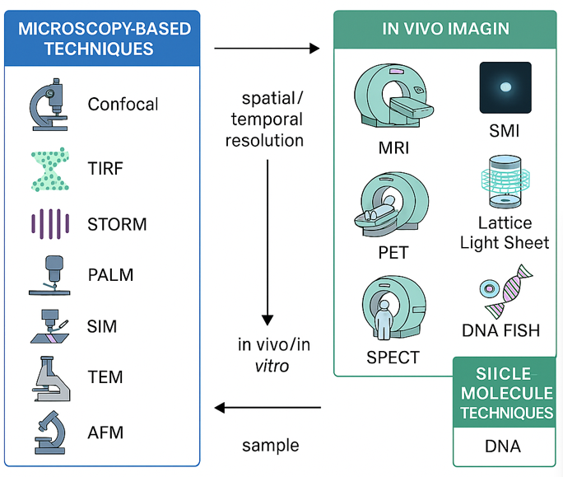

Fig 1 VARIOUS IMAGING TECHNIQUES

* 3D IMAGING METHODS AND ITS APPLICATION

Three-dimensional imaging has emerged as a very powerful tool for studying the immune system and cancer immunology. This allows for detailed examination of immune cells within their natural microenvironment, thus providing insights into cell-cell interactions and inflammatory responses. These methods, along with some other high-throughput “-omics” techniques, develop some mechanistic models that describe immune system behaviour across multiple scales. In oncology-related studies, 3d in vitro models such as organoids, microfluidic cultures, and bioprinting are more advantageous over traditional 2D models by providing a better understanding of tumour replication and allowing co-culture of immune cells [3].

Table 1 3D IMAGING MODELS

|  |  |  |  |
| --- | --- | --- | --- |
| MODEL TYPE | APPLICATION | IMAGING METHOD | ADVANTAGE |
| Organoids | Tumor immune interaction | Confocal, LLSM | Mimics in vivo environment |
| Microfluidic chips | Immune migration | TIRF, SRM | Real-time perfusion |
| Bioprinted constructs | Immunotherapy testing | Multi-photon, AFM | 3D architecture & functioning |

* + 3D IMAGING IN IMMUNE SYNAPSE STUDY

Fluorescence images of an immunological synapse were initially captured with confocal microscopy [4][5]. Earlier, most immune signalling studies relied on Commercial spinning disk confocal microscopes with diffraction-limited resolution (lateral: 200 nm, axial: 500 nm) with video rate 2D imaging (20 Hz), examples such as release of cell killing particles [6], or calcium influx [7]. The main disadvantage of this method is limited speed and high chances of photobleaching. However, this has been avoided in 3D imaging, which can capture structures like the cell-cell interface.

Widefield fluorescence methods use cameras to transcend the shortcomings of confocal microscopy, albeit with less axial sectioning. Structured Illumination microscopy (SIM) is a super-resolution microscopy method that employs interface patterns to generate a fluorescence image from different directions. A combination of SIM with new techniques, such as image correlation spectroscopy, has made membrane protein dynamics analysis faster [9].

Lattice light-sheet microscopy (LLSM) provides high-speed and high-resolution imaging with minimum phototoxicity and photo bleaching effects. This method has been the most promising technique for immune cell 3D imaging, such as unveiling the topological changes of T cell IS formation[10], how finger-like cellular protrusions search for antigens[11] and how the actin cytoskeleton supports immune activation [12][13].

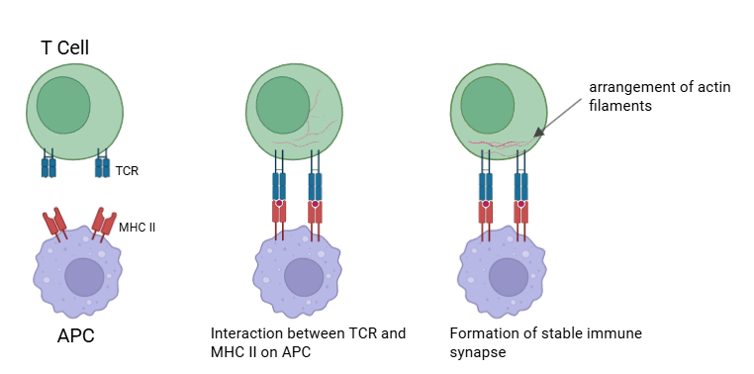 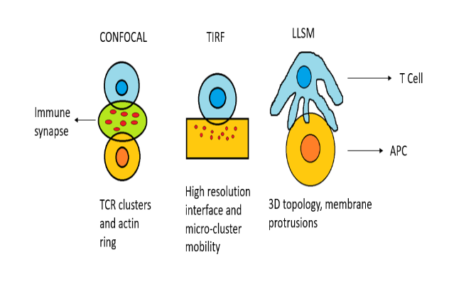

Fig 3Immune synapse visualisation using various microscopy techniques

Fig 2 Formation of Immune synapse

* IN SITU SINGLE MOLECULE IMAGING OF IMMUNE CELL

Recent advancements in single-molecule imaging techniques have helped revolutionise our knowledge and understanding of immune cell functions and behaviour [14][15]. Single-molecule level in situ imaging of the cell membrane provides crucial insights into molecular structures and signal transduction [16][17]. This requires high sensitivity, fast acquisition and minimal photobleaching. T cell receptor signalling, immune synapse formation are investigated using SMI[18].Single-cell imaging based on total internal reflection fluorescence microscopy at the basal cell interface is widely employed to investigate the initiation of immune response by the T cell receptor. Single-molecule light-sheet microscopy allows imaging of single receptors in any plane within a cell to investigate protein dynamics and organisation within suspended T cells. The light sheet generated high-quality single-molecule fluorescence images that could be matched to those acquired by total internal reflection fluorescence microscopy, thereby elucidating how protein diffusion and cellular activation are influenced by surface contact [19].

In studying granulomas in tuberculosis, Single-molecule fluorescent in situ hybridisation was used for developing multiplex imaging of mRNA markers, enabling the classification of immune cell subtypes and their distribution in the granulomas[20]. Intravital microscopy enables real-time observation of immune cell behaviour in living tissues, their migration pattern, cell-cell communication and regulation[21]. These techniques collectively aid in investigating immune cell dynamics at unprecedented resolution, advancing our understanding of immunology and potential therapeutic interventions.

* HOW ELECTRON MICROSCOPY REVEAL PREVIOUSLY UNDETECTED MORPHOLOGICAL VARIATIONS IN NEUTROPHIL ACTIVATION DURING INFLAMMATORY PROCESSES

Electron microscopy has helped in revealing significant morphological variations in neutrophil activation during inflammatory processes. Visualisation of neutrophils by transmission electron microscopy(TEM) explained the morphology of the para-inflammatory phenotype of oral neutrophils & comparing it with the naïve blood neutrophil, revealed that proinflammatory neutrophils have fewer granules, lighter cytoplasm and greater nuclear euchromatin compared to para-inflammatory neutrophils[22]. Activated neutrophils develop more prominent cytoplasmic structures and processes[23]. Confocal and fluorescence microscopy, although employed to examine neutrophil activation and NET-osis, do not expose the neutrophil membrane surface, its nanostructure, and morphology. Atomic force microscopy can reveal the changes in neutrophil membrane structure at the nanoscale level during activation and NET-osis, including cell spreading, fragmentation, and membrane disruption[24].TEM revealed the development of vacuoles in electropermeabilized neutrophils, upon stimulation, along with the fusion of azurophilic and specific granules in both the vacuoles as well as cell membrane[25].

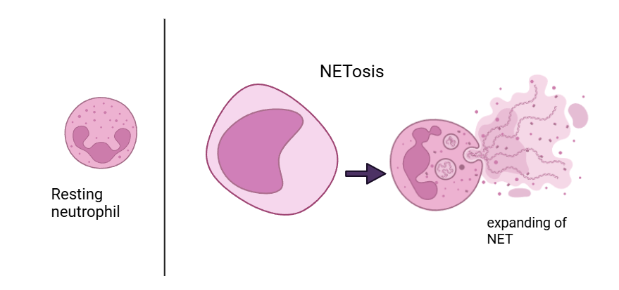

Fig 4 Visualisation of neutrophils during NETosis using electron microscope

* CELL IMAGING TECHNIQUES IN UNDERSTANDING THE FUNCTIONING OF DENDRITIC CELLS

Dendritic cells are the primary antigen-presenting cells (APC) and link innate and adaptive immunity. Advances in imaging methods focusing on live cell imaging in situ have opened up new windows of understanding the interactions between antigen-presenting cells and T cells. Techniques such as TPM, TIRF microscopy, and SDCM allowed high-resolution imaging and deep visualisation into dendritic cell processes in real time[26]. Advanced imaging methods and high resolution illuminating instruments like intravital imaging by multiphoton microscopy, LSM, AFM, and SRM allowed us to determine the specific cell subtypes, monitor the cell migration with time using time-lapse imaging, observing the in vivo cell contacts in the resolution of individual cells, and investigating the molecular mechanism responsible for the cell behavior and interaction, like the intravital imaging monitors dynamic organisms within living, intact animals to generate continuous and simultaneous information in an intact organism with full interactions. Atomic force microscopy provides high-resolution nanoscale images of the cell surface. STORM and STED are the most widely used super-resolution methods, which are employed to expose the nano-level structure of various structures in cells. These techniques enabled researchers to observe dendritic cell manufacturing, antigen capture and presentation, as well as their migration and interaction with T cells during any immune response[27]. Spatiotemporal tracking of dendritic cells has revealed their role during the period of infection and inflammation, giving important insights into their role in initiating an adaptive immune response.[28]. Moreover, recent developments in multiplexed imaging techniques have enabled the study of the spatial localisation of dendritic cells within tissues, providing valuable information about cellular cross-talk and tissue-specific functions[29]. These advancements have significantly enhanced our understanding of dendritic cells and their role in immune regulation.

* CONFOCAL MICROSCOPY IMAGING IN T-CELL AND B-CELL ANALYSIS

Advanced confocal microscopy has greatly revolutionised our understanding of lymphocyte dynamics and the study of T and B cells. These have offered high spatial and temporal resolution, thus enabling direct observation of cellular activation processes. Electron and sophisticated light microscopy methods have been utilised to generate high-resolution images of lymphocytes in vitro. High-resolution techniques have overcome the diffraction limit of light to examine subcellular characteristics as minute as a single molecule. Advances in imaging technologies have therefore allowed visualisation of signalling events in lymphocytes with increasingly higher spatial and temporal resolution.[30]. Super-resolution microscopy methods, such as Airy-Scan, STED, and TEM, have improved imaging of mitochondrial morphology and metabolism in B and T cells, demonstrating activation-induced modifications and internal structural modifications[31].Moreover, recent imaging modalities like TPM, TIRF microscopy, and SDCM have confronted current dogma and offered new knowledge regarding dendritic cell function and spatiotemporal interactions between antigen-presenting cells and T cells. These imaging methods together provide unparalleled cellular and molecular resolution, supporting the validation, revision, and replacement of lymphocyte activation models.

* SUPER RESOLUTION IMAGING IN STUDYING IMMUNE SIGNALLING PATHWAYS

Super resolution microscopy has revolutionised our knowledge of immune cell signalling by visualisation at the nano scale, protein organisation and dynamics. This method has been used for studying immunological synapses, revealing valuable details about receptor distribution and signalling processes. Super-resolution techniques have provided new insights into NK Cell biology. Recent developments, such as SPARCOM with improved resolution, enabled real-time imaging of T Cell receptors during the activation process[32]. Several super-resolution techniques, such as 3D-SIM[33], STED[34], SMLM, TIRF[35] and LLSM[36] [37] have been used for the visualisation of actin dynamics and lytic granules within the immunological synapse of T Cells and NK Cells. DNA FISH is used to quantify the nuclear position of the immunoglobulin heavy chain locus on B-cell progenitors.[38]

Techniques like STORM[39], PALM[40][41], PAINT[42] or GSDM[43]cause the fluorophores to switch between visible and invisible states [44]. Conditions are chosen as such that most molecules become invisible and hence do not get imaged. Thus, the average distance b/w visible molecules becomes greater than the resolution limit of the microscope, and individual molecules can now be localised. By recording several such images, a super-resolution image can be produced. These are often used for the determination ofthe local and global distribution of molecules on the cell membrane.

These advanced imaging techniques have answered long-standing immunological conundrums and are still providing promising directions for future work in molecular immunity. The use of super-resolution microscopy to image immune cells has greatly improved our comprehension of intricate immunological processes and their spatial organisation [45].

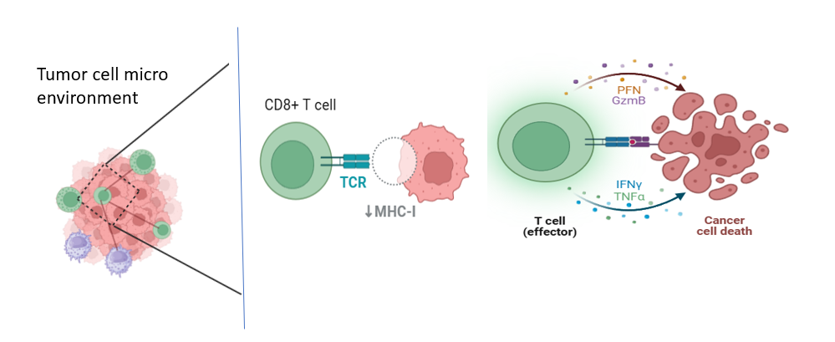

Fig 5 Visualisation of T-Cell interaction with tumor cell at tumor micro environment with super resolution imaging techniques

* ADVANCED MOLECULAR IMAGING TECHNIQUES ALLOWS REAL-TIME VISUALISATION OF IMMUNE CELL INTERACTIONS DURING IMMUNE TOLERANCE

Immunologic tolerance and immune metabolism are essential to immune homeostasis and the immune response against disease. Advances in molecular imaging technologies, particularly optical molecular imaging, nuclear medicine imaging, and magnetic resonance imaging, have led to a tremendous improvement in imaging immune tolerance and immune metabolism. The technologies of molecular imaging allow for real-time monitoring and analysis of dynamic immune tolerance processes and immune metabolism in living beings, enabling to development of novel strategies for early diagnosis of disease, targeted therapy, and immunotherapy [46]. These techniques allow non-invasive tracking of immune cells in vivo, thus providing better visualisation of cellular behaviour and therapeutic responses[47][48]. Multiple imaging modalities, such as MRI, CT, PET, SPECT, and optical imaging, possess distinct strengths for immune cell tracking[49]. Multimodal imaging strategies leverage the strengths of each method to surmount its weaknesses. These technologies have enabled the creation of cell-based therapies, like NK cell-based cancer immunotherapies. Molecular imaging has improved our knowledge of immune priming, tolerance, and T-B cell interactions. Nonetheless, scientists need to take into account possible physiological effects when developing immune-monitoring imaging tracers. In general, these advances in imaging technologies are essential for maximising immune cell therapies and understanding intricate immunological mechanisms [50].

Table 2 COMPARISON OF IMAGING TECHNIQUES IN IMMUNE CELL STUDIES

|  |  |  |  |  |
| --- | --- | --- | --- | --- |
| TECHNIQUES | RESOLUTION | SAMPLE TYPE | STRENGTH | LIMITATIONS |
| Confocal | ~200 nm | Live/fixed cell | 3D imaging | Limited depth |
| TIRF | ~100 nm axial | Cell membrane | Surface interaction | Only surface imaging |
| STORM | ~20-30 nm | Fixed cell | Nanoscale resolution | Complex setup |
| MRI | ~100 um | In vivo | Non-invasive, deep tissue | Low molecular resolution |
| PET | ~1-2 mm | In vivo | Functional tracking | Radiation exposure |

Table 3 APPLICATION OF IMAGING TECHNIQUES TO IMMUNE CELLS

|  |  |  |
| --- | --- | --- |
| IMAGING TECHNIQUE | CELL TYPE STUDIED | KEY INSIGHTS |
| LLSM | T cells | Topological changes in IS formation |
| Electron microscopy | Neutrophils | Membrane granule morphology |
| Multiphoton microscopy | Dendritic cell | Intravital dynamics |
| DNA FISH | B cell progenitors | Gene locus localisation |
| Flow cytometry | Mixed | Cell population phenotyping |

CONCLUSION

Recent innovations in imaging technologies have revolutionised our knowledge of immune cell function and signalling pathways. The convergence of a variety of imaging modalities—from confocal and two-photon microscopy to super-resolution approaches such as STORM, PALM, STED, and lattice light-sheet microscopy—has been achieved to visualise immune events at the cellular and molecular levels with great accuracy. These methods have enabled real-time observation of dynamic processes such as immune synapse formation, antigen presentation, activation of T and B cells, and dendritic cell movement. Moreover, high-throughput and ultrastructural approaches like flow cytometry, TEM, and AFM have extended our assessment capabilities further, providing detailed insights into immune cell morphology, heterogeneity of populations, and subcellular structure. The use of these technologies has not only added substantially to fundamental immunological research but also has provided insight into the development of therapeutic approaches, most notably in cancer immunotherapy, infectious disease surveillance, and autoimmune diagnostics.

FUTURE ASPECTS

In the future, immune imaging will facilitate real-time imaging of complex biological processes in their native physiological context with faster, more sensitive, and less invasive methods. The need is acute for modalities with improved spatial and temporal resolution without phototoxicity, especially for live-cell and in vivo imaging. The combination of artificial intelligence and machine learning with imaging platforms holds the promise of transforming image analysis by facilitating pattern recognition, predictive modelling, and large-scale interpretation of data in an automated way. Additionally, Innovations such as machine learning-integrated image analysis and high-content screening technologies will speed up the visualisation of dynamic immune processes with unprecedented resolution. The development of patient-derived 3D models such as organoids, microfluidic systems, and bio-printed immune tissues will greatly increase the physiological relevance of experimental systems, especially in cancer immunology and personalised medicine. Moreover, the integration of multiplexed and multimodal imaging strategies—combining optical methods with MRI, PET, SPECT, and molecular probes—will yield comprehensive insights into immune dynamics at cellular, tissue, and systemic levels. These advances will further our mechanistic insight into the immune system, inform the development and assessment of future immunotherapies, and facilitate the application of precision medicine. As these technologies continue to become more precise, scalable, and accessible, they are likely to become essential tools in research and clinical settings, determining the future landscape of immunological discovery and therapy.

ABBRIVIATIONS

STORM-Stochastic Optical Reconstruction Microscopy

PALM-Photo Activated Localisation Microscopy

SIM-Structured Illumination Microscopy

LLSM-Lattice Light Sheet Microscopy

SMI-Single Molecule Imaging

TEM-Transmission Electron Microscopy

TPM-Two-Photon Microscopy

TIRF-Total Internal Reflection Fluorescence Microscopy

SDCM-Scanning Disc Confocal Microscopy

LSM-Light Sheet Microscopy

AFM-Atomic Force Microscopy

SRM-Super Resolution Microscopy

STED-Stimulation Emission Depletion Microscopy

GSDM-Ground State Depletion Microscopy

SMLM- Single Molecule Localisation Microscopy

PAINT-Point Accumulation for Imaging in Nanoscale Topography

SPECT-Single Photon Emission Computed Tomography

PET-Positron Emission Tomography

Disclaimer (Artificial intelligence)

Option 1:

Author(s) hereby declare that NO generative AI technologies such as Large Language Models (ChatGPT, COPILOT, etc.) and text-to-image generators have been used during the writing or editing of this manuscript.

Option 2:

Author(s) hereby declare that generative AI technologies such as Large Language Models, etc. have been used during the writing or editing of manuscripts. This explanation will include the name, version, model, and source of the generative AI technology and as well as all input prompts provided to the generative AI technology

Details of the AI usage are given below:

1.

2.

3.

REFERENCES

1.Hofmann, J., & Keppler, S. J. (2021). Tissue clearing and 3D imaging – putting immune cells into context. Journal of Cell Science, 134(5), jcs258494. https://doi.org/10.1242/jcs.258494

2.Ludewig, B., Odermatt, B., Landmann, S., Hengartner, H., & Zinkernagel, R. M. (2012). Dendritic cells induce autoimmune diabetes and maintain disease via de novo formation of local lymphoid tissue. European Journal of Immunology, 42(11), 3116–3125. https://doi.org/10.1002/eji.201242508

3.Mu, P., Zhou, S., Lv, T., Xia, F., Shen, L., Wan, J., Wang, Y., Zhang, H., Cai, S., Peng, J., Hua, G., & Zhang, Z. (2023). Newly developed 3D in vitro models to study tumor–immune interaction. Journal of Experimental & Clinical Cancer Research, 42, 81. https://doi.org/10.1186/s13046-023-02653-w

4.Toledo, E., Iraqi, M., Pandey, A., Tzadka, S., Le Saux, G., Porgador, A., &#38; Schvartzman, M. (2023). Multifunctional Nanoscale Platform for the Study of T Cell Receptor Segregation. ACS Omega, 28968–28975. <https://doi.org/10.1021/acsomega.2c08194>

5.Friedman, D., Simmonds, P., Hale, A., Bere, L., Hodson, N., White, M. R. H., &#38; Davis, D. M. (2021). Natural killer cell immune synapse formation and cytotoxicity are controlled by tension of the target interface. Journal of Cell Science7). <https://doi.org/10.1242/JCS.258570>

6.Bálint, Š., Müller, S., Fischer, R., Kessler, B. M., Harkiolaki, M., Valitutti, S., et al. (2020). Supramolecular attack particles are autonomous killing entities released from cytotoxic T cells. Science, 368(6491), 897–901. https://doi.org/10.1126/science.aay9207

7.Santos, A. M., Ponjavic, A., Fritzsche, M., Fernandes, R. A., de la Serna, J. B., Wilcock, M. J., et al. (2018). Capturing resting T cells: The perils of PLL. Nature Immunology, 19(3), 203–205. https://doi.org/10.1038/s41590-018-0048-8

8.Bolger-Munro, M., Choi, K., Scurll, J.M., Abraham, L., Chappell, R.S., Sheen, D. et al. (2019) Arp2/3 complex-driven spatial patterning of the BCR enhances immune synapse formation, BCR signaling and B cell activation. eLife 8, e44574 https://doi.org/10.7554/eLife.44574

9.Ashdown, G.W., Cope, A., Wiseman, P.W. and Owen, D.M. (2014) Molecular flow quantified beyond the diffraction limit by spatiotemporal image correlation of structured illumination microscopy data. Biophys. J. 107, L21–L23 https://doi.org/10.1016/j.bpj.2014.09.018

10.Chen, B.-C., Legant, W.R., Wang, K., Shao, L., Milkie, D.E., Davidson, M.W. et al. (2014) Lattice light-sheet microscopy: imaging molecules to embryos at high spatiotemporal resolution. Science 346, 1257998 https://doi.org/10.1126/science.1257998

11.Cai, E., Marchuk, K., Beemiller, P., Beppler, C., Rubashkin, M.G., Weaver, V.M. et al. (2017) Visualizing dynamic microvillar search and stabilization during ligand detection by T cells. Science 356, eaal3118 https://doi.org/10.1126/science.aal3118

12.Fritzsche, M., Fernandes, R.A., Chang, V.T., Colin-York, H., Clausen, M.P., Felce, J.H. et al. (2017) Cytoskeletal actin dynamics shape a ramifying actin network underpinning immunological synapse formation. Sci. Adv. 3, e1603032 https://doi.org/10.1126/sciadv.1603032

13.Ritter, A.T., Asano, Y., Stinchcombe, J.C., Dieckmann, N.M.G., Chen, B.-C., Gawden-Bone, C. et al. (2015) Actin depletion initiates events leading to granule secretion at the immunological synapse. Immunity 42, 864–876 https://doi.org/10.1016/j.immuni.2015.04.013

14.Felce, J., Sezgin, E., Wane, M., Brouwer, H., Dustin, M.L., Eggeling, C. et al. (2018) CD45 exclusion and cross-linking based receptor signaling together broaden FcεRI reactivity. Sci. Signal. 11, eaat0756 https://doi.org/10.1126/scisignal.aat0756

15.Jenkins, E., Santos, A.M., O’Brien-Ball, C., Felce, J.H., Wilcock, M.J., Hatherley, D. et al. (2018) Reconstitution of immune cell interactions in free-standing membranes. J. Cell Sci. 132, jcs219709 https://doi.org/10.1242/jcs.219709

16.Lühr, J.J., Alex, N., Amon, L., Kräter, M., Kubánková, M., Sezgin, E. et al. (2020) Maturation of monocyte-Derived DCs leads to increased cellular stiffness, higher membrane fluidity, and changed lipid composition. Front. Immunol. 11, 590121 https://doi.org/10.3389/fimmu.2020.590121

17.Rossboth, B., Arnold, A.M., Ta, H., Platzer, R., Kellner, F., Huppa, J.B. et al. (2018) TCRs are randomly distributed on the plasma membrane of resting antigen-experienced T cells. Nat. Immunol. 19, 821–827 https://doi.org/10.1038/s41590-018-0162-7

18.Pi, J., Jin, H., Yang, F., Chen, Z.W., & Cai, J. (2014). In situ single molecule imaging of cell membranes: linking basic nanotechniques to cell biology, immunology and medicine. Nanoscale, 6 21, 12229-49 .

19.Ponjavic, A., McColl, J., Carr, A. R., Santos, A. M., Kulenkampff, K., Lippert, A., Davis, S. J., Klenerman, D., & Lee, S. F. (2018). Single-molecule light-sheet imaging of suspended T cells. Biophysical Journal, 114(9), 2200–2211. https://doi.org/10.1016/j.bpj.2018.02.044

20.Author(s). (2023). Imaging architecture of granulomas induced by Mycobacterium tuberculosis. bioRxiv. https://doi.org/10.1101/2023.02.02.526702

21.Mikael J. Pittet et al.Recording the wild lives of immune cells.Sci. Immunol.3, eaaq0491(2018). DOI:10.1126/sciimmunol. aaq0491

22.Borenstein, A., Fine, N., Hassanpour, S., Sun, C., Oveisi, M., Tenenbaum, H. C., &Glogauer, M. (2018). Morphological characterization of para‐ and proinflammatory neutrophil phenotypes using transmission electron microscopy. Journal of Periodontal Research, 53(6), 1023–1031. https://doi.org/10.1111/jre.12595

23. Borenstein, A., Fine, N., Hassanpour, S., Sun, C., Oveisi, M., Tenenbaum, H. C., Tenenbaum, H. C., &#38; Glogauer, M. (2018). Morphological characterization of para- and proinflammatory neutrophil phenotypes using transmission electron microscopy. <i>Journal of Periodontal Research(6), 972–982. <https://doi.org/10.1111/JRE.12595>

24.Sergunova, V.; Inozemtsev, V.; Vorobjeva, N.; Kozlova, E.; Sherstyukova, E.; Lyapunova, S.; Chernysh, A. Morphology of Neutrophils during Their Activation and NETosis: Atomic Force Microscopy Study. Cells 2023, 12, 2199. https://doi.org/10.3390/ cells12172199

25.Sergunova, V. A., Inozemtsev, V. S., Vorobjeva, N., Kozlova, E., Sherstyukova, E., Lyapunova, S., &#38; Chernysh, A. M. (2023). Morphology of Neutrophils during Their Activation and NETosis: Atomic Force Microscopy Study. (17). <https://doi.org/10.3390/cells12172199>

26.Jatin M. Vyas (2012) Insights into dendritic cell function using advanced imaging modalities, Virulence, 3:7, 690-694, DOI: 10.4161/viru.22981.

27.Xiao Q and Xia Y (2023) Insights into dendritic cell maturation during infection with application of advanced imaging techniques. Front. Cell. Infect. Microbiol. 13:1140765. doi: 10.3389/fcimb.2023.1140765

28.Bošnjak, B., Do, K.T., Förster, R., & Hammerschmidt, S.I. (2021). Imaging dendritic cell functions *. Immunological Reviews, 306, 137 - 163.

29.Rocca, G., Galli, M., Celant, A., Stucchi, G., Marongiu, L., Cozzi, S., Innocenti, M., & Granucci, F. (2024). Multiplexed imaging to reveal tissue dendritic cell spatial localisation and function. FEBS letters.

30.Balagopalan, L., Sherman, E., Barr, V. A., & Samelson, L. E. (2011). Imaging techniques for assaying lymphocyte activation in action. Nature Reviews Immunology, 11(1), 21–33. https://doi.org/10.1038/nri2903

31.Roesler, A.S., Miozzo, P., Akkaya, B., Smelkinson, M.G., Brzostowski, J.A., Kabat, J., Traba, J., Dorward, D.W., Pierce, S.K., & Akkaya, M. (2017). Application of super-resolution microscopy to the study of B and T lymphocyte mitochondria morphology and metabolism. The Journal of Immunology.

32.Sahel, Y.B., Dardikman-Yoffe, G., Eldar, Y.C., Gosh, S., & Haran, G. (2021). Super-Resolved Imaging of Early-Stage Dynamics in the Immune Response. 2021 IEEE International Conference on Image Processing (ICIP), 3468-3472.

33.Jang JH, Huang Y, Zheng P, Jo MC, Bertolet G, Zhu MX, et al. Imaging of Cell-Cell Communication in a Vertical Orientation Reveals High-Resolution Structure of Immunological Synapse and Novel PD-1 Dynamics. J Immunol (2015) 195:1320–30.

34.Rak GD, Mace EM, Banerjee PP, Svitkina T, Orange JS. Natural Killer Cell Lytic Granule Secretion Occurs Through a Pervasive Actin Network at the Immune Synapse. PloSBiol (2011) 9:e1001151

35.Ashdown GW, Burn GL, Williamson DJ, Pandzic E, Peters R, Holden M, et al. Live-Cell Super-Resolution Reveals F-Actin and Plasma Membrane Dynamics at the T Cell Synapse. Biophys J (2017) 112:1703–13

36.Ritter AT, Asano Y, Stinchcombe JC, Dieckmann NM, Chen BC, GawdenBone C, et al. Actin Depletion Initiates Events Leading to Granule Secretion at the Immunological Synapse. Immunity (2015) 42:864–76. doi: 10.1016/ j.immuni.2015.04.013

37.Ritter, A. T., Kapnick, S. M., Murugesan, S., Schwartzberg, P. L., Griffiths, G. M., & Lippincott-Schwartz, J. (2017). Cortical actin recovery at the immunological synapse leads to termination of lytic granule secretion in cytotoxic T lymphocytes. Proceedings of the National Academy of Sciences, 114(33), E6585–E6594. <https://doi.org/10.1073/pnas.1710751114>

38.Fuxa M, Skok J, Souabni A, Salvagiotto G, Roldan E, Busslinger M. Pax5 Induces V-To-DJ Rearrangements and Locus Contraction of the Immunoglobulin Heavy-Chain Gene. Genes Dev (2004) 18:411–22.

39.Rust, M.J., Bates, M. and Zhuang, X. (2006) Sub-diffraction-limit imaging by stochastic optical reconstruction microscopy (STORM). Nat. Methods 3, 793–795 <https://doi.org/10.1038/nmeth929>

40.Betzig, E., Patterson, G.H., Sougrat, R., Lindwasser, O.W., Olenych, S., Bonifacino, J.S. et al. (2006) Imaging intracellular fluorescent proteins at nanometer resolution. Science 313, 1642–1645 <https://doi.org/10.1126/science.1127344>

41.Hess, S.T., Girirajan, T.P. and Mason, M.D. (2006) Ultra-high resolution imaging by fluorescence photoactivation localization microscopy. Biophys. J. 91, 4258–4272

42.Sharonov, A. and Hochstrasser, R.M. (2006) Wide-field subdiffraction imaging by accumulated binding of diffusing probes. Proc. Natl Acad. Sci. U.S.A. 103, 18911–18916 <https://doi.org/10.1073/pnas.0609643104>

43.Fölling, J., Bossi, M., Bock, H., Medda, R., Wurm, C.A., Hein, B. et al. (2008) Fluorescence nanoscopy by ground-state depletion and single-molecule return. Nat. Methods 5, 943–945 <https://doi.org/10.1038/nmeth.1257>

44.Baumgart, F., Arnold, A.M., Rossboth, B.K., Brameshuber, M. and Schütz, G.J. (2018) What we talk about when we talk about nanoclusters. Methods Appl. Fluoresc. 7, 013001 <https://doi.org/10.1088/2050-6120/aaed0f>

45.Johanson TM, Keenan CR and Allan RS (2021) Shedding Structured Light on Molecular Immunity: The Past, Present and Future of Immune Cell Super Resolution Microscopy. Front. Immunol. 12:754200. doi: 10.3389/fimmu.2021.754200

46.Li K, Xie F, Xiong Y, Jiang J and Huang B (2025) Progress in the application of molecular imaging technology in immunological tolerance and immune metabolism visualization research. Front. Immunol. 16:1583228. doi: 10.3389/fimmu.2025.1583228

47.Gangadaran P and Ahn B-C (2017) Molecular Imaging: A Useful Tool for the Development of Natural Killer Cell-Based Immunotherapies. Front. Immunol. 8:1090. doi: 10.3389/fimmu.2017.01090

48.Garside, P., & Brewer, J.M. (2008). Real‐time imaging of the cellular interactions underlying tolerance, priming, and responses to infection. Immunological Reviews, 221.

49.McCarthy CE, White JM, Viola NT and Gibson HM (2020) In vivo Imaging Technologies to Monitor the Immune System. Front. Immunol. 11:1067. doi: 10.3389/fimmu.2020.01067

50.Lee, Ho Won, Gangadaran, Prakash, Kalimuthu, Senthilkumar, Ahn, Byeong-Cheol, Advances in Molecular Imaging Strategies for In Vivo Tracking of Immune Cells, BioMed Research International, 2016, 1946585, 10 pages, 2016. <https://doi.org/10.1155/2016/1946585>