Barriers to Writing Skill Development in English Learners: A Systematic Review of Quantitative Studies (2020–2024)

ABSTRACT

This systematic review explores the key barriers hindering writing skills development in English learners, particularly focusing on instructional methods, emotional factors, technological integration, and socio-cultural constraints. The study adhered to PRISMA guidelines and analyzed 30 peer-reviewed quantitative studies sourced from Scopus, PubMed, and Google Scholar. Inclusion criteria required empirical quantitative studies focusing on writing challenges among English learners, offering useful ideas that can help improve teaching, teacher training, and education policies. The study aimed to identify the primary factors impeding writing proficiency and examine how these challenges vary across demographics such as age, language proficiency, and educational background. This manuscript is important for the scientific community because it brings together recent research on the problems English learners face when developing writing skills. It clearly shows how different factors—like teaching methods, emotions, technology, and culture—affect writing. The study is especially helpful because it connects global teaching strategies with local challenges. Key findings show that writing anxiety and low self- efficacy undermine learner performance, while tools like Automated Writing Evaluation (AWE) systems and collaborative platforms can enhance engagement when properly guided by educators. Additionally, cognitive challenges, such as limited vocabulary and structural difficulties, are compounded by socio-economic factors and rigid curricula. The study underscores the need for holistic interventions that integrate effective pedagogy, emotional support, and technology. It calls for teacher training, equitable access to resources, and reforms that prioritize writing in English as a Foreign Language (EFL) instruction. Collaboration among educators, policymakers, and researchers is essential to overcome these barriers and foster student-centered learning environments that enhance writing proficiency. Lastly, this systematic research review focused on quantitative studies investigating factors impeding writing skill advancement in English learners.

Keywords: Writing skills development, English learners, process-based writing instruction, writing anxiety,
self-efficacy, instructional methods, socio-cultural constraints, cognitive challenges.

1. INTRODUCTION

Writing proficiency has emerged as a pivotal skill in education and professional domains globally. Studies underscore significant challenges faced by English as a Foreign Language (EFL) learners in mastering written communication. Research highlights issues such as limited lexical choices, grammatical errors, and cognitive barriers stemming from the allocation of working memory to low-level writing tasks instead of higher-order processes like organization and revision. For instance, a study conducted in Hong Kong by Bai et al. (2020) found that high writing achievers demonstrated stronger motivation and frequent use of self-regulated writing strategies compared to low achievers. Similarly, Xia (2023) identified language block as the most significant barrier to English writing proficiency among Chinese college students, emphasizing the interplay of cultural and instructional influences.

In the Philippines, challenges in English writing are similarly pervasive. Studies have revealed that Filipino students face difficulties stemming from inadequate vocabulary, grammatical errors, and a lack of writing practice and motivation. Peter and Singaravelu (2020) noted problems such as redundancy, mother tongue interference, and limited exposure to writing tasks, which hinder learners' ability to express ideas effectively. Despite the country's emphasis on English as a medium of instruction, these issues persist, underscoring a gap between pedagogical approaches and students' needs in academic and professional writing contexts.

However, existing literature reveals gaps in addressing these challenges holistically. While international studies emphasize motivation, self-regulated strategies, and instructional approaches, research in the Philippines often focuses narrowly on technical aspects such as grammar and syntax without exploring systemic or socio- cultural factors. Additionally, innovative strategies like technology-assisted writing tools have been explored internationally (Zhai & Ma, 2021) but lack localized implementation studies. This disconnect highlights a pressing need to bridge pedagogical methods and contextual realities to enhance writing proficiency effectively.

This study aims to systematically analyze the factors impeding the advancement of writing skills among Filipino English learners. By identifying the primary barriers and examining how these vary across different demographics, such as age, language proficiency, and educational background, the research provides a comprehensive understanding of the challenges faced by learners. This analysis seeks to bridge existing gaps by offering insights into the contextual factors that hinder writing development, thus equipping educators and policymakers with data-driven recommendations to design targeted interventions and foster improved writing proficiency.
2. material and methods

RESEARCH OBJECTIVES
This study seeks to systematically analyze the factors that impede the advancement of writing skills among English learners. Specifically, it aims to address the following questions:

- What are the primary factors that hinder English learners' development of writing skills?
- How do these factors vary across different demographics, such as age, language proficiency, and educational background?

METHODS
This systematic research review focused on quantitative studies investigating factors impeding writing skill advancement in English learners. Studies included quasi- experimental designs, surveys, and statistical analyses such as t-tests and ANCOVA. For instance, Abdullah (2021) on his research about the “Effectiveness of the ADDIE Model within an E-Learning Environment in Developing Creative Writing in EFL Students”, employed a quasi-experimental method to examine the impact of creative writing instruction through e-learning environments on English learners’ writing skills, highlighting significant improvements in their performance. Similarly, studies like Rad and Jafarpour (2022) explored the effects of emotional well- being on writing proficiency. These methods provided rigorous evidence for evaluating challenges in English writing instruction.

DATA COLLECTION
Data for this systematic review were gathered using Google Scholar, a widely accessible academic search engine. A comprehensive search strategy was employed, utilizing keywords such as “factors impeding writing skills,” “English learners,” and “quantitative research in writing education.” Boolean operators and filters were applied to refine results to peer-reviewed studies published from 2020 to the present. Abstracts were scanned to determine relevance, followed by a full-text review of potential studies. This rigorous process resulted in the selection of 30 articles, ensuring they adhered to the inclusion criteria of being quantitative studies focused on writing challenges in English learners while excluding qualitative, mixed-method research, and publications predating 2020.

Fig 1: PRISMA FLOW DIAGRAM: IDENTIFICATION OF STUDIES VIA DATABASES AND REGISTERS

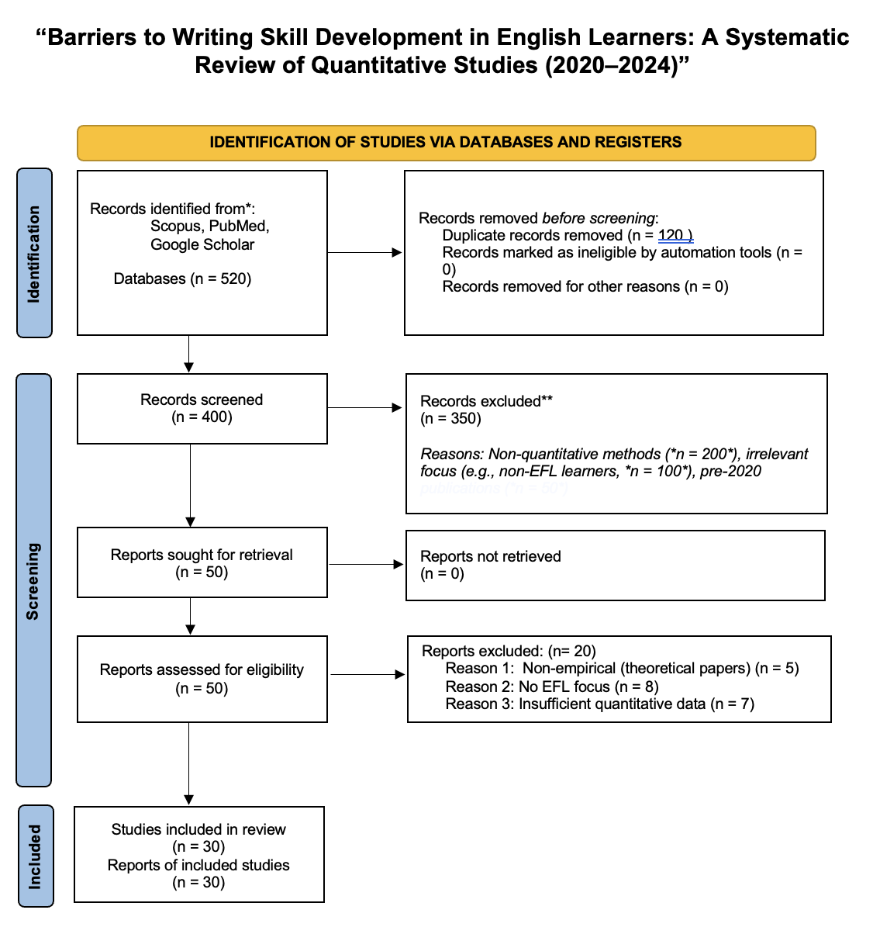
This systematic review followed the PRISMA 2020 guidelines to identify and select studies examining barriers to writing skill development in English learners. Initially, 520 records were retrieved from Scopus, PubMed, and Google Scholar, with 120 duplicates removed, leaving 400 studies for screening. After reviewing titles and abstracts, 350 studies were excluded for using non-quantitative methods (n=200), lacking EFL focus (n=100), or being published before 2020 (n=50). The remaining 50 full-text articles were assessed for eligibility, and 20 were excluded for being non-empirical (n=5), unrelated to EFL writing (n=8), or having insufficient quantitative data (n=7). Ultimately, 30 studies met all inclusion criteria and were analyzed in the review. This transparent process ensures methodological rigor and reproducibility while aligning with the study’s focus on quantitative research from 2020–2024.

TABLE 1: INCLUSION AND EXCLUSION CRITERIA
Inclusion Criteria | Exclusion Criteria
Quantitative studies focusing on writing challenges in English learners. | Qualitative or mixed-method studies.
Articles, journals, and publications published from 2020 to the present year. | Studies published before 2020.
Peer-reviewed and methodologically sound research related to English writing skills. | Studies unrelated to writing skill advancement in English learners.

PROCESS OF GATHERING DATA
The collection of data adhered to the inclusion and exclusion criteria defined for this review. Initially, potential articles were identified using keywords and systematically filtered based on publication year, methodology, and relevance to the research objective. Thirty quantitative studies were selected, encompassing a diverse range of writing challenges faced by English learners. These studies were rigorously evaluated to ensure they provided empirical data aligned with the study’s objectives.

3. results and discussion

RESULTS
Table 2 : List of themes and sub-themes used for the study
Themes | Sub-Themes | Core Ideas
Instructional Approaches | - Traditional vs. Process Approach | The process approach is more effective in improving writing skills and reducing anxiety  compared to traditional (product-based) methods.
 | - Feedback Practices | Lack of corrective written feedback hinders improvement in writing.
 | - Teacher Attitudes | Teachers’ reliance on outdated approaches  and lack of motivation to foster writing impede student progress.
Motivational and Emotional Factors | - Self-Efficacy | High self-efficacy correlates with improved writing performance, while low self-efficacy  and lack of confidence are barriers.
 | - Writing Anxiety | Anxiety negatively affects learners’ writing  ability, creating mental blocks and discouraging practice.
 | - Growth Mindset | A growth mindset encourages resilience and persistence in improving writing skills.
Technological Integration | - Automated Tools (AWE, Grammar  Checkers) | Tools like AWE enhance feedback quality and student motivation but need teacher  guidance for effective use.
 | - Collaborative  Platforms (Google Docs, Wiki) | Collaborative tools improve self-regulation,  writing fluency, and group learning, making them effective in writing instruction.

Cognitive and Linguistic  Challenges | - Language Blocks | Limited vocabulary, grammar deficiencies, and mother tongue interference are  significant barriers to effective writing.
 | - Structural Blocks | Issues in organizing ideas, maintaining  coherence, and paragraph structuring impact writing clarity.
 | - Cognitive Load | EFL learners struggle with balancing lower- level (spelling, grammar) and higher-level  (organization, creativity) writing tasks.
Classroom Environment | - Student-Teacher Relationship | Positive relationships foster motivation and engagement in writing.
 | - Learning Atmosphere | A supportive classroom environment and  appropriate and proper air circulation improve students' concentration and writing quality.
Socio-Cultural and Contextual Factors | - Cultural Attitudes Towards English | Negative perceptions of English and lack of societal support discourage writing skill  development.
 | - Socio-Economic Constraints | Limited access to learning materials and technological tools impedes progress.
 | - Educational Systems | Rigid curricula and insufficient focus on  writing in EFL education systems reduce opportunities for skill development.
Pedagogical Challenges | - Lack of Teacher Training | Teachers often lack the necessary training to effectively implement modern writing  instruction methods.
 | - Inadequate Practice Opportunities | Limited writing practice in and outside the  classroom prevents learners from honing their skills.
 | - Assessment and Feedback Gaps | Absence of regular assessments and detailed feedback leaves students without  clear direction for improvement.

DISCUSSION

Instructional Approaches

The analysis highlights the comparative advantage of the process approach over traditional methods in fostering writing skills and reducing learner anxiety. Process approach in teaching and learning writing skills refers to a student-centered method that treats writing as a multi-stage process rather than focusing solely in the final product. Studies by Graham et al. (2020) emphasize the significance of the process approach, demonstrating its effectiveness in improving writing performance by encouraging planning, drafting, and revising. Effective feedback practices are critical, yet the lack of constructive feedback in many settings impedes progress (Lee, 2020). Teacher attitudes also play a crucial role, with outdated approaches (such as: product-only approach or grammar drills, "red pen" grading, five-paragraph essay dogma, isolated grammar instruction, and one-draft submissions) and low motivation among educators negatively affecting student outcomes (Richards & Burns, 2021). These findings underscore the need for a shift in teaching practices to prioritize student-centered methods and continuous, corrective feedback.

Motivational and Emotional Factors
High self-efficacy among learners is positively associated with better writing outcomes (Bandura & Schunk, 2021), while low self-confidence often acts as a barrier. Writing anxiety, as highlighted by Cheng et al. (2022), emerges as a significant challenge, hindering creativity and increasing reluctance to write. Adopting a growth mindset has been shown to enhance persistence and resilience in writing (Dweck, 2020). Addressing emotional and motivational factors is essential to create an encouraging learning environment that supports students' writing journeys.

Technological Integration
The integration of automated tools, such as Automated Writing Evaluation (AWE) systems and grammar checkers, enhances feedback quality and fosters student self- regulation (Li & Zhang, 2023). Collaborative platforms like Google Docs and wikis promote engagement and fluency in writing tasks (Kim et al., 2022). However, effective implementation of these tools requires teacher guidance and training to maximize their potential (Sharma & Jain, 2021). These findings highlight technology's role as a facilitator, not a replacement, in writing instruction.

Cognitive and Linguistic Challenges
Learners face significant hurdles due to limited vocabulary, grammar deficiencies, and interference from their first language (Liu et al., 2020). Structural difficulties, such as organizing ideas and ensuring coherence, further complicate writing tasks. Moreover, the cognitive load of balancing lower-level mechanics and higher-level creativity poses challenges for English learners (Sweller et al., 2021). Targeted interventions and tailored support are necessary to address these multifaceted challenges.

Classroom Environment
A positive student-teacher relationship fosters motivation and engagement, making writing instruction more effective (Wentzel, 2020). Similarly, a supportive classroom atmosphere enhances students' focus and writing quality (Jones et al., 2023). By prioritizing emotional and environmental aspects, educators can create a conducive space for learners to thrive. These findings emphasize the importance of interpersonal dynamics and classroom management in writing education.

Socio-Cultural and Contextual Factors
Societal attitudes toward English and socio-economic constraints act as major barriers to writing skill development (Gao & Wang, 2021). Cultural perceptions often discourage learners, while limited access to resources and technological tools further impede progress (Tran et al., 2022). Additionally, rigid educational systems fail to prioritize writing in EFL contexts, reducing opportunities for skill-building (Zhang, 2023). Systemic reforms and cultural shifts are required to address these contextual challenges comprehensively.

Pedagogical Challenges
The lack of teacher training in modern writing instruction methods is a recurring issue (Richards & Burns, 2021). Limited practice opportunities and inadequate assessments prevent learners from honing their skills effectively. Moreover, the absence of regular, detailed feedback hampers improvement (Lee, 2020). These pedagogical challenges call for professional development initiatives and structured, feedback-driven practice sessions to enhance learning outcomes.

Pedagogical Challenges
The lack of teacher training in modern writing instruction methods is a recurring issue (Richards & Burns, 2021). Limited practice opportunities and inadequate assessments prevent learners from honing their skills effectively. Moreover, the absence of regular, detailed feedback hampers improvement (Lee, 2020). These pedagogical challenges call for professional development initiatives and structured, feedback-driven practice sessions to enhance learning outcomes.

4. Conclusion
The findings of this study highlight the intricate dynamics influencing the development of writing skills among English learners, emphasizing the need for a multifaceted approach to address these challenges. Instructional strategies, such as the process approach and the provision of constructive feedback, stand out as pivotal in fostering writing proficiency. However, these must be supported by addressing emotional factors, including learners’ self-efficacy and writing anxiety, which play a critical role in shaping their motivation and persistence. Technological tools, when implemented effectively, offer valuable support, promoting engagement and self-regulation in writing tasks. Nevertheless, cognitive and linguistic challenges, alongside socio-cultural and systemic constraints, underscore the complexity of enhancing writing instruction across diverse learner contexts.
To achieve meaningful improvements in writing education, a collaborative effort among educators, policymakers, and researchers is essential. Establishing a supportive classroom environment that prioritizes positive interpersonal relationships and provides comprehensive assistance can significantly enhance students’ writing performance. Additionally, systemic reforms that address socio-cultural barriers and promote equitable access to resources are crucial. A holistic approach, integrating effective pedagogy, emotional encouragement, and technological innovation, has the potential to empower learners, equipping them with the skills needed to excel in writing and beyond. This study serves as a call to action for stakeholders to work together in overcoming these multidimensional challenges and fostering an environment conducive to writing success.

Disclaimer (Artificial intelligence)
Option 1:
Author(s) hereby declare that NO generative AI technologies such as Large Language Models (ChatGPT, COPILOT, etc.) and text-to-image generators have been used during the writing or editing of this manuscript.
Option 2:
Author(s) hereby declare that generative AI technologies such as Large Language Models, etc. have been used during the writing or editing of manuscripts. This explanation will include the name, version, model, and source of the generative AI technology and as well as all input prompts provided to the generative AI technology
Details of the AI usage are given below:
1.
2.
3.

References

Abdullah, A. (2021). Effectiveness of the ADDIE Model within an E-Learning Environment in Developing Creative Writing in EFL Students. v14 n2 p20-36 https://eric.ed.gov/?id=EJ1284437.
Alobaid, A. (2020). Smart multimedia learning of ICT: role and impact on language learners’ writing fluency—YouTube online English learning resources as an example. Smart Learning Environments, . 7(1), 24.
Bai, B., Wang, J., & Nie, Y. (2020). Self-efficacy, task values and growth mindset: what has the most predictive power for primary school students’ self-regulated learning in English writing and writing competence in an Asian Confucian cultural context? https://www.tandfonline.com/doi/abs/10.1080/0305764X.2020.1778639.
Baresh, E. F. (2022). Developing Libyan Undergraduates’writing Skills Through Reflective Journaling: A Critical Literature Review. Journal of English Language Teaching and Learning, . 3(1), 27-35.
Basri, N., & Syamsia, S. (2020). The Effect of Applying Mind Mapping Method in Writing Descriptive Text. https://doi.org/10.5281/zenodo.4087103.
Briones, S. K. F., Dagamac, R. J. R., & Sapungan, G. D.,. (2022). Factors Affecting the Students’ Scholastic Performance: A Survey Study. Indonesian Journal of Educational Research and Technology,. 2(2), 97–102.
Camacho, A., Alves, R. A., & Boscolo, P. (2021). Writing motivation in school: A systematic review of empirical research in the early twenty-first century. Educational Psychology Review, . 33(1), 213-247.
Chuswatun, C., & Budi, R. (2020). The Effectiveness of Learning Models on Written Mathematical Communication Skills Viewed from Students' Cognitive Styles. https://eric.ed.gov/?id=EJ1262491.
Fatsah, H., Ashrafiany, N. A., & Basalama, N. . (2020). The Students' Writing Difficulties in Writing an Essay Based on Cognitive Process. Lingua, . 16(1), 61-69.
Gashaye, S. (2024). Students’ Perception and Practice of Cooperative Learning In EFL Class: Second-Year English Language Students in Focus. . Zhongguo Kuangye Daxue Xuebao, 29(3), 283-290. https://zkdx.ch/journal/zkdx/article/view/106.
Gayed, J. M., Carlon, M. K. J., Oriola, A. M., & Cross, J. S. (2022). Exploring an AI-based writing Assistant's impact on English language learners. Computers and Education: Artificial Intelligence, . 3, 100055.
Hassan, A., Kazi, A., Shafqat, A., & Ahmed, Z. . (2020). The Impact of Process Writing on the Language and Attitude of Pakistani English Learners. Asian EFL Journal Research Articles, Vol. 27 Issue No. 4.3.
Kazemian, M., Irawan, L. A., & Haerazi, H. . (2021). Developing Metacognitive Writing Strategy to Enhance Writing Skills Viewed from Prospective Teachers' Critical Thinking Skills. Journal of Language and Literature Studies, . 1(1), 15-28.
Ly, T. T. M., Nguyen, T. T. H., Phan, T. M. U., Dinh, T. T. H., & Huynh, T. V. (2021). EFL
Student’s Problems with Paragraph Writing at Tay Do University, Vietnam. European Journal of English Language Teaching,. 6(4).
Nasri, N., Habali, A.H., & Adam, M.H. (2022). Google Docs: Students’ Perceptions as Online Collaborative Tool in Learning Writing Skills. https://ijarped.com/index.php/journal/article/view/1654.
Oktawati, H., & Silfia, E. (2020). Students Writing Ability In Narrative Paragraph At Third Semester Of English Education Program Of Stkip Ypm Academic Year 2020/2021. https://ejournal.polbeng.ac.id/index.php/IJ/article/view/1708.
Peter, J., & Singaravelu, G. . (2020). Problems in Writing in English among High School Learners. https://www.researchgate.net/profile/Govindarajan- Singaravelu/publication/351048985_Problems_in_Writing_in_English_among_Hi gh_School_Learners/links/60811e828ea909241e16e201/Problems-in-Writing-in- English-among-High-School-Learners.pdf.
Rad, H., & Jafarpour, A. (2022). Effects of Well-being, Grit, Emotion Regulation, and Resilience Interventions on L2 Learners’ Writing Skills. https://doi.org/10.1080/10573569.2022.2096517.
Rahimi, M., & Fathi, J. ( 2022). Exploring the impact of wiki-mediated collaborative writing on EFL students’ writing performance, writing self-regulation, and writing self- efficacy: a mixed methods study. Computer Assisted Language Learning,. 35(9), 2627-2.
Ramzan, M., Mushtaq, A., & Ashraf, Z. . (2023). Evacuation of Difficulties and Challenges for Academic Writing in ESL Learning. Journal of Linguistics and Literature, https://doi.org/10.33195/maxskq26.
Seyoum, W. M., Yigzaw, A., & Bewuketu, H. K. . (2022). Students’attitudes and Problems on Question-Based Argumentative Essay Writing Instruction. Journal of English Language Teaching and Learning, . 3(2), 58-63.
Silalahi, D., Sihombing, P., Herman, H., & Purba, L. (2021). High Order Thinking Skill (Hots) Questions on Learners’ Writing Ability of Report Text at Efl of Fkip Universitas Hkbp Nommensen. https://doi.org/10.51212/jdp.v14i2.33.
Wahyudin, A.Y., & Wahyuni, A. (2022). Exploring Students’ Learning Style and Proficiency at a University in Indonesia: A Quantitative Classroom Research. https://ejurnal.teknokrat.ac.id/index.php/teknosastik/article/view/2150.
Wu, W. C. V., Yang, J. C., Scott Chen Hsieh, J., & Yamamoto, T. (2020). Free from demotivation in EFL writing: The use of online flipped writing instruction. Computer Assisted Language Learning, . 33(4), 353-387.
Xia, Z. (2023). English Writing Block among Chinese Non-English Majors. International Journal of Education and Humanities, 11(3), 320-323.
https://doi.org/10.54097/ijeh.v11i3.14921.
Zhai, N., & Ma, X. (2021). Automated writing evaluation (AWE) feedback: a systematic investigation of college students’ acceptance. Computer Assisted Language Learning , 2817-2842. https://doi.org/10.1080/09588221.2021.1897019.

