**A Multimodal Discourse Analysis: Exploring the Discursive Power of Online Cartoons in the ASUU Strike**

**Abstract**

This study explores the multimodal discourse in online cartoons reporting on the ASUU strike, emphasizing the critical role of visual elements in conveying complex societal issues. By analyzing ten purposively selected cartoons from Facebook and X (formerly known as Twitter), the study examines the linguistic and visual features that contribute to the portrayal of socio-political realities. Employing O’Halloran’s Systemic Functional Multimodal Discourse Analysis, the research reveals how Nigerian social media users leverage verbal-visual communication to critique societal issues and influence public opinion. The findings underscore the importance of visual and linguistic devices such as imagery, metaphor, sarcasm, and irony in enhancing the communicative power of cartoons. This study highlights the potential of visual communication to convey meaning beyond verbal language, making it a vital tool for social critique and discourse

**Keywords**: *Multimodal, Discourse, Cartoon, Online, Functions.*

**Introduction**

All over the world, the tertiary institution both universities, polytechnics and colleges of education also known as ivory towers is regarded as the bedrock of knowledge and intellectualism and most appropriate ground for incubation of future leaders. However, over the last twenty years in Nigeria, the University system has witnessed an unprecedented industrial unrest and so many official assaults than other social institution. Many have argued that those in authority see the university as a burden and as an institution to be exploited and left desolated.

“This study focuses on the use of cartoon as a medium of communication, communication is means through which social integration is fostered in the society. One of the powerful modes of visual communication which has become famous in Nigerian Newspaper is the cartoon. Cartoons are simplified drawings, representational or symbolic, which make satirical, witty or humorous points. Cartoons play prominent role in correcting societal ills, entertainment etc” (Oyedeji 2013). “Among the genre of visual art that proofs potent in putting checks on the political class in the contemporary society is the art of political cartooning. Cartoonist are like traditional palace jesters who lampoon the political class using satire as tools” (Akinloye, 2014).

In 2022, ASUU declared a one-month strike, beginning 14 February 2022. Some of the lecturers' demands included the revitalisation of public universities, earned allowances, improved funding of state universities and payment of promotion arrears On 7 March 2022, Minister of Education, Adamu Adamu inaugurated a committee to renegotiate the 2009 agreement with ASUU. The seven-man panel had Prof. Emeritus Nimi Briggs as chairman. On 14 March, ASUU extended the strike by 8 more weeks. The Federal Government eventually met ASUU on 11 April 2022, exactly 56 days since the commencement of the strike. On 9 May, ASUU extended the strike by additional 12 weeks, and the strike reached six months without resolution, making it one of the longest ASUU strikes in history. On 1 August 2022, ASUU extended the strike by another four weeks. The FG met ASUU on 16 August 2022, to continue negotiations, with ASUU promising to suspend the strike if its demands were met, but the meeting ended in deadlock. ASUU subsequently said it would begin consultation on the next line of action. ASUU local chapters at ABU, BUK, UDUS, OAU voted for continuation and declaration of an indefinite strike in response to government's offer. State universities such as [Benue State University](https://en.wikipedia.org/wiki/Benue_State_University), [TASUED](https://en.wikipedia.org/wiki/Tai_Solarin_University_of_Education), [Adekunle Ajasin University](https://en.wikipedia.org/wiki/Adekunle_Ajasin_University), [Kano State University of Technology](https://en.wikipedia.org/wiki/Kano_State_University_of_Technology) have also insisted on prosecuting the strike to its logical conclusion.

After 234 days (33 weeks) of strike action by ASUU, the Federal Government of Nigeria on Thursday, 5 October 2022 announced the formation of two new academic unions - the National Association of Medical and Dental Academics (NAMDA) and the [Congress of Nigerian University Academics](https://en.wikipedia.org/wiki/Congress_of_Nigerian_University_Academics) (CONUA). ASUU eventually called off the 8-month strike on 14 October 2022.

Language use varies as it is used to perform different functions: we communicate ideas, thoughts and opinions through language: we use language to warn of danger, to advice, to arouse emotions and to make people accept our point of view. The use of language for these purposes is dictated by the context and they have their own unique form. The expressive use of language with its unique features is captured by cartoonists’ use of language in their cartoons.

This study is therefore significant in exploring how reality maintenance, as Kress (1998) puts it, is a multimodal negotiates meanings in a conversation that requires average readers to fix the meaning(s) of and ascribe evaluative character of cartoons. In this regard Fowler (1998) argues that “the greater part of reality maintenance in conversation is implicit, not explicit. Most conversations do not in so many words define the nature of the words. Rather it takes place against the background of a world that is silently taken for granted. It is against this backdrop that this paper tries to investigate on ‘A multimodal discourse study and discursive functions of online cartoon reportage of ASUU Strike.”

**Multimodal**

“Nevertheless, Multimodality attempts to identify how different semiotic modes or resources are combined within a particular socio-cultural domain in order to create a semiotic event, this explanation is based on the concept that verbal communication can never be completed or through without mentioning the non-verbal communications like painting, images and colors etc” (Kress & Van Leeuwen 2001). Ariyo(2007) opines that “Multimodal discourse analysis is essentially concerned with the theory and analysis of semantic resources at the semantic expansion which occur as semiotic choices combined in multimodal phenomena”.

In other words, Multimodal Discourse analysis is the combination of words with other modalities such as pictures, films, video images and sounds to make meaning. It considers how multimodal texts are designed and how semiotic tools such as color, framing, focus and position of elements contribute to the making meaning of these texts.

**Cartoon**

“Cartoons are also designed to stand alone as works of arts, needing no guidance from an interpreter to be understood. The public want to know hidden truths. They are classified as cartoon of opinion and cartoon of jokes. Cartoon of opinion focus on domestic politics and social themes while cartoons of jokes are designed to communicate humor” (Adejuwon 2009). The cartoon of opinion is synonymous to an editorial or political cartoon. An editorial cartoon can be defined as an illustration containing a commentary that usually relates to current events or personalities. This type of cartoon serves as a visual commentary on current events or personalities – editorial cartoon are usually satirical rather than merely humorous in nature as they may communicate the political viewpoint of the cartoonist or add depth to an opinion article in a newspaper or magazine.

Cartoons often use caricatures, which is a deliberate distortion or exaggeration of a person’s features in order to make fun of well-known figures who are often politicians. They typically combine artistic skill, hyperbole and biting humor in order to question authority and draw attention to corruption and other social ills in the society. The presentation of cartoons in this manner is an avenue for cartoonist to effectively express their thought about any event in the society in a comical manner. Cartoons are illustrations usually in a single panel with visual symbolic elements to express the cartoonist’s views on societal issues in humorous or subtle ways. Most Commonly, Cartoons address a current political issue or event, a social trend, or a famous personality in a way that takes a stand or presents a particular point of view. Although cartoons are mostly humorous, they do generally contain element of irony.

**Text Discourse**

The term text is usually refers to a message which has been recorded in some way( writing, audio and video recording) so that it is physically independent of its sender or receiver (Chandler:9). A sequence of cohesive and coherent sentences realizing a set of mutual irrelevant intentions. Discourse is modes of speaking and writing which involve participants in adopting a particular attitude towards areas of sociocultural activity. So, text discourse is a message which may be written or recorded that demands its participants to adopt a particular attitude towards areas of sociocultural activities.  
**Theoretical Framework**

This research adopted O’Halloran’s (2008) Systemic Functional Multimodal Discourse Analysis. O’Halloran’s (2008) framework is an approach which shows that the systemic functionl (SF) approach to multimodal discourse analysis (MDA) is concerned with the theory and practice of analyzing meaning arising from the use of multiple semiotic resources in discourses which range from written, printed and electronic texts to material lived in reality. It extends the study of language in combination with other resources, such images, colors, scientific symbolism, gestures, actions, music and sound (O’Halloran, 1). Multimodal discourse analysis is the study of the intersection and interdependence of various modalities of communication within a given context (Synder, 1). Researchers in this area seek to identify the influence of mode on meaning within a given context, focusing on co-occurrence interaction between multiply semiotic systems (Baldry and Thibault, 31). The Multimodal discourse is essentially concern with the theory and analysis of semiotic resources is essentially concern with the theory and analysis of semiotic resources and the semantic expressions which occur as semiotic choices combined in multi-cultural phenomena. The ‘intersemiotic’ relations arising from the interaction of semiotic choice known as intersemiosis is a central area of multimodal research (Jewitt, 14). Multimodal discourse analysis is also concerned with the design, production and distribution of multimodal resources in social settings (Van Leeuwen ,32)

However, Multimodal discourse is faced with some challenges as O’Halloran notes: the major challenges facing multimodal discourse analysis include the development of theories and frameworks for semiotic resources other than language, the modeling of social semiotic processes ( in particular, intersemiosis and resioticisation), and the interpretation of the complex semantic space which unfolds within and across multimodal phenomena.

Nevertheless, in an era of multimodality, semiotic mode rather than language is treated as fully capable of serving for the representation and communication. Prior to this time, language had been studies alone. But recently, there has been a paradigmatic shift from studying language alone. O’Halloran identifies reasons for this shift as, there are several reasons for the paradigmatic shift away from the study of language alone to the study of the integration of language with other resources. First, discourse analyst attempting to interpret the wide range of human discourse practices have found the need to account for the meaning arising from multiple semiotic resources deployed in various media. Second, technologies to develop new methodological approach for multimodal discourse analysis, for example multimodal annotation tools (Rohfing et al) have become available and affordable. Lastly, interdisciplinary research has been more common as scientist from various disciplines seek to solve to solve similar problems.

**Methodology**

The data for this study were purposively selected from Twitter and Facebook. In the first instance, the data were purposively selected based on the visual modes employed by the cartoonist. In the second instance, ten cartoons were randomly selected from the purposively selected one from Twitter and Facebook. These cartoons were selected because they generate so much reaction online. The data were subjected to a multimodal discourse analysis to show how societal realities are portrayed through visual modes.

The analysis of the selected cartoons is done in close reference to the issue of industrial action – attention is paid particularly on the use of color, gaze, posture symbols and icons. Also, the functional relationship between the visual components and meanings of the signs is examined. Therefore , the discussions for the study are tailored towards some issues that vividly mirror the realities of the society.

**Result and Discussion**

**Datum One**

**Fig 1: Pocket cartoon**

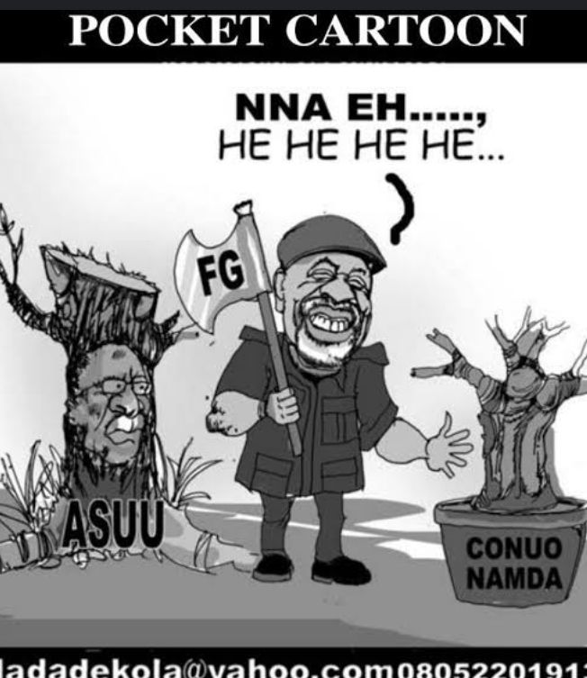

The text here which can be seen to be brutally dehumanizing, shows the cartoonist using a semiotic imagery to depict the minister of Labor and Productivity Dr Chris NwabuezeNgige with an axe, smiling cheerfully showing satisfaction on a job well-done. The image of ASUU is depicted in the mold of the National President Prof EmmanuelOsodeke carrying a remnant of a big tree slashed halfway. While on the left is a new plant placed in basin lettered by the cartoonist CONUA and NAMDA, these are breakaway faction of ASUU. The discursive function of the cartoonist is to depict tussle between the Federal Government and Academic staff union of Universities, it is designed to show that the Federal Government agents led by the Minister of Labor and Productivity is engaging in a divide and rule approach amongst members of the union by approving the registration of rival union.

**Datum Two**

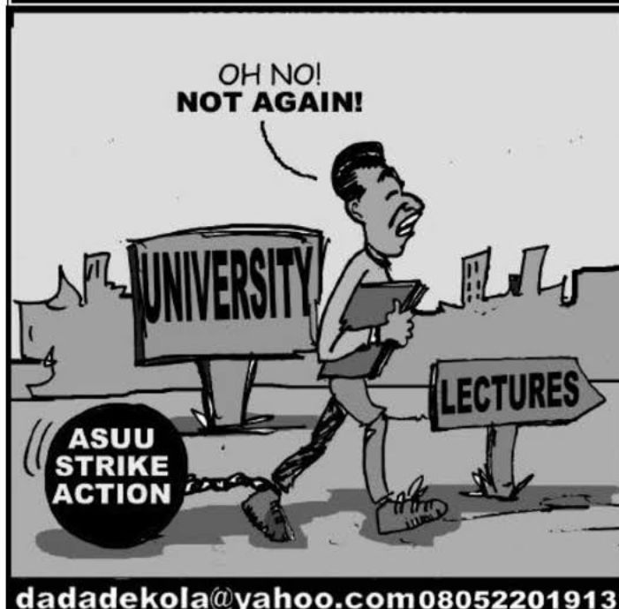

Fig 2: Picture of students dilemma during the strike action

This text paints the picture of students dilemma during the strike action, the cartoonist presents a picture of a male student tied on the foot which he represents with ASUU industrial action, the students is presently in the university but couldn’t attend lectures. It is a picture of likely newly admitted students who after tortuously laboring to gain admission, but the strike action has made the university journey began on a wrong note, incidentally, most universities joined the strike at the beginning of the session. The discursive function of the text is to paint an entanglement between the strike and students development in the ivory tower.

**Datum Three**

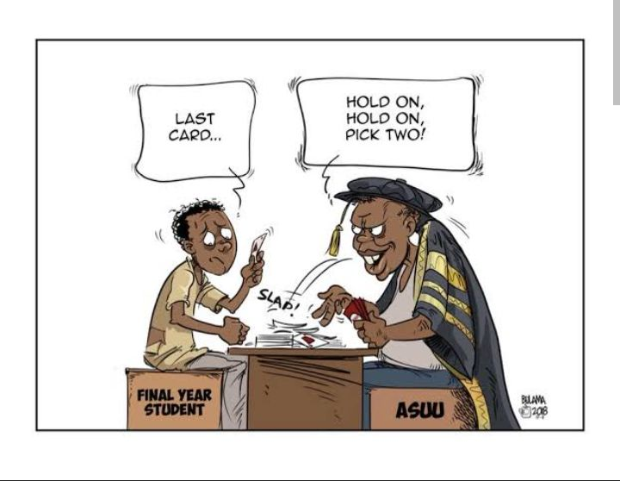

Fig 3: Picture of a struggling student sitting in a game position with someone dressed in ceremonial gown

This text presents the picture of a struggling student sitting in a game position with someone dressed in ceremonial gown. The cartoonist labeled the student as a final year student and the man with the ceremonial dress as ASUU. The cartoonist using language of ‘whot’ game, while the student is eager to graduate, the union is telling the student to ‘hold on’ signifying a delay in next action (graduation) twice and the word ‘pick two’ denotes additional burden of two cards in the game, also worthy of note is the sound made while dropping the card ‘slap’.The discursive function is to paint ASUU as not being considerate of the need to graduate students on time.

**Datum Four**

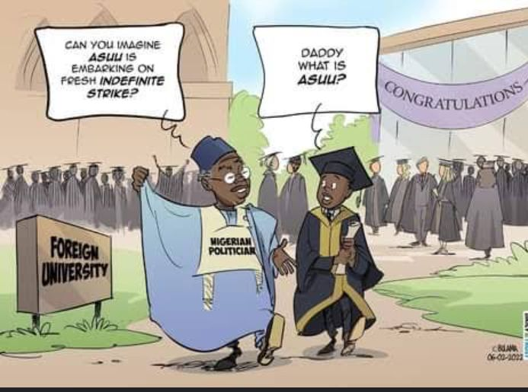

Fig 4: Picture of flamboyant Nigerian Politician with his son in a foreign university

The text humorously paints the picture of flamboyant Nigerian Politician with his son in a foreign university celebrating an occasion which wasn’t stated. There seems to be the use of what can be regarded as semiotic innuendos and Euphemism. The discursive function of the texts is to show the lackadaisical attitude of the ruling class on education to the masses. This is someone elected to provide quality education, but ended up sending his child to a foreign institution and even sarcastically lampooning ASUU on embarking on an industrial action- to make matter worst, the child in the picture is not aware of ASUU’s existence which signals his lack of awareness, because ASUU is a foremost trade union in Nigeria of which its actions and statements ruminates fast across the country.

**Datum Five**

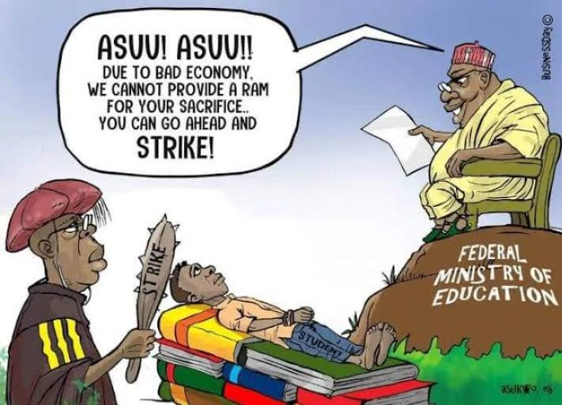

Fig 5: Semiotic imagery shows someone sitting atop a rock on a chair dishing out imperative expression

The text sarcastically captures a tensed situation, the cartoonist through the use of semiotic imagery shows someone sitting atop a rock on a chair dishing out imperative expression and where this man was seated is themed Federal Ministry of Education. While facing the man directly is someone dressed in ceremonial gown of an academe: holding a baton which ‘strike’ was inscribed on it. A young man was drawn, lying down on his books, with his hands tied, that is the student. By linguistic extension, the image of the rock is also a form of semiotic metaphor to show that the man dishing out instruction is sitting on huge resources. Also, the image of the student tied down is a form of exaggeration, worthy of note is the ironical expression made that ‘due to bad economy’ and this man is painted as a representative of the federal government who constitutionally is in charge of coordinating the nation’s economy . The discursive function is to show that the Federal government has what it takes to end the industrial action, if it wishes: but rather it was so arrogant to have insisted it doesn’t have the ram for ASUU’s sacrifice, so it dare any consequence.

**Datum** 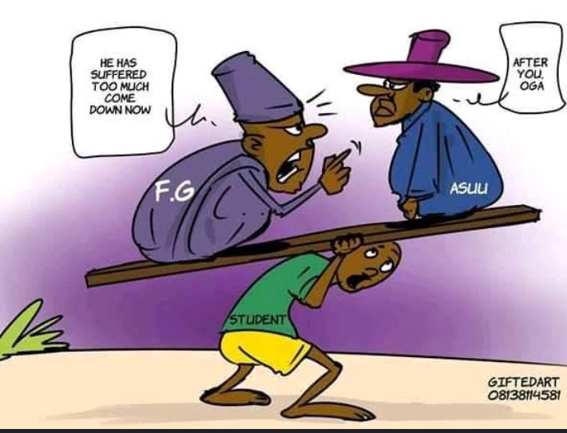

Fig 6: Image of a helpless young man carrying two baggage

In the text, we see an image of a helpless young man carrying two baggage. It is instructive to note that the baggage is so heavy that the student looks so tired and weary. The cartoonist painted the baggage as Federal Government (FG) and ASUU. The man who represents the Federal Government is admonishing ASUU to come down, that the student has suffered so much, while ASUU is insisting that the Federal Government must come down first. The discursive function is to tell the world that both ASUU and Federal Government are the causative agents to the student’s plight.

**Datum Seven**

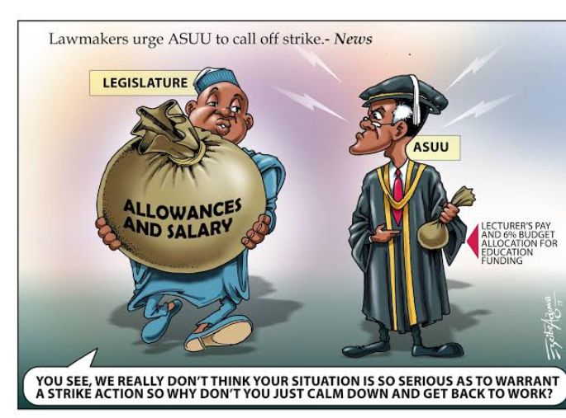

Fig 7: Picture of the legislative arm been selfish

The Cartoonist using his pen unveils a picture of the legislative arm been selfish, it paints the legislature as an over bloated individual with an outrageous allowances and salary at the same time ASUU as someone going home with peanuts. On top of the picture is an inscription that ‘*lawmakers urge ASUU to call off strike’* and beside the image of an ASUU member is another inscription reading ‘*lecturer’s pay and 6% budget allocation for education funding’.* The image also employs the use of sarcasm and irony: the legislature as an independent arm of government is expected to checkmate the executives, but rather work in cahoots with the executives by instructing members of ASUU to return to classroom without paying attention their demands.

The image used to represent the legislature uttered words that are sarcastic and ironical when juxtaposed with the demands of ASUU. The union is praying for increase in education funding, checkmate the proliferation of universities and enhancing the welfare of its members. These with other issues were deemed not to be serious by the lawmakers to warrant strike action. The discursive function of this image is that it portrays lawmakers as been bereft of problem solving mechanism and fails to perform their constitutional obligation.

**Datum 8**

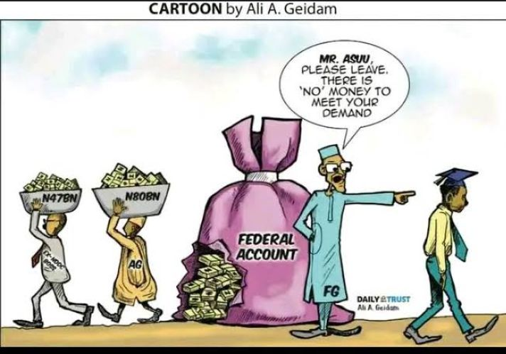

Fig 8: Picture of Nigerian political corridor

The text mirrors the reality in the Nigerian political corridor. The cartoonist employs the linguistic tool of imagery to depict the picture of the Federal Government yelling at ASUU that the government account is empty as ‘*there is no money to meet your demand’* while behind the scene a notorious looting is taking place by senior government officials, those identified by the cartoonist are the former Niger Delta Development Commission ( Ex-NNDC) carting away forty-seven billion Naira and the nation’s Accountant General treating himself illegally of eighty billion naira. The discursive function of this picture is to expose the decadence in the Nigerian government accountability system. While those who are in charge of the country’s treasury couldn’t give proper account but choses to embezzle what is meant to take care of the entire citizenry.

**Datum Nine**

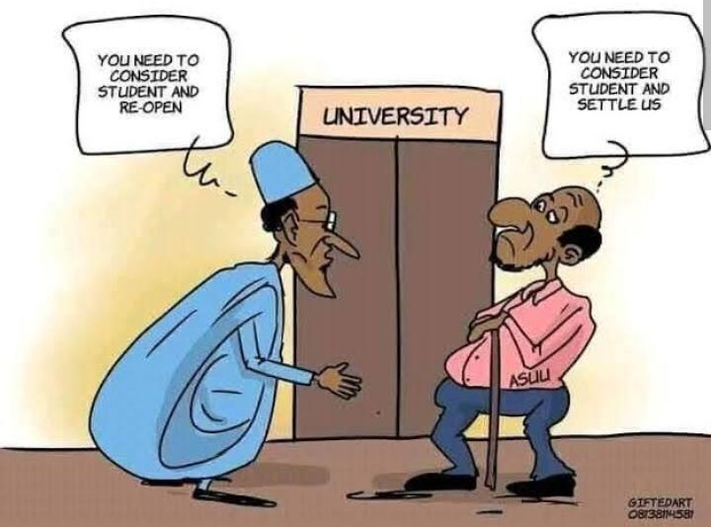

Fig 9: Picture of closed university and turn taking scenario

The text which is presented in a form of gentle interpersonal discussion, the cartoonist depicts a closed university and turn taking scenario. An individual is seen with a physique similar to that of the president Federal Republic of Nigeria, President MuhammaduBuhari insinuating that the union need to consider students and re-open. While the receiver who stood facing the president directly, folding his arms of which the cartoonist inscribed ASUU on, is insisting on being settled before school re-open. The discursive function of this picture is to intimate the general public that the industrial action undertaken by the members of ASUU is as a result of disagreement with the Federal government. While the head of the federal government is not pro -active enough to settle the dispute, he rely solely on rhetoric to seek sympathy from the populace and paint ASUU bad.

**Datum 10**

**Fig 10:** picture of a man who is in love with a lady

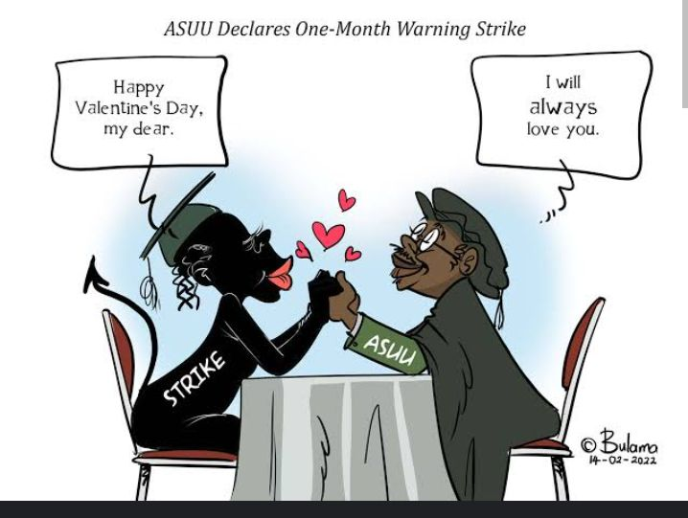

The text depicts a romantic set-up between two individuals. The Cartoonist paints a picture a man who is in love with a lady. The man is portrayed as ASUU and the Lady is ‘Stike’. Using the tool of imagery, the picture denotes ASUU telling the lady that ‘ I will always love you’. The use of the word ‘always’ signals a promise that seems to be everlasting. Similarly, the sitting posture and the gesture of holding each other hands also connotes as strong connection. The discursive function of this picture is extending narratives from other peoples opinion that ASUU for long has chosen not to change it tactics towards addressing it demands from government. For over thirty years it has always employ the strike approach in pressing home it demands, while ASUU on the other hand, has argued that strike is the only language understood by government.

**Conclusion**

Multimodal discourse analysis has made it possible to account for visual components of the study. The lexical choices employed by the author have also been identified. This is made possible by the theoretical framework we have used in this study. However, it is instructive to note that interpretation of images is by its very nature subjective and an image can carry multiple messages depending upon the nature of the visually interpreting culture.

This study has shown through discussion that cartoons are made to express underlying critical societal issues and draw attention of stakeholders to effect necessary changes. The study has been able to additionally show that social media is not only an avenue to establish social relationships and interactions but a medium of discussing national issues.

The study emphasizes the vitality of visual elements as important devices in understanding a text, the use of linguistic and literary devices such as imagery, metaphor, sarcasm, irony, allusion, also, this study reveals the potentials of visual images to convey meaning beyond the verbal language in any human society.

**Ethical approval and consent**

The informed written consent, privacy, and the ethical use of the materials sourced from the Facebook and X accounts are taken to carried out the study.

Disclaimer (Artificial intelligence)

Option 1:

Author(s) hereby declare that NO generative AI technologies such as Large Language Models (ChatGPT, COPILOT, etc) and text-to-image generators have been used during writing or editing of manuscripts.

Option 2:

Author(s) hereby declare that generative AI technologies such as Large Language Models, etc have been used during writing or editing of manuscripts. This explanation will include the name, version, model, and source of the generative AI technology and as well as all input prompts provided to the generative AI technology

Details of the AI usage are given below:

1.

2.

3.

References

1. Bignell, J. Media Semiotics, an Introduction. Manchester: Manchester University Press. 1997. Print. 
2. Chandler, D. Semiotics: The Basics. London: Routledge. 2002. Print.
3. Chandler,D. Semiotics for Beginners,URLwww.aber.ac.uk/media/ document/s4b/serniotics.html. Web.Accessed 14 January 2017.
4. Crystal, David &David. Investigating English Style. London: Longman Press. 1969. Daily Christian Life Ministry. "Christian Women Mirror Magazine" (ed. February to November 2016). Lagos. 2016. Print.
5. Keane, Webb. " Religious Language" Annual Review of Anthropology 26: 4771. 1977. Print.
6. Kress, G., & Van Leeuwen, T. **(**2020**).** *Reading Images:* The Grammar of Visual Design. Longman.
7. Machin, D., & Mayr, A. How to Do Critical Discourse Analysis: A Multimodal Introduction. London: Sage. 2012
8. Messaris, P. & Abraham.The Role of Images in Framing News Stories. In S. D Reese, O. H Gandy, A. E Grant (eds.), Framing Public Life: Prospective on Media and Our Understanding of the Social World. London:
9. Lawrence Erlbaum Associate pp. 215-226.2001. Print. In O'Halloran, K. L. , Tan, S. , Smith, B.A. 'Multimodal Studies'. K.L.O'Halloran and B. A. Smith, (eds.) Multimodal Studies: Exploring Issues and Domains. London and New York: Routledge, pp.68-77.2011. Print.
10. Rappoport, L. 2005. Punch lines: the case for racial, ethnic, and gender humour. Praeger Publishers: Westport, CT.
11. Raskin, V. (1985).Semantic mechanisms of humour.Dordretch: Reidel..
12. Simpson, P. (2003). On the Discourse of Satire •wards a Stylistic Model of Satirical Humour.Amsterclam: John Benjamins.
13. Taiwo, R. 'Forms and Functions of Interrogation in Christian Pulpit Discourse .Nebula 2.4 117-131. 2005. Print.
14. Taiwo, R. "Response Elicitation in English- medium Christian Discourse" Linguistic online 127- 143. 2006. Print.
15. Taiwo, R. "Language, Ideology and Power Relations in Nigeria Newspaper Headlines" Nebula, vol. 4 (l). 2007. Print.
16. Taiwo, R. (2007). "Satirizing Politicians and Public Officers in Nigerian Newspapers",The International Journal of Language Society and culture, Issue 22, 19-28.
17. Taiwo, R. (2011). Emerging Trends in English Language in the New Media: A Case Study of Satire in Nigerian Text Messages, a paper at the 281) International Nigeria English Studies Association (NESA) Conference, University of Benin.
18. Jewitt, C. (Ed.). (2014). The Routledge Handbook of Multimodal Analysis. Praeger Publishers: Routledge.
19. Zhao, S., & Zappavigna, M**.** Digital Media, Social Interaction, and MultimodalityLondon: Longman Press. 2020.