**Mini-review**

**The Role of Trained Immunity in Protection Against Infectious Diseases: Epigenetic Reprogramming and Long-Term Immune Responses**

**Abstract**

Trained immunity, a concept introduced more than a decade ago, defines the non-specific memory capacity of innate immunity by epigenetic and metabolic reprogramming. It involves features of epigenetic and metabolic reprogramming of innate immune cells that induce long-term functional changes in host defense. This review explores the mechanisms and duration of trained immunity, as well as the therapies related to its potential in infectious diseases. A systematic literature search was conducted across PubMed, Google Scholar, and Web of Science for studies published between 2019 and 2025. Experimental and clinical studies on innate immune memory, epigenetic modifications, and metabolic pathways associated with long-term immune responses were selected as study criteria. The synthesized data was narratively summarized to assess key themes, including molecular mechanisms, sustainability, and translational applications. A total of eight studies were included in this review. The findings revealed that trained immunity is mediated by histone modifications, metabolic changes, and long-term myelopoiesis. Studies also show that immune training has varying durations, with effects lasting from weeks to months. Emerging therapeutic strategies will focus on vaccine enhancement, cancer immunotherapy, and sepsis management. However, challenges remain, including a lack of clinical validation, incomplete mechanistic understanding, and ethical concerns. Trained immunity is a promising approach to immunomodulation between innate and adaptive immunity. Future research should aim to conduct clinical trials, assess safety, and develop precision medicine approaches to efficiently utilize this concept in therapeutic applications.

**Keywords:** Trained immunity, Innate immune memory, Infectious diseases, Metabolic reprogramming, Epigenetics

**1. Introduction**

Trained immunity, referred to as innate immune memory, is an inherent capability of innate immune cells to mount enhanced response to secondary infections after an initial exposure. In contrast to adaptive immunity where memory cells are antigen-specific, trained immunity relies on functional reprogramming of the innate immune cells, mainly monocytes, macrophages, and natural killer cells by epigenetic and metabolic modifications (Dulfer & Domínguez-Andrés, 2024). This is a phenomenon shown previously in invertebrates without an adaptive immune system suggesting that innate immune memory has provided a fundamental evolutionary advantage (Netea et al., 2020). Trained immunity has its historical basis as early as its prolific documentation in the nonspecific protective effects of vaccines. For example, the bacillus Calmette-Guérin (BCG) vaccine used for tuberculosis has been shown to boost resistance to unrelated infections and is contrary to the prevailing separation of innate and adaptive immunity (Berendsen et al., 2021; Ciarlo et al., 2020). Further studies have demonstrated that long-lasting changes in innate immune function can be induced by microbial components like β glucans and lipopolysaccharides, mediated by epigenetic modifications e.g. histone methylation and acetylation in particular to inflammatory response gene (Bomans et al., 2018; Sánchez-Ramón et al., 2018). Trained immunity is mediated through changes in metabolism including the reprogramming of immune progenitor cells from the bone marrow to convert to aerobic glycolysis. However, it has been shown that histone modifications, such as H3K4me3 and H3K27ac, are associated with a heightened inflammatory response on reinfection (Katzmarski et al., 2021). In addition, evidence shows that trained immunity is inherited transgenerationally by germ cell epigenetic modifications and shapes immune responses in the offspring (Kaufmann et al., 2022).

Two differing mechanisms of immunological memory, namely trained immunity and adaptive immune memory, have a distinct cellular basis, specificity, duration, and underlying molecular mechanisms. Training immunity involves the innate immune cells such as monocytes, macrophages, and NK cells, while adaptation immune memory is dependent on antigen-specific T and B lymphocytes which get clonally expanded and persist for a long period (Netea et al., 2020). In contrast to adaptive immunity, which works via highly specific somatically revisers in antigen receptors to encounter antigens previously exposed, trained immunity based on broad Pattern Recognition Receptors (PRRs), like toll-like receptors (TLRs), to detect conserved microbial components (Mulder et al. 2019). The length of immune memory is otherwise very different in these two systems. Adaptive immune memory does persist for years or even a lifetime, as the presence of long-lived memory T and B cells (Bekkering et al., 2021). These epigenetic and metabolic reprogramming programs that train immunity tend to be at the molecular level and include histone modifications and shifts in glycolytic metabolism to enhance the responsiveness of innate immune cells to reinfection (Saeed et al., 2014). Adaptive immune memory, however, is sustained through clonal expansion, long-lived plasma cells and memory T cells upon receipt of antigens with specialized effector functions (Sallusto et al., 2010). These immune strategies also form an important distinction in terms of their evolutionary origin. Conserved across the wide spectrum of diverse species ranging from plants and invertebrates, this ancient type of immunity definitely plays a selective role in the host defense (Duggan et al., 2023). In contrast to adaptive immunity, this is unique to the vertebrates and gives highly refined and long-lasting protection against pathogens (Sun & Lanier, 2021).

The aim of this review was to investigate the complete analysis of protective mechanisms in infectious diseases through the synthesis of contemporary evidence on molecular processes and duration of effect and therapeutic possibilities of trained immunity. Figure 1 illustrates the conceptual framework of the study.

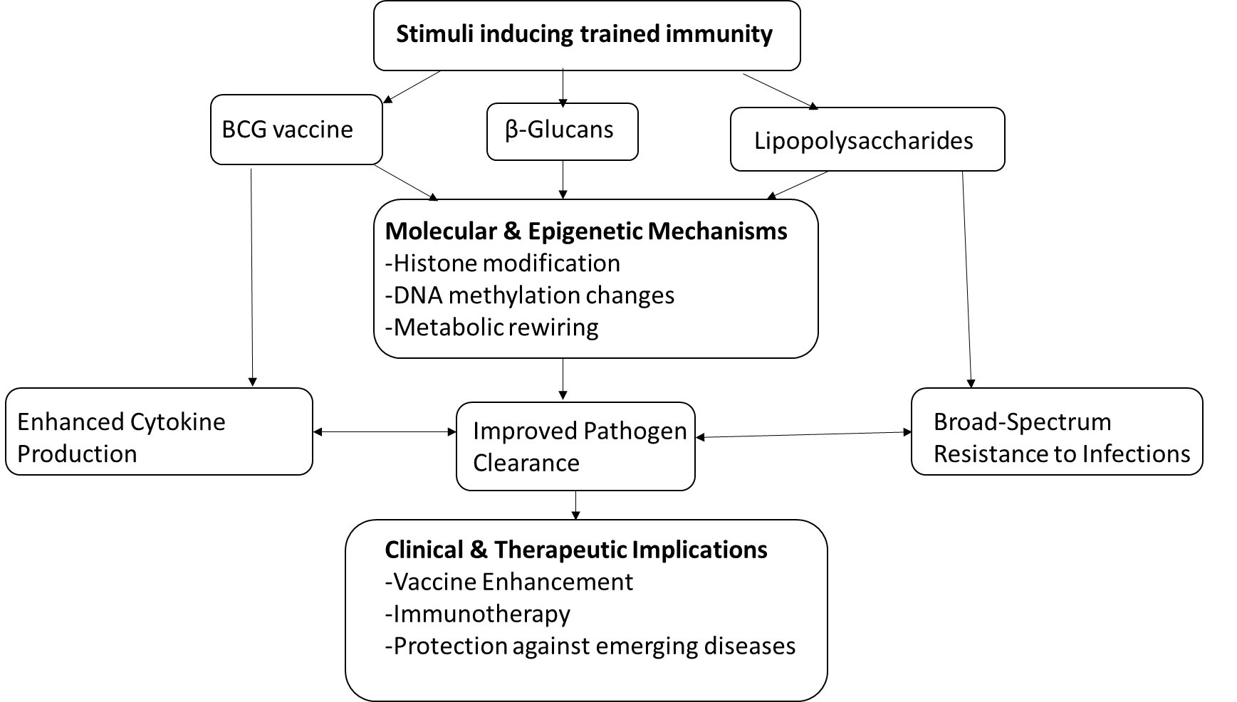

**Fig 1 Conceptual framework of the study**

**2. Methodology**

*2.1 Literature Search Strategy*

A comprehensive and systematic literature search was conducted to identify relevant studies on trained immunity, epigenetic reprogramming, and long-term immune responses in the context of infectious diseases. The search was performed across multiple databases, including PubMed, Web of Science, and Google Scholar, with a timeframe of 2019 to 2025, ensuring broad coverage of biomedical and immunological research. The search strategy combined Medical Subject Headings (MeSH) terms and keywords related to trained immunity, innate immune memory, epigenetics, histone modifications, metabolic reprogramming, and infectious disease protection. Boolean operators (AND, OR) were used to refine searches (Table 1), and database-specific filters like full-text availability, and publication date restrictions. This review was not registered in PROSPERO.

**Table 1 Search String**

|  |
| --- |
| **Combination of Keywords** |
| (“trained immunity” OR “innate immune memory”) AND (“epigenetic reprogramming” OR “histone modification” OR “DNA methylation”) AND (“infectious disease” OR “pathogen defense”) AND (“metabolic shift” OR “glycolysis”) |

*2.2 Selection Criteria*

This review was conducted following the PRISMA guidelines, and a corresponding PRISMA flowchart is included in the results to illustrate the study selection process. To ensure relevance and quality, the following selection criteria were applied:

2.2.1 Inclusion Criteria

* Peer-reviewed articles of original research published in English.
* Studies that investigated trained immunity and its mechanisms, including epigenetic and metabolic changes.
* Research focusing on infectious disease protection through innate immune memory.
* Experimental and clinical studies involving humans and relevant animal models.

2.2.2 Exclusion Criteria

* Studies focusing exclusively on adaptive immunity without reference to trained immunity.
* Non-English publications.
* Opinion pieces, editorials, reviews, and conference abstracts without full data.

*2.3 Data Extraction and Synthesis*

Search results were screened based on the predefined inclusion criteria and data from the selected studies were extracted independently by two reviewers using a standardized data extraction form, capturing the study design, population involved, interventions, outcomes, and key findings. When there were discrepancies, it was resolved through consensus. A narrative synthesis was used to summarize key findings and highlight common themes.

**Table 2 Methodology**

|  |  |
| --- | --- |
| **Theme** | **Method** |
| Literature search | PubMed, Web of Science, Google Scholar |
| Keywords | “trained immunity,” “epigenetic reprogramming,” “infectious disease,” “metabolic reprogramming” |
| Timeframe | 2019 to 2025 |
| Selection criteria | Peer-reviewed articles of original research published in English.  Studies that investigated trained immunity and its mechanisms, including epigenetic and metabolic changes.  Research focusing on infectious disease protection through innate immune memory.  Experimental and clinical studies involving humans and relevant animal models. |
| Data extraction & synthesis | Data were extracted using a standardized data extraction form.  Narrative synthesis approach was used to summarize key findings and highlight common themes. |

**3. Results and Discussion**

*3.1 Included Studies*

Figure 2 illustrates the included studies selection processes. Eight studies were included in this review, after a broad selection and screening of 205 articles. The studies included were conducted between 2019 and 2025, with a majority of them employing experimental study design. Three of the studies had Histone modifications as their mechanism of trained immunity while two studies identified epigenetic modulation as their trained immunity mechanism. Bacterial & viral infections were observed to be the most common pathogen context across the studies and the duration of immune training was long-term.

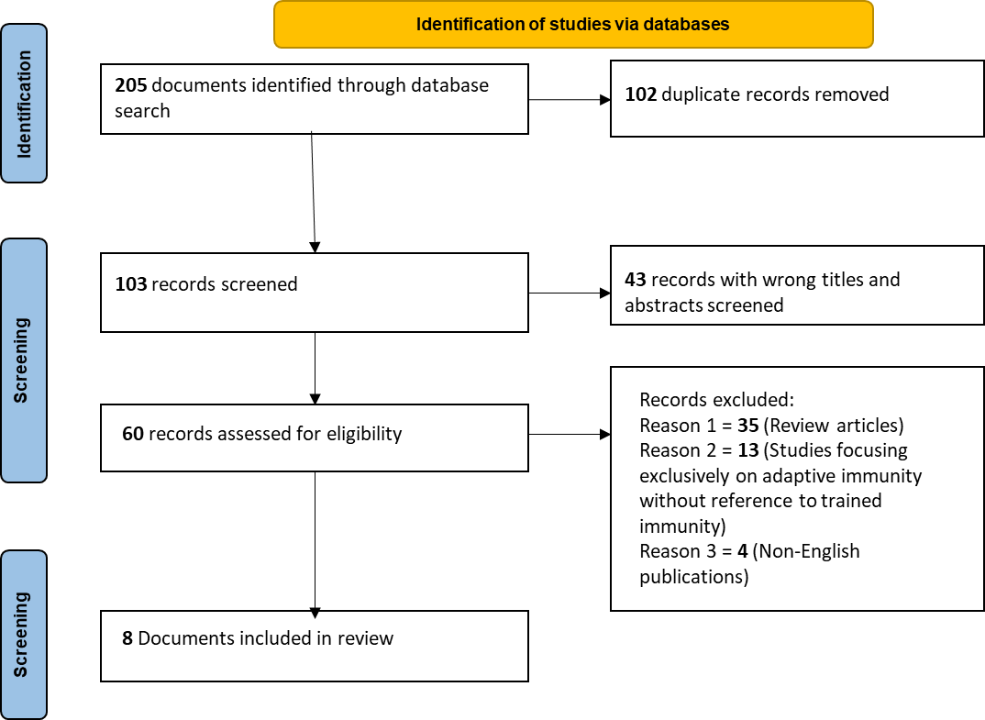

**Fig 2 PRISMA flow diagram**

*3.2 Mechanisms Underlying Trained Immunity*

Trained immunity is primarily driven by epigenetic and metabolic reprogramming, enabling innate immune cells to mount enhanced responses upon secondary stimulation. Key epigenetic mechanisms such as histone modifications, DNA methylation and their regulation have all been the focus of several studies. As an example, Jentho et al. (2021) established that heme-trained immunity results in heme long-lasting epigenetic remodelling that alters myelopoiesis and enhances monocyte function. In addition, the Set7 lysine methyltransferase regulates oxidative phosphorylation plasticity for trained immunity in response to β glucan stimulation which was previously shown by Keating et al. (2020). Additionally, these findings are consistent with previous work that demonstrated the importance of histone methylation and acetylation of immune gene promoters to promote hypercytokinemia on secondary T-cell stimulation (Fok et al., 2019). Other important drivers of trained immunity are metabolic reprogramming; glycolysis, oxidative phosphorylation, and lipid metabolism are shifted. Hao et al. (2025) stated that metabolic adaptations, such as enhanced glycolysis and glutaminolysis, have a crucial role in innate immune memory. This is in alignment with Rusek et al. (2018) who showed that even bacterial and viral stimuli, elicit metabolic shifts that sustain immune memory. In addition, Salauddin et al. (2024) rethink that both shifts from oxidative phosphorylation and lipid metabolism are crucial for the immune response, so that metabolic pathways may be targeted to amplify the response. Participation of non-coding RNAs in trained immunity has also been recently highlighted. In the case of Fok et al. (2019), they observed that lncRNAs mediate the crosstalk between cellular metabolism and epigenetic modifications to modulate innate immune reprogramming. This coincides with Abhimanyu et al. (2021), who showed that targeting RNA-based regulatory pathways can reverse the post-infectious epigenetic-mediated immune suppression. Overall, the convergence of epigenetic and metabolic reprogramming in the form of trained immunity indicates the possibility of its therapeutic manipulation. While the reliance on antigen-specific lymphocytes for classical immunological memory, trained immunity might be a broader, non-specific protective mechanism that can be used for vaccine development and immunotherapy (Hajishengallis et al., 2025).

**Table 3 Findings from Included Studies**

|  |  |  |  |  |  |  |  |
| --- | --- | --- | --- | --- | --- | --- | --- |
| **Author & Year** | **Study Objective** | **Study Design** | **Mechanisms of Trained Immunity** | **Disease/Pathogen Context** | **Duration of Immune Training** | **Clinical/Translational Relevance** | **Key Findings** |
| Abhimanyu et al., 2021 | Investigate the reversal of post-infectious immune suppression via epigenetic modifications | Experimental study (in vitro & in vivo) | Epigenetic modulation through histone acetylation | Bacterial & viral infections | Long-term effects assessed | Potential for therapeutic reprogramming of immune responses | Identified key epigenetic markers that can reverse immune suppression post-infection |
| Hao et al., 2025 | Explore metabolic adaptations driving innate immune memory | Review of metabolic pathways | Glycolysis and oxidative phosphorylation shifts | Broad infectious diseases | Variable depending on stimulus | Identifying metabolic targets for immunotherapies | Highlighted the role of metabolic rewiring in sustaining trained immunity |
| Jentho et al., 2021 | Study epigenetic modulation in trained immunity induced by heme | Experimental study (animal models) | Histone methylation and DNA modifications | Heme-related immune disorders | Long-lasting (several months) | Potential for improving anemia and inflammatory conditions | Demonstrated sustained myelopoiesis and immune adaptation via heme exposure |
| Xing et al., 2020 | Examine trained immunity in tissue-resident macrophages | Experimental & review | Epigenetic and metabolic modifications in macrophages | Respiratory infections | Months to years | Implications for vaccine strategies | Proposed a new vaccination model leveraging trained macrophage responses |
| Fok et al., 2019 | Investigate lncRNA involvement in metabolic-epigenetic immunity links | Experimental study | Long non-coding RNAs (lncRNAs) in immune reprogramming | Bacterial & viral infections | Persistent effects | Possible RNA-based immunotherapies | Found lncRNA-mediated regulatory pathways crucial for trained immunity |

**Table 3 Cont’d.**

|  |  |  |  |  |  |  |  |
| --- | --- | --- | --- | --- | --- | --- | --- |
| **Author & Year** | **Study Objective** | **Study Design** | **Mechanisms of Trained Immunity** | **Disease/Pathogen Context** | **Duration of Immune Training** | **Clinical/Translational Relevance** | **Key Findings** |
| Wang et al., 2024 | Explore trained immunity’s impact on sepsis | Experimental study (animal models) | Histone modifications, cytokine reprogramming | Sepsis | Weeks to months | New therapeutic avenues for sepsis management | Found that trained immunity can enhance sepsis resistance but also risk hyperinflammation |
| Lajqi et al., 2024 | Investigate trained immunity in pediatric infections | Experimental study (pediatric models) | Histone modifications, cytokine memory | Pediatric bacterial & viral infections | Months to years | Potential for improving pediatric vaccine efficacy | Found that early-life infections induce long-lasting immune adaptations |
| Keating et al., 2020 | Examine Set7 methyltransferase’s role in trained immunity | Experimental study | Set7-driven oxidative phosphorylation plasticity | Fungal infections (β-glucan exposure) | Long-term metabolic imprinting | Targeting Set7 for trained immunity-based therapies | Identified Set7 as a key regulator of trained immunity in response to β-glucan |

*3.3 Duration and Sustainability of Trained Immunity*

Trained immunity varies with different persistence depending on the stimulus, the immune cell type, as well as metabolic and epigenetic adaptations. Several studies show that trained immunity can persist from weeks to months and for years in some cases. According to Jentho et al. (2021), when myeloid progenitors are exposed to heme, these epigenetic modifications lead to long-term immune reprogramming beyond the life span of a single immune cell through altered hematopoiesis. As in Keating et al (2020), β glucan-induced trained immunity can persist for up to several months through the sustained effect of changes in oxidative phosphorylation and mitochondrial function. Recovery of trained immunity also depends on repeated exposure to stimuli. By repeatedly encountering the same microbes, recurrent encounters furthered the training of the immune system, keeping it lasting much further by continuously reprogramming metabolic and epigenetic pathways (Rusek et al., 2018). On the other hand, Abhimanyu et al. (2021) reported that the longevity of trained immunity is context-dependent and reversible under immunosuppressive conditions. This is further corroborated by Capriotti and Klase (2024), who demonstrate that trained immunity mechanisms break down in chronic HIV infection and are lost more quickly than would have been otherwise the case. In addition, it has been noted in studies that trained immunity persistence is disease model-dependent. In sepsis-induced trained immunity, metabolic adaptations shown by Hao et al. (2025) are transient and come back to baseline in a couple of weeks. Hajishengallis et al. (2025) demonstrated that chronic inflammatory disease would maintain trained immunity for extended periods, and they suggest a possible role in disease progression. Taken as a whole these findings suggest that trained immunity can be maintained on a sustained basis but its persistence depends on external stimuli disease states and the cellular environment. Consequently, this opens up the potential for vaccine development, as prolonging trained immunity from a trained immunity-inducing vaccine, could provide wide-spectrum protection against infectious diseases (Salauddin et al., 2024).

*3.4 Emerging Therapeutic Strategies Leveraging*

Recent advancement has highlighted trained immunity as a promising avenue for the development of new therapeutic strategies for the promotion of host defense, modulation of chronic inflammatory conditions, and other desirable effects by vaccine. Using trained immunity inducing agents (TIIs), a class of agents including the β-glucan and the cell wall component vaccine Bacillus Calmette Guérin (BCG) is one of the most actively explored approaches to providing general protection against infections. BCG vaccination induces long-term metabolic and epigenetic reprogramming in monocytes and enhanced resistance to viral and bacterial pathogens beyond tuberculosis (Xing et al., 2020). Wang et al. (2024) also suggested that trained immunity-inducing compounds could be used to strengthen innate immune responses and thus help host resilience to sepsis. Trained immunity is also a target beyond infectious diseases towards autoimmune and chronic inflammatory disorders. Based on their results, Hajishengallis et al. (2025) proposed that the trained monocytes and macrophages seem to participate in the continuous inflammatory cascade in chronic diseases, which makes them potential target of immunomodulatory therapies. Lajqi et al. (2024) explored pediatric infectious diseases and showed that manipulating trained immunity could improve immune response in immunocompromised children. An additional creative aspect is using epigenetic and metabolic modulators to control trained immunity in therapeutic areas. This led Fok et al. (2019) to find that Immune training is driven by long noncoding RNAs (lncRNAs) as critical regulators, that provide new targets of epigenetic-based therapies. Metabolic intervention strategy targeting lysine methyltransferase Set7 was also found by Keating et al. (2020) to boost trained immunity via optimization of mitochondrial function. Trained immunity is currently being studied as a potential tool for the treatment of neuro-inflammatory and chronic infection conditions, including HIV-associated neurocognitive disorders (HAND). According to Capriotti and Klase (2024), trained immunity-modulating agents might reverse innate immune dysfunction in HIV resulting in the restoration of immune function.

**4. Challenges and Future Perspectives**

Despite all of this interest in trained immunity as a therapeutic target, many challenges and knowledge gaps remain. The lack of an understanding of the long-term consequences of trained immunity induction is a major limitation. Although many studies have uncovered the links between epigenetic and metabolic hallmarks of innate immune memory (Keating et al., 2020; Fok et al., 2019), how long and whether these changes have sustained adverse effects remains unknown. It is of particular concern, however, how excessive immune activation can lead to chronic inflammation or autoimmunity (Hajishengallis et al., 2025). In addition, most recent research relies on in-vitro models or preclinical animal studies without necessary translation to human immune responses (Xing et al., 2020). With these, rigorous clinical trials for validation of the efficacy and safety of trained immunity-based interventions are required to advance the field. Some of the studies have demonstrated that vaccination with Bacillus Calmette- Guérin (BCG) and β-glucans may promote host defense against heterologous infections (Xing et al., 2020; Wang et al., 2024), but the results should be confirmed in RCTs for various populations. In addition, clinical studies should determine what the optimal dosing is and when and with what population it does and does not respond, as it appears that the effects of trained immunity might be affected by age, genetics, and metabolic status (Salauddin et al., 2024). Large-scale trials of trained immunity for sepsis, cancer immunotherapy, and chronic infections would provide crucial insights into its therapeutic potential (Xia et al., 2021; Capriotti & Klase (2024). From the perspectives of ethics and safety, there are multiple concerns when manipulating innate immune memory. Trained immunity is antigen non-specific, as opposed to adaptive immunity, and therefore carries the risk of off-target effects, including inappropriate inflammation or immune exhaustion (Hajishengallis et al., 2025). Intergenerational epigenetic inheritance is also a cause for concern since the immune changes could be passed on to a generation, with uncertain consequences (Fok et al., 2019). Regulatory bodies must construct a catalog of clear guidelines for the clinical medicines involving stimulated immunity, as the use of the agents must be both safe and ethically justified, and available. To make these possible, tailored interdisciplinary research and robust clinical trial and oversight will need to be guided toward the translation of trained immunity-based strategies to practical and sustainable clinical interventions.

**5. Conclusion**

Trained immunity has the potential to fundamentally change the field of immunology by providing novel information regarding the process by which innate immune cells learn a memory-like response in the context of epigenetic and metabolic reprogramming. It is reviewed for its mechanisms, duration, and potential for therapy, including how these might impact infectious diseases, cancer, as well as inflammatory disorders. Emerging strategies in β-glucan-based immunomodulation and vaccine adjuvants are promising, but remain challenging due to gaps in mechanistic understanding, the need for rigorous clinical validation, and ethical dilemmas of immune manipulation. Future studies should focus on large size clinical trials, individualization of immunomodulatory approaches, and policies that can make implementation safe and effective. With trained immunity, disease prevention and treatment of many diseases could make this revolution, bridging innate and adaptive immune strategies for long-term health benefits.

**Abbreviations**

BCG – bacillus Calmette-Guérin

HAND – HIV-associated Neurocognitive Disorders

lncRNA – long non-coding RNA

MeSH – Medical Subject Headings

NK – Natural Killer

PRRs – Pattern Recognition Receptors

TIIs – Trained Immunity-inducing agents

TLR – Toll-like receptors

**Clinical Trial Number:** Not applicable

**Data availability:** No new datasets were generated or analyzed in the current study.

Disclaimer (Artificial intelligence)

Option 1:

Author(s) hereby declare that NO generative AI technologies such as Large Language Models (ChatGPT, COPILOT, etc.) and text-to-image generators have been used during the writing or editing of this manuscript.

Option 2:

Author(s) hereby declare that generative AI technologies such as Large Language Models, etc. have been used during the writing or editing of manuscripts. This explanation will include the name, version, model, and source of the generative AI technology and as well as all input prompts provided to the generative AI technology

Details of the AI usage are given below:

1. No AI was used in the preparation of this manuscript.

2.

3.

**References**

Abhimanyu, Ontiveros, C. O., Guerra-Resendez, R. S., Nishiguchi, T., Ladki, M., Hilton, I. B., ... & DiNardo, A. R. (2021). Reversing post-infectious epigenetic-mediated immune suppression. *Frontiers in Immunology, 12*, 688132.

Bekkering, S., Arts, R. J. W., Novakovic, B., Kox, M., van der Heijden, C. D. C. C., Li, Y., ... & Netea, M. G. (2021). Metabolic induction of trained immunity through the mevalonate pathway. *Cell, 172*(1–2), 135–146.

Berendsen, M. L., Øland, C. B., Jensen, K. J., & Netea, M. G. (2021). The immunological mechanisms underlying heterologous effects of BCG vaccination. *Clinical Microbiology and Infection, 27*(5), 651–657.

Bomans, K., Schenz, J., Sztwiertnia, I., Schaack, D., Weigand, M. A., & Uhle, F. (2018). Sepsis induces a long-lasting state of trained immunity in bone marrow monocytes. *Frontiers in Immunology, 9*, 2685.

Duggan, J. M., Siegersma, K., & Dunsmore, G. (2023). Evolutionary conservation of innate immune training. *Trends in Immunology, 44*(3), 183–195.

Dulfer, S., & Domínguez-Andrés, J. (2024). Mechanisms involved in the transmission of trained immunity. *Nature Immunology.*

Fok, E. T., Davignon, L., Fanucchi, S., & Mhlanga, M. M. (2019). The lncRNA connection between cellular metabolism and epigenetics in trained immunity. *Frontiers in Immunology, 9*, 3184.

Gee, S., Mohr, C., & Felger, J. C. (2021). Epigenetic mechanisms of trained innate immunity and its implications for neuroimmune disorders. *Neuropsychopharmacology, 46*(4), 990–1001.

Hao, D., McBride, M. A., Bohannon, J. K., Hernandez, A., Klein, B., Williams, D. L., & Sherwood, E. R. (2025). Metabolic adaptations driving innate immune memory: Mechanisms and therapeutic implications. *Journal of Leukocyte Biology, qiaf037.*

Jentho, E., Ruiz-Moreno, C., Novakovic, B., Kourtzelis, I., Megchelenbrink, W. L., Martins, R., ... & Weis, S. (2021). Trained innate immunity, long-lasting epigenetic modulation, and skewed myelopoiesis by heme. *Proceedings of the National Academy of Sciences, 118*(42), e2102698118.

Katzmarski, N., Domínguez-Andrés, J., Cirovic, B., Renieris, G., Mertes, M. M., Cavallari, G., ... & Netea, M. G. (2021). Transmission of trained immunity and heterologous resistance to infections across generations. *Nature Immunology, 22*(12), 1382–1390.

Kaufmann, E., Sanz, J., Dunn, J. L., Khan, N., Mendonça, L. E., Pacis, A., ... & Netea, M. G. (2022). BCG educates hematopoietic stem cells to generate protective innate immunity. *Cell, 184*(1), 297–311.

Keating, S. T., Groh, L., van der Heijden, C. D., Rodriguez, H., Dos Santos, J. C., Fanucchi, S., ... & Riksen, N. P. (2020). The Set7 lysine methyltransferase regulates plasticity in oxidative phosphorylation necessary for trained immunity induced by β-glucan. *Cell Reports, 31*(3).

Lajqi, T., Köstlin-Gille, N., & Gille, C. (2024). Trained innate immunity in pediatric infectious diseases. *The Pediatric Infectious Disease Journal, 43*(2), e57–e59.

Mulder, W. J. M., Ochando, J., Joosten, L. A. B., Fayad, Z. A., & Netea, M. G. (2019). Therapeutic targeting of trained immunity. *Nature Reviews Drug Discovery, 18*(9), 553–566.

Netea, M. G., Joosten, L. A., Latz, E., Mills, K. H., Natoli, G., Stunnenberg, H. G., ... & Xavier, R. J. (2020). Trained immunity: A program of innate immune memory in health and disease. *Science, 367*(6481), eaay1916.

Saeed, S., Quintin, J., Kerstens, H. H., Rao, N. A., Aghajanirefah, A., Matarese, F., ... & Netea, M. G. (2014). Epigenetic programming of monocyte-to-macrophage differentiation and trained immunity. *Science, 345*(6204), 1251086.

Sallusto, F., Geginat, J., & Lanzavecchia, A. (2010). Central memory and effector memory T cell subsets: Function, generation, and maintenance. *Annual Review of Immunology, 22*, 745–763.

Shad, R., & Doris, L. (n.d.). Innate immune memory: Understanding trained immunity and its implications for future vaccine design.

Sun, J. C., & Lanier, L. L. (2021). Natural killer cell memory in immunity and disease. *Nature Reviews Immunology, 21*(3), 200–213.

Wang, W., Ma, L., Liu, B., & Ouyang, L. (2024). The role of trained immunity in sepsis. *Frontiers in Immunology, 15*, 1449986.

Xia, L., Oyang, L., Lin, J., Tan, S., Han, Y., Wu, N., Yi, P., Tang, L., Pan, Q., Rao, S., & Liang, J. (2021). The cancer metabolic reprogramming and immune response. *Molecular Cancer, 20*, 1–21.

Xing, Z., Afkhami, S., Bavananthasivam, J., Fritz, D. K., D’Agostino, M. R., Vaseghi-Shanjani, M., ... & Jeyanathan, M. (2020). Innate immune memory of tissue-resident macrophages and trained innate immunity: Re-vamping vaccine concept and strategies. *Journal of Leukocyte Biology, 108*(3), 825–834.

Ciarlo, E., Heinonen, T., Théroude, C., Asgari, F., Le Roy, D., Netea, M. G., & Roger, T. (2020). Trained immunity confers broad-spectrum protection against bacterial infections. The Journal of infectious diseases, 222(11), 1869-1881.

Sánchez-Ramón, S., Conejero, L., Netea, M. G., Sancho, D., Palomares, Ó., & Subiza, J. L. (2018). Trained immunity-based vaccines: a new paradigm for the development of broad-spectrum anti-infectious formulations. Frontiers in immunology, 9, 2936.