**Geoheritage Sites in Rajasthan, India: A strategy towards Sustainable Development**

**Abstract**

Geoheritage refers to geological features that have significant scientific, cultural, aesthetic or educational value. Rajasthan, with its vast desert landscapes, ancient rock formations and rich fossil records, is a treasure trove of geoheritage sites. These sites not only provide insight into the Earth’s geological past, but also offer significant educational, recreational and economic benefits. The Geological Survey of India has identified and protected numerous sites of geological significance, fostering both conservation and geo-tourism. This paper explores the potential of geoheritage conservation in Rajasthan as a tool for promoting sustainable development. It discusses the challenges and opportunities associated with the development and management of these sites. It examines key geoheritage sites, the threats they face, and strategies to integrate their preservation with eco-tourism, education and community participation.

Keywords: Geodiversity, geoheritage, national geological monuments, geotourism in Rajasthan.

**Introduction**

“Geological diversity refers to the natural portion of the planet that is not alive both at the surface and in the planet's interior. By geodiversity, we mean the earth's minerals, rocks, fossils, soils, sediments, landforms, topography and hydrological features such as rivers and lakes. The term ‘geodiversity’ also spans the processes that create and modify these features. At a time when humanity faces the greatest challenge of modern age human-induced climate change – geodiversity helps us to understand past changes to the climate. This knowledge will be vital to predict future changes in the climate and help us adapt more effectively. Geodiversity is present in every aspect of our daily lives; in the objects and services we use” (UNESCO). “Geodiversity is the foundation of all biodiversity. It creates the conditions in which life can develop and thrive and underpins all the environments and ecosystems in on earthGeodiversity plays a crucial role in ecosystem services, scientific research, and tourism, necessitating its integration into conservation planning” *(Gray, 2013).*

No other body in the Solar System has the geodiversity of the Earth and it is suggested that the major factors explaining this are:

• Plate tectonics - absent on all other planets, with the possible exception of periods of plate growth on Mars;

• Climatic differentiation through space and time with related diversity of physical processes, sediments and landforms;

• Evolution and extinction - creating the diversity of the fossil record.

“‘Geoheritage’ are those parts of the ‘Identified Geodiversity’ of the Earth that are deemed to be worthy of conservation because of their scientific, educational, cultural, aesthetic or touristic value. importance/value. ‘Geodiversity’ is a value-neutral term describing the variety of abiotic phenomena on Earth, the abiotic equivalent of biodiversity. ‘Geoheritage’, on the other hand, is a value-laden term used to identify those specific elements of geodiversity that are selected for geo-conservation” *(Brilha*, *2018).* Mining, tourism, climate change and urbanisation are just some of the potential hazards faced by geoheritage.

“Among the various forms of heritage, natural heritage is particularly significant, encompassing diverse ecosystems, landscapes, and species that have evolved over millennia. This natural heritage includes national parks and geological formations, which not only provide essential ecosystem services but also support biodiversity conservation and sustainable development efforts. Alongside natural heritage, built heritage, such as architectural, engineering, and urban planning achievements, serves as tangible evidence of human history and creativity. They can serve as a sustainable economic driver for underexplored regions, as demonstrated in South Morocco” *(Berred et al., 2019).*

“A UNESCO Global Geopark uses its geological heritage, in connection with all other aspects of the area’s natural and cultural heritage, to enhance awareness and understanding of key issues facing society, such as using our earth’s resources sustainably, mitigating the effects of climate change and reducing natural hazard-related risks. UNESCO Global Geoparks are single, unified geographical areas where sites and landscapes of international geological significance are managed with a holistic concept of protection, education and sustainable development. Their bottom-up approach of combining conservation with sustainable development while involving local communities is becoming increasingly popular. At present, there are [213 UNESCO Global Geoparks](https://www.unesco.org/en/iggp/geoparks?hub=67817#full-list-of-unesco-global-geoparks) in 48 countries. Little help is required from the local communities to maintain these sites through a bottom-up approach. India still hasn’t managed to get any of its sites on the list” *(UNESCO,* 2023*)*. Geotourism is defined as “a form of nature tourism that specifically focuses on landscape and geology” *(Dowling, 2011).* The subject of geotourism is growing rapidly all over the world and India is no exception to this. “Geoheritage conservation involves the identification, protection, and promotion of geological features of scientific, educational, cultural, and aesthetic significance” (Brocx and Semeniuk, 2007).

Unfortunately, “many geoheritage sites suffer from neglect and lack of sufficient protection. The development of geoparks worldwide highlights the growing recognition of geotourism as a tool for conservation and economic growth” (Bailey & Hill, 2010). “In India, geoheritage sites like the Western Ghats and the Nanda Devi Biosphere Reserve play a pivotal role in contributing to the country's natural heritage, supporting biodiversity conservation, and promoting sustainable development” *(Tamang, Mandal, Karmakar, Banerjee and Ghosh, 2023).*

**Geodiversity and Geoheritage sites/(NGMs) status in Rajasthan**

The geology of Rajasthan is very diverse in terms of various parameters, including the ages of rocks, rock types, physiographic features, fossils, landforms etc., having a great scientific value and aesthetic appeal. Besides many geosites of scientific significance and aesthetic value, Rajasthan is also rich in archaeological and cultural sites of great importance and value which attract tourists from all over the world.

Geological Survey of India has declared many rare geo-sites in India as National Geological Monuments, which display significant geological features and processes, and form places of geoscience learning at field. These are (1) Ramgarh Meteorite Impact Crater, Baran District, (2) Akal Wood Fossil Park, Jaisalmer District, (3) Welded Tuff, Jodhpur District, (4) Zawar Mines, Udaipur District, (5) Stromatolite Park, Bhojunda, Chittorgarh District, (6) Stromatolite Park, Jhamarkotra, Udaipur District, Udaipur, (7) Barr Conglomerate, Pali District, (8) Sendra Granite, Pali District, (9) Gossan, Rajpura- Dariba, Rajsamand District, (10) Nepheline Syenite, Kishangarh, Ajmer District, (11) Great Boundary Fault at Satur, Bundi District, and (12) Jodhpur Group, Malani Igneous Suite Contact, Jodhpur *(Anantharamu et al., 2001).* Ramgarh Meteorite Impact Crater, Baran District and Zawar Mines, Udaipur District, are Recently added as National Geological Monument/ Geo-Heritage sites in the State. However, there are many more potential geosites that need to be declared as National Geoheritage Sites in Rajasthan. Balancing the geological and cultural heritage of Rajasthan is essential for creating a sustainable and integrated approach to conservation and tourism. The systematic promotion of geotourism with the application of modern concepts of conservation will enable optimal utilisation of natural resources and sustainable socio-economic development of the local community  *(Wadhawan, 2020).*

**Research Methodology**

The research study is based on primary and secondary databases. Particularly qualitative information has been analyzed through the bibliographical-speculative method and during the process, the descriptive method is used for data interpretation. To acquire more reliable and scientific results of research, the Strength, Weakness, Opportunity and Threat (SWOT) Analysis was employed in this study. SWOT Analysis results are useful for development strategies. The geo-heritage and geo-tourism factors in study area are analyzed.

**Objectives**

In this research paper it has been attempted to demonstrate:

1. This article presents Recognized Geoheritage Sites of Rajasthan emphasising their geotourism potential to develop and popularize them as geoparks.

2. The Study of the Geoheritage sites/National Geological Monuments (NGMs) of Rajasthan, their SWOT analysis, challenges and conservation strategies.

**Result and Discussion**

**Geoheritage sights (NGMs) of Rajasthan**

Geological Survey of India has declared many rare geo-sites in India as National Geological Monuments (NGMs) to protect and preserve the country’s geological heritage which display significant geological features and processes for enhancement of geotourism. These sites serve as important resources and attract geotourists around the world for:

*Educational value*

NGMs serve as natural laboratories for students and re-searchers in geology. They provide opportunities to under-stand geological processes, rock formations and fossil records in their natural settings.

*Conservation and heritage*

Designating sites as geological monuments helps in the preservation of unique geological features and promotes awareness about the importance of geological heritage.

*Economic and recreational benefits*

Geotourism has the potential to boost local economies by attracting tourists, generating employment and promoting local crafts and products.

In Rajasthan, twelve geo-sites are National Geological Monuments (NGMs) declared by GSI. These are:

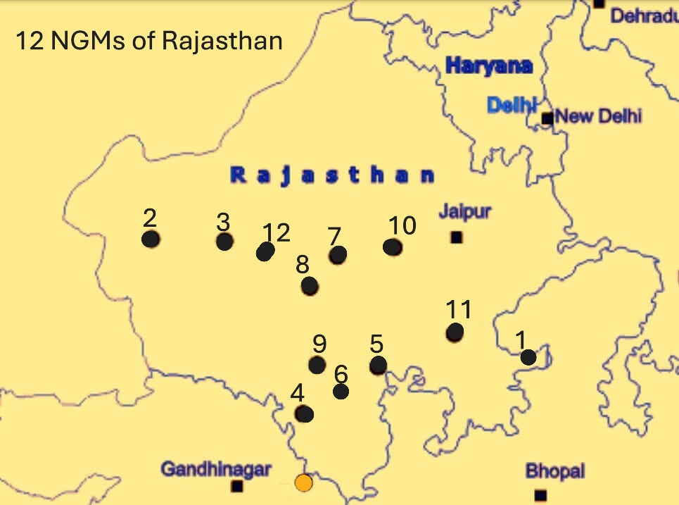

Fig 1: Map of Geoheritage sights (NGMs) of Rajasthan, Source: INTACH and modified

1. **Ramgarh Meteorite Impact Crater, Baran District, Rajasthan**

The Ramgadh Meteorite Impact Crater (MIC) displays a circular bowl-like geomorphologic depression of about 4 km diameter that is surrounded by a chain of hills conspicuously rising above nearly plain area of Vindhyan sedimentary rocks (240 m MSL). The central area of the crater has a small “Central Uplift Mound”, considered a "Natural Shivling" hence a few Shiv temples were built near it in the tenth century CE. Including the popular Shiv temple- Ulkapindeshwar.

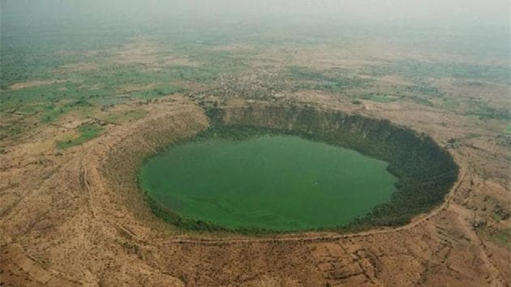

Pic 1: The Ramgarh Crater in Rajasthan’s Baran district, Source: INTACH

**2. Akal Wood Fossil Park, Jaisalmer District, Rajasthan**

An NGM marked amidst the desert city of Jaisalmer that is surrounded by the Thar desert from various sides. Akal wood fossil park is spread across a total area of 21 hectares and gets its name from its location that is in the Akal village situated 18 km from Jaisalmer. The terrain around the village is rocky and barren. This fossil park has the potential to be turned into a geological park as well. It boasts the fossils and footprints of pterosaurs near the Thaiyat area. The Jaisalmer Basin hosts unique and continuous rock records: the geological formations ranging from Lower Jurassic to the recently active dune sand deposits and characteristic biodiversity of dryland environment and other associated cultural attributes and the evolving desert landscapes have the potential for developing into a national Geopark (Wadhawan, 2016). “This site has a great potential to be transformed into a Geopark. 180 million years old fossils of animals and plants are preserved at Wood Fossil Park at Akal, situated 17 km away from Jaisalmer city. The Jaisalmer Basin formed part of the southern shelf of the Neotethys during the Jurassic. The area is well known for its rich geodiversity, both in terms of landscapes and outcrops of rock types and the variety of fossils that these rocks have preserved. Lithostratigraphy of the mapped formations, namely the Lathis, Baisakhi and Bhadasar formations are well established, and displays an array of Jurassic siliciclastic, mixed carbonate-siliciclastic and carbonate rocks that range in age from early Jurassic to Tithonian” *(Pandey et al., 2014)* The desert landscape includes a variety of stable and active dune fields including parabolic, linear transverse and barchans of different size and generations, desiccated rocky plains and pebble-boulder spreads as deflation lag deposits and salt lakes. Here the fragile dryland ecosystem supports unique and varied wildlife. The vegetation is sparse and patches of *sewan* grass and *aak* shrubs (*Calotropis*) can be seen in abundance. Desert National Park harbours a wide array of flora and fauna species and naturally supports the symbolic and protected Rajasthan State bird: Godawan- the Great Indian Bustard; animal: Camel; tree: *Khejri* and flower: *Rohida*. The Chinkara or Indian Gazelle (*Gazella gazelle bennetti*) is a common antelope of this region.

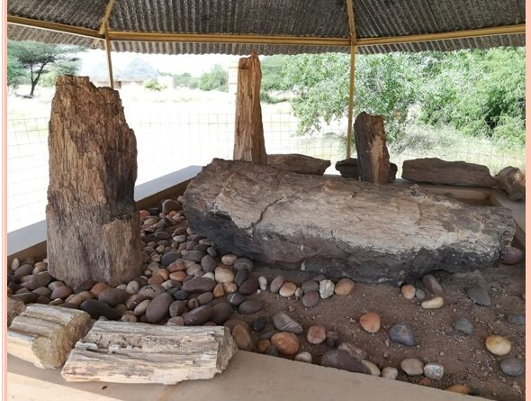

Pic 2: Wood Fossils at Akal park, Source: INTACH

**3. Welded Tuff, Jodhpur District, Rajasthan**

“Another NGM in the Jodhpur district of Rajasthan, the welded tuffs are a product of emanations that spurted millions of years ago from the volcanic vents and then were carried down by air till they finally settled down. Welded tuff is a pyroclastic rock, (volcanic materials) that was sufficiently hot at the time of eruption to weld together. During welding, the glass shards and pumice fragments stick together, deform and compact. When this air cooled down it gave rise to terraces and columnar structures. These structures are composed of glass, quartz and also feldspar. The malani rhyolites essentially comprise of welded tuff, pyroclastic rocks and various coloured rhyolites such as green, grey, pink, maroon, brown and purple. The terraces and the columnar structures are hexagonal to rectangular in shape and stretch to nearly 30 meters in dimensions” (Ranawat, P. S., & Student, P. G. D. M. 2020).

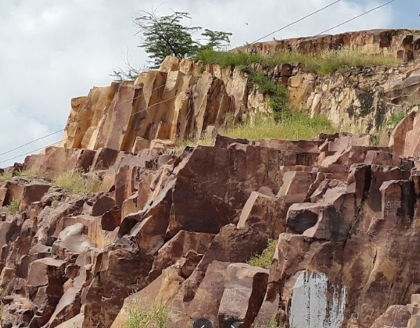

Pic 3: Welded Tuff, Source: INTACH

**4. Zawar Mines, Udaipur District, Rajasthan**

Zawar in Rajasthan is the world’s oldest mining and metallurgy site, dated to have existed around 750 BCE, marking ancient India’s acumen in the sector. Zinc and lead mined from the Aravalli rocks, extracted through a unique distillation process was shipped to Europe to bolster brass instrumentation for the industrial revolution. The American Society of Metals (ASM International) recognized Zawar as an “International Historic Landmark” in 1988 as this site preserve the zinc retort distillation furnaces and remnants of related operation. Zinc is a metal that can be difficult to extract from the core, the process being known as ‘Smelting.’ A geo-archaeological site of this importance thus mandates a holistic conservation.

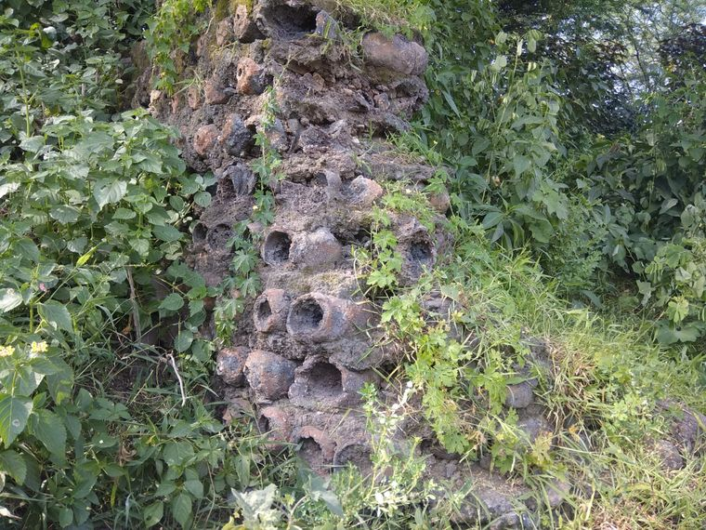

Pic4: A wall made of used clay retorts, Zawar Mines, Source: INTACH

**5. Stromatolite Park, Bhojunda, Chittorgarh District, Rajasthan**

“Bhojunda stromatolite park is an exposure inside the Bhagwanpura Limestone of the Lower Vindhyan range. They are formed by blue-green algae which forms a mat by attracting and bonding carbonate particles through their filaments into stratiform, columnar and nodular structures in carbonate rocks. Stromatolites are an indication of the earliest form of life on earth and is formed by a combination of life activity, sediment trapping and binding activity of algae and bacteria. They generally form in shallow water. The location of the Bhojunda village lies 7KM south-west from Chittorgarh, which hosts one of the best exposures of the stromatolites” *(Ranawat et al., 2016)*.

**6. Stromatolite Park, Jhamarkotra, Udaipur District, Udaipur, Rajasthan**

“It is the largest and richest deposit of phosphorite associated with stromatolite. It is another site preserving pieces of evidence of early life on the earth. The stromatolites occur over a strike length of 15 km in rock phosphate within the Precambrian Aravalli Supergroup of rocks. The rock phosphate occurs in dolomitic limestone associated with stromatolites appearing in grey to bluish-grey color shades and invariable forms and shapes. The presence of unique algal stromatolite fossils in the Proterozoic Aravalli dolomitic limestone 1800 Ma at Stromatolite Park. Jhamarkotra attracted the attention of geologists all around the world.  This NGM is present in the Udaipur district of Rajasthan and is nearly 25 km away from the city of Udaipur” *(Ranawat et al., 2016)*.

**7. Barr Conglomerate, Pali District, Rajasthan**

“Another geologist friendly spot in the Pali district, this conglomerate is composed of quartzite and rare granite pebbles, which then seem to be combined in some form of grained pelitic matrix. This structure rests conformably on Barr vicinity. A conglomerate is particularly of interest to geologists as it helps subdividing geologic history on the basis of various sedimentary breaks. The weathering process of millions of years have stretched the pebbles in this place by 20 to 30 times of their original dimensions” *(Ranawat et al., 2016)*.

**8. Sendra Granite, Pali District, Rajasthan**

Nature is the best sculptor and this NGM is a representative of that fact. The Sendra granites of the Pali district in Rajasthan were formed nearly 900 million years ago and is a set of plutonic igneous rocks. They also intrude in the Delhi supergroup of meta sedimentary rocks *(Ranawat et al., 2016)*. Over millions of years the natural phenomenon of weathering and erosion have constantly acted on the granite and this has created marvellous structures in the place. Granite batholith (900 million years old), undergone years of sculpting by wind and water action to form beautiful structures.

**9. Gossan, Rajpura- Dariba, Rajsamand District, Rajasthan**

A spectacular in-situ zone of gossan is found in the form of a ridge cap between Dariba and Rajpura villages of the Udaipur district. It is a unique world-class gossan formation that acts as the principal guide and indicator of the base metal mineralization of Zn-Pb-Cu-Ag deposits in this area. The gossan here is intensely oxidized, weathered, decomposed rock consisting of erosion-resistant iron oxides and quartz, giving it a reddish-brown, orange or yellow colour. The mineralization is confined to graphitic mica-schist, dolomitic marble, and cherts of the Pre-Aravali group. **Rajpura-Dariba** is a typical area for the study of oxidized ores and is declared as a **geological monument** by the Geological Survey of India in collaboration with Hindustan Zinc Limited.

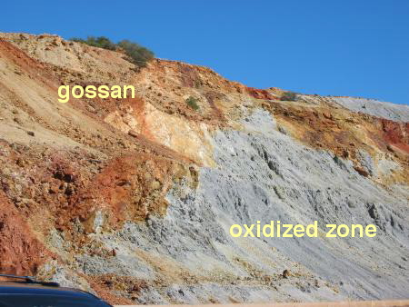

Pic 5: Gossan, Rajpura- Dariba, Source: INTACH

**10. Nepheline Syenite, Kishangarh, Ajmer District, Rajasthan**

An interesting suite of alkaline rocks with nepheline syenite as the most dominant component occurs in the area around Kishangarh, northeast of Ajmer.  The syenite body extends for about 25 km long and 1-5 km wide. The syenite body consists of feldspar minerals and variable amounts of mafic minerals. Nepheline syenite here is an intrusive igneous pluton emplaced along with the core of an anti form of metamorphites in the Aravalli craton which has been dated 1590 million years to 1910 million years old. Nepheline syenite at Kishangarh showing the gneissose appearance, form one major body and nine smaller bodies to the north and NE of Kishangarh. They are emplaced conformably within Precambrian schists, gneisses, and quartzites of the Aravalli system. This holocrystalline plutonic igneous rock consists largely of nepheline and alkali feldspar.

**11. Great Boundary Fault at Satur, Bundi District, Rajasthan**

The great boundary fault is a major tectonic lineament in the south-eastern Rajasthan along the Bundi-Sawai madhopur hills. It separates Aravalli and Vindhyan. It is extended over Chittorgarh in the south, Bundi and Sawai Madhopur (Machilpur) in the north, and has a strike length of about 400 km. The Great boundary fault zone contains different types of fault rocks, ductile shear zones and multiple sets of fractures and faults. Great Boundary Fault at Satur, Bundi district in Rajasthan represents a zone of disruption constituted by a number of parallel and oblique faults resulting in a step-like feature. Deformed limestone at the site is worth viewing. Geologically the area consists of diverse rock types belonging to the oldest Archean metamorphites of the Bhilwara Supergroup and the Upper Proterozoic sedimentary of the Vindhyan Supergroup. NE-SW part of the district is exposed by the rock types belonging to Bhilwara Supergroup and in the remaining part rock types of the Vindhyan Supergroup exist.

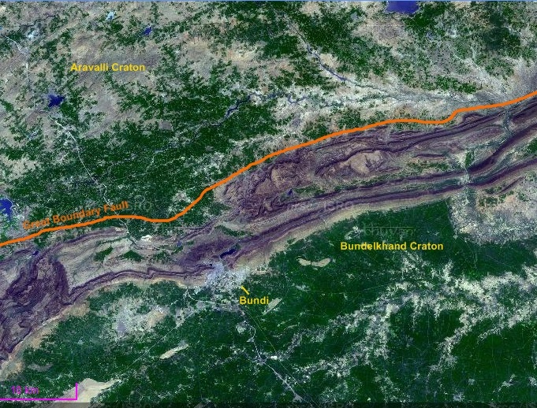

Pic 6: Great Boundary Fault at Satur, Bundi District, Source: INTACH

**12. Jodhpur Group, Malani Igneous Suite Contact, Jodhpur, Rajasthan**

The Jodhpur group of Malani rocks is a geological feature that represents the last phase in the Precambrian age in the Indian subcontinent. This group of rocks lies at the bottom of the famous Mehrangarh Fort in the heart of Jodhpur city and forms a vivid picturesque. Rajasthan was formerly divided into two regions namely Mewar and Marwar. Malani was the name of a district in the former state of marwar. This was one such place in the region of Marwar where volcanic rocks were found and hence the name Malani bed rocks. The name had undergone several changes over the years: Malani Beds (1877), Malani Volcano Series (1902), Malani System (1933), The Malani Granite and Volcanic Suite (1968) and finally it came to be known as Malani Igneous Suite.

Besides above, there are many other potential geoheritage sites/National Geological Monuments (NGMs) which might be of worth for future ‘geotourism’ in Rajasthan. These are (i) Ancient Gold mining Site at Bhukia, Banswara district, (ii) Old Copper Mining site at Naldeshwar, Alwar district, (iii) Pratap Khan, Zawar area, Udaipur district, (iv) Dhanota Gossan and Old Workings in Jhunjhunu district, (v) Bhambolai Pillow Lavas, Pali district, and (vi) Deccan Trap Calc Tuff and Cave in Chittaurgarh district *(GSI WR, 2013).*

**SWOT Analysis**

The following are the findings of the SWOT analysis (Strengths, Weakness, Opportunities and Threats):

**Strengths:**

* These locations have a great biodiversity
* It is a nature-based geotourism attraction
* Many cultural and heritage sites enroute
* No environmental impact

**Weakness:**

* The natural and geographical beauty is being ruined by encroachments and illegal constructions
* The roads, transport and conveyance facilities are not conducive to tourism
* Large amounts of noise and plastic waste are caused by a variety of religious programs
* Geoheritage is often overlooked in mainstream heritage conservation policies
* Small volume outcrops
* Lack of geotourism knowledge

**Opportunities:**

* Developing a vision for the benefit of all residents and stakeholders is a possibility
* Possibilities for employment, socioeconomic growth and travelling
* Develop and improve geotourism education initiatives
* Creation of a geopark for developing geotourism
* Spreading geological knowledge

**Threats:**

* Unregulated development and mining activities have caused irreversible damage to many geological features
* The natural and geographical beauty is being ruined by the unplanned and uncontrolled development
* Lack of thought process to develop rare rock sites as geoparks
* Quarrying may vanish the outcrops as they are small

**Recommendations For Sustainable Development of These Geoheritage Sites**

The SWOT analysis also showed that besides substantial strengths and prospective opportunities, weaknesses are also more. Some strategic aspects drawn from the SWOT analysis which are required to plan for developing the geoheritage sites as geoparks are listed below:

1. Illegal activities such as mining in these sites should be prohibited so that these sites can be preserved.
2. Proper fencing should be done around the area to protect geological monuments.
3. Water bodies around geological sites often are subjected to sewage, garbage and industrial waste dumping. This needs to be resolved and checked to better maintain these sites.
4. Incorporating geoheritage into school and university curriculum can raise awareness and interest in Earth sciences.
5. NGMs with an immediate need or ability to be converted into a Geopark should be identified. This will also help display these sites on an international radar with the help of UNESCO’s initiatives.
6. There is an urgent need for a national and state-level geoheritage policy. Rajasthan can pioneer this effort by mapping its geoheritage sites and integrating them into regional planning and conservation laws.
7. Sign boards, with clear and concise descriptions that can be understood by everyone, need to be placed at the turnings of road to reach the spot.
8. The sites need to be cleaned, made appealing and beautified by gardening and electrification.
9. Engaging local communities in the management and promotion of geoheritage sites ensures economic benefits. Training locals as guides and facilitators can create employment opportunities and reduce out migration also.
10. Infrastructure development is another key area of focus. Improved accessibility, visitor amenities, and interpretative signage can significantly enhance the visitor experience while minimizing the environmental impact.

**Conclusion**

The research has found that Rajasthan has a scope of geotourism development with some limitations, such as insufficient government support to develop geosites and low local people awareness. The state has wide possibilities to become a geoheritage hotspot because it could attract geotourists due to its natural, cultural and geological features. Rajasthan is endowed with extraordinary and rich geo-wealth whereas the Aravali ranges and the Thar Desert are iconic landscape features. There are countless fascinating and exquisite features, landforms and landscapes in the state that have immense scientific, cultural and socio-economic value. However, geological and geomorphological heritage is not sufficiently recognised in Rajasthan. Geoheritage conservation in Rajasthan is more than an environmental imperative - it is a pathway to sustainable development. By recognizing the value of its unique geological features, the state can promote eco-tourism, education and community empowerment. NGMs and geotourism sites of Rajasthan offer a unique blend of natural beauty, scientific value and cultural heritage. Preserving these sites is essential for future generations to understand and appreciate the Earth’s geological history. By addressing the challenges and leveraging opportunities, Rajasthan can enhance its geotourism potential and contribute to sustainable tourism development. Collaborative efforts, innovative approaches and community involvement are key to ensuring the successful conservation and promotion of these valuable natural assets. The GSI may step forward to preserve the geoheritage sites and develop them as geoparks. It also can generate an expansion of economic benefits for local communities including revenue creation, job generation, diversification and infrastructure improvement

**Acknowledgements**

The authors acknowledge the support extended by the Government of Rajasthan under Teachers interface for excellence (TIE) scheme.

Disclaimer (Artificial intelligence)

Option 1:

Author(s) hereby declare that NO generative AI technologies such as Large Language Models (ChatGPT, COPILOT, etc.) and text-to-image generators have been used during the writing or editing of this manuscript.

Option 2:

Author(s) hereby declare that generative AI technologies such as Large Language Models, etc. have been used during the writing or editing of manuscripts. This explanation will include the name, version, model, and source of the generative AI technology and as well as all input prompts provided to the generative AI technology

Details of the AI usage are given below:

1.

2.

3.

**Reference**

Anantharamu, T.R., Bellur, D. and Bhasker, A.A. 2001. National Geological Monuments; Geol. Surv. Ind. Spl. Pub. No. 61, p 98.

Bailey H., Hill W., 2010. The future of North American geoparks

Berred S., Fadli D., El Wartiti M., Zahraoui M., Berred K., Sadki R. (2019). Geomorphosites of the semi-arid Tata region: Valorization of an unknown geoheritage for geotourism sustainable development (Anti-Atlas, South Morocco) Geoheritage, 11 (4) (2019), pp. 1989-2004,

Brilha, J. 2018. Geoheritage: inventories and evaluation. In: Reynard, E., Brilha, J. (Eds.), Geoheritage: Assessment, Protection, and Management. Elsevier, Amsterdam, pp. 69-86.

Brocx. M., Semeniuk V., 2007. Geoheritage and geoconservation: History, definition, scope and scale Journal of the Royal Society of Western Australia, 90 (2007), pp. 53-87

Dowling, R. K. 2011. Geotourism’s Global Growth. Geoheritage, 3(1): 1-13.

Geological Survey of India. (2022). Geoheritage Sites in India.

Gray, M. 2013. Geodiversity: Valuing and Conserving Abiotic Nature. Wiley-Blackwell, Chichester.

Grover, A.K. 2016. Hamare Rashtriya Bhuvaigyanik Smarak; Bhugaurav. Geol. Surv. Ind. Western Region Hindi Periodical; V. 16, pp 1-14.

GSI WR, 2013: National Geological Monuments and other Geo-heritage sites in Rajasthan & Gujarat. Proc. of Nat. Workshop and Brainstorming Session on Geoheritage - Need for an Indian Activism, 30-31 May, pp 70-75.

https://www.unesco.org/en/tags/geoheritage.

INTACH, 2016. A Monograph on National Geoheritage Monuments of India. Lodhi Estate, New Delhi: Indian National Trust for Art and Cultural Heritage, (pp. 12-19).

Pandey, D.K., Fürsich, F.T. and Alberti, M. 2014. Stratigraphy and palaeo-environments of the Jurassic rocks of the Jaisalmer Basin - Field Guide. 9th Int. Cong. on the Jurassic System, University of Rajasthan, Jaipur.

Ranawat, Dr. P.S. 2016. Monograph on National Geological Monuments and Potential Geoheritage Sites of Rajasthan. Udaipur, Rajasthan: Kumbha Exclusives.

Singh, R. B. Anand S. 2013. Geodiversity, geographical heritage and geoparks in India. Int Jour Geoheritage 1:10–26.

Tamang L , Mandal U. K., Karmakar M., Banerjee M , Ghosh D. 2023. Geomorphosite evaluation for geotourism development using geosite assessment model (GAM): A study from a Proterozoic terrain in eastern India International Journal of Geoheritage and Parks, 11 (1) (2023), pp. 82-99,

UNESCO Global Geoparks. 2023. Guidelines for Geoheritage Conservation.

Wadhawan Sudesh Kumar 2016. Jaisalmer Basin in Thar Desert - Potential for Developing Geopark in Rajasthan, West India. In Proceedings of the 35th International Geological Congress, IUGS, Cape Town South Africa. Association of Geoscience Societies of America. p.11.

Wadhawan, Sudesh Kumar 2020. Geoheritage Sites and Potential Geoparks in India – Strategies for Sustainable Development. Indian Journal of Geosciences, 74(3), July - September, 2020; 354-362.

Ranawat, P. S., & Student, P. G. D. M. (2020). Recognized geoheritage and geotourism sites in India. International Journal of Engineering Applied Sciences and Technology, 4(11), 224-231.