GROWTH AND SURVIVAL OF Sargassum spp . WITH DIFFERENT TOTAL AMMONIA NITROGEN CONCENTRATIONS

.
ABSTRACT
Sargassum spp. is grass the sea that enters in category brown algae macro which is still Not yet wide cultivated in waters beach so that tried cultivation scale laboratory with treatment fertilization nutrients macro . Research This done For analyze resilience life and growth on Sargassum spp. with different Total Ammonia Nitrogen (TAN) concentrations . This research method uses an experimental method with a Completely Randomized Design (CRD) consisting of 5 treatments (P0: No Concentration, P1: TAN Concentration 0.010 ppm, P2: TAN Concentration 0.025 ppm, P3: TAN Concentration 0.050 ppm, P4: TAN Concentration 0.075 ppm) and 3 replications, so that there are 15 total experiments. Sargassum spp. maintenance was carried out for 15 days at the Aquaculture Environment Laboratory, Mataram University. The parameters observed include survival, growth weight absolute , rate growth heavy specific , long thallus , number strands leaves and water quality . Based on one-way anova test results concentration tested​ with level 95% confidence level obtained results that are not significant (p>0.05) against growth and resilience live on grass sea Sargassum spp. Results of the second order polynomial regression test between TAN concentration with growth grass sea obtained mark determination of R ² (70-80%) which reveals strong relationship and 20-30% is influenced by other factors . The concentration given to maintenance This No utilized For growth Sargassum spp. however used For endure life come to the phase death . Based on the results obtained , then can concluded that the concentration of TAN given Still low . Because of that that , for study furthermore recommended use higher concentration of TAN high and use coral dead as substrate .
Keywords: Sargassum spp., growth , resistance life , TAN concentration .
- INTRODUCTION
Grass sea is one of the source Power abundant life in Indonesian waters . One of the type grass abundant sea in the waters that is type of brown algae ( Phaeophyta ) which consists of of 400 known species​ as the most numerous type from type grass sea others . One of the its members is Sargassum spp. Sargassum spp. still made into as indicator contaminated waters Because his ability as a biofilter that can absorb various type compounds in water , including metal weight that is toxic (Azizah et al. , 2018) .
Sargassum spp. has not been cultivated and is still taken in a way free in nature . The number of Sargassum spp. will the more reduce Because the more Lots researcher about Sargassum spp. and already Lots found a number of content utilized​ as medicines , cosmetics and so on . According to Febriani et al., (2022) state Sargassum spp. have content compound bioactive like alginate , fucoidan , fucoxanthin and phlorotannin . Nuraini et al., (2021) add compound bioactive can used as extract or as component main in industry food and pharmaceuticals . Research results Muslim & Sari, (2017) state fucoidan has investigated functioning as anti- tumor , anti -proliferation , and anti - inflammatory in laboratory experiments .
Grass sea chocolate contains carotenoid pigments . Carotenoid pigments namely pigments that help the process of photosynthesis . The amount Carotenoid pigment content in grass sea will influential along with increase growth that is with existence availability nutrients such as nitrogen, phosphorus and conditions environment like optimal water quality (Gazali et al., 2017) . Growth Sargassum spp. supported with existence availability sufficient nutrition in the container cultivation that can sourced from urea fertilizer . Urea fertilizer contains 45-46% nitrogen in form (CO(NH ₂ ) ₂ ). Urea fertilizer is easy late in waters and will absorbed by the grass sea after the existence of a decomposition process become nitrate and ammonia . Nitrate and Ammonia this is what will be utilized by plants sea as nutrients (Opat et al ., 2024) .
According to Rendiansyah et al. (2024) , urea fertilizer is a type of single fertilizer whose nitrogen element functions to accelerate the growth of thallus. Seaweed is unable to absorb nitrogen directly. Plants absorb nitrogen element in the form of nitrate ions or ammonium both of which is a soluble ion in water (Miarti & Legasari, 2022) . Based on the description above , then need he did study For analyze extent of growth and resilience life grass sea type Sargassum spp. with variation different concentrations of TAN .
- methodOLOGY
research was conducted for 15 days in January - February 2025 at the Aquatic Environment Laboratory, Aquaculture Study Program, Department of Fisheries and Marine Sciences, Faculty of Agriculture, University of Mataram. Testing of TAN, Nitrate and Orthophosphate parameters was carried out on days 0, 3, 5, 10 and 15 at the Analytical Chemistry Laboratory, Faculty of Mathematics and Natural Sciences, University of Mataram. Water quality testing such as light intensity, temperature, salinity and pH was carried out every day during maintenance. The tools used were containers, aeration, refractometer, pH meter, lux meter, ruler, analytical scales, scissors, distilled water, urea fertilizer and phosphate fertilizer.
This research method is experimental using a Completely Randomized Design (CRD) consisting of 5 treatments and 3 replications, so that there are 15 total experiments, namely (P0): without TAN concentration; (P1): TAN concentration 0.010 ppm; (P2): TAN concentration 0.025 ppm; (P3): TAN concentration 0.050 ppm; (P4): TAN concentration 0.075 ppm. The research procedures carried out are as follows:
The seaweed culture procedure of Sargassum spp. begins with the preparation of a culture container using a tiered rack equipped with LED lights with an intensity of 1,300.6-4,160.5 Lux (Fitriani et al., 2023) , equipped with an oxygen pipe installation for the aeration device. Sargassum spp. seaweed seeds were adapted for 7 days in floating net cages, Ekas Bay. After 7 days of adaptation, they were transferred to the laboratory, weighed 50 g/sample and tied to the substrate. Culture maintenance lasted for 15 days with daily water quality monitoring and the addition of urea fertilizer based on TAN concentration. Growth observations were carried out at the beginning and end of the study including survival, absolute weight, specific weight growth, thallus length and number of Sargassum spp. leaves.
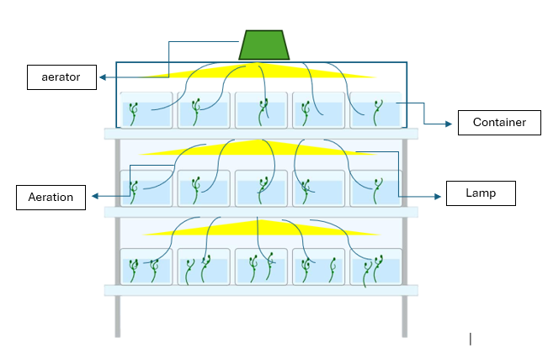
Figure 1 Layout of Sargassum Maintenance Container spp .
3. RESULTS
3. 1 Survival of Sargassum spp. Seaweed
Based on the results of the study that has been conducted for 15 days, it was found that the survival of S. argassum spp. at different TAN concentrations had a survival percentage value of 41-57% (Figure 1). One-way test results anova with a confidence level of 95%, the survival of Sargassum spp. to different TAN concentrations in each treatment was not significant (P>0.05). The results of the second-order polynomial regression with the determination value of R2 ⁽ 70%) showed a strong relationship between TAN concentration and the survival of Sargassum spp., while the remaining R2 value ⁽ 30%) showed that the survival rate was influenced by other factors such as environmental conditions and so on. The presence of TAN in the cultivation container is very important because it is a nutrient for the growth and survival of Sargassum.
In the research this , growth Sargassum spp. no show mark significant growth​ like increase weight , increase long thallus and number strands leaves . This is allegedly that Sargassum spp. absorb available nutrients​ utilized only For source energy endure live in its environment . This is in line with results study Rendiansyah et al., (2024) who stated that urea fertilizer given to grass sea type ( Caulerpa lentillifera ) no used For growth but as source energy For adapt with the environment .

Figure 2 Survival of Sargassum Seaweed spp . at Different TAN Concentrations.
On study this , maintenance Sargassum spp. use basket as substrate with tie thallus to remain upright on the container maintenance and coral dead as ballast For overcome existence shakiness . This is carried out so that Sargassum spp. is maintained capable endure live and grow in a container maintenance . In Figure 3. it is known that root Sargassum spp. no attached to the basket but attached to coral dead . This is in line with opinion Fitriani et al., (2023) who stated that Sargassum spp. should cultivated on hard substrate​ like coral dead , gravel and shells molluscs .
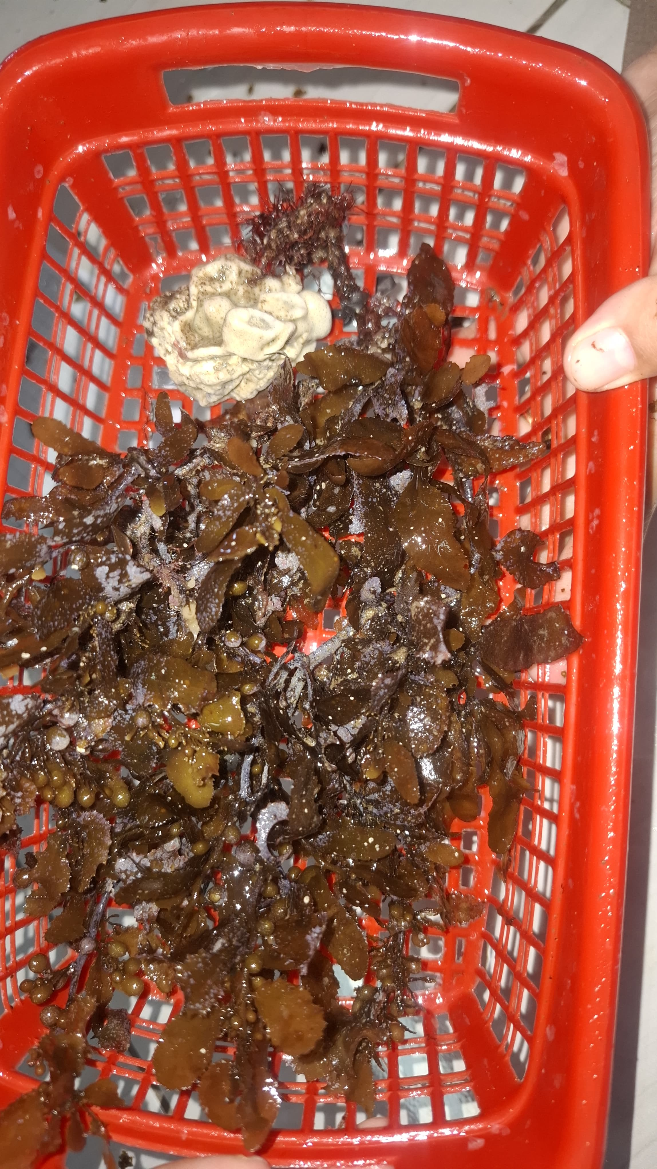
Figure 3. Sargassum spp. Roots Attached to Dead Coral
  - Absolute Weight and Specific Weight Growth Rate of Sargassum spp .
Based on the results of the research that was conducted for 15 days, it was found that the absolute weight at different TAN concentrations own average weight value absolute of (-35) – (-25) gr. One-way test results anova with level 95% confidence , weight absolute Sargassum spp. at different TAN concentrations in each treatment show value that is not significant (P>0.05). Regression results polynomial order 2 in Figure 4. obtained results mark determination of R ² (79%) which shows that TAN against growth weight absolute own very strong relationship because TAN is nutrition for grass sea .

Figure 4. Absolute Weight of Sargassum Seaweed spp . at different TAN concentrations.
Amount TAN content on the container cultivation This known from test result count TAN concentration carried out at the time maintenance . Testing amount TAN concentration was performed every 5 days . The first TAN test done on the day to 0 for know the amount of TAN present in the maintenance water . The third day until with day Fifth , Sargassum spp. has absorb the TAN available in the container cultivation . On the day to 10 continued testing amount TAN concentration and known that amount TAN concentration increases from amount dose the treatment given so that No done addition urea fertilizer . This is possibility due to Because Sargassum spp. already No absorb the available TAN .
Improvement TAN concentration in the container maintenance possibility due to Because existence release of N to in receptacle maintenance . N release in cultivation water containers show that Sargassum spp. Already enter into the phase death . This is in line with results study Rendiansyah et al., (2024) which was tested on grass sea type ( Caulerpa lentillifera ) which states that decline growth grass sea ( Caulerpa lentillifera ) in every treatment due to Because grass the sea is spread after 3-10 days will show signs death like the color changed become white and over time thalus , stolons, ramuli and rhizoids changed become soft and easy destroyed . This is possibility due to Because height nitrogen concentration and lack of element phosphate at the beginning study will influence growth grass sea .
Based on the results of research that has been conducted that with different TAN concentrations in each treatment give influence that is not different real (P>0.05) ( one-way anova test ) against growth heavy specific daily Sargassum spp. Regression results polynomial order 2 in Figure 5. obtained results mark determination by 81% which shows existence strong relationship​ between TAN and SGR or growth heavy specific . The relationship between TAN and growth grass sea said to be very strong because TAN is nutrition for grass sea .
Specific Weight Growth Data show that No happen growth per day at the time maintenance . This is known from amount increasing concentration of TAN high on the container possible maintenance​ caused by Sargassum spp. already No absorb available nutrients​ optimally for​ growth , but rather as energy For endure live in its environment and not give mark growth specific . This is in line with opinion Hutabarat et al., (2024) stated that that low rate growth specific due to low absorption nutrients and penetration light with the process of photosynthesis . Grass sea No experience significant growth​ but in a way gradually dead Because fertilizer used as source energy For adapt with environment new . Cokrowati, et al., (2024) stated that low growth daily This allegedly due to Because grass sea No absorb existing nutrients​ For growth daily .

Figure 5. Specific Weight Growth Seaweed Sargassum spp. at Different TAN Concentrations
Difference Fresh Sargassum spp. and Sargassum spp. which are already wilted in the container maintenance can seen in Figure 6. Based on results observation , known that still water color clear in container maintenance Sargassum spp. which is still fresh. While Sargassum spp. which has wilted , water in the container will dirty or called depigmentation caused​ Because existence decomposition to grass the sea that has dead . Research results obtained that there is the average SGR value is (-3.75%) – (-6.05%). This is different with results research obtained​ Muktiniati et al., (2022) stated that growth weight absolute best with 195 grams value and growth rate specific highest with mark growth specifically reached 4.35%/ day . While results research obtained​ Maryunus & Hussein, (2018) , growth specific daily (SGR) ranges between 6.58 – 6.76%. Hulpa et al., (2021) state that rate heavy good specificity is also caused Because influence nutrients found in waters , their presence nutrients from​ level abundant nitrates and phosphates​ can influential to algae reproduction .

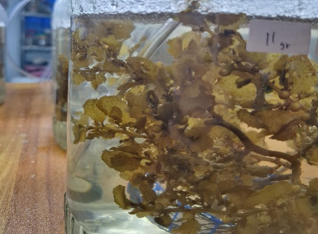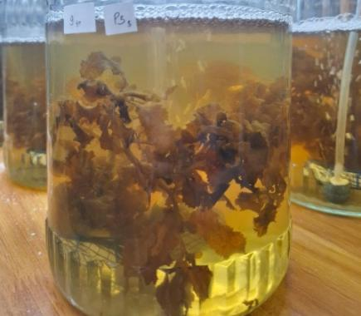
Figure 6. Difference between Fresh Sargassum spp. and Wilted Sargassum spp.
  - Reduction of Sargassum Thallus and Leaf Blade Number spp .
The results of the research that has been carried out with different TAN concentrations in each treatment obtained mark difference from subtraction long thallus during maintenance Sargassum spp by 3-6 cm. The result of the reduction thallus This counted in a way descriptive with to describe long thallus early and thallus end (Figure 6).

Figure 7. The Number of Initial and Final Thalus Lengths of Sargassum spp. at Different TAN Concentrations
Growth grass sea Sargassum spp. known from increase weight , length thallus and number strands the leaves obtained during maintenance . Thalus functioning as factor main For absorb TAN, so that when thallus experience disturbance so Sargassum spp. no Can optimally absorb TAN . This is in line with opinion Sari et al., (2021) stated that grass sea absorb or to obtain food through the cells contained in the thallus with method diffusion through surface body . Nutrition has a big influence to abundance grass sea and good nutrition​ will give good growth of grass​ cultivated sea .​
Based on results research , found that No there is growth but subtraction thallus and number strands leaves . Reduction This happen because of thallus Sargassum spp. broken and leaves attached to the thallus will follow simultaneously fall and some leaf fall with by itself every day . This is allegedly that Sargassum spp. experiencing stress towards new environment​ so that infected ice-ice disease ( Figure 8 ).

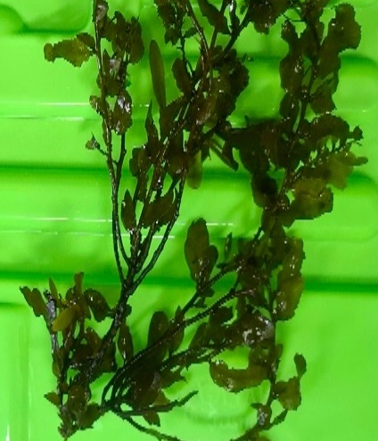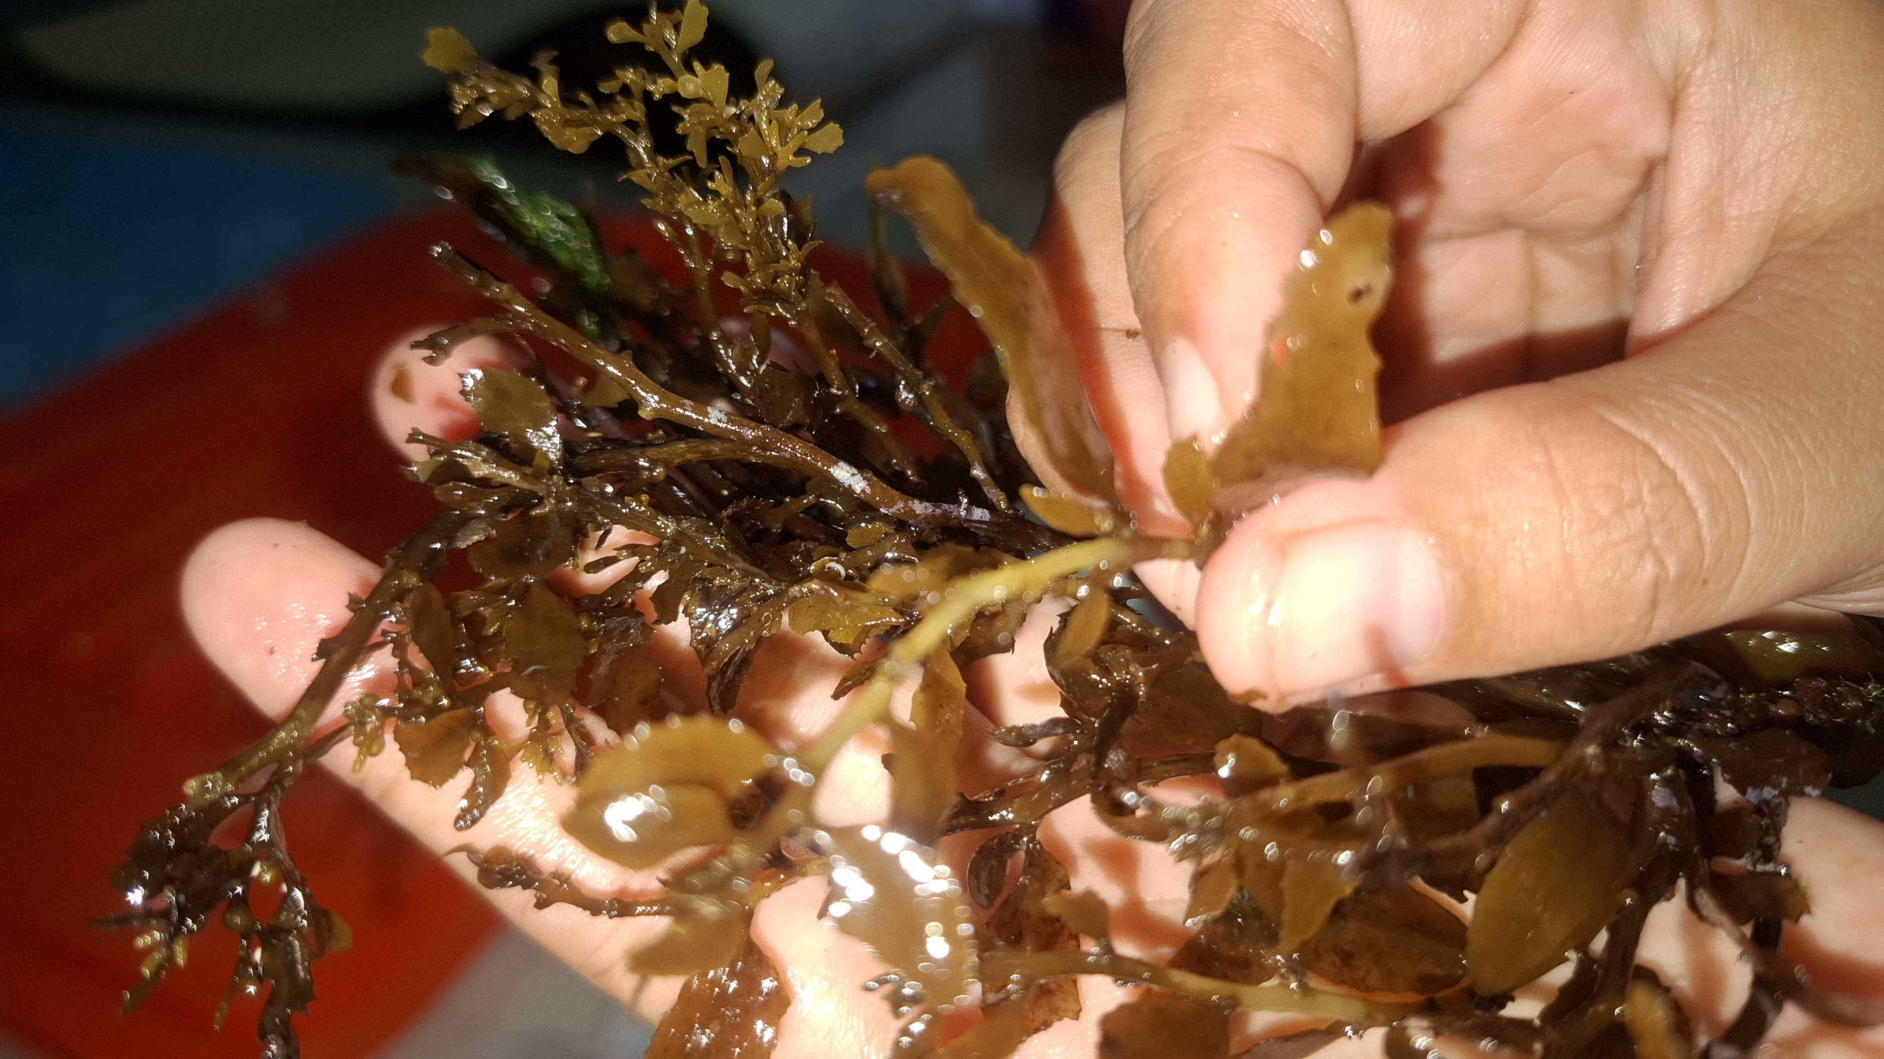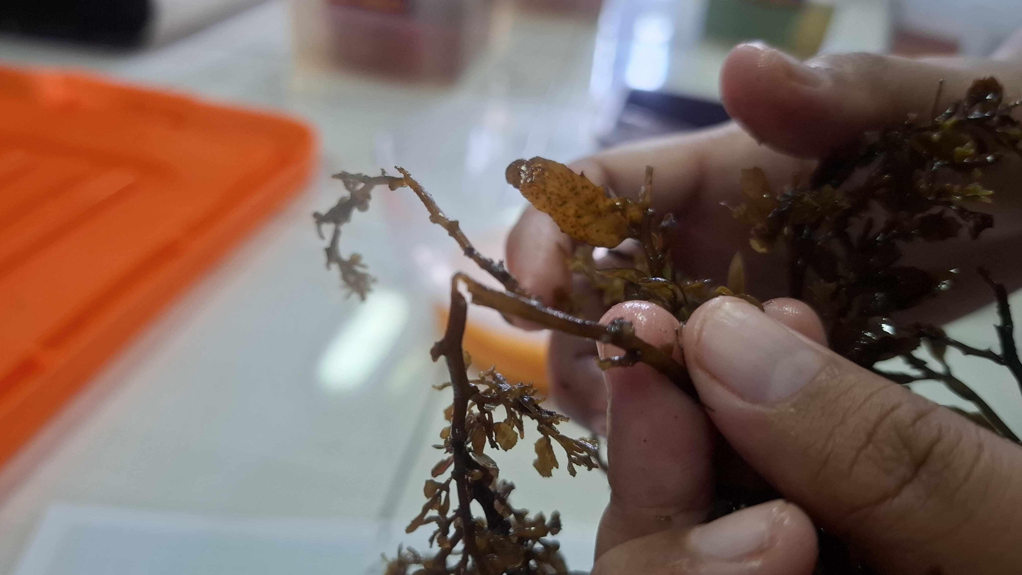
Thalus which is still Healthy suspected thallus​ affected / infected ice-ice disease
Figure 8. Differences between Healthy Sargassum spp. Thalus and Thalus Suspected of Being Infected with Ice-Ice Disease
The results of the research that has been carried out with different TAN concentrations in each treatment obtained mark difference from amount fallen leaves ( strands ) during maintenance Sargassum spp. namely as many as 49-112 total strands fallen leaves .​ Subtraction results amount strands This counted in a way descriptive with to describe amount strands leaf beginning and amount strands leaf end (Figure 9). Number strands leaf will reduce with existence weakened thallus​ so that strands leaves on the thallus​ the will follow weaken . Then fall on the container maintenance .
Thallus and leaves have strong relationship​ Because with increase growth from grass sea , then will the number also increases strands growing leaves​ along with increase long thallus . Figure 5 can seen that fallen leaves​ will destroyed so that the occurrence depigmentation in culture water with marked water color like yellow brownish . This is in line with opinion Supiandi et al., (2023) stated that growth leaf happen Because existence cells active who experience division and distribution in a way random as well as cause increase size the leaves that will followed with growth . Factors that influence leaf is factor environment that is nutrients , temperature , pH and nitrogen. Factors those that can stimulate growth leaf that is sufficient nitrogen availability . sufficient nitrogen availability will increase wide leaves , because nitrogen can stimulate growth of shoots and leaves especially in the phase growth vegetative .

Figure 9. Number of Early and Late Leaves of Sargassum spp. at Different TAN Concentrations

Water Quality
Water quality parameters observed during the research activities were pH , temperature, salinity and light intensity. These parameters were measured daily for 15 days of cultivation while orthophosphate , nitrate and TAN testing were carried out on days 0, 3, 5, 10 and 15. The results obtained during the research from all parameters were optimal. Water quality data can be seen in Table 1.
Table 1 Water Quality During Research
No | Parameter | Unit | Results | Optimal | Literature
1 | pH | - | 7.8 | 7-8.5 | (Cokrowati et al. , 2021)
2 | Temperature | ^{O} C | 27-27.1 | 24-35 | (Ruslaini, 2016)
3 | Salinity | ppt | 36.5-36.6 | 30-31 | (Supiandi et al. , 2023)
4 | Light Intensity | Lux | 1,460 | 1,300.6- 4,160.5 | (Fitriani et al., 2023)
5 | Nitrate | mg/L | 0.59-07 | 0.200-0.420 | (Safitri et al ., 2021)
6 | Orthophosphate | mg/L | 1.01-1.77 | 1.0-3.5 | (Marlin et al., 2022)
7 | TAN | mg/L | 0.10-0.23 | <0.3 | (Neisila et al. , 2020)
Water quality is one of the factor the main thing to do be noticed in activity cultivation in room controlled scope . Water quality values must be in accordance with standard cultivation grass farmed sea​ as one of the factor Supporter For its growth . Intensity the light obtained during study this is 1460 lux. This is in line with Fitriani et al., (2023) who stated that intensity optimum light range between 1300.6-4160.5 lux . Suboptimal temperatures will cause metabolism grass sea disturbed so that cause grass sea become stress . The average temperature value obtained during cultivation grass sea This ranges from 27-27.1 o ^{C.} The temperature value obtained Already including optimal for cultivation grass sea . This is in line with Ruslaini, (2016 ) stated that optimal temperature for growth grass sea is around 25-30 º C. Growth grass sea in the environment cultivation determined by salinity and pressure between grass sea with room scope cultivation . The salinity value obtained during cultivation is in the range of 36.5 ppt. This value Still classified as Good For cultivation grass sea . This is in line with Supiandi et al . , (2023) stated that water salinity function For arrange pressure existing osmotic​ in body organism sea and its environment . Good salinity range For cultivation Sargassum spp. is 30-37 ppt. Degree acidity or pH is factor chemistry that determines growth grass sea . pH is influenced by compounds or content in culture water such as CO2 , concentration of carbonate salts and decomposition material organic in water . The pH value obtained during study range between 7.8. This is in line with opinion Cokrowati et al., (2021) state that the pH of the water influence toxicity a waters . Organisms aquatic part big sensitive to change pH. The appropriate pH value of water for Sargassum spp. ranges from between 6.9-8.
Grass sea need nutrients For help growth . Nutrients needed by grass​ sea For growth that is nitrate , orthophosphate and TAN. The results of the nitrate test obtained known that amount nitrate present in container water cultivation on the day to 0 around 0.04 mg/L and the N test results on the day 3-10 ranges from 0.92-1.23 mg/L. Based on the N test can concluded that amount nitrate present in the container maintenance the more increased . This is possibility due to Because thallus grass sea experience damage so that existence improvement nitrate . This is in line with opinion Desanti et al., (2023) stated that the existence of a decomposition process grass the sea that has dead result in concentration high nitrate in the waters . The nitrate value obtained at the time maintenance exceed optimal value for growth grass sea Sargassum spp . This​ in line with Safitri et al., (2021) stated that that optimal nitrate value For growth Sargassum spp. is 0.200-0.420 ppm. Advantages and disadvantages nitrate in container cultivation will hinder growth grass sea . This is in line with Desanti et al., (2023) stated that death grass the sea that occurred during time maintenance can caused by Because concentration Too much nitrate high . Concentration Too much nitrate tall will cause damage to grass sea . Orthophosphate is influential nutrients​ for metabolism cell Plants . Content phosphate in waters will influence fertility waters For growth grass sea . The results of the orthophosphate test obtained during maintenance namely 1.01-1.77 mg/L. The amount content orthophosphate the Already including optimal but Sargassum spp. which is maintained Still Not yet maximum absorb so that No utilise orthophosphate as nutrition For its growth . This is in line with opinion Marlin et al., (2022) stated that phosphorus required For growth grass sea . Range of values content proper phosphate​ for fertility grass sea is 0.1–3.5 ppm.
Total Ammonia Nitrogen is amount ammonia obtained​ from nitrogen originating from fertilizer that is nitrified by bacteria waters so that Then become nitrate . This is in line with opinion Lastriana et al., (2023) stated that that ammonia is one of nitrogen form as nutrients needed by grass​ sea . This nitrogen furthermore will used by grass sea as material in synthesis amino acids and proteins. Compounds This produced from the decomposition process organism death that occurs in the waters . The TAN value obtained during study which is 0.10-0.23 mg/L. This is in line with Neisila et al., (2020) stated that range mark ammonia the Still within the limits that have been set Decree of the Minister of Environment 2004 , namely <0.3 mg/L. The high availability N value in waters so grass sea will save the N in the network nya , but at the time low N values in waters cultivation , N stored in the thallus put into operation as its growth .
4. Conclusion
Based on results research that has been done , then can concluded that TAN concentration (0.000-0.075 ppm) is not influential to growth and resilience life Sargassum spp. ( ANOVA test results ) with level 95% confidence in P>0.05 is not significant ). This is allegedly due to Because the concentration of TAN given Still low so that nutrients available in the container maintenance only utilized For endure live . Therefore that , for research furthermore recommended For use higher concentration of TAN high and use coral dead as the substrate .
Acknowledgement
The author would like to thank the main supervisor, Mrs. Nanda Diniarti S.Pi. , M.Si., who has given permission to use the facilities and infrastructure for the 2024 Regular Fundamental research funded by the Directorate of Research, Technology and Community Service, Ministry of Higher Education, Science and Technology.

Disclaimer (Artificial intelligence)

Option 1:
Author(s) hereby declare that NO generative AI technologies such as Large Language Models (ChatGPT, COPILOT, etc) and text-to-image generators have been used during writing or editing of manuscripts.
Option 2:
Author(s) hereby declare that generative AI technologies such as Large Language Models, etc have been used during writing or editing of manuscripts. This explanation will include the name, version, model, and source of the generative AI technology and as well as all input prompts provided to the generative AI technology
Details of the AI usage are given below:
1.
2.
3.
Reference
Azizah, R., Malau, R., Susanto, A. B., Santosa, G. W., & Hartati, R. (2018). Kandungan Timbal Pada Air, Sedimen, Dan Rumput Laut Sargassum spp. Di Perairan Jepara, Indonesia. Kelautan Tropis, 21(23), 155–166.
Cokrowati, N., Nur, D., & Lumbessy, S. Y. (2021). Jurnal Biologi Tropis Growth Performance Sargassum spp. Cultivated in Labuan Ijuk , Moyo Hilir Sumbawa Besar Regency , Nusa Tenggara Barat. 21, 783–791.
Cokrowati, N., Prasedya, E. S., Raihanun, B., Putra, D. P., Astuti1, N. K. P., Ilhami, B. T. K., Hariadi1, H., Jumat, M., Jayusri, Padmi, H., Waang, D. C., & Kurniawan3, N. S. H. (2024). Performa Pertumbuhan Rumput Laut Sargassum cristaefolium Di Teluk Gerupuk Lombok Tengah. Jurnal Ilmiah Jurusan Budidaya Perairan, 9(1), 24–34.
Desanti, I. A., Pramesti, R., & Sunaryo. (2023). Pertumbuhan Gracilaria sp. dengan Kepadatan Berbeda Pada Air Limbah Pemeliharaan Udang Intensif. Journal of Marine Research, 12(1), 103–109.
Febriani, A., Diniarti, N., & Setyono, B. D. H. (2022). Pengaruh Kedalaman Berbeda Terhadap Kandungan Klorofil-a Dan Karotenoid Rumput Laut Kappaphycus alvarezii Di Perairan Teluk Ekas, Lombok Timur. Jurnal Perikanan Unram, 12(4), 493–503. https://doi.org/10.29303/jp.v12i4.329
Fitriani, Cokrowati, N., & Mukhlis, A. (2023). Pengaruh Budidaya Rumput Laut Sargassum spp. Dengan Substrat Yang Berbeda di Skala Laboratorium. Indonesian Journal of Aquaculture Medium, 3(3), 162–171.
Gazali, M., Safutra, E., & Zamani, N. P. (2017). Eksplorasi Potensi Senyawa Bioaktif Makroalga Laut Sargassum spp. Sebagai Antibakteri Asal Pesisir Barat Selatan (BARSELA) Aceh. SEMDI UNAYA, 11, 289–300.
Hulpa, W. L., Cokrowati, N., Dinarti, N., Studi, P., Perairan, B., Pertanian, F., & Mataram, U. (2021). Pertumbuhan Rumput Laut Sargassum spp. Yang Dibudidaya Pada Kedalaman Berbeda Di Teluk Ekas Lombok Timur. 14(2), 185–191.
Hutabarat, A., Irawan, H., & Putri, D. S. (2024). Laju Pertumbuhan Calon Bibit Rumput Laut Kappaphycus alvarezii Dengan Pemberian Pupuk Yang Berbeda. Jurnal Ilmiah Jurusan Budidaya Perairan, 9(4), 32–42.
Lastriana, B. H., Cokrowati, N., & Putra, A. P. (2023). Analisis Tingkat Pencemaran Perairan Di Lokasi Budidaya Rumput Laut, Labuhan Sangoro, Teluk Saleh Kabupaten Sumbawa. Journal Perikanan, 13(3), 744–754.
Marlin, Kasim, M., & Munier, T. (2022). Studi Kondisi Fisika dan Kimia Perairan Kaitannya Dengan Kepadatan Neosiphonia pada Thalus Kappaphycus alvarezii di Pantai Lakeba Bau-Bau. Jurnal Manajemen Sumber Daya Perairan, 7(4), 273–287.
Maryunus, R. P., & Hussein, R. (2018). Performansi Pertumbuhan Bibit Kultur Jaringan Rumput Laut Kotoni (Kappaphycus alvarezii) Di Perairan Teluk Vid Bangir. Jurnal Akuatika Indonesia, 3(2), 91–95.
Miarti, A., & Legasari, L. (2022). Ketidakpastian Pengukuran Analisa Kadar Biuret, Kadar Nitrogen, Dan Kadar Oil Pada Pupuk Urea Di Laboratorium Kontrol Produksi Pt Pupuk Sriwidjaja Palembang. Jurnal Cakrawala Ilmiah, 2(3), 861–874.
Muktiniati, M., Junaidi, M., Dwi, B., & Setyono, H. (2022). Nitrogen Absorption Rate in Kappaphycus alvarezii with a Longline System in the IMTA (Integrated MultiTrophic Aquaculture) Area at Ekas Bay. Jurnal Biologi Tropis, 22((3)), 815 – 823.
Muslimin, & Sari, W. K. P. (2017). Budidaya Rumput Laut Sargassum spp. Dengan Metode Kantong Pada Beberapa Tingkat Kedalaman Di Dua Wilayah Perairan Berbeda. Jurnal Riset Akuakultur, 12(3), 221–230.
Neisila, R. I., Junaidi, M., & Scabra, A. R. (2020). Pengaruh Jenis Rumput Laut Terhadap Tingkat Penyerapan Nitrogen Di Perairan Teluk Ekas Lombok Timur. Jurnal Ilmu-Ilmu Perikanan Dan Budidaya Perairan, 15(1), 1–5.
Nuraini, D., Amin Alamsjah., & M., Eka Saputra (2021). Aplikasi Ekstrak Pigmen Fukosantin dari Sargassum spp. terhadap Kualitas Fisik Sediaan Pewarna Pipi (Blusher). Journal of Marine and Coastal Science, 10(2), 74–84.
Opat, Y. N., Tobing, W. L., Tefa, A. Y., Desy, N., & Ndua, D. (2024). Pengaruh Perbedaan Sumber Pupuk Nitrogen Dan Jenis Amelioran Terhadap Pertumbuhan Dan Hasil Serta Serapan Nitrogen Tanaman Pakcoy (Brassica rapa L.) Melalui Fertigasi Sistem Sumbu Dalam Vertikultur Di Lahan Kering. Jurnal Agroqua, 22(1), 132–139.
Rendiansyah, Arbit, N. I. S., & Sahruddin. (2024). Pengaruh Pemberian Pupuk Urea Dengan Dosis Berbeda Terhadap Pertumbuhan Rumput Laut (Caulerpa lentillifera). Jurnal Teknologi Perikanan Dan Kelautan, 15(1), 11–20.
Ruslaini. (2016). Kajian Kualitas Air Terhadap Pertumbuhan Rumput Laut (Gracilaria verrucosa) Di Tambak Dengan Metode Vertikultur. Jurnal OCTOPUS, 5(2), 522–527.
Safitri, W., Cokrowati, N., & Diniarti, N. (2021). Pertumbuhan Sargassum spp . dengan Berat Bibit Berbeda pada Sistem Budidaya Rakit Apung di Teluk Ekas Lombok Timur. JURNAL PERIKANAN DAN KELAUTAN, 26(3), 147–153.
Sari, R. R., Cokrowati, N., & Diniarti, N. (2021). Pertumbuhan Sargassum spp. dengan Berat Bibit Berbeda pada Budidaya dengan Metode Patok Dasar. Jurnal Airaha, 10(02), 213–221.
Supiandi, Cokrowati, N., & Lestari, D. P. (2023). Pengaruh Umur Panen Berbeda terhadap Kandungan Alginat pada Rumput Laut Sargassum spp. Menggunakan Longline. Indonesion Journal of Aquaculture Medium, 3(3), 149–161.

