Gonad Maturity and Growth of Abalone Shells (Haliotis Asinina) Maintained in a Compartment System at Different Depths

.
ABSTRACT

The current production of abalone shells (Haliotis asinina) is mostly from natural catches, which may lead to overexploitation. Adequate seed supply, skilled labor and long maintenance time are the constraints of abalone aquaculture in Indonesia. The compartment system, which utilizes the bundled area of floating net cage suspended at different depths, can increase the production capacity of abalone without increasing the horizontal area of the culture area, so this method is effectively used in abalone culture. This study aims to determine the best depth for the growth and maturation of abalone gonads. This research was conducted from October to December 2024 in Ekas Bay, Ekas Village, Jerowaru District, East Lombok Regency, West Nusa Tenggara Province. West Nusa Tenggara. The method used is an experimental method with a complete randomized design (CRD) consisting of 4 depth treatments, namely 0 m, 2 m, 4 m, and 6 m, each repeated 4 times. The results showed that the depth treatment gave a significantly different effect (p<0.05) on absolute weight growth and specific growth rate, where the treatment depth of 4 m (P3) was significantly different or higher than the other treatments. Depth treatment did not significantly differ (p<0.05) on absolute length growth and survival rate of abalone shells. The level of gonad maturity of abalone shells reaching level II at each depth was different. Water quality during the study was: temperature 30-32⁰C, pH 7-8, salinity 35-37 ppt, disloved oxygen 8-9 mg/l, and brightness 4-7 m. These values are still within the optimum range of abalone life.

Keywords: Abalone Shells, Gonad Maturity, overexploitation, abalone life

1. INTRODUCTION
One of the marine commodities that has high prospects and market value is abalone shells (Haliotis asinina) with high market demand and high nutritional content (Zain et al., 2023). The nutritional content of abalone shells includes protein content of 71.99%, moisture content of 0.60%, fat 3.20%, fiber 5.60%, ash 11.11% (Novia et al., 2010). These advantages make abalone shells have a high selling price in the market such as H. supertextra or H. squamata can reach a price of Rp 600,000/kg. Meanwhile, H. asinina in Lombok, Makassar, Kendari, Maluku is sold dry at Rp 150,000-300,000/kg (Farliani et al., 2020). Abalone shells (Haliotis asinina) or commonly referred to as seven-eyed shells belong to the large Gastropod class (Sari et al., 2020). Most abalone shells (Haliotis asinina) can be found in waters with a depth of 3-10 m which are overgrown with seaweed as their natural food up to a depth of 90 m in deep sea waters. Types of seaweed that are mostly eaten by abalone shells (Haliotis asinina) such as Gracilaria sp. and Ulva sp. (Mau’ud et al., 2024). The natural habitat of abalone shells (Haliotis asinina) is in rocky or craggy waters and has a habit of hiding in coral crevices and holes in rocks (Ishak et al., 2020).
The availability of abalone shells stock for market needs has been supported by the availability of abalone in nature. The increasing market demand with high prices has increased the capture and exploitation in nature (Maharani et al., 2021). The development of abalone shells cultivation technology in Indonesia is still relatively slow due to several factors such as environmental factors, seed availability, and limited experts in the field. Abalone shells have a slow growth period, making it difficult to meet the availability in large quantities, where the abalone mother experiences gonadal maturity in approximately 2 years of maintenance with a shell length of about 45-50 mm in male abalone and 50-55 mm in female mothers (Nur, 2020). Abalone shells have 3 phases of Gonad Maturity Level, namely GM (Gonad Maturity) I classified as premature characterized by gonads covering a small part of the hepatopancreas, GM II gonads covering 25% of the hepatopancreas, and mature gonads in GM III with gonads covering 50% of the hepatopancreas (Eko et al., 2016). Male abalone shells have characteristics of testicular gonads changing color to cream or light orange and female abalone shells have greenish ovaries and usually immature gonads are gray and cannot be distinguished by sex (Sari, 2024). In addition to visual observations of the level of maturity of the gonads can be done histologically by observing the structure of the gonads microscopically (Purwaningsih et al., 2013).
The cultivation of abalone shells (Haliotis asinina) can be influenced by many factors namely water quality such as temperature, pH, and salinity so that it is necessary to carry out the cultivation process in a controlled and efficient manner to meet high market demand (Syahrin, 2018).by many factors so that it is necessary to carry out the cultivation process in a controlled .The abalone shells cultivation method (Haliotis asinina) using a compartment system that utilizes the bund area in the floating net cage which is suspended at different depths can be a solution to abalone cultivation that takes a long time. This compartment system can increase the production capacity of abalone shells without increasing the horizontal area of the cultivation area so that this method is effectively used in the cultivation of abalone shells for a long time (Deni et al., 2018). Therefore, this study aims to determine the effect of depth on the growth and maturity of abalone shells gonads with a compartment system.

2. METHODOLOGY
This research was conducted from october to December 2024 at ekas bay, ekas village, jerowaru sub-district, east lombok district, west nusa tenggara province. in addition, histological observations were made at the sekotong seawater aquaculture center laboratory. This research is an experimental study using a completely randomized design (CRD) consisting of 4 treatments an 6 replicates with the treatment of placement of cultivation containers at different depths: 0 meters (P1), 2 meters (P2), 4 meters (P3), and 6 meters (P4). The construction of the research design can be seen in Fig. 1.
Fig. 1. construction of the research design
2.1 Research Procedure
This study was conducted by providing tools and materials to be used, namely 16 buckets with a height of 45 cm and a diameter of 25 cm 16 baskets, sample bottles, knives, drop pipettes, spatulas, rulers, scales and water quality measuring instruments refractometer, DO meter, pH meter, sechi disk, and thermometer. Meanwhile, the materials consist of abalone shells, distilled water, water samples, PE rope, tissue and seaweed. After the tools and materials are ready, the next step is to spread the abalone shellfish seeds into the basket with the density used, namely 100 heads with a size of 2-3 cm which is 2 months old with the size of the maintenance container with a length of 15 cm wide 40 cm which is hung with different depths, namely a depth of 0 meters, 2 meters, 4 meters, and 6 meters. After that, the container is hung on the floating net cage raft. During maintenance, feeding is done as much as 500 grams of Ulva sp. every 3 days and cleaning the container., feeding

2.2 Data Collection
Observations of the level of gonadal maturity are carried out once a week, the determination of the level of gonadal maturity is based on direct eye observation based on (Eko et al., 2016). Length and weight growth data were obtained by sampling each treatment which can be calculated by looking at the initial and final length of the study. Calculation of absolute length and weight growth can be calculated using the formula (Nurfajrie et al., 2014). Calculation of specific growth rate can be calculated using the formula according to (Setyawan & Tasruddin, 2023). Survival rate is the percentage of the number of live abalone shells and the number at the end of the study according to (Ina et al., 2022). Water quality measurements including temperature, brightness, pH, DO, and salinity were conducted every 2 weeks.
2.3 Data Analysis
Data obtained from the results of the study such as absolute length growth, absolute weight, specific growth rate and survival rate of abalone shells (Haliotis asinina) were analyzed statistically using analysis of variance (ANOVA) with a confidence level of 95%. Data that showed a significant effect, conducted further tests with the Duncan method.

3. RESULTS
3.1 Gonad Maturity Level
Observations of the level of gonad maturity was done by visual observation and histology. The distribution of abalone shells GM based on the depth of maintenance during the study can be seen in Fig. 2.
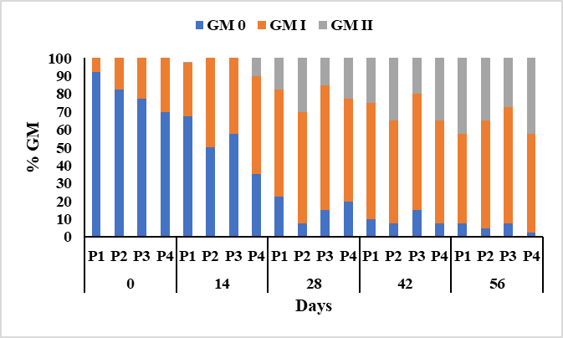
Fig. 2. Distribution of abalone shells gonad maturity level by depth during the study
Visual observation of the level of gonadal maturity performed by the naked eye resulted in a similar pattern of gonad maturnity (GM) distribution in all treatments, where the longer the rearing period, the more gonadal maturity of abalone shells was seen by showing a higher GM (Fig. 2). The beginning of rearing showed that abalone shells were not gonadally mature (GM 0) with the highest number reaching 92.5%. While on the 28th day of maintenance up to 56 days showed that the abalone gonads were increasingly mature and developed marked by the highest GM I reached 65% and GM II reached 42.5%. The results of histological tests of the level of gonadal maturity in abalone shells show the results of GM II which is characterized by gonads covering part or about 25% of the hepatopancreas (digestive gland) and oocytes and spermatozoa begin to fill the ovaries and testes. While GM I is characterized by gonads only covering a little or < 25% of the hepatopancreas and only visible early female gametes (oogonia) (Fig. 3).
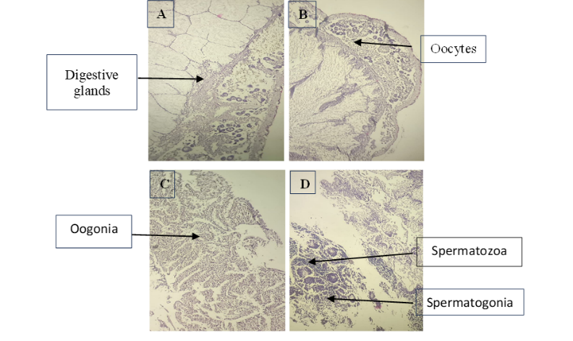
Fig. 3. Histology test results of abalone shells GM: GM II (A, B and D) and GM I (C)
3.2 Growth and Survival Rate
Weight and length gain of abalone shells during rearing can be seen in Fig. 4 & Fig. 5.
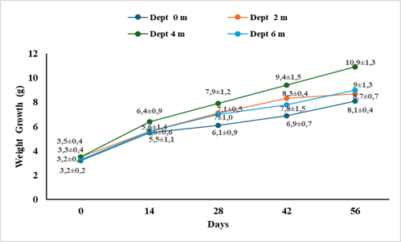
Fig. 4. Weight growth of abalone shells by depth during the study
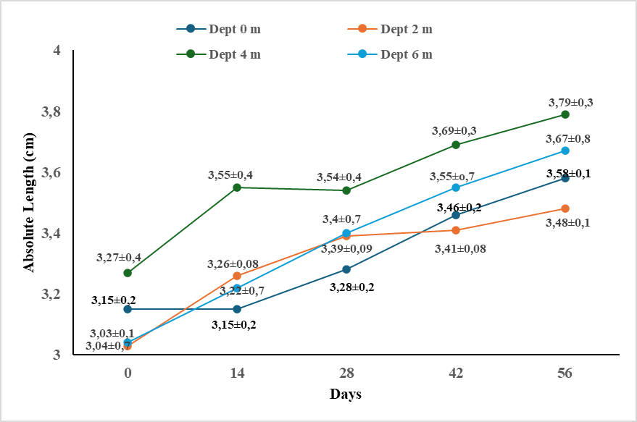
Fig. 5. Abalone shell length growth by depth during the study
Weight and length gain of abalone shells during 56 days of rearing showed that the 4 m depth treatment had a tendency of higher weight growth than other treatments with weight and length of 10.13±1.3 g and 3.79±0.3 cm respectively (Fig. 4). While the lowest weight and length gain in the 0 m depth treatment with weight and length respectively 8.1 ± 0.4 and 3.48 ± 0.1 cm. Based on the growth analysis of absolute weight and length of abalone shells showed that the 4 m treatment (P3) gave the highest average absolute weight and length of 73.25 g and 6.35 cm, respectively. 6.35 cm. While the lowest absolute weight in the 0 m treatment (P1) amounted to 49.75 g and 4.28 cm, respectively (Fig. 6 & Fig. 7).
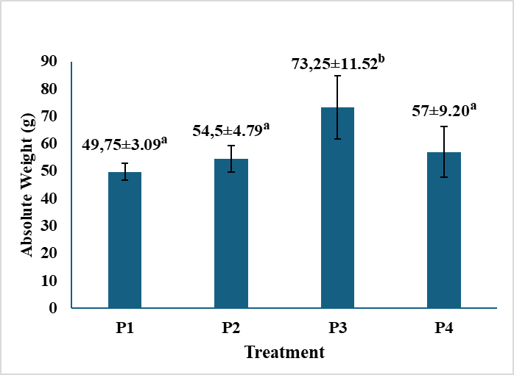
Fig. 6. Absolute weight growth of abalone shells at different depths during the study
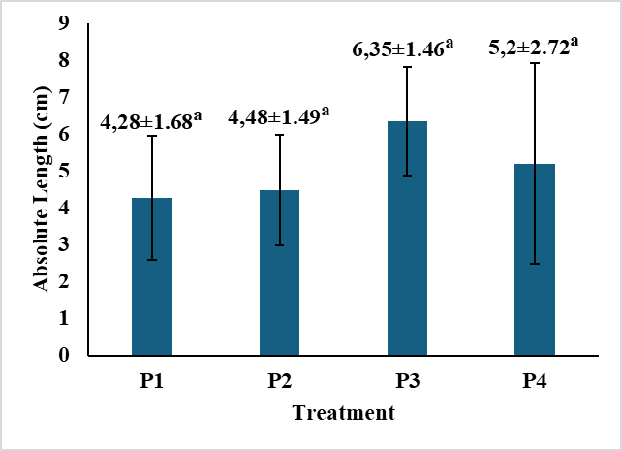
Fig. 7. Absolute length growth of abalone shells at different depths during the study
The results of the ANOVA test showed that the depth treatment gave a significantly different effect (p < 0.05) on absolute weight growth, where the treatment of 4 m depth (P3) was significantly different or higher than the other treatments. The treatment of 0 m depth (P1) was not significantly different (p < 0.05) with the treatment of 2 m depth (P2) and 6 m depth (P4). The depth treatment gave an effect that was not significantly different (p < 0.05) on the absolute length growth of abalone shells.
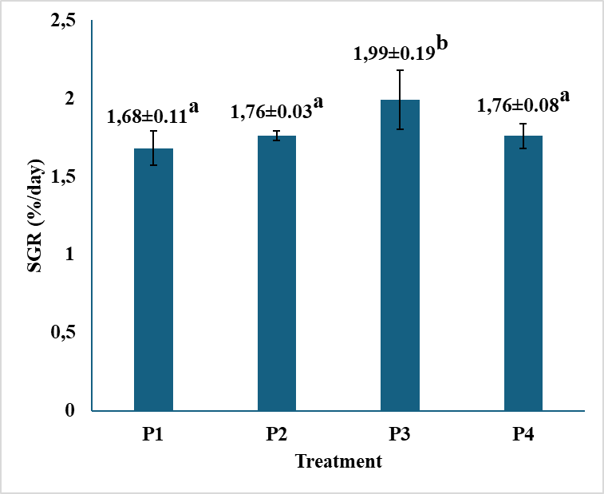
Fig. 8. Specific growth rate of abalone shells at different depths during the study
The ANOVA test results showed that the depth gave a significantly different effect (p < 0.05) on the specific growth rate, where the treatment of 4 m depth (P3) was significantly different or higher than the other treatments. The treatment of 0 m depth (P1) was not significantly different (p < 0.05) with the treatment of 2 m depth (P2) and 6 m depth (P4) (Fig. 8).
Fig. 9. Survival rate of abalone at different depths during the study period
The results of the ANOVA test showed that the depth treatment gave no significantly different effect (p>0.05) on the survival rate of abalone shells during maintenance. The highest survival rate was 77% in the 4 m depth treatment (P3) and the lowest was 70.5% in the 6 meter depth treatment (P4) (Fig. 9).
3.3 Water Quality
The results of water quality observations during the 56-day abalone shells rearing showed that all water quality parameters during the abalone shells rearing period were still in the optimal range and suitable to support the growth and survival needs of abalone shells (Table 1).
Table 1. Water Quality During the Study
Parameters | Result | Ideal | Literatur
Temperature (⁰C) | 30 - 32 | 24-32 | (Tanto & Riswanto, 2022)
pH | 7 - 8 | 7,5-8,7 | (Pebriani & Dewi, 2016)
Dissloved oxygen (mg/L) | 8 - 9 | > 5 | (Hayati et al., 2017)
Salinity (ppt) | 35 - 37 | 30–37 | (Pebriani & Dewi, 2016)
Brightness (m) | 4 - 7 | > 5 | (Patty et al., 2020)

4. DISCUSSION
4.1 Gonad Maturity Level
The level of gonad maturity in abalone shells is the process of reproductive and sexual development that occurs when reaching adulthood before and after abalone shells spawn Astutie (2012). Based on Fig 3, the highest level of gonad maturity in the 0 m, 2 m, and 6 m depth treatments is level II and the lowest level of gonad maturity is level I in the 4 m depth treatment. The low level of gonad maturity at the end of the study was due to the relatively short rearing period of abalone shells while abalone shellls reach adulthood and mature gonads after about 1-1.5 years of rearing. This is in line with the statement Hadijah (2017) which states that Haliotis asinina can grow to a marketable size and mature gonads in less than two years or 12-18 months. According to Meusel et al., (2022) states in captivity, 50% of male and female abalone reach sexual maturity at 18 and 24 months of age respectively and take about 4 years from hatching to reach marketable weight.
Gonad development can be influenced by two factors, namely genetic and environmental factors such as temperature and feed nutrition. The treatment of 4 m depth (P3) shows the lowest level of gonad maturity compared to other treatments, this is because the nutrients from the Ulva sp. feed given are used for the growth needs of abalone shells so that P3 is the treatment with the highest weight growth. In addition, the type of feed given can also affect the level of gonad maturity because the type and quality of good feed will provide appropriate nutrition so as to accelerate gonad maturity in abalone shells. This is in line with the statement of Eko et al., (2016) which states that the feed consumed by abalone is utilized for growth activities and reproductive activities including gonad development. The quality and quantity of good macroalgae feed can increase the maturity of abalone gonads, it is known that adult abalone prefer feed from red algae species such as Gracilaria sp. according to Giri et al., (2014) states that the energy obtained by abalone shells 37.4%-45.8% is used for growth and metabolic.
4.2 Growth and Survival Rate
The growth of abalone shells in the cultivation process is one of the important factors to determine the success of the cultivation itself. Growth in fishery biota includes length and weight at a time during the maintenance period Mahdaliana et al., (2022). Growth parameters in this study include absolute weight and length growth, specific growth rate, and survival rate.
Data on absolute weight growth and specific growth rate of abalone shells reared at different depths during the study period showed significantly different results (p<0.05) in each treatment with the highest absolute growth at a depth of 4 m (P3) and the lowest at a depth of 0 m (P1) (Fig. 6). One of the important factors affecting the growth and survival of abalone shells is depth. Depth affects salinity, temperature, pH, and brightness. Water quality conditions can be influenced by natural conditions and water depth so that it can change at each depth. The 4 m depth treatment is the treatment with the highest absolute weight and specific growth rate this is because at a depth of 4 meters is an ideal depth where the water temperature is not too high or warm as at the surface or depth of 0 meters and 2 meters. This is in line with the statement Setyawan & Tasruddin (2023) which states that the depth of water has a significant influence on the biota in it where the surface will tend to be warmer than the layer below. According to Hadijah (2017) abalone reared at 20⁰C showed better growth than abalone reared at 25⁰C. According to Vilchis et al., (2005), the concentration of nutrients in seawater is inversely correlated with temperature, therefore warm seawater such as at the surface causes a lack of nutrients in the water causing consumer groups to lack food of much lower quality during the warm water phase. In addition, abalone shells have different growth from each other even though they are in the same place and at P4 which is a depth with higher osmotic pressure so that the energy obtained from food is used to adapt to their environment which causes their growth to be inhibited. This is in line with the statement Masyahoro et al., (2024) that the growth rate of abalone by giving seaweed looks quite slow and differs from one species to another (heterogeneous).
The absolute length growth parameter showed that rearing abalone shells at different depths did not result in significant changes or not significantly different (p>0.05) to absolute length growth (Fig. 7). The average absolute length growth for 10 abalone shells samples obtained during the study period ranged from 4.28-6.35 cm. So it can be said that each abalone shells only experienced a length growth of 0.42-0.63 cm during the 56-day study period. The value obtained is not much different from the results of previous research Mau'ud et al., (2024) where the depth of 1 m, 2 m, 3 m, 4 m and 5 m did not have a significant effect on the absolute length of abalone shells and the results obtained ranged from 0.5-0.59 cm. According to Bauer et al., (2020) stated that the surface and depth of 5 m did not produce an average increase in shell length that was not significantly different so that depth did not affect the growth of length or survival of abalone shells. Long growth in abalone shells is the growth of their shells where shell growth in abalone shells takes longer and slower than body weight growth. This is in accordance with the statement Hadijah, (2017) which states that in general the growth rate of abalone is relatively slow at 2-3 cm/year.
Different depths did not result in significant changes or not significantly different (p>0.05) to the survival rate of abalone shells. The results obtained were the survival rate of abalone shells in all treatments ranging from 70.5-77%. The survival rate obtained is quite high for the success of abalone shells cultivation where the abalone shells it self has a high mortality rate at the juvenile to adult stage. Most abalone shells (Haliotis asinina) can be found at depths ranging from 3-10 m. So the depth treatment of 0 to 6 meters is still appropriate. So that the treatment of depths of 0 to 6 meters still produces a high survival rate because of the suitability of its habitat. Death in abalone shells can be caused by several factors such as bad weather changes at the time of the study resulting in not optimal quality in the cultivation environment and pests or parasites such as barnacles attached to the cultivation media can cause stress to death in abalone shells. This is in line with the statement Masyahoro et al., (2024) which states that the survival rate of abalone is quite high, namely 70-90% and the causes of mortality are abiotic factors including chemical physical properties of water quality and biotic factors such as parasites, predators, age and human handling and adaptability. In addition, the size of the seeds at the beginning of maintenance is a factor that affects the survival rate, the smaller or younger the seeds used, the more vulnerable and prone to death. This is in line with the statement Minh et al., (2010) which states that abalone has a low initial survival rate in the initial size group of 4-5 mm and higher in abalone with an initial size of 10-11 mm.
4.3 Water Quality
The results of measuring water quality parameters during the study are in optimal conditions, where the temperature parameter ranges from 30-32⁰C which is classified as optimal Tanto & Riswanto (2022). The pH measurement obtained values ranging from 7-8 which is classified as optimal according to Pebriani & Dewi (2016). Dissolved oxygen parameters obtained ranged from 8-9 mg/L which is considered optimal Hayati et al., (2017). Salinity observations obtained values ranging from 35-37 ppt which is classified as optimal according to Pebriani & Dewi (2016). The brightness parameter obtained ranges from 4-7 meters which is considered optimal according to the statement Patty et al., (2020). Overall, the water quality values obtained during the study were classified as in the optimal range of conditions for the habitat of abalone shells.
5. CONCLUSION
Based on the results of the research that has been done, it can be concluded that different depth treatments have a significant effect (p < 0.05) on growth (absolute weight and specific growth rate). But not significantly different (p>0.05) on the growth of absolute length and survival rate of abalone shells. The highest growth was at a depth of 4 meters with an absolute weight of 73.25 grams, a specific growth rate of 1.99% per day, absolute length growth of 6.35 cm and a survival rate of 77%. The level of gonad maturity of abalone shells reached level II at different depths.
DISCLAIMER (ARTIFICIAL INTELLIGENCE)
Author(s) hereby declare that NO generative AI technologies such as Large Language Models (ChatGPT, COPILOT, etc.) and text-to-image generators have been used during the writing or editing of this manuscript.
References
- Astutie, R. As. (2012). Induction of Gonad Maturity Males Broodstock Abalone Shells (Haliotis asinina) with Laserpunctur Methods. Journal of Fisheries and Marine Sciences 4(9), 32.
- Bauer, J., Lorda, J., Beas-Luna, R., Malpica-Cruz, L., Lafarga-De la Cruz, F., Micheli, F., et al. (2020). The Effects of Depth and Diet on Red Abalone Growth and Survival in Cage Mariculture at San Jeronimo Island, Baja California, Mexico. Ciencias Marinas, 46(4), 343–357. https://doi.org/10.7773/CM.V46I4.3117
- Deni, L., Rahman, A., & Balubi, A. M. (2018). The Effect of Different Depths on Growth and Survival Rate of Abalone (Haliotis asinina) Maintained in Pipe Chamber La. Media Aquatika, 3(3), 723–729.
- Eko W, Effendy I, I. E. (2016). Feed Consumption and Gonad Maturation of Abalone (Haliotis asinina) Using Different of Feed (G. salicornia and G. arcuata) the Wild and IMTA System Cultured at SystemIntegrated Multi-Trophic Aquaculture (IMTA). Jurnal Media Aquatika, 1(3), 144–151.
- Farliani, I., Diniarti, N., & Mukhlis, A. (2020). Growth of Yuwana Abalon (Haliotis squamata) by Using Ulva sp. with Urea Enhancement. Jurnal Kelautan: Indonesian Journal of Marine Science and Technology, 13(2), 115–125. https://doi.org/10.21107/jk.v13i2.6493
- Giri, I. N. A., Sutarmat, T., Yudha, H. T., Rusdi, I., & Susanto, B. (2014). Grow-Out of Abalone Haliotis squamata in Floating Cages Fed Different Proportions of Seaweed and with Reduction of Stocking Density. Indonesian Aquaculture Journal, 9(1), 15. https://doi.org/10.15578/iaj.9.1.2014.15-21
- Hadijah. (2017). Getting to Know Tropical Abalone, Biology and Ecology. In Paper Knowledge . Toward a Media History of Documents (Issue July).
- Hayati, H., Dirgayusa, I. G. N. P., & Puspitha, N. L. P. R. (2017). Growth Rate of Haliotis squamata Abalone Shellfish Through IMTA (Integrated Multi Trophic Aquaculture) Cultivation at Geger Beach, Nusa Dua, Badung Regency, Bali Province. Journal of Marine and Aquatic Sciences, 4(2), 253. https://doi.org/10.24843/jmas.2018.v4.i02.253-262
- Ina, I., Linggi, Y., & Santoso, P. (2022). The use of Different Macroalgae Feeds on theGrowth and Survival of Abalone (Haliotis sp.). Jurnal Aquatik, 5(2), 38–46. https://doi.org/10.35508/aquatik.v5i2.8453
- Ishak, E., Setyobudiandi, I., Yulianda, F., Boer, M., & Bahtiar, B. (2020). Effect of Habitat Type Diversity on Population Structure and Morphometrics of Abalone Haliotis asinina Linnaeus, 1758. Journal of Tropical Biology, 20(1), 29–39. https://doi.org/10.29303/jbt.v20i1.1484
- Maharani, M., Patadjai, A. B., Hasidu, L. O. A. F., Riska, R., Muis, M., Anindita, F., & Disnawati, D. (2021). Nutritional Content During Processing of Haliotis asinina Linnaeus, 1758 (Gastropoda:Haliotidae). Journal of Marine Research, 10(4), 565–569. https://doi.org/10.14710/jmr.v10i4.32275
- Mahdaliana, M., Salamah, S., & Muliani, M. (2022). The Effectiveness of Ecdysteroid Hormones Through Feed in Increasing Growth and Reproductive Performance of Mangrove Crab (Scylla sp.). Acta Aquatica: Aquatic Sciences Journal, 9(1), 06. https://doi.org/10.29103/aa.v9i1.6965
- Masyahoro, A., Zen, M., Rukka, A. H., Wahyudi, D., & Akbar, M. (2024). Growth and Survival of Abalone (Haliotis asinina) on Various Doses of Seaweed (Eucheuma spinosum) in Controlled Containers. AgriSains Scientific Journal, 25(2), 129–141. https://doi.org/10.22487/jiagrisains.v25i2.2024.129-141
- Mau’ud, M., Junaidi, M., & Scabra, A. R. (2024). The Effect of Depth on Growth and Survival of Abalone Shells (Haliotis sp.) with A Multi-Level System. Journal of Tropical Biology, 24(3), 403–411. https://doi.org/10.29303/jbt.v24i3.7346
- Meusel, E., Menanteau-Ledouble, S., Naylor, M., Kaiser, H., & El-Matbouli, M. (2022). Gonad Development in Farmed Male and Female South African Abalone, Haliotis Midae, Fed Artificial and Natural Diets Under a Range of Husbandry Conditions. Aquaculture International, 30(3), 1279–1293. https://doi.org/10.1007/s10499-022-00850-6
- Minh, N. D., Petpiroon, S., Jarayabhand, P., Meksumpun, S., & Tunkijjanukij, S. (2010). Growth and survival of Abalone, Haliotis asinina linnaeus 1758, Reared in Suspended Plastic Cages. Kasetsart Journal - Natural Science, 44(4), 621–630.
- Nur, K. U. (2020). Abalone Aquaculture in Asia: Its Technology and Aquaculture Management. Jurnal Media Akuatika, 5(3), 95. https://doi.org/10.33772/jma.v5i3.13188
- Nurfajrie, Suminto, R. S. (2014). Utilization Of Various Types Of Macroalgae For The Growth of Abalone (Haliotis squamata) in Large Cultivation. Journal of Aquaculture Management and Technology, 3(4), 142–150.
- Patty, S. I., Nurdiansah, D., & Akbar, N. (2020). Temperature, Salinity, Turbidity Distribution in Tumbak-Bentenan, Minahasa Tenggara. Journal of Archipelagic Marine Science,3(1), 78–87.
- Pebriani, D. A. A., & Dewi, A. P. W. K. (2016). Analysis of Water Carrying Capacity Based on Water Quality to the Opportunities Cultivation Abalone (Haliotis sp.) in Coastal Kutuh, Bali. Samakia: Journal of Fisheries Science, 7(2), 66–71. http://www.samakia.aperiki.ac.id/index.php/JSAPI/article/view/105.
- Purwaningsih, N. T., Amir, S., & Cokrowati, N. (2013). The Effect of Feed Differences on Gonads Maturity of Abalone (Haliotis squamata). Unram Fisheries Journal, 1(2), 5–6.
- Sari Kartika, W. (2024). Abalone (Haliotis squamata) Breeding Techniques at The Lombok Marine Aquaculture Center. GANEC SWARA, 18(3). http://journal.unmasmataram.ac.id/index.php/GARA
- Sari, S., Said, A., Okmawaty Anwar, L., Nurdiyanty Nurdin, U. K. (2020). Antioxidant Activity and Bioactive Compound Components of Methanol Extract of Tropical Abalone, Haliotis Asinina. Indonesian Journal of Fisheries Science and Technology Available, 16(2), 104. http://ejournal.undip.ac.id/index.php/saintek
- Setyawan, A. C., & Tasruddin, T. (2023). Growth of Abalone (Haliotis asisina) Reared in Different Depth at Uwedikan Village Beach, East Luwuk. MAIYAH, 2(2), 121. https://doi.org/10.20884/1.maiyah.2023.2.2.8774
- Tanto, T. Al, & Riswanto, R. (2022). Sea Surface Temperature Studies Using Time Series Analysis in Banda Sea Water. Jurnal Kelautan: Indonesian Journal of Marine Science and Technology, 15(3), 270–279. https://doi.org/10.21107/jk.v15i3.14386.
- Vilchis, L. I., Tegner, M. J., Moore, J. D., Friedman, C. S., Riser, K. L., Robbins, T. T., & Dayton, P. K. (2005). Ocean Warming Effects on Growth, Reproduction, and Survivorship of Southern California Abalone. Ecological Applications, 15(2), 469–480. https://doi.org/10.1890/03-5326.
- Zain, Muhammad Junaidi, L. F. M. (2023). The Effect of Different Substrates on the Growth and Survival of Abalone (Haliotis squamata). Journal of Marine Science.www.jurnal.utu.ac.id/JLIK.

