Isolation And Characterisation Of Indigenous Phosphate Solubilising Microbes And Their Probiotic Potentials In Malawi Aquatic Ecosystems
ABSTRACT
Phosphate solubilizing microbes (PSM) were isolated from the rhizosphere of different aquatic plants, water and benthic soils of aquatic ecosystem with the aim of having cheap and environmental friendly biofertiliser and probiotics. Extensive research has been performed with respect to PSM isolation from the rhizospheres of various plants in different locations, but little is known about the in-depth of PSM and their probiotic potential in Malawi aquatic ecosystem.
Isolates were screened on the basis of solubilizing inorganic Phosphorous (P) using Pikovskaya’s media, soil and rock supplemented. Molecular characterization of the conserved genes (16S rRNA and 18S rRNA) and biochemical test were employed in taxonomic analysis. Candidacy of strains was primarily based solubilisation index of more than 3 complimented by production of diverse plant growth promoting, bioremediation and probiotic traits.
The selected strains with commercial implications were identified as Alcaligenes ammonioxydans, Enterococcus faecium, Citrobacter braakii, Enterobacter cancerogenus, Geotrichum sp. and Aspergillus sibiricus. Isolates showed higher solubilisation values in-vitro through synergistic effect of co-inoculation.
The present compilation of these diverse diazotrophs along with P solubilisation, probiotic and plant growth promoting traits potentially suggests that these indigenous microbes can be exploited as biofertilisers. The present study explores potentiality of indigenous microbe’s ability to solubilize insoluble phosphates like tricalcium, aluminium, and iron phosphate for development of biofertiliser.
Keywords: Phosphate Solubilisation; Phosphate Solubilizing Microbes; Phosphorous; Plant Growth Promoting Traits; Biofertilisers; Rock Phosphate; Probiotics; Malawi.

INTRODUCTION
Tropical soil fertility sustainable management is complex due to diverse interaction of physical, chemical and biological factors. To improve land productivity commercial farmers have adopted green revolution techniques which base on inorganic chemicals while smallholder farmers have adopted low cost technologies like Mbeya based organic fertiliser (Kayeke, 2007; Lunduka & Kelly, 2012; Gupta et al., 2015; Mwafulirwa, 2023).
Unlike organic fertilisers which make plant have access to all nutrients, inorganic fertilisers supply mainly the macronutrients and have detrimental effect to the ecological footprint (Kayeke et al., 2007; Hardy et al., 1998; Kabwe & Bigsby, 2016; Mwafulirwa, 2023; Snapp et al., 2014). Phosphorous (P) is the second major element that limits growth after nitrogen and it’s in large quantities in insoluble form (Hajjam & Cherkaoui, 2017; Hameeda et al., 2008; Chotchutima et al., 2016). Several metabolic processes have P in their ingredient e.g. respiration of plants, photosynthesis, signal transduction, energy transport, cell development and division etc. (Sharma et al., 2013).
The continuous application of P based fertiliser cause high accumulation of total insoluble P which most of times is accompanied by heavy metals which are associated rock phosphate. These heavy metals have an implication in the food chain and environment (Javanbakht et al., 2014). The excessive phosphate inputs causes eutrophication through percolation and run-off to waterbodies (Alori et al., 2017; Park et al., 2011; Savci, 2012).
Tropical and subtropical agricultural soils in which Malawi is categorized contain high levels of total P, due to frequent applications of P based inorganic fertilizers and parent materials yet low yields due to available (soluble) P deficiency (Mikkelsen, 2004). Malawi has above 2000 mg/kg of total P yet available P is below crop requirement level of 25 mg/kg which can’t be accessed by crop (Kumssa et al., 2022). Applied available P is easily fixed due to high sorption to abundant elements like aluminum and iron in acidic soil or Calcium and magnesium in alkaline soils. Phosphate the available form of P in its soluble state forms strong bonds with these elements (Awasthi et al., 2011; Karpagam & Nagalakshmi, 2014; Kumar & Sharma, 2017).
Naturally insoluble P is transformed to soluble P by microbes called phosphate solubilizing microorganisms (phosphate solubilizing fungus and phosphate solubilizing bacteria) through the release of organic acid (Braz & Nahas, 2012; Hajjam & Cherkaoui, 2017; Investigación et al., 2015; Mukhtar et al., 2017). Studies have shown that phosphate solubilizing microorganisms (PSM) are environmental friendly which provides an option for provision of inexpensive P to plants in areas with deﬁcient of soluble P but high total P using soil or rock phosphate (RP) (Anand et al., 2016; Khan et al., 2014; Mehrvarz & Chaichi, 2008; Qarni et al., 2021; Sharma et al., 2013). In addition to solubilising P most of these microbes have bioremediation, probiotic and plant growth regulatory traits (Walpola & Yoon, 2013). In the present study, PSM were isolated from for development of biofertiliser, probiotic adjuncts as well as a bioremediation tool.

METHODOLOGY

STUDY DESIGN
The study used purposive sampling in a Completely Randomised Design (CRD).

STUDY SITE
Rhizospheric soil from aquatic plants, water and benthic soils of aquatic ecosystem were sampled in the peripherals of protected areas of Malawi with no history of inoculation. These areas were chosen because of high ecological footprint (Nathanailides et al., 2021)

SAMPLE COLLECTION AND PREPARATION
The samples were collected from the rhizosphere of different aquatic plants, water and benthic soils of aquatic ecosystem no history of inoculation. Rhizospheric benthic soil was preferred due higher CFU of PGPM than rhizoplane and endorhizosphere (Awasthi et al., 2011; Ghevariya & Desai, 2015). Aquatic plants rhizospheric soil was obtained using a method documented by Mwafulirwa, (2023) Li et al., (2017); López-ortega et al., (2013); Walpola & Yoon, (2013)

ISOLATION OF PSM
All samples were homogenized and 1 g or 1 ml of each sample was 10 fold serially diluted from neat homogenate to 10⁻⁵. Thereafter, 5 ml of 10⁻² and 10⁻⁵ dilutions were inoculated on pikovskaya’s medium plate containing (NH₄)₂SO₄ ₍0.5) optional use of AlPO₄ or Ca₃(PO₄)₂ as insoluble sources of phosphate as the selective active ingredient (5), glucose (10), NaCl (0.2), MgSO₄·7H₂O (0.1), KCl (0.2), FeSO₄·7H₂O (0.002) yeast extract (0.5) MnSO₄·H₂O (0.002) and gar, 18 all g/L. Positive colonies were selected by showing clear halozone on colonies borders on agar plates (Elias et al., 2016; Hajjam & Cherkaoui, 2017; Kadiri et al., 2013; Report et al., 2014).

QUALITATIVE PHOSPHATE SOLUBILISATION ANALYSIS
All isolates that showed clear halo zone were subjected to measure Phosphate Solubilisation Index (PSI). Selected Isolates were individually inoculated on Pikovskaya s medium plate and successively measuring diameter of clearance zone and colony up to 7 days. Experiment was set up in a CRD manner with 3 replicates. PSI was measured by taking Colony diameter plus Halo zone diameter divided by Colony diameter (Goswami & Deka, 2020; Kumar, 2012; Swift et al., 2016)

QUANTITATIVE PHOSPHATE SOLUBILISATION ANALYSIS
Isolates (1*10⁷ CFU ml⁻¹ for bacteria and 5 disks of 8 mm of the mycelium of fungi) were cultured in pikovskaya medium as indicated by Karpagam & Nagalakshmi, (2014) with the pH adjusted to 6.6 to test their ability to solubilize tri-calcium phosphate or aluminum phosphate. AlPO₄ and Ca₃(PO₄)₂ acted as sole source of P in the culture medium by incubating at 28 ⁰C for 6 days. Turbidity of the media was a growth indicator.

IN-VITRO PHOSPHATE SOLUBILISATION ANALYSIS
Isolates were tested for solubilisation of grounded rock phosphate from phalombe and pure field soils from areas with low P values based on guidance from Chitedze agricultural research station as documented by Mwafulirwa (2018) with slight modification of not autoclaving the rock phosphate and the soil.

DETERMINATION OF PLANT GROWTH PROMOTING TRAITS
The determination of Plant growth promoting traits (PGPT) was done for several traits like solubilisation of zinc, production of ammonia, solubilisation potassium, IAA, hydrogen cyanide, siderophores production, nitrogen-fixing ability, catalase etc. (Mwafulirwa et al., 2017)

ASSESSMENT OF AMMONIA PRODUCTION BY ISOLATES
Ammonia production assessment was done by inoculating 1*10⁹ CFU of individual isolate into a 10 ml tube of peptone water on tryptic digest of casein broth incubated at 35 for 36-60 hrs. for bacteria and fungus respectively. Thereafter, addition of Nessler's reagent (0.5 ml ) to detect the presence of ammonia by development of yellow or brown colour (Mwafulirwa, 2023b; Mwafulirwa et al., 2017).

ASSESSMENT OF IAA PRODUCTION BY ISOLATES
IAA assessment was done by inoculating 1*10⁹ CFU of individual isolate (in nutrient and SD broth amended with 100µg/ml tryptophan in rotating incubator at 35 °C for 48 hours at 120 rpm bacteria and fungus respectively. Thereafter the media was centrifuged and supernatant was collected. The supernatant was inoculated with two drops of o-phosphoric acid, and four mls of Salkowski reagent. Appositive was confirmed by development of pink colour (Ahmad et al., 2019; Ashry et al., 2022; Leontidou et al., 2020).

ASSESSMENT OF HYDROGEN CYANIDE PRODUCTION BY ISOLATES
Hydrogen Cyanide production was confirmed in-vitro by inoculating isolates in nutrient broth and sabouraud dextrose broth supplemented with glycine for bacteria and fungus respectively as documented by Mwafulirwa, (2023).

ASSESSMENT OF NITROGEN FIXING ABILITY BY ISOLATES
Nitrogen fixing traits were confirmed using Liu et al. (2016) with manipulation of the pH. Winogradsky's N-free medium was used as a selective media because it does not contain nitrogen in its ingredients. isolates ability to grow was an indication of its ability to fix nitrogen (Aquilanti et al., 2004; Doroshenko et al., 2007, 2007; Navarro-noya et al., 2012).

ASSESSMENT OF SOLUBILISATION POTENTIAL FOR PHOSPHOROUS AND POTASSIUM BY ISOLATES
Isolates were assessed on their ability to solubilise phosphorous and potassium using Pikovskaya’s (PVK) Medium using a method documented and described by Karpagam & Nagalakshmi, (2014), and Aleksandrov medium (Rajawat et al., 2016; Mubarik et al., 2014; Saha et al., 2016; Vishwavidyalaya, 2012) for phosphorous and potassium respectively. A modified Pikovskaya medium was formulated using different concentrations of bromophenol blue.( Gupta et al.,1994)

ASSESSMENT CATALASE PRODUCTION BY ISOLATES
The isolates potentiality to produce catalase was done by dropping 3% of hydrogen peroxide on the colony. Gas bubbles formation was considered as isolates ability to produce catalase.

DETERMINATION OF ISOLATES POTENTIALITY IN BIOREMEDIATION
Isolates ability to be involved in bioremediation was assessed using production of laccase enzyme. This was assessed by inoculating isolates Sabouraud Dextrose Agar which had 1% 2, 2’-azino-bis3-ethylbenzothiazoline-6-sulphonic acid. Colour change to purple or dark green was used as a positive indicator (Mwafulirwa et al., 2017; Mwafulirwa, 2023b).

DETERMINATION OF ISOLATES POTENTIALITY AS PROBIOTIC STRAINS

SCREENING FOR AMYLASE PRODUCTION
Isolates ability to produce amylase were observed by halo zone (hydrolysis zone) after pouring Gram’s iodine on starch agar plates inoculated with isolates colonies using the method documented by Bhatt, Rajiv and Vyas, (2014).

SCREENING FOR CELLULASE PRODUCTION
Cellulase production by isolates was assessed using CMC (for endoglucanase) and modified MM (for exoglucanase) medium using a methods as described by Bhagat & Kokitkar, (2021); Jayasuyra et al., (2020); Upadhyaya et al., (2012) with slight modifications because gut contents were not used. Isolates were repeatedly streaked on CMC and MM agar plates for verification of endoglucanase and exoglucanase. 1% Congo red was poured on colonies grown on CMC agar followed by de-staining with 1M NaCl. The efficiency of hydrolysis was formulated by subtracting the Colony diameter from Clear zone diameter then dividing with Colony diameter then multiplying by100. Growth on MM medium indicated positive response.

SCREENING FOR PROTEASE PRODUCTION
Protease production by isolates was assessed using gelatine agar using methods documented by Sony and Potty, (2016) Mary et al., (2017) and Balaji et al., (2012) incubated at 35ºC under aerobic condition for 72-192 hours with slight modifications because gut contents were not used. The gelatine agar medium contained (g/l) glucose 1.0, K2HPO4 2.0, Peptone 5.0, gelatin 15.0, and agar 15 and. The presence of halos around the colony was used as a positive indicator. Halos diameters were measured using gelatine clear zone method as described by Abomughaid, (2020) which adds mercuric chloride solution to the brim of the plates.

SCREENING FOR LIPASE PRODUCTION
Lipase production by isolates was assessed using lipolytic agar medium using a methods as described by Jini et al.,, (2011) Bakteria and Pekasam, (2018) with slight modifications because gut contents were not used. Lipolyitic agar contained 50ml/l tributyrin 50g/l NaCl, 10g/l peptone, 0.1g/l CaCl₂ .2H₂O, and 20g/l g agar. The presence of halophilic colonies with an opaque zone around the colony was used as a positive indicator.

SCREENING FOR LACTIC ACID PRODUCTION
Lactic acid by isolates was assessed using Man Rogosa Sharp (MRS) medium (incubated at 37˚C +/- 2) as documented by using Chowdhury and Islam, (2016), Dowarah et al., (2018) and Maji et al., (2016) methods. colonies showing halo-zone indicated a positive result.

SCREENING FOR BILE SALTS HYDROLASES (BSH) PRODUCTION
The qualitative BSH assessment was done as described by Shehata et al., (2016) where isolates were inoculated on specific media that had been supplemented by CaCl₂ (0.037%) and taurodeoxycholic acid sodium salt (0.5% {w/v}). Precipitate formation around the colonies after 96 hrs. anaerobic incubation at 37 °C indicated a positive result.

ASSESSMENT OF ISOLATES TO DIVERSE PH AND BILE SALT (BS)
Isolates tolerance to diverse pH was be assessed using pH of 2.0-4.5 and 7.0-8.0 for acidic and basic conditions in growth medium using HCl and NaOH as documented by Dowarah et al., (2018) and Maji et al., (2016). To assess tolerance bile salt levels, microbes were inoculated in modified Man Rogosa Sharp broth at diverse concentration ranging from 0.075-1%. The growth was measured using optical density method at OD 580 nm for pH and 620 nm BS.

ASSESSMENT OF ISOLATES FOR PHYTASE PRODUCTION
The phytase production of isolates was assessed by inoculating on specific phytase enzymatic medium as documented by Dowarah et al., (2018). The phytase enzymatic medium contained 0.5% NH₄NO₃, 1.5% glucose, 0.05% MgSO₄7H₂O, 0.5% calcium phytate, 0.02% MnSO₄7H₂O, 1.5% agar, 0.001% FeSO₄7H₂O and 0.05% KCl with pH adjusted to 7.0.

ASSESSMENT OF ISOLATES ADHESION ON SURFACE HYDROPHOBIC ASSAY
The microbial adhesiveness to epithelium surface was done using hydrocarbons modeling, xylene, toluene and hexadecane according to Chaia and Gonza, (1999) and Sánchez-Ortiz et al., (2015). Five mls of the isolate with CFU of 10⁷/ml was harvested by centrifuge from which 2 mls was deliberately made into contact with 0.6 mls of each of the hydrocarbons for 15 minutes. Thereafter they were mixed thoroughly by vortex for 2 minutes. The OD of the vortexed mixture was obtained at 600nm. The percent hydrophobicity (H) was calculated based on the formula as documented by Chaia and Gonza, (1999). H(%)=[(AA0)/A]x100.

HAEMOLYTIC ACTIVITY TEST
isolates were assessed for haemolysis using sheep blood (SP) agar. A loopful of isolate culture was inoculated on SP agar plate and incubated for 24 h at 37 ºC and observed for haemolytic zones around the colonies.

PHYLOGENETIC ANALYSIS
Isolates were identified using genetic characterisation by sequencing the 16S rRNA genes using both forward and reverse strands. BioEdit software was used to have the consensus sequences which was used in the BLAST algorithm query against the public nucleotide sequence in National Center for Biotechnology Information (NCBI) database to find the closely related strains (http://blast.ncbi.nlm.nih.gov/Blast.cgi.). Results on analysis will be based on the maximum identity score in which high similar sequences will be downloaded and aligned with isolate sequences in BioEdit. All isolates sequences were deposited in the GenBank and accession numbers were given.
The evolutionary history was inferred using the Neighbor-Joining method to define the datasets because it establishes relationships between sequences according to their genetic distance (a phenetic criterion), without considering an evolutionary model (Kuan et al., 2016). The evolutionary distances were computed using the Maximum Composite Likelihood method and are in the units of the number of base substitutions per site. Evolutionary analysis and phylogenetic tree construction was done using MEGA11 software.

DATA ANALYSIS AND STATISTICS:
Data was analyzed and subjected to descriptive statistics, t-test and analysis of variance using the GENSTAT.

RESULTS AND DISCUSSION
A total of one hundred twenty-two strains of PSM were isolated out of which 6 were selected based on their potentiality for commercial implication. These PSM had the capability to solubilize different sources of insoluble inorganic phosphorous. These isolates had SI of above 3 on both AlPO₄ and Ca₃(PO₄)₂ surpassing the recommended of 1.5 on one insoluble phosphate. These isolates were designated 82B2, 58F1, 5005, 23F3, 57F1 and 63F3 based on local laboratory numbering system. Molecular characterization accompanied by biochemical test showed that 82B2, 58F1, 5005, 23F3, 57F1 and 63F3 were Alcaligenes ammonioxydans, Enterococcus faecium, Citrobacter braakii, Enterobacter cancerogenus, Geotrichum sp. and Aspergillus sibiricus. Isolates 82B2, 58F1, 5005 and 23F3 were bacteria while 57F1 and 63F3 were fungi.
Table 1: Sites where samples were collected
District | River/Lake | Protected and Conserved areas
Chikwawa | Shire river | Elephant marsh
Nsanje | Shire river | Shrine and Ndindi marsh
Zomba | Shire river | Lake chirwa
Machinga | Shire river | Liwonde national park
Mangochi | Shire river and Lake Malawi | Lake Malawi national park
Nkhotakota | Lake Malawi, Bua river and Chia lagoon | Nkhotakota game reserve
Nkhatabay | Lake Malawi and Lweya river | Shrine
Karonga | Chimbiriri river and Lake Malawi | Chitende shrine and Nyika national park

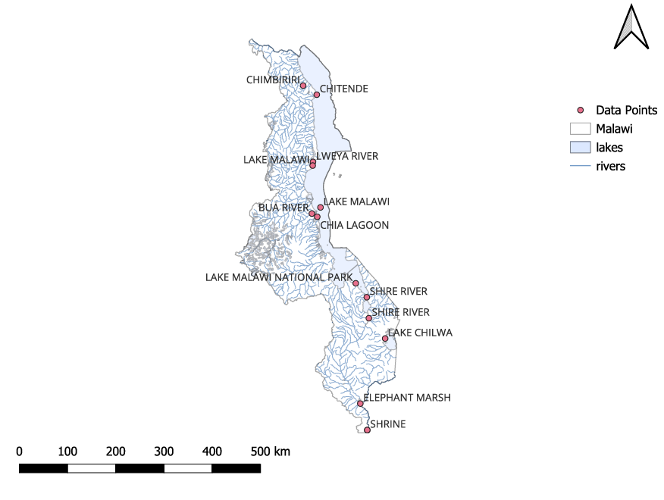
Figure 1.Map of study sites
Table 2: Location where samples were collected
 | Location
Isolates lab No | Chikwawa | Nsanje | Zomba | Machinga | Mangochi | Nkhotakota | Nkhatabay | Karonga
82B2 | + | + | + | - | - | + | + | +
58F1 | - | + | - | - | + | - | - | +
5005 | + | - | + | + | + | - | - | +
23F3 | + | + | + | + | + | + | - | +
57F1 | + | + | + | - | + | + | + | +
63F3 | - | - | - | + | + | + | + | +

Figure 2: Solubilisation index and final ph. values exhibited by microbes 6days after inoculation

Figure 3: Solubilisation efficiency of isolate on different insoluble sources of phosphate.
Table 3. Characterization of isolates for plant growth regulatory and bioremediation traits.
Serial Number | Ammonia production | IAA production | Catalase production | Nitrogen fixation | Cyanide production | ACC deaminase | Zn solubilisation | K solubilisation
82B2 | + | + | + | + | - | + | + | -
58F1 | - | + | + | + | - | + | - | -
5005 | - | + | + | + | - | + | - | +
23F3 | + | + | + | + | - | + | - | +
57F1 | + | + | + | + | - | + | + | -
63F3 | + | + | + | + | - | + | + | -

Table 4. Characterization of isolates for other probiotic traits
Serial Number | Cellulase production | Protease production | Lipase production | lactic acid production | phytase production | BSH production | Haemolytic activity | surface hydrophobic assay | Chitinase production | Pectinase production | Amylase production
82B2 | ++ | - | - | + | + | + | - | + | - | + | -
58F1 | + | + | - | + | - | + | - | + | - | + | +
5005 | - | + | - | - | - | + | - | + | + | + | +
23F3 | + | - | - | - | - | + | - | + | + | + | -
57F1 | - | - | + | + | - | + | - | + | + | + | +
63F3 | + | - | + | + | - | + | - | + | + | + | +

Table 5. Susceptibility of Cellolytic and amylolytic isolates to selected antibiotics.
 | Antibiotics and their susceptibility
Isolate number | Chloramphenicol | Ampicillin | Carbenicillin | Vancomycin | Oxytetracyclin | Novobiocin
82B2 | - | - | - | - | - | -
58F1 | - | - | - | - | - | -
5005 | - | - | - | - | - | -
23F3 | - | - | - | - | - | -
57F1 | - | - | - | - | - | -
63F3 | - | - | - | - | - | -

Figure 4: Solubilisation rate of isolate on rock phosphate from day 1 to day 5 designated RP-1 and RP-5 respectively.

Figure 5: Solubilisation rate of isolate on field soil from day 1 to day 5 designated SS-1 and SS-5 respectively.
Table 6: Isolates and their BLAST related species and GenBank deposit accession numbers.
Lab Serial No | Related Species(Homologs) | Nucleotide Identity % | Given Accession NO | Strain Name
82B2 | Alcaligenes ammonioxydans | 98.86 | PQ676104 | LOGO41
58F1 | Enterococcus faecium | 99.54 | PQ676105 | LOGO43
5005 | Citrobacter braakii | 99.33 | PQ676108 | LOGO47
23F3 | Enterobacter cancerogenus | 98.32 | PQ676110 | LOGO49
57F1 | Geotrichum sp. | 91.07 | PQ721393 | LOGO42
63F3 | Aspergillus sibiricus | 99.22 | PQ721395 | LOGO59

In order to demonstrate solubilisation kinetic; comparative studies were carried out on the isolated strains available in Malawi. Results showed that all strains had higher phosphate solubilisation efficiency based on SI which are above 3 and in-vitro had values of above 750mg/L and 750mg/kg of available phosphate broth and rock phosphate respectively. The results of the concoction of isolates showed higher and stable results compared to the individual strain usage. this may be a result of positive synergistic effect of microbes (Akhtar et al., 2013; Gupta et al., 2012; Khan et al., 2007; Markowiak & Ślizewska, 2018).
Isolates candidacy as PSM is in agreement with other studies which found that same species were involved P solubilisation (Prabhu et al., 2019). The capability of being P solubilizer was observed using diverse methods which are in line with the set of standards for commercial implication as described by Mendes et al. (2014a). The observation was also made in-vitro experiment using soil and rock phosphate through increase in available P as shown in figure 4 and 5. In the present study, periodical evaluation of P using soil and rock phosphate revealed the potentiality of the isolates in releasing P from insoluble phosphate sources.
There was a high solubilisation efficiency in concoction of isolated strains in Pikovskaya’s broth, soil and RP compared to individual strain indicating that solubilisation is dependent on strain (Sahoo and Gupta, 2016; Sane and Mehta, 2015; Menon and Mohan, 2007).
Several studies have found different solubilisation efficiency at different incubation period due to biotic and abiotic factors that impacted the evolution of strains (Nosrati et al., 2014). Strains performed differently on different media regardless of their SI. This indicates that standard method for measuring solubilisation cannot be a sole test for P solubilisation. The study showed that P solubilisation efficiency and rate is based on strain and this is in line with other studies (Sahoo & Gupta, 2016) while it contrast with the study by Sumatera, 2016 which reported that fungus have higher solubilisation efficiency.
The PSM exhibited a strong capacity to reduce pH which indicates that solubilisation is as a result of organic acid production which in tandem with other studies which proved negative correlation of (r = -0.8; p <0.04) between the available P and pH values (Behera et al., 2017; Z. Li et al., 2016; Stella & Halimi, 2015). The production of gluconic acid is the most frequent agent of P solubilisation regardless of other acid production such as nitric, sulphuric, and carbonic (Stella & Halimi, 2015). Excretions of metabolites for P solubilisation are influenced by both biotic and abiotic factors (Liu et al., 2016).
The use of natural phosphate bearing materials such as RP as fertilizer for P deficient soils has received attention because deposits of cheaper and low grade RP are locally available in many parts of Malawi. RP is chemically processed by costly and environmental hazard process by reacting with sulphuric acid or phosphoric acid to produce partially acidulated RP. Biofertilisers are cheap and convenient alternative for reclamation of exhausted soil (Investigación et al., 2015). Thus, PSM may play acritical role in natural P cycle and can improve the agronomic value of rock phosphate which is underutilized in Malawi (Sane & Mehta, 2015).
The evaluated microbes in the study were isolated from diverse areas, therefore, it is likely that some factors such as temperature, pH and redox potential, could affect solubilisation (López-ortega et al., 2013). These microbes were isolated from aquatic ecosystem contrary to what other studies reported which means that these microbes are site specific (Sarathambal and Ilamurugu, 2014; Pilar et al., 2013; Sachdev et al., 2009).
Phylogenetic analysis based on the NJ and ML methods revealed that diversified divergent genera and species are involved in P solubilisation. Karonga dominated in having diverse microbes as phosphare solubiliser due to diverse environment of catchment area (Nyika National Park). The indigenous isolates are unique genetically shown by forming their own clade as an outgroup to those in database. This could be based on evolutional factors which caused biostimulation of the favored strains. In most studies, microbes are isolated using conventional culture-based methods which are said to be time-consuming, non-accurate and not representing whole diversity in the GIT even while using diverse media (Das et al., 2014; Dey et al., 2016). However, the use of a conventional culture-based methods by employing a specific substrate containing selective media is justifiable, as the major aim of the present study is to detect and isolate different extracellular enzyme-producing microbes which are cultured for development of biofertilisers and probiotics. In the present study, the isolates are to be used in development of probiotics while using genetic analysis may capture microbes which cannot be cultured or multiplied to be used as a biofertiliser inoculum (Hossain et al., 2022; Sumathi & Priya, 2011).
The extracellular enzyme-producing isolates of the present study were all identified genetically from their 16S rDNA gene analysis which was further supported by their morphological and biochemical properties. The isolates appeared taxonomically diverse at the genus level each belonging to a separate phylotype. All isolates therefore seem to be autochthonous to location. Moreover, these site-specific GITM strains other possess extracellular beneficial properties, and are, therefore, considered as probiotic candidates for all fishes.

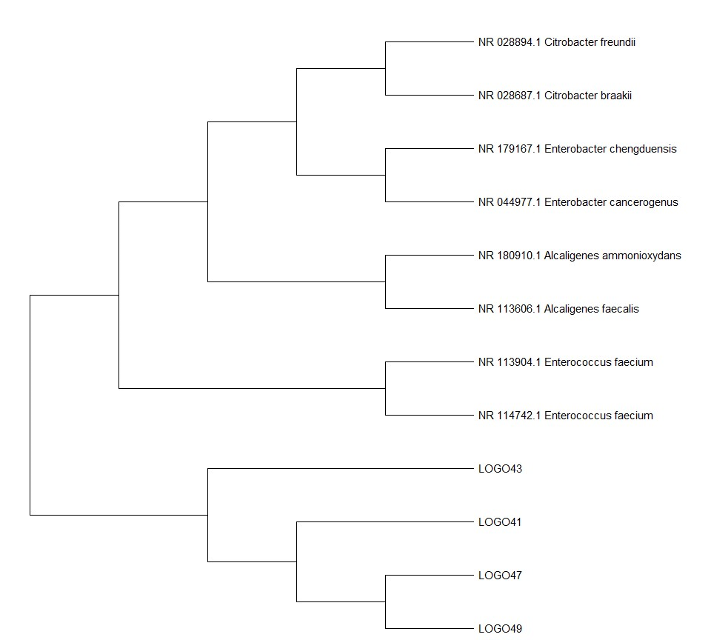
Figure 6: Phylogenetic tree based on 16S rRNA gene sequence showing the position of indigenous diverse phosphate solubilising bacteria in Malawi compared with those available in GenBank of NCBI.
The evolutionary history was inferred by using the Maximum Likelihood method and Tamura-Nei model conducted in MEGA11 with a total of 1462 positions in the final dataset. The tree with the highest log likelihood (-7924.31) was taken. Initial tree(s) for the heuristic search were obtained automatically by applying Neighbor-Join and BioNJ algorithms to a matrix of pairwise distances estimated using the Tamura-Nei model, and then selecting the topology with superior log likelihood value. This analysis involved 12 nucleotide sequences.

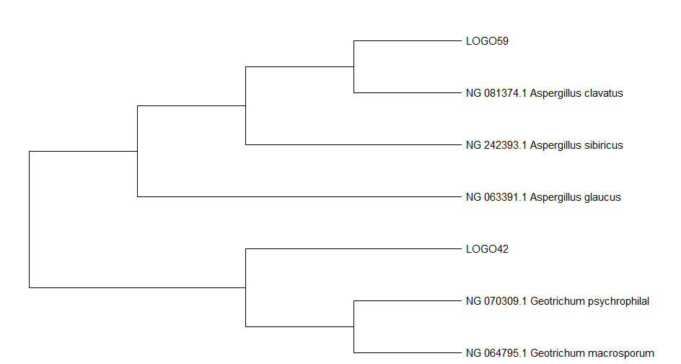
Figure 7: Phylogenetic tree based on 16S rRNA gene sequence showing the position of indigenous diverse phosphate solubilising fungus in Malawi compared with those available in GenBank of NCBI.
The evolutionary history was inferred by using the Maximum Likelihood method and Tamura-Nei model conducted in MEGA11 with a total of 636 positions in the final dataset. The tree with the highest log likelihood (-1574.70) was taken. Initial tree(s) for the heuristic search were obtained automatically by applying Neighbor-Join and BioNJ algorithms to a matrix of pairwise distances estimated using the Tamura-Nei model, and then selecting the topology with superior log likelihood value. This analysis involved 7 nucleotide sequences.

Phylogenetic tree of fungus in P solubilization also revealed uniqueness of strain LOGO42 (Geotrichum sp.) based on outgroup formation which was also depicted by percentage identity to those in the databases. The findings contradict to other studies which found out that some of these microbes are disease causing microbes. This indicates that these strains are of different phylotypes because of different ecological zones and selection pressure as shown and depicted by the research.

CONCLUSION AND RECOMMENDATION
The study explored and found out that indigenous phosphate solubilizing microbes that have potential for development of phosphate biofertilisers. The study also revealed new strains of phosphate solubilisation microbes and puts proposition that its presence in field is as a result of abundance of different insoluble phosphate composition due to natural selection pressure. Further field performance investigations are required for these aquatic ecosystem microbes on various crops as biofertilisers as well as livestock as probiotics.
Disclaimer (Artificial intelligence)
Author(s) hereby declare that NO generative AI technologies such as Large Language Models (ChatGPT, COPILOT, etc.) and text-to-image generators have been used during the writing or editing of this manuscript.
ACKNOWLEDGEMENTS
The authors would like to thank the management of LOGO INSTITUTE FOR COMMECIAL RESEARCH AND INNOVATIONS for their financial support and provision of facilities for the study. Special thanks go to samuel mwafulirwa, who provided invaluable assistance in setting up the experimental design and data collection.

REFERENCES
Abomughaid, M. M. (2020). Isolation and Identification of Some Probiotic Bacteria and Their Potential Role in Improving Immune Response and Resistance of Nile Tilapia ( Oreochromis niloticus ) in Comparison with a Commercial Product. 2020.
Ahmad, F., Ã, I. A., & Khan, M. S. (2008). Screening of free-living rhizospheric bacteria for their multiple plant growth promoting activities. 163. https://doi.org/10.1016/j.micres.2006.04.001
Ahmad, M., Naseer, I., Hussain, A., Mumtaz, M. Z., Mustafa, A., Hilger, T. H., Zahir, Z. A., & Xu, M. (2019). Appraising endophyte - Plant symbiosis for improved growth, nodulation, nitrogen fixation and abiotic stress tolerance: An experimental investigation with chickpea (cicer arietinum L.). Agronomy, 9(10). https://doi.org/10.3390/agronomy9100621
Akhtar, N., Arshad, I., Shakir, M. A., Qureshi, M. A., & Ali, L. (2013). co-inoculation with rhizobium and bacillus sp to improve the phosphorus availability and yield of wheat ( Triticum aestivum L .). 23(1), 190–197.
Alori, E. T., Glick, B. R., & Babalola, O. O. (2017). Microbial phosphorus solubilization and its potential for use in sustainable agriculture. In Frontiers in Microbiology (Vol. 8, Issue JUN). https://doi.org/10.3389/fmicb.2017.00971
Anand, K., Kumari, B., & Mallick, M. A. (2016). Phosphate solubilizing microbes: An effective and alternative approach as biofertilizers. International Journal of Pharmacy and Pharmaceutical Sciences, 8(2).
Andriani, Y., & Pratiwy, F. M. (2020). International Journal of Fisheries and Aquatic Studies 2020; 8(4): 61-64 Isolation and identification of rumen microbes and rumen fluid enzymes to use as the bio-degradator feed in aquaculture. http://www.fisheriesjournal.com
Aquilanti, L., Favilli, F., & Clementi, F. (2004). Comparison of different strategies for isolation and preliminary identification of Azotobacter from soil samples. 36, 1475–1483. https://doi.org/10.1016/j.soilbio.2004.04.024
Article, F. L. (2008). Rhizobium and Phosphate Solubilizing Bacteria Improve the Yield and Phosphorus Uptake in Wheat ( Triticum aestivum ). 85–88.
Ashry, N. M., Alaidaroos, B. A., Mohamed, S. A., Badr, O. A. M., El-Saadony, M. T., & Esmael, A. (2022). Utilization of drought-tolerant bacterial strains isolated from harsh soils as a plant growth-promoting rhizobacteria (PGPR): Utilization of drought-tolerant bacterial strains. Saudi Journal of Biological Sciences, 29(3), 1760–1769. https://doi.org/10.1016/j.sjbs.2021.10.054
Awasthi, R., Tewari, R., & Nayyar, H. (2011). Synergy between Plants and P-Solubilizing Microbes in soils : Effects on Growth and Physiology of Crops. International Research Journal of Microbiology (IRJM), 2(12), 484–503.
Bakteria, P., & Pekasam, I. (2018). Characterization and Screening of Lipolytic Bacteria from Thai Fermented Fish. 47(1), 91–97.
Balaji, N., Rajasekaran, K. M., Kanipandian, N., Vignesh, V., & Thirumurugan, R. (2012). Isolation and screening of proteolytic bacteria from freshwater Fish Cyprinus carpio. 2(6), 56–59.
Behera, B. C., Yadav, H., Singh, S. K., Mishra, R. R., Sethi, B. K., Dutta, S. K., & Thatoi, H. N. (2017). Phosphate solubilization and acid phosphatase activity of Serratia sp. isolated from mangrove soil of Mahanadi river delta, Odisha, India. Journal of Genetic Engineering and Biotechnology, 15(1). https://doi.org/10.1016/j.jgeb.2017.01.003
Bhagat, S. A., & Kokitkar, S. S. (2021). Isolation and identification of bacteria with cellulose-degrading potential from soil and optimization of cellulase production. Journal of Applied Biology and Biotechnology, 9(6), 154–161. https://doi.org/10.7324/JABB.2021.96020
Bhatt, P. V., Rajiv, B., & Vyas, M. (2014). Original Research Article Screening and Characterization of Plant Growth and Health Promoting Rhizobacteria. 3(6), 139–155.
Braz, R. R., & Nahas, E. (2012). Synergistic action of both Aspergillus niger and Burkholderia cepacea in co-culture increases phosphate solubilization in growth medium. FEMS Microbiology Letters, 332(1), 84–90. https://doi.org/10.1111/j.1574-6968.2012.02580.x
Chaia, R. E. Z., & Gonza, S. (1999). Lactobacilli Isolated from Chicken Intestines : Potential Use as Probiotics. 62(3), 252–256.
Chotchutima, S., Tudsri, S., Kangvansaichol, K., & Sripichitt, P. (2016). Effects of sulfur and phosphorus application on the growth, biomass yield and fuel properties of leucaena (Leucaena leucocephala (Lam.) de Wit.) as bioenergy crop on sandy infertile soil. Agriculture and Natural Resources, 50(1), 54–59. https://doi.org/10.1016/j.anres.2015.09.002
Chowdhury, T., & Islam, S. (2016). Isolation, Identification and Determination of Probiotic potential of Lactic Acid Bacteria from Local Curd. 7(4), 263–267.
Das, P., Mandal, S., Khan, A., Manna, S. K., & Ghosh, K. (2014). Distribution of extracellular enzyme-producing bacteria in the digestive tracts of 4 brackish water fish species. Turkish Journal of Zoology, 38(1), 79–88. https://doi.org/10.3906/zoo-1205-3
Dey, A., Ghosh, K., & Hazra, N. (2016). Evaluation of extracellular enzyme-producing autochthonous gut bacteria in walking catfish, Clarias batrachus (L.). Journal of Fisheries, 4(1), 345. https://doi.org/10.17017/jfish.v4i1.2016.115
Doroshenko, E. V, Boulygina, E. S., Spiridonova, E. M., Tourova, T. P., & Kravchenko, I. K. (2007). Isolation and Characterization of Nitrogen-Fixing Bacteria of the Genus Azospirillum from the Soil of a Sphagnum Peat Bog. 76(1), 107–115. https://doi.org/10.1134/S0026261707010134
Dowarah, R., Verma, A. K., Agarwal, N., & Singh, P. (2018). Selection and characterization of probiotic lactic acid bacteria and its impact on growth , nutrient digestibility , health and antioxidant status in weaned piglets.
Elias, F., Woyessa, D., & Muleta, D. (2016). Phosphate Solubilization Potential of Rhizosphere Fungi Isolated from Plants in Jimma Zone , Southwest Ethiopia. 2016(1).
Firmani, U. (2022). Molecular Identification of Amylolytic Bacteria Isolated from Digestive Tract of Milkfish (Chanos chanos Forskal) based on 16S rRNA Gene Sequences. Pakistan Journal of Zoology. https://doi.org/10.17582/journal.pjz/20220216070257
Ghevariya, K., & Desai, P. (2015). Zinc Solubilizing Rhizobacteria Associated with Sugarcane from South Gujarat Region. 4(12), 2235–2238.
Goswami, M., & Deka, S. (2020). Isolation of a novel rhizobacteria having multiple plant growth promoting traits and antifungal activity against certain phytopathogens. Microbiological Research, 240(May), 126516. https://doi.org/10.1016/j.micres.2020.126516
Gupta, M., Kiran, S., Gulati, A., Singh, B., & Tewari, R. (2012). Isolation and identification of phosphate solubilizing bacteria able to enhance the growth and aloin-A biosynthesis of Aloe barbadensis Miller. Microbiological Research, 167(6), 358–363. https://doi.org/10.1016/j.micres.2012.02.004
Hajjam, Y., & Cherkaoui, S. (2017). The influence of phosphate solubilizing microorganisms on symbiotic nitrogen fixation : Perspectives for sustainable agriculture. 8(3), 801–808.
Hameeda, B., Harini, G., Rupela, O. P., Wani, S. P., & Reddy, G. (2008). Growth promotion of maize by phosphate- solubilizing bacteria isolated from composts and macrofauna. 163, 234–242. https://doi.org/10.1016/j.micres.2006.05.009
Hardy, T., Kanyama-phiri, G., Kumwenda, J., Mann, C., Mughogho, S., Phiri, A., & Blackie, M. (1998). MALAWI : SOIL FERTILITY ISSUES AND OPTIONS. May, 1–55.
Hossain, M. K., Iehata, S., Noordin, N. M., Kader, M. A., Emilia, S. N., Sung, Y. Y., & Abol-Munafi, A. B. (2022). Isolation and identification of potential host probiotic bacteria from Malaysian mahseer, Tor tambroides for aquaculture practices. Biodiversitas, 23(10), 5423–5430. https://doi.org/10.13057/biodiv/d231053
Hossain, T. J., Chowdhury, S. I., Mozumder, H. A., Chowdhury, M. N. A., Ali, F., Rahman, N., & Dey, S. (2020). Hydrolytic Exoenzymes Produced by Bacteria Isolated and Identified From the Gastrointestinal Tract of Bombay Duck. Frontiers in Microbiology, 11. https://doi.org/10.3389/fmicb.2020.02097
Investigación, A. D. E., Patricia, Á., Quevedo, M., Walter, N., Vega, O., Augusto, O., & Murillo, G. (2015). In vitro dissolution of acidulated rock phosphate by phosphate solubilizing microorganisms Disolución in vitro de rocas fosfóricas aciduladas por microorganismos solubilizadores de fósforo. 20(2), 65–71.
Isolation and characterization of Rhodococcus qingshengii, a cellulolytic bacteria from Cnaphalocrocis medinalis (Lepidoptera: Crambidae) gut. (2021). Environmental and Experimental Biology, 19(4). https://doi.org/10.22364/eeb.19.19
Jayasuyra Sathish Kumar, R. T., & Arif Nisha, S. (2020). Isolation and characterization of cellulolytic bacteria enterobacter xiangfangensis from the gut of armoured catfish pterygoplichthys multiradiatus. In International Journal of Engineering Applied Sciences and Technology (Vol. 5). http://www.ijeast.com
Kabwe, G., & Bigsby, H. R. (2016). Why is adoption of agroforestry stymied in Zambia ? Perspectives from the ground-up Why is adoption of agroforestry stymied in Zambia ? Perspectives from the ground-up. November. https://doi.org/10.5897/AJAR2016.10952
Kadiri, D. D., Gorle, N., Varada, K., Peetala, R., & Peela, S. (2013). Isolation , screening and identification of phosphate solubilizing bacteria from different regions. 4(4), 518–526.
Karpagam, T., & Nagalakshmi, P. K. (2014). Original Research Article Isolation and characterization of Phosphate Solubilizing Microbes from Agricultural soil. 3(3), 601–614.
Khan, M. S., Zaidi, A., Wani, P. A., Khan, M. S., Zaidi, A., & Wani, P. A. (2007). Role of phosphate-solubilizing microorganisms in sustainable agriculture - A review To cite this version : Review article Role of phosphate-solubilizing microorganisms in sustainable agriculture – A review. https://doi.org/10.1051/agro
Khan, S., Zaidi, A., & Ahmad, E. (n.d.). Mechanism of Phosphate Solubilization and Physiological Functions of Phosphate-Solubilizing Microorganisms. https://doi.org/10.1007/978-3-319-08216-5
Kumar, V. (2012). Phosphate Solubilizing Activity of Some Bacterial Strains Isolated from Chemical Pesticide Exposed Agriculture Soil. 3(9), 1–6.
Kumar, V., & Sharma, N. (2017). Plant Growth Promoting Rhizobacteria as Growth Promoters for Wheat : A Review. 12(4). https://doi.org/10.19080/ARTOAJ.2017.12.555857
Kumssa, D. B., Mossa, A. W., Amede, T., Ander, E. L., Bailey, E. H., Botoman, L., Chagumaira, C., Chimungu, J. G., Davis, K., Gameda, S., Haefele, S. M., Hailu, K., Joy, E. J. M., Lark, R. M., Ligowe, I. S., McGrath, S. P., Milne, A., Muleya, P., Munthali, M., … Nalivata, P. C. (2022). Cereal grain mineral micronutrient and soil chemistry data from GeoNutrition surveys in Ethiopia and Malawi. Scientific Data, 9(1), 1–12. https://doi.org/10.1038/s41597-022-01500-5
Leontidou, K., Genitsaris, S., Papadopoulou, A., Kamou, N., Bosmali, I., Matsi, T., Madesis, P., Vokou, D., Karamanoli, K., & Mellidou, I. (2020). Plant growth promoting rhizobacteria isolated from halophytes and drought-tolerant plants: genomic characterisation and exploration of phyto-beneficial traits. Scientific Reports, 10(1), 1–15. https://doi.org/10.1038/s41598-020-71652-0
Li, Y., Liu, X., Hao, T., & Chen, S. (2017). Colonization and Maize Growth Promotion Induced by Phosphate Solubilizing Bacterial Isolates. https://doi.org/10.3390/ijms18071253
Li, Z., Bai, T., Dai, L., Wang, F., Tao, J., Meng, S., Hu, Y., Wang, S., & Hu, S. (2016). A study of organic acid production in contrasts between two phosphate solubilizing fungi: Penicillium oxalicum and Aspergillus Niger. Scientific Reports, 6. https://doi.org/10.1038/srep25313
Liu, M., Liu, X., Cheng, B., Ma, X., Lyu, X., Zhao, X., Ju, Y., & Min, Z. (2016). Selection and evaluation of phosphate-solubilizing bacteria from grapevine rhizospheres for use as biofertilizers. 14(4).
López-ortega, M. P., Criollo-campos, P. J., & Gómez-vargas, R. M. (2013). Characterization of diazotrophic phosphate solubilizing bacteria as growth promoters of maize plants Caracterización de bacterias diazotróficas solublizadoras de fosfato como promotoras de crecimiento en plantas de maíz. di(2), 115–123.
Lunduka, B. R., & Kelly, V. (2012). Economic benefits of integrated soil fert i lity management ( ISFM ). May, 1–4.
Maji, U. J., Mohanty, S., Mahapatra, A. S., & Maiti, N. K. (2016). Diversity and Probiotic Potentials of Putative Lactic Acid Bacteria for Application in Freshwater Aquaculture. 818, 805–818. https://doi.org/10.4194/1303-2712-v16
Markowiak, P., & Ślizewska, K. (2018). The role of probiotics, prebiotics and synbiotics in animal nutrition. In Gut Pathogens (Vol. 10, Issue 1). BioMed Central Ltd. https://doi.org/10.1186/s13099-018-0250-0
Mawardi, M., Indrawati, A., Wibawan, I. W. T., & Lusiastuti, A. M. (2023). Antimicrobial susceptibility test and antimicrobial resistance gene detection of extracellular enzyme bacteria isolated from tilapia (Oreochromis niloticus) for probiotic candidates. Veterinary World, 264–271. https://doi.org/10.14202/vetworld.2023.264-271
Mehrvarz, S., & Chaichi, M. R. (2008). Effect of Phosphate Solubilizing Microorganisms and Phosphorus Chemical Fertilizer on Forage and Grain Quality of Barely ( Hordeum vulgare L .). 3(6), 855–860.
Mendes, G. D. O., Luiz, A., & Freitas, M. De. (2014). Mechanisms of phosphate solubilization by fungal isolates when exposed to different P sources. 239–249. https://doi.org/10.1007/s13213-013-0656-3
Menon, S., & Mohan, V. (2007). Isolation of Potential Phosphate Solubilizing Bacteria from the Rhizosphere of Fast Growing Native Tree Species. 98–105.
Mikkelsen, R. (2004). Managing phosphorus for maximum alfalfa yield and quality. … , National Alfalfa Symposium. UC Cooperative …. http://alfalfa.ucdavis.edu/+symposium/proceedings/2004/04-173.pdf
Mukhtar, S., Shahid, I., Mehnaz, S., & Malik, K. A. (2017). Assessment of two carrier materials for phosphate solubilizing biofertilizers and their effect on growth of wheat (Triticum aestivum L.). Microbiological Research, 205. https://doi.org/10.1016/j.micres.2017.08.011
Mwafulirwa, S. (2023a). Evaluation of Mbeya Based Organic Fertilizer on Maize Yield and Yield Components in Malawi. xx(XX). https://doi.org/10.9734/APRJ/20
Mwafulirwa, S. (2023b). Isolation Characterization and Diversity of Indigenous Pesticide Degrading Microbes from Selected Agro Ecological Zones of Malawi. 11(3), 29–40. https://doi.org/10.9734/APRJ/2023/v11i3213
Mwafulirwa, S., Obiero, G., Mpeketula, P., & Aboge, G. (2017). Isolation of indigenous glyphosate degrading microbes from selected agro ecological zones of Malawi. 6(12), 1–9.
Nathanailides, C., Kolygas, M., Choremi, K., Mavraganis, T., Gouva, E., Vidalis, K., & Athanassopoulou, F. (2021). Probiotics have the potential to significantly mitigate the environmental impact of freshwater fish farms. In Fishes (Vol. 6, Issue 4). MDPI. https://doi.org/10.3390/fishes6040076
Navarro-noya, Y. E., Hernández-mendoza, E., Morales-jiménez, J., Jan-roblero, J., Martínez-romero, E., & Hernández-rodríguez, C. (2012). Isolation and characterization of nitrogen fixing heterotrophic bacteria from the rhizosphere of pioneer plants growing on mine tailings. Applied Soil Ecology, 62, 52–60. https://doi.org/10.1016/j.apsoil.2012.07.011
Nosrati, R., Owlia, P., Saderi, H., Rasooli, I., & Malboobi, M. A. (2014). Phosphate solubilization characteristics of efficient nitrogen fixing soil Azotobacter strains. 6(4), 285–295.
Park, J. H., Bolan, N., Megharaj, M., & Naidu, R. (2011). Comparative value of phosphate sources on the immobilization of lead, and leaching of lead and phosphorus in lead contaminated soils. Science of the Total Environment, 409(4). https://doi.org/10.1016/j.scitotenv.2010.11.003
Pilar, M., Jimena, P., Milena, R., & Fernanda, M. (2013). Characterization of diazotrophic phosphate solubilizing bacteria as growth promoters of maize plants Caracterización de bacterias diazotróficas solublizadoras de fosfato como promotoras de crecimiento en plantas de maíz.
Prabhu, N., Borkar, S., & Garg, S. (2019). Phosphate solubilization by microorganisms: Overview, mechanisms, applications and advances. In Advances in Biological Science Research: A Practical Approach. https://doi.org/10.1016/B978-0-12-817497-5.00011-2
Qarni, A., Billah, M., Hussain, K., Shah, S. H., Ahmed, W., Alam, S., Sheikh, A. A., Jafri, L., Munir, A., Malik, K. M., & Khan, N. (2021). Isolation and Characterization of Phosphate Solubilizing Microbes from Rock Phosphate Mines and Their Potential Effect for Sustainable Agriculture.
R, M. S., Arumugam, P., Palavesam, A., & B, C. W. (2017). Isolation and Determination of Protease Enzyme Synthesized by Pseudomonas Sp . from the Gut of Estuarine Fish Etroplus suratensis. 2(3), 1–6. https://doi.org/10.19080/JOJMS.2017.02.555586
RAJAWAT, M. V. S., SINGH, S., TYAGI, S. P., & SAXENA, A. K. (2016). A Modified Plate Assay for Rapid Screening of Potassium-Solubilizing Bacteria. In Pedosphere (Vol. 26, Issue 5). https://doi.org/10.1016/S1002-0160(15)60080-7
Mubarik, N. R., Wibowo, R. H., Angraini, E., Mursyida, E., & Wahdi, E. (2014). Exploration of Bacterial Diversity at Cirebon Quarry by Nisa Rachmania Mubarik * Risky Hadi Wibowo Erni Angraini Eliya Mursyida Emil Wahdi. September, 1–13.
Sachdev, D. P., Chaudhari, H. G., Kasture, V. M., Dhavale, D. D., & Chopade, B. A. (2009). Isolation and characterization of indole acetic acid ( IAA ) producing Klebsiella pneumoniae strains from rhizosphere of wheat ( Triticum aestivum ) and their effect on plant growth. 47(December), 993–1000.
Saha, M., Maurya, B. R., Meena, V. S., Bahadur, I., & Kumar, A. (2016). Identification and characterization of potassium solubilizing bacteria (KSB) from Indo-Gangetic Plains of India. Biocatalysis and Agricultural Biotechnology, 7. https://doi.org/10.1016/j.bcab.2016.06.007
Sahoo, H. R., & Gupta, N. (2016). Variation in rock phosphate solubilization by three isolates of Aspergillus niger van Tieghem grown in liquid media supplemented with different carbon and nitrogen sources. 3(April), 243–248.
Sánchez-Ortiz, A. C., Luna-González, A., Campa-Córdova, Á. I., Escamilla-Montes, R., Carmen Flores-Miranda, M. Del, & Mazón-Suástegui, J. M. (2015). Aislamiento y caracterización de bacterias de la almeja “pata de mula” (anadara tuberculosa) con potencial probiótico para el cultivo de camarón. Latin American Journal of Aquatic Research, 43(1), 123–136. https://doi.org/10.3856/vol43-issue1-fulltext-11
Sane, S. A., & Mehta, S. K. (2015). Journal of Fertilizers & Pesticides Isolation and Evaluation of Rock Phosphate Solubilizing Fungi as Potential Bio- fertilizer. 6(2). https://doi.org/10.4172/2471-2728.1000156
Sarathambal, C., & Ilamurugu, K. (2014). Phosphate solubilising diazotrophic bacteria associated with rhizosphere of weedy grasses. 46(4), 364–369.
Savci, S. (2012). Investigation of Effect of Chemical Fertilizers on Environment. APCBEE Procedia, 1(January), 287–292. https://doi.org/10.1016/j.apcbee.2012.03.047
Sharma, S. B., Sayyed, R. Z., Trivedi, M. H., & Gobi, T. A. (2013). Phosphate solubilizing microbes : sustainable approach for managing phosphorus deficiency in agricultural soils. Richardson 1994, 1–14.
Shehata, M. G., Sohaimy, S. A. El, El-sahn, M. A., & Youssef, M. M. (2016). Screening of isolated potential probiotic lactic acid bacteria for cholesterol lowering property and bile salt hydrolase activity. ANNALS OF AGRICULTURAL SCIENCES, April. https://doi.org/10.1016/j.aoas.2016.03.001
Sony, I. S., & Potty, V. P. (2016). Isolation and Identification of Protease Producing Bacteria from Food Processing Industries. 5(3), 181–189.
Stella, M., & Halimi, M. S. (2015). Gluconic acid production by bacteria to liberate phosphorus from insoluble phosphate complexes. 43(1), 41–53.
Sumatera, N. (2016). Effect of Microbes Phosphate Solubilizing and Organic Matter to Status the Phosphate on Andisol Impacted by Mount Sinabung. 4.
Sumathi, C., & Priya, D. M. (2011). Analysis of Enzyme Activities of the Gut Bacterial Communities in Labeo rohita fed Differentially Treated Animal Fleshing Diets. Journal of Microbial & Biochemical Technology, 3(5). https://doi.org/10.4172/1948-5948.1000061
Swift, R. G., Murdoch, H., & Swift, R. G. (2016). Plant growth-promoting bacteria from Western Australian soils. December.
Taheri, H. R., Moravej, H., Tabandeh, F., Zaghari, M., & Shivazad, M. (2009). Screening of lactic acid bacteria toward their selection as a source of chicken probiotic. Poultry Science, 88(8), 1586–1593. https://doi.org/10.3382/ps.2009-00041
Upadhyaya, S. K., Manandhar, A., Mainali, H., Pokhrel, A. R., Rijal, A., Pradhan, B., & Koirala, B. (2012). Subodh K. Upadhyaya et al.: Isolation and characterization of cellulolytic bacteria from gut of termite Isolation and Characterization of Cellulolytic Bacteria from Gut of Termite. In Rentech Symposium Compendium (Vol. 1).
Vishwavidyalaya, K. S. (2012). Published on : 1 st May 2012 Isolation of two potassium solubilizing fungi from ceramic industry soils. 4297(May), 71–75.
Walpola, B. C., & Yoon, M. (2013). Isolation and characterization of phosphate solubilizing bacteria and their co-inoculation efficiency on tomato plant growth and phosphorous uptake. 7(3), 266–275. https://doi.org/10.5897/AJMR12.2282

