Beyond the pen: Rethinking Authorship from the perspective of intangible contributions

Abstract
Aims: The paper tries to rethink and highlight the importance of intangible contributions to authorship, such as idea generation, emotional labor, inspiration, or conceptual input, widening the otherwise narrow traditional boundary that checks authorship in the creative field.
Study Design: Qualitative research using in-depth interviews which was thematically analyzed.
Place and Duration of Study: Conducted in Jamshedpur (Jharkhand, India) over a three-month period (Approx).
Methodology: The study was conducted through in-depth interviews, with 20 participants including authors, researchers, and filmmakers, reached through institutional contacts and LinkedIn. All participants were interviewed via telephone or in a face-to-face manner after ethical clearance. The data collected was manually coded and undergoes thematic analysis and creation of related figures using Adobe InDesign. The qualitative approach was selected to give proper justice to the emotional connotations of creative contribution that might be lost in survey approaches.
Results: Analysis of data exposes a major gap in acknowledging intangible authorship contributions. Some participants indicated that emotional and intellectual support actually constitute one of the heaviest forces behind the creative outputs, though they are rarely acknowledged formally. Failing to recognize such support is reinforcing current hierarchies while avoiding true collaborative engagement.
Conclusion: Existing authorship models mainly recognize visible contributions: Those less visible yet somehow equally important contributions are neglected. Hence this study argues for the expansion of the concept of authorship to embrace inclusivity within academia and the creative field. Acknowledging emotional and conceptual support implies an ethical consciousness that will facilitate the right attribution of intellectual products.
Key Words- Authorship, Creative Process, Qualitative works, Intangible Contributions

Introduction
The practice of authorship has for many years now been a central idea in both creative industries as well as in academic discourse, long cherished traditionally as something within the domain of those whose concrete efforts—such as writing, directing, or composing—are visible in the end product. Typically, this involves forgetting that intangible contributions, such as emotional support, ideas, and even inspirational influence upon the creative input, play an instrumental role in shaping the product and so cannot be credited in the usual sense. The paper discusses a more general definition of authorship that would be more inclusive and sensitive to recognizing these intangible contributions, giving them due significance in the creative process and actual formal appreciation.
Traditionally, authorship has been seen from a legalistic and individualistic viewpoint, wherein the author holds all the rights and intellectual and creative content ownership over a work. As Foucault (1979) defines, authorship is a function of discourse in which a text is attributed to one creator and thereby owned and authorized. While this influential approach cannot grasp the collaborative and mainly invisible nature of creativity, it also finds Barthes (1977) challenging the very idea of an author's centrality. As soon as a work is disseminated to the audience, the intentions of the creator or even his or her contributions become of less importance. However, both these strategies remain limited in dealing with the multifaceted nature of creative labor.
Literatures on collaborative creativity evidence that intangible inputs into creative labor(Sawyer,2012), such as brainstorming, emotional labor and conceptual support, are essential towards the final output of creative works. According to Sawyer (2012), creativity is linked to the collaboration of authors' input in various ways, which means that it arises from sharing ideas and interaction rather than from the sole labor of a single person. Therefore, the traditional paradigm of authorship—which places a strong emphasis on visible and quantifiable inputs—is challenged by intangible contributions. Furthermore, Fine in 1996 clarifies that emotional labor shapes creative professions, arguing that personal and emotional inputs by collaborators are as crucial to the overall success of a project as technical expertise is.
Although creative processes are increasingly recognized as collaborative, intangible contributions to those processes are rarely formally acknowledged in the final product. Take film, for example: although it is common for the director and screenwriter to receive all or most of the credit, there may be an entire team of contributors-producers and editors, and even less formalized collaborators-including them to make the final product (Sawyer, 2012). The same is true in research studies. Although co-authorship often represents intellectual collaboration, many contributions, such as mentorship, inspiration, and emotional support, are relegated to acknowledgement sections, if mentioned at all (Cronin, 2001).
The ethical implications arising from narrow authorship attribution- especially concerning intellectual property, creative rights, and academic recognition-in such discussions are succinctly the following: it reduces labor and fortifies hegemonic tendencies within these creative industries and academia that only recognize work fitting the traditional definitions of authorship (Moser, 2020). These exclusionary practices have long-term effects on the division of credit, ownership, and ethical responsibility in collaborative work.
This paper tries to fill the gap for this purpose by focusing on exploring intangible dimensions of authorship and then demanding their formal acknowledgment. With qualitative interviews conducted with creatives from different fields and content analysis of acknowledgement sections in creative and academic works, it is almost obvious that the role of intangible contributions to authorship is very widespread but completely ignored. In conclusion, the meaning and attribution of authorship in an age of collaboration should be transformed to encompass the seriousness of creativity as approached and carried out today.
Need of the study
The study recognizes and emphasizes the need to acknowledge intangible contributions in the process of giving authorship in the creative process of generating knowledge, as often intangible contributions such as emotional and support, brain storming, inspiration etc. are major drive forces to carry a creative project such as research, writing a book or film making. Thus, this study provides a glimpse of what and how important these intangible contributions are.
Research Objectives
- To examine to what extent intangible contributions (idea generation, emotional support, inspiration etc.) are acknowledged in the authorship process.
- To understand the process of giving authorship acknowledgement in a creative process (research, film making, writing etc.)
Research Questions
- What constitutes ‘authorship’ in academic and creative domains?
- How are intangible contributions—such as ideation, inspiration, emotional labor, and conceptual input—currently recognized or ignored in the process of credit attribution?

Review of Literature
The theme of authorship has been explored extensively in the realms of literary theory, sociology, intellectual property law, and creative industries, among other related disciplines. Mainstream models of authorship normally focus on explicit, measurable inputs and leave most of the intangible inputs behind, such as emotional support, brainstorming, and conceptual guidance. This section details the major theoretical frameworks on authorship and the new recognition of the existence of intangible contributions.
Traditional Theories of Authorship
Historically, authorship has been presented as the personal domain of the person whose direct, visible contributions actually shape the final product. For Foucault, it is more precisely that the author functions as a "principle of unity" that defines and organizes a text (1979). It is in this light that the authorship view portrays the author as creating and, at the same time, being an authority, in line with the legal apparatus overseeing intellectual property rights, where ownership is accorded to those whose contribution can easily be identified (Frith & Marshall, 2004).
Barthes (1977) then takes this to ask if there is any value in the author's intentions once a work is produced, to argue on the "death of the author." That is, less importance is placed on the invention of one single author. The meaning of works is invented by the reader or audience, not the one who created the work. In fact, despite his great influence on literary theory, many have criticized Barthes' argument because of his neglect of the collaborative nature of creative work in processes such as filmmaking and music production and even the work of academics, which is also a collective shaping of the final product (Smith, 2017).
However, the point is that much more attention to authorship studies needs to consider the collaborative and social nature of creativity. In this regard, Woodmansee and Jaszi (1994) stress that the concept of the "solitary genius" has always been built up in history and has never been able to depict most creative activities as collective and interdependent.
Collaborative Creativity and the Role of Intangible Contributions
Collaborative creation in a general sense refers to a process of creation in which several individuals take part in the work of intellectual or informational material by pooling and merging their creative and informational resources, skills and knowledge (Camarinha-Matos and Afsarmanesh, 2006, retrieved from Mendis,2019).
Collaborative creativity always challenges the previous belief on single authorship. Creativity works are a collective activity, a claim that most of them are of shared making. Sawyer further argues that creativity rarely happens in isolation but rather as the outcome of a collaborative process involving the contribution of a number of actors, either offering emotional support, brainstorming, or conceptual guidance. This broader perspective of creativity aligns with the debate and thought process of sociocultural theories, in which creative outputs are seen as results of an interplay, culture, and shared experiences (Amabile, 1996).
Some forms of the creative industries, including film and music, recognize these interactive practices to a certain extent but give irregular recognition to the intangible contribution. For example, all the credits of respective movies mention the film's directors, screenwriters, and producers but hardly state names of those people providing affective labor or realization of the initial idea (Frith & Marshall, 2004). The same situation occurs in the music sphere, where co-authorship is mainly provided to those who have contributed directly in terms of lyrics or music compositions, while those who have offered emotional or intellectual resources are not visible (Negus & Pickering, 2004).
It is not to be considered light; while informal, uncredited inputs do often influence the direction and quality of creative work. It is even more pronounced in brainstorming, wherein ideas emanating from combined members are both conceptualized and streamlined to better reflect a group consensus; however, it is only rare that formal recognition for the output is attributed to any but its few most active contributors.
Intangible Contributions in Academic and Intellectual Work
The problem of intangible contribution is of import to the discussion of academic authorship, in which several stakeholders commonly participate in collaborative research works and publication, with authorship limited to those directly making the material contributions to the text or contribution of data. Cronin refers to the issue of "hyper authorship" in massive scientific collaborations, dozens or hundreds of authors, while others who may have influenced the work by way of being mentors, conceptual leaders, or technical advisors may not share in the credit. This throws up normative questions of fairness and equity in the division of credit and raises questions about how contributions beyond the scope of traditional notions of authorship can be acknowledged.
Second, there is an increased recognition that intellectual contributions arise from informal networks and emotional labor which enables the formally acknowledged author to sustain her work. For example, Fine (1996) labels kitchen culture in restaurants as an antecedent that is relatively very influential in determining the success or failure of innovative inputs among employees in such service environments. This analogy extends to academia, where researchers have acquired their knowledge through coaching, peer review, and psychosocial support but are rarely recognized and only featured in thin acknowledgement pages if they are remembered at all (Moser, 2020).
Ethical Considerations of Omitting Intangible Contribution
The exclusion of intangible contributions from authorship not only marginalizes critical creative labor but also extends inequities within the creative and academic fields. As Moser said, "The existing system of authorship at its heart reflects and reinforces imbalances of power whereby those persons holding the most influence realize credit" and both junior researchers and assistants are denied recognition. This exacerbates gender, race, and class inequalities, as marginalized groups are more likely to occupy roles that contribute to creative work in unrecognized ways.
Fine (1996) outlines the ethical commitment involved in reclaiming emotional and social labor systematically feminized and devalued within the academy, as much as the creative industries do; thus, unveiling already constructed definitions of authorship because they are rooted in practices that avoid offering serious credit to what constitutes a product. It reinforces the hierarchy and observes the privilege of what are highly visible or direct inputs over invisible yet necessary collaboration and support.
To address the ethical questions that have been raised, there should be greater emphasis on more inclusive models of authorship, really recognizing a broad spectrum of contributions. For example, Cronin (2001) suggests broadening the criteria for academic authorship to include those individuals who provide mentorship, conceptual input, and emotional support, as these are varieties of labor integral to the eventual completion of joint projects.
Method Used
The study employed interview method to gather data. The authors arranged 20 in depth interviews (Table 1) from authors, researchers and film makers residing in Jamshedpur. The interviews were made through telephonic calls and face to face interaction. The respondents were mostly found through LinkedIn and from institute from where the authors were pursuing their doctorate studies. Before the interview, due permissions were taken taking ethical considerations into count. The data was manually coded and themes were generated and reported later and a visual diagram was created using Adobe InDesign for ease to understand the themes. Qualitative method was best suited for this study to emphasize more on emotional part of acknowledging authors rather going for a survey which was assumed to be vague in this context by analyzing previous studies which were carried out on similar methods.
Interview structure
For the most part, throughout the interviews, some emerged as far as unacknowledged contributions to authorship are concerned. Those interviewed often stated that for them, emotional support and brainstorming as well as coming up with the ideas were essential yet invisible contributions to their work. For instance, one of the authors remarked, "If not for my partner's emotional support while writing the book, I would never have finished it, yet they receive no formal recognition.
The in depth-interviews were semi-structured, thereby exercising flexibility in exploring individual opinions but with an intact consistency on touching the key themes. The interview questions included three main aspects:
Personal Experiences of Contribution: The contributors described their most significant projects and the contributions they made, which are tangible (writing, directing, etc.) and intangible (idea generation, emotional support, etc.).
Acknowledging Intangible Inputs: At one stage, participants were asked to reflect upon how the intangible inputs they received or made along the way in actually producing their work were compensated. Such intangible inputs included emotional labor, inspiration, brainstorming, and intellectual input without any credit.
Authorship Ethics: The concluding part of the interview touched upon the opinions of the participants about authorship ethics. They were requested to address, in view of their knowledge on the issue, whether they would be for creditable intangible contributions by a manner of formal recognition in credits, through publications and indeed in legal frameworks.
In an effort to ensure that the transcripts are rigorous and reliable, they were coded independently by two different researchers; any discrepancy was addressed until a consensus was reached. This minimizes the impact of researcher bias and increases the credibility of the findings. Participant validation was also applied wherein a summary of interview data from the participants was presented to them, and its accuracy was confirmed through their checking so that the experiences would be captured correctly.
The interview data proved to be rich while exploring this underexplored territory of intangible contribution. It thus becomes possible to provide nuances regarding the ways and means of creative labor being considered for sharing and acknowledging practice. These insights became a basis of discussion for the study while expanding authorship recognition.

Table 1: Overview of interview participants with codes involved in the study
Source of idea (Fahad. A, Mustafa. E.S,2025)
Participant code | Role
R1 | Researcher
R2 | Researcher
R3 | Researcher
R4 | Researcher
R5 | Researcher
F1 | Film Maker
F2 | Film Maker
F3 | Film Maker
F4 | Film Maker
F5 | Film Maker
A1 | Author
A2 | Author
A3 | Author
A4 | Author
A5 | Author
A6 | Author
A7 | Author
A8 | Author
A9 | Author
A10 | Author

Table 1 Shows the number of participants participated in the interview some over telephonic and some face to face as per the convenience of the researcher.

Findings:
Emotional Labor remains silent in the creative process
Emotions play a vital role in any process of creation specially when one dealing with outcome which involves rigorous mental works ("There were days I couldn’t write a single line, and he just sat beside me in silence. That kind of support doesn’t get citations."-R1).
Feeling bored, stuck or depressed is very common in these creation practices, - "She held me through the breakdowns, made coffee at 2 AM, reminded me that my words mattered"(R2), "Writing this book was hell some days. She never wrote a line, but she pulled me out of every dark hole I fell into."(A3)
Often these practices when performed alone, the person gets into a position where he/she starts to doubt the ideas, "He believed in the idea more than I did. His belief kept me going when I was ready to shelve it."(F1)
These interviews reflect how important are emotional investments from people in the creative process which are often acknowledged that directly helps in project completion.
The process of idea and acknowledging idea givers
The process of creativity may it be in film making, writing a research paper or creation of a music clip- all starts with idea seeding. Thus, it’s very important for us to understand the importance of people or sources through which we get ideas, it’s always not necessary that the person who is providing idea will be there in the process, thus the acknowledgement is necessary, "They didn’t write a word, but every single idea was shaped during our long talks. Still, I’m the only one listed as the author." "It feels weird(A5). He gave me the whole concept in a casual conversation, but I’m the one getting all the credit."
"My thesis came out of our shared experiences, our fights, our healing. I wrote it, yes—but it was never just mine."(R3)
These text highlights that how people contribute to core ideas sometimes which actually results in fruitful outcome.
Data highlights the emotional and ethical disjuncture between the social experience linked with production of the project and the official recognition systems for authorship. Many contributors who provided emotional support, psychological grounding, or conceptual starting points, are often not formally credited—an embarrassing lack of consideration on the part of the relevant formal systems for the ways in which labour is acknowledged, more to the point informal or emotional labour.
This mismatch hints at an institutional bias that favours contributions that are visible, quantifiable, and formally organized. Intellectual and emotional labour done informally, such as late-night emotional support, picking someone up from self-doubt, or help in keeping up morale, is widely recognized by the parties involved as being part of the creative process. Those kinds of labour claim no existence in conventional authorship.
The participatory accounts speak strongly against such exclusion. There is an agreed notion that existing systems for awarding creative effort are too constrictive for not being able to capture the wider support network that enables production to take come forth. These expresses that sense:
"I worked on the draft. She worked on me. We both did the work, just in different ways."(R5)
"The emotional labour—being present, keeping me grounded, picking me up when I was doubting myself—that's authorship in its own right, just not the kind that academia honours."(A10)
"We produce in community, even if only one name ends up on the title page."(A7)
"People always want to know, 'Who wrote it?' but never, 'Who helped you believe you could?' That's the part that goes unseen."(A6)
These observations highlight an urgent need to deepen the concept of authorship beyond measurable inputs. The feelings of guilt or unease expressed among several creators concerning the failure to offer these second forms of credit only aggravate this conflict, given how difficult it is to define the contours of ethical, institutional, or discursive recognition.
These comments imply that not only do the normative academic and creative practices fail to adequately explain the collaborative, and far more often, emotionally intertwined processes of creation, but the consequences urge a thorough rethinking of authorship, where emotional and conceptual work will be given legitimate status, recognized, and acknowledged.

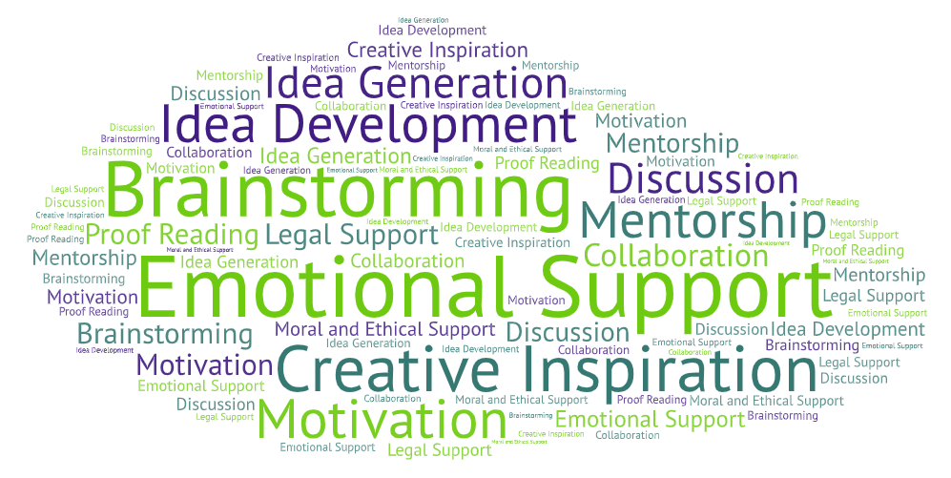
Figure 1: Comprehensive word cloud of themes (source-From Nvivo)
In the following section, the word cloud highlights some of the major themes surrounding intangible contributions from the interviews. "Emotional support" and "creative inspiration" appear as the most common types of contribution that were cited ignored.

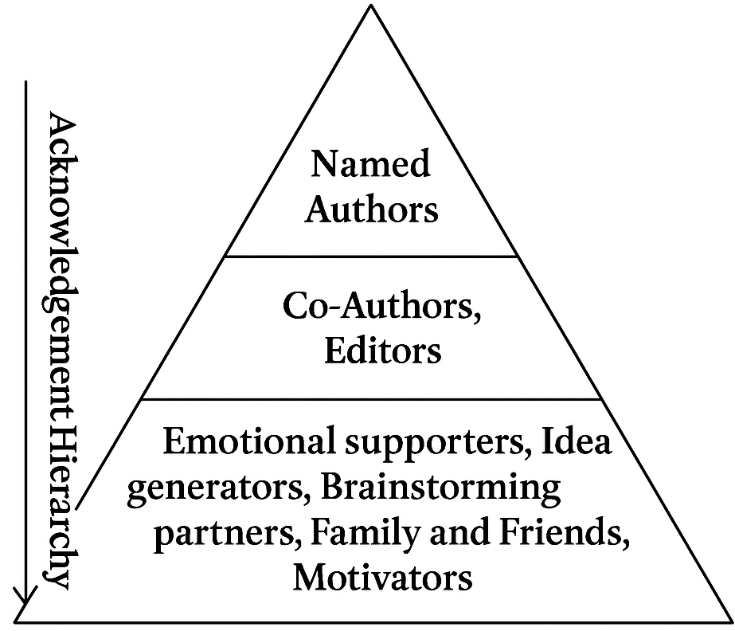
Figure 2- A pyramid of acknowledgments (Source-Author’s own creation)
The pyramid shows the pattern of giving due credits in the process of creativity, where people who contribute tangibly are recognized most and people who support the work intangibly gets least attention or acknowledgements.
Discussion and Conclusion
There was an enormous gap in the recognition of intangible contributions to authorship. Although emotionally laboring, developing ideas, and conceptual input may play very crucial roles in the actual creative process, they are very rarely acknowledged in formal authorship. This leads to questions revolving around intellectual property and ethics surrounding authorship. Should such intangible contributions be recognized through legal rights as part of authorship? How is that all reflected in current practice through recognition that supports the hierarchy within creative industries, creating those who have a marginal place because their contributions are outside the traditional framework of authorship?
The findings also align with other works regarding the collaborative aspect of creativity, whereby intangible contributions are excluded by a narrow, individualistic model of authorship (Sawyer, 2012). This study has underlined recognition of intangible contributions in the process of creativity by appealing to broader understanding of authorship. The researchers through both content analysis and qualitative interviews proved the essence of uncredited inputs such as emotional and intellectual support in creating works. Expanding the definition of authorship on such contributions makes intellectual property rights as well as ethical practices sharp both in the creative spheres as well as academic activity.
Further Scope of the study- The paper tries to bring in authorship rights in the creative process challenging the traditional norms, but arguments regarding intellectual contributions and emotional contributions are still there to be answered whether to give authorship for only intellectual contributions or having a mandatory acknowledgment section for every creation where emotional and other intangible contributions are mentioned. This paper seeds the idea of challenging authorship norms and leaves further scope for developing a legal framework upon the paper’s argument on considering intangible contributions as authorship.

Ethical Approval:
All participants were interviewed via telephone or in a face-to-face manner after ethical clearance.

Disclaimer (Artificial intelligence)

Option 1:

Author(s) hereby declares that NO generative AI technologies such as Large Language Models (ChatGPT, COPILOT, etc.) and text-to-image generators have been used during the writing or editing of this manuscript.

References
Amabile, Teresa M. Creativity in Context: Update to the Social Psychology of Creativity. Westview Press, 1996.
Barthes, Roland. "The Death of the Author." Image-Music-Text, translated by Stephen Heath, Fontana Press, 1977, pp. 142–148.
Cronin, Blaise. "Hyperauthorship: A Postmodern Perversion or Evidence of a Structural Shift in Scholarly Communication Practices?" Journal of the American Society for Information Science and Technology, vol. 52, no. 7, 2001, pp. 558–569.
Camarinha-Matos L.M. & Afsarmanesh H. (2006). Collaborative Networks: Value Creation in a Knowledge Society. IFIP International Conference on Knowledge Enterprise. Shanghai, China. Retrieved from https://www.researchgate.net/publication/237142495_Collaborative_networks_Value_creation_in_a_knowledge_society_invited_keynote_paper (accessed 2 February 2018).
Fine, Gary Alan. Kitchens: The Culture of Restaurant Work. University of California Press, 1996.
Foucault, Michel. "What Is an Author?" Language, Counter-Memory, Practice: Selected Essays and Interviews, edited by Donald F. Bouchard, translated by Donald F. Bouchard and Sherry Simon, Cornell University Press, 1979, pp. 113–138.
Frith, Simon, and Lee Marshall. Music and Copyright. Routledge, 2004.
Mendis. S, (2019) ‘Public open collaborative creation (POCC): a new archetype of authorship?’ Journal of World Intellectual Property Law 22(1-2), pp. 59-75.
Moser, Sarah. "Recognition and Invisibility in Collaborative Research." Social Studies of Science, vol. 50, no. 2, 2020, pp. 175–197.
Negus, Keith, and Michael Pickering. Creativity, Communication, and Cultural Value. SAGE Publications, 2004.
Sawyer, R. Keith. Explaining Creativity: The Science of Human Innovation. 2nd ed., Oxford University Press, 2012.
Smith, Andrew. "Beyond the Author: Collaborative Creativity and Cultural Production." Journal of Media and Cultural Studies, vol. 31, no. 4, 2017, pp. 532–548.
Woodmansee, Martha, and Peter Jaszi, editors. The Construction of Authorship: Textual Appropriation in Law and Literature. Duke University Press, 1994.
Fahad, A., and E. S. Mustafa. "Locked in Echoes: Unveiling the Dynamics of Social Media Echo Chambers and Hindu Radicalization Targeting Muslim Youth in Delhi." Humanities and Social Sciences Communications, 2025, https://doi.org/10.1057/s41599-025-04638-w.

