EFFECTIVENESS OF GAME-BASED LEARNING IN THE LANGUAGE AND LITERACY OF KINDERGARTEN PUPILS IN BALASI ELEMENTARY SCHOOL

Abstract
This study investigated the effectiveness of game-based learning in enhancing the language and literacy skills of kindergarten pupils at Balasi Elementary School. Using a quasi-experimental design, the research involved two groups of learners: one exposed to traditional teaching methods (control group) and another engaged through game-based learning strategies (experimental group). Data were gathered through pre-tests and post-tests focusing on key language and literacy indicators. The findings revealed a significant improvement in the performance of pupils in the experimental group compared to those in the control group, suggesting that game-based learning positively impacts early literacy development. These results support the integration of interactive and playful instructional approaches in early childhood education, particularly in linguistically diverse and indigenous communities such as Balasi. The study concludes with recommendations for incorporating game-based strategies in kindergarten curricula to foster more engaging and effective literacy instruction.

Keywords: Game-Based Learning, Language Development, Early Literacy Skills

Introduction
Language and literacy development are critical components of early childhood education, serving as the foundation for children’s future academic achievement and communication abilities. In kindergarten, effective instruction in these areas is essential, particularly as young learners begin to acquire vocabulary, phonological awareness, and basic comprehension skills (Pitt et al., 2015). Traditional teaching methods, while structured and systematic, may not fully address the developmental needs and learning styles of kindergarten pupils, especially those from diverse cultural backgrounds (All et al., 2016).
Recent pedagogical approaches have emphasized the value of integrating play and instruction through game-based learning. Game-based learning refers to the use of structured games as educational tools to enhance student engagement and reinforce academic content (Wickstrom, 2020; Dewantara et al., 2020). This method is especially suited to young learners, who naturally learn through interaction, exploration, and play. By making learning more enjoyable and student-centered, game-based strategies have shown promise in improving early literacy outcomes (Valiquette, 2020).

Balasi Elementary School, located in a rural area and serving a significant number of indigenous Aeta pupils, provides a meaningful setting to explore the application of game-based learning. Considering the unique linguistic and cultural context of the learners, it is imperative to investigate instructional approaches that are not only effective but also culturally inclusive and developmentally appropriate [7-10].

This study aims to examine the effectiveness of game-based learning in enhancing the language and literacy skills of kindergarten pupils at Balasi Elementary School. Specifically, it compares the performance of pupils taught using traditional methods with those exposed to game-based learning strategies. The findings are expected to inform early childhood educators and policymakers about the potential benefits of integrating play-based methods into the kindergarten curriculum, especially in underserved and culturally diverse communities (All et al., 2015).
Based on the beginning of school year pre-assessment results using the Early Childhood Care and Development (ECCD) Checklist at Balasi Elementary School, four (4) kindergarten pupils were identified as showing slight delay in overall development, while only two (2) pupils were assessed to be average in overall development. This suggests that a majority of learners are still developing foundational skills, particularly in language and literacy domains such as letter recognition, vocabulary, and phonological awareness. These gaps underscore the need for more interactive, engaging, and developmentally appropriate strategies to support early literacy. In Balasi Elementary School, teacher addresses this need through game-based learning strategies that include storytelling, role-playing, and group games, which promote cognitive, language, and social development. These practices align with DepEd’s play-based learning policies and reflect the school’s grassroots commitment to progressive teaching methods. Despite challenges such as limited resources and inconsistent teacher training, strong support from educators and parents sustains these efforts. Teacher also engages in community events like storytelling and cultural games, strengthening the link between education and local heritage (Boyer, 2019). Game-based learning not only supports literacy but also provides a culturally responsive and child-centered approach to teaching indigenous kindergarten learners.

Literature Review

Game-based learning has emerged as an effective strategy in early childhood education, particularly in enhancing language and literacy skills. Research by Boyer (2019), Wickstrom (2020), and Valiquette (2020) supports the idea that integrating play into instruction boosts engagement, vocabulary development, comprehension, and oral communication among young learners. Educational games foster meaningful language use, improve retention, and support diverse learners, including those from non-dominant linguistic and cultural backgrounds. While most studies have been conducted in urban or Western contexts, there is limited research on the effectiveness of game-based learning in rural and indigenous settings like Balasi Elementary School. This study addresses that gap by exploring how game-based instruction impacts kindergarten pupils' language and literacy development in a culturally relevant environment.
Game-based learning is increasingly recognized as an effective approach in early childhood education for enhancing language and literacy outcomes. According to Boyer (2019), play-based and game-based instructional strategies promote holistic development, with strong correlations to improvements in vocabulary, listening comprehension, and oral language fluency. Boyer emphasized that when children are actively engaged in games, they are more motivated and willing to take linguistic risks, which enhances their ability to use language expressively and confidently.
In the same vein, Valiquette and Sutton (2020a) reported that structured play environments significantly improve vocabulary acquisition, particularly in diverse classrooms. Their research emphasized the importance of repetition, contextual usage, and meaningful interaction during play. In another study, Valiquette and Sutton (2020b) further noted that game-based strategies enhanced phonemic awareness and narrative skills, which are essential precursors to reading and writing proficiency in young learners.
Wickstrom (2020) examined the effects of language-rich games on early literacy and found that children exposed to these games demonstrated greater cognitive flexibility and phonological awareness. These findings are particularly relevant to kindergarten pupils in Balasi Elementary School, where game-based strategies can be adapted to local cultural contexts and promote interactive, joyful learning.
While many studies affirm the benefits of game-based learning in early literacy, there is a need for more research in rural, multilingual, and indigenous contexts in the Philippines. The effectiveness of GBL strategies among marginalized groups, particularly in public schools with limited resources, is not well-documented. This research at Balasi Elementary School aims to contribute to this gap by examining how game-based strategies influence language and literacy development among kindergarten pupils, offering practical insights for teachers, administrators, and policy-makers in similar settings.

Theoretical Framework
According to Vygotsky’s Sociocultural Theory (Vygotsky, 1978) and Piaget’s Cognitive Development Theory (Piaget, 1952), play and social interaction are essential components of children's learning...
Game-based learning supports these principles by allowing meaningful, hands-on activities that enhance both language and cognitive development. In Vygotsky’s view, social interaction is key to cognitive growth, with the Zone of Proximal Development (ZPD) guiding how children benefit from guided learning. In Balasi Elementary School, game-based learning facilitates language development through peer interaction and structured play (Vygotsky, 1978). Piaget emphasized active exploration as a means for cognitive development, where play-based tasks like storytelling and role-playing enhance critical thinking and language acquisition (Piaget, 1952).
Research further supports these ideas. Boyer (2019) highlighted that play-based learning enhances holistic and literacy development. Valiquette and Sutton (2020a, 2020b) emphasized how structured play boosts vocabulary and narrative skills. Wickstrom (2020) demonstrated that language games improve early literacy and cognitive flexibility.

Methodology
The study used a repeated measures design, a type of research design where the same participants are involved in each condition or level of the dependent variable. The researcher exposed the same group of pupils to all the treatments or conditions. This design allowed the researcher to observe and measure changes in academic achievement by comparing pupil performance before and after the intervention, ensuring a clear understanding of the impact of game-based learning. This approach is supported by the study of Celik and Aytug (2020), who employed a repeated measures design to evaluate the effects of game-based learning on student achievement in early childhood education. Their results demonstrated that using the same participants across all conditions increased the validity of findings and provided clearer insights into the effectiveness of the intervention.
To measure the impact of the intervention: A pre-test was administered before the control period to assess the pupils' initial language and literacy skills. A post test was given at the end of the control period to identify any improvements from traditional teaching alone. A second pre-test was conducted before the experimental period to re-establish the pupils' starting point. A final post test was administered after the implementation of game-based learning strategies to determine the effectiveness of the intervention.
The process of conducting the study began with the preparation phase, where pre-test and post test assessment tools were developed based on the kindergarten curriculum in language and literacy. During the control period implementation, regular language and literacy lessons were delivered without the use of games, and a pre-test was administered at the beginning while a post test was given at the end of the period to measure academic achievement under traditional instruction. This was followed by the transition and orientation phase, where pupils were introduced to the concept of game-based learning to ensure their familiarity and comfort with the new instructional approach. The experimental period implementation then commenced, during which language and literacy lessons were integrated with game-based activities. Similar to the control period, a pre-test was administered before and a post test after the experimental period. Finally, in the data collection and analysis phase, the pre-test and post test scores from both periods were gathered and compared, and statistical analysis was conducted to determine if there was a significant difference in academic achievement attributed to the implementation of game-based learning.
This study was conducted at Balasi Elementary School, located in the municipality of Flora, Apayao, within the Cordillera Administrative Region. The school caters to a diverse population of kindergarten pupils, including those from the indigenous Aeta community. The Aeta are a distinct ethnic group known for their rich cultural heritage and traditional way of life, primarily residing in the mountainous regions of the Cordillera. These children represent a community that has maintained its traditional practices while increasingly integrating into mainstream Filipino society.
The respondents come from the Aeta community, an indigenous group in the Philippines known for their distinct cultural identity and close-knit community values. These children bring with them a unique cultural perspective, shaped by oral traditions, storytelling, and hands-on learning, which aligns naturally with the principles of play-based education. Their inclusion in the study provides a culturally rich context for examining the effectiveness of game-based learning strategies.
This study, which employed a repeated measures design to evaluate the effectiveness of game-based learning on the language and literacy development of kindergarten pupils at Balasi Elementary School, was conducted over the course of the second and third grading quarters. The second quarter, which served as the control period, spanned 8–10 weeks and focused on traditional instruction, while the third quarter, the experimental period, also lasted 8–10 weeks and implemented game-based learning strategies.
The data gathering process for this study followed three distinct phases: pre-data gathering, data gathering, and post-data gathering. During the pre-data gathering phase, the researcher secured the necessary permissions from school administrators and obtained informed consent from the parents or guardians of the participating kindergarten pupils. An orientation session was conducted with the teachers to explain the study’s objectives, methods, and their roles in facilitating the game-based learning activities aligned with language and literacy assessments. Preparations for collecting baseline data, including preliminary assessments of each child’s language and literacy abilities, were also completed during this stage.
In the data gathering phase, the researcher conducted structured observations and administered assessments. This phase focused on tracking language and literacy development through repeated measures. The researcher documented structured observations of the children as they engaged in various game-based learning activities such as storytelling, role-playing, and nature-inspired games to capture behavioral and developmental changes. Pre-tests and post tests were administered at planned intervals to measure progress in language and literacy development throughout the study period.
During the post-data gathering phase, the researcher analyzed and interpreted the collected data to assess the effectiveness of game-based learning. The findings were synthesized to compare results from the control period (traditional approach) and the experimental period (game-based approach), while also taking into consideration any cultural factors that may have influenced play-based learning outcomes. This phase concluded with the preparation of a comprehensive report that highlighted key findings and implications for early childhood education. The researcher then presented these findings to the administration and teaching staff of Balasi Elementary School, offering actionable recommendations for enhancing game-based learning in their kindergarten program.

Results and Discussions
The study began by assessing the language and literacy performance of kindergarten pupils during the control period, where traditional instruction methods were applied. The control period aimed to establish a baseline measurement of the pupils’ academic achievement in language and literacy, using pre-test and post test assessments. As shown in Table 1, the results indicated an improvement in the pupils’ performance from the pre-test to the post-test.
In table 1, the pre-test mean score was 15.17, with a Mean Percentage Score (MPS) of 75.85% with a descriptive value of fairly satisfactory, reflecting the initial language and literacy proficiency of the pupils prior to any instructional intervention. After the implementation of regular language and literacy lessons, the post-test scores showed a mean of 16 and an MPS of 80% with a descriptive value of satisfactory. This represents a 4.15% increase in the MPS, demonstrating a positive improvement in academic achievement under the traditional teaching methods.
These results suggest that the pupils made progress in their language and literacy skills through the regular delivery of lessons, highlighting the effectiveness of consistent, structured instruction in early childhood education. However, while traditional methods proved beneficial, the improvements observed were limited when compared to the potential effects of more engaging, interactive teaching methods such as game-based learning.
The findings of this study are consistent with the work of (Boyer 2019), who argued that even without innovative approaches, traditional instructional methods could lead to improvements in early literacy development. Boyer’s research supports the notion that structured teaching remains valuable in promoting language acquisition. Similarly, Wickstrom (2020) noted that while traditional approaches have their merits, they often lack the engaging elements necessary to foster deeper learning and motivation among young learners.
Table 1. Language and Literacy Performance during the Control Period
Pupil | Pre-test Score (Out of 20) | Post-test Score (Out of 20)
Pupil 1 | 14 | 15
Pupil 2 | 15 | 17
Pupil 3 | 14 | 15
Pupil 4 | 16 | 16
Pupil 5 | 15 | 16
Pupil 6 | 17 | 17
Total | 91 | 96
Mean | 15.17 | 16.0
MPS | 75.85% | 80%
Interpretation | Fairly Satisfactory | Satisfactory
The results presented in Table 2 demonstrate a notable improvement in the language and literacy performance of the pupils during the experimental period, where game-based learning was integrated into the language and literacy lessons. The pre-test mean score was 16.5 (MPS = 82.5%) with a descriptive value of satisfactory, and after the introduction of game-based learning, the post test mean score increased to 19 (MPS = 95%) with a descriptive value of outstanding. This represents a significant improvement of 12.5% in the MPS, suggesting that the game-based learning intervention had a substantial positive impact on the pupils' academic achievement in language and literacy.
In the pre-test, the pupils already displayed a good understanding of language and literacy concepts, as evidenced by the 16.5 mean score. However, after experiencing the interactive and engaging nature of game-based learning, the pupils demonstrated a higher level of mastery, as reflected in the post-test scores. The 95% MPS in the post-test suggests that the pupils were not only more motivated but also able to apply their knowledge and skills in a more effective and meaningful way.
These results align with previous research that has highlighted the positive effects of game-based learning on language development in early childhood education. For example, Boyer (2019) found that game-based learning environments foster increased engagement and motivation, which in turn leads to better retention and mastery of academic content, particularly in language and literacy. Boyer’s study emphasized the role of interactive, play-based methods in creating a more engaging and dynamic learning environment for young children, which is consistent with the findings of this research.
Similarly, Wickstrom (2020) reported that incorporating games into the classroom enhances cognitive development and language acquisition among young learners. According to Wickstrom, game-based learning encourages active participation and problem-solving, which are essential for the development of literacy skills. This aligns with the significant improvement in the pupils' post-test results, suggesting that the hands-on, interactive nature of games positively influenced their academic performance.
Additionally, Valiquette (2020) discussed the importance of providing children with opportunities for playful, collaborative learning through games. Valiquette found that game-based learning helps children develop both cognitive and social skills, which are critical for language development. By fostering a sense of achievement and teamwork, games enhance children’s ability to communicate effectively and understand language in a more contextually rich manner.
Table 2. Language and Literacy Performance during the Experimental Period
Pupil | Pre-test Score (Out of 20) | Post-test Score (Out of 20)
Pupil 1 | 15 | 18
Pupil 2 | 17 | 19
Pupil 3 | 16 | 18
Pupil 4 | 17 | 20
Pupil 5 | 16 | 19
Pupil 6 | 18 | 20
Total | 99 | 114
Mean | 16.5 | 19.0
MPS | 82.5% | 95%
Interpretation | Satisfactory | Outstanding
A comparison of the language and literacy performance of the kindergarten pupils during the control period and the experimental period was conducted to determine if there was a significant difference in their academic achievement. The pre- test and post test scores from both periods were analyzed, and the results showed a noticeable improvement in the pupils' performance during the experimental period, where game-based learning was implemented.
During the control period, the pre-test mean score was 15.17, with a Mean Percentage Score (MPS) of 75.85% with a descriptive value of fairly satisfactory. At the end of the control period, the post-test mean score increased slightly to 16, with an MPS of 80% with a descriptive value of satisfactory. This demonstrates a modest improvement of 4.15% in the pupils' language and literacy performance, indicating that traditional instruction had some impact, but the progress was relatively limited.
In contrast, during the experimental period, where game-based learning was integrated into the curriculum, the pre-test mean score was 16.5 (MPS = 82.5%). After the implementation of game-based learning, the post-test mean score increased significantly to 19, with an MPS of 95% (Outstanding). This represents a remarkable improvement of 12.5% in the pupils' performance during the experimental period, showing that the game-based approach led to a much greater enhancement in language and literacy skills.
The difference in MPS between the two periods is striking: the experimental period exhibited an 8.35% greater increase in MPS compared to the control period. This substantial improvement suggests that game-based learning created a more engaging, motivating, and effective environment for the pupils to develop their language and literacy skills. Games likely provided a more interactive and hands-on approach to learning, which could have been more appealing to the pupils, enhancing their ability to retain information and apply their knowledge in meaningful ways.
Statistical analysis of the data revealed a significant difference in the language and literacy performance between the control and experimental periods. The introduction of game-based learning resulted in a notable increase in the pupils' academic achievement, suggesting that the interactive and engaging nature of games contributed to better language acquisition, retention, and literacy skills compared to the traditional teaching methods used during the control period.
These findings are consistent with research by Boyer (2019), who found that game-based learning significantly enhances students' language skills by promoting active engagement, motivation, and improved cognitive processing. Similarly, Wickstrom (2020) and Valiquette (2020) reported similar improvements in language and literacy outcomes when games were integrated into early childhood education, supporting the notion that game-based learning is an effective instructional strategy for enhancing academic achievement in young learners.
Table 3: Comparison of Language and Literacy Performance Between the Control Period and Experimental Period
Period | Pre-test Mean Score | Post-test Mean Score | Mean Percentage Score (MPS) | Difference in MPS | Descriptive Interpretation
Control Period | 15.17 | 16 | 75.85% | 4.15% | Fairly Satisfactory
Experimental Period | 16.5 | 19 | 82.5% | 12.5% | Satisfactory
Difference | +1.33 | +3 | +6.65% | +8.35%
Overall, the data in this study confirms that game-based learning is an effective strategy to enhance the language and literacy skills of kindergarten pupils. The use of interactive, engaging, and play-oriented activities provided a more stimulating learning environment, which significantly contributed to the improvement of the pupils' academic performance.

Conclusion and Recommendations
Based on the results of the study, it is concluded that game-based learning significantly enhances the language and literacy development of kindergarten pupils. During the control period, where traditional teaching methods were employed, pupils demonstrated only a slight improvement in their academic performance, as reflected by the small increase in their Mean Percentage Scores (MPS). However, during the experimental period, where game-based learning strategies were integrated into the lessons, a substantial improvement in pupils’ language and literacy performance was observed. The remarkable increase in both the mean scores and MPS indicates that game-based activities provided a more engaging, interactive, and motivating learning environment, which allowed pupils to better grasp and apply literacy skills.
This finding supports the idea that young learners thrive in settings where learning is associated with play, interaction, and enjoyment. Through games, pupils were able to develop their vocabulary, comprehension, oral communication, and critical thinking skills in a manner that traditional instruction could not achieve as effectively. The integration of games into classroom instruction not only increased pupil participation and enthusiasm but also promoted deeper understanding and retention of language concepts. Thus, it can be concluded that game-based learning is a powerful and effective approach in early childhood education, and its use in the classroom should be encouraged to foster greater academic growth among young learners.
Based on the findings and conclusion of the study, the following recommendations are proposed:
- Integrate Game-Based Learning into Kindergarten Instruction
The Department of Education, particularly at the school level, is encouraged to integrate game-based learning strategies into the regular kindergarten curriculum. The significant improvement in pupils’ language and literacy performance demonstrates the effectiveness of interactive and play-based methods.
- Provide Professional Development for Teachers
Regular training and workshops should be conducted to equip kindergarten teachers with the skills and knowledge to effectively implement game-based learning. Emphasis should be placed on designing age-appropriate, engaging, and culturally relevant games that promote literacy and language development.
- Develop and Distribute Game-Based Learning Materials
Schools and educational stakeholders should invest in the development and distribution of instructional materials that support game-based learning. These materials may include story-based games, word and phonics games, and culturally grounded activities that align with the learning competencies.

Disclaimer (Artificial intelligence)
Option 1:
Author(s) hereby declare that NO generative AI technologies such as Large Language Models (ChatGPT, COPILOT, etc.) and text-to-image generators have been used during the writing or editing of this manuscript.
Option 2:
Author(s) hereby declare that generative AI technologies such as Large Language Models, etc. have been used during the writing or editing of manuscripts. This explanation will include the name, version, model, and source of the generative AI technology and as well as all input prompts provided to the generative AI technology
Details of the AI usage are given below:
1.
2.
3.

References

Piaget, J. (1952). The origins of intelligence in children. International Universities Press.

Vygotsky, L. S. (1978). Mind in society: The development of higher psychological processes. Harvard University Press.
Cornito, C. M. (2023). The effectiveness of contextualized digital game-based learning resource in improving kindergarten pupil’s alphabet knowledge level. International Journal on Studies in Education, 5(2), 130-140.
Guo, P. (2023). Approaches to enhance game-based teaching literacy for kindergarten major students. Pacific International Journal, 6(4), 120-124.

Tang, J. T., Chu, S. T., & Chang, T. F. (2024). Enhancing English alphabet handwriting skills in preschool children through digital game-based learning approach. Innovation in Language Learning and Teaching, 1-19.
Mahayanti, N. W. S., Ashadi, A., & Rachman, D. (2024). The Impact of Digital Game-Based Learning on Children's Self-Efficacy and Reading Success. Voices of English Language Education Society, 8(1), 303-313.
All, A., Castellar, E. P. N., & Van Looy, J. (2016). Assessing the effectiveness of digital game-based learning: Best practices. Computers & Education, 92, 90-103.

Dewantara, D., Wati, M., Misbah, M., Mahtari, S., & Haryandi, S. (2020, March). The effectiveness of game based learning on the logic gate topics. In Journal of Physics: Conference Series (Vol. 1491, No. 1, p. 012045). IOP Publishing.

All, A., Castellar, E. P. N., & Van Looy, J. (2015). Towards a conceptual framework for assessing the effectiveness of digital game-based learning. Computers & Education, 88, 29-37.

Pitt, M. B., Borman-Shoap, E. C., & Eppich, W. J. (2015). Twelve tips for maximizing the effectiveness of game-based learning. Medical teacher, 37(11), 1013-1017.

Appendices
Appendix A
Letter to the Public Schools District Supervisor
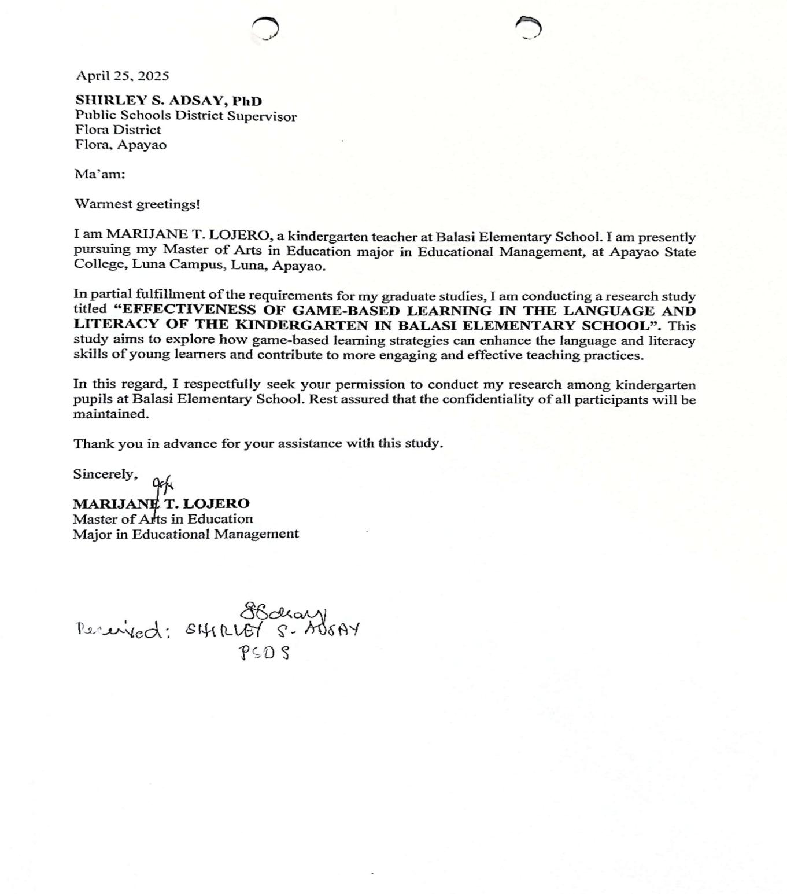

Appendix B
Letter to the School Head


Appendix C
Letter to the Parents


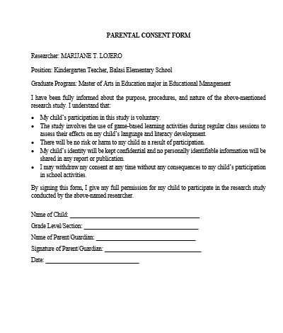

Appendix D
Pre-Test and Post Test

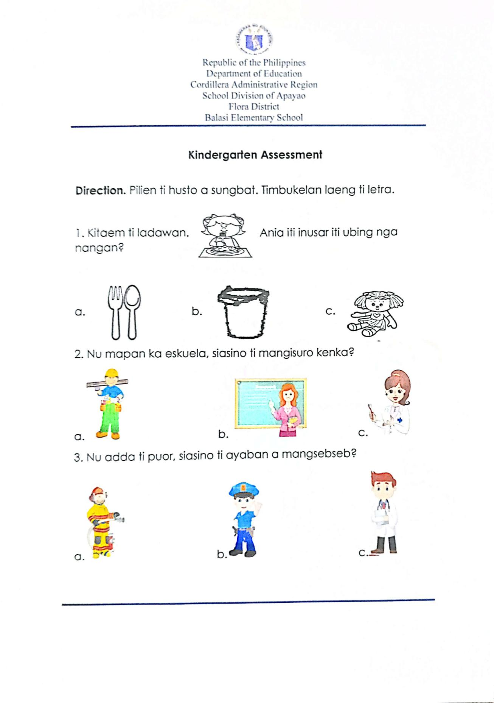

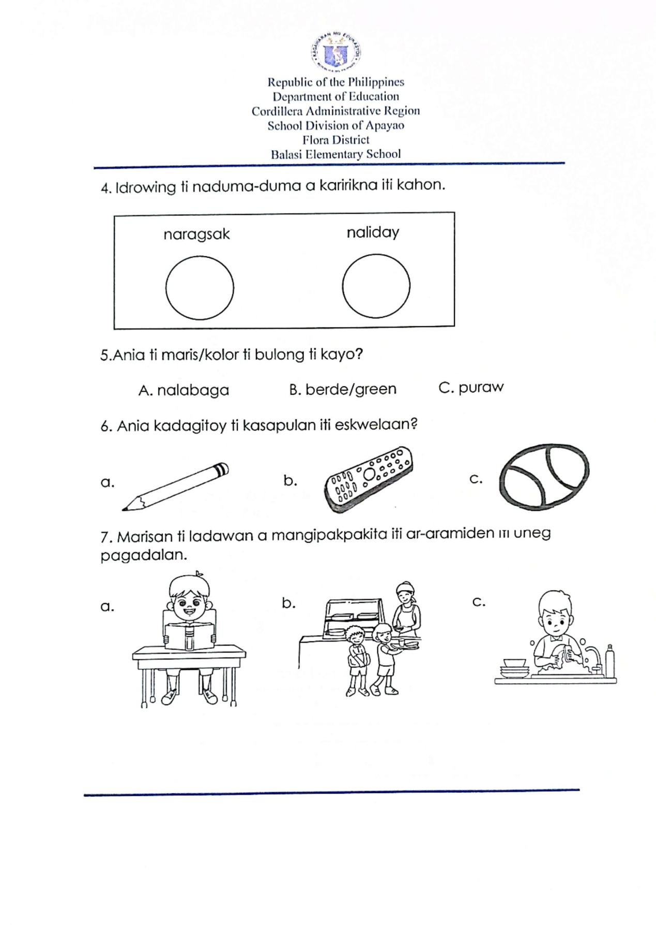

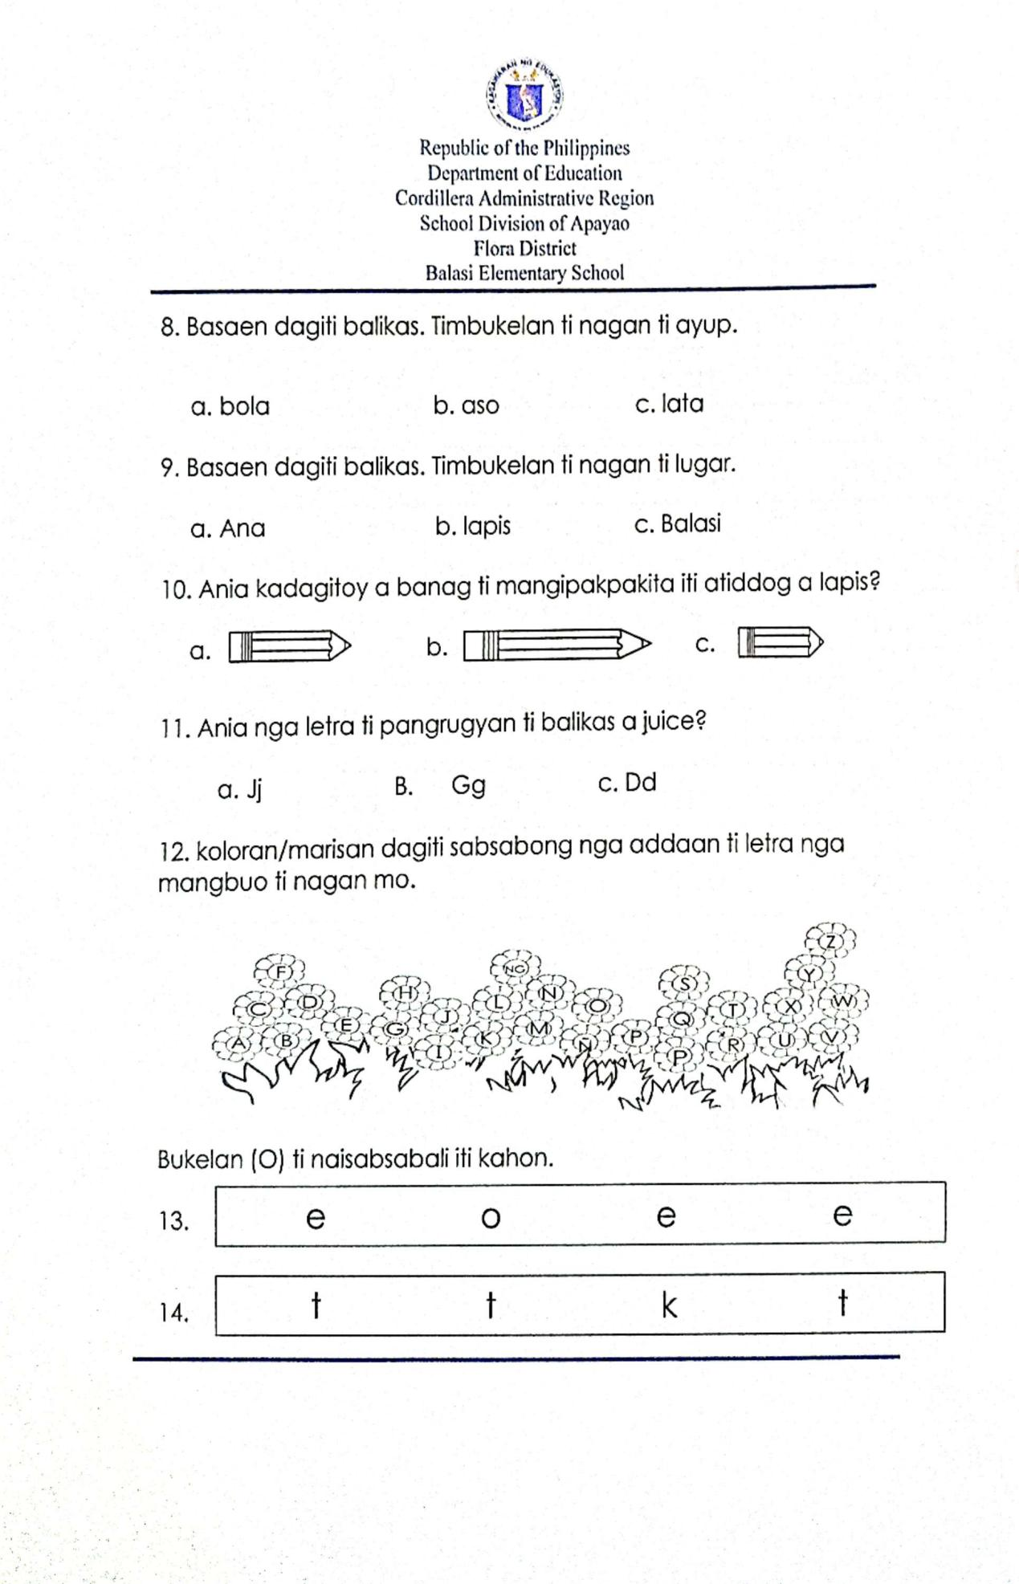

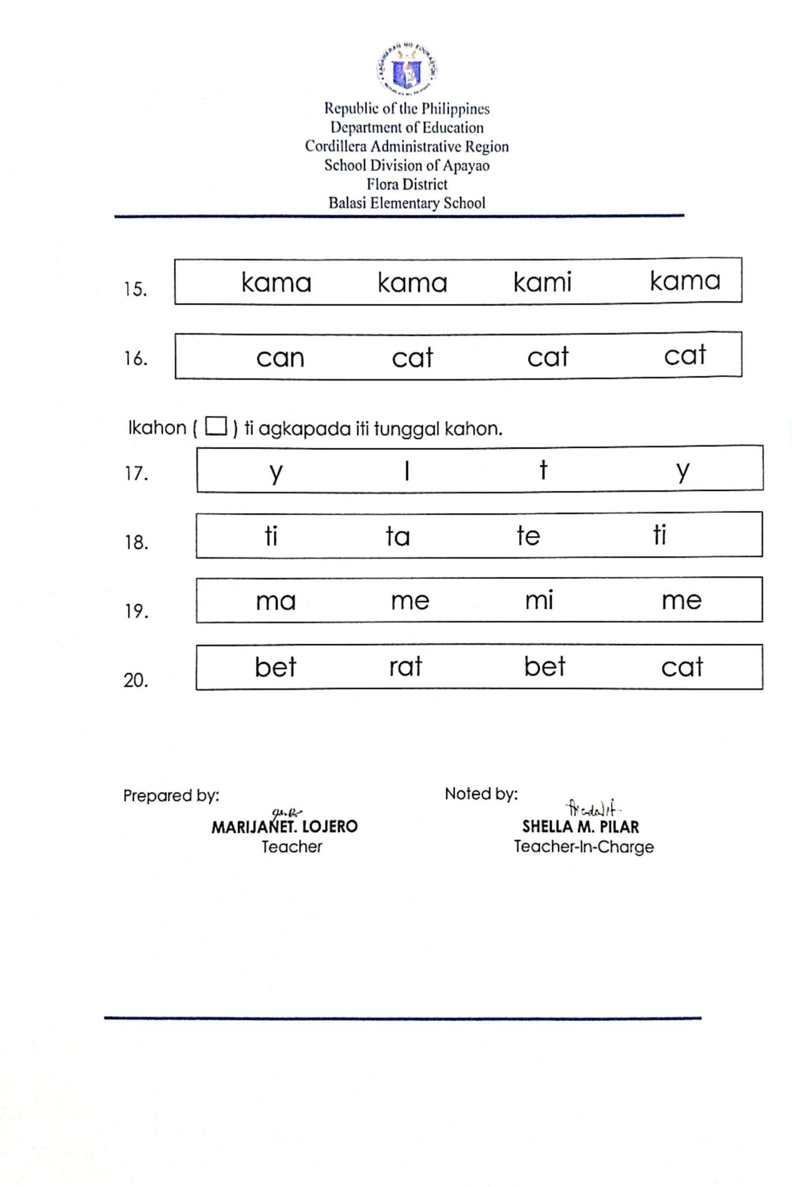

Appendix E
Daily Lesson Log ( DLL )
