Learning Management System Integrate Local Wisdom for Enhanced Chemistry Learning

.

ABSTRACT

|  |
| --- |
| **Objectives:** to determine the response of students to the Integrated Learning Management System of Local Wisdom developed by the researcher.  **Methods:** This research is a descriptive quantitative research. The population of this study was all students of Senior High School who have implemented the independent curriculum. The sample was taken by random sampling, with 554 respondents participating. Data collection in this study was a survey using a perception questionnaire with valid cognitive, psychomotor and affective competency indicators. The data analysis technique to obtain descriptive analysis results used the help of formulas in Spreadsheets on WPS Office.  **Results:** The results of data processing obtained that the percentage of responses strongly agreed that the LMS based on local wisdom had higher affective competency (41.24%) compared to cognitive competency (37.76%) and psychomotor competency (37.28%). According to several studies, cognitive, affective and psychomotor are interrelated in the student learning process. Based on the results of this study, the researcher suggests that teachers pay attention to the psychomotor development of students through chemistry learning. This happens because the implementation of the curriculum is affective, while psychomotor competency is still not optimally developed.  **Impact:** This study provides valuable insight into the integration of local wisdom within a Learning Management System (LMS) for chemistry learning in the context of the independent curriculum. The findings indicate a positive student response, particularly in the affective domain, suggesting that LMS platforms that incorporate culturally relevant content can foster emotional engagement and contextual understanding in students. |

Keywords: chemistry, independent curriculum, learning, LMS, local wisdom

1. INTRODUCTION

The industrial revolution 5.0 is a challenge for all stakeholders in the field of education (Taj & Zaman, 2022). Quality education is one of the steps to achieve the goals of the Indonesian nation, as stated in the opening of the 1945 Constitution in paragraph four (Hrp & Thalib, 2019). Higher education as a formal institution is the center for improving the quality of competitive human resources (Afandi & Rochman, 2015; Adriani, 2015). The world university ranking institution The Times Higher Education (THE) released THE Asia University Rankings 2021, the results obtained that Indonesia was ranked 194th in the world. Competitiveness in various aspects must be a concern for all education implementers at the higher education level (Panday, 2018; Ahmad, 2018) especially in the field of Science and Technology (IPTEK) (Nasir, 2018; Purba, 2019; Minanlarat *et al*, 2021). The development of science and technology in the implementation of learning at the higher education level is supported by the availability of adequate facilities and infrastructure (Irawan, 2018). Procurement of adequate facilities and infrastructure needs to be planned properly (Indrawan, 2015) so that its use is effective and efficient (Sholihah, 2019; Agustin & Permana, 2020; Ng & Loosemore, 2007). The effectiveness of facilities & infrastructure in higher education to improve the quality of learning, research and community service (Cordiaz, 2017; Darari *et al*. 2019). The limited use of information technology in higher education is an obstacle to improving the quality of the tridharma (Umanailo, 2017). Learning as one part of the tridhama of higher education must be facilitated with good technology to create a pleasant learning climate (Rap & Bionder, 2017; Coudret & Dietrich, 2020). Each university has different technology needs (Indrayani, 2011), so it takes effort for education implementers in the university environment to evaluate and develop their learning technology (Sharpe *et al*. 2006; Oh & Park, 2009). In reality, there are still many campuses that have not evaluated and then developed the technology used for learning through the evaluation results, even though there are many steps that can be taken by universities to carry out these activities (Purba *et al*, 2021; Swastikasari *et al,* 2020). The development of a learning management system (LMS) model is a strategic step to answer the need for learning technology in universities. By referring to various studies that utilize LMS-based learning models (Raharja, 2011; Febriyani, 2018; Rohaeti *et al*. 2021), by paying attention to local wisdom (Hernani & Mudzakir, 2012; Septiani *et al*. 2020). College students come from different regions so that they will help lecturers to enrich students' understanding of topics in various courses (Adiasih & Brahmana, 2015). A good learning management system model must be adaptable and flexible to support the learning process (García-Peñalvo & Alier Forment, 2014). Availability of tools that help teachers (Kautsar et al. 2013), students and administrative staff (Holmes & Prieto-Rodriguez, 2018), parents (Curtis, 2014), Chancellors or vice-chancellors (Ilyas, 2017) in planning, implementing, evaluating, documenting and socializing learning outcomes. Development of a learning management system model by accommodating the availability of virtual lab tools that facilitate practical materials in accordance with local wisdom in all provinces in Indonesia. The development of a learning management system model based on local wisdom in higher education is the basis for developing an effective and efficient LMS. Based on the background above, the objective of this study is to determine the effectiveness of the local wisdom-based learning management system (LMS) model developed for chemistry learning.

2. material and methods

This research is a quantitative descriptive study using a survey method (Nardi, 2018). This research was carried out in stages starting from the development to evaluation of local wisdom-based LMS from August 2023 to August 2024. The population in this study were all high school (SMA) students who had implemented the independent curriculum and sample was taken by random sampling (Sumoargo, 2020) with a target of ≥500 students.

The data collection technique in this study was by using a student response questionnaire to the local wisdom-based LMS reviewed from 3 dimensions as presented in table 1 below:

Table 1. Research Instrument Grid

|  |  |
| --- | --- |
| **Dimension** | **Indicators** |
| Cognitive Competence | 1. Understanding of concepts |
| 1. Application of knowledge: |
| 1. Analytical skills |
| 1. Problem-solving ability |
| 1. Knowledge retention |
| Affective Competence | 1. Interest and curiosity |
| 1. Appreciation of local wisdom |
| 1. Motivation to learn |
| 1. Respect for diversity |
| 1. Engagement and participation |
| Psychomotor Competence | 1. Execution of virtual experiments |
| 1. Use of LMS tools |
| 1. Data collection and interpretatio |
| 1. Manipulation of learning media |
| 1. Project creation |

The Instrumentt with the distribution of statements in each dimension above is arranged according to the Likert scale (Munandar *et al*. 2019), namely strongly agree (score= 5), agree (score= 4), undecided (score= 3), disagree (score= 2), strongly disagree (score= 1). The above Instrumentt was validated (Widiana *et al*. 2023) by an expert validator to make it suitable for use in this study. Validated Instrumentts are presented in a google form to facilitate the distribution of questionnaires.

The data obtained through the distribution of questionnaire links that attach the local wisdom-based LMS design are generally presented in a pie chart and in detail for each dimension will be presented in a respondent hystogram (Sulisti *et al*. 2024), to provide information on the percentage of responses that strongly agree to strongly disagree with each statement in each dimension. Data analysis in the study is descriptive analysis, which is a data analysis technique by describing the data collected in the form of an average without intending to generalize conclusions. This analysis is used to determine the number of respondents who will be divided according to dimensions, namely cognitive, affective and psychomotor competency dimensions.

3. results and discussion

One example of local wisdom presented in the questionnaire is Tape. Tape is one of Indonesia's local wisdoms known by its basic ingredients and different names in several regions. In Java it is generally known as tapai or peuyeum, one type of which is peuyeum ketan, because the basic ingredient is sticky rice (Cempaka, 2021). In North Sumatra it is known as tape gadong (gadong is the Batak language, one of the tribes in North Sumatra, which means cassava), because it is made from cassava (Syafitri *et al.* 2022).

Integrating visual representations of local wisdom, such as "tape," into Learning Management Systems (LMS) significantly enhances students' engagement and contextual understanding. Visual content aids learners in connecting abstract scientific concepts with real-world applications, particularly when cultural elements like traditional fermentation are involved. By observing the actual form of tape, students can better appreciate the chemical processes involved and relate them to their cultural background, thereby making the learning experience more meaningful and relevant. This approach aligns with findings from Verawati and Wahyudi (2021), who demonstrated that incorporating local wisdom into science education significantly improves students' scientific literacy and engagement.

The appearance of the Learning Management System Integrated Local Wisdom which was developed and then presented on the data collection Instrumentt related to user perception is presented in Figures 1 (a-d).

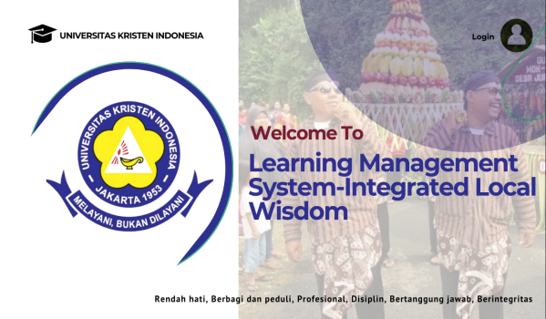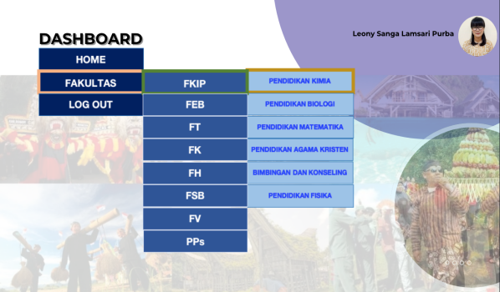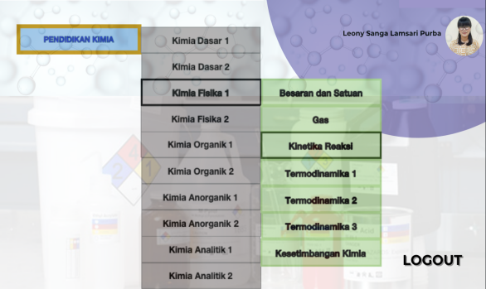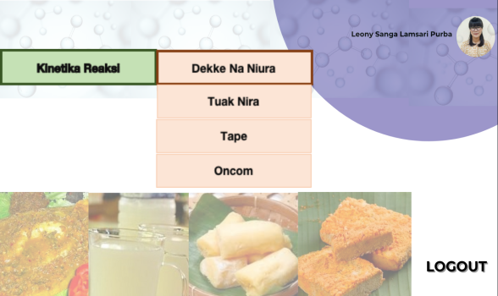

Fig 1a. LMS Front View Fig 1b. LMS User Account View

Fig 1c. Advanced Dashboard View Fig 1d. Local Wisdom Selection Display

The use of local wisdom of tapai in the chemistry learning process can be used in several topics such as learning chemical formulas, chemical reactions and reaction kinetics. The catalyst sub-topic in the reaction kinetics topic can be taught by interpreting the role of yeast as a catalyst in the fermentation process of sticky rice or cassava (Mueedin, 2021; Purnomo et al. 2023). The following List 1 is a fermentation reaction using the catalyst "Yeast".

|  |  |  |  |  |  |  |
| --- | --- | --- | --- | --- | --- | --- |
| C6H12O6 | → | C2H5OH | + | 2CO2 | + | 2ATP |
| Glukosa |  | Etanol |  | Karbon Dioksida |  | Energi |

List 1. Fermentation Reaction of Cassava Using Yeast

The fermentation reaction in making tape is carried out by yeast. Glucose (C6H12O6) is the simplest sugar, then when fermented it can produce ethanol (2C2H5OH). The microorganism in this chemical reaction is Saccharomyces cerevisiae which is a fungus that has the ability to convert carbohydrates (fructose and glucose) into alcohol and carbon dioxide. Making tape using cassava as the main ingredient undergoes a fermentation process. This process makes the texture of cassava different from before. The texture becomes soft and mushy with a sour taste. In addition to the influence of microorganisms to break down the components of cassava substances. Another indicator of chemical changes in cassava is the change in smell and color. Temperature greatly influences the fermentation process. If cassava tape is fermented at cold temperatures, the process will take longer, but the resulting tape will be better. However, if fermented at hot temperatures, the process of becoming cassava tape is also faster (Indasah & Muhith, 2020)

Presentation of information related to the use of tape in chemistry learning using LMS provides an overview for respondents who respond to its usefulness in learning. Respondents who filled out the questionnaire on the need for a local wisdom-based learning management system (LMS) model to support chemistry learning, which was distributed via Google Form, were 554 students. Interpretation of the research data is presented in Table 2:

Table 2. Average Score of the Needs Dimension of the Local Wisdom-Based LMS Model

|  |  |  |  |  |  |
| --- | --- | --- | --- | --- | --- |
| **Dimension** | **Average Percentage of Respondents** | | | | |
| **SS** | **S** | **R** | **TS** | **STS** |
| Cognitive | 37.76 | 30.08 | 26.48 | 5.68 | 0 |
| Affective | 41.24 | 29.12 | 23.38 | 6.26 | 0 |
| Psychomotor | 37.28 | 31.42 | 25.12 | 6.18 | 0 |

Based on the table above, it is concluded that the percentage of responses strongly agree and agree that LMS based on local wisdom is effective for cognitive, affective and psychomotor competencies in chemistry learning. The affective competency dimension obtained a higher percentage of strongly agree responses followed by the cognitive competency dimension and the last is the psychomotor competency dimension. In detail, the results of the responses to each dimension provide a general picture of the effectiveness of Chemistry Learning using LMS integrated with Local Wisdom.

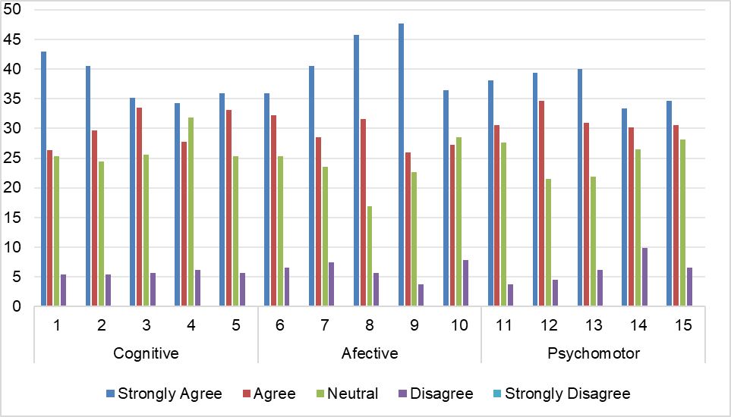

**X-Axis:**  
**Response Categories**  
(Strongly Agree, Agree, Neutral, Disagree, Strongly Disagree)

**Y-Axis:**  
**Percentage of Students Who Responded (%)**

Fig 2. Student Response About Effectiveness of Chemistry Learning using LMS integrated with Local Wisdom

The students' responses stated that they strongly agreed that Chemistry Learning using LMS integrated with Local Wisdom effectively improves students' learning achievement in line with the research results. The implementation of LMS in chemistry learning can improve students' learning achievement (Nazika, 2021; Sari & Sapri, 2021). The use of local wisdom in chemistry learning can improve students' competence (Amini, 2020) both in cognitive (Hikmawati & Syahidi, 2022), affective (Mulatsih & First, 2023; Ridho *et al* 2021) and psychomotor (Khery *et al* 2025) aspects of students. The combination of LMS utilization by involving local wisdom maximizes students' learning achievement.

Learning outcomes in cognitive, affective and psychomotor aspects will be achieved if they are interrelated or closely related to each other in the student learning process (Parwati *et al* 2023; Putri, 2023), so that the results of this study show no significant difference in the responses of students who strongly agree with the effectiveness of learning using LMS integrated with local wisdom when viewed from Learning outcomes in cognitive, affective and psychomotor aspects. Sedikit lebih tinggi pada aspek afektif dibandingkan kognitif dan psikomotorik merupakan salah satu fakta teori belajar yang pertama kali muncul adalah teori behaviouristik (Khodijah & Setiawan, 2023; Muhajirah, 2020). Through the results of this study, the researcher suggests that chemistry teachers use LMS by involving local wisdom in learning to improve student competencies as a whole, starting from abilities in the affective aspect, then cognitive and building good psychomotor abilities, so that Indonesia has a competitive generation.

4. Conclusion

The findings of this study clearly demonstrate that the integration of local wisdom into a Learning Management System (LMS) significantly enhances students’ cognitive, affective, and psychomotor competencies in chemistry learning. Among these, the affective dimension showed the strongest student response, indicating that culturally relevant content plays a key role in shaping student engagement and emotional connection to scientific material. This research contributes both theoretically and practically. Theoretically, it supports the notion that meaningful learning occurs when educational content is situated within a learner’s cultural context, reinforcing constructivist and contextual learning theories. Practically, it offers an innovative approach for educators to enhance science instruction by incorporating local traditions such as the fermentation of tape, to make abstract chemical concepts more relatable and accessible. However, this study is not without limitations. The data were collected from a single large sample of 554 students but limited to a specific time frame and educational level. Additionally, the research relied on perception-based responses without tracking actual learning gains over time. These contextual and methodological constraints may affect the generalizability of the findings. Future research is recommended to explore the long-term impacts of local wisdom-based LMS on students’ academic performance and retention of scientific concepts. Further studies could also investigate how this approach can be adapted across different subjects, educational levels, and cultural contexts to broaden its applicability and impact in science education.

**Disclaimer (Artificial intelligence)**

Author(s) hereby declare that NO generative AI technologies such as Large Language Models (ChatGPT, COPILOT, etc.) and text-to-image generators have been used during the writing or editing of this manuscript.

References

Adiasih, P., & Brahmana, R. K. (2015). Persepsi terhadap makanan tradisional Jawa Timur: Studi awal terhadap mahasiswa perguruan tinggi swasta di Surabaya. doi.org/10.24002/kinerja.v19i2.538

Afandi, R., & Rocmah, L. I. (2015). Pramuka Sebagai Wadah Mengembangkan Life Skill Mahasiswa Calon Guru Pada Perguruan Tinggi LPTK. *PEDAGOGIA: Jurnal Pendidikan*, 4(2), 135-140. [doi.org/10.21070/pedagogia.v4i2.16](https://doi.org/10.21070/pedagogia.v4i2.16)

Agustin, H. Y., & Permana, J. (2020, February). Management of Facilities and Infrastructures for Improving the Learning Quality of Vocational High School. In *3rd International Conference on Research of Educational Administration and Management* (ICREAM 2019)(pp. 64-68). Atlantis Press. doi.org/[10.2991/assehr.k.200130.141](https://doi.org/10.2991/assehr.k.200130.141)

Ahmad, I. (2018). Pendidikan tinggi “4.0” yang mampu meningkatkan daya saing bangsa. Makassar, Indonesia.

Amini, R. (2020, February). The effect of integrated science learning based on local wisdom to increase the students competency. In *Journal of Physics: Conference Series* (Vol. 1470, No. 1, p. 012028). IOP Publishing.   doi.org/[10.1088/1742-6596/1470/1/012028](https://ui.adsabs.harvard.edu/link_gateway/2020JPhCS1470a2028U/doi:10.1088/1742-6596/1470/1/012028" \t "/Users/user/Documents/2024 Genap/Prodi/A/PKF2/x/_blank)

Andriani, R., & Rasto, R. (2019). Motivasi belajar sebagai determinan hasil belajar siswa. *Jurnal Pendidikan Manajemen Perkantoran* (JPManper), 4(1), 80-86. doi.org/[10.17509/jpm.v4i1.14958](https://doi.org/10.17509/jpm.v4i1.14958)

Cempaka, L. (2021). Peuyeum: Fermented cassava from bandung, west java, Indonesia. *Journal of Ethnic Foods*, 8(1), 3. doi.org/[10.1186/s42779-021-00079-3](http://dx.doi.org/10.1186/s42779-021-00079-3)

Cordiaz, M. (2017). Penerapan Smart Campus sebagai Pendukung Kegiatan Pendidikan dalam Tri Dharma Perguruan Tinggi. *Jurnal Informatika Universitas Pamulang*, 2(2), 77-80 doi.org/[10.32493/informatika.v2i2.1508](https://doi.org/10.32493/informatika.v2i2.1508)

Coudret, C., & Dietrich, N. (2020). Fun with Flags and Chemistry. *Journal of Chemical Education*, 97(12), 4377-4384.

doi.org/ff10.1021/acs.jchemed.0c00514

Darari, F., Pratama, G. G., & Krisnadhi, A. (2019, October). Open Tridharma: A Framework for Digital Openness in Higher Education. In 2019 *International Conference on Advanced Computer Science and information Systems* (ICACSIS) (pp. 395-402). IEEE. doi.org/10.1109/ICACSIS47736.2019.8979901

Febryani, A. (2018). Penggunaan Aplikasi Learning Management System Pada Model Pembelajaran Hybrid/Blended Learning Sebagai Strategi Menghadapi Era Revolusi Industri 4.0 Di Prodi Pendidikan Antropologi Unimed.

García-Peñalvo, F. J., & Alier Forment, M. (2014).Learning management system: Evolving from silos to structures. *Interactive Learning Environments*, 22(2), 143-145. doi.org/10.1080/10494820.2014.884790

Hatta, F. A. M. The Use of Malay Cultural Ethnobotany As Natural Colourants in Eco-Friendly Dyeing. EHMAP, 183.

Hernani, M., & Mudzakir, A. (2012). Meningkatkan Relevansi Pembelajaran Kimia Melalui Pembelajaran Berbasis Kearifan Dan Keunggulan Lokal (Suatu Studi Etnopedagogi Melalui Indigenous Materials Chemistry). *Jurnal Pengajaran MIPA,*17(1), 96-106. doi.org/[10.18269/jpmipa.v17i1.36057](https://doi.org/10.18269/jpmipa.v17i1.36057)

Hikmawati, H., & Syahidi, K. (2022). Effects of learning with ethnoscience context on learning outcomes in cognitive aspects of prospective physics teacher students.*Jurnal Penelitian Pendidikan IPA*, 8(6), 2793-2801. doi.org/10.29303/jppipa.v8i6.2388

Holmes, K., & Prieto-Rodriguez, E. (2018). Student and staff perceptions of a learning management system for blended learning in teacher education. *Australian Journal of Teacher Education* (Online), 43(3), 21-34. doi.org/[10.14221/ajte.2018v43n3.2](http://dx.doi.org/10.14221/ajte.2018v43n3.2)

Hrp, A. R., & Thalib, A. A. (2019). undang-undang dasar 1945.

Ilyas, M. (2017). Making of a Corporate University Model: Transition from Traditional Training to Learning Management System.*Journal of Education and Practice*, 8(15), 85-90.

Indasah, I., & Muhith, A. (2020, June). Local microorganism from “tape”(fermented cassava) in composition and its effect on physical, chemical and biological quality in environmental. In *IOP Conference Series: Earth and Environmental Science*(Vol. 519, No. 1, p. 012003). IOP Publishing. 51-67. doi.org/1088/1755-1315/519/1/012003

Indrawan, I. (2015). Pengantar manajemen sarana dan prasarana sekolah. *Deepublish.*

Indrayani, E. (2011). Pengelolaan sistem informasi akademik perguruan tinggi berbasis Teknologi Informasi Dan Komunikasi (TIK). *Jurnal Penelitian Pendidikan*, 12(1), 51-67.

Irawan, D. E. (2018). Kajian Pendidikan Tinggi IDRI untuk DPR RI dan Ristek Dikti 2018.

Kautsar, I. A., Kubota, S., Musashi, Y., & Sugitani, K. (2013). A supportive tool for lecturers to upload lms learning contents automatically. In *66th Joint Conference of Electrical, Electronics and Information Engineers in Kyushu*. Kumamoto University.

Khery, Y., Hakim, A., Rokhmat, J., & Sukarso, A. (2025). Effectiveness of ethnoscience oriented project to improve students performance. *Multidisciplinary Science Journal*, 7(8), 2025417-2025417. doi.org/[10.31893/multiscience.2025417](https://doi.org/10.31893/multiscience.2025417)

Khodijah, K., & Setiawan, D. (2023). Teacher Competence in Planning Affective Learning in Elementary Education.*Journal of Research in Islamic Education*, 5(2), 75-90. [doi.org/10.25217/jrie.v5i2.4196](https://doi.org/10.25217/jrie.v5i2.4196)

Minanlarat, B., Purba, L. S. L., & Azzahra, S. F. (2021). Improving chemical learning outcomes with explicit instruction learning models with quizizz evaluation media. *Jurnal Pendidikan Kimia*, 13(2), 94-102. doi.org/[10.24114/jpkim.v13i2.26977](https://doi.org/10.24114/jpkim.v13i2.26977)

Momoh, J. O., & Olaleye, O. N. (2022). Evaluation of secondary metabolites profiling of ginger (Zingiber officinale Roscoe) rhizome using GC-MS and Its antibacterial potential on Staphylococcus aureus and Escherichia coli. *MRJI*, 32(7), 7-31. doi.org/[10.9734/mrji/2022/v32i730397](https://doi.org/10.9734/mrji/2022/v32i730397)

Mueedin, N. (2021, February). Fermentation of Tapai and Alcohol Content Released From Tapai. In *IOP Conference Series: Materials Science and Engineering* (Vol. 1053, No. 1, p. 012050). IOP Publishing. doi.org/[10.1088/1757-899X/1053/1/012050](http://dx.doi.org/10.1088/1757-899X/1053/1/012050)

Muhajirah, M. (2020). Basic of learning theory:(behaviorism, cognitivism, constructivism, and humanism). *International Journal of Asian Education*, 1(1), 37-42. doi.org/[10.46966/ijae.v1i1.23](http://dx.doi.org/10.46966/ijae.v1i1.23)

Mulatsih, D., & First, S. Y. (2023, June). The Influence of Local Wisdom-Based Learning Media On Students' Critical Thinking Ability. In *Proceeding of International Conference on Innovation in Elementary Education* (Vol. 1, No. 1, pp. 27-36).

Muliani, L. (2017). Mempromosikan bir pletok sebagai minuman khas betawi melalui penyajian sebagai welcome drink. *Majalah Ilmiah Bijak*, 14(2), 219-235. [doi.org/10.31334/bijak.v14i2.19](https://doi.org/10.31334/bijak.v14i2.19)

Munandar, A., Maryani, E., Ir Dede Rohmat, M. T., & Ruhimat, M. (2019). Buku Pedoman Fieldstudy. Uwais Inspirasi Indonesia.

Nardi, P. M. (2018). *Doing survey research: A guide to quantitative methods*. Routledge.

Nasir, M. (2018). Pendidikan Tinggi Berkualitas: “Mendorong Kemajuan IPTEK, Inovasi, dan Daya Saing Bangsa di Era Revolusi Industri 4.0”.

Nazika, A. (2021). Penggunaan Learning Management System (LMS) Moodel pada Konsep Sistem Pencernaan di SMA Huffadz Darul Munir Bekasi (Bachelor's thesis, Jakarta: FITK UIN Syarif Hidayatullah Jakarta).

Ng, A., & Loosemore, M. (2007). Risk allocation in the private provision of public infrastructure. *International journal of project management,*25(1), 66-76. doi.org/[10.1016/j.ijproman.2006.06.005](http://dx.doi.org/10.1016/j.ijproman.2006.06.005)

Panday, R. (2018). Strategi peningkatan mutu perguruan tinggi untuk penguatan daya saing menghadapi masyarakat ekonomi Asia Tenggara: Studi Kasus.

Parwati, N. N., Suryawan, I. P. P., & Apsari, R. A. (2023). *Belajar dan pembelajaran.* PT. RajaGrafindo Persada-Rajawali Pers.

Purba, L. S. L. (2019). Peningkatan konsentrasi belajar mahasiswa melalui pemanfaatan evaluasi pembelajaran quizizz pada mata kuliah kimia fisika I. *Jurnal Dinamika Pendidikan*, 12(1), 29-39. [doi.org/10.51212/jdp.v12i1.1028](https://doi.org/10.51212/jdp.v12i1.1028)

Purba, L. S. L., Harefa, N., Afridika, S., & Savera, D. (2021). The differences of achievement of the national olympiad in chemistry at the public and private senior high school by utilizing quizizz media. *Jurnal Pendidikan Kimia*, 13(1), 69-77. doi.org/[10.24114/jpkim.v13i1.24146](https://doi.org/10.24114/jpkim.v13i1.24146)

Purnomo, J. S., Victor, H., Dikson, Cornelia, M., & Pinontoan, R. (2023). Decolorization potential of malachite green by Ralstonia Mannitolilytica isolated from Indonesian cassava-based fermented food tapai*. Archives of Microbiology*, 205(10), 339. doi.org/ [10.1007/s00203-023-03678-7](https://doi.org/10.1007/s00203-023-03678-7)

Putri, F. A. Z. (2023). Hubungan Hasil Belajar Siswa Antara Aspek Kognitif, Afektif Dan Psikomotorik Tentang Biologi Di SMA Negeri 1 Palu (Doctoral dissertation, Universitas Tadulako).

Rachman, D., Nasori, A. S., Atmaji, P., Wiguna, B., Kahfi, J., Maryana, E., ... & Bachtiar, A. (2023, September). The Influence of Ginger Rhizome Extraction on the Content of the Active Ingredients [6]-Gingerol Produced. In *IOP Conference Series: Earth and Environmental Science* (Vol. 1246, No. 1, p. 012004). IOP Publishing. doi.org/[10.1088/1755-1315/1246/1/012004](http://dx.doi.org/10.1088/1755-1315/1246/1/012004)

Raharja, S. (2011). Model pembelajaran berbasis learning management system dengan pengembangan software moodle di SMA Negeri Kota Yogyakarta.*Jurnal Kependidikan: Penelitian Inovasi Pembelajaran*, 41(1).

Rap, S., & Blonder, R. (2017). Thou shall not try to speak in the Facebook language: Students' perspectives regarding using Facebook for chemistry learning. *Computers & Education*, 114, 69-78. doi.org/[10.1016/j.compedu.2017.06.014](https://doi.org/10.1016/j.compedu.2017.06.014)

Ridho, S., Wardani, S., & Saptono, S. (2021). Development of local wisdom digital books to improve critical thinking skills through problem based learning. *Journal of Innovative Science Education*, 10(1), 1-7. doi.org/[10.15294/jise.v9i1.37041](http://dx.doi.org/10.15294/jise.v9i1.37041)

Rohaeti, E. E., Amelia, R., Rukanda, N., & San Fauziya, D. (2021). Team Teaching Model (TTM) Berbasis Learning Management System (LMS) Pada Mahasiswa Disabilitas Netra. *Jurnal Ilmiah P2M STKIP Siliwangi,* 8(1), 15-22.

Sari, N., & Sapri, J. (2021). Pengembangan Pembelajaran Virtual Berbasis LMS Schoology Untuk Meningkatkan Prestasi Belajar Siswa (Studi Pengembangan Pada Mata Pelajaran Ekonomi Kelas XI IPS Di SMA Negeri 1 Pagar Alam) doi.org/10.33369/diadik.v11i2.18485

Septiani, D. R., Agung, S., & Bahriah, E. S. (2020). Pengembangan buku pengayaan kearifan lokal: Jakarta dalam kimia.*JIPVA (Jurnal Pendidikan IPA Veteran)*, 4(2). doi.org/[10.31331/jipva.v4i2.1209](https://doi.org/10.31331/jipva.v4i2.1209)

Sholihah, N. K. (2019, December). Management of Education Facilities and Infrastructure. In *3rd International Conference on Education Innovation* (ICEI 2019) (pp. 183-186). Atlantis Press. doi.org/[10.2991/icei-19.2019.24](https://doi.org/10.2991/icei-19.2019.24)

Sulisti, H., Naufal, N., Shaliza, F., Rahmawati, R., Safitri, Y., Zulkarnain, R., & Septianawati, D. (2024). *Buku Ajar Statistika Dasar*. PT. Sonpedia Publishing Indonesia.

Sumargo, B. (2020).*Teknik sampling*. Unj press.

Syafitri, A., Hartini, M. Y. S., & Simanjuntak, W. R. L. (2022). Effect of Incubation Time on Amylase Enzyme Activity in Cassava Tape.

Swastikasari, M. M., Manongga, D., & Iriani, A. (2020). Penggunaan Soft System Methodology Dalam Mengevaluasi Permasalahan Pembelajaran Komposisi Pada Mahasiswa Fotografi FTI-UKSW Salatiga. *Jurnal Dimensi DKV Seni Rupa dan Desain*, 5(1), 57-70. doi.org/[10.25105/jdd.v5i1.6886](https://doi.org/10.25105/jdd.v5i1.6886)

Taj, I., & Zaman, N. (2022). Towards industrial revolution 5.0 and explainable artificial intelligence: Challenges and opportunities. *International Journal of Computing and Digital Systems*, 12(1), 295-320. doi.org/[10.12785/ijcds/120128](http://dx.doi.org/10.12785/ijcds/120128)

Umanailo, M. C. B. (2017). Keterbatasan penggunaan teknologi informasi pada pelayanan dan pembelajaran di universitas iqra buru. doi.org/[10.31219/osf.io/8u52p](http://dx.doi.org/10.31219/osf.io/8u52p)

Verawati, N. N. S. P., & Wahyudi, W. (2024). Raising the issue of local wisdom in science learning and its impact on increasing students' scientific literacy.*International Journal of Ethnoscience and Technology in Education*, 1(1), 42-54. doi.org/10.33394/ijete.v1i1.10881

Widiana, I. W., Gading, I. K., Tegeh, I. M., & Antara, P. A. (2023). *Validasi Penyusunan Instrumen Penelitian Pendidikan.* PT. RajaGrafindo Persada-Rajawali Pers.