Design and Evaluation of a Multi-Functional Drafting Tool for Technical Drawing Instruction

ABSTRACT

Aims: In the current technical drawing classrooms, educators face challenges in delivering smooth and effective instruction due to the constant need to switch between multiple separate tools. Hence, this study sought to address this by introducing a multi-functional demonstration tool that is teaching-efficient. This study aimed to (1) design and fabricate a multi-functional drafting tool combining six essential instruments (protractor, ruler, 30°×60°×90° triangle, 45°×45°×90° triangle, beam compass, and digital angle finder) for instructional use; (2) evaluate its functionality in classroom demonstrations; and (3) validate its precision against metrological standards.
Study design: Design and Development Research was employed to create the tool and assess its functionality and accuracy.
Place and Duration of Study: The tool was developed and evaluated over six months. Functionality testing was conducted at the University of Southern Mindanao and Malasila National Vocational and Technological High School. Precision calibration was performed at the Department of Science and Technology (DOST), Region X, Philippines.
Methodology: The project underwent three phases: design, fabrication, and testing and evaluation. Technical drawings were created to outline the tool’s structure, which was then constructed through cutting, drilling, and assembly technique. Functionality in demonstration was assessed via a Likert-scale survey (rated 1–5) by 40 respondents (30 students, 10 instructors). Survey data were analyzed using weighted means and descriptive statistics. The precision was validated through linear calibration. Results: The precision test revealed that the tool’s measurements showed minimal deviations (≤0.30 mm) within acceptable uncertainty limits (0.80 mm). Sample readings, such as 144 mm with zero corrections, confirmed high accuracy. The functionality evaluation achieved an overall weighted mean of 4.71 after survey, rated as Highly Functional.
Conclusion: The tool can assist teachers and instructors in conducting smoother demonstrations while students particularly benefit from the digital angle finder’s real-time feedback when practicing isometric projections. The design eliminated tool-switching delays, allowing teachers to maintain better classroom engagement during demonstrations. The tool streamlines technical drawing instruction by consolidating multiple instruments into a single, portable device. Its high precision and user-rated functionality demonstrate its potential as a cost-effective alternative to traditional drafting toolkits in educational settings.
Keywords: multi-functional drafting tool, instructional materials development, technical drawing, design and development research

1. INTRODUCTION

Technical drafting remains a core skill in disciplines such as Art, Architecture, and Engineering, serving as a universal visual language to express detailed designs, geometric concepts, and spatial relationships with accuracy (Arslan & Dazkir, 2017). Effective instruction in this field requires not only theoretical understanding but also the use of precise and reliable tools that foster spatial reasoning and technical proficiency (Da Silva & Agostinho, 2018; Rathore, & Gadge, 2024).

To demonstrate technical drawings effectively on a blackboard, what is important is to use smudge-free chalk/markers for clear lines, differentiate line types, break complex drawings into step-by-step stages, and explain key concepts during the process. This often relies on separate instruments—rulers, protractors, compasses, and triangle sets—that must be continuously switched during demonstrations (Duren, 2024). This fragmented method interrupts instructional flow, consumes valuable time, and can overwhelm students when constructing complex shapes. For instance, demonstrating how to draw a regular heptagon requires educators to alternate between multiple tools such as compasses, rulers, and dividers. These inefficiencies bring out the demand for a more integrated solution tailored to educational settings.

To address these challenges, this study introduces a Multi-functional Drafting Tool that consolidates six essential features—protractor, ruler, 30°×60°×90° triangle, 45°×45°×90° triangle, beam compass, and digital angle finder—into a single board-compatible instrument. By integrating multiple functions into one tool, this innovation aims to streamline instruction, reduce setup time, and improve both engagement and precision in technical drawing lessons. This can improve instructional flow matching Instructional Design’s concept of focusing on analyzing needs towards adaptive design and development (Smart, 2024).

While several multi-functional drafting tools have been developed, they remain limited in their application for classroom use. For instance, a Multifunctional set square offers a flexible, combined set square with common angles but lacks a beam compass and digital feedback capability (Song, 2012). Furthermore, a multi-task protractor incorporates a rotating protractor, adjustable triangle, and leveler but omits essential triangle configurations and is not optimized for large-format teaching (Johnson, 2005). Multi-function drafting instrument combines a ruler, compass, and protractor suitable for flat surfaces but is more appropriate for small-scale drafting and lacks specific features needed for live classroom demonstrations (Khan, 2003).

These existing tools, while innovative in design, do not fully respond to the needs of educators who require large-format, multi-functional, and demonstration-friendly instruments. For instance, none of the reviewed prior art includes a digital angle reader capable of offering real-time feedback during angular measurements—a critical feature for helping students visualize angular relationships as they are being taught.

Table 1 features how the multi-functional drafting tool is practical, and possessive of a novel part compared to the existing technologies. One special part of this developed instructional tool utilizes a digital angle finder to read an angle or oblique line accurately. The table also highlights key limitations of the prior arts.

Table 1. Functional comparison of prior arts and the proposed multi-functional drafting tool
Feature | Proposed Tool: Multi-functional drafting tool | Multifunctional set square | Multi-task protractor | Multi-function drafting instrument
30°×60°×90° triangle | ✓ | ✓ | ✗ | ✗
45°×45°×90° triangle | ✓ | ✓ | ✗ | ✗
Beam compass | ✓ | ✗ | ✗ | ✓
Protractor | ✓ | ✗ | ✓ | ✓
Digital angle finder | ✓ | ✗ | ✗ | ✗
Board-scale compatibility | ✓ | ✗ | ✗ | ✗

The proposed tool addresses these limitations by enabling instructors to draw precise geometric constructions directly on boards, with minimal interruptions. The inclusion of a beam compass allows large-radius arcs and circles to be drawn with ease, while the digital angle finder enhances conceptual understanding by displaying live angle measurements, which supports visual and spatial learning. This functionality is particularly valuable in classrooms where time efficiency and clarity of demonstration are key to student engagement and comprehension.

Thus, the objectives of this study are threefold: (1) Design and fabricate a multi-functional drafting tool; (2) Test the functionality of this instructional material when used as a protractor, ruler, 30ᴼx60ᴼx90ᴼ triangle, 45ᴼx45ᴼx90ᴼ triangle, beam compass, and angle finder; and (3) Subject this instructional material to a precision test.

Theoretically, System Design views educational environments as interconnected systems, where each component influences the whole. Applying this theory ensured that this drafting tool aligns with educational objectives and integrates seamlessly into instructional practices. This tool is planned considering factors such as teacher workflows, student engagement, and classroom dynamics. The tool is designed to enhance the overall learning experience (Ahmad, 2025; Hirumi, 2022).

This study built on contemporary insights into instructional tool design. Boling and Gray (2015) investigated and emphasized the need for tools that transcend mere functionality, instead fostering intuitive and engaging learning experiences. These instruments are effective as pedagogical innovations that improve visual learning and spatial reasoning. Aligned with this vision, the present research developed a multi-functional drafting tool that consolidates six essential instruments into a single, precision-calibrated device. By streamlining technical drawing instruction, the tool not only addresses classroom inefficiencies but also exemplifies how thoughtfully designed tools can reshape contemporary education.

2. material and methods

This section encompasses the project's technical drawings and specifications, supplies and materials used to fabricate this instructional material, tools and equipment utilized in its construction and development, construction procedures, instruments for gathering data and procedures, project evaluators, statistical treatment, and project evaluation.

2.1 Research Design

This study employed design and development research. Hence, the concentration is on creating and evaluating educational tools among products and programs through systematic analysis and evaluation (Yusop, 2022). The following parts detail the design and fabrication phase of the developed instructional tool, its testing on functionality and precision, and how users evaluated it.

2.2 Design and Development Phase

This phase is aimed at creating and developing a new product, directing its form, function, and user experience. Here, innovation and aesthetics are the objectives (Dhore, 2024). Thus, the following figures allowed the intended use of the project to be illustrated with its features, functionalities, and dimensions.

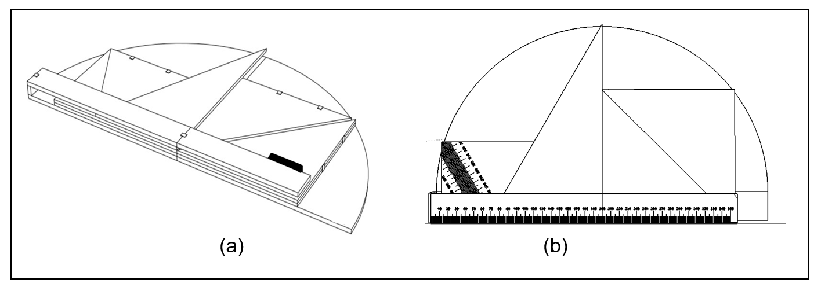
Fig. 1. Isometric drawing of the combined drafting tool (a) and top view in its folded form (b)

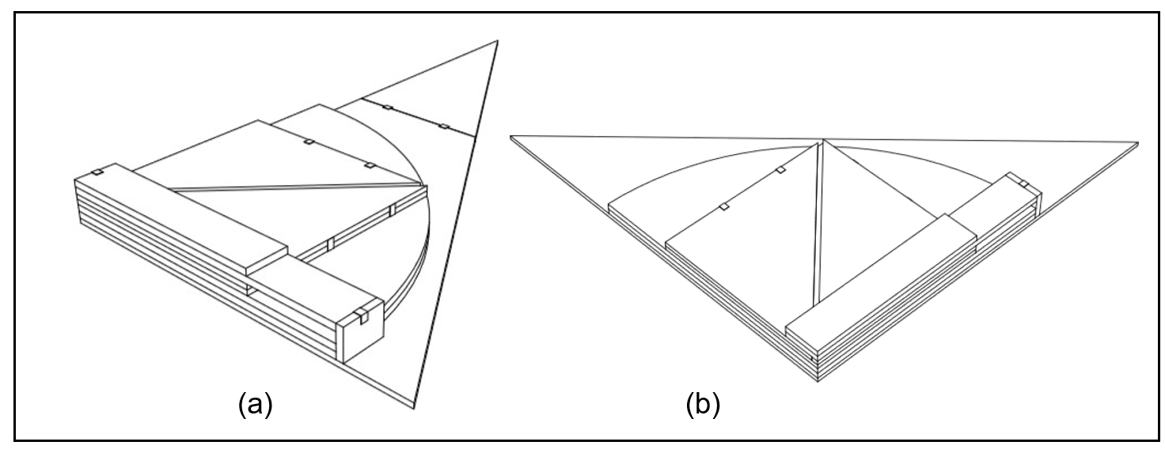
Fig. 2. Isometric drawing of the 30ᴼx60ᴼx90ᴼ triangle of multi-functional drafting tool (a) and its 45ᴼx45ᴼ90ᴼ triangle (b)

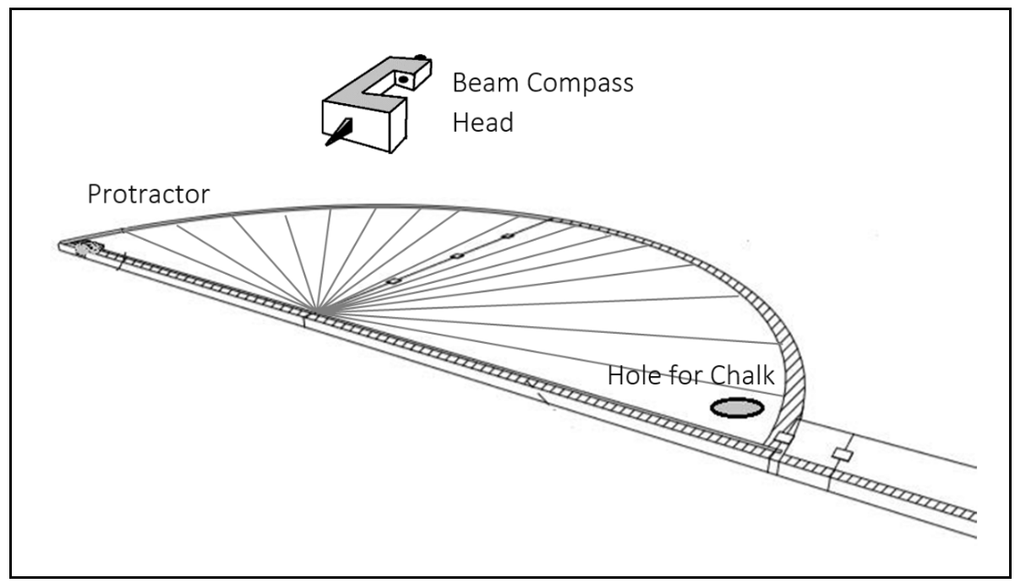
Fig. 3. Isometric drawing of protractor and beam compass functions of multi-functional drafting tool

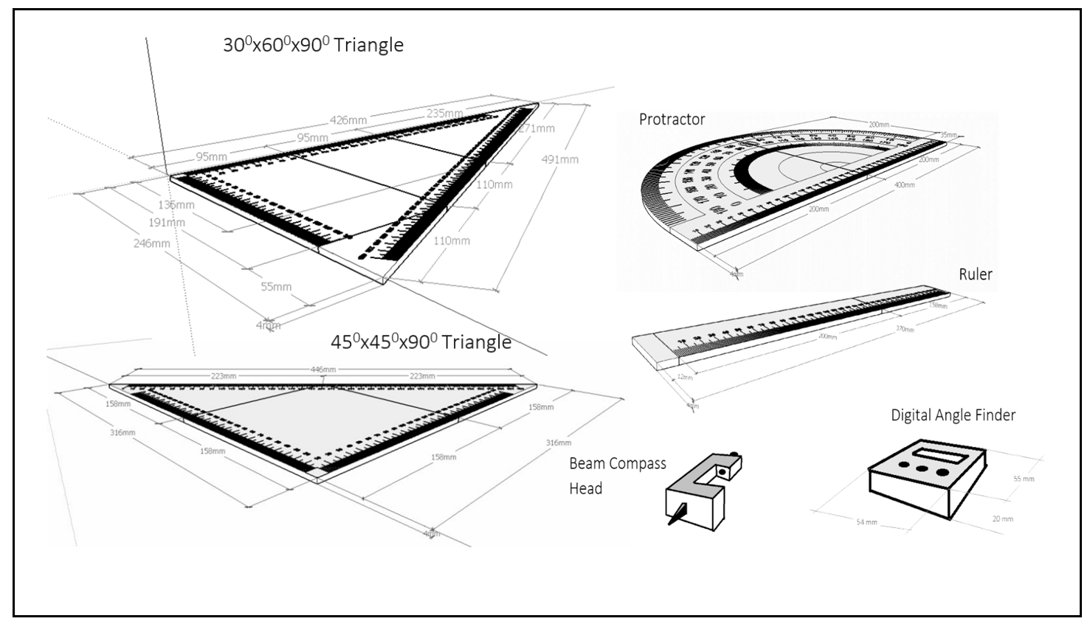
Fig. 4. Exploded view of the multi-functional drafting tool showing the separated 6 instruments of the two types of triangles, protractor, ruler, beam compass, and digital angle finder

2.3 Materials and Dimensions

As to the general dimensions of this multi-functional drafting tool, its weight is 0.5 kilograms. Its height is 3 centimeters with width and length of 40 centimeters, respectively. The main material used is marine plywood. Its measuring graduations are printed with a lock for its folding mechanism, which is a neodymium magnet.

Table 2. Parts of the multi-functional drafting tool
Parts and Specifications | Functions
Beam compass pin (metal, acrylic material) | Holds the instrument as the multi-functional drafting tool draws arcs and circles while fastening by pinning on the blackboard.
Magnet (Neodymium/20mm x 10mm x 2mm) | Holds the folded part of the tool as a lock.
Hinge (metal/20mm x 15mm) | Connects and pivots the parts of the instrument.
Protractor (400 mm basal length) | Allows the user to draw and read angles and oblique lines.
Angle finder (digital/4-button: ON/OFF, Calibrate, Hold, and Unit) | Determines and shows the reading of an angle digitally and automatically.
Ruler (350 mm) | Allows the user to read and draw straight lines.
30°-60°-90° triangle (180 mm x 320 mm x 430 mm) | Allows the user to read and draw lines and angles of 30°, 60°, and 90°.
45°-45°-90° triangle (250 mm x 250 mm x 400 mm) | Allows the user to read and draw lines and angles of 45° and 90°.

Table 2 presents the specific parts of the multi-functional drafting tool, including their material specifications and corresponding roles in facilitating various drafting functions.

Table 3. List of supplies and materials for the fabrication of multi-functional drafting tool
Quantity | Unit | Description
½ | Sheet | Marine Plywood
3 | Pack | Hinges
2 | Set | Neodymium Magnets
2 | Piece | Epoxy Glue
1 | Piece | Angle Finder
1 | Set | Drill Bit and Disk
1 | Piece | Spray Paint

Table 3 presents the supplies and materials utilized for fabricating the multi-functional drafting tool, listing the items along with their quantities, units, and descriptions.

2.4 Evaluation Phase

2.4.1 Evaluators and Sampling

The evaluators were selected through purposive sampling, subjectively describing the population samples chosen based on the experience of teaching and or learning about technical drawing (Bullard, 2024). Forty respondents were chosen, and they assessed the functionality of the combined drafting tool. This number was comprised of 10 teachers and professors in one high school and one university who have proficiency in the technical and theoretical aspects of the project. The other 30 respondents came from first-year and second-year sections at the University of Southern Mindanao and enrolled in technical drawing subjects. These evaluators were chosen according to how the significance of the project study would impact them. As for students enrolled in drafting subjects, they would be the primarily affected individuals once the combined drafting tool is harnessed for the teaching-learning process. As for teachers and professors who have the appropriate knowledge and skills to assess the project’s technical and theoretical dimensions, they could be the ones to make use of the project in a learning milieu.

2.4.2 Instrument and Statistical Treatment

Data on the project's functionality was collected through a survey questionnaire developed by the researcher and validated by 10 university professors. The 40 respondents answered the instrument after the researcher demonstrated how to use the tool to draw a heptagon on a board.

The evaluation of the project was quantitative, considering that the survey used a Likert scale. There was a column containing 30 descriptions of the tool’s functionality. Other columns comprise the assessment scale, where evaluators are checked using a gauge of 1- 5, as shown in Table 4. The questionnaire included profiles of evaluators, and for teachers and professors, inclusions were name, gender, educational attainment, certifications, and nature of work. As for the student- evaluators, the profile asked for name, gender, year and section, school name, and address.

Table 4. Criteria for rating the functionality of the multi-functional drafting tool
Rating | Range | Qualitative Interpretation
5 | 4.50 – 5.00 | Highly Functional
4 | 3.50 – 4.49 | Functional
3 | 2.50 – 3.49 | Moderately Functional
2 | 1.50 – 2.49 | Slightly Functional
1 | 1.00 – 1.49 | Not Functional

Table 4 shows the measures in the survey questionnaires that were resorted to check the functionality of the multi-functional drafting tool.

Descriptive statistics were employed using weighted means to assess the functionality of the tool. Respondents' answers were summarized and interpreted using frequency counts and percentage distribution.

Furthermore, to evaluate the precision of the drawing tool, a linear precision test was performed in the Department of Science and Technology Region X. The process involved checking the tool against a standard measurement to identify any discrepancies in length or angle measurements. Results from the linear calibration determined the tool's level of precision, with any necessary adjustments made to enhance its accuracy. This step ensured that the tool met industry standards for drafting instruments, providing users with confidence in its precision and reliability for professional utilization (Cross Precision Measurement, 2019).

2.4.3 Data Gathering Procedures

This phase started with formulating goals and planning a survey that is focused on testing the functionality of the multi-functional drafting tool. Resources were verified, and arrangements for transportation and communication with respondents were made. Purposive sampling was performed to get 30 students and 10 teachers and professors. Next, a questionnaire was drafted considering the project’s features with guidance from the research adviser. Subsequently, it was validated by professionals from the College of Technology, University of Southeastern Philippines. Communication preparations included drafting a letter requesting permission from institutional heads to conduct the survey. This was followed by securing necessary approvals. Respondents were then shown the features and demonstrated the functions of the instructional drafting tool before the survey was conducted using the prepared questionnaires. Data was processed by tallying responses and calculating results, which were then analyzed to evaluate the tool's functionality. Finally, the responses were stored for the study's exclusive use.

3. results and discussion

The project was appraised on the aspects of functionality and precision. The latter was completed by submitting the multi-functional drafting tool to the Department of Science and Technology for linear tests, where graduations were checked and juxtaposed to the standards in length. To accomplish the assessment, the graduations of the shortest leg of the 30ᴼx60ᴼx90ᴼ triangle were regarded as a sample of the entire tool, for it is flat and gap-free since this part is not along the folding structure of the project. As a result, it was found that the tool’s sample readings did not exceed the estimated uncertainty associated with the corrections of 0.80 mm. Corrections were .30 mm or below.

More so, the level of functionality was determined through a researcher-made questionnaire that competent professionals from the College of Technology, University of Southeastern Philippines, validated. The validation resulted in a weighted mean of 4.56, which indicated the instrument's applicability to the survey. These evaluators demonstrated the use of the tool in geometrically drafting a heptagon in order to come up with a sound assessment of its functionality. After statistical treatment, it was revealed that the multi-functional drafting tool is highly usable as a demonstration tool.

Table 5 shows the questionnaire items that gauged the functionality of the multi-functional drafting tool and its corresponding means. These statistical results emerged from the responses of 40 respondents, including 10 first-year and 20 second-year university students enrolled in drafting subjects and 10 drafting teachers and professors. Consequently, the developed technology acquired an overall weighted mean of 4.71, which indicates highly operational qualitative value. Similar to Clinciu and Clinciu’s (2021) findings on innovative teaching methods stressing student motivation and performance gains through new approaches, the high functionality ratings of the tool suggest that streamlined, user-centered designs positively impact technical drawing instruction.

Table 5. Result of the survey on the functionality of the project
Functions | Mean | Description
1. The 300x600x900 triangle is capable of:
1.1 drawing 300 angle | 4.58 | Highly Functional
1.2 drawing lines of 300 inclination | 4.55 | Highly Functional
1.3 drawing 600 angle | 4.63 | Highly Functional
1.4 drawing lines of 600 inclination | 4.58 | Highly Functional
1.5 drawing 900 angle | 4.80 | Highly Functional
1.6 drawing lines of 900 inclination | 4.75 | Highly Functional
1.7 reading 300 angle | 4.70 | Highly Functional
1.8 reading lines of 300 inclination | 4.70 | Highly Functional
1.9 reading 600 angle | 4.70 | Highly Functional
1.10 reading lines of 600 inclination | 4.65 | Highly Functional
1.11 reading 900 angle | 4.78 | Highly Functional
1.12 reading lines of 900 inclination | 4.75 | Highly Functional
2. The 450x450x900 triangle is capable of:
2.1 drawing 450 angle | 4.80 | Highly Functional
2.2 drawing lines of 450 inclination | 4.68 | Highly Functional
2.3 drawing 900 angle | 4.75 | Highly Functional
2.4 drawing lines of 900 inclination | 4.63 | Highly Functional
2.5 reading 900 angle | 4.75 | Highly Functional
2.6 reading lines of 900 inclination | 4.72 | Highly Functional
3. The protractor is capable of:
3.1 drawing oblique lines of varied degrees | 4.73 | Highly Functional
3.2 drawing angles of varied degrees | 4.75 | Highly Functional
3.3 reading angles | 4.73 | Highly Functional
3.4 reading oblique lines’ angles | 4.73 | Highly Functional
3.5 drawing arcs and semi-circles | 4.75 | Highly Functional
3.6 reading angles and distances of  arcs and semi-circles | 4.68 | Highly Functional
- The angle finder is capable of:  4.1 changing screen figures as the tool is  moved on different inclinations of line | 4.68 | Highly Functional
4.2 reading angles accurately | 4.59 | Highly Functional
5. The ruler is capable of:
5.1 drawing straight lines | 4.83 | Highly Functional
5.2 reading lines’ lengths | 4.75 | Highly Functional
6. The compass is capable of:
6.1 drawing arcs | 4.80 | Highly Functional
6.2 drawing circles | 4.75 | Highly Functional
6.3 bisecting figures (e.g. angles, lines, and circles) | 4.78 | Highly Functional
Total Mean | 4.71 | Highly Functional

Furthermore, Table 6 displays the result of the examination of the multi-functional drafting tool’s triangle leg having a 0- 180 mm range. This was undertaken by the Regional Metrology Laboratory, Department of Science and Technology Region X, by comparison with traceable standards. This calibration result was obtained with a reference temperature of 200C with a tolerance of 20C, relative humidity of 45.9% with a tolerance of 5%, and standards used 0- 1000 mm, Grade 1 steel rule, Mitutoyo.

Table 6. Result of the linear test for precision
Reference Value, mm | Sample Reading, mm | Correction, mm
20 | 19.90 | 0.10
36 | 35.70 | 0.30
54 | 53.70 | 0.30
72 | 71.80 | 0.20
90 | 89.85 | 0.15
108 | 107.85 | 0.15
126 | 125.90 | 0.10
144 | 144.00 | 0.00
162 | 161.95 | 0.05
180 | 179.85 | 0.15

Table 6 details the sample readings of graduations of the multi-functional drafting tool in the second column and the corrections in millimeters in the third column. These figures in the last column were above the standard measures. On the other hand, although only one sample reading, 144 mm, is measured exactly, other values still did not go beyond the estimated uncertainty associated with the correction, which is 0.80 mm.

The survey revealed that the project can be used to perform its intended roles, with the top four functions having the highest ratings.
1. The ruler can draw a straight line.
2. The 30ᴼx60ᴼx90ᴼ triangle is capable of drawing 90ᴼ angle.
3. The 45ᴼx45ᴼx90ᴼ triangle is capable of drawing 45ᴼ angle.
4. The compass is capable of drawing arcs.

The evaluation also resulted in the bottom three, with the lowest ratings being the following.
1. The 30ᴼx60ᴼx90ᴼ triangle is capable of drawing lines of 30ᴼ inclination.
2. The 30ᴼx60ᴼx90ᴼ triangle is capable of drawing lines of 30ᴼ angle.
3. The 30ᴼx60ᴼx90ᴼ triangle is capable of drawing lines of 60ᴼ inclination.

The calibration results from the Regional Metrology Laboratory revealed that the three least inexact sample readings were the following.
1. 144 mm, with no correction
2. 125.90 mm, with 0.10 mm correction
3. 19.90 mm, with 0.10 mm correction

To get the correct value of measurement, the calibration certificate remarked that the value of positive correction must be added to the instrument reading and the value of negative correction to the instrument reading. It was then established that the top imprecise readings were the following:
1. 35.70 mm, with 0.30 mm correction
2. 53.70 mm, with 0.30 mm correction
3. 71.80 mm, with 0.20 mm correction

The multi-functional drafting tool is fabricated to perform varied drafting tasks on the board. It can perform the following operations:
1. draw and read angles and lines of 30ᴼ, 45ᴼ, 60ᴼ and 90ᴼ;
2. draw and read oblique lines and angles of different degrees;
3. draw arcs and circles;
4. read angles and distances of arcs and semi-circles;
5. read and present angles digitally; and
6. bisect or trisect angles, lines, and circles.

4. Conclusion

This study successfully developed a Multi-functional Drafting Tool that addresses key limitations of traditional drafting instruments through its integrated six-function design. Validation tests demonstrated exceptional performance, with functionality surveys yielding an overall high rating and precision tests confirming measurement accuracy within acceptable tolerances. The tool excelled in core functions including straight-line drawing (ruler), 90° angle construction (30°×60°×90° triangle), 45° angle drafting (45°×45°×90° triangle), and arc creation (beam compass). While performance in 30° and 60° angle operations ranked slightly lower, all functions maintained "highly serviceable" ratings, confirming the tool's effectiveness as an instructional aid. The digital angle finder and board-compatible design represent significant improvements over existing solutions, particularly for classroom demonstrations where tool-switching traditionally disrupts instructional flow. Precision testing by the Department of Science and Technology verified the instrument's reliability for educational measurements, with minimal corrections that fall well within practical tolerance for chalk-based drafting.

The study's findings and user feedback yield important recommendations for implementing and improving the Multi-functional Drafting Tool. First and foremost, the tool demonstrates strong potential for classroom implementation despite minor limitations. Its integrated design offers significant advantages for technical drawing instruction, particularly in blackboard demonstrations where tool-switching typically disrupts lesson flow. Educators in drafting and related subjects are encouraged to adopt this tool to enhance teaching efficiency and student engagement.

For optimal performance, several design improvements should be considered. The tool's wooden construction could benefit from thinner materials to reduce overall thickness when folded, improving portability and blackboard usability. Precision cutting of components would ensure proper alignment when folded, while laser-engraved graduations would enhance long-term durability compared to printed markings. The magnetic fastening system could be recessed for both aesthetic improvement and to prevent accidental detachment during use.

Proper maintenance protocols are essential to preserve the tool's functionality. Regular inspections should check hinge mechanisms, measurement edges, and moving parts for wear. After each use, surfaces should be cleaned of chalk residue, and the tool should be stored in a dedicated wall-mounted organizer. The digital angle finder requires particular attention to battery status, with immediate replacement of both batteries when the low-power indicator appears.

Looking ahead, further development could enhance the tool's educational value and market viability. Future research might explore improved angle precision mechanisms, alternative lightweight materials, or smart features like digital measurement logging. Longitudinal studies could assess the tool's impact on student learning outcomes, while market research could guide commercial adaptation.

Conclusively, the study demonstrates the tool's effectiveness as an instructional aid. All integrated components - including the ruler, protractor, beam compass, triangles, and angle finder - performed their designated functions reliably. These findings position the Multi-functional Drafting Tool as a valuable innovation for technical drawing education, combining practical utility with instructional efficiency.

DISCLAIMER (ARTIFICIAL INTELLIGENCE)
The author hereby declares that AI technologies such as Large Language Models have been used during the preparation of this manuscript for grammar checking, proofreading, and improving clarity of language. The author carefully reviewed and revised all suggestions, ensuring the final work reflects his original ideas and adheres to academic standards.
Details of the AI usage are given below:
DeepSeek-V3 Model

References

Ahmad, A. (2025, April 22). Mastering the system design interview: Landing your dream job. Design Gurus. https://www.designgurus.io/blog/mastering-the-system-design-interview-landing-your-dream-job
Arslan, A. R., & Dazkir, S. S. (2017). Technical drafting and mental visualization in interior architecture education. International Journal for the Scholarship of Teaching and Learning, 11(2), Article 15. https://doi.org/10.20429/ijsotl.2017.110215
Boling, E., Gray, C. M. (2015). Designerly tools, sketching, and instructional designers and the guarantors of design. In B. Hokanson, G. Clinton, & M. W. Tracey (Eds.), The design of learning experience: Creating the future of educational technology (pp. 103–115). Springer. https://doi.org/10.1007/978-3-319-16504-2_8
Bullard, E. (2024). Purposive sampling. EBSCO Research Starters: Social Sciences and Humanities. https://www.ebsco.com/research-starters/social-sciences-and-humanities/purposive-sampling
Clinciu, M. R., & Clinciu, R. (2021). Current perspectives on innovative methods used in teaching technical drawing. IOP Conference Series: Materials Science and Engineering, 1009(1), 012014. https://doi.org/10.1088/1757-899X/1009/1/012014
Cross Precision Measurement. (2019). Linearity calibration – definition & examples. CrossCo. https://www.crossco.com/resources/glossary/metrology-glossary-linearity-calibration/
Da Silva, I. B., & Agostinho, O. L. (2018). A strategy for teaching and learning technical drawing. International Journal of Engineering Education, 34(6), 1939–1950. https://repositorio.usp.br/directbitstream/d39ecfa3-72a2-43d9-8abd-f1dbdc6b823d/APznzaahLWHMggoCnjQx9Zg2pfNkgEEkGgcH2-uVIYVEksFnqiJGmSM1z6oyJ0JhVOuQ5-dT5I9je81fFqSf4zGO7J7rqoJyJqwaerOJdB8UvlmygUKot6FUvM8JuDfJepjcpLK0oWbcLbvCKIePqrs6bJ63Jb7EbSWAb3VmrCjbq_tVrFqvqAhqBut72uVov74fWXIBfJ-96dgZcgd8.pdf
Dhore, V. (2024, July). Introduction of product design & development [Lecture notes]. ResearchGate. https://www.researchgate.net/publication/382679485_Introduction_of_Product_Design_Development
Duren, K. (2024). DFTG-1405 Introduction to Technical Drawing [Syllabus]. Austin Community College. https://lighthouse.apps.austincc.edu/faculty/syllabus?id=499012
Hirumi, A. (2022). Overview of the systematic design process. In Instructional system design (Unit 1). University of Central Florida Pressbooks. https://pressbooks.online.ucf.edu/eme6613ah/chapter/overview-systematic-design-process/
Johnson, M. (2005). Multi-task protractor (U.S. Patent Application No. US20060174503A1). United States Patent and Trademark Office. https://patents.google.com/patent/US20060174503A1/en
Khan, A. (2003). Multi-function drafting instrument (U.S. Patent Application No. US20030154608A1). United States Patent and Trademark Office. https://patents.google.com/patent/US20030154608A1/en
Manandhar, R., & Khadka, S. S. (2024). Teaching engineering drawing in Kathmandu University—Exploring faculty preparedness, methods and assessment. In A. Varma, V. C. Sharma, & E. Tarsi (Eds.), Proceedings of the 2nd International Conference on Trends in Architecture and Construction (ICTAC 2024) (Vol. 527, pp. 889–900). Lecture Notes in Civil Engineering. Springer. https://doi.org/10.1007/978-981-97-4988-1_79
Rathore, M., & Gadge, L. (2024). Study of the difficulties and challenges faced by engineering students in engineering drawing. International Journal for Research in Applied Science and Engineering Technology, 12(12). https://doi.org/10.22214/ijraset.2024.65934
Smart, J. (2024, May 20). What is instructional design? (+ examples and tips!). SessionLab. https://www.sessionlab.com/blog/what-is-instructional-design/#:~:text=In%20the%20preparation%20phase%2C%20instructional%20designers%20gather,your%20team%20would%20like%20them%20to%20achieve.​
Song, Y. (2012). Multifunctional set square (CN103879202A). CNIPA. https://patents.google.com/patent/CN103879202A/en
Yusop, F. D. (2022, January 27). Design and development research (DDR) [Conference presentation]. PPS Research Skills Workshop, UniSZA, Malaysia. https://www.researchgate.net/publication/358139014_Design_and_Development_Research_DDR

