A Systematic Review of Educational Leadership Practices in Achieving Sustainable Development Goals

Abstract

This systematic review looks at how Sustainable Development Goals (SDGs) and educational leadership practices intersect through an analysis of 34 research articles published between 2020 and 2024. Following the PRISMA guidelines and Campbell and Cochrane Economics Methods Group protocols, the study synthesizes current research trends, methodological approaches, and theoretical frameworks in the field. The results show that the education sector places a strong priority on social justice, with 28 instances of Quality Education (SDG 4), followed by SDG 5: Gender Equality and SDG 10: Less Inequality. Digital Learning Integration emerged as the most researched topic, reflecting the sector's technological transformation, while Community Engagement showed limited representation. The methodological analysis indicates a preference for qualitative approaches (41%), with quantitative (35%) and mixed methods (24%) showing balanced representation. Theoretically, the field demonstrates a sophisticated integration of transformational leadership theory, systems thinking, and sustainable development theory. However, geographical distribution shows a bias toward developed countries (45%), with developing countries (35%) and cross-cultural settings (20%) receiving less attention. The study identifies critical gaps in environmental sustainability research and community engagement, recommending expanded focus on these areas and increased attention to cross-cultural contexts. The predominance of Quality Education (SDG 4), coupled with a substantial focus on Gender Equality (SDG 5) and Reduced Inequalities (SDG 10), demonstrates the education sector's commitment to addressing social inequities through leadership initiatives. This commitment is further reflected in the research methodologies employed, with a balanced distribution between qualitative and quantitative approaches indicating a mature field of study. These findings contribute to understanding how educational leadership can better support SDG implementation while highlighting areas requiring additional research attention to create more comprehensive and inclusive sustainable development approaches in education. Future research should prioritize cross-cultural studies and investigations in developing countries to address the current geographical imbalance in the literature.

Keywords: Sustainable Development Goals, Educational Leadership, Systematic Review, Quality Education, Digital Learning Integration

1. Introduction

The integration of Sustainable Development Goals (SDGs) into educational leadership practices presents a complex challenge for educational institutions worldwide. Education for peace, sustainable development and global citizenship is enshrined in the UN’s SDG Target 4.7, which focuses on equipping learners with ‘knowledge and skills needed to promote sustainable development (Mochizuki & Vickers, 2024). Despite the UN's emphasis on sustainable development in education, there remains a significant disconnect between theoretical frameworks and practical implementation at the leadership level (Fia et al., 2022). Educational leaders struggle to effectively align their institutional policies and practices with SDG objectives while maintaining academic excellence and addressing local educational needs (Ferrer-Estévez & Chalmeta, 2021).
Higher education institutions are among the different types of organizations that are responsible for creating a sustainable future. They should contribute to sustainable development by teaching students and researching sustainability, knowledge dissemination and integration with industry. They develop the future generation of leaders, policymakers and decision-makers in the area of sustainable development more than any other single sector of society (Iqbal & Piwowar-Sulej, 2022). Countries like Qatar (Zguir et al., 2021), Japan (Fiel’ardh et al., 2023), and India (Priyadarshini & Abhilash, 2020) have reported difficulties in fully incorporating SDGs into their educational leadership frameworks. Studies from these nations indicate challenges in measuring SDG implementation impacts, training educational leaders in sustainability practices, and balancing competing priorities. Finland has documented similar struggles in creating cohesive policies that bridge the gap between sustainable development objectives and educational management practices (Balinggan, 2023).
In the Philippines, the integration of SDGs in educational leadership faces unique challenges due to resource constraints, geographical disparities, and varying institutional capacities (Albert et al., 2023). Local studies indicate that while the Department of Education has policies supporting SDG implementation, school leaders often lack the necessary tools, training, and support systems to effectively integrate sustainable development principles into their leadership practices. This situation is particularly evident in rural and underserved areas (Ceblano et al., 2023).
While existing literature extensively covers either SDGs or educational leadership separately, there is a notable absence of systematic reviews that comprehensively examine their intersection. Current research lacks a thorough analysis of how educational leadership practices specifically contribute to or hinder SDG achievement. Additionally, there is limited understanding of the conceptual frameworks that could guide the successful integration of SDGs into educational leadership practices.
The pressing need for this study stems from the approaching 2030 deadline to attain the United Nation's SDGs and the critical role of education in this global agenda. The rapid changes in educational landscapes, coupled with emerging sustainability challenges, demand immediate attention to how educational leadership can effectively support SDG implementation. Without such understanding, educational institutions risk falling short of their potential contribution to sustainable development objectives.

Research Questions

The aim of this study is to give a thorough grasp of the conceptual framework of the current investigation of sustainable development goals in leadership practices in education. Specifically, this study aims to answer the following questions:
1. Which sustainable development goals are examined in the sphere of education?
2. Which study topics are most popular, and what are the main conclusions drawn from them?
3. How far along are the main components of research design—such as research methodologies, guiding theories, and study contexts—in examining sustainable development goals in the field of education?

2. Method

This systematic review was conducted following the criteria of Preferred Reporting Items for Systematic Reviews and Meta-Analyses (O'Dea et al., 2021). The search parameters, information gathering, synthesis, and critical evaluation have also been conducted in accordance with The Cochrane Economics Methods Group and Campbell recommendations (Wang et al., 2021).

2.1. Search Strategy

A comprehensive search was carried out to locate relevant papers published in databases between 2020 and 2024. The researcher used the databases Web of Science and the International Database of Education Systematic Reviews (IDESR) to search for published articles. Using backward and forward snowball searches, the researcher found more publications on Google Scholar based on the reference lists of the included articles. To guarantee the work's reproducibility and transparency, Appendix 1 contains the specifics of the search technique, including key phrases and initial hits.

2.2. Inclusion and Exclusion Criteria

In order to ensure academic rigor and quality of research, the researcher only included studies that met the following criteria in the review: (1) studies had to be published in peer-reviewed research journals, conference proceedings, or scholarly books; (2) only research studies published between 2020 and 2024 would be included to capture the most recent intersections between educational leadership practices and the Sustainable Development Goals (SDGs); (3) studies published in English that directly address the integration of SDGs in educational contexts; and (4) original studies, meta-analyses, and systematic reviews, and empirical studies that show application of SDGs into school leadership practices.
The researcher excluded studies that: (1) do not specifically focus on educational applications and instead discuss SDGs in general or in other sectors; (2) examine SDGs that are not relevant to current educational leadership practices; and (3) are not available in full-text format or cannot be accessed through institutional subscriptions.

2.3. Selection and Data Extraction

The researcher downloaded the first hits after every search in the aforementioned databases. Then, he evaluated all titles and abstracts to choose the pertinent research based on the inclusion and exclusion criteria after duplicates were eliminated. A flow chart of the study selection procedure is displayed in chart 1.

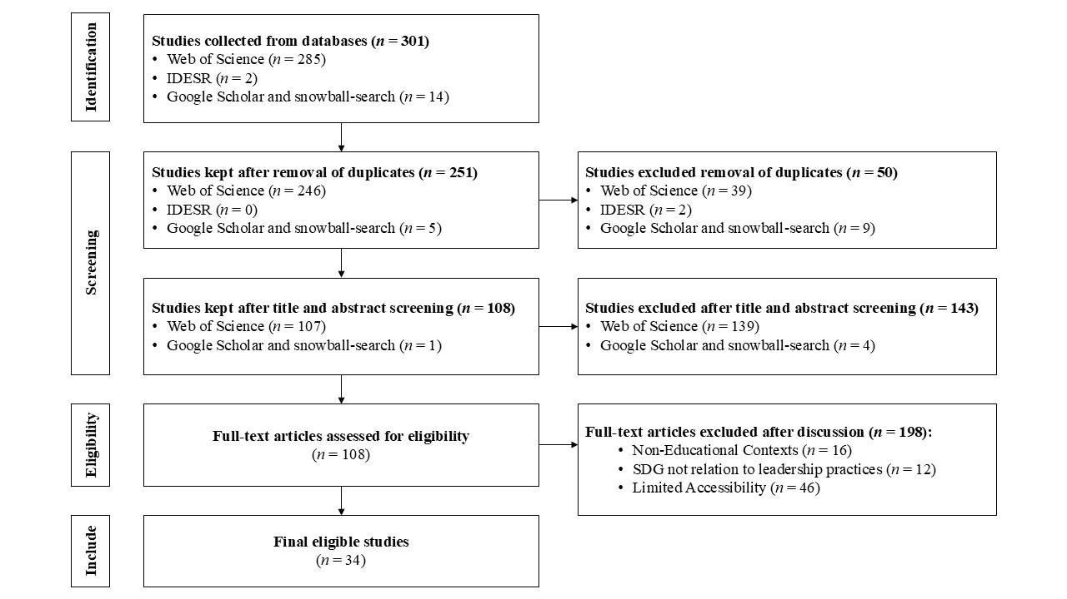
Fig 1. Flow chart depicting the process of the study selection for the systematic review.
The researcher did the selection of the papers and subsequently examined a random sample of included and rejected studies following the initial evaluation to verify the comparability of the studies. The whole text of the remaining research was evaluated against the inclusion criteria after papers that satisfied the exclusion criteria during the initial screening were eliminated. Any discrepancies were then discussed and a consensus was established.

3. Results and Discussion

3.1. SDGs Explored in Education Research

Figure 2 shows the synthesis of the Sustainable Development Goals explored in the 34 research on education articles.

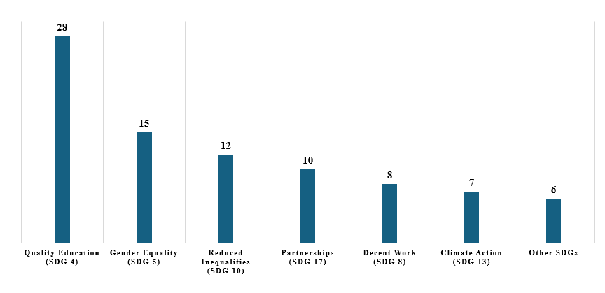
Figure 2. Sustainable Development Goals Explored in Education Research

The data reveals a pronounced emphasis on Quality Education (SDG 4) in educational research, accounting for the highest frequency with 28 occurrences. This predominant focus aligns with findings from Laumann et al. (2022), who identified SDG 4 as a central node connecting multiple sustainable development objectives. The significant attention to Quality Education reflects the education sector's natural gravitation toward this goal, while simultaneously highlighting the sector's potential to address broader sustainability challenges through educational interventions.
Gender Equality (SDG 5) and Reduced Inequalities (SDG 10) emerge as the second and third most explored goals, with 15 and 12 occurrences respectively. This pattern supports research by Unterhalter et al. (2022) demonstrating the intrinsic relationship between educational access, gender parity, and social equality. The substantial focus on these equality-oriented SDGs suggests that educational leadership increasingly recognizes its role in addressing systemic social disparities through institutional policies and practices.
The relatively lower representation of Climate Action (SDG 13) and other environmental SDGs presents an interesting gap in current educational research priorities. Despite mounting global environmental concerns, only 7 studies focused on climate action, echoing findings by Pizzutilo and Venezia (2021) about the limited integration of environmental sustainability in educational leadership frameworks. This underrepresentation suggests an opportunity for educational institutions to more actively engage with environmental SDGs, particularly given schools' potential to influence environmental awareness and action among younger generations.

3.2. Predominant Research Topics

Figure 3 shows the synthesis of the predominant research topics on Sustainable Development Goals explored in the 34 education research articles.

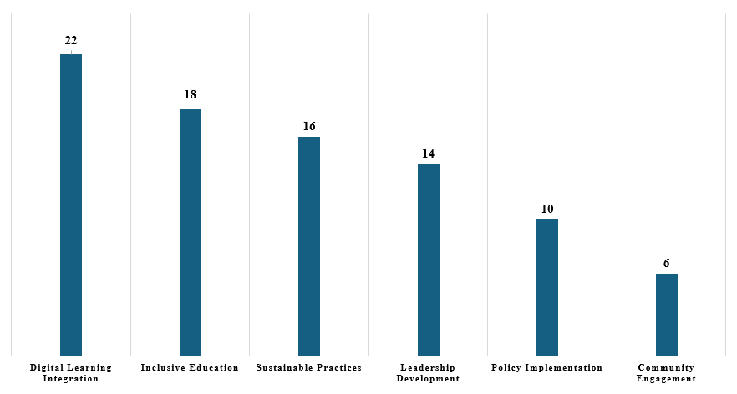
Figure 3. Predominant Research Topics on Sustainable Development Goals explored in Education Research

The prominence of Digital Learning Integration as the most frequently studied topic (22 occurrences) reflects the education sector's rapid technological transformation. This finding aligns with research by Adi Badiozaman et al. (2022), who documented the accelerated adoption of digital learning platforms in response to global educational disruptions. The high frequency of digital learning studies suggests that educational leaders are prioritizing technological innovation while grappling with questions of accessibility, effectiveness, and equity in digital education delivery.
Inclusive Education and Sustainable Practices emerge as the second and third most researched topics, with 18 and 16 occurrences respectively. These findings correspond with Hajisoteriou and Sorkos (2023) observation that educational institutions are increasingly focusing on creating inclusive learning environments while simultaneously pursuing sustainable operational practices. The substantial attention to these areas indicates a growing recognition among educational leaders of their responsibility to foster both social inclusion and environmental sustainability within their institutions.
Leadership Development and Policy Implementation collectively account for 24 studies, highlighting the sector's focus on institutional capacity building. However, the relatively low frequency of Community Engagement research (6 occurrences) suggests a potential oversight in the literature, particularly given Eweje et al.'s (2021) emphasis on the crucial role of community partnerships in achieving educational sustainability goals. This gap indicates a need for more research exploring how educational leaders can effectively engage with broader community stakeholders to advance sustainable development initiatives.

3.3. Research Methods Distribution

Figure 4 shows the synthesis of the research methods, theoretical frameworks, and research contexts in the exploration of the Sustainable Development Goals among the 34 education research articles.

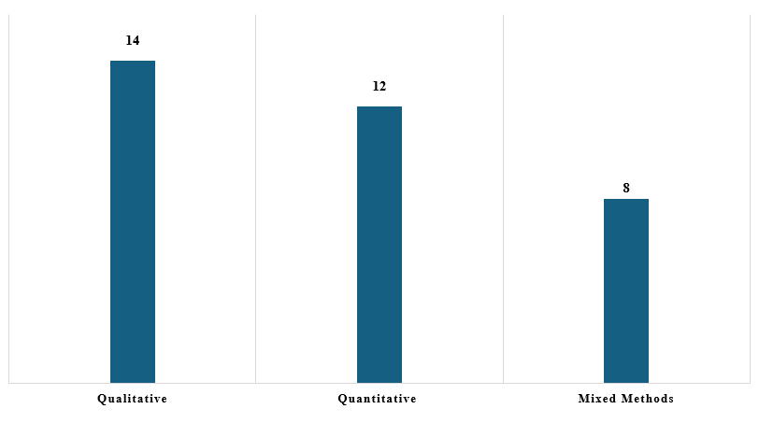
Figure 4. Research Methods Distribution

The methodological distribution reveals a clear preference for qualitative research approaches (41%), suggesting researchers' inclination toward understanding the nuanced complexities of sustainable development in educational leadership. This aligns with Figueiró et al.'s (2022) findings that qualitative methods are particularly effective in capturing the multifaceted nature of sustainability initiatives and their implementation challenges in educational settings.
The relatively balanced representation between qualitative (41%) and quantitative (35%) approaches, with mixed methods comprising 24%, indicates a mature research field employing diverse methodological tools. This methodological diversity echoes recommendations by Caniglia et al. (2021) who emphasize the importance of methodological pluralism in understanding the intersection of sustainable development and educational leadership, particularly when examining complex organizational changes and policy implementations.
On the other hand, the theoretical landscape demonstrates a sophisticated integration of established frameworks, with transformational leadership theory emerging as a dominant lens through Safaruddin et al.'s (2023) work. This theoretical choice reflects the field's recognition that sustainable development in education requires transformative approaches that can catalyze systemic change while engaging stakeholders at multiple levels.
The complementary use of systems thinking and sustainable development theory, as evidenced in Green et al.'s (2021) and Iqbal and Piwowar-Sulej’s (2022) work respectively, suggests a growing appreciation for holistic theoretical frameworks. This theoretical triangulation aligns with Sajjad et al.’s (2024) assertion that complex educational challenges require multifaceted theoretical approaches that can capture both the systemic nature of sustainability challenges and the leadership practices needed to address them.
Exploring further, the geographical distribution of research contexts, with 45% of studies conducted in developed countries, points to a continuing dominance of Global North perspectives in educational leadership research. This imbalance reflects broader patterns identified by Abo-Khalil (2024) regarding the need for more diverse geographical representations in sustainability leadership studies, particularly given the unique challenges faced by educational institutions in different economic contexts.
The presence of cross-cultural studies (20%) alongside research in developing countries (35%) suggests an emerging recognition of the importance of diverse contextual perspectives. However, as noted by Zickafoose et al. (2024), this distribution still indicates a significant gap in understanding how sustainable development goals are pursued in different cultural and economic contexts, particularly in terms of how educational leadership practices adapt to local conditions and constraints.

4. Conclusions and Recommendations

The systematic review reveals significant patterns in the intersection of Sustainable Development Goals and educational leadership practices. The predominance of Quality Education (SDG 4), coupled with a substantial focus on Gender Equality (SDG 5) and Reduced Inequalities (SDG 10), demonstrates the education sector's commitment to addressing social inequities through leadership initiatives. This commitment is further reflected in the research methodologies employed, with a balanced distribution between qualitative and quantitative approaches indicating a mature field of study. However, the limited attention to environmental SDGs, particularly Climate Action (SDG 13), alongside the underrepresentation of community engagement research, suggests critical gaps in current educational leadership practices.
Based on these findings, it is recommended that educational institutions and researchers expand their focus to include more environmental sustainability initiatives and strengthen community partnerships. Future research should prioritize cross-cultural studies and investigations in developing countries to address the current geographical imbalance in the literature. Additionally, educational leaders should consider adopting more integrated theoretical frameworks that combine transformational leadership with systems thinking and sustainable development theory to better address the complex challenges of implementing SDGs in educational settings. These recommendations aim to create a more comprehensive and inclusive approach to sustainable development in educational leadership.

Disclaimer (Artificial intelligence)
Option 1:
Author(s) hereby declare that NO generative AI technologies such as Large Language Models (ChatGPT, COPILOT, etc.) and text-to-image generators have been used during the writing or editing of this manuscript.
Option 2:
Author(s) hereby declare that generative AI technologies such as Large Language Models, etc. have been used during the writing or editing of manuscripts. This explanation will include the name, version, model, and source of the generative AI technology and as well as all input prompts provided to the generative AI technology
Details of the AI usage are given below:
1.
2.
3.

References

Abo-Khalil, A. G. (2024). Integrating sustainability into higher education challenges and opportunities for universities worldwide. Heliyon. DOI: 10.1016/j.heliyon.2024.e29946
Adi Badiozaman, I. F., Leong, H. J., & Wong, W. (2022). Embracing educational disruption: A case study in making the shift to a remote learning environment. Journal of Applied Research in Higher Education, 14(1), 1-15. DOI: https://doi.org/10.1108/JARHE-08-2020-0256
Albert, J. R. G., Basillote, L. B., Alinsunurin, J. P., Vizmanos, J. F. V., Muñoz, M. S., & Hernandez, A. C. (2023). Sustainable Development Goal 4 on Quality Education for All: How Does the Philippines Fare and What Needs to Be Done?. Retrieved on January 4, 2025 from https://hdl.handle.net/10419/284615.
Balinggan, L. F. (2023). A Long Way To Go: A Comparative Study on the Implementation of Education for Sustainable Development in Secondary Education in Finland and the Philippines. Retrieved on January 4, 2025 from https://www.doria.fi/bitstream/handle/ 10024/186953/balinggan_laila_fe.pdf?sequence=3&isAllowed=y
Caniglia, G., Lüderitz, C., von Wirth, T., Fazey, I., Martín-López, B., Hondrila, K., ... & Lang, D. J. (2021). A pluralistic and integrated approach to action-oriented knowledge for sustainability. Nature Sustainability, 4(2), 93-100. DOI: https://doi.org/10.1038/s41893-020-00616-z
Ceblano, M. V., Canlas, I. P., & Japay, R. (2023). Leadership for Sustainable Development in Public Rural Schools. In SDGs in the Asia and Pacific Region (pp. 1-20). Cham: Springer International Publishing. DOI: https://doi.org/10.1007/978-3-030-91262-8_87-1
Eweje, G., Sajjad, A., Nath, S. D., & Kobayashi, K. (2021). Multi-stakeholder partnerships: A catalyst to achieve sustainable development goals. Marketing Intelligence & Planning, 39(2), 186-212. DOI: https://doi.org/10.1108/MIP-04-2020-0135
Ferrer-Estévez, M., & Chalmeta, R. (2021). Integrating sustainable development goals in educational institutions. The International Journal of Management Education, 19(2), 100494. DOI: https://doi.org/10.3390/su14031273
Fia, M., Ghasemzadeh, K., & Paletta, A. (2022). How higher education institutions walk their talk on the 2030 agenda: a systematic literature review. Higher education policy, 1. DOI: https://doi.org/10.1057/s41307-022-00277-x
Fiel’ardh, K., Torkar, G., Rožman, H., & Fujii, H. (2023, November). Sustainable development goals in teacher education: comparing syllabi in a Japanese and a Slovenian university. In Frontiers in Education (Vol. 8, p. 1215500). Frontiers Media SA. DOI: https://doi.org/10.3389/feduc.2023.1215500
Figueiró, P. S., Neutzling, D. M., & Lessa, B. (2022). Education for sustainability in higher education institutions: A multi-perspective proposal with a focus on management education. Journal of Cleaner Production, 339, 130539. DOI: https://doi.org/10.1016/j.jclepro.2022.130539
Green, C., Molloy, O., & Duggan, J. (2021). An empirical study of the impact of systems thinking and simulation on sustainability education. Sustainability, 14(1), 394. DOI: https://doi.org/10.3390/su14010394
Hajisoteriou, C., & Sorkos, G. (2023). Towards a new paradigm of “Sustainable Intercultural and inclusive education”: A comparative “blended” approach. Education Inquiry, 14(4), 496-512. DOI: https://doi.org/10.1080/20004508.2022.2071016
Iqbal, Q., & Piwowar-Sulej, K. (2022). Sustainable leadership in higher education institutions: social innovation as a mechanism. International Journal of Sustainability in Higher Education, 23(8), 1-20. DOI: https://doi.org/10.1108/IJSHE-04-2021-0162
Laumann, F., von Kügelgen, J., Uehara, T. H. K., & Barahona, M. (2022). Complex interlinkages, key objectives, and nexuses among the Sustainable Development Goals and climate change: a network analysis. The Lancet Planetary Health, 6(5), e422-e430. DOI: 10.1016/S2542-5196(22)00070-5
O'Dea, R. E., Lagisz, M., Jennions, M. D., Koricheva, J., Noble, D. W., Parker, T. H., ... & Nakagawa, S. (2021). Preferred reporting items for systematic reviews and meta‐analyses in ecology and evolutionary biology: a PRISMA extension. Biological Reviews, 96(5), 1695-1722. DOI: https://doi.org/10.1111/brv.12721
Pizzutilo, F., & Venezia, E. (2021). On the maturity of social responsibility and sustainability integration in higher education institutions: Descriptive criteria and conceptual framework. The International Journal of Management Education, 19(3), 100515. DOI: https://doi.org/10.1016/j.ijme.2021.100515
Priyadarshini, P., & Abhilash, P. C. (2020). From piecemeal to holistic: Introducing sustainability science in Indian Universities to attain UN-Sustainable Development Goals. Journal of Cleaner Production, 247, 119133. DOI: https://doi.org/10.1016/j.jclepro.2019.119133
Safaruddin, S., Ibrahim, M. A., Rusdi, M., & Hasniati, H. (2023). Unlocking Potential: The Role of Transformational Leadership in Achieving Sustainable Development Goals at the Village Level in Gowa Regency. International Journal of Multicultural and Multireligious Understanding, 10(5), 431-437. DOI: http://dx.doi.org/10.18415/ijmmu.v10i5.4835
Sajjad, A., Eweje, G., & Raziq, M. M. (2024). Sustainability leadership: An integrative review and conceptual synthesis. Business Strategy and the Environment, 33(4), 2849-2867. DOI: https://doi.org/10.1002/bse.3631
Unterhalter, E., Longlands, H., & Peppin Vaughan, R. (2022). Gender and intersecting inequalities in education: Reflections on a framework for measurement. Journal of Human Development and Capabilities, 23(4), 509-538. DOI: https://doi.org/10.1080/19452829.2022.2090523
Wang, X., Welch, V., Li, M., Yao, L., Littell, J., Li, H., ... & Grimshaw, J. M. (2021). The methodological and reporting characteristics of Campbell reviews: A systematic review. Campbell Systematic Reviews, 17(1), e1134. DOI: https://doi.org/10.1002/cl2.1134
Zguir, M. F., Dubis, S., & Koç, M. (2021). Embedding Education for Sustainable Development (ESD) and SDGs values in curriculum: A comparative review on Qatar, Singapore and New Zealand. Journal of Cleaner Production, 319, 128534. DOI: https://doi.org/10.1016/j.jclepro.2021.128534
Zickafoose, A., Ilesanmi, O., Diaz-Manrique, M., Adeyemi, A. E., Walumbe, B., Strong, R., ... & Dooley, K. (2024). Barriers and Challenges Affecting Quality Education (Sustainable Development Goal# 4) in Sub-Saharan Africa by 2030. Sustainability, 16(7), 2657. DOI: https://doi.org/10.3390/su16072657
Mochizuki, Y., & Vickers, E. (2024). Still ‘the conscience of humanity’? UNESCO’s vision of education for peace, sustainable development and global citizenship. Compare: A Journal of Comparative and International Education, 54(5), 721-730.
Iqbal, Q., & Piwowar-Sulej, K. (2022). Sustainable leadership in higher education institutions: social innovation as a mechanism. International Journal of Sustainability in Higher Education, 23(8), 1-20.

