Sustainability in Biopharma: A Review of Environmental Considerations in Manufacturing Processes

Abstract
Waste disposal, CO2 emissions, plastic use, air pollution, and energy and water consumption—including that associated with the transportation and refrigeration of pharmaceuticals—all contribute to the substantial environmental effect of pharmaceutical enterprises. According to figures from 2019, pharmaceutical companies' CO2 emissions were 13% more than those of the automobile sector. To adopt a more sustainable approach, pharmaceutical companies should prioritize investments in eco-friendly production and supply methods, establish standard criteria, implement rewards programs, and provide staff training. Paracelsus famously noted in the sixteenth century that "the dose makes the poison, Because only a small portion of the population receives a given dosage, environmental concentrations of medicines expelled by people are usually modest. Recent research, however, has shown that direct emissions from the production of pharmaceuticals can lead to far greater environmental discharges, frequently exceeding dangerous threshold values. The dangers involved are not affected by consumption patterns since manufacturing is confined. Furthermore, human metabolism does not lower the concentrations of these medications since they are not consumed. As a result, manufacturing-related environmental hazards cover a wider variety of medications than excretion-related ones. Manufacturing pollution is less common, yet it may nevertheless have an impact on the entire world by encouraging the growth of microbes that are resistant to drugs.
Key words: Environmental impact, CO₂ emissions, Waste disposal, pharmaceutical manufacturing, Drug-resistant microorganisms
1. INTRODUCTION
The hazard that pharmaceutical pollution poses to ecosystems and human health is becoming more widely acknowledged. All phases of a pharmaceutical's life cycle—production, usage, and disposal—can result in environmental contamination. As a result, they may find their way into our drinking water and build up in fish and vegetables. Surface water, sewage effluents, groundwater, drinking water, manure, soil, and other environmental matrices across the world have all been shown to contain pharmaceutical residues [Pharmaceuticals in the environment: Our Haleon viewpoint, n.d.]. According to scientific data, medicines can impair both plant and animal life even at low environmental quantities. These consequences include fish reproductive problems, vulture renal failure, and stunted development in some aquatic animals [Jean-Yves Stenuick, 2020]. For the future of biopharmaceutical production, continuous manufacturing offers a number of encouraging prospects, including improved scalability, lower prices, and higher efficiency. Numerous cutting-edge methods are presently being investigated for the continuous upstream and downstream purification of biologics [Jagschies et al., 2018]. The use of perfusion bioreactors and techniques for continuous downstream operations have advanced significantly, despite the lack of truly continuous processes for commercially accessible biologics and the existence of major technological obstacles. Other barriers to adopting this technology include regulatory uncertainty, risk aversion (e.g., hesitancy to convert a working batch process to a continuous one), and difficulties with data analysis and integration, in addition to the technical difficulties of converting a biomanufacturing process to a fully continuous system [Alper, 2019].The environmental effect of Biopharmaceutical Continuous Manufacturing (BCM) in comparison to conventional batch methods is a frequently disregarded feature. It is well known that choices made throughout the production process have a big impact on the environment and the health of the planet. There is still much to be taken into account, despite some attempts to compare batch procedures with BCM and estimate the environmental effect of biopharmaceutical production. Since the existing fragmented understanding of the impact of different components of BCM systems may result in inaccurate information on their environmental effects, a thorough review of this issue is necessary. For example, even if consumables account for a small portion of the total environmental effect, the widespread use of disposable manufacturing equipment (also known as single-use technologies, or SUT) in BCM processes may indicate that they are less sustainable than batch processes. employing monoclonal antibodies (mAbs) as the main example, we will review the research on the environmental effects of fixed-facility batch production vs flexible facilities employing BCM in this two-part series [John F et al., 2022].
Biotechnologies are used to generate biopharmaceuticals, which are medications that structurally resemble substances occurring in the body. Certain medications, such as cytokines, enzymes, hormones, clotting factors, vaccinations, monoclonal antibodies, cell treatments, antisense pharmaceuticals, and peptide therapeutics, have the potential to treat diseases rather than only treat their symptoms and have fewer adverse effects due to their specificity. The production of monoclonal antibodies is one example of emerging biopharmaceutical technology ( Sekhon, 2010).
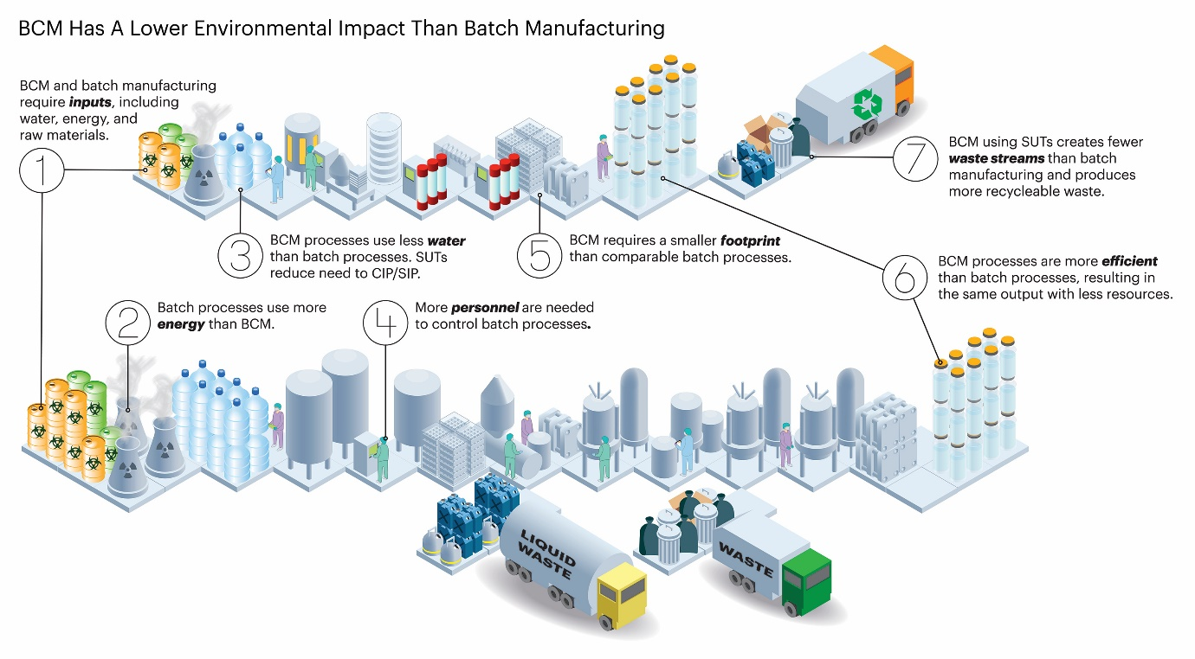
Figure 1: Measuring the Environmental Impact of a Manufacturing Process [John F et al., 2022]
The environmental effect of a biomanufacturing process is influenced by a number of elements, including process efficiency, water and power consumption, and the physical footprint of the manufacturing facility. There are now quantitative evaluations of how biomanufacturing techniques affect the environment. One such measure is Process Mass Intensity (PMI), which calculates the total mass input (in kilograms) required to generate one kilogram of output material in order to analyze the efficiency of a manufacturing process. PMI operates as a preliminary comparison between two comparable processes, even if it does not include all environmental consequences. [John F. and others, 2022].
PMIs are often greater in biological manufacturing methods that employ fermenters or bioreactors than in those that produce small molecule active pharmaceutical ingredients (APIs). For example, a monoclonal antibody (mAb) yield of 1 kilogram takes around 7,700 kg of input materials, but the usual small molecule API process has a PMI of 100 to 200 kg/kg. This input consists of raw materials, additional consumables needed in the production stream, and water for media and buffers. However, because it ignores elements like water required for cleaning equipment, electricity used to operate the facility, and trash produced during the operation, PMI is not a perfect tool for assessing environmental impacts. To conduct a thorough environmental impact assessment, more metrics are thus required [Environmental Metrics | EME 807: Technologies for Sustainability Systems].
Global Warming Potential (GWP), Cumulative Energy Demand (CED), and Life Cycle Assessment (LCA) are more encompassing approaches to quantifying environmental effect. These measures take into account other elements in addition to PMI. LCA looks at how a process affects the environment at every stage, from the extraction of raw materials to the disposal of trash. LCA can analyze the environmental impacts of processes with comparable PMIs but differing total environmental effects, despite the fact that it requires a lot of time and resources and substantial environmental impact data. [John F. and others, 2022]
LCA creates an inventory of environmental consequences across a number of areas, including material and energy use, and necessitates well-defined system limits. Two processes with comparable PMIs but dissimilar environmental effects can be compared using this thorough evaluation. The process's life cycle stages are also taken into account by other metrics like CED and GWP. The supply chain phase, the usage phase (including clean-in-place/sterilize-in-place operations [CIP/SIP]), and the end-of-life phase—which entails recycling durable components and disposing of consumables—are the three stages that these assessments usually comprise. These several metrics are useful for assessing a manufacturing process's total environmental effect [LCA approaches for buildings, 2001].
It used to be thought that the major ways that drugs got into the environment were through use or inappropriate disposal. However, it has been shown that some production facilities release pharmaceutical concentrations into the environment at far greater levels than those caused by drug use. Both the pharmaceutical industry and regulatory bodies now have serious concerns about the pervasiveness of pharmaceutical residues in environmental samples and the resulting threats to animal habitats.In 2010, Shalini et al.
The production of biopharmaceuticals may have a major effect on human health and the environment. Environmentally speaking, the industrial procedures used in the creation of biopharmaceuticals can produce a variety of waste products, such as biological materials and chemical wastes. When these wastes are improperly disposed of, they can pollute the air, water, and soil, which might endanger animals and ecosystems. Furthermore, energy-intensive production methods have the potential to worsen climate change by increasing greenhouse gas emissions. Human health can also be affected by biopharmaceutical manufacturing, both directly and indirectly. Occupational exposure to hazardous substances during the manufacturing process can pose risks to workers' health if proper safety measures are not in place. Furthermore, if contaminants from manufacturing processes are released into the environment, they can potentially enter the food chain and water supply, leading to unintended human exposure[Herold et al., 2023]..
In recent times, there has been a notable shift towards prioritizing climate change and the risks associated with environmental harm. It's imperative for businesses, individuals, public administrations, and policymakers to incorporate environmental concerns into their decision-making processes. (Hartini et al.,2022). The most influential factors affecting the environment are the utilization of resources and population growth. Given the critical importance of the environment, disruptions caused by climate change could lead to global instability. ISO has established a comprehensive quality management system addressing both product quality and environmental concerns. Presently, the company is dedicated to minimizing its environmental footprint (Paul et al., 2014). Of all the toxins of growing concern, pharmaceuticals are the ones that cause the most anxiety. The production, consumption, and waste management phases of a drug's life cycle represent potential points of entry into various environmental matrices. Two factors have drawn particular attention to psychiatric medications. To start, more people are using them. Secondly, a large number of them have the ability to impact numerous non-target organisms because they operate on neuroendocrine systems that are phylogenetically highly conserved. ( Julene et al ., 2021) .
As drugs can have ecotoxicological impacts on microbes, flora, fauna, and even human health because they are made to have pharmacological effects at low concentrations. The biopharmaceutical industry produces a diverse range of drugs and products derived from biological sources such as vaccinations, recombinant proteins, gene therapy products, and monoclonal antibodies. Throughout the manufacturing process of these pharmaceuticals, various toxic substances can be released into the environment, including chemical solvents, biological waste, residual contaminants, and air emissions. These pollutants pose threats to both human health and the environment if not effectively handled. Biopharmaceutical businesses use stricter safety and environmental regulations, cleaner production technologies, waste management techniques, and comprehensive risk assessments to reduce environmental impact and safeguard human health in order to allay these worries [Sharma et al., 2023].
A complicated web of channels allows pharmaceuticals to enter the environment, underscoring the complexity of this expanding issue. Direct release from industrial sources, indirect release through biological excretion, and inappropriate disposal of unwanted drugs are the three basic categories into which these routes may be generally divided. (Ashiwaju & colleagues, 2024). It is impossible to overestimate the significance of raw materials in the production of biopharmaceuticals as they are essential to process efficiency and product quality. It has become more and more important to precisely fingerprint essential raw materials within the Quality by Design (QbD) framework. The importance of raw materials as a possible source of variability in process control and product quality is highlighted by regulatory recommendations like ICH Q8. (Anurag and others, 2018).
Controlling the environmental and human health impacts of biopharmaceuticals requires a multifaceted approach that addresses various stages of the drug lifecycle and potential pathway of contamination. Efficient methods to control the environmental and human health impacts of biopharmaceuticals include implementing green chemistry principles to minimize hazardous substances and waste generation during manufacturing. Pharmaceutical residues may be efficiently eliminated by advanced wastewater treatment technology prior to release into the environment, and their release can be avoided by appropriate disposal practices and pharmaceutical take-back initiatives. Environmental effect is further reduced by public education on responsible drug use and research into sustainable production methods, while strict regulatory control guarantees adherence to environmental norms. This comprehensive strategy promotes environmental sustainability and human health by addressing different phases of the drug lifecycle and possible contamination routes [Moermond et al., 2022].
The purpose of this review is to increase knowledge, promote more study, and aid in the development of sensible and practical policies. This study aims to provide a solid foundation for future initiatives to address the expanding issue of pharmaceutical pollution in the environment by discussing the difficulties as well as possible solutions.
LITERATURE SURVEY
Sustainability in biopharmaceutical manufacturing has gained significant scholarly attention due to the environmental impacts associated with traditional production processes. Multiple studies have identified key areas of concern, including excessive energy consumption, water usage, waste generation, and reliance on non-renewable resources (Sartorius, 2020; Raut et al., 2021). Life Cycle Assessment (LCA) has emerged as a crucial tool for evaluating environmental impacts across the product lifecycle, from upstream bioprocesses to downstream purification and packaging (Li & Zhang, 2022; D’Angelo et al., 2020). Researchers have highlighted the adoption of green chemistry principles and lean manufacturing as vital strategies for minimizing environmental footprints (Jiménez-González & Constable, 2011). The introduction of single-use technologies and continuous manufacturing has shown promise in reducing energy demand and process-related emissions (Pora, 2016; Eibl et al., 2014). In addition, frameworks for circular economy and resource recovery are increasingly being proposed to manage biopharma waste more sustainably (Rosen & Kishawy, 2012). Despite these advancements, challenges persist in standardizing sustainability metrics, integrating environmental goals with strict regulatory requirements, and scaling green innovations across global facilities (Papageorgiou, 2019; Seuring & Müller, 2008). The literature indicates a growing consensus that sustainable biomanufacturing requires cross-sector collaboration, regulatory support, and continued investment in green innovation.
2. PROFILE OF THE PHARMACEUTICAL INDUSTRY
The production of pharmaceutical goods in the pharmaceutical business involves a variety of techniques. It offers a broad set of waste minimization rules that would be applicable to all drug manufacturing processes because of the variety of these operations. Four techniques utilized in pharmaceutical production are taken into consideration in addition to research and development:
- Development and research
- Synthesis of chemicals
- Extraction of natural products
- Development.

2.1 Development and research
Chemical, microbiological, and pharmacological research are all included in the pharmaceutical industry's research and development (R&D) division. This generates a variety of biological and chemical laboratory byproducts. Halogenated and non-halogenated solvents, photographic chemicals, radionuclides, bases, and oxidizers are among the most frequent chemical wastes generated by the research and development department [Shalini et al., 2010].
2.2 Synthesis of chemicals
Reaction vessels and related equipment are frequently organized into distinct process units and process functions (such as flow rate, pH, and temperature) in drug production facilities in accordance with good manufacturing practice guidelines. The equipment is properly cleaned at the end of the entire operation. Reactants and catalysts, both organic and inorganic, are among the chemicals employed in chemical synthesis processes. Manufacturers employ a wide range of solvents that are classified as priority pollutants10; they are utilized as reaction media, for product recovery, and for purification [Shalini et al.,].
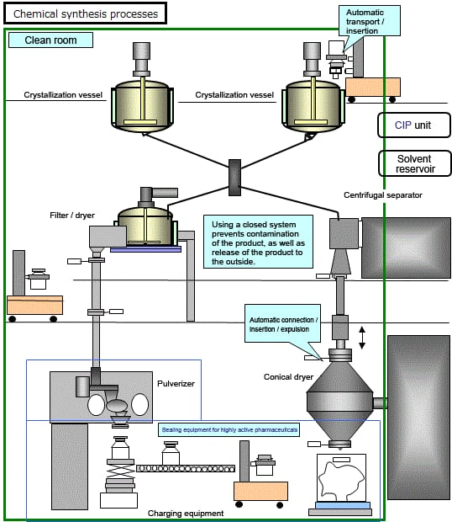
Fig 2: Hitachi, n.d.; Chemical Synthesis Pharmaceutical Plants: Pharmaceutical Plant & Systems
2.3 Extraction of natural products
The process of making medications from natural materials such roots, leaves, bark, and animal glands is known as "natural product extraction." These medications, which usually have special pharmacological characteristics, include insulin, morphine, alkaloids, papaverine, and allergy medications. The quantities of materials are decreased at each stage of the process, and final purification may take place on volumes that are significantly lower than the starting volume. Water-soluble solvents, solvent vapors, waste fluids, and discarded raw materials like leaves and roots are among the wastes from the extraction of natural products. The pH of extraction waste fluids is normally between 6 and 8 [Shalini et al., 2010], and their chemical and biological oxygen demands (BOD and COD) are generally modest.
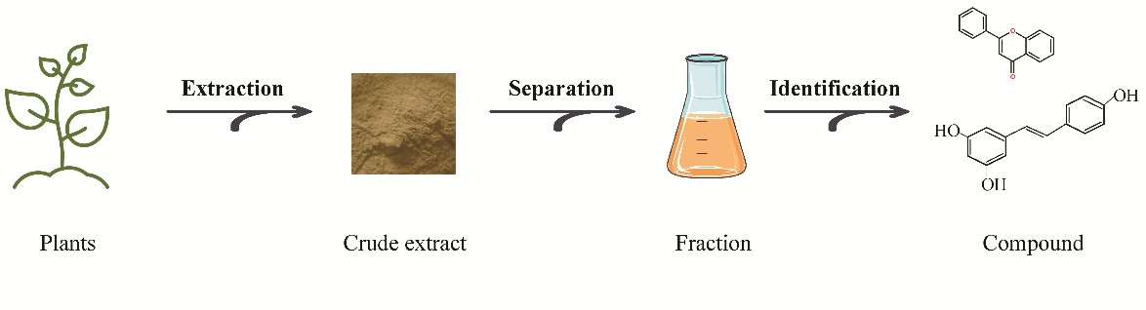
Fig 3: Extraction and Chemical Composition Analysis of Plants and Natural Products (Yang et al., 2023)
2.4 Development.
The creation of different dosage forms, including tablets, capsules, liquids, parenterals, creams, and ointments, is known as pharmaceutical formulation. More than 90% of all oral drugs are in the form of tablets, which come in plain, compressed, coated, and molded varieties 9. The second most popular oral dose form for solid medications is a capsule, either soft or hard. The liquid dosage form for injectable or oral administration, which includes solutions, syrups, elixirs, suspensions, and tinctures, is the third category of pharmaceutical formulation. These forms are often made by combining the solutes with a particular solvent. Typically, ointments are made by melting a base, generally petrolatum, a petroleum derivative. The drug and this base are then combined, and the cooled combination is run through a roller mill or colloid mill [Wang et al., 2022]. Creams are emulsions of water and oil or water and oil. Three primary human activities—chemical pollution, habitat fragmentation, and community alteration—are responsible for a significant portion of ecological changes.
These substances have long-term, extremely harmful effects and are known as persistent bio accumulative toxicants (PBTs) or persistent organic pollutants (POPs), including lead, mercury, and dioxin. A toxin's propensity to rise in concentration when ingested in a succession food chain is known as bioaccumulation. For example, fish have higher quantities of mercury than shellfish, and larger fish have higher concentrations of mercury. The most harmful of these compounds have been reduced to varied degrees by the EPA (Environmental Protection Act), state and local governments, and others through detection and regulation [Shalini et al., 2010].
3. OVERVIEW OF BIOPHARMACEUTICAL MANUFACTURING PROCESS
According to the European Medicines Agency, biopharmaceuticals derived from biological sources are thought to pose little environmental risk and are linked to the groundbreaking treatment of several illnesses. Even though improved technology has made it possible to manipulate biopharmaceuticals to create more effective medications, there is currently no widely accepted classification or categorization of these substances, which raises concerns about their biological origins and potential risks [citations].

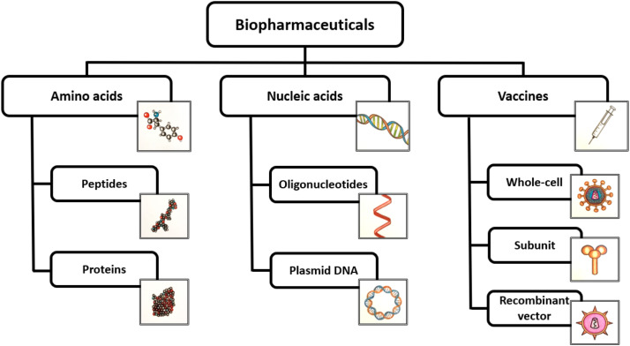
Fig 4: Classification of Biopharmaceutical Substances
Source: (Definition, categorization, and environmental risk assessment of biopharmaceuticals. Science of The Total Environment, 789, 147884. Rasmussen et al., 2021)
Biological medicines, encompassing biopharmaceuticals and vaccines, constitute a vast array of therapeutic and preventive agents derived from various sources and synthesized through different methods. These medicines span a spectrum from small organic molecules extracted from plants to complex macromolecules such as proteins, DNA, RNA, and entire viral or bacterial entities. Biopharmaceuticals, serving the purpose of treating diseases, are meticulously crafted macromolecular entities intended for either acute or long-term therapeutic interventions.
They are manufactured through intricate processes involving cultures of eukaryotic or prokaryotic cells, isolation from natural sources, or synthetic methodologies. However, they distinctly exclude small molecules like antibiotics. The term "biopharmaceuticals" encompasses a broad spectrum of biotherapeutics, including therapeutic proteins or those derived from human plasma, and this book primarily delves into the production processes of recombinant biotherapeutics. Specifically, it covers the manufacturing of immunoglobulin G (IgG) from human plasma, vaccine production, and cell production for therapeutic purposes. Vaccines, on the other hand, are designed for disease prevention, inducing a long-lasting immune response that confers immunity against specific pathogens.
Unlike biopharmaceuticals, vaccines often consist of larger complexes such as subcellular structures or attenuated viruses or bacteria. These biological entities contain antigens that trigger the immune system, leading to the generation of long-term immunity. While both biopharmaceuticals and vaccines are crucial in healthcare, they present distinct challenges in production due to their diverse structures and purposes. Despite these differences, they collectively contribute to the advancement of therapeutic and preventive medicine, catering to a wide range of medical needs with their unique mechanisms of action and production methodologies. ( Jagschies 2018).
3.1 Upstream Processing:
In upstream processing, the journey towards producing biopharmaceuticals begins with cell line development. This involves selecting or engineering cell lines capable of producing the desired product efficiently and consistently. Once a suitable cell line is identified, it undergoes a series of expansions in small-scale culture vessels known as seed trains. These seed trains are crucial for generating a large quantity of cells necessary for inoculation into the production bioreactor. Once the cells are ready, they are carefully transferred into the production bioreactor, where they will undergo controlled cultivation. To maximize cell growth and production, parameters including temperature, pH, dissolved oxygen levels, and agitation rate are carefully monitored and modified inside the bioreactor [citations].
Samples are collected for examination at several points during the culture process to guarantee the cells' well-being and production. Usually using methods like centrifugation or filtering, the cells are removed from the bioreactor after they have reached the appropriate stage of development and production. To maintain process uniformity, a subset of the collected cells may be saved as a cell bank for later use.Cleaning and sterilization of equipment are essential after each batch to prevent contamination and maintain product integrity. This comprehensive approach to upstream processing lays the foundation for the successful production of high-quality biopharmaceutical products.
4. SOURCES OF BIOPHARMACEUTICAL POLLUTION
The production of pharmaceuticals, human and animal waste, and inappropriate medication disposal are the three main causes of the complicated problem of pharmaceutical residues polluting our ecosystems [additional details and problems]. Pharmaceutical residues can be released during the production of pharmaceuticals, through urine and feces after use in domestic animals or people, through usage on plants in some situations, and by improper disposal of leftover medications (Boxall et al., 2012).
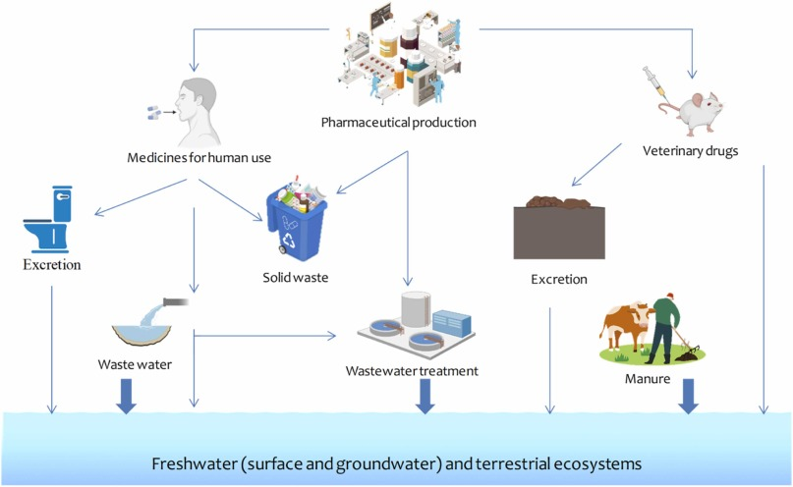
Fig 5: Source of Pharmaceutical Pollution
Source: (Extensive analysis of clay materials' ability to adsorb pharmaceutical compounds from wastewater) Oumaima Fraiha et al., 2023
4.1 Manufacturing of Pharmaceuticals
Since pharmaceuticals are produced on a huge scale, the industry itself is the first major source of pollution. Manufacturing facilities frequently discharge effluents into wastewater streams in spite of stringent controls. If appropriate treatment procedures are not followed or are not successful, these effluents, which include active pharmaceutical ingredients (APIs), may find their way into aquatic habitats. Significant localized pollution results from this issue, which is especially acute in areas with high concentrations of pharmaceutical industry [citations].
4.2 Excretion in Humans and Animals
Human and animal excretion of pharmaceutical residues is the second main cause of pharmaceutical pollution, and it affects almost every home. The body does not completely metabolize all of the APIs that are taken; significant quantities are eliminated through feces and urine and end up in sewage systems. Veterinarian medications exacerbate this problem since their residues can reach the environment directly through the use of manure on agricultural land. As a result, one common and difficult source of pharmaceutical contamination is human and animal excrement [Ortuzer et al., 2022].

4.3 Inappropriate Drug Disposal
Finally, the health of the environment is seriously threatened by the inappropriate disposal of unwanted or expired pharmaceuticals. Since unused medications are frequently disposed of in the trash or flushed down toilets and sinks, they end up in landfill leachate or residential wastewater without having any possibility of being removed or degraded before entering the environment [additional details and problems]. Despite its apparent insignificance, this practice significantly contributes to pharmaceutical pollution on a worldwide basis [citations].
Fig 6: Disposal of Pharmaceuticals on the Environment
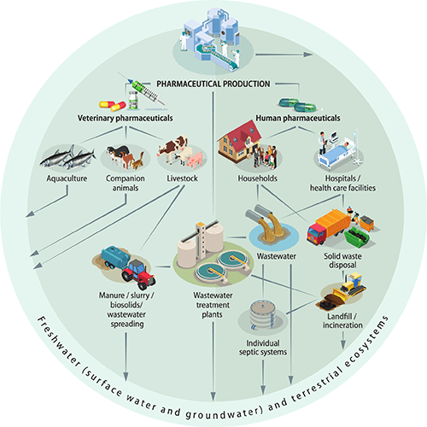
Source: Global Chemicals Outlook II, UNEP, 2019
It is essential to comprehend these sources in order to create methods that effectively reduce the negative effects of medications on the environment. Consequently, every source necessitates a careful examination and a pressing need for long-term fixes.

5. BIOPHARMACEUTICAL MANUFACTURING RESOURCE CONSUMPTION AND UTILIZATION
Water is an essential resource since it is used extensively in the production of biopharmaceuticals at all stages. Water has several uses, such as process water, filtered water, and water for injection (WFI). When WFI is used to formulate injectable medications, it must meet the strictest purity requirements and be devoid of any impurities or contaminants that can jeopardize the final product's efficacy and safety. Purified water is widely used for media and buffer preparation, cleaning, and as a solvent in manufacturing processes. Process water is used for non-product-contact uses like steam production and cooling. When such high-purity water is required, energy-intensive purification techniques are frequently required. One popular technique is distillation, which entails boiling water to produce steam before it condenses back into liquid. The majority of pollutants are adequately removed by this procedure, although it uses a lot of energy. Another popular purification method is reverse osmosis, which filters contaminants out of water by forcing it through semi-permeable membranes. This method works well, but it also uses a lot of energy and creates a concentrated brine byproduct that can be difficult to dispose of. [sources].
Significant environmental effects may result from the extraction of significant amounts of water for these purposes. It can strain local water resources, lower water tables, and decrease river and stream flow, particularly in regions that are vulnerable to drought or water shortages. The plants and animals that rely on these water sources may be impacted by the disruption of aquatic ecosystems caused by this over-extraction. Additionally, it may have socioeconomic effects, such decreasing the amount of water available to nearby villages, farms, and other businesses. Furthermore, a variety of organic compounds, chemicals, and bacteria may be present in the wastewater produced during the production of biopharmaceuticals.
This effluent can cause serious environmental pollution if it is not sufficiently treated before being released. In receiving water bodies, organic compounds can raise the biological oxygen demand (BOD), lowering oxygen levels and endangering aquatic life. Chemical pollutants have the ability to linger in the environment, perhaps making their way into the food chain and harming both human and animal health. If harmful, microorganisms can directly endanger both human and animal health [citations].
To mitigate these issues, biopharmaceutical manufacturers implement rigorous wastewater treatment processes. These typically involve multiple stages, including physical, chemical, and biological treatments, to remove contaminants and ensure that discharged water meets regulatory standards. Advanced treatment technologies such as membrane bioreactors and UV disinfection are also employed to enhance the effectiveness of wastewater treatment, reducing the environmental impact and ensuring that water released back into the environment is safe. In summary, while water is an indispensable resource in biopharmaceutical manufacturing, its use and the resultant wastewater pose significant environmental challenges. Addressing these challenges requires a combination of energy-efficient purification technologies, sustainable water management practices, and robust wastewater treatment systems to minimize the environmental footprint and ensure the sustainable use of water resources. Energy is an essential component in biopharmaceutical manufacturing, powering a wide array of processes and equipment. This includes everything from bioreactors and centrifuges to HVAC systems and sterilization units. The energy demand in these facilities is substantial due to the need to maintain precise environmental conditions, ensure sterility, and power intensive production processes.Traditionally, biopharmaceutical facilities have relied heavily on electricity and steam, with natural gas often used for heating and steam generation. The production of electricity and steam from fossil fuels such as coal, oil, and natural gas is associated with significant environmental consequences.
Fossil fuel combustion releases large quantities of carbon dioxide (CO2), a major greenhouse gas, contributing to global warming and climate change. Additionally, it produces other harmful pollutants like nitrogen oxides (NOx) and sulfur dioxide (SO2), which can lead to air quality degradation, acid rain, and respiratory health issues in nearby populations.The reliance on fossil fuels also means that biopharmaceutical manufacturing facilities have a considerable carbon footprint. High energy consumption, driven by the need to power advanced and energy-intensive equipment continuously, exacerbates this issue.
For example, maintaining cleanroom environments requires extensive heating, ventilation, and air conditioning (HVAC) systems to ensure the air quality and temperature are controlled to strict standards. These HVAC systems are significant energy consumers. Additionally, processes like fermentation and purification require constant operation of large-scale bioreactors, centrifuges, and chromatography columns, all of which draw substantial power. Recognizing the environmental impact, there is a growing shift towards integrating renewable energy sources such as solar, wind, and biomass into the energy mix of biopharmaceutical facilities. Solar panels can be installed on the rooftops of manufacturing plants to harness sunlight and convert it into electricity, reducing reliance on grid electricity derived from fossil fuels. Wind turbines, if feasible based on geographical conditions, can provide a significant portion of a facility's energy needs. Biomass, derived from organic materials, can be used in cogeneration plants to produce both heat and power efficiently. Despite these advances, the transition to renewable energy presents challenges. The initial capital investment for installing renewable energy systems can be high, and the intermittent nature of solar and wind power requires reliable storage solutions or backup systems to ensure a consistent energy supply. However, the long-term benefits of reducing greenhouse gas emissions and operational costs make this transition increasingly attractive.
To further mitigate the environmental impact of energy consumption, biopharmaceutical manufacturers are also implementing energy efficiency measures. These include upgrading to energy-efficient lighting systems, optimizing HVAC operations through smart controls and regular maintenance, and adopting high-efficiency motors and equipment. Conducting energy audits helps identify areas where energy use can be reduced without compromising the quality or safety of the products. Overall, while traditional fossil fuel-based energy production has considerable environmental drawbacks, the biopharmaceutical industry is making strides towards sustainability. By embracing renewable energy sources and enhancing energy efficiency, manufacturers can significantly reduce their carbon footprint, contributing to the fight against climate change and promoting a healthier environment.
This shift not only aligns with global sustainability goals but also meets increasing regulatory and consumer demands for environmentally responsible practices.Raw materials are the cornerstone of biopharmaceutical production, encompassing a variety of biological and chemical components essential for manufacturing therapeutic products. These materials include cell lines, culture media, chemicals, and reagents, each playing a critical role in the production process but also posing significant environmental challenges.
6. THE EFFECTS OF PHARMACEUTICALS ON THE ENVIRONMENT AND HUMAN HEALTH
There are serious environmental and human health issues with the pervasiveness of medications in the environment. When these substances reach the environment, they may have unexpected impacts on creatures and systems that are not their intended targets, even if they were initially created to interact with biological systems in certain ways. Their effects on terrestrial and aquatic ecosystems will be discussed in this section [citations].
Fig 7: Effect of Pharmaceutical Substances on Environment

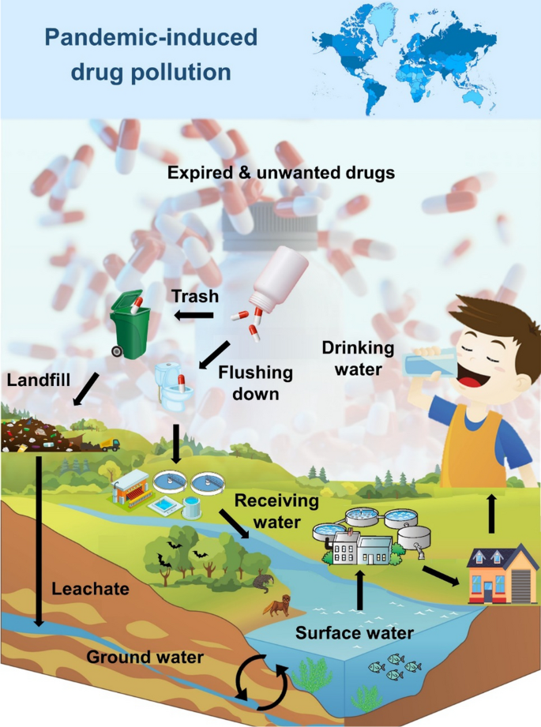
Source: ( waves of pharmaceutical waste ) Hans et al., 2023

6.1 Effects on Aquatic and Terrestrial Wildlife
6.1.1 Aquatic Wildlife
It is still unclear how drugs and their byproducts affect aquatic species biologically and ecotoxicologically. Aquatic creatures confront a variety of chemical hazards since they are constantly exposed to large amounts of wastewater wastes. Because pharmaceuticals are bioactive, they can be extremely dangerous to aquatic habitats. Numerous pharmaceutical residues frequently end up in water bodies including rivers, lakes, and seas, endangering aquatic life such as fish, amphibians, crustaceans, and phytoplankton. These substances can affect organisms at the molecular, cellular, and population levels and have a variety of harmful consequences, ranging from acute to chronic [citations].
For example, feminization of male fish has been associated with synthetic estrogens from contraceptives, resulting in skewed sex ratios and reproductive abnormalities. About 700 kilos of synthetic estrogens and 30,000 kilograms of natural steroidal estrogens are released annually by the world's population, mostly as a result of using birth control pills. Due to renal failure, nonsteroidal anti-inflammatory medications like diclofenac have caused numerous vulture species in Asia to come dangerously close to extinction. Both freshwater and marine animals' eating patterns, growth rates, and predator-prey relationships can be impacted by antidepressants such as fluoxetine [citations].

6.1.2 Terrestrial Wildlife
Pharmaceuticals are also a source of exposure for terrestrial wildlife, particularly that found near water bodies or irrigated areas. Herbivores may be exposed to medications found in the soil since plants can absorb them. Antibiotics and hormones used in cattle production are examples of veterinary medications that might linger in manure. This manure can pollute terrestrial habitats when used as fertilizer, impacting plant health and soil organisms. Pharmaceuticals have complicated ecological effects on the environment that can have repercussions on entire ecosystems. Risk evaluation and prediction can be made more difficult by the additive, antagonistic, or synergistic effects of these substances' interactions with one another or with other environmental pollutants [Grzesiuk et al., 2023].
6.1.3 Potential Human Exposure Pathways
There is currently no conclusive evidence linking prolonged exposure to low concentrations of medicines in the water supply to long-term health effects in humans. The quantitative examination of these hazards does, however, contain ambiguities and inconsistencies. Therefore, more study is necessary to completely comprehend the possible effects on human health. The expected and actual ambient concentrations of active pharmaceutical ingredients (APIs) are determined using a variety of techniques. Pharmaceuticals in the environment can also have an impact on human health, mostly through exposure to tainted food and water sources. Pharmaceuticals have the potential to pollute drinking water, including groundwater and surface water. Although a large percentage of pharmaceutical residues may be eliminated by wastewater treatment procedures, some substances do not break down and wind up in the treated water that is reintroduced into the environment. Both source and processed drinking water have been shown to contain pharmaceuticals, usually in trace amounts.
7. SUGGESTIONS
A comprehensive approach, like the Dutch chain method put out by Moermond and de Rooy, is necessary to address the rising problem of pharmaceutical contamination. This approach incorporates a variety of stakeholders, including consumers and legislators. Public education and awareness efforts are the first important step in handling this issue. These programs can successfully draw attention to the dangers that incorrect medicine disposal poses to the environment and human health. We can drastically lower the quantity of pharmaceutical contaminants that enter our water systems by educating the public about the significance of returning unused medications to pharmacies or approved collection locations rather than flushing them down the toilet or sink [citations]. Systemic reforms can also assist reduce pharmaceutical pollution in addition to individual initiatives. For instance, governments and pharmacies may offer a safe and eco-friendly method for people to get rid of their unwanted or expired prescription drugs by implementing drug take-back programs. Pharmaceutical corporations have a critical role in this matter. To cut waste and lessen the negative effects of medicine manufacture on the environment, these businesses should improve their manufacturing procedures. The environmental burden of pharmaceuticals can be significantly reduced by adopting technologies such as "green chemistry" and encouraging the development of "green" pharmaceuticals, which are medications that are effective in treatment but made to break down quickly in the environment after excretion [citations].Combating pharmaceutical contamination also requires advancements in wastewater treatment technology. The fight against pharmaceutical pollution, an increasingly pressing environmental issue, depends on advancements in wastewater treatment technology. Pharmaceutical chemicals accumulate in water bodies as a result of traditional treatment procedures' frequent failure to eliminate them. New methods that have showed promise in tackling this problem include membrane filtration, biofiltration, advanced oxidation processes (AOPs), and electrochemical treatments. Furthermore, advancements include photocatalysis, enzyme-based therapies, activated carbon adsorption, and nanotechnology-based methods improve the elimination of persistent medications. Constructed wetlands offer a low-energy, environmentally benign alternative, while hybrid systems that combine these techniques offer increased efficiency. When combined, these developments result in wastewater treatment methods that are more sustainable and efficient. Governments and water authorities have to spend money on cutting-edge techniques that may eliminate medications and their byproducts. Protecting water systems against pharmaceutical contaminants, which present serious dangers to aquatic ecosystems and human health, requires the use of creative approaches in wastewater treatment and control. Pharmaceutical chemicals that traditional treatments are unable to remove can be effectively removed by sophisticated technologies such membrane filtration, biofiltration, and advanced oxidation processes (AOPs).Eco-friendly alternatives are also offered by natural treatment methods as charcoal filters and artificial wetlands. Although scalability and affordability are still issues, emerging technologies including nanotechnology and enzyme-based therapies also show promise. Reducing pharmaceutical pollution requires stricter regulatory restrictions, such as more thorough Environmental Risk Assessments (ERAs) and international standards. Progress is hampered by problems such the partial elimination of persistent medications, exorbitant expenses, a lack of public awareness, and regional regulatory differences. In order to safeguard aquatic life and lower the long-term health hazards associated with pharmaceutical pollutants in water systems, it is imperative that these issues be addressed while introducing cutting-edge technology and enhancing public involvement. In order to reduce pharmaceutical contamination, regulation is essential. Regulation is key to reducing pharmaceutical pollution, and more stringent Environmental Risk Assessments (ERAs) are necessary to control the release of pharmaceuticals into the environment. Stricter regulatory frameworks for ERAs of pharmaceuticals can help manage their release into the environment. Regulators can more accurately assess the possible environmental consequences of medications, including their persistence, degradation, and effects on ecosystems, by requiring more stringent pre-market testing. Post-market surveillance also guarantees ongoing pharmaceutical monitoring, spotting long-term hazards that might not be apparent at first. Making ERA data publicly available can improve accountability and empower stakeholders to make well-informed choices. In order to stop inappropriate disposal, which is a primary cause of pharmaceutical contamination, improved rules should also support safe medication disposal practices, such as take-back programs. Nonetheless, there are also issues that make cross-border initiatives to mitigate pharmaceutical pollution more difficult, such as uneven international regulatory requirements. Comprehensive environmental testing for medications is still lacking in many nations, particularly for older pharmaceuticals that might not have passed contemporary risk evaluations. To reduce pharmaceutical pollution and safeguard the environment, it is imperative to strengthen ERAs, harmonize international standards, and hold pharmaceutical firms accountable through extended producer responsibility (EPR).
This may entail stricter rules governing the production and disposal of pharmaceutical waste, as well as legislation guaranteeing that drugs are incorporated into environmental monitoring initiatives. According to Paut Kusturica et al. (2022), it makes more sense to address pharmaceutical pollution from its source rather than concentrating just on enhancing removal procedures once these compounds have reached the environment [Ashiwaju et al., 2024].

8. CONCLUSION
The public uses pharmaceuticals on a regular basis because they are physiologically active substances. Wastewater and sludge from sewage treatment plants have the greatest quantities of waste medicines. It is clear that these drugs have a big effect on nature, especially when it comes to altering susceptibility and causing associated clinical symptoms via influencing host immunology and physiology. Before putting any environmental measures or thorough environmental risk assessments (ERAs) into place, it is crucial to choose which medications to monitor because of the enormous number of pharmaceutical drugs used globally. Reverse distributors are now used by the pharmaceutical industry to retrieve unwanted medications from pharmacies and medical facilities. A more comprehensive pharmaceutical take-back scheme that involves the general population may be built upon this approach. An project of this kind can potentially be seen as a continuation of the pharmaceutical industry's existing product stewardship initiatives. Pharmaceutical firms have a greater environmental effect than many other sectors. To reach NetZero as soon as feasible, these businesses must strike a compromise between their corporate goals and environmental sustainability.

Disclaimer (Artificial intelligence)
Option 1:
Author(s) hereby declare that NO generative AI technologies such as Large Language Models (ChatGPT, COPILOT, etc.) and text-to-image generators have been used during the writing or editing of this manuscript.
Option 2:
Author(s) hereby declare that generative AI technologies such as Large Language Models, etc. have been used during the writing or editing of manuscripts. This explanation will include the name, version, model, and source of the generative AI technology and as well as all input prompts provided to the generative AI technology
Details of the AI usage are given below:
1.
2.
3.

REFERENCES
- Alper, J. (Ed.). 2019. Continuous Manufacturing for the Modernization of Pharmaceutical Production: Proceedings of a Workshop.
- Argaluza, J., Domingo-Echaburu, S., Orive, G., Medrano, J., Hernandez, R., & Lertxundi, U. 2021. Environmental pollution with psychiatric drugs. World Journal of Psychiatry, 11(10), 791.
- Ashiwaju, B. I., Uzougbo, C. G., & Orikpete, O. F. 2024. Environmental Impact of Pharmaceuticals: A Comprehensive Review. Matrix Science Pharma, 7(3), 85-94.
- Boxall, A. B. A., Rudd, M. A., Brooks, B. W., Caldwell, D. J., Choi, K., Hickmann, S., et al. 2012. Pharmaceuticals and Personal Care Products in the Environment: What Are the Big Questions? Environmental Health Perspectives, 120, 1221–1229.
- Budzinski, K., Blewis, M., Dahlin, P., D'Aquila, D., Esparza, J., Gavin, J., et al. 2019. Introduction of a process mass intensity metric for biologics. N Biotechnology, 49, 37-42.
- Budzinski, K., Constable, D., D'Aquila, D., Smith, P., Madabhushi, S. R., et al. 2022. Streamlined life cycle assessment of single-use technologies in biopharmaceutical manufacture. N Biotechnology, 68, 28-36.
- Bunnak, P., Allmendinger, R., Ramasamy, S. V., Lettieri, P., & Titchener-Hooker, N. J. 2016. Life-cycle and cost of goods assessment of fed-batch and perfusion-based manufacturing processes for mAbs. Biotechnol Prog, 32, 1324-1335.
- Deloitte. 2016. Options for a Strategic Approach to Pharmaceuticals in the Environment. Task 1 Report – Revised Version. Available at: https://ec.europa.eu/info/sites/info/files/study_report_public_consultation_pharmaceuticals_environment.pdf
- Ebert et al. 2011. Toxicity of the Fluoroquinolone Antibiotics Enrofloxacin and Ciprofloxacin to Photoautotrophic Aquatic Organisms. Environmental Toxicology and Chemistry, 30(12), 2786-2792. Available at: https://www.ncbi.nlm.nih.gov/pubmed/21919043
- Flanagan, W., Brown, A., Pietrzykowski, M., Pizzi, V., Monge, M., & Sinclair, A. 2011. An environmental life cycle assessment comparing single-use and conventional process technology. Biopharm Int, 2011.
- Gerstweiler, L., Bi, J., & Middelberg, A. P. J. 2021. Continuous downstream bioprocessing for intensified manufacture of biopharmaceuticals and antibodies. Chemical Engineering Science, 231.
- Gjoka, X., Gantier, R., & Schofield, M. 2017. Transfer of a three-step mAb chromatography process from batch to continuous: Optimizing productivity to minimize consumable requirements. J Biotechnol, 242, 11-18.
- Han, J., He, S., & Lichtfouse, E. 2023. Waves of pharmaceutical waste. Environmental Chemistry Letters, 21(3), 1251-1255.
- Hartini, S., Sari, D. P., & Ningrum, D. T. K. 2023. Assessment of the Environmental Impact of Drug Products Using Life Cycle Assessment: A Case Study in a Pharmaceutical Company, Semarang. Jurnal Presipitasi: Media Komunikasi dan Pengembangan Teknik Lingkungan, 20(1), 140-152.
- Herold, N. 2023, August 15. Improving sustainability in the biopharmaceutical industry. Meco, June 5, 2024. Available at: https://www.meco.com/improving-sustainability-in-the-biopharmaceutical-industry
- Ho, S. V., McLaughlin, J. M., Cue, B. W., & Dunn, P. J. 2010. Environmental considerations in biologics manufacturing. Green Chemistry, 12(5), 755-766.
- Jagschies, G., Lindskog, E., Lacki, K., & Galliher, P. M. (Eds.). 2018. Biopharmaceutical Processing: Development, Design, and Implementation of Manufacturing Processes. Elsevier.
- Kokai-Kun, J. F. 22 C.E., August 8. What’s the environmental impact of biopharma continuous manufacturing? Part I. Available at: https://www.bioprocessonline.com/doc/what-s-the-environmental-impact-of-biopharma-continuous-manufacturing-part-i-0001
- Khanal, O., & Lenhoff, A. M. 2021. Developments and opportunities in continuous biopharmaceutical manufacturing. MAbs, 13, 1903664.
- Kusturica, M. P., Jevtic, M., & Ristovski, J. T. 2022. Minimizing the environmental impact of unused pharmaceuticals: Review focused on prevention. Front Environ Sci, 10, 1077974. doi: 10.3389/fenvs.2022.1077974.
- Linke, B., Huang, Y.-C., & Dornfeld, D. 2012. Establishing greener products and manufacturing processes. International Journal of Precision Engineering and Manufacturing, 13, 1029-1036.
- Ma, J., & Li, L. 2024. VOC emitted by biopharmaceutical industries: Source profiles, health risks, and secondary pollution. Journal of Environmental Sciences, 135, 570-584.
- Madabhushi, S. R., Gavin, J., Xu, S., Cutler, C., Chmielowski, R., et al. 2018. Quantitative assessment of environmental impact of biologics manufacturing using process mass intensity analysis. Biotechnol Prog, 34, 1566-1573.
- Moermond, C. T., Puhlmann, N., Brown, A. R., Owen, S. F., Ryan, J., et al. 2022. Greener pharmaceuticals for more sustainable healthcare. Environmental Science & Technology Letters, 9(9), 699-705.
- Nash et al. 2004. Long-term exposure to environmental concentrations of the pharmaceutical Ethynylestradiol causes reproductive failure in fish. Environmental Health Perspectives, 112(17), 1725-1733. Available at: https://www.ncbi.nlm.nih.gov/pubmed/15579420
- Ortúzar, M., Esterhuizen, M., Olicón-Hernández, D. R., González-López, J., & Aranda, E. 2022. Pharmaceutical pollution in aquatic environments: A concise review of environmental impacts and bioremediation systems. Frontiers in Microbiology, 13, 869332.
- Paul, I. D., Bhole, G. P., & Chaudhari, J. R. 2014. A review on green manufacturing: Its importance, methodology, and application. Procedia Materials Science, 6, 1644-1649.
- Rasmussen, A. S. B., Hammou, A., Poulsen, T. F., Laursen, M. C., & Hansen, S. F. 2021. Definition, categorization, and environmental risk assessment of biopharmaceuticals. Science of The Total Environment, 789, 147884.
- Rathore, A. S., Kumar, D., & Kateja, N. 2018. Role of raw materials in biopharmaceutical manufacturing: Risk analysis and fingerprinting. Current Opinion in Biotechnology, 53, 99-105.
- Renteria Gamiz, A. G., De Soete, W., Heirman, B., Dahlin, P., et al. 2019. Environmental sustainability assessment of the manufacturing process of a biological active pharmaceutical ingredient. Journal of Chemical Technology & Biotechnology, 94(6), 1937-1944.
- Sekhon, B. S. 2010. Biopharmaceuticals: An overview. Thai J. Pharm. Sci, 34(34), 1-19.
- Shalini, K., Anwer, Z., Sharma, P. K., Garg, V. K., & Kumar, N. 2010. A review on pharma pollution. Int J Pharmtech Res, 2(4), 2265-2270.
- Sharma, A. K., Sharma, M., Sharma, A. K., & Sharma, M. 2023. Mapping the impact of environmental pollutants on human health and the environment: A systematic review and meta-analysis. Journal of Geochemical Exploration, 107325.
- Swan et al. 2006. Removing the threat of Diclofenac to critically endangered Asian vultures. PLoS Biology, 4(3), e66. Available at: https://journals.plos.org/plosbiology/article?id=10.1371/journal.pbio.0040066
- Verdecia, M., Kokai-Kun, J. F., Kibbey, M., Acharya, S., Venema, J., & Atouf, F. 2021. COVID-19 vaccine platforms: Delivering on a promise? Human Vaccines & Immunotherapeutics, 17(9), 2873–2893. Available at: https://doi.org/10.1080/21645515.2021.1911204
- Zhang, M., Zhao, J., Dai, X., & Li, X. 2023. Extraction and analysis of chemical compositions of natural products and plants. Separations, 10(12), 598.

