Additional site record of an Indian Giant Squirrel (Ratufa indica indica) with potential habitat connectivity in northern Sahyadri Western ghats and discussion on new sighting records across Maharashtra from various News sources

ABSTRACT
The Indian Giant Squirrel (Ratufa indica), a large arboreal rodent mammal endemic to India’s tropical forests, is experiencing habitat fragmentation and decline due to local hunting. During routine works in Biodiversity Park of Konkan Krishi Vidyapeeth, Dapoli in the summer month May, a sighting of R. i. indica was recorded for the first time in Dapoli, Ratnagiri district, Maharashtra, outside its previously known range. The squirrel was observed foraging and nesting in a biodiversity park surrounded by orchards and exotic plantations. Dapoli, located within the Northern Western Ghats, offers varied vegetation types and may serve as a corridor connecting known populations to new habitats. Study accumulates all the new sighting records from news reports to present the small-scale movement of species within the Maharashtra state. These records suggest a possible range expansion, potentially driven by habitat adaptability and the availability of food sources in orchards. The finding highlights the need for revisiting subspecies distribution and ensuring the conservation of emerging corridors vital for sustaining viable metapopulations of this iconic species.

Keywords: Ratufa indica indica, wander individuals, new sighting, northern western ghats, Konkan, Dapoli, orchard diversity

INTRODUCTION
Indian Giant Squirrel Ratufa indica (Erxleben 1777), is arboreal, diurnal, and herbivorous species endemic to tropical forests of India. Occurring at altitudes from 180 to 2,300 meters above sea level often favouring denser riparian growth (Molur et al. 2005 ; Datta & Goyal 1996). Its habitat encompasses wooded areas in Andhra Pradesh, Chhattisgarh, Goa, Gujarat, Jharkhand, Karnataka, Kerala, Madhya Pradesh, Maharashtra, Orissa, and Tamil Nadu. (Srinivasulu et al. 2004; Molur et al. 2005). The species exhibits fragmented distribution primarily due to sensitivity to habitat degradation (Molur et al. 2016). Ratufa indica (R. i.) is a schedule I protected species by Wildlife protection act, 1973, India. It is classified as "least concern," in IUCN red list but with a declining population trend (Molur 2016). Corbet and Hill (1992), following Moore & Tate (1965), identified four subspecies namely R. i. indica, located in the northern and central Western Ghats, R. i. centralis is found in central-east India, particularly in the Satpura Range and the Eastern Ghats. R. i. maxima are from the southern Western Ghats in Kerala. The subspecies from Gujrat’s northern Western Ghats is R. i. dealbata, is extinct (Molur et al. 2005). Given that one unique subspecies has already become extinct from the northern Western Ghats the persistence of another subspecies from northern western ghats is likely under significant threat. This highlights the urgency and conservation relevance of the present findings. Also, Species is vanished from much of western ghats of Maharashtra and constricted in small forest pockets making every report of the species important.
2. MATERIAL AND METHODS
the College of Forestry biodiversity park is under the jurisdiction of Dr. Balasaheb Sawant Konkan Krishi Vidyapeeth (DBSKKV), Dapoli campus, located in Ratnagiri district of the Konkan region, Maharashtra state, India. Situated 650 m above sea level and 7 km from nearest cost line. The park is encircled by mango, cashew orchards. Park has extensive areas of exotics like Acacia mangium, A. auriculiformis, Gliricidia sepium and bamboo septum. Terminalia paniculata (Kinjal), T. arjuna (Arjun) trees, Gmelina arborea plantations is also there. Water availability is less except monsoon channel and excavated pond. This park is harbouring large number of species of butterflies, birds and Mammals. Present observation is done while work in the in the park.
Dapoli lies in the Western Ghats and is characterized by a complex terrain comprising undulating low hills and valleys. The elevation ranges between 20 m and 800 m above sea level. The forest type predominantly includes Southern Tropical Semi-Evergreen and Moist Deciduous Forests (Champion & Seth, 1968), interspersed with lateritic plateaus, riparian corridors, and sacred groves. Vegetation is dominated by species such as Terminalia paniculata, Mangifera indica, Careya arborea, Memecylon umbellatum, and bamboo clumps (Bambusa bambos). The region experiences a humid tropical climate with an annual rainfall exceeding 3,500 mm, primarily during the southwest monsoon (June–September), and moderate to warm temperatures year-round.
numerous traditionally managed sacred groves contribute to habitat connectivity and regional biodiversity. The area holds high conservation value due to its endemic flora and faunal records, making it ecologically significant within the northern Western Ghats landscape. The landscape surrounding Dapoli is interspersed with traditional orchards dominated by the particularly renowned the Alphonso mango, locally known as Hapus (Mangifera indica), Cashew (Anacardium occidentale), and Arecanut (Areca catechu) plantations. These orchards form an integral component of the agroforestry mosaic of the Konkan region. These orchard systems not only provide seasonal livelihoods but also serve as secondary habitats for several species of wild animals, thereby enhancing biodiversity outside forested zones.
Other secondary data is gathered from various local newspapers and online news channels along with social media sites as www.YouTube.com, Facebook, etc. Data gathering is done from May 2018 to January2019. Opportunistic personal communications to locals and forest staffs were also done. Those had sightings are focused and detailed information about sighting (n=2) is taken. Though local personal communications could not provide photographic evidences but repetition of sighting and detailed descriptions are considered authentic. Every location from the news is cross-checked with reputation of News source and whether same sight photo of animal is provided or not. Also, news without actual photographs of animals is withdrawn from the data if it is not from reputed News source. Location of every news and direct sightings were obtained from Google earth engine. After finalizing new records from all these locations according to photos and descriptions subspecies were identified. Map was created using QGIS version 3.36 “Firenze”, 2024.
3. RESULT AND DISCUSSION
On 5 May 2018 at 10:16 AM, a male Ratufa indica was sighted the individual was observed ascending a tree and coming to the ground to forage on fallen fruits of Khaya senegalensis. The species was sporadically observed during the following months, with complete absence recorded in the intervening periods. It was subsequently re-sighted in few months, indicating a possible refuge in the area. and individual might be the wanderer individual. It was again seen at the Biodiversity Park constructing nests on tall trees and feeding on Terminalia. This sighting happened in a region where the species has not been previously reported (Molur et al. 2005). Previous Occupancy modeling studies also did not predicted occupancy in Dapoli region (Prachi et al. 2012).
The fur coloration of the observed individual closely matches that of the Ratufa indica indica subspecies. The dorsal surfaces of the coat and the proximal end (tail base) of the tail display a lush reddish-maroon or brown hue. The distal end of the tail (tail tip) appears whitish or buff in colour (Abdulali & Daniel 1952). This specific colour pattern is restricted to the northern Western Ghats of Maharashtra and some darker coloured population with same colour in parts of Karnataka including Bhadra wildlife sanctuary. R. i. indica is Apart from R.i. centralis subspecies which have black shoulder region, and black base of the tail and white tip (Thorington et al., 2012; Abdulali & Daniel, 1952). R.i. maxima are also Western ghats dweller but it has darker rump and shoulder and entire tail black. Another ambiguous subspecies bengalensis which is morphologically similar to R.i. indica but tail is entire black without pale tip. But it could be regarded as an intergrade and treated as variation of R.i. maxima (Abdulali & Daniel, 1952; Corbet & Hill, 1992).
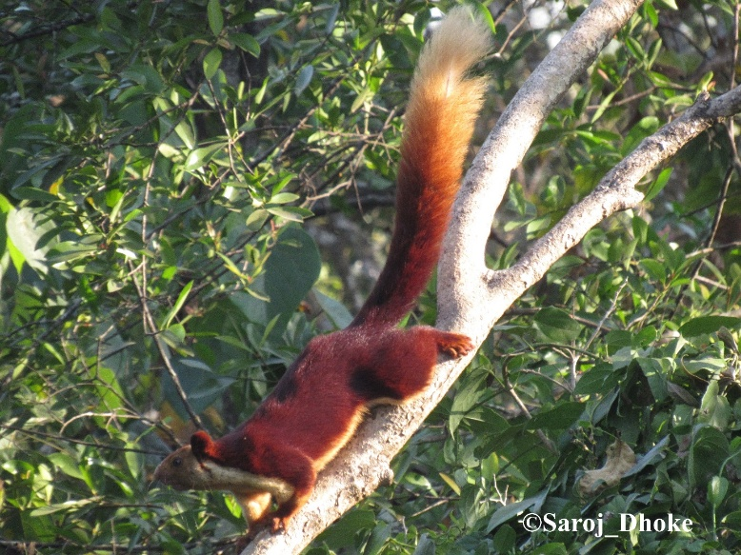

Plate 1: Ratufa indica indica coat colour pattern and creamy coloured tail tip can be seen.

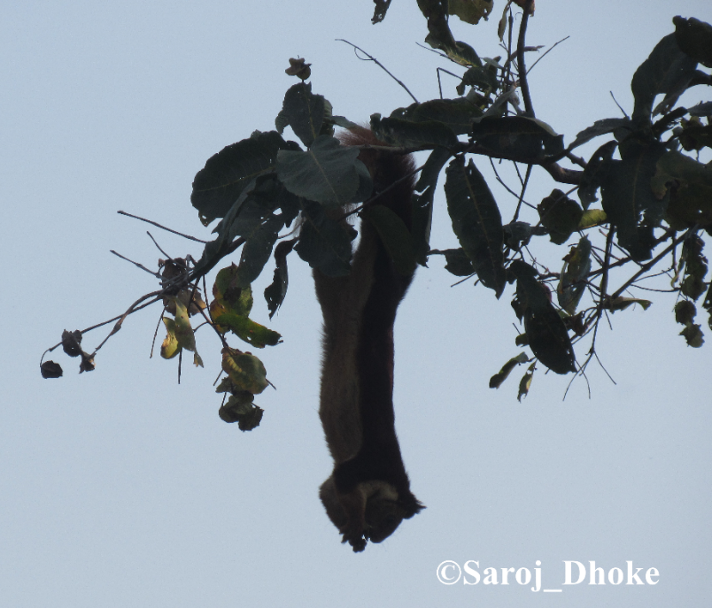
Plate 2: Ratufa indica indica feeding on fresh Terminalia elliptica fruits.

In Maharashtra, reports indicated the distribution of Ratufa indica is notably uneven and population constricted in protected areas (Molur et al. 2005). In the Satpuda region of Amravati district, the subspecies R. i. centralis is identified. From eastern Maharashtra, population of R. i. maximas subspecies seen at Tadoba National Park (Molur et al. 2005) and in the Giant Squirrel Conservation Centre, Gadchiroli (Shukla & Mishra 2017) which exhibit a deciduous forest type, distinct from the evergreen forests found in the Western Ghats habitats (Table 1).
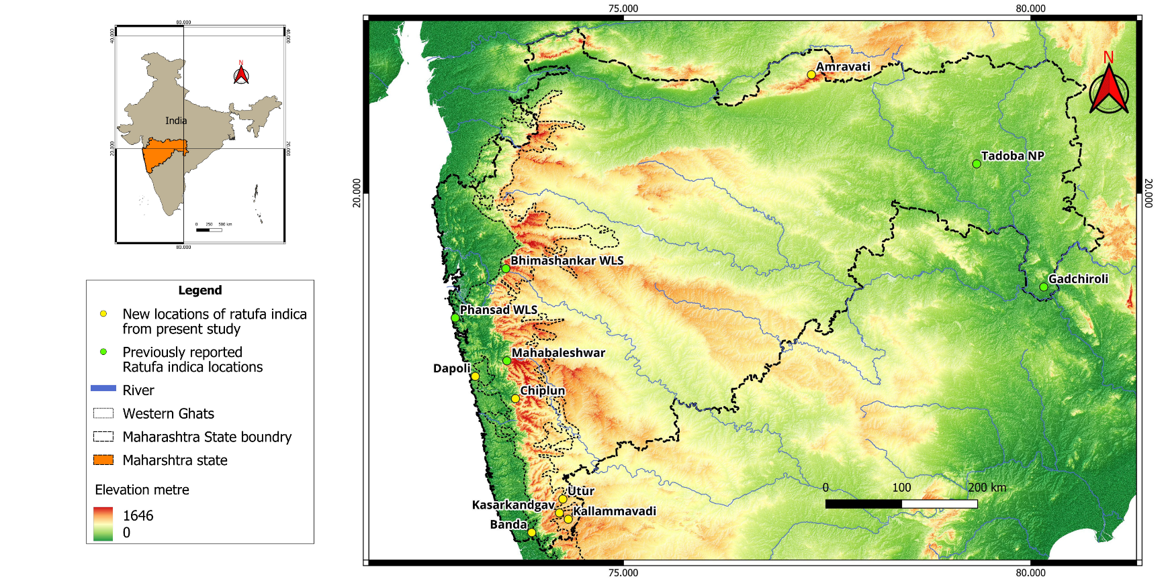

Figure 1: Reports of Ratufa indica presence: previously recorded and newly recorded in the Maharashtra state

High elevation southern tropical semi-evergreen forests of Bhimashankar WLS enriched with sacred groves (Rahangdale & Rahangdale 2017) and Phansad WLS with west coast semi-evergreen forests aligned by Memecylon umbellatum slopes (Katwate et al. 2013) this protected areas are habitat of Ratufa indica in Western Ghats of Maharashtra. Latter being the only low land habitat of R. i (Shinde 2012) (Table 1). These two sites have population of R. i. indica subspecies (Molur et al. 2005). Subspecies also reported from the protected areas in the vicinity of Bhimashankar WLS viz., the Bhandara WLS, Harishchandra gad- Kalsubai WLS (Ladge 2017) and in the ghats of Mahabaleshwar hill ranges (Sayyad et al 2014) (Figure 1).
As compared to above mentioned isolated sites (Table 1), Dapoli is situated in Western ghats of Ratnagiri district having large spectrum vegetation types including sacred groves, mangroves, riparian forests, and extensive orchards. Though Ratufa indica preferred tall trees with considerable girth which represented by old forest, still its adaptable to disturbed habitats (Datta & Goyal 1996). We speculate this Dapoli individuals came from Mahabaleshwar as there is connectivity of mountains via Mandangad tehsil.

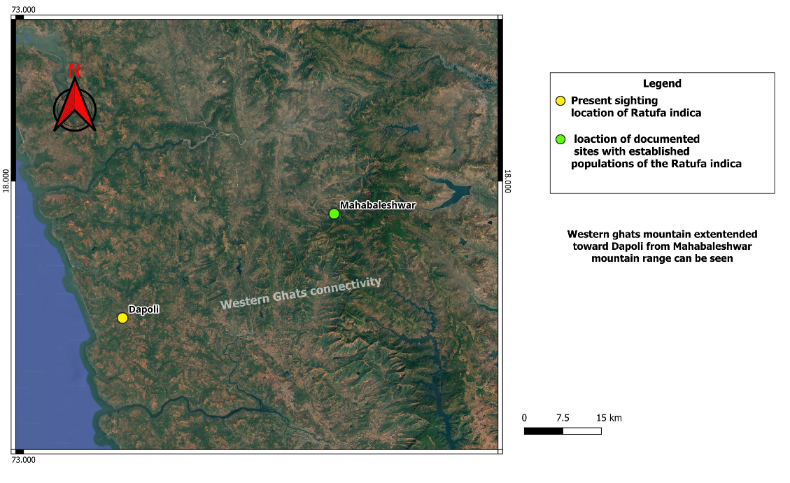

Figure 2; Map showing present sighting location and probable habitat connectivity via Western Ghats Mountain range to nearest establish population

Table 1: Recent and previously recorded locations of Ratufa indica and probable subspecies
Sr. no | Place name | Date of sighted | Identified subspecies colouration | Reference
1. | Bhimashankar WLS | Previous records (PR) | R. i. indica | Molur et al 2005; Rathod et al 2022
2. | Phansad WLS | (PR) | R. i. indica | (Dhamorikar 2013)
3. | Mahabaleshwar | (PR) | R. i. indica | Sayyad et al 2014;
4. | Tadoba NP | (PR) | R. i. maxima | Molur et al 2005
5. | Gadchiroli IGS rescue centre | (PR) | R. i. maxima (photographic evidence not available) | (Shukla & Mishra, 2017) (Anonymous, 2016)
6. | DBSKKV campus, Dapoli, Ratnagiri | 5 May 2018 | R. i. indica | Present study
7 | Riparian forest of the Bandhtivare (Lat 17.7940020; Long 73.1809566) on the ‘Jog River’. | 2017 | unknown | (Varak, personal communication 2017) RFO, Maharashtra Forest department gave account of presence of Ratufa indica by local forest workers
8 | Kolkewadi, Chiplun, Ratnagiri  17°32'50.90"N Latitude 73°32'5.16"E Longitude | 21 January 2021 | Probably R. i. maxima (Dark coloured claimed by viewer) | (Indulkar,2019 personal communication 2019)
9 | Utur, Kolhapur | 11 June 2020 | R. i. indica | Toraskar 2020
10. | Kallammavadi village in Kolhapur | 2020 | unknown | Kesarkar, 2020
11. | Kasarkand gav of Amboli- Ajra forest Sindhudurg-Kolhapur border district | 2020 | Probably R. i. maxima | Toraskar 2020
12. | Private reserved area for Giant squirrels, Banda, Sindhudurg | 10 January 2021 | R. i. indica | Lad, 2021
13. | Satpuda region of Amravati district | 5 June 2019 | R. i. centralis | Babrekar, 2019

R. indica expanding its range have become common in recent years (Seetharamaraju 2011; Srinivasulu & Srinivasulu 2011). May be due to expanding population needs, more territories and farmers shifting from agricultural crops to perennial orchards. Such fruit crops act as habitat connectivity, refuge, and food source for expanding giant squirrel population. In historical notes migration of squirrels were recorded like mass migration of Gray squirrel (Sciurus carolinensis) in Texas, USA (Casto 2003). The survival of species is significantly influenced by the creation of new habitats, new habitat connectivity and the disconnection of existing corridors. Research on squirrels has indicated that metapopulations exhibiting robust rescue effects can be beneficial for the survival of species (Stacey et al. 1997). Habitat connectivity is one of ignored variable in the conservation for arboreal mmmals. Specially expansion of agriculture, roadways and rapid urbanization make habitats isolated.
Data in table 1. shows the presence of three Ratufa indica. subspecies in Maharashtra state. These local records are mentioned by various local news reports and crucial for further dispersion and habitat suitability’s studies. In many places of Western ghats of Maharashtra there are overlapping records of R. i. maxima and R. i. indica thereby advocating for a re-evaluation of documented distributions of subspecies. Which will help to reveal and conserve undiscovered migration routes for these arboreal mammals.
CONCLUSION:
This new record of Ratufa indica indica from Dapoli suggests a possible range extension and highlights the species’ adaptability to semi-modified habitats like perennial fruit orchards. It underscores the importance of protecting emerging habitat corridors and conducting further studies to reassess subspecies distribution for informed conservation planning in the Northern Western Ghats region.
AKNOWLWDGMENT:
We sincerely thank the College of Forestry, Dapoli (DBSKKV) for providing institutional support throughout this study. I am especially grateful to Dr. V. K. Patil, Associate Professor, and the Hon’ble Dean, for their valuable guidance and encouragement.

AUTHORS’ CONTRIBUTIONS
Author Zende J. Y. encountered the observation initially and designed the study and reviewed the literature wrote the first draft of the manuscript. Author Dhoke S. did the survey and managed to take photographic evidence. All authors read and approved the final manuscript.
Disclaimer (Artificial intelligence)
Option 1:
Author(s) hereby declare that NO generative AI technologies such as Large Language Models (ChatGPT, COPILOT, etc.) and text-to-image generators have been used during the writing or editing of this manuscript.
Option 2:
Author(s) hereby declare that generative AI technologies such as Large Language Models, etc. have been used during the writing or editing of manuscripts. This explanation will include the name, version, model, and source of the generative AI technology and as well as all input prompts provided to the generative AI technology
Details of the AI usage are given below:
1.
2.
3.

REFERENCES:
- Abdulali, H.; J.C. Daniel (1952). "Races of the Indian giant squirrel (Ratufa indica)". Journal of the Bombay Natural History Society. 50: 469–474.
- Abdulali, H.; J.C. Daniel (1952). "Races of the Indian giant squirrel (Ratufa indica)". Journal of the Bombay Natural History Society. 50: 469–474.
- Anonymous, (2016, June 18). Lokmat news: Shakaru-found-Gadchiroli; Online accessed 4 June 2023 [https://www.lokmat.com/gadchiroli/shakaru-found-gadchiroli/]
- Babrekar Vaibhav, (2019). State animal an Indian Giant squirrel reached Amravati (5 June 2019), Lokmat e-paper [https://www.lokmat.com/amravati/state-animal-indian-giant-squirrel-reached-amravati/\]
- Casto, S. D. (2003). The Texas gray squirrel migration of 1857. East Texas Historical Journal, 41(2), 9.
- CITES. (2023). CONVENTION ON INTERNATIONAL TRADE IN ENDANGERED SPECIES OF WILD FAUNA AND FLORA (CITES). Appendices I, II and III valid from 21 May 2023. Retrieved from https://cites.org/eng/app/appendices.php
- Corbet, G. B., & Hill, J. E. (1992). The mammals of the Indomalayan region: a systematic review (Vol. 488): oxford university press Oxford.
- Corbet, Gordon Barclay; Hill, John Edwards (1992). The mammals of the Indomalayan Region: a systematic review. Oxford: Oxford University Press. ISBN 0-19-854693-9. OCLC 25281229
- Datta, A., & Goyal, S. (1996). Comparison of forest structure and use by the Indian giant squirrel (Ratufa indica) in two riverine forests of Central India. Biotropica, 394-399. doi:10.2307/2389203
- Dhamorikar A. 2013. Phansad Wildlife Sanctuary (October 09, 2013) [https://www.sahyadrica.com/2013/10/phansad-wildlife-sanctuary.html]
- Indulkar R, personal communication, (November 19, 2019).
- Katwate, U., Apte, D., & Raut, R. (2013). CEPF Western Ghats Special Series: Diversity and distribution of anurans in Phansad Wildlife Sanctuary (PWS), northern Western Ghats of India. Journal of Threatened Taxa, 5(2), 3589-3602.
- Kesarkar, V. (Producer). (2020, August 5). Indian Giant Squirrel | हाक मारल्यावर खांद्यावर येणारा शेकरू, दुर्मिळ असणारा प्राणी थेट घरात! [vedio news] Retrieved from https://www.youtube.com/watch?v=k7ALnJhqpNY
- Lad Sadashiv. (10 January 2021) Declared His Own Private Farm Reserved For State Animal Shekru, abp Maza https://marathi.abplive.com/news/maharashtra/declared-his-own-private-farm-reserved-for-state-animal-shekru-849391
- Landge, A. A. (2017). Tourism potential in Akole tahsil of Ahmednagar District (Maharashtra). International Journal of Researches in Social Sciences and Information Studies, 5(1), 26-29. chrome-extension://gphandlahdpffmccakmbngmbjnjiiahp/https://ijrssis.in/upload_papers/080320171236165.pdf
- Molur, S. (2016). Ratufa indica. The IUCN Red List of Threatened Species, 6, T19378A2226202. [doi:10.2305/IUCN.UK.2016-2.RLTS.T19378A22262028.en.]
- Molur, S., Srinivasulu, C., Srinivasulu, B., Walker, S., Nameer, P., & Ravikumar, L. e. (2005). Status of south Asian non-volant small mammals: conservation assessment and management plan (C.A.M.P.) workshop report. Zoo Outreach Organization/CBSG-South Asia, Coimbatore, India, 618pp.
- Prachi, M., Kulkarni, J., Pawar, T., Sahoo, R. K., Arulmalar, E., & Punjabi, G. (2012). Status and Distribution of Malabar Giant Squirrel Ratufa indica in Western Ghats of Maharashtra. Wildlife Research and Conservation Society, Pune. pp74.
- Rahangdale, S. S., & Rahangdale, S. R. (2017). Floristic diversity of Bhimashankar Wildlife Sanctuary, northern Western Ghats, Maharashtra, India. Journal of Threatened Taxa, 9(8), 10493-10527.
- Rathod, G., Bharucha, E., & Yardi, K. (2022). Population density and nesting behaviour of Indian Giant squirrel Ratufa indica (Erxlebeln, 1777) in Bhimashankar wildlife sanctuary, Western Ghats of Maharashtra, India. Journal of Threatened Taxa, 14(9), 21786-21796.
- Sayyed, A., Mahabal, A., & Sharma, R. M. (2014). Albinism in Indian Giant Squirrel Ratufa indica (Erxleben) and Lesser Bandicoot Rat Bandicota bengalensis (Gray)(Rodentia: Mammalia) from Satara District, Maharashtra. Small Mammal Mail, 5(2), 28â.
- Seetharamaraju M., C. S. a. B. S. (2011). Additional site records of Indian Giant Squirrel Ratufa indica (Erxleben, 1777) (Mammalia: Rodentia) in Godavari River Basin, Andhra Pradesh, India Small Mammal Mail - Bi-Annual Newsletter of CCINSA & RISCINSA, 2(July-December 2010), 6-7.
- Shinde, P. (2012) Saving the White-rumped Vultures at Phansad Wildlife Sanctuary.
- Shukla, P. N., & Mishra, V. K. (2017). Population distribution of Indian Giant squirrel Ratufa indica in dry and moist deciduous forest of Sironcha forest Division, Central India. Indian Forester, 143(10), 1021-1026.
- Srinivasulu, A., & Srinivasulu, C. (2011). New site records of the Indian Giant Squirrel Ratufa indica and the Madras Tree Shrew Anathana ellioti (Mammalia, Rodentia and Scandentia) from the Nagarjunasagar-Srisailam Tiger Reserve, Andhra Pradesh. Small Mammal Mail-Bi-Annual Newsletter of CCINSA & RISCINSA, 3(2), 8-9.
- Stacey, P. B., Taper, M. L., & Johnson, V. A. (1997). Migration within metapopulations: the impact upon local population dynamics. In Metapopulation biology (pp. 267-291): Elsevier.
- Thorington, R.W. Jr.; J.L. Koprowski; M.A. Steele; J.F. Whatton (2012). Squirrels of the World. Baltimore: Johns Hopkins University Press. pp. 26–27. ISBN 978-1-4214-0469-1.
- Toraskar Ashok, (11 June 2020) Shekru is a rare animal found in Utur area of ​​Ajra taluka, Sakal e-paper https://www.esakal.com/paschim-maharashtra-news/kolhapur/shekru-rare-animal-found-utur-area-%E2%80%8B%E2%80%8Bajra-taluka-305817
- Varak S, personal communication, (January 21, 2017).

