Characterization and Conservation of Marine Turtle Nesting Habitats Near Kribi Port, Cameroon

Abstract:
A description of marine turtle nesting habitats was conducted around the Port Authority of Kribi in order to propose a conservation strategy for these species in the area. The main objective is to characterize the nesting sites to define their status, with secondary objectives to identify and describe different nesting sites around the city of Kribi, assess threats to marine turtle habitats, and propose conservation measures. The study area covers the beaches on the outskirts of the city of Kribi, located in the Ocean Department, South Region of Cameroon. Its geographical coordinates range from N03°15'830''; E009°54'319'' to N02°71'200''; E009°86'64''. Data collection focused on micro-geographical parameters, ecological characteristics, and threats to these species. It was found that there are approximately ten main nesting beaches with an average length of 0.82 ± 0.26 km. The substrate is predominantly sandy and brown in color, with vegetation cover estimated at 80% of the surveyed sites further from the city. The urbanization rate is estimated at more than 60% for sites near the city and 20% for those further away. Various tourist attractions offered by these beaches are one of the causes of the increasing urbanization, leading to many activities that contribute to substrate compaction, making it more and more difficult for turtles to bury their eggs. Deforestation is another threat. The destruction of vegetation on the beaches and back shores is carried out by local populations for various needs: timber, charcoal, agriculture, aquaculture, or coastal construction. Threats to marine turtles are present and persistent, with 90% of surveyed individuals admitting to consuming turtle meat. Nest predation is also high on beaches farther from the city. Additionally, coastal erosion is increasing, disturbing the beach structure. Therefore, it is ideal to develop and propose special participatory conservation statuses for these nesting sites. Considering the various threats described on the studied beaches, several conservation measures have been proposed. Some of them include the development and implementation of spatial planning plans, protection and effective management through nesting site monitoring programs during the nesting seasons and awareness, training, and education of the public regarding conservation measures.

Keywords: Conservation status, marine turtles, nesting habitats, Port Authority of Kribi and Port infrastructures,
Introduction
The terrestrial habitats of sea turtles consist of a nesting habitat, an embryonic development habitat, and a basking habitat. The nesting habitat, also known as the nesting site or nesting beach, is defined as "any coastal land surface where at least one female of any species has laid eggs in historical times" (Fretey & Girondot, 1996). However, a nesting habitat must meet several factors and minimum requirements. The site must be easily accessible from the ocean; this criterion differs between a female Leatherback turtle and a female Hawksbill turtle. The Leatherback turtle is the largest sea turtle, with distinct physical characteristics such as leathery skin, lack of scales, a hard shell, and backwards-pointing spines in the throat that aid the passage of food. Leatherbacks reach sexual maturity at around 13–14 years of age and exhibit natal homing behavior for nesting. These turtles have low hatching rates; only 50% of the eggs hatch, and just 2% of those hatchlings survive (Piboon et al., 2025). They avoid rocks that could easily injure their unscaled, unarmoured body, whereas the Hawksbill turtle, protected by a hard shell, does not hesitate to cross sharp "beach rocks." Theoretically, the nest must be dug in a location that does not flood at high tide, and the substrate must have grain cohesion that allows for the solid construction of a nest chamber and incubation pit. The substrate, usually fine sand, should facilitate gas diffusion, not retain too much moisture, and maintain temperatures conducive to proper embryonic development (Mortimer, 1990). Sea turtles are a classic example of a broadly distributed group that has historically suffered population declines, as a result of, for example, bycatch and harvesting adults and eggs. These declines have motivated worldwide conservation efforts since the 1950s. Efforts included various beach protection measures, strict fisheries bycatch regulations [for example, turtle excluder devices, and the establishment of marine protected areas (Mazaris et al., 2017).
One of the most remarkable and mysterious aspects of sea turtle biology is the ability of certain adult female populations to return to nests in the geographical area from which they originally emerged as hatchlings, often after traveling thousands of kilometers. English speakers refer to this phenomenon as natal homing, which can be translated as "retour au bercail" in French.
Philopatry, meaning the return of a female to her birthplace habitat, is generally strong in sea turtles but is not systematic across all species or populations within a species.
It is widely accepted that most nesting females show some degree of fidelity to nesting habitat, cyclically returning to the same beach to lay eggs at intervals of one or more years (Carr & Meylan, 1978). Hendrickson (1958) suggested that mature turtles gather at sea and that younger turtles follow mature individuals migrating to a well-known nesting beach. Lohmann (1989) and Wyneken et al. (1990) introduced the idea that magnetic imprinting of the future nesting area occurs in hatchlings during their offshore frenzy phase. It is known that most, if not all, sea turtles exhibit some degree of natal homing, although the precision of this homing behavior can vary significantly between species and populations within species. Two hypotheses have been proposed: that sea turtles record distinctive chemical cues associated with their natal beach (Owens et al., 1982).
These habitats consist of a nesting habitat, an embryonic development habitat, and a basking habitat.
1. Problem Statement and Objectives
The Cameroonian coastal environment is facing degradation due to numerous factors, both anthropogenic and natural, which primarily affect these fragile ecosystems. Sand extraction, illegal fishing, poaching—particularly of sea turtle eggs—and coastal development are among the anthropogenic factors impacting sea turtle habitats. Additionally, natural factors such as storms, waves, currents, and the relative rise in sea level due to climate change contribute to coastal erosion in some areas.
The major issue here is the destruction of sea turtle habitats, which prevents them from fulfilling their biological role of seasonal nesting. The hypothesis of this study is that the degradation of sea turtle habitats, particularly nesting beaches, is a contributing factor to the decline of these species due to nesting failures.
The general objective of this work is to describe sea turtle nesting habitats to determine their status for better species conservation. The specific objectives are:
- To identify and describe the different nesting sites around the city of Kribi;
- To assess the threats to sea turtle habitats;
- To propose conservation measures.

2. Materials and Methods

2.1. Study area
The study area covers the beaches on the outskirts of the city of Kribi, located in the Ocean Department, South Region of Cameroon. Its geographical coordinates range from N03°15'830''; E009°54'319'' to N02°71'200''; E009°86'64''. The main study beaches include Bipaga, Londji, Mpalla, Talla, Ebome, Mbeka’a, Bwambé, Lobé, Luma, and Grand Batanga. The figure below illustrates the study area.
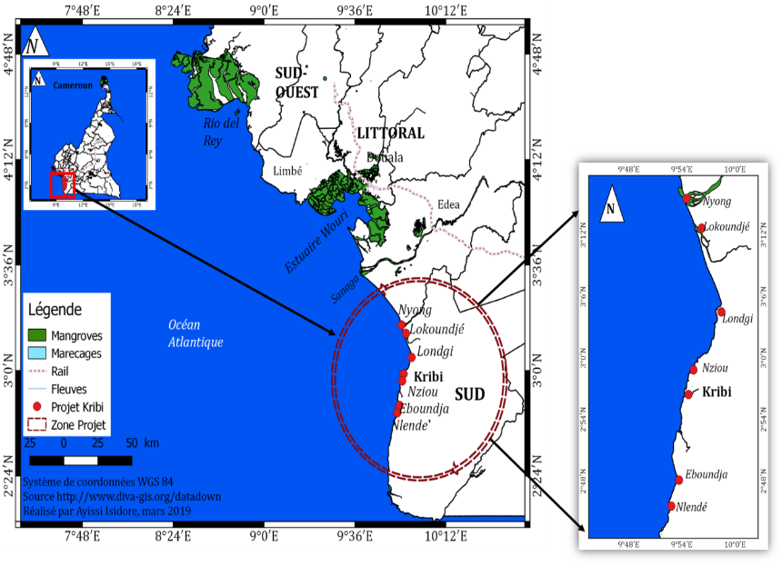
Figure 1: Location of the study area (© ACBM, 2021)
The Kribi-Campo region is predominantly characterized by yellow ferralitic soils with a high level of acidity. Other soil types present include gneiss-based soils, lateritic schist soils, and hydromorphic soils. The yellow color of the ferralitic soils appears to result from either rainfall patterns or the transition from a tropical to an equatorial climate. Physicochemical characteristics indicate that these soils are highly acidic, with a pH ranging from 4.7 to 5.1. The degree of saturation varies from 15 to 20% at the surface and less than 10% at depth (Segalen, 1967).
The hydrography of this area consists of major rivers, most of which originate from the southern Cameroonian plateau. The Kienke River drains the entire city of Kribi. It is approximately 130 km long with an average water flow of 49.2 m³/s. The Lobe River, known for its numerous scenic waterfalls, is located 5 km from Kribi. The Lokoundje River is 216 km long, runs east-west, and originates in the Akom II region.
The climate of Kribi is of the equatorial monsoon type, with four seasons of unequal length, consisting of two maxima and two minima. Precipitation is significant. The average temperature is 25.7°C, and annual rainfall is about 2,957 mm. January is the driest month, with 116 mm of rain, while September records the highest precipitation, averaging 340 mm. March is the hottest month of the year, with a temperature of 26.7°C, whereas August is the coldest month, with an average temperature of 24.4°C. The major rainy season lasts from August to October, with September being the least rainy month. The major dry season extends from December to February. The minor rainy season occurs from March to June, followed by the minor dry season in July.
The coastal vegetation consists of macrophytes, mangroves, and coastal forests. Macrophytes have been extensively described by Valet (1973 and 1975). The Biafran Atlantic evergreen forest is rich in Caesalpiniaceae, including Calpocalyx heitzii and Saccoglotis gabonensis. Lophira alata (Ochnaceae) and other coastal indicators dominate the Atlantic coastal district. Around 20 types of vegetation have been identified along the Kribi-Campo coast. The main mangrove species include Rhizophora mangle, covering 90% of the area, along with Rhizophora harrisonii, Avicennia germinans, and other swamp plants such as Nypa fruticans and Pandanus candelabrum (Letouzey, 1985).
The wildlife of this region includes birds, reptiles, and mammals. The aquatic fauna consists of fish (e.g., cartilaginous species such as sharks), crustaceans (crabs, crayfish, shrimp), mollusks, amphibians, and reptiles, including four species of sea turtles, which are under strong anthropogenic pressure (Ayissi, 2015). Freshwater aquatic turtles are found in the streams of the Nyong and Lokoundje rivers. The marine mammals of this area include small cetaceans (dolphins) and manatees (Trichechus senegalensis), which dominate the estuarine waters of the Nyong and Lokoundje rivers.
This region has a population estimated at 93,246 inhabitants. The main ethnic groups include Batangas (the majority in the area), Iyassas, Bagyelis, Mabis & Mvae, Bakokos, Bulu, Ewondos, Ngoumbas, and Fangs. The primary economic activities in the region are fishing, sand extraction, agriculture, timber exploitation, and hunting.
2.2. Data Collection
- Secondary Data
This study began with research in the documentation available at the library of ACBM (Cameroonian Association of Marine Biology) related to sea turtles, as well as other technical administrations, NGOs in the area, and digital documentation.
- Primary Data
Primary data were obtained during our various field visits, during which we conducted surveys in households, technical services of the State based in the area, resource persons such as fishermen operating in our study area, and local residents.
During these surveys, the geographical coordinates of the study sites were recorded using a Garmin GPS to georeference these habitats. We used a camera to capture images of beaches, as well as the coastal and marine environment. Interviews were conducted with fishermen and local residents to gather information on the presence of sea turtles on these priority beaches and the various threats affecting these sites.
The characterization of nesting beaches was carried out through direct observations to identify ecological characteristics (vegetation, fauna, climate, soil elements, etc.). All this information was coded into field data sheets, describing the survey frameworks (see appendix...). Additional data helped describe the beaches and provided insights into the presence of other species in the study area. The method used to identify nesting beaches was based on the PROTOMAC method (Sea Turtle Protection Program in Central Africa). This work was preceded by a survey among villagers to identify priority areas. This determination was followed by a description of the beach, using a descriptive sheet in which the following elements were noted:
- The common name of the beach in the local language;
- Micro-geographic characteristics, including the length and width of the beach, obtained using the average step method, a description of the vegetation present on the beach, and the presence of obstacles for sea turtles (fallen trees, dead trunks, stumps, boats, rocks), the sand color, and sand granulometry;
- Backshore characteristics, such as biotope, vegetation cover height, and the presence of a watercourse flowing into the sea;
- Anthropogenic activities on the site (presence of fishermen near the site, fishing methods, urbanization, etc.);
- Presence of sea turtles, determined through patrols or documented in existing literature;
- Presence of other marine species and their status;
- Threats to sea turtles (e.g., slaughter of females, egg collection, etc.);
- Details on data collection, including observer’s name, date of observation, geographical coordinates, etc.
2.3. Data Processing and Statistical Analysis
- Laboratory Parameters
A first set of parameters includes characteristic and qualitative elements that allow for a better description of the sites and the threats to sea turtle nesting habitats.
- Habitat Parameters
The geometric parameters of the habitats were calculated using the numerical formula for the mean, standard deviations, and percentages.
3. Results and Discussion:
3.1. Micro-geographical Parameters of the Habitat
At the outskirts of the city, ten main marine turtle nesting beaches (Mpalla, Londji, Bipaga, Talla, Ebome, Mbeka’a, Lobe, Luma, Grand-Batanga, and Bwambe) have been identified. The average length of these beaches is 0.82 km ± 0.26 km, while the average width is 0.36 km ± 0.15 km.
The substrate of the peripheral beaches of the city of Kribi presents different aspects, which can be rocky, rocky-sandy, and sandy, with varied colors such as brown, black, and white. Only four beaches have a sandy substrate at 90%, while the rest have rocky-sandy substrates, and none of these beaches have a purely rocky substrate. The sandy and rocky-sandy substrates are mainly composed of fine sand. The colors of the substrates of the sandy and rocky-sandy beaches are primarily brown and white, with only the beaches of Londji and Mpalla presenting a substrate color that is entirely whitish.
3.2. Characteristics of the Backshore
The backshore of the described sites has varied characteristics. Natural elements such as vegetation (herbaceous, shrubby, and tree layers), hotel infrastructures, and individual houses can be found. Each of these beaches is more or less crossed by a watercourse. The peripheral beaches of the city of Kribi are increasingly urbanized, in contrast to those that are slightly farther away, which are still almost in their wild state.
At the most distant beaches, vegetation is still abundant, estimated to cover about 80% of the total land area. This vegetation can be characterized by various layers (herbaceous, shrubby, and tree), as is the case at the beaches of Bwambé, Bipaga, and Grand-Batanga, which are heavily occupied by shrubby and tree layers, covering about 75% of the total area of the site.
Hotels, restaurants, and other recreational establishments are increasingly present on the peripheral beaches of the city. Their land occupancy rate is estimated to be about 60% for the beaches closest to the city, such as Talla, Bwambé, and Mbeka’a, and less than 20% for those farther away (Bipaga, Grand-Batanga).
Individual homes are also observed at these beaches. They are more abundant at the outskirts of the city and are found sporadically at the more distant beaches.
3.4. Threats to Marine Turtle Habitats
The terrestrial habitats of marine turtles in this area are subjected to numerous pressures, which can be both natural and anthropogenic.
- Poaching
Poaching at these sites mainly concerns female marine turtles and their eggs. Turtles are often captured and killed for their meat when they come ashore to nest. The eggs of these species are collected by local populations to be consumed or sold, thus providing a source of income for them. This is the case for the beaches of Bwambé, Grand-Batanga, Lobé, Luma, Mpalla, and Bipaga, where, out of a total of 40 individuals interviewed, 18 acknowledge consuming marine turtles. The figure below shows the poaching rates at these sites.

Figure 2: Marine turtle poaching rates at different nesting sites
- Erosion
All the surveyed beaches show signs of erosion, varying in severity, caused by both climatic and anthropogenic factors. Indeed, climate change leads to rising sea levels, which, through their effects, progressively erode these beaches, thereby reducing the available terrestrial habitat space for nesting. Anthropogenic factors also contribute to the degradation of these beaches, especially through activities such as marine sand extraction and the construction of tourism infrastructures (hotels, restaurants). According to Folack et al. (1999), Atangana (1996), and Morin and Kuete (1989), these beaches experience persistent anthropogenic action due to their chaotic encroachment by major works, individual homes, the presence of numerous fishermen, and plantations.

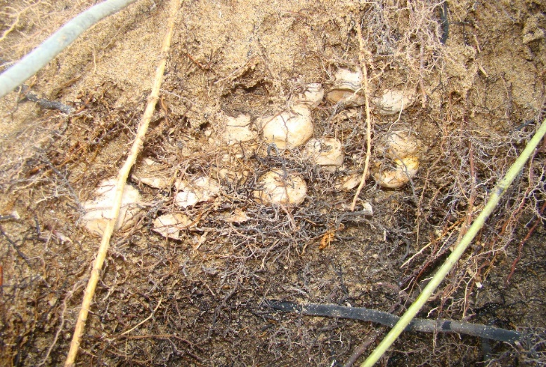

Figure 3: Destruction of an olive ridley nest by coastal erosion (© Ayissi, 2011)
- Urbanization
The various tourist attractions offered by these beaches are one of the causes of the increasing urbanization, leading to many activities that contribute to substrate compaction, making it more and more difficult for turtles to bury their eggs. The figure below illustrates the collection of sand from the beaches for large construction projects.

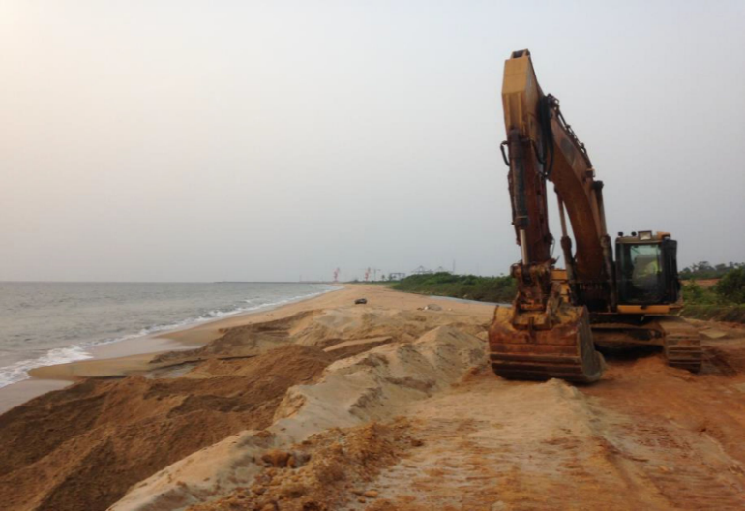

Figure 4: Sand collection at one of the marine turtle nesting sites for construction (© ACBM, 2017).
- Deforestation
The destruction of vegetation on the beaches and backshores is carried out by local populations for various needs: timber, charcoal, agriculture, aquaculture, or coastal construction. This is the case for the beaches of Mpalla, Londji, Luma, and Grand-Batanga, where more than half of the local population exerts pressure on forest resources. The figure below illustrates the distribution of threats to the habitats.
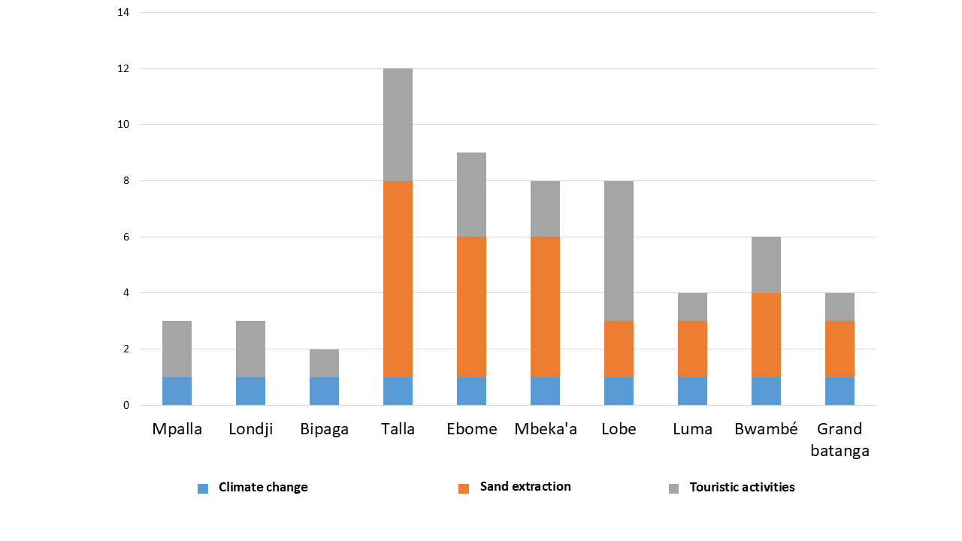
Figure 5: Distribution of threats to nesting habitats
At the sites closest to the city, the development of the beaches and backshores into tourist areas by economic operators increases human trampling, leading to substrate compaction.
- Various Pollutions
The heavy and chaotic occupation of the beaches inevitably leads to pollution, characterized here by the invasion of the beaches by all kinds of solid waste, which attracts predators.
- Predation by Domestic Animals
The most distant beaches from the city are mainly occupied by domestic and wild animals (dogs, cats, pigs, rats) that proliferate due to poorly managed waste. These animals are indeed significant predators of marine turtle eggs and hatchlings. Their distribution across the different beaches is shown in the figure below.

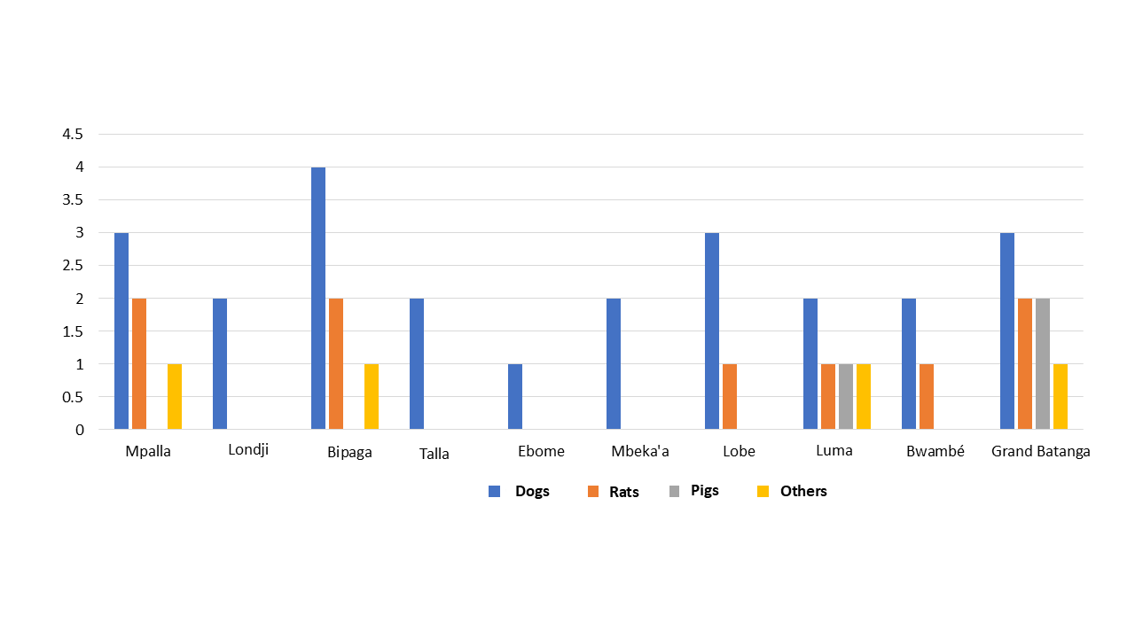
Figure 6: Distribution of predation factors across the nesting beaches
3.5. Proposal for Conservation Measures
Considering the various threats described on the studied beaches, several conservation measures can be proposed, namely:
- Development and implementation of spatial planning plans in accordance with and in application of marine and coastal environment management legislation;
- Protection and effective management through nesting site monitoring programs during the nesting seasons (including the adjacent ocean);
- Restoration of degraded nesting beaches through nature-based solutions, such as planting herbaceous plants to stabilize the beaches;
- Awareness, training, and education of the public on issues related to marine turtle conservation and their habitats;
- Proposal of special conservation statuses for some of these sites, such as (Ramsar, Heritage, Sanctuaries...).
Conclusion
The description of marine turtle nesting habitats on the peripheral beaches of the city of Kribi indicates that:
- The peripheries of the city of Kribi contain numerous nesting sites (10) with varying characteristics, including morphometric parameters, substrate type, granulometry, and backshore characteristics for the different species of marine turtles found in Cameroon;
- These sites are subjected to numerous threats, the majority of which are due to anthropogenic activities (heavy urbanization, economic activities, agricultural activities, poaching, etc.);
- Several conservation measures can be proposed, particularly on legislative, practical, educational, and training levels to preserve these ecosystems.

Disclaimer (Artificial intelligence)
Option 1:
Author(s) hereby declare that NO generative AI technologies such as Large Language Models (ChatGPT, COPILOT, etc.) and text-to-image generators have been used during the writing or editing of this manuscript.
Option 2:
Author(s) hereby declare that generative AI technologies such as Large Language Models, etc. have been used during the writing or editing of manuscripts. This explanation will include the name, version, model, and source of the generative AI technology and as well as all input prompts provided to the generative AI technology
Details of the AI usage are given below:
1.
2.
3.

References
Ayissi, I. 2015. Impact of artisanal fishing on sea turtles in the seagrass meadows of southern Cameroon: Conservation opportunities. Ph.D. thesis; Abdelmalek Essaậậdi University Tetouan, Morocco. 167p.
Atangana, E. R. 1996. Biogeography of coastal and marine ecosystems. National Environmental Management Plan Report. 34 p.
Carr, A., Carr, M. H. & A. Meylan. 1978. The ecology and migrations of sea turtles, 7. The West Caribbean green turtle colony. Bulletin of the American Museum of Natural History 162: 1-46.
Folack, J., Mbome, I. L.; Bokwe, A.; Tagang, A. 1999. Cameroon Coastal Profile.MINEP-C/UNIDO/UNDP-GEF, 1999.102 p.
Fretey J. & M. Girondot. 1996. Development of a description sheet for nesting sites. Report. Ministry of the Environment, Nature and Landscapes Department, 15 p
Hendrickson, J. R., 1958. The green turtle, Chelonia mydas (Linn.) in Malaya and Sarawak. Proceedings of the Zoological Society of London, 130: 455-535.
Letouzey, R. 1985. Notice of the Phytogeographic Map of Cameroon at 1:500,000, 1985 IRA, National Institute of Vegetation, Toulouse, France.
Lohmann, K. J., 1989. Magnetic orientation by hatchling loggerhead sea turtles. Page 101 in: Eckert, S. A., Eckert, K. A. & T. H. Richardson (Compils.), Proceedings Ninth Annual Workshop Sea Turtle Conservation and Biology, 7-11 February 1989, Jekyll Island, Georgia, NOAA Techn. Memr., NMFS-SEFC-232, 251 pp.
Morin and Kuete, M. 1989. The Cameroonian Coast: morphological problems. Trav. Lab. Goegr. Phys. applied. Inst. Geogr. Univ. Bordeaux III, No. 11: pp 5-53.
Mortimer, J. A. 1990. The influence of beach sand characteristics on the nesting behavior and clutch survival of green turtles (Chelonia mydas). Copeia, 1990:802817.
Owens, D. W., Grassman, M. A. & J. R. Hendrickson, 1982. The imprinting hypothesis and sea turtle reproduction. Herpetologica, 38: 124-135.
Segalen Pierre. 1967. Soils and geomorphology of Cameroon. Cahiers ORSTOM. Pedology Series, 5 (2), pp. 137-187.
Valet, G. 1973. Overview of marine vegetation in Cameroon. Ann. Fac. Sci. Uni. Yaoundé, No. 15/16: 516-532.
Valet, G. 1975. Marine algae of Cameroon, I. chlorophyceae. Ann. Fac. Sci. Uni. Yaoundé, No. 15/16: 516-532.
Wyneken, J., Salmon, M. & K. L. Johnson, 1990. Orientation by hatchling loggerhead sea turtles Caretta caretta L. in a wave tank. J.Exp. Mar. Biol. Ecol., 139:41-50..
Mazaris, A. D., et al. (2017). Global sea turtle conservation successes. Science Advances, 3(9), e1600730.
Piboon, P., Brown, J., Kaewmong, P., Kittiwattanawong, K., & Nganvongpanit, K. (2025). Biology, Nesting Behavior, Genetic Diversity, and Conservation of Leatherback Sea Turtles: Insights From Thailand and Global Perspectives. Ecology and Evolution, 15(2), e71014.

