Examining the Role of Artificial Intelligence in Auditing for Tax Gap
Reduction

Abstract:
Effective tax collection is one of the most important problems facing governments and the cornerstone of a fair tax system. It is essential to prevent the loss of uncollected tax revenues due to non-compliance resulting from tax avoidance and evasion practices. The research aims to highlight the use of artificial intelligence in auditing to address the challenges facing tax administrations and to demonstrate how to deal with and reduce the problem of the tax gap, given its clear impact on lost tax revenues for the benefit of the state's public treasury. This is achieved by relying on the descriptive analytical approach based on describing the use of artificial intelligence techniques in auditing and analyzing its benefits, as it has become an integral part of the routine procedures required by tax administrations in order to decrease the tax gap, protect lost revenues through tax evasion, and achieve justice. In addition, the statistical analysis method is adopted to demonstrate the nature of the relationship between the independent and dependent research variables according to a questionnaire designed from two axes and distributed to a purposive sample of (80) estimators and auditors working in tax administrations. The results of the hypotheses were tested according to the statistical program (SPSS). The value of the research was represented in the results reached, the most prominent of which is the existence of a significant correlation between the use of artificial intelligence in auditing and reducing the tax gap. This confirms the significant role of using artificial intelligence techniques in auditing as an effective means of raising the efficiency of tax administration By simplifying procedures, improving the work environment, increasing employee satisfaction, and enhancing the effectiveness of tax collection, the study concluded that tax administrations must invest resources in developing and adopting modern artificial intelligence technologies, including data analysis programs, machine learning systems, and expert systems. There is also the need to establish clear regulatory policies to ensure the ethical and safe use of AI technologies while protecting taxpayer data.

Keywords: artificial intelligence, tax gap, audit, fair tax system, tax administration
Introduction:
Taxes are the most important source of public revenue and the fundamental essence of any tax legislation. They are also one of the basic mechanisms for achieving social justice among different segments of society (Baghdasaryan et al., 2022). Their role in achieving social, health, and economic goals varies depending on the prevailing tax system (Adefolake & Omodero, 2022). The main task of the tax policy is to ensure the stable mobilization of budget income on the one hand, and on the other hand - to encourage enterprises to increase the production of products necessary for the republic (Ruziev, 2022; Kamara & Kamara, 2025). Effective tax collection is one of the most important problems facing governments and the cornerstone of a fair tax system (Spence, 2021). It is essential to prevent the loss of uncollected tax revenues due to non-compliance resulting from tax avoidance and evasion practices (Bezditnyi, 2024). This involves companies reducing their tax liabilities to the lowest possible level, which leads to a decrease in the amount of taxes actually collected based on financial statements relative to the amount of taxes due. This is known as the tax gap, which impacts the state's general budget, particularly public finances, and individuals' perceptions of tax fairness (Ansarullah et al., 2025).
According to the World Bank, taxation must be recognised as a key driver for state building and accountability, and tax reform as a possible contributor to broader gains in state capacity and quality of governance. To remain relevant and effective, tax administrators must continually invest in scanning the external environment for emerging innovations in technology (such as cryptocurrencies and digital currency) and their implications on taxpayers’ new ways of managing the risk of tax evasion (Junquera-Varela et al., 2022).
Artificial Intelligence and Machine Learning are at the forefront of transformative forces spanning a great number of industries, and the tax and revenue sector is not an exception (Rahman et al., 2024; Saba & Monkam, 2024).
The use of artificial intelligence in auditing, and the revolutionary solutions it has provided for developing the tax system, has paved the way for a more efficient and fair future by automating routine tasks such as data entry and verification, submitting tax returns, analyzing spending patterns and taxpayer behaviours, and auditing large amounts of data from diverse sources such as banks, telecommunications companies, and social media sites (Belahouaoui & Attak, 2024). This helps identify individuals who do not pay their fair share of taxes, expand the taxpayer base, ensure the state receives its fair dues, and narrow the tax gap.
Artificial intelligence has been in use in tax administrations for many years. Examples include such applications as chatbots and machine learning-based scoring models to find high-risk tax cases (Cumberland, 2024, Islam et al., 2025).
Artificial intelligence can also identify cases of fraud and tax evasion early on, as it helps uncover non-compliant activities (Atayah & Alshater, 2021). Advanced tax auditing is important in detecting abnormal patterns in financial transactions, which helps protect tax revenues, preserve the rights of the state's public treasury, and recover funds lost through tax evasion ( (Raikov, 2021).

Methodology

Research Problem: The research problem can be summarized as follows: Most tax administrations face a loss of part of their tax revenues due to the decrease in the amount of tax collected compared to the amount of tax due. This loss negatively impacts the state's general budget. Therefore, integrating artificial intelligence technology into tax systems has become crucial to improving service provision, and data collection, reducing the tax gap, protecting revenues lost through tax evasion, and achieving justice. The research problem arises from the fundamental question:
Will the use of artificial intelligence in auditing reduce the tax gap?
Importance of the Research: The research gains special importance based on the novelty of using artificial intelligence in auditing and its contributions to changing the lives of individuals and society. It has become not just a machine that can be used in daily practices, but rather methods that mimic human intelligence. It also highlights the significant benefits that artificial intelligence offers when used in tax administrations by auditing and verifying data and declarations, analyzing spending patterns and taxpayer behaviours, which helps identify individuals who do not pay their fair share of taxes, expanding the taxpayer base, ensuring the state receives its fair dues, and reducing the tax gap
Research Objectives: The research primarily seeks to achieve a set of objectives through the following:
. 1.Shedding light on the use of artificial intelligence in auditing to address the challenges facing tax administrations.
2.Identifying the benefits that tax administrations can achieve through the use of artificial intelligence.
. 3.Studying the factors and determinants that affect the size of the tax gap
4.Shedding light on the problem of the tax gap and reducing it, given its clear impact on lost tax revenues for the benefit of the state treasury.
5.Measuring and analyzing the relationship, impact, and correlation between the use of artificial intelligence in auditing and reducing the tax gap.
Research Hypotheses: The research is based on a main hypothesis: There is a statistically significant relationship between the use of artificial intelligence in auditing and reducing the tax gap. The following sub-hypotheses emerge from it:
First Sub-hypothesis: There is a statistically significant correlation between the use of artificial intelligence in auditing and reducing the tax gap.
Second Sub-hypothesis: There is a statistically significant impact relationship between the use of artificial intelligence in auditing and reducing the tax gap.
Research Methodology: The research is based on a descriptive and analytical approach based on describing the use of artificial intelligence in auditing and analyzing its benefits, as it has become an integral part of the routine procedures required by tax administrations to reduce the tax gap, protect revenues lost through tax evasion, and achieve justice. This is achieved by studying research that has addressed this topic, leading to the extraction of a set of results that will serve as a fundamental tributary to build upon in the future when conducting further research. In addition, the statistical analysis method is adopted to prove or disprove the research hypotheses in the practical aspect of the research.
Collection and sample of the Research: Tax departments were chosen as the research community, and a random sample of (80) tax managers, appraisers, and auditors at various job levels were chosen.
Research Tools: To enrich the theoretical and practical aspects of the research with the necessary information, the following tools will be relied on following:
Theoretical Aspect Tools: To enrich the theoretical aspect, we relied on Arabic and foreign books, scientific research, and studies related to the research topic, available in libraries, published on the Internet, and unpublished.
Practical Aspect Tools: We relied on the questionnaire to collect data from the research sample after verifying its validity and reliability according to scientifically approved statistical methods.
Theoretical Aspect
Artificial Intelligence: It is difficult to determine an exact date for the emergence and use of artificial intelligence. Some date the birth of artificial intelligence to 1948, while others date it to 1956, by the American scientist John Marquis at a scientific forum. Artificial intelligence is considered one of the branches of computer science concerned with designing models of intelligent machines similar to human behaviour. Comparative studies then took over artificial intelligence with technological developments, so its capabilities multiplied and its uses deepened in many fields. Accordingly, it is difficult to find consensus on a single definition of artificial intelligence. Artificial intelligence is defined as a combination of software and devices that operate in a manner similar to the human brain and human capabilities to perform human tasks that require understanding, interpretation, thinking, movement, and the performance of skills Diverse Life. Artificial intelligence is defined as an independent science whose goal is to make computer systems acquire the characteristic of intelligence and perform transactions such as thinking, learning, and communication.
From the above, artificial intelligence can be defined as a technology included in machines and computers based on preparing computers to perform auditing tasks that depend on human intelligence with minimal effort and in the fastest time, providing accuracy and efficiency in performance.
The importance of using artificial intelligence in auditing: Artificial intelligence is important through reproducing behaviours associated with humans, such as thinking, experience, creativity, and planning, and transferring them to smart machines so that the machine becomes capable of overcoming the difficulties facing the auditing process, solving problems, detecting fraud and tax evasion, and making decisions in a scientific and logical way similar to the way the human mind thinks. The importance of artificial intelligence lies in the following: (Karim & Karima, 2024) , (Al-Fakhri, 2018), (Al-Qamoudi, 2024), (Nuryani, Mutiara, Wiruana, & putra, 2024),
: (Ali, Abdullah, & & Khattab, 2022)
*Smart systems can audit and analyze massive amounts of data, identify fraud in financial transactions, and uncover tax evasion, expanding the taxpayer base and ensuring countries receive their fair dues.
*Expert systems can audit millions of tax returns with incredible accuracy and speed, helping to uncover illegal activities, reduce errors, improve compliance, and increase revenues.
*Smart systems can improve transparency in tax procedures, increasing trust between taxpayers and tax administrations.
*Expert systems can audit and analyze the challenges facing tax administrations by measuring and detecting tax evasion in countries around the world and narrowing the tax gap.
*Smart systems can protect and audit the personal data of individuals and companies by implementing strict audit controls to ensure protection.
Based on the above, the use of artificial intelligence in auditing offers numerous benefits, including tremendous speed and extreme accuracy. Expert systems can also be used in audit planning, obtaining evidence, assessing audit risks, determining audit opinion decisions, preparing audit reports, and more.
The Tax Gap: It is not easy to determine the beginning of the use of the term tax gap, which represents the difference between the total taxes collected and the taxes due imposed under tax laws, which results in a loss of a portion of the state’s tax revenues. Most tax administrations seek to reduce this difference by supporting policy formulation, risk analysis, and tax auditing (Hijazi, 2024). The tax gap was defined as: the difference between the actual tax collected and the theoretical tax due (Manal & Mansour, 2020). It was also defined as: “the extent to which taxpayers are able to evade taxes, which leads to an unjustified reduction in the tax base and, consequently, a decrease in the amount of public revenues due to the state budget” (Hijazi, 2024) The tax gap was also defined as: “the difference between the taxes that taxpayers actually pay based on their declarations and the taxes that they should pay on their actual profits”
(Sulaiman, 2016)

Reasons for the tax gap: There are several factors and reasons that contribute to the tax gap. The most important of these reasons can be summarized as follows: (Manal & Mansour, 2020), (Sulaiman, 2016), (Hijazi, 2024)., (Raikov, 2021):
First: Tax avoidance refers to the taxpayer taking advantage of legal loopholes contained in tax legislation to evade paying the tax or part of it without violating the law, or the taxpayer refraining from engaging in an activity that would subject his profits to tax, such as when the taxpayer refuses to import goods subject to a high tax, which does not constitute a violation of the provisions of the law.
Second: Tax evasion refers to the taxpayer refraining from paying the tax, in whole or in part, by concealing, distorting, or falsifying the information provided to the tax administration with the aim of reducing the tax, or resorting to fraud to evade the tax or reduce its amount
Third: The Hidden Economy: This refers to all economic activities carried out by investors or producers that are subject to tax but not reported to tax administrations.
Fourth: Tax Non-Compliance: This refers to taxes reported but not paid on time, or failure to report tax liabilities on time. The time taken to prepare tax reports and pay taxes is one of the most important causes of tax non-compliance.
Applying Artificial Intelligence in Auditing to Reduce the Tax Gap: The use of new artificial intelligence models helps tax administrations identify taxpayers most likely to evade or not pay their taxes. Artificial intelligence cannot solve all tax gap problems facing tax administrations but rather requires the use of multiple methods. Perhaps the most important areas of using artificial intelligence to reduce the tax gap are as follows: (Azibi & Yahya, 2024), (Xavier, Pires, & Marques, 2022)
First: Annual Audit: AI techniques are used in tax administrations to help select a sample of taxpayer returns for audit and to detect tax fraud. AI techniques are also used to identify returns that are likely to contain errors and owe additional taxes, with the aim of creating an estimate of the tax gap and helping tax administrations better understand situations in which taxpayers do not comply with tax laws.
Second: Refundable Credits: Tax administrations use both manual processes and AI to help select taxpayers who claim refundable credits, such as the Earned Income Tax Credit, for audit. AI is used to help them identify taxpayers who are likely to owe additional taxes.
Third: Partnership Audits: Tax administrations use artificial intelligence techniques to help prioritize the tax returns of large, high-risk partnerships to determine taxable income and detect tax fraud.
Based on the above, some tax gaps will remain forever, but reducing this gap will improve confidence in the tax system, protect revenues lost through tax evasion, achieve justice, and expand the tax base.
The practical aspect: This axis includes analyzing the research variables at the level of the research sample, represented by
tax administrations, with (100) employees, including managers, auditors, and appraisers, to whom the questionnaire was distributed.
Approximately (80) questionnaires were returned. This was done based on the frequency distributions of the research sample members' answers and their percentages, arriving at the arithmetic mean and standard deviation for each paragraph of the questionnaire.
The research relied on the five-point Likert scale for the sample's answers.
First: Description and reliability of research variables: This section aims to code the research variables to familiarize the reader with the most important variables addressed, and to identify the dimensions and paragraphs associated with each one, such as the use of artificial intelligence in auditing to decrease the tax gap. It also seeks to measure the reliability of the measurement tool towards the research sample testing by Cronbach's alpha coefficient for the dimensions and variables. The research results showed that the reliability coefficient of the measurement tool for the variable of using artificial intelligence reached 0.909, while the reliability coefficient for the variable of reducing the tax gap reached 0.908, with an overall reliability coefficient of 0.916. This reflects the consistency and consistency of the study variables across their dimensions, as well as the validity of the questionnaire tool towards the target sample.

Table (1). Description and Reliability of Research Variables
Main variables | Dimensions | Code | Paragraphs |  | Measurement Tool Stability
 |  |  |  |  | paragraphs | stabilities | For search
Using artificial intelligence in auditing | احادي البُعد | UAI | 11 | UAI1 | 0.912 | 0.909 | 0.916
 |  |  |  | UAI2 | 0.915 | 0.909 | 0.916
 |  |  |  | UAI3 | 0.918 | 0.909 | 0.916
 |  |  |  | UAI4 | 0.913 | 0.909 | 0.916
 |  |  |  | UAI5 | 0.912 | 0.909 | 0.916
 |  |  |  | UAI6 | 0.914 | 0.909 | 0.916
 |  |  |  | UAI7 | 0.913 | 0.909 | 0.916
 |  |  |  | UAI8 | 0.913 | 0.909 | 0.916
 |  |  |  | UAI9 | 0.914 | 0.909 | 0.916
 |  |  |  | UAI10 | 0.914 | 0.909 | 0.916
 |  |  |  | UAI11 | 0.912 | 0.909 | 0.916
Reducing the tax gap | احادي البُعد | NTG | 11 | NTG1 | 0.911 | 0.908 | 0.916
 |  |  |  | NTG2 | 0.910 | 0.908 | 0.916
 |  |  |  | NTG3 | 0.913 | 0.908 | 0.916
 |  |  |  | NTG4 | 0.910 | 0.908 | 0.916
 |  |  |  | NTG5 | 0.914 | 0.908 | 0.916
 |  |  |  | NTG6 | 0.914 | 0.908 | 0.916
 |  |  |  | NTG7 | 0.912 | 0.908 | 0.916
 |  |  |  | NTG8 | 0.911 | 0.908 | 0.916
 |  |  |  | NTG9 | 0.915 | 0.908 | 0.916
 |  |  |  | NTG10 | 0.910 | 0.908 | 0.916
 |  |  |  | NTG11 | 0.916 | 0.908 | 0.916
Source: Prepared by researchers based on the program : spss
Second: Data normality: The data normality test helps define a basic concept for analyzing variables in research, which contributes to explaining how the data is distributed in a balanced manner around the value. The normality test aims to ensure that there are no extreme or abnormal values ​​that affect the results. Hence, the results of Table (2) demonstrate that the data follow a normal distribution, paving the way for generalizing the results to the researched population.
Table (2). Data normality test
Variable/Tests |  | Using artificial intelligence in auditing | Reducing the tax gap
Moderation test | Mean | 4.10 | 4.07
Moderation test | Std. Deviation | 0.316 | 0.339
Moderation test | Kom-Smi | 0.232 | 0.240
Moderation test | Sig. | 0.200^{c}

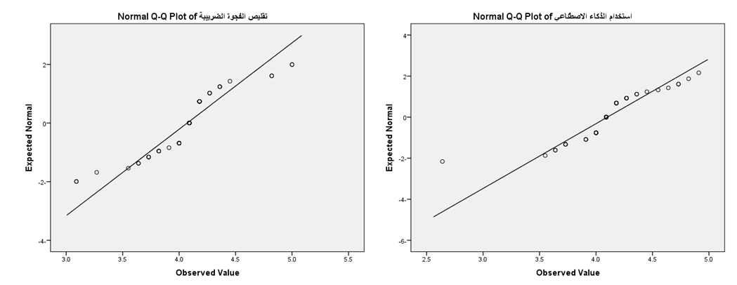
Figure (1). Data normality test for research variables.
Third: Description of the research variables: The results of Table (3) below indicate the importance of using artificial intelligence in tax administrations in the auditing process, as the ninth paragraph (UAI9) obtained the highest arithmetic mean (4.47) and standard deviation (0.642), which indicates a great consensus among opinions about the role of artificial intelligence.
In improving the audit process to ensure the accuracy of financial statements and transactions. These results reflect the positive impact of artificial intelligence in reducing tax evasion and narrowing the tax gap, with a relative importance of 89%. In contrast, the eleventh statement (UAI11) ranked last, with the lowest mean (3.98) and standard deviation (0.519). These results reflect a greater diversity of opinions regarding the role of artificial intelligence in auditing in supporting and enhancing tax administration decisions, with a relative importance of 80%. It can be said that there is widespread recognition of the importance of artificial intelligence in improving tax performance, particularly in the areas of auditing to ensure the accuracy of submitted statements and reduce tax evasion. However, challenges related to how artificial intelligence can be used to enhance economic policy decisions remain, requiring further research and development in this area. The overall rate of use of artificial intelligence in tax administrations in the audit field was 4.10, with a relative importance of 82%, indicating growing interest but requiring further reinforcement to achieve its full benefits.
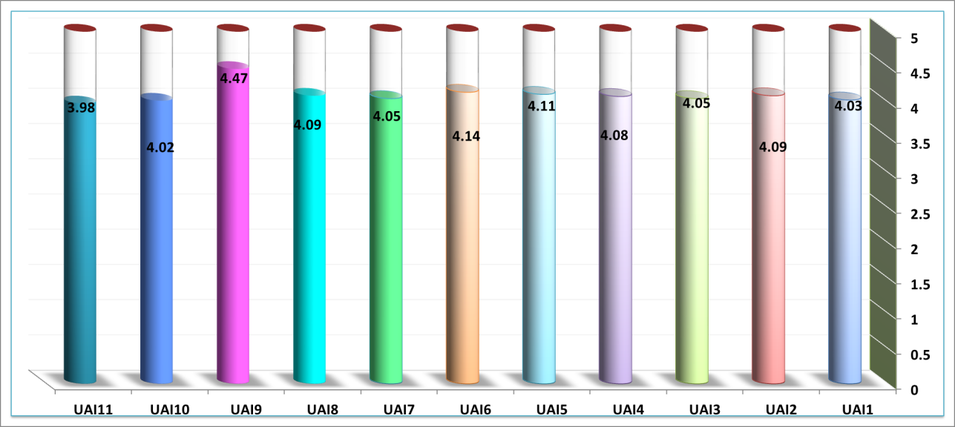
Figure (2) Distribution of the importance of the arithmetic means of the paragraphs of the variable of using artificial intelligence.
The results presented in Table (3) below indicate the importance of using artificial intelligence in achieving tax justice. Item five (NTG5) ranked first, with an arithmetic mean of 4.55 and a standard deviation of 0.615, indicating a broad consensus on the ability of AI-based auditing to detect tax evasion and prevent the loss of tax revenue, thus contributing to narrowing the tax gap. The relative importance of this item reached 91%, reflecting widespread awareness of its effective role. In contrast, item three (NTG3) ranked last, recording the lowest arithmetic mean (3.89) and standard deviation (0.538). These results reflect a greater divergence of opinions regarding the impact of AI-based auditing in reducing the informal economy, which is considered a factor in widening the tax gap, with a relative importance of 78%.
It can be said that there is a strong recognition of the role of AI-based auditing in enhancing tax fairness and reducing the tax gap in general, with the overall rate for the tax gap reduction variable reaching 4.07 with a relative importance of 81%. However, there is still room to develop effective strategies to reduce the impact of the informal economy on tax revenues. These results indicate the importance of investing in AI technologies to achieve tax fairness goals and improve the state's financial performance. 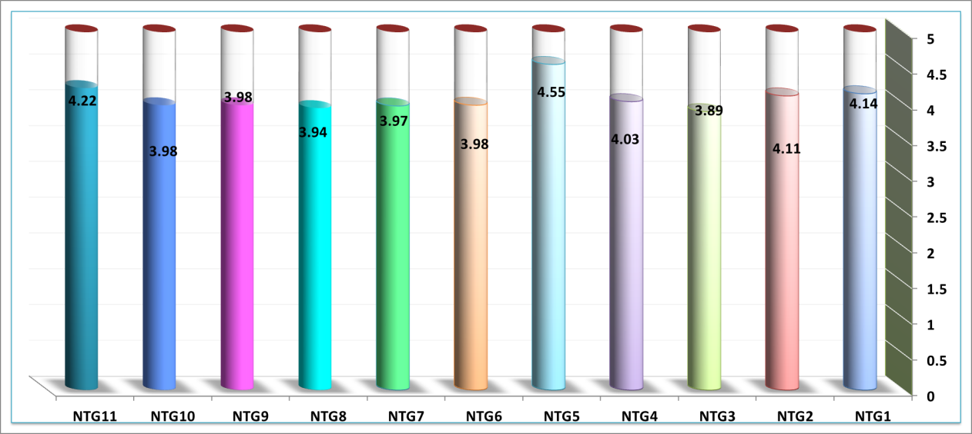
Figure (3) Distribution of the importance of the arithmetic means for the items of the tax gap reduction variable.

Table (3). Descriptive statistics for the research variables
S | Middle arithmetic | standard deviation | Relative importance | S | Middle arithmetic | standard deviation | Relative importance
UAI1 | 4.03 | 0.503 | 81% | NTG1 | 4.14 | 0.531 | 83%
UAI2 | 4.09 | 0.555 | 82% | NTG2 | 4.11 | 0.508 | 82%
UAI3 | 4.05 | 0.602 | 81% | NTG3 | 3.89 | 0.538 | 78%
UAI4 | 4.08 | 0.482 | 82% | NTG4 | 4.03 | 0.534 | 81%
UAI5 | 4.11 | 0.567 | 82% | NTG5 | 4.55 | 0.615 | 91%
UAI6 | 4.14 | 0.560 | 83% | NTG6 | 3.98 | 0.488 | 80%
UAI7 | 4.05 | 0.517 | 81% | NTG7 | 3.97 | 0.534 | 79%
UAI8 | 4.09 | 0.583 | 82% | NTG8 | 3.94 | 0.588 | 79%
UAI9 | 4.47 | 0.642 | 89% | NTG9 | 3.98 | 0.519 | 80%
UAI10 | 4.02 | 0.418 | 80% | NTG10 | 3.98 | 0.488 | 80%
UAI11 | 3.98 | 0.519 | 80% | NTG11 | 4.22 | 0.487 | 84%
Rate of use the artificial intelligence in auditing |  |  |  | Reducing rate of tax gap
 | 4.10 | 0.317 | 82% |  | 4.07 | 0.339 | 81%
Source: Prepared by researchers based on the program : spss
Fifth: Testing Research Hypotheses
H1: There is a statistically significant correlation between the use of artificial intelligence in auditing and reducing the tax gap.
The results of the correlation analysis indicate a strong, positive relationship between the use of artificial intelligence in auditing and reducing the tax gap. The Pearson correlation coefficient was 0.731, indicating that increased use of artificial intelligence is associated with increased effectiveness of efforts to decrease the tax gap. The statistical value (Sig.) also reflects a strong significance for this relationship, as it was 0.000, meaning that the calculated probability is less than 0.01, indicating that the relationship between the two variables is statistically significant.
From the above, it can be concluded that the adoption of auditing using artificial intelligence techniques in tax administration contributes significantly to reducing the tax gap. These results support the idea of ​​investing in AI technology.
Artificial intelligence is an effective means of enhancing tax efficiency and achieving economic justice. Therefore, further research and development in this area is recommended to further achieve the desired results.
Table (4). Correlation Matrix
 |  | Using artificial intelligence in auditing | Reducing the tax gap
Using artificial intelligence in auditing | Pearson Correlation | 1 | .731**
Using artificial intelligence in auditing | Sig. (2-tailed) |  | .000
Using artificial intelligence in auditing | N | 64 | 64
Reducing the tax gap | Pearson Correlation | .731** | 1
Reducing the tax gap | Sig. (2-tailed) | .000
Reducing the tax gap | N | 64 | 64
**. Correlation is significant at the 0.01 level (2-tailed).
Source: Prepared by researchers based on the program : spss

H2:There is a significant impact of using artificial intelligence in auditing to decrease the tax gap.
The results of the standard model indicate that the use of artificial intelligence in auditing has a significant impact on reducing the tax gap in the target sample. The analysis shows that increasing the use of artificial intelligence in auditing by 0.861 enhances the mechanisms used to reduce the tax gap, indicating a strong positive relationship between the two variables. This is accompanied by a standard error of 0.093, demonstrating the accuracy of the estimates. The critical value (9.258) reflects the strength of the relationship, while the tabular value of (F) reached 71.337, indicating a very strong statistical significance (p < 0.001).
From the above, it can be said that the second hypothesis, which states that the use of artificial intelligence contributes to reducing the tax gap, has been strongly confirmed by the results. Therefore, it is recommended to continue enhancing auditing using artificial intelligence techniques in tax administration as an effective means of improving efficiency and increasing tax revenues. This proves the validity of the second hypothesis.

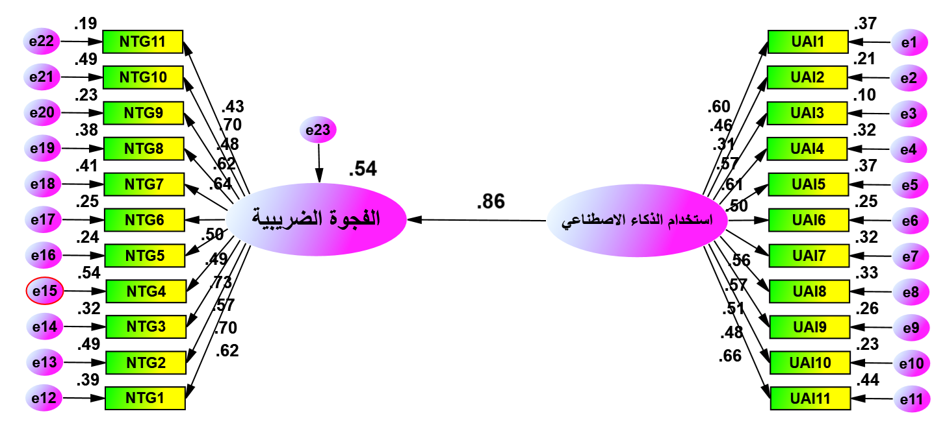
Figure (4). The scaling model for the impact of using artificial intelligence in auditing to reduce the tax gap.

The results of Table (5) below show that the reasons that contributed to improving the reduction of the tax gap are due to the contribution of using artificial intelligence in auditing by explaining an amount of (0.535) of the square of the variance in reducing the tax gap.

Table (5). Outputs of the measurement model for the impact of using artificial intelligence in auditing to reduce the tax gap
Path |  |  | Estimate | S.E | C.V-value | R² | F | Sig.
Using artificial intelligence in auditing | <--- | Reducing the tax gap | 0.861 | 0.093 | 9.258 | 0.535 | 71.337 | 0.001
Source: Prepared by researchers based on the program : spss

Conclusions:
1.There is a significant correlation between the use of artificial intelligence in auditing and reducing the tax gap. This confirms the important role of using AI technologies in auditing as an effective means of increasing the efficiency of tax administration by simplifying procedures, improving the work environment, increasing employee satisfaction, and enhancing the effectiveness of tax collection.
2.Reducing the tax gap depends on the ability of tax administrations to improve the efficiency of the tax system to enhance tax revenue and reduce the general budget deficit.
3.The use of AI technologies allows auditors to expand the sample size without increasing effort or cost, thus reducing audit risks and helping them choose the appropriate timing for verification operations.
4.There is widespread recognition of the importance of AI in improving tax performance, particularly in the areas of auditing and reducing tax evasion. However, challenges related to how AI can be used to enhance economic policy decisions remain, requiring further research and development in this area. The overall rate of AI use in tax administrations was 4.10, with a relative importance of 82%, indicating growing interest but requiring further enhancement to achieve its full benefits.
Recommendations:
1.Tax administrations must invest resources in developing and adopting modern artificial intelligence technologies, including data analysis programs, machine learning systems, and expert systems.
2.The need to enhance the efficiency of the tax system, which will help prevent tax evasion by taxpayers and improve tax revenues, which are the primary source of public revenue.
3.The need to prepare the administrative apparatus to use artificial intelligence technologies in auditing by training and qualifying tax employees to keep pace with new developments and enhance their skills in using artificial intelligence tools in data auditing.

4.The need to improve the taxpayer experience by providing smart and rapid services, such as AI-based tax consulting and creating advanced analytical models that use AI to identify patterns and trends related to tax evasion.
5.The need to establish clear regulatory policies to ensure the ethical and safe use of AI technologies, while protecting taxpayer data
.Disclaimer (Artificial intelligence)
Option 1:
Author(s) hereby declare that NO generative AI technologies such as Large Language Models (ChatGPT, COPILOT, etc.) and text-to-image generators have been used during the writing or editing of this manuscript.
Option 2:
Author(s) hereby declare that generative AI technologies such as Large Language Models, etc. have been used during the writing or editing of manuscripts. This explanation will include the name, version, model, and source of the generative AI technology and as well as all input prompts provided to the generative AI technology
Details of the AI usage are given below:
1.
2.
3.

REFERENCE
Al-Habaet, & Ahmed Taha Al-Arabi Abdel-Fattah. (2024). The Role of Artificial Intelligence in Increasing Income Tax. Benha Journal of Humanities, 3(3), 105-126.
Raikov, A. L. E. X. A. N. D. E. R. (2021). Decreasing tax evasion by artificial intelligence. IFAC-PapersOnLine, 54(13), 172-177.
Xavier, O. C., Pires, S. R., Marques, T. C., & Soares, A. D. S. (2022). Tax evasion identification using open data and artificial intelligence. Revista de Administração Pública, 56, 426-440.
Pavlova, K. S., & Knyazeva, N. V. (2022). Artificial intelligence technologies in tax consulting and forensic tax expertise. Digital Technologies in the New Socio-Economic Reality, 291-300.
Nuryani, N., Mutiara, A. B., Wiryana, I. M., Purnamasari, D., & Putra, S. N. W. (2024). Artificial intelligence model for detecting tax evasion involving complex network schemes. Aptisi Transactions on Technopr (Raikov, 2021)eneurship (ATT), 6(3), 339-356.
Baghdasaryan, V., Davtyan, H., Sarikyan, A., & Navasardyan, Z. (2022). Improving tax audit efficiency using machine learning: the role of taxpayer’s network data in fraud detection. Applied Artificial Intelligence, 36(1), 2012002.
Bezditnyi, V. (2024). Use of Artificial Intelligence for Tax Planning Optimization and Regulatory Compliance. Research Corridor Journal of Engineering Science, 1(1), 103-142.
Ansarullah, S. I., Ikhlaq, S., & Yousuf, T. (2025). Artificial Intelligence in Tax Compliance: Transforming Taxpayer Behavior. Modeling and Profiling Taxpayer Behavior and Compliance, 251.
Belahouaoui, R., & Attak, E. H. (2024). Digital taxation, artificial intelligence and Tax Administration 3.0: improving tax compliance behavior–a systematic literature review using textometry (2016–2023). Accounting Research Journal, 37(2), 172-191.
Cumberland, T. (2024). A look at the risks and opportunities for AI in tax administrations. OECD.AI. https://oecd.ai/en/wonk/risks-and-opportunities-ai-tax-administrations
Junquera-Varela, R. F., Lucas-Mas, C. Ó., Krsul, I., Calderon Yksic, V. O., & Arce Rodriguez, P. (2022). Digital transformation of tax and customs administrations. World Bank Group. https://documents1.worldbank.org/curated/en/099448206302236597/pdf/IDU0e1ffd10c0c208047a30926c08259ec3064e4.pdf
Ruziev, Z. I. (2022). The Role of Taxes in the Formation of State Budget Revenues. European International Journal of Multidisciplinary Research and Management Studies, 2(09), 58-65.
Spence, M. (2021). Government and economics in the digital economy. Journal of Government and Economics, 3, 100020.
Kamara, A. K., & Kamara, S. (2025). The Impact of Tax Strategies on Revenue Mobilization in Sierra Leone. European Journal of Political Science Studies, 5(2).
Adefolake, A. O., & Omodero, C. O. (2022). Tax revenue and economic growth in Nigeria. Cogent Business & Management, 9(1), 2115282.
Rahman, S., Sirazy, M. R. M., Das, R., & Khan, R. S. (2024). An exploration of artificial intelligence techniques for optimizing tax compliance, fraud detection, and revenue collection in modern tax administrations. International Journal of Business Intelligence and Big Data Analytics, 7(3), 56-80.
Saba, C. S., & Monkam, N. (2024). Leveraging the potential of artificial intelligence (AI) in exploring the interplay among tax revenue, institutional quality, and economic growth in the G-7 countries. AI & SOCIETY, 1-23.
Islam, M. I., Nisa, K. U., Mufti, S., Ansarullah, S. I., Ikhlaq, S., & Yousuf, T. (2025). Artificial Intelligence in Tax Compliance: Transforming Taxpayer Behavior and System Efficiency. In Modeling and Profiling Taxpayer Behavior and Compliance (pp. 251-270). IGI Global Scientific Publishing.
Atayah, O. F., & Alshater, M. M. (2021). Audit and tax in the context of emerging technologies: A retrospective analysis, current trends, and future opportunities. International Journal of Digital Accounting Research, 21.

