Cloud Technology: A Financial Innovation in Accounting and Microfinance Institutions
Abstract
The efficacy of Cloud technology is remarkable for young professionals who are players in Accounting, finance, banking, etc. The growing adoption of cloud-based solutions in the financial sector has transformed the way accounting and microfinance institutions operate. This study focuses on the Mambu model, a cloud-native core banking platform, to examine its role in enhancing institutional efficiency and service delivery. The key objectives are to evaluate the adoption of cloud technology frameworks in accounting and microfinance, and to explore how Mambu contributes to these domains. Relying on a descriptive and exploratory research design, the study uses secondary data sourced from industry reports, academic publications, and official Mambu documentation. Findings indicate that Mambu’s Process Orchestrator (MPO) supports automation, compliance, and data management across over 65 countries. Its Software-as-a-Service (SaaS) model and scalability promote financial inclusion and operational agility. The study further highlights Mambu’s indirect benefits for accounting firms through integration, reporting, and client service improvements, positioning it as a key enabler in the digital transformation of financial services.
Keywords- Cloud Technology, Financial Innovation, Accounting, Microfinance Institutions, Mambu Portfolio Management.
Introduction
In the fast-changing financial environment, cloud technology has become a game-changer, revolutionizing conventional practices across various sectors, including accounting and microfinance institutions (MFIs). Cloud-based solutions provide a platform for real-time data processing, enhanced security, and scalability, which are essential for organizations striving for efficiency and transparency.
The major advantages of cloud technology in the area of accounting is the automation of routine tasks such as bookkeeping, financial reporting, and compliance management. By utilizing cloud platforms, businesses can optimize their accounting operations, reduce human error, and facilitate seamless collaboration across departments. This digital shift in accounting practices is enhancing operational efficiency as well as enabling better decision-making through data-driven insights.
In the domain of microfinance, cloud technology represents a key financial innovation that is democratizing availability of financial services for underserved populations. Microfinance institutions are increasingly adopting cloud-based platforms to improve their operational performance, reduce costs, and improve customer outreach. Cloud technology enables MFIs to maintain comprehensive portfolios, manage client data securely, and offer financial products tailored to the specific needs of low-income clients.
Mambu, a cloud-based portfolio management system, exemplifies the integration of cloud technology within microfinance. Mambu allows MFIs to efficiently manage loans, savings, and other financial products through a highly flexible and scalable system. This innovation reduces the reliance on legacy systems and opens up new avenues for growth by enabling MFIs to scale their operations without being hindered by infrastructure constraints.
Thus, cloud technology, as a financial innovation, is revolutionizing both accounting and microfinance institutions, enabling them to operate with greater agility, security, and inclusivity. The adoption of cloud-based solutions such as Mambu marks a significant leap forward in fostering financial inclusion and operational excellence in these sectors.

Cloud Technology means storing and accessing data/services through the “internet”. Mambu is a microfinance portfolio management tool delivered online as Software-as-a-service (SaaS). With Mambu Microfinance institutions can offer loans and manage savings. Cloud technology allows users to access information and applications over the internet. For several reasons such as lower price, improved efficiency, ease of access to data, greater data security, reduced paperwork, flexible and scalable operations, improved customer relationships, etc., cloud technology is beneficial for accounting firms and microfinance institutions. Cloud technology Software-as-a-Service (SaaS) platform is very useful in Accounting and Microfinance institutions as it provides quality professional services platform. Cloud computing provides accountants with the ability to access financial data from anywhere with an internet connection, collaborate in real time with clients and colleagues, and ensure data security and backup. Financial Innovation is the process of creating new financial technologies, products, and services. Financial innovation contributes to the economic growth of a country and improves the effectiveness of financial institutions.
An Accounting institution is a company that provides several accounting services for clients. Accounting involves various tasks such as recording financial transactions, preparing financial statements, conducting audits, and analyzing financial data to provide valuable insights for stakeholders and decision-makers. Microfinance institutions are specialized financial organizations that provide a range of financial services such as small loans, savings accounts, and insurance to low-income individuals and microentrepreneurs who often lack access to traditional banking services.
Portfolio Management in Mambu for microfinance involves loan portfolio tracking, risk assessment, diversification, interest rate management, collections, reporting and analytics, compliance, etc. The implementation may vary depending on the specific needs of the microfinance institution and the version of Mambu in use. Thus Portfolio management plays an important role in several financial institutions from different perspectives. Mambu is a cloud-native core banking and financial services platform used by various financial institutions, including banks, fintechs, and microfinance institutions. Mambu is just one of many technology solutions available to microfinance institutions. The choice of a specific platform or solution depends on the institution's needs, budget, and regulatory environment.
Research Question
This study seeks to address the following research question: How does cloud technology function as a financial innovation in enhancing accounting practices and the operational efficiency of microfinance institutions?
Objectives of the Study
The specific objectives of this study are:
- To assess the adoption of cloud technology frameworks in the fields of accounting and microfinance institutions.
- To identify how the Mambu model is useful in improving efficiency, service delivery, and financial innovation in accounting and microfinance institutions.
Cloud impact for India
Cloud has the potential to account for ~8% of India’s GDP in 2026 growing 4x over the next five years. Key sectors contributing to this GDP will be Financial Services, Communication, Media and entertainment, and industries. Similarly, the cloud has the potential to create 14 million jobs in 2026 growing 3x over the next five years.

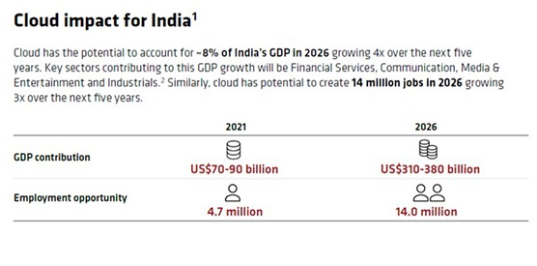
Fig 1 Harnessing the power of Cloud technology for India’s Success [Source: NASSCOM]

Conceptual Framework
Cloud technology plays a significant role in the field of accounting and microfinance in many countries. This technology enables easier access to financial data, streamlines operations, and enhances collaboration, ultimately improving efficiency and reducing overhead costs for these institutions.
Cloud architecture refers to the design and structure of a cloud computing environment, which includes all the components such as Servers, virtual desktops, software platforms, applications, store data, and cloud storage devices, and computing over cloud-based clusters that are tied together by the internet using mobile, laptop, and printers. This architecture typically encompasses various layers and components that include front-end and back-end layers, cloud service models, virtualization and containers, networking, etc. The client devices (e.g., laptops, smartphones, tablets) are used to access cloud services and applications. The front end is the user interface and user experience layer, often delivered through web browsers or mobile apps. It allows users to interact with cloud-based services. This layer represents the various cloud services (e.g., AWS, Azure, Google Cloud), including Software as a Service (SaaS). These services may encompass virtual machines, databases, storage, and more. Cloud architecture can be complex, and organizations often choose to work with cloud architects and service providers to design, implement, and manage their cloud environments effectively.
Cloud accounting software plays a major role in offering several benefits, including:
- Automation: Automation is a key feature of cloud platforms. It can automate loan origination, underwriting, disbursement, and repayment processes, reducing manual workloads and improving efficiency.
- Accessibility: Users can retrieve their financial data from any location with an internet connection, making it perfect for remote work and collaboration.
- Lower overhead expenses: By implementing some strategies, such as choosing the right plan, usage monitoring, financial reporting, and analytics it becomes easy to reduce overhead expenses.
- Scalability: It refers to the ability of a system, business, or software to handle increased workload or demand while maintaining or improving.
- Increased Collaboration: To promote teamwork and efficiency multiple users can collaborate on the same data simultaneously.
- Faster implementation: Faster implementation can reduce the risk of project delays and uncertainties, making it easier to stay on track.
Here are some popular cloud accounting software namely:
- Netsuite: Netsuite is an enterprise-level cloud ERP (Enterprise Resource Planning) software that includes accounting as one of its modules.
- Quickbooks Online: Quickbooks Online is one of the most widely used cloud accounting solutions. It offers features for invoicing, expense tracking, tax preparation, and financial reporting.
- Xero: Xero is known for its user-friendly interface and comprehensive accounting features. It includes tools for payroll, and inventory management, and integrates with a wide range of third-party applications.
- Wave: Wave is a free cloud accounting software designed for small businesses and freelancers. It includes features for invoicing, accounting, and receipt scanning.
- Kashoo: Kashoo is a straightforward cloud accounting software designed for small businesses and offers double-entry accounting, expense tracking, and invoicing features.
To further enhance the impact of cloud accounting software and its integration with platforms like Mambu, it is essential to recognize the transformative role these solutions play in streamlining financial operations for businesses, especially microfinance institutions (MFIs). By integrating cloud accounting software with Mambu, MFIs can automate and centralize financial processes, resulting in significant improvements in operational efficiency, accuracy, and compliance. Data integration between Mambu and cloud accounting systems, such as NetSuite, QuickBooks Online, or Xero, allows seamless flow of financial information across platforms. This synchronization helps maintain real-time financial visibility, reducing the need for manual data entry and minimizing errors. It also enables institutions to make informed financial decisions based on live data, improving agility in responding to market changes or client needs.
Additionally, transaction recording and reconciliation become more efficient as Mambu integrates with accounting software. Financial institutions can automate the tracking of loans, repayments, and interest, directly syncing these transactions into the accounting system. This automation simplifies auditing and helps maintain a robust audit trail, ensuring compliance with local and international financial regulations. From a reporting standpoint, integrating accounting software with Mambu enables financial institutions to generate comprehensive, customizable financial reports. This is particularly important for MFIs that need to demonstrate financial health to stakeholders, regulatory bodies, and investors. The ability to produce accurate financial statements and cash flow reports fosters greater transparency and supports the institution's long-term sustainability. Moreover, the integration supports compliance with evolving regulatory standards. MFIs can benefit from the automated compliance checks offered by cloud accounting software, reducing the risk of non-compliance penalties. Platforms like Wave or Kashoo may be particularly beneficial for smaller institutions or startups, as they offer affordable, easy-to-use solutions while still maintaining compliance features. To handle accounting tasks, there is a need to integrate accounting software alongside Mambu or consider dedicated accounting solutions. However, in the context of financial institutions that use Mambu, it may indirectly impact cloud accounting in the following ways: Data integration, transaction recording, reporting, and compliance. Mambu can integrate with other software and systems, including accounting software. This integration allows financial institutions to synchronize data between Mambu and their accounting system, ensuring accurate and up-to-date financial records. Integrating cloud accounting software with Mambu offers holistic financial management, ensuring streamlined operations, real-time data accuracy, enhanced reporting capabilities, and robust compliance features—all of these contribute towards the financial sustainability and growth of MFIs.

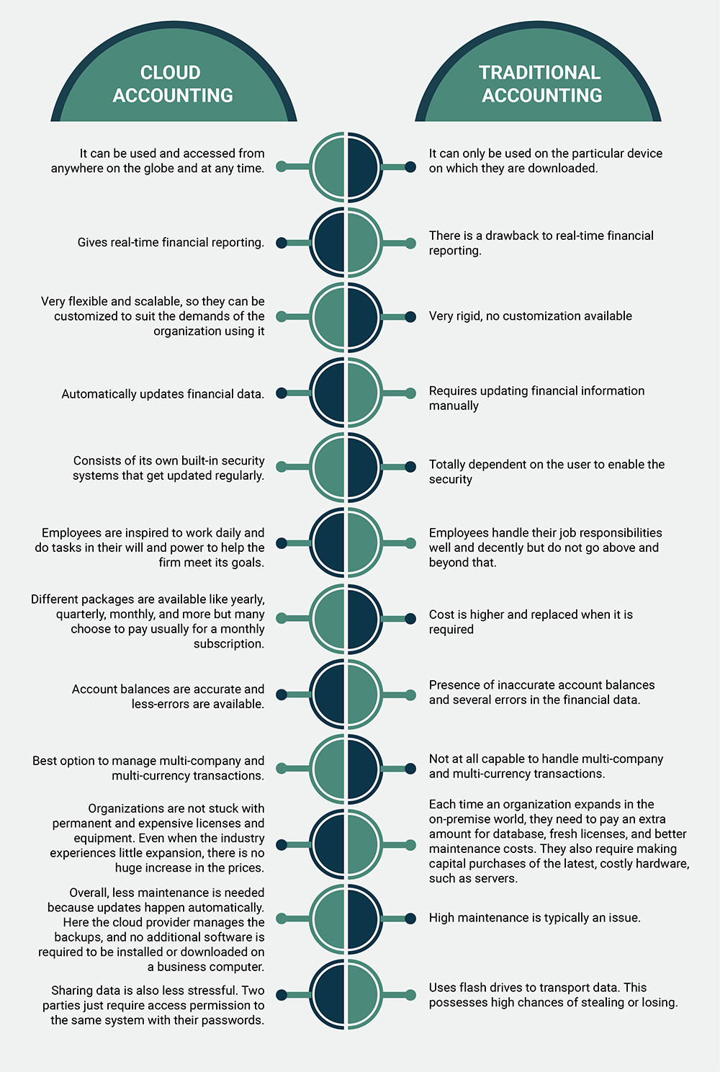

Fig 2 Accounting in the Cloud: A New Era vs Traditional Methods [Source: CIMA]

MAMBU Framework
Mambu is one of the cloud software meant for microfinance companies to uncover the requirements of microfinance institutions and to support their operations. Mambu is unique in the way that what an MFI requires to start using Mambu is available online. One big merit of Mambu for microfinance institutions is its scalability and pay-as-you-go model. Cloud technology Software-as-a-Service (SaaS) platform is very useful in Microfinance and Accounting as it provides quality professional services platform. Mambu is a platform that primarily serves accounting firms indirectly as compared to financial institutions. Mambu serves accounting firms in the following ways such as client services, integration, data analysis, and regulatory compliance.
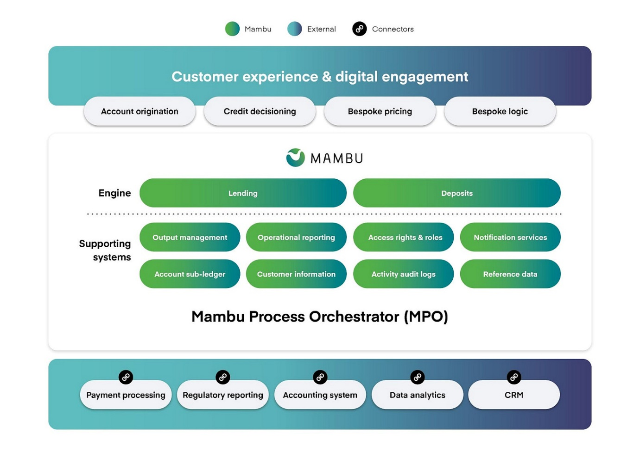
Fig 3 Mambu’s Agile Architecture [Source: Mambu]
Mambu Portfolio Management :
- Account origination in Mambu: This involves the process of creating and setting up customer accounts for various financial products and services offered by financial institutions, including banks, credit unions, and microfinance organizations. Mambu's cloud-based approach to account origination provides financial institutions with the flexibility, scalability, and cost-efficiency required to meet the demands of a dynamic and competitive financial services landscape. It allows organizations to focus on serving their customers while relying on the cloud provider for the underlying infrastructure and security. How account origination works in Mambu from a cloud perspective is as follows:
In the realm of account origination, cloud infrastructure is integral, utilizing multi-tenant architecture to allow multiple institutions to share resources securely while maintaining data privacy. This approach not only optimizes costs but also enhances system efficiency. Through automation and workflow management, manual tasks are minimized, leading to faster processing and improved operational efficiency. The scalability of cloud systems allows institutions to easily adjust their resources based on demand, supporting growth and adaptability. Ensuring data security through encryption, multi-factor authentication, and access controls is a core aspect, safeguarding sensitive client information. Furthermore, API integration connects cloud platforms with third-party applications, streamlining account origination workflows and enhancing the overall customer experience. Continuous monitoring and analytics provide real-time insights, allowing for system optimization, compliance adherence, and high service levels, ensuring that financial institutions remain responsive and efficient in their operations.
- Credit Decisioning: Credit decisioning has been revolutionized by advancements in technology, leveraging data storage solutions that enable institutions to store and access vast amounts of financial data efficiently. The integration of machine learning (ML) and AI enhances the credit decision process by analyzing patterns, predicting borrower behavior, and assessing credit risk with greater accuracy. Additionally, integration with external data sources, such as credit bureaus and alternative data providers, enriches the credit profile, offering a more comprehensive evaluation of applicants. Real-time decisioning is made possible through automated systems that rapidly process data and deliver instant credit decisions, improving customer experience and reducing processing times. Ensuring compliance and security is crucial in this process, with strong encryption and regulatory adherence protecting sensitive information. Finally, this technological approach brings cost efficiency, as automated decision-making reduces operational costs, minimizes human error, and accelerates the lending process, benefiting both financial institutions and borrowers.
- Bespoke Pricing: Bespoke pricing models offer financial institutions flexibility through usage-based pricing, where costs are aligned with actual resource consumption, ensuring efficiency and cost-effectiveness. This approach supports scalability, allowing institutions to adjust their services and pricing as they expand. With customization, businesses can tailor their pricing structures to fit their unique needs, incorporating add-on services such as advanced analytics or additional data storage. Data storage and processing are integral components, with costs fluctuating based on the volume of data handled. Ensuring compliance and security is part of the pricing model, as regulatory and security measures are factored into the cost. Support and training packages are often included to help clients maximize the system’s potential. Flexible contract terms, such as pay-as-you-grow options, allow institutions to scale without upfront financial strain. This approach ensures cost optimization, balancing resource use with growth potential while maintaining operational excellence.
- Bespoke Logic: Bespoke logic in financial systems allows institutions to tailor custom workflows that align with their specific operational needs, offering flexibility in managing processes. A rules engine enables the creation of dynamic decision-making criteria, ensuring that each transaction or process follows pre-defined, institution-specific guidelines. The ability to conduct A/B testing and optimization helps refine workflows and strategies, allowing for continuous improvement and performance enhancement. In addition, compliance management is embedded within these custom systems, ensuring that regulatory standards are consistently met while reducing the risk of violations. This approach also promotes cost control, as tailored workflows and decision-making reduce unnecessary expenses and streamline operations. Real-time monitoring and reporting provide immediate insights into performance metrics and system health, enabling quick adjustments and fostering agility. All of these elements contribute to a seamless user experience, where the system is responsive, efficient, and aligned with both institutional goals and customer expectations.
- Mambu's lending and deposit: In modern financial systems, lending and deposits are streamlined through seamless integration with core banking platforms, enabling institutions to manage both functions efficiently in a unified environment. This integration ensures that loan origination, servicing, and deposit management are all connected, providing a smooth customer experience. Robust compliance and security measures are built into these systems to ensure that all regulatory requirements are met and sensitive financial data is protected. Advanced analytics and reporting tools allow institutions to gain valuable insights into loan performance, deposit trends, and customer behaviors, driving data-driven decision-making. Innovative deposit solutions offer flexibility in managing accounts, enabling clients to make various types of deposits, from savings accounts to fixed-term products, while ensuring liquidity management. Additionally, automated workflows and digital capabilities enhance cost efficiency, reducing operational expenses and streamlining lending and deposit processes for both the institution and its customers.
- Mambu supporting systems: A robust supporting system is crucial for ensuring smooth financial operations, starting with comprehensive activity audit logs that track all system interactions, providing transparency and a reliable record for security and compliance purposes. The account sub-ledger offers detailed transaction-level information that complements the general ledger, ensuring granular financial oversight. Access rights and roles management ensures that only authorized personnel have access to sensitive data and functions, maintaining system security and operational integrity. Output management facilitates the generation of essential reports and documents, while operational support handles system maintenance, troubleshooting, and issue resolution. Integrated notification services keep users informed of critical events or tasks, enhancing responsiveness. Centralized customer information and reference data management streamline data handling, ensuring consistency across systems and improving decision-making. Together, these components create a comprehensive supporting system that drives efficiency, security, and effective financial management.
- Payment Processing: It includes the following:
Payment Types: Mambu supports various payment types, including loans, savings, and transactional accounts. It enables payment processing for deposits, withdrawals, transfers, loan disbursements, and repayments.
Integration with Payment Networks: Mambu integrates with payment networks and gateways to facilitate electronic payments, including ACH transfers, card payments, and direct debits.
Payment Workflows: Mambu allows financial institutions to define payment workflows, including approval processes, transaction limits, and routing rules.
Real-time Processing: Payment transactions can be processed in real-time, providing customers with immediate access to their funds and transaction confirmations.
Payment processing systems today are designed to handle a wide variety of payment types, including credit cards, digital wallets, bank transfers, and mobile payments, ensuring flexibility and convenience for users. These systems are seamlessly integrated with payment networks, such as Visa, Mastercard, and ACH, enabling fast, secure transactions across multiple platforms. Customized payment workflows allow businesses to automate payment processing steps, from transaction initiation to settlement, streamlining the entire process for improved efficiency.

- Regulatory Reporting: It covers the following:
Compliance Checks: Mambu includes compliance checks to help financial institutions adhere to regulatory requirements. It can enforce rules related to Anti-Money Laundering (AML), Know Your Customer (KYC), and other regulations.
Data Collection: The platform collects and stores transactional and customer data, which can be used for regulatory reporting purposes.
Reporting Tools: Mambu typically offers reporting tools that help institutions generate regulatory reports, such as transaction reports, capital adequacy reports, and other compliance-related documents.
Automation: Regulatory reporting is a critical function in financial institutions, ensuring adherence to compliance standards. Automated compliance checks are embedded within reporting systems to continuously monitor transactions and processes, flagging any potential regulatory violations in real time. Effective data collection tools aggregate and organize vast amounts of financial data from various sources, ensuring accuracy and completeness. Advanced reporting tools then transform this data into comprehensive reports required by regulatory bodies, making the process more efficient and less prone to error. Through automation, the entire regulatory reporting workflow—from data gathering to report generation—becomes streamlined, reducing manual labor and ensuring timely submission of reports. This not only helps institutions stay compliant but also minimizes the risk of penalties, fostering better operational integrity.

- Accounting System: This includes the following:
General Ledger: Mambu includes a general ledger system that records and manages financial transactions, ensuring accurate accounting and financial reporting. Accounting Rules: It allows organizations to define accounting rules and configure a chart of accounts to align with their specific accounting practices and regulatory requirements.
Real-time Updates: The accounting system provides real-time updates of account balances, transaction history, and financial statements.
Integration: Mambu can integrate with external accounting software or systems to streamline financial reporting and reconciliation processes.
An accounting system forms the backbone of financial management by maintaining a comprehensive general ledger that records all transactions and balances, ensuring accuracy and transparency in financial reporting. Customizable accounting rules allow institutions to define how transactions are categorized, posted, and reconciled, ensuring compliance with industry standards and internal policies.

- Data Analytics: It includes:
Data Collection: Mambu collects extensive data on customer transactions, behavior, and account activity.
Reporting and Dashboards: It offers reporting and analytics tools to help financial institutions create custom reports, dashboards, and visualizations to gain insights into their operations, customer behavior, and portfolio performance.
Predictive Analytics: Some organizations use data analytics in Mambu to implement predictive models for credit scoring, risk assessment, and customer segmentation.
Data Export: Data analytics plays a crucial role in transforming raw information into actionable insights. Efficient data collection systems aggregate data from various sources, ensuring a comprehensive and accurate foundation for analysis. Advanced reporting and dashboards present this data in an intuitive, visual format, allowing users to easily interpret trends, patterns, and performance metrics. Predictive analytics further enhances decision-making by using historical data to forecast future trends and outcomes, enabling proactive strategies and informed planning. Additionally, the capability for data export allows users to transfer analyzed data into various formats for external use, facilitating deeper analysis, sharing with stakeholders, or integration with other systems.

- CRM (Customer Relationship Management): This covers the following:
Customer Information Management: Mambu stores and manages customer data, including personal information, contact details, and transaction history.
Customer Communication: It facilitates customer communication through various channels, including email, SMS, and in-app notifications.
Customer Insights: CRM features in Mambu offer insights into customer behavior, preferences, and interactions, enabling institutions to offer personalized services and targeted marketing campaigns.
Task Management: Some CRM functionalities in Mambu include task management and follow-up actions for customer inquiries, complaints, and support requests.
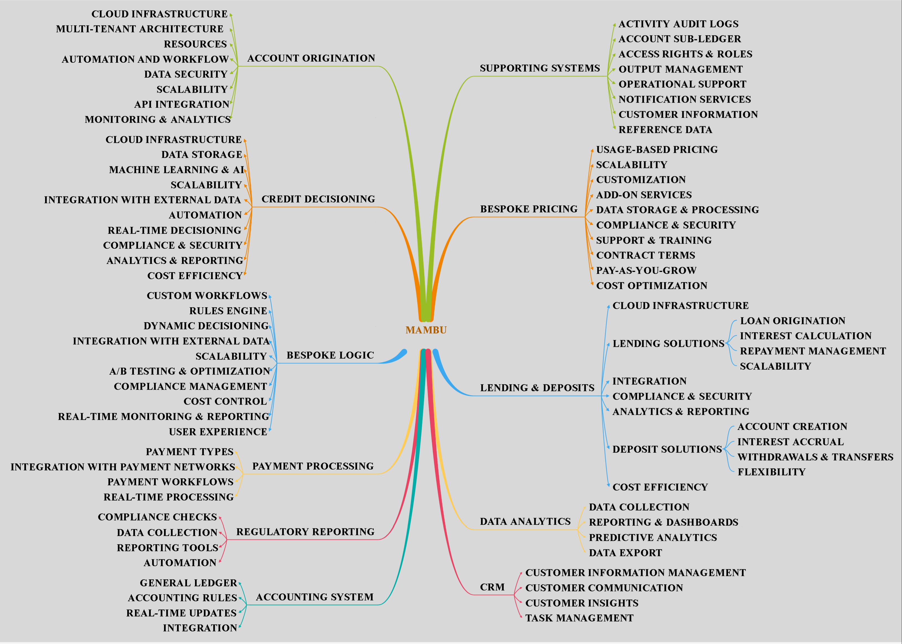

Fig 4 Mambu Portfolio Management [Source: Author]
Literature Review
Before the advent of cloud technology, accounting and microfinance institutions (MFIs) largely relied on traditional methods and on-premises systems, which were often fraught with limitations, including high costs, security risks, and scalability issues. With the introduction of cloud technology, both accounting and MFIs have seen significant improvements, particularly in cost efficiency, scalability, and service delivery. These advantages make cloud technology a compelling innovation, driving its widespread adoption across industries. As cloud solutions allow for real-time data access and better data security, they have proven to be transformative in the financial services sector, especially for smaller institutions seeking operational efficiency.
Studies such as Ashta & Patel (2013) explore how Software as a Service (SaaS) can disrupt the microfinance software market by providing affordable, scalable solutions that enable MFIs to operate more efficiently. In their research, they identify two key areas: institutional innovation and microenterprise-level case studies, shedding light on emerging actors in the SaaS space for MFIs.
Dimitriu & Matei (2015) highlight cloud accounting as a revolutionary approach that emerged in response to a challenging financial landscape. They discuss how cloud computing has the potential to transform accounting practices by enhancing accessibility, reducing costs, and improving financial management. The study also addresses the risks associated with cloud adoption, such as data privacy concerns and the reliance on third-party vendors.
Similarly, Khanom (2017) provides a theoretical foundation for cloud accounting, discussing its benefits, shortcomings, and its potential to redefine how financial data is managed in organizations. However, while cloud technology is already widely implemented in microfinance institutions globally, its use in India is still in the nascent stages, and only a limited number of studies have been conducted on its adoption in this region. This underscores the need for further research on how cloud technology can be integrated within Indian MFIs to improve their financial performance and outreach.
In the European context, Hon & Millard (2018) focus on the use of public cloud computing services by EU banks, emphasizing the legal and regulatory challenges that can affect adoption. This study also highlights the need for clear regulatory frameworks to facilitate cloud adoption within the banking and financial services industries.
In the Indian microfinance landscape, Mambu (2018) has emerged as a key technology provider. The Mambu platform was selected by Kreditech to aid its expansion into India, supporting the digital transformation of the lending sector. This partnership demonstrates the increasing interest in cloud technology among MFIs in India and its potential to enhance service delivery.
Further research by Dorfleitner, Forcella, & Nguyen (2022) identifies the factors driving digital transformation in MFIs. Their study suggests that MFIs' adoption of digital technologies is strongly linked to improved social performance and overall sustainability. This trend is also echoed by Pal et al. (2021), who explore the role of blockchain and other cutting-edge technologies in MFIs’ digitalization journey. They propose a framework that can guide MFIs in adopting innovative technologies to achieve long-term sustainability.
Despite these advancements, there is a lack of comprehensive studies that simultaneously explore the intersection of cloud technology adoption and operational performance in both accounting and microfinance sectors, particularly in India. The research gap lies in the limited understanding of how cloud technologies, specifically platforms like Mambu, impact the dual domains of accounting practices and microfinance operations in the Indian context. While existing research covers either accounting or MFIs in isolation, there is a significant gap in examining how cloud technology can bridge these two areas to improve both operational efficiency and financial sustainability in MFIs.
The rationale of the Study
The rationale of the present research work resides in the fact that most countries are lacking in adopting the Mambu cloud technology in the field of accounting and microfinance for several reasons. Still, more than 65 countries are taking advantage of Mambu cloud technology. In early (Kreditech, 2018) had selected Mambu for expansion into India. With Mambu we can focus on growth and therefore create a differentiated and tailored client experience towards various financial services such as loan servicing, digital lending, accounting systems, payment processing, account origination, and so on in accounting firms and microfinance institutions.

Research Methodology
Research Design
This study adopts a descriptive and exploratory approach, utilizing secondary data to explore the relevance of cloud technology framework adoption in the area of accounting and microfinance institutions. Also, to identify the usefulness of the Mambu model in these fields. The present study is based on the conceptual framework.
Data Collection Methods
Data was gathered from multiple secondary sources including academic journals, industry reports, newspapers, and websites. The inclusion criteria for the sources were publications from the last ten years, relevance to cloud technology financial innovation, and a focus on accounting and microfinance institutions. Exclusion criteria included non-peer-reviewed articles and sources not directly related to the research topic.
Ethical Considerations
All sources were properly cited to maintain academic integrity and avoid plagiarism. The data were accurately represented to ensure the reliability of the analysis.
Limitations
This study is limited by the scope and specificity of available secondary data. Potential biases in the data may affect the findings, and the conclusions drawn are based on the interpretation of existing data.

Findings
- The Cloud impact for India reveals GDP contribution in the year 2021 as US$70-90 billion and will reach up to US$ 310-380 billion by 2026. Similarly, Employment opportunity in 2021 reveals a growth of 4.7 million and will reach 14.0 million by 2026. (Nasscom)
- Still, more than 65 countries are taking advantage of Mambu cloud technology to improve microfinance institution's operations. In early 2018, Kreditech selected Mambu for expansion into India (Mambu, 2023)
- Cloud technology enables easier access to financial data, streamlines operations, and enhances collaboration, ultimately improving efficiency and reducing overhead costs for these institutions.
- To handle accounting tasks, there is a need to integrate accounting software alongside Mambu or consider dedicated accounting solutions.
- In the context of financial institutions that use Mambu, it may indirectly impact cloud accounting in the following ways: Data integration, transaction recording, reporting, and compliance.
- One big merit of Mambu for microfinance institutions is its scalability and pay-as-you-go model.
- Cloud technology Software-as-a-Service (SaaS) platform is very useful in Microfinance institutions and Accounting as it provides quality professional services platform.
- Mambu serves accounting firms indirectly in the following ways such as client services, integration, data analysis, and regulatory compliance.
- Innovators who want to make a difference in the financial digital world use Mambu’s platform to grow, change, and build excellent financial products and services.
- The overall performance of Mambu Process Orchestrator (MPO) is remarkable in terms of its functionalities and in providing solutions for microfinance institution's operations and accounting firms.

Executive Summary
This paper is the first to specifically focus on the adoption of Mambu cloud technology by microfinance institutions. Additionally, it addresses the indirect role Mambu plays in serving accounting firms, emphasizing the need for integrating dedicated accounting software alongside the Mambu platform. The study employs the Mambu model to examine the Mambu process Orchestrator used by these institutions.
The research explores the adoption and impact of Mambu cloud technology in accounting and microfinance institutions, particularly focusing on its relevance in India. Despite the global availability of Mambu, its adoption has been uneven across countries. However, over 65 countries, including India, are benefiting from this technology, which offers significant advantages in financial operations and services. Kreditech’s 2018 expansion into India using Mambu highlights the technology's potential in enhancing financial services in emerging markets.
The study's primary objectives were to assess the adoption framework of cloud technology in accounting and microfinance institutions and to evaluate the specific utility of the Mambu model in these fields. The research adopts a descriptive and exploratory approach, relying on secondary data from various sources like academic journals, industry reports, and websites, focusing on publications from the last decade.
Findings reveal that cloud technology has a profound impact on financial sectors, with projections showing a substantial increase in GDP contribution and employment opportunities in India due to cloud adoption. Mambu, as a cloud-based platform, streamlines financial operations, facilitates data integration, enhances collaboration, and provides scalability through its pay-as-you-go model. For accounting firms, Mambu indirectly supports client services, data analysis, and regulatory compliance, while in microfinance, it significantly boosts financial inclusion by extending services to underbanked populations.
The study also highlights the significance of integrating accounting software with Mambu for comprehensive financial management. The overall performance of Mambu, particularly its Process Orchestrator, has been commendable, offering solutions customized to meet the specific requirements of accounting and microfinance institutions.
In conclusion, cloud technology, spearheaded by platforms like Mambu, represents a critical innovation in the financial sector. It has revolutionized the management of financial data, streamlined operations, and improved service delivery in accounting and microfinance institutions. Mambu’s scalable and adaptable cloud-based solutions are instrumental in promoting financial inclusion, reducing operational costs, and enhancing the overall efficiency of these institutions. However, the study also highlights the necessity for strong data protection measures and compliance management to fully harness the advantages of cloud technology in these sectors.

Conclusion
According to the study, cloud technology has become a significant financial innovation in accounting and microfinance institutions. It has revolutionized the way these organizations manage their data, streamline operations, and serve their clients. In accounting, cloud technology enables firms to access and store financial data securely on remote servers, reducing the need for on-premises infrastructure. This leads to cost savings and allows for real-time collaboration among accountants and clients. It also provides scalability, ensuring that accounting firms can easily adapt to changing client needs.
In Microfinance institutions, cloud technology has enhanced financial inclusion. By using cloud-based systems, these institutions can efficiently manage and analyze client data, extending services to underbanked populations. Overall, cloud technology has increased efficiency, reduced costs, and improved financial services in accounting and microfinance institutions, making it a vital financial innovation in these sectors.
Mambu, as a cloud-based technology, has indeed become a noteworthy financial innovation in accounting and microfinance institutions. Mambu’s cloud technology is a significant financial innovation that has transformed how accounting and microfinance institutions operate, ultimately leading to increased efficiency, reduced costs, and improved financial services for clients. However, it also underscores the importance of data security, compliance, and prudent management to fully realize its potential benefits. Cloud-based Mambu solutions improve accessibility for both clients and employees. This is especially vital in microfinance, where serving remote and underserved populations is a priority. It promotes financial inclusion by extending services to a broader demographic. Cloud-based Mambu platforms also enable advanced data analytics and reporting, providing valuable insights for decision-making. Mambu’s cloud technology is highly scalable and adaptable for accounting firms and microfinance institutions as they grow and evolve.

References
Ashta, A., & Patel, J. (2013). Software as a service: An opportunity for disruptive innovation in the microfinance software market? . Journal of Innovation Economics & Management, 11, 55-82. doi:https://doi.org/10.3917/jie.011.0055
BasuaMallick, C. (2021). What Is Cloud Computing? Definition, Benefits, Types, and Trends. Retrieved from https://www.spiceworks.com/tech/cloud/articles/what-is-cloud-computing/
Chander, D. A. (2008). Technical Guide on Accounting for Microfinance Institutions. Sahitya Bhawan Publications, https://kb.icai.org/pdfs/PDFFile663b05e61ad9f8.20567684.pdf
CIMA. (2022). An overview of - What is Cloud Computing in Accounting -CIMA. Retrieved 2023, from Slideserve: https://www.cima.institute/blog/an-overview-of-what-is-cloud-computing-in-accounting
Dimitriu, O., & Matei, M. (2015). Cloud Accounting: A New Business Model in a Challenging Context. Procedia Economics and Finance, 32, 665-671. doi:https://doi.org/10.1016/S2212-5671(15)01447-1
Dorfleitner, G., Forcella, D., & Nguyen, Q. A. (2022). The digital transformation of microfinance institutions: an empirical analysis. Journal of Applied Accounting Research, 23, 454-479. doi:https://doi.org/10.1108/JAAR-02-2021-0041
Hon, W. K., & Millard, C. (2018). Banking in the cloud: Part 1 – banks’ use of cloud services. Computer Law & Security Review. The International Journal of Technology Law and Practice, 34(1), 4-24. doi:https://doi.org/10.1016/j.clsr.2017.11.005
Khanom, M. T. (2017). Cloud Accounting: A Theoretical Overview. IOSR Journal of Business and Management, 19, 31-38. doi:10.9790/487X-1906053138
Kreditech. (2018). Member News: Mambu Selected by Digital Lender Kreditech for Expansion Into India. Retrieved from Bank Automation News: https://www.smefinanceforum.org/post/member-news-mambu-selected-by-digital-lender-kreditech-for-expansion-into-india
Mambu. (2023). Mambu. Retrieved from https://mambu.com/
McCue, I. (2021). Cloud Accounting Basics: What It Is & Reasons to Use. Retrieved from NetSuite: https://www.netsuite.com/portal/resource/articles/accounting/cloud-accounting.shtml
Nasscom. (2022). Future of Cloud and Its Economic Impact: Opportunity for India. Retrieved from https://nasscom.in/: https://nasscom.in/knowledge-center/publications/future-cloud-and-its-economic-impact-opportunity-india
Pal, A., Dey, S., Nandy, A., Shahin, S., & Singh, P. K. (2021). Digital Transformation in Microfinance as a Driver for Sustainable Development. doi:https://doi.org/10.1007/978-3-030-68074-9_74-1

