Integrating Media Literacy into TESOL Curriculum for Adult Learners in Community Colleges

ABSTRACT

Aim: This study investigates how media literacy is integrated into the TESOL (Teaching English to Speakers of Other Languages) curriculum and how its incorporation could encourage adult learners in U.S. community colleges to learn more effectively, enhance cultural consciousness, and become better critical thinkers.
Study Design: A thorough peer-reviewed literature review was conducted to examine recent studies on media literacy practice in TESOL programs for adult learners.
Methodology: The study employed systematic literature review methodology in analyzing peer-reviewed scholarly journals between 2020 and 2025 from repu pic academic databases such as Google Scholar, JSTOR, and the TESOL Quarterly. The reviewed studies analyzed media literacy pedagogy, adult education, and intercultural communication in community college settings. The inclusion criteria emphasized peer-reviewed publications documenting teaching methods, learning outcomes, and program implementation concerns.
Results: The study shows that integrating media literacy into TESOL instruction improves learners' critical evaluation of digital content, cross-cultural awareness, and engagement with real English language use. Different studies cite increased learner confidence, classroom participation, and use of English in daily digital communication.
Conclusions: The incorporation of media literacy into TESOL curriculum facilitates linguistic and cognitive growth of adult learners. It also enables students to engage with media-rich environments in thoughtful and responsible ways. The study encourages TESOL teachers and curriculum developers to incorporate media literacy practices into teaching planning in an effort to foster balanced, holistic, and relevant language learning.

Keywords: Media Literacy, TESOL, Curriculum, Digital Content, Cross-cultural, Community Colleges

1. INTRODUCTION

With the prevailing globalization and digital interconnectedness, media literacy is now an essential component of education, particularly for adult learners struggling to navigate the complex media environments. Media literacy may be defined as the ability to access, analyze, evaluate, and produce messages in numerous formats, ranging from digital to print to visual [1 - 3]. For immigrant, refugee, and non-traditional adult English language learners (ELLs) at community colleges, media literacy is not only a communication tool but also an entry point for learning sociocultural norms, civic participation, and job readiness [4]. Therefore, the integration of media literacy into the TESOL curricula has become extremely significant in equipping learners with linguistic ability as well as critical thinking processes needed in the 21st century.

United States community colleges are extremely significant in offering flexible and affordable educational opportunities to diverse groups of adult learners. However, traditional English as a Second Language (ESL) instruction in such schools has traditionally focused primarily on grammar, vocabulary, and functional language use, with little regard for critical engagement with real-world texts [5, 6]. This may discourage students from applying English meaningfully in actual, contemporary contexts. The inclusion of media literacy within the TESOL curriculum addresses this gap since it enables learners to engage with authentic materials such as news reports, social media posts, podcasts, and multimedia content in order to develop enhanced understanding and applicability to cultures [7, 8].

TESOL learning also enhances the development of intercultural competence through media literacy. While dealing with global media, learners encounter various perspectives, cultural values, and socio-political beliefs. Exposure to critical thinking and interpretive skills needed in grasping messages cross-culturally fosters proficiency in effective cross-cultural communication [9]. Additionally, by means of students' learning process, exposure of students to biased reporting, errors, and ethical aspects of engaging online come into view, so integral to our age and era of information overload and "fake news" [10].

Pedagogically, the integration of media literacy aligns with learner-centered and constructivist approaches to adult education. Adult learners bring with them extensive experience and worldviews. When students analyze media from both their home countries and host cultures, they learn language skills as well as negotiate their identities and worldviews. This active interaction has been shown to boost learner motivation, self-efficacy, and class participation [4].

In everyday usage, media literacy facilitates language acquisition by exposing students to varied language forms, lexis, and discourse types. Students not only learn about the workings of language in real-life communication but also about how language creates meaning, influences opinion, and demonstrates power dynamics [11]. For instance, learning political oratory or online arguments teaches students persuasive language and rhetorical techniques, while learning adverts reveals implicit cultural values and consumption patterns [12, 13].

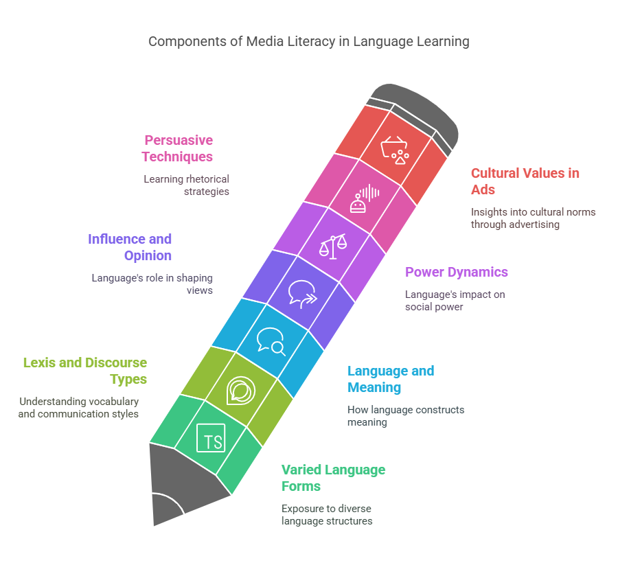

Figure 1: Components of Media Literacy in Language Learning

Furthermore, the digital world that students live in daily—through smartphones, social media, online news, and streaming platforms—provides a wide variety of communicative forms that are seldom included in traditional TESOL curricula. Inability to adapt curricula to the digital nature of learners' daily lives risks creating a gap between classroom learning and actual use [14]. Adult learners, who usually need to balance family, work, and other responsibilities, need learning materials that not only teach English but are also applicable to their actual circumstances. Media literacy, when combined with language instruction, closes the gap by presenting rich, real-life content that reflects contemporary issues, encourages classroom engagement, and facilitates retention of language structure [15].

The COVID-19 pandemic also further emphasized the need for digital and media literacies in adult education [16, 17]. As face-to-face classrooms shifted to online learning spaces, teachers and students had to depend on digital technology and internet materials for communication, teaching, and collaboration. This shift emphasized digital access and literacy gaps among adult ESL learners, especially those who are low-income or immigrants [16, 18]. But it also revealed promise for TESOL pedagogy innovation—many teachers began employing online videos, social media projects, and multimedia texts for teaching language skills and constructing critical media awareness. These innovative approaches demonstrate the practicability and efficacy of establishing media literacy in adult ESL education on a larger scale [19].

In particular, adult learners have diverse existing literacies—linguistic, cultural, and experiential—which can be addressed with the assistance of critical media pedagogy. Identification of and drawing on such literacies upholds Freirean principles of empowerment, student agency, and social transformation, particularly relevant to community college environments where students themselves face systemic inequality on the bases of race, class, gender, or immigration status [10]. Through directed study of media texts, students not only learn linguistic skills but voice, agency, and a feeling of belonging within the new sociocultural setting.

In response to such shifting needs, researchers and educators have called for TESOL to shift towards critical media literacy as opposed to functional literacy—treated with attention to reflection, questioning, and sociopolitical awareness [20].
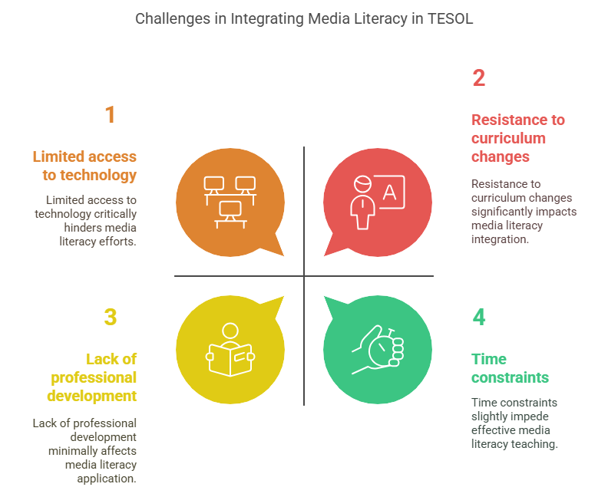

Figure 2: Challenges in Integrating Media Literacy in TESOL

While recognition of the potential value of media literacy for teaching TESOL continues to rise, little empirical research on media literacy is present specifically among adult learners within the community college context. Much current research either focuses on K–12 or university ELLs, or neglects to consider how media-enriched instruction influences language acquisition outcomes and learner motivation in the long term [20]. Additionally, little has been done in systematic examination of the kinds of media texts best suited to adult ESL settings or the pedagogical models best applied to carrying out critical media literacy in varied classrooms.

Adult TESOL programs nevertheless experience unequal integration of media literacy. Educators grapple with insufficient training, poor curriculum resources, and bureaucratic obstacles to change [21]. Furthermore, there have been limited empirical investigations systematically studying the effectiveness of instruction integrated with the media in community college ESL contexts. This gap in the literature serves as a need for more specific studies to identify how media literacy practices affect adult learners' language acquisition, critical thinking, and cultural awareness. This study aims to bridge that gap by synthesizing current studies on integrating media literacy into TESOL curricula for adult learners. By analyzing successful teaching strategies, student performance, and implementation problems, this review informs educators, curriculum developers, and policymakers who are interested in revising and improving adult education in community colleges.

2. METHODOLOGY

The research design of this peer-reviewed study involved a systematic approach to identifying and exploring recent scholarly work regarding the integration of media literacy into the TESOL curriculum for adult students in community college settings. The review was grounded on the purpose of presenting pedagogical practice, empirical evidence, and practical application of media-integrated teaching for English language learners with focus on adult education environments in the United States.

Literature search strategy was carried out across three credible academic databases: Google Scholar, JSTOR, and TESOL Quarterly. These were selected since they are widely encompassing educational research, applied linguistics, and TESOL scholarship. It was limited to studies from 2020 to 2025 since new literature that is recent and still relevant to current educational challenges and innovations was only looked for. Keywords searched included "media literacy in TESOL," "adult ESL learners," "community college language instruction," "critical media literacy," "integrated ESL curriculum," and combinations thereof. Boolean operators (i.e., AND, OR) were used to limit search results and improve relevance.

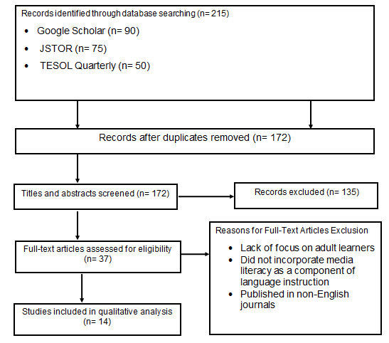
Figure 3: Flow diagram of the literature search and study selection for the review.

215 records were discovered through initial database searching—90 through Google Scholar, 75 through JSTOR, and 50 through TESOL Quarterly. After the removal of duplicates, 172 unique studies remained and were screened by title and abstract. During this phase, 135 studies were removed because they were either K–12 or university students rather than adult learners; they did not incorporate media literacy as a component of language instruction; or they were not research articles in the strict sense (i.e., opinion pieces, theoretical essays, or reviews). In addition, articles published earlier than 2020 were excluded to ascertain the novelty of conclusions and relevance to ongoing educational settings.

Following this screening, 37 full-text articles were thoroughly read to see if they could be included. Of these, 14 studies were selected for final qualitative analysis. The studies were all in English language, and specifically outlined the inclusion of media literacy in TESOL instruction for adult learners, particularly in community college contexts. They included empirical studies, classroom interventions, and qualitative research with adult ESL participants and teachers.

While the study selection process was stringent and conducted to ensure scholarly integrity, several limitations must be taken into account. Firstly, restricting the search to only three databases, potentially valuable studies under other platforms such as ERIC or Scopus may have been omitted. Moreover, reliance upon available full-text has potentially constrained the scope of reviewed studies, especially those pay walled or access-restricted to institutions. Lastly, while this review has aimed to reflect a range of instructional models, the fact that few studies met all of the inclusion criteria perhaps indicates a lack of enough prior research addressing the specific intersection of media literacy, adult ESL education, and the community college setting.

Despite such limitations, the literature chosen here provides a sound foundation for the understanding of current practices, identifying emerging trends, and informing future directions of TESOL curriculum design. The approach used here ensures findings are based on relevant, high-quality, and recent scholarship that closely aligns with the goals of developing language learning and critical media competencies among adult English language learners.

3. RESULTS AND DISCUSSION

The integration of media literacy in TESOL instruction of adult learners at community colleges has garnered more scholarly attention in recent years. A synthesis of recent studies shows that media literacy, when integrated systematically into language instruction, promotes critical thinking, learner autonomy, communicative competence, and cross-cultural awareness. However, implementation issues persist with respect to teacher preparedness and access to digital resources.

3.1 Development of Critical Thinking and Communicative Competence

One of the strands that is prevalent in much of the TESOL media literacy literature is that it promotes communicative competence and critical thinking among adult learners. Media literacy goes beyond more traditional grammar teaching by asking learners to engage with real content that requires critical evaluation, assessment, and synthesis. This interaction builds skills required to analyze the rich media landscape of today's world, such as evaluating sources for credibility, identifying bias, and understanding how media shape social narratives.

Zhang et al. [22] offer compelling evidence that adult ESL learners engaged in media-rich projects show significant improvement in interpreting meaning, identifying bias, and evaluating the reliability of sources. They reported that students who participated in media-based activities demonstrated higher cognitive involvement and critical thinking, particularly in argumentative writing and oral communication tasks. Similarly, Mustafina et al. [23], and Ezeh et al. [24], reported that routine media analysis activities allowed the students to participate in more extensive cognitive processes, expanding their vocabulary and linguistic resources, particularly when the students were instructed to analyze the authenticity, bias, and representation in media texts. These findings are reinforced by Al Mamari et al. [37], whose study of WhatsApp-based learning demonstrates how familiar digital platforms can facilitate critical media analysis in both formal and informal learning contexts. Incorporating media literacy into TESOL courses enhances language use and vocabulary breadth, as students are encouraged to think critically about the employment of language in the media [1, 15, 25].

These findings are consistent with principles of Communicative Language Teaching (CLT), which emphasizes contact with authentic materials, learner independence, and the development of linguistic and metacognitive skills. By analyzing media messages, media literacy encourages students to engage in tasks of higher-order cognition that make it possible for them to think critically about information and meaning, such as analyzing, evaluating, hypothesizing, and creating meaningful contents. Adult learners, above all, are best served by such a pedagogy, for it allows them to prepare productively for social, political, and academic environments.

3.2 Learner Autonomy and Increased Motivation

Another significant benefit of integrating media literacy into TESOL instruction is the enhancement of learner motivation and autonomy. In traditional TESOL settings, students are often inclined to follow a pre-planned curriculum with little space for choice or self-direction. However, media literacy activities inherently emphasize learner choice, self-directed inquiry, and relevance to students' daily lives, which enhances learning's value of interest and personal significance. This corroborates adult learning theories, particularly andragogy, which emphasizes the importance of autonomous learning and the need for adult learners to see the application of their learning to their own experience.

Zahira et al. [26], found that when students can select media sources such as news clips, podcasts, or YouTube videos, they become more invested in class and are more likely to manage their own learning. This aligns with research by Mechie et al. [38], who found that adult learners using self-selected digital media resources showed greater motivation and language proficiency gains. This sense of agency not only inspires adult students to engage more meaningfully with the content but also makes them responsible for their learning outcomes. Wong and Hughes [27], also observed that when students are engaged with media content that resonated with their own experiences, they became more engaged with their own learning outcomes. This form of customized instruction closes the gap between institutional education and adult students' everyday lives and imposes the intrinsic value of learning.

Marzuki et al. [28], demonstrated how access to media-integrated instruction assisted in enhancing learners' self-regulation skills, such as independent reading, online explorations, and content sharing with others. These behaviors signal that media literacy not only enhances intrinsic motivation but also lays the ground for a lifetime of learning. The ability of self-directed learning is a fundamental competence for adult learners, particularly those in immigrant integration courses or continuing education while working and discharging family responsibilities.

3.3 Enhancement of Cultural Awareness and Intercultural Competence

Beyond the language benefits, media literacy courses have been the prime mover in developing cultural awareness and intercultural literacy among adult learners. Learning through different forms of media—social media, documentaries, and others—exposes the learners to different perspectives, social norms, and power structures. This exposure allows students to learn the cultural codes and values that shape communication in their host society as well as in global societies, thereby developing their capacity for intercultural dialogue and connection across cultures. The European Commission's Digital Competence Framework for Educators [39], provides a comprehensive model for integrating these intercultural competencies through media literacy in adult education settings.

Students who studied cross-cultural communication using social media came to know more about cultural codes and improved their ability to engage in effective intercultural communication [29]. This outcome is particularly important in community college settings, where adult students regularly struggle with linguistic acclimation and cultural integration. Through such media exposure to multiple cultural norms, students not only learn language but also develop the cultural competence necessary to succeed in their new environments.

Kim and Li [31], and Humairoh [32], argued that media literacy allows students to reclaim their voices and own their identities through digital stories. This approach allows students to critically engage with the host culture and their own cultural heritage, building social confidence and a greater sense of belonging to their community. Digital storytelling, indeed, offers adult learners a way to express themselves creatively, hence promoting their sense of belonging and consolidating their social and cultural identities.

3.4 Challenges and Limitations in Implementation

Despite its huge potential, the integration of media literacy in the teaching of TESOL is faced with some enduring challenges. One of the most serious challenges is limited access to digital resources. Most adult students, particularly those who belong to low-income neighborhoods, face obstacles while getting online or other forms of technology such as computers and cell phones. This situation is still faced by adult learners, particularly within those communities that have no decent internet to go to or even proper devices [26, 33, 34].

Besides the issues of access to digital resources, teacher preparedness remains a vital issue. The majority of TESOL instructors report feeling under-prepared to design and teach media-integrated lessons that combine language acquisition with critical media analysis [34]. Teacher Digital Competency (TDC) framework offers valuable guidance for addressing this gap through targeted professional development programs focusing on digital pedagogy and media-integrated lesson design [40]. This reveals the imperative of providing ongoing professional development for TESOL teachers, particularly in digital pedagogy and culturally responsive instructional practices. Without sufficient training, teachers would struggle to create engaging, media-integrated lessons that balance language acquisition goals with critical thinking and media literacy competencies.

Furthermore, institutional and systemic constraints are yet another challenge. Neoliberal education policies, which prioritize standardized testing and quantifiable outcomes, promise to eliminate media literacy from TESOL courses [35, 36]. In those circumstances, there is little room for the kind of inquiry-oriented, critical pedagogy that media literacy demands. To mitigate these challenges, education institutions must advocate for curriculum reform that puts media literacy at the forefront and incorporates it into adult TESOL programs.

3.5 Future Research Directions

Prioritizing media literacy as a central aspect in adult TESOL programs is central to transforming language education. To promote this shift, professional development must be directed towards equipping educators with essential skills in digital pedagogy, media analysis, and multimodal communication. These skills will enable educators to bring authentic media content into classrooms with confidence, facilitate critical debate, and create student-led digital projects. Curriculum redesign to integrate student-led media interaction and common digital tools will not only foster language learning but also creativity and intercultural sensitivity, necessary in today's globalized context.

Structural issues are equally as important to ensure equitable access to media-integrated teaching. Community colleges and policymakers need to invest in reliable digital infrastructure and provide assistance to students with low technological abilities. Closing the digital divide is important in supporting active engagement with media-based TESOL practice. Also, accrediting organizations should incorporate media literacy into TESOL standards to officially sanction its place in language teaching. Subsequent studies must examine media-integrated TESOL practices' long-term impact, the learners' attitude towards media utilization, and how media literacy affects employment, political participation, and social mobility for adult learners.

4. CONCLUSION

In this review, the integration of media literacy within adult TESOL education within community college settings was examined while highlighting its potential to enhance language development, critical thinking, digital literacy, and cultural sensitivity. While adult learners navigate complex sociocultural realities, a media-literate mindset positions them to engage with real-world texts and locations in thoughtful, empowered ways. While promising, several challenges exist to the use of media literacy, including restricted access to digital technologies, poor teacher training, and rigid institutional structures. However, the scholarly consensus emphasizes that media literacy should not be viewed as an optional item, but as a foundational element of inclusive and effective TESOL education. Since technology continues to redefine learning and communication, TESOL instruction needs to adapt to such changes. By promoting intentional practice, institutional commitment, and learner-centered design, media literacy can assist in transforming language classrooms into spaces of empowerment, equity, and engagement for adult learners.

Disclaimer (Artificial intelligence)

Author(s) hereby declare that NO generative AI technologies such as Large Language Models (ChatGPT, COPILOT, etc.) and text-to-image generators have been used during the writing or editing of this manuscript.

REFERENCES

1. Hobbs R. Media literacy in action: Questioning the media. Rowman & Littlefield; 2024 Oct 14.

2. Cuervo Sánchez SL, Foronda Rojo A, Rodríguez Martínez A, Medrano Samaniego C. Media and information literacy: a measurement instrument for adolescents. Educational Review. 2021;73(4):487-502.

3. Ugurhan YZ, Kumtepe EG, Kumtepe AT, Saykılı A. From media literacy to new media literacy: A lens into open and distance learning context. Turkish Online Journal of Distance Education. 2020;21(Special Issue-IODL):135-151.

4. Suh EK, Dyer J, McGee B, Payne E. To, through, and beyond higher education: A literature review of multilingual immigrant students’ community college transitions. Community College Journal of Research and Practice. 2022;46(5):301-317.

5. Hashim AA. Innovative Approaches in English Language Teaching: A Comparative Analysis of Traditional and Modern Methods. South Asian Research Journal of Arts, Language and Literature. 2025;7(1):1–7.

6. Sattarova M. A Comparative Analysis of Traditional and Modern Approaches in Language Teaching. Mental Enlightenment Scientific-Methodological Journal. 2024;5(09):214-23.

7. Turayeva N. Using Media Contents in Teaching English Language. Multidisciplinary Journal of Science and Technology. 2024;4(5):308-14.

8. Nawaila MB, Kanbul S, Alhamroni R. Technology and English language teaching and learning: a content analysis. Journal of Learning and Teaching in Digital Age. 2020;5(1):16-23.

9. Ismail S, Zubaku B. Enhancing Cross-Cultural Reading in The English Language Classroom Through Literature. International Journal of Education & Philology (IJEP). 2023;4(1):47-57.

10. Birla R. The Challenges of Media Education in the Digital Era. Journal of Communication and Management. 2023;2(04):281-288.

11. Yudintseva A. Virtual reality affordances for oral communication in English as a second language classroom: A literature review. Computers & Education: X Reality. 2023;2:100018.

12. Gass RH, Seiter JS. Persuasion: Social influence and compliance gaining. 7th ed. New York: Routledge; 2022. 500 p. Available from: https://doi.org/10.4324/9781003081388.

13. Kjeldsen J, Hess A. Experiencing multimodal rhetoric and argumentation in political advertisements: a study of how people respond to the rhetoric of multimodal communication. Visual communication. 2021;20(3):327-352.

14. Backes S, Baumann I, Harion D, Sattler S, Lenz T. Why flipping the classroom is not enough: Digital curriculum making after the pandemic. Prospects. 2021;51(1):347-361.

15. Afrilyasanti R, Basthomi Y, Zen EL. Critical Media Literacy Instruction in English as a Foreign Language (EFL) Class. InEngaging Students in Critical Media Literacy: A Guidebook for Educators 2025 Jan 31 (pp. 65-92). Cham: Springer Nature Switzerland.

16. Goodloe LD. Post-Pandemic Digital Experiences & Attitudes Among Adult Immigrant ESOL Learners. 2023.

17. Lopes H, McKay V. Adult learning and education as a tool to contain pandemics: The COVID-19 experience. International review of education. 2020 Aug;66(4):575-602.

18. Cicha K, Rutecka P, Rizun M, Strzelecki A. Digital and media literacies in the Polish education system—Pre-and Post-COVID-19 perspective. Education Sciences. 2021;11(9):532.

19. Gjerazi B. Media literacy in the era of globalization: Innovative strategies for decoding information. Interdisciplinary Journal of Research and Development. 2024;11(1):18-26.

20. Perks BJ. Critical media literacy and English for academic purposes: an examination of teacher and student perspectives and practices. 2023.

21. Snow OR. Andragogy, Accessibility, and Adult ESL: An Analysis of English Language Teaching Curricula. 2024.

22. Zhang D, Wu Y, Wu JG. Exploring language learners’ new media literacy: instrument development and validation. Innovation in Language Learning and Teaching. 2025:1-8.

23. Mustafina AZ, Yelubayeva PK, Tutbayeva ZA. Developing students’ critical and creative communication by incorporating media literacy into English language teaching. Bulletin of LN Gumilyov Eurasian National University. Pedagogy. Psychology. Sociology series. 2022;141(4):216-27.

24. Ezeh NG, Anidi OC, Nwokolo BO. Media-Support Teaching and Learning of English Language as a Second Language: Eliminating Stereotypes. English Language Teaching. 2021;14(4):94-104.

25. Ng CH, Cheung YL, Zhang W. Fostering a Culture of Research in TESOL: A Review and a Look Ahead. Building a Culture of Research in TESOL: Collaborations and Communities. 2024:13-38.

26. Zahira K, Amna Zahid CH, Munir S. Media Influence on English Language Proficiency: A Study on ESL Learners of Sialkot, Pakistan. Journal of Applied Linguistics and TESOL (JALT). 2024;7(4):79-98.

27. Wong JT, Hughes BS. Leveraging learning experience design: digital media approaches to influence motivational traits that support student learning behaviors in undergraduate online courses. Journal of Computing in Higher Education. 2023;35(3):595-632.

28. Marzuki, Rusdin D, Darwin, Hidayati, Indrawati I. Media education in EFL class: teachers’ challenges and students’ perspectives. Educational Media International. 2025:1-23.

29. Casañ-Pitarch R, Candel-Mora MÁ, Carrió-Pastor ML, Demydenko O, Tikan I. Enhancing language and cross-cultural competence through telecollaboration. Advanced Education. 2020:78-87.

30. Zhou Y, Sun JA. Using social media to promote intercultural communication between Chinese and American university students. Chinese Journal of Applied Linguistics. 2020;43(2):169-187.

31. Kim D, Li M. Digital storytelling: Facilitating learning and identity development. Journal of Computers in Education. 2021;8(1):33-61.

32. Humairoh MF. Building undergraduate students’ cultural identity through digital storytelling. Communication Teacher. 2023;37(3):235-345.

33. Darvin R, Hafner CA. Digital literacies in TESOL: Mapping out the terrain. Tesol Quarterly. 2022;56(3):865-882.

34. Share J, Mamikonyan T. Preparing English teachers with critical media literacy for the digital age. Contemporary Issues in Technology and Teacher Education. 2020;20(1):37-54.

35. Ruecker T. The impact of neoliberal evaluation systems on rural schools, teachers, and their bilingual learners. Educational Policy. 2022;36(6):1288-1314.

36. Shah WA, Pardesi HY, Memon T. Neoliberalizing subjects through global ELT programs. TESOL Quarterly. 2024;58(2):693-725.

37. Al Mamari N, Dydowicz J, Mirza C. WhatsApp for Educational Purposes: Exploring Omani English Language Teachers WhatsApp Use and Corresponding Beliefs. Asian J Educ Soc Stud. 2021;24(4):1–17. doi: 10.9734/ajess/2021/v24i430582.

38. Mechie LA, Carlo Vinci LA, Keysie Jean AA. The English Language Difficulties and Language Learning Strategies of Foreign Students. Asian J Lang Lit Cult Stud. 2024;7(2):282–90. Available from: https://journalajl2c.com/index.php/AJL2C/article/view/185

39. European Commission. Digital Competence Framework for Educators. Available from: https://ec.europa.eu/jrc/en/digcompedu

40. Falloon G. From digital literacy to digital competence: The teacher digital competency (TDC) framework. Educ Technol Res Dev. 2020;68(5):2449–72. doi: 10.1007/s11423-020-09767-4.

