**COMPARATIVE EVALUATION OF IRRIGANT ACTIVATION SYSTEMS FOR SMEAR LAYER REMOVAL IN THE APICAL THIRD OF ROOT CANALS : A SEM ANALYSIS**

**Background:** The smear layer is a surface film of debris that remains on dentin or other tooth surfaces, such as enamel or cementum, after instrumentation with either rotary instruments or endodontic files.Sodium hypochlorite is the gold standard in endodontic irrigation, but it does not remove the inorganic components of the smear layer. Twin Kleen, a mild chelating agent based on 1-Hydroxyethylidene-1,1-Diphosphonic Acid (HEBP), enhances debris removal and prevents smear layer formation, allowing for simplified irrigation as a single solution. Researchers have developed activation devices to improve the delivery of irrigant to the working length.

**Aim:** The study aimed to evaluate and compare the efficacy of different irrigation activation systems: manual, sonic, ultrasonic and Laser activation on the removal of smear layer from the apical third of instrumented root canal using Scanning electron microscope.

**Method:** Thirty two single rooted teeth were prepared with the help of Neo endo S files .Copious irrigation was done using twinkleen (HEBP+3% NaOCl) in between instrumentation. All the specimens were randomly divided into 4 equal groups according to the method of activation used: group 1 (n = 8) manual agitation; group 2 (n = 8) sonic activation; group 3 (n = 8) ultrasonic activation; and group 4 (n = 8) laser activation. Samples were then sectioned and sent for SEM examination. In all groups, canals were rinsed with saline to rinse off the residual irrigants and dried with paper points.

**Statistical analysis:** One-way ANOVA test followed by Sceffe’s Post hoc test was used to compare the significant difference between 4 groups

**Results:** All the four groups removed the smear layer and the laser group showed the best smear layer removing capability compared to other groups but this was significant only with respect to group (MDA) and group 2 (sonic activation) (p<0.05). The study mainly showed that sonic activation efficiently removed the smear layer in the apical third of the root canal. Groups I (MDA) and III (Ultrasonic) had more residual smear layer on the canal walls than sonic activation, but this was only significant with respect to the MDA group. A probable explanation for irrigant activation providing cleaner canals is that higher frequency results in higher flow velocity, which aids in the efficient removal of debris.

**Conclusions:** Within the limitations of the study, all the activation systems were able to remove the smear layer from the apical third of the root canal with laser showing the best result followed by sonic, ultrasonic and manual dynamic agitation.

**Keywords:** Etidronic Acid, Irrigation, Laser, Scanning Electron Microscopy, Sodium Hypochlorite, Manual dynamic agitation

**INTRODUCTION:**

Root canal treatment aims to effectively clean and seal the canal system, preventing bacterial infiltration post-treatment 1. Disinfection of the root canal system is crucial for the success of endodontic treatment as it significantly reduces pathogens 2. However, root canal preparation alone cannot effectively decrease bacterial count in the root canal system, and all nickel-titanium files leave a smear layer along the root canal walls 3. Therefore, irrigants and activation are essential for cleaning and disinfecting the root canal system. Recent designs of endodontic instruments have variable tapers, giving improved shaping ability. Nickel-Titanium rotary instruments can be used to rapidly and safely open the main root canals, creating deep space to permit full permeation of irrigant solutions (Singla et al., 2021).

Sodium hypochlorite solution is one of the most potent and widely used irrigation solutions due to its antibacterial properties, ability to eliminate and dissolve residual and infected dental pulp, lubricating properties, low cost, and availability 4. However, it lacks specific properties, such as the capacity to remove the smear layer. Twin Kleen is a mild chelating agent, 1-Hydroxyethylidene-1,1-Diphosphonic Acid (HEBP), which exhibits short-term compatibility with sodium hypochlorite. The combination eliminates debris impaction in the anatomical irregularity. The combination also reduces AHTD (Accumulated Hard Tissue Debris) and inhibits smear layer formation during rotary instrumentation. Mixing Tween Kleen and sodium hypochlorite, one can avoid the irrigation sequence and use the combination as a single irrigating solution. Twin Kleen serves as an antimicrobial remedy, moderate chelating agent, proteolytic agent, lubricant, and smear layer preventer that might be added to endodontic irrigating solutions throughout root canal instrumentation in addition to a last rinse solution (Kottur et al., 2025). Previous research suggests that while HEBP as a standalone irrigant does not surpass the antimicrobial efficacy of established agents like sodium hypochlorite or EDTA, it demonstrates comparable disinfection capabilities (Shetty et al., 2024).

The smear layer is a surface film of debris that remains on dentin or other tooth surfaces, such as enamel or cementum, after instrumentation with either rotary instruments or endodontic files. Many researchers assume that the smear layer prevents bacterial or toxin entry by altering dentinal permeability (5,6). While some authors believe that this loosely adherent smear layer should be completely removed from the surface of the root canal wall because it can harbour bacteria and provide an avenue for leakage, it also limits disinfection of the dentinal tubules by preventing irrigants and medicaments from penetrating deep into the tubules (7,8). Because of these toxic and undesirable effects of the smear layer, the probability of inadequate disinfection and reinfection increases, leading to failure of the endodontic treatment, making smear layer removal critical in order to obtain the desired outcome.

According to studies, root canal instrumentation induces higher smear layer development on root canal walls in the apical third. To achieve optimal efficacy of irrigants, an excellent irrigation delivery system is necessary that will transport them with appropriate flow and volume to the working length to be effective in debriding the entire canal system9. Based on studies, irrespective of the arrangement of instrumentation and irrigation, the efficiency of the irrigating solution in prepared root canals remains limited (10,11). As a result, improving irrigation methods during root canal treatment is critical to achieving higher cleaning efficiency in a very complex area.

There are novel devices that activate the irrigants and enhance their penetration and disinfection efficacy in the root canal system.Therefore, this study was planned to evaluate and compare in vitro the efficacy of various irrigation activation methods—MDA, sonic, ultrasonic, and laser—on the removal of smear layer from the apical third of instrumented root canals using a scanning electron microscope.

**MATERIALS AND METHODS**

The study protocol was approved by the ethical committee of Sri Hasanamba Dental College And Hospital, Hassan. 32 human mandibular first premolars which were extracted for periodontal or orthodontic purposes, having single straight canals without bi/trifurcation were included. Fractured teeth, carious teeth, teeth with internal or external resorption and teeth with hypoplasia were excluded.

**Specimen preparation**

All the specimens were cleaned of superficial debris, calculus, tissue tags and stored in normal saline They were then decoronated below the cemento-enamel junction using a diamond disk to leave a root of 12mm in length. A size 10 K file was then introduced into the canal until it was visible at the apical foramen and the working length was determined by reducing 1mm from the total root length.

All root canals were prepared with rotary Ni-ti instruments (Neo-Endo S) with a pre-determined working length till size 6%25. Copious irrigation was done using twin kleen(3%NaOCl+HEBP) in between instrumentation.

**Irrigation Protocol**

The thirty-two specimens were then randomly divided into four experimental groups with 8 samples each and were treated as follows:

**1. Group I : MDA**

After preparing the canal as mentioned above, canals were irrigated with 1.5mL of Twin Kleen and manual agitation using master cone with an up-and-down motion at 2mm amplitude at a frequency of 100 strokes for approximately 1  min.

**2. Group II : SONIC ACTIVATION**

Canals were irrigated with 1.5mL of Twin Kleen, and the medium-sized tip (# 25 ISO) was attached to the sonic activator and used 2mm short of the working length with pumping motion for 30 sec for 2 cycles at high speed. Fresh irrigant was introduced in between cycles.

**3. Group III : ULTRASONIC ACTIVATION**

Endo 3 Ultrasonic Endo Activate Device(# 25 size tip) was used Canals were irrigated with 1.5mL of Twin Kleen, and the tip was held stationary 2mm short of the working length for 2 cycles of 30 seconds each with 1.5mL of Twin Kleen in each cycle.

**4. Group IV : LASER ACTIVATION**

After filling the root canal with Twin Kleen, diode laser (980 nm, 2 W, 200 μm tip) was used for 6 cycles of 10 seconds each. During lasing the laser was held stationary 2mm short of the working length for the first 2 seconds in each lasing period and then withdrawn at the rate of 1mm s-1 for the remaining 8 seconds.

In all groups canals were rinsed with saline to rinse off the residual irrigants and dried with paper points.

**Evaluation**

All samples from the four groups were split longitudinally by first creating grooves on the buccal and lingual side without entering the lumen using a diamond disk and then a chisel was used to split the samples into two halves to give a total of 64 halves. One of the two halves in which the apical third was prominently visible was examined under a scanning electron microscope for debris and smear layer coverage at 1500X. Photographs were taken from the apical third and were graded from 0 to 3 by blinded observers as follows:

0. No smear layer, open dentinal tubules, smear layer completely removed or melted.

1. Moderate smear layer, outlines of dentinal tubules observable, removed or melted in some areas.

2.A Thin smear layer covering the surface outline of the dentinal tubules which were not discernible, and the location of the tubule will be indicated by a crack, scattered laser, removed or melting.

3. Heavy smear layer, outlines of tubules obliterated, no visible smear layer removed or melting.

The data was then statistically analyzed using a One-way ANOVA test followed by Scheffe’s Post hoc test was be used to compare the significant differences between the 4 groups

**RESULTS**

The scores given by two blinded observers are given in Table 1 and Table 2:

**Table 1:** Scores given by the blinded Observer 1

|  |  |  |  |
| --- | --- | --- | --- |
| **GROUP 1**  **(MANUAL)** | **GROUP 2**  **(SONIC)** | **GROUP 3**  **(ULTRA SONIC)** | **GROUP 4**  **(LASER)** |
| **1** | **2** | **2** | **0** |
| **2** | **0** | **1** | **1** |
| **0** | **1** | **0** | **0** |
| **3** | **1** | **1** | **0** |
| **3** | **2** | **0** | **1** |
| **2** | **1** | **2** | **0** |
| **1** | **0** | **1** | **2** |
| **2** | **0** | **1** | **0** |

**Table 2:** Scores given by the blinded Observer 2

|  |  |  |  |
| --- | --- | --- | --- |
| **GROUP 1**  **(MANUAL)** | **GROUP 2**  **(SONIC)** | **GROUP 3**  **(ULTRA SONIC)** | **GROUP 4**  **(LASER)** |
| **2** | **0** | **1** | **0** |
| **0** | **2** | **0** | **0** |
| **1** | **1** | **0** | **0** |
| **3** | **1** | **2** | **0** |
| **3** | **0** | **0** | **1** |
| **3** | **1** | **2** | **0** |
| **1** | **2** | **0** | **1** |
| **2** | **0** | **1** | **0** |

As Per One-Way ANOVA, there is a significant difference between the groups. As per Post Hoc Scheffe Test, there is a significant difference between Group 1 and Group 2, and Group 1 and Group 3, Group 1 and Group 4, and Group 2 and Group 4. The Laser group showed the minimum smear layer remaining or maximal removal of smear layer in the apical third of the root canal followed by sonic, ultrasonic, and MDA groups. Maximum remaining smear layer was found in the MDA group.(table 3) On pairwise comparison laser was found to be the best in removal of smear layer compared to ultrasonic activation but the value was not statistically significant. MDA group showed maximum remaining smear layer which was found to be statistically significant when compared to all other groups (p < 0.05). There was also a significant difference in the remaining smear layer between the sonic group and laser group (p < 0.05).

|  |  |  |  |  |  |  |
| --- | --- | --- | --- | --- | --- | --- |
| *Groups* | *Count* | *Average* | *SD* | *F* | *P-value* | *F crit* |
| G1 - Manual | 8 | 3.625 | 1.923 | 5.938 | 0.003 | 2.947 |
| G2 - Sonic | 8 | 1.75 | 0.707 |
| G3-Ultra Sonic | 8 | 1.75 | 1.488 |
| G4-Laser | 8 | 0.75 | 0.365 |

**As Per One-Way ANOVA, There is a significant difference between the groups**

|  |  |  |  |  |
| --- | --- | --- | --- | --- |
| **Groups** | **Average** | **SD** | **T Value** | **P Value** |
| G1 - Manual | 3.625 | 1.923 | 2.589 | 0.021 |
| G2 - Sonic | 1.75 | 0.707 |  |  |
|  |  |  |  |  |
| G1 - Manual | 3.625 | 1.923 | 2.181 | 0.047 |
| G3-Ultra Sonic | 1.75 | 1.488 |  |  |
|  |  |  |  |  |
| G1 - Manual | 3.625 | 1.923 | 4.155 | 0.001 |
| G4-Laser | 0.75 | 0.365 |  |  |
|  |  |  |  |  |
| G2 - Sonic | 1.75 | 0.707 | 0.000 | 1.000 |
| G3-Ultra Sonic | 1.75 | 1.488 |  |  |
|  |  |  |  |  |
| G2 - Sonic | 1.75 | 0.707 | 3.554 | 0.003 |
| G4-Laser | 0.75 | 0.365 |  |  |
|  |  |  |  |  |
| G3-Ultra Sonic | 1.75 | 1.488 | 1.846 | 0.086 |
| G4-Laser | 0.75 | 0.365 |  |  |

**AS per the Post Hoc Scheffe Test, there is a significant difference between Group 1 and Group 2, and Group 1 and Group 3, Group 1 and Group 4, Group 2 and Group 4**

**DISCUSSION:**

Using a scanning electron microscope, this in vitro study compared and evaluated how well various irrigation systems removed the smear layer from the apical third of the root canal system. The study was conducted under strict and uniform conditions to minimise bias and confounding factors. To ensure consistent apical enlargement, samples of each group were enlarged to a size of 6% 25. The time and volume of irrigant used during and after biomechanical preparation were standardised to 1 min and 3 ml, respectively, and the tip of the agitation system was kept 2 mm short of the apex for all samples.

The apical portion of the root canal was examined because of the significant smear layer accumulation there and the inability of the conventional needle delivery device to deliver the irrigant 1 mm beyond the tip. Since the studies have shown that the removal of the smear layer is much easier in the coronal and middle thirds due to improved irrigant administration, only the apical third was assessed in this study (9,10,11).

Previous studies have employed a variety of scoring schemes, ranging from basic criteria like "debris present or absent" (12,13) to capricious three-, four-, five-, or seven-point scoring schemes (14-17). Scores can be expressed as a percentage of the root surface occupied or as the amount of debris or smear layer per root level or canal 18. Although they are rarely reported, repeatability tests of some kind should be carried out due to the subjective nature of the grading. The SEM pictures used in this experiment were reviewed by two blinded observers using the criteria published by Takeda et al. 19 in 1998, due to their simplicity, clarity, and ease of scoring.

In order to eliminate the smear layer during or after root canal instrumentation, irrigants with the ability to dissolve both organic and inorganic components are required. The organic part of the infected root canal is effectively removed with the most often used irrigant, 1-7% NaOCl. However, its ability to remove smear layers from instrumented root canal walls has been demonstrated to be insufficient 20. Many authors have determined that employing NaOCl during or after instrumentation produces superficially clean canal walls with the smear layer (10,21). In the current study, the MDA group had the largest mean remaining smear layer on the canal walls, which was statistically significant when compared to the other groups, in accordance with previous research.

Twin Kleen, also known as Single Step - Chelation and Irrigation, is a mild chelating agent based on HEBP that enhances debris removal and prevents smear layer formation, allowing for simplified irrigation using a single solution. It provided superior dentinal tubule disinfection than the Sodium Hypochlorite- Ethylenediaminetetraacetic Acid (NaOCl-EDTA) combination 22.The main difference between HEBP and disodium EDTA is that HEBP is a mild alkaline chelator that functions in the pH range of 10.8-12.2, whereas disodium EDTA operates at a lower pH (1,23). NaOCl is more compatible with HEBP than with EDTA because HEBP is a non-nitrogenous chelator containing phosphorus instead of nitrogen. In NaOCl, chlorine carries a positive charge and attacks the electrophilic centres of nitrogen atoms. Phosphorus is less electronegative than nitrogen, which makes it less likely to react with NaOCl 24. In addition, final irrigation with Twin Kleen resulted in greater sealer penetration than EDTA34.

The present study showed that sonic activation efficiently removed the smear layer in the apical third of the root canal. Groups I (MDA) and III (Ultrasonic) had more residual smear layer on the canal walls than sonic activation, but this was only significant with respect to the MDA group. A probable explanation for irrigant activation providing cleaner canals is that higher frequency results in higher flow velocity, which aids in the efficient removal of debris 25. The findings are consistent with a study conducted by Mathew et al 26. to assess antimicrobial efficacy, in which EndoActivator outperformed conventional needle irrigation, as well as a study conducted by Manuele Macini et al.27, in which EndoActivator effectively removed the smear layer in the apical third of the root canal when compared to ultrasonic activation.

The results of this study revealed that ultrasonic activation was more effective in removing smear layers than the MDA group (Group I), which was significant. Laser and sonic activation had higher cleaning efficacy in terms of smear layer removal than ultrasonics. The findings are consistent with the majority of previous research in which lasers were found to be effective in removing the smear layer from root canals, due to cavitation and subablative laser settings that do not damage the canal wall 28.Ultrasonic activation causes an undesired damping effect, particularly when the instrument comes into contact with the lateral walls of a formed canal, which is absent in sonics (29,30).

Due to the compactness and low cost, recently introduced laser techniques and devices have gained popularity. It is appropriate for endodontic treatment since its wavelength is in the infrared range, and thin and flexible fibres can be used. Previous research has demonstrated the bactericidal properties of 810-nm and 980-nm diode lasers 31 . Because of the benefits indicated above, we used a diode laser with a 200 nm fibre tip to agitate the irrigant in our investigation.

The diode laser parameters chosen for this study were based on the known threshold laser settings required to induce agitation, cavitation, and shockwaves. The present study demonstrated that laser efficiently eliminated the smear layer in the apical third of the root canal with the lowest remaining smear layer score. The findings are consistent with prior work conducted by Manfred Langemann et al.32 and Kottur A.A et al.33, in which a diode laser effectively eradicated the smear layer. This result can be attributed to the warming of the irrigant solution as well as the physical agitation of the fluid, which improves debridement by agitating the solution with shear forces and hydraulic stresses.

**CONCLUSION:**

1. Within the limitations of the study it can be inferred that *Laser showed the best result* in removing smear layer from the apical part of root canal and on pairwise comparison, it showed significant smear layer removing capability when compared to MDA and sonic group but was found to be non-significant when compared with other agitation systems.
2. *Twin kleen(NaOCl+HEBP)* can be a potential alternative to the conventional use of (NaOCl+EDTA) combination as an irrigant.

**REFERENCES:**

1. Zehnder, M.; Schmidlin, P.; Sener, B.; Waltimo, T. Chelation in Root Canal Therapy Reconsidered. J. Endod. 2005, 31, 817–820. [CrossRef] [PubMed]
2. Alghamdi F, Shakir M. The influence of Enterococcus faecalis as a dental root canal pathogen on endodontic treatment: a systematic review. Cureus. 2020 Mar 13;12(3).
3. Asnaashari M, Safavi N. Disinfection of contaminated canals by different laser wavelengths, while performing root canal therapy. Journal of lasers in medical sciences. 2013;4(1):8.
4. Ali IA, Layous K, Alzoubi H, Layous Sr KJ. Evaluating the effectiveness of different irrigant activation techniques in removing the smear layer and opening the dentinal canals: a scanning electron microscopic study. Cureus. 2023 Jan 19;15(1).
5. Michelich VJ, Schuster GS, Pashley DH. Bacterial penetration of human dentin in vitro. Journal of Dental Research. 1980; 59:1398-403.
6. Safavi KE, Spa°ngberg LSW, Langeland K Root canal dentinal tubule disinfection. JOE. 1990; 16:207– 10.
7. Mader CL, Baumgartner JC, Peters DD. Scanning electron microscopic investigation of the smeared layer on root canal walls. JOE, 1984; 10:477–83.
8. Meryon SD, Brook AM. Penetration of dentine by three oral bacteria in vitro and their associated cytotoxicity. International Endodontic Journal. 1990; 23:196-202.
9. Zivkovic S, Brkanic T, Dacic D, Opacic V, Pavlovic V, Medojevic M. Smear Layer in Endodontics. Serbian dental journal 2005, 52
10. Baker NA, Eleazer PD, Averbach RE, Seltzer S. Scanning electron microscopic study of the efficacy of various irrigating solutions. J Endod. 1975; 1:127-35.5.
11. Cunningham WT, Martin H, Forrest WR. Evaluation of root canal debridement by the endosonic ultrasonic synergistic system. Oral Surg Oral Med Oral Pathol. 1982; 53:401-4.
12. Evans GE, Speight PM, Gulabivala K. The influence of preparation technique and sodium hypochlorite on removal of pulp and predentine from root canals of posterior teeth. Int Endod J. 2001: 34:322–330.
13. Suffridge CB, Hartwell GR, Walker TL. Cleaning efficiency of nickel-titanium GT and .04 rotary files when used in a torque-controlled rotary handpiece. JOE 2003; 29:346–348.
14. Wu MK, Wesselink PR. Efficacy of three techniques in cleaning the apical portion of curved root canals. Oral Surg Oral Med Oral Pathol Oral Radiol Endod. 1995; 79(4):492-6.
15. Hu¨lsmann M, Ru¨mmelin C, Scha¨fers F. Root canal cleanliness after preparation with different endodontic handpieces and hand instruments: a comparative SEM investigation. JOE. 1997: 23:301–306.
16. Jeon IS, Spa°ngberg LS, Yoon TC, Kazemi RB, Kum KY. Smear layer production by 3 rotary reamers with different cutting blade designs in straight root canals: a scanning electron microscopic study. Oral Surg Oral Med Oral Pathol Oral Radiol Endod. 2003; 96:601-607.
17. Cameron JA. The choice of irrigant during hand instrumentation and ultrasonic agitation of the root canal: a scanning electron microscope study. Aust Dent J. 1995b: 40:85-90.
18. Barbizam JV, Fariniuk LF, Marchesan MA, Pecora JD, Sousa-Neto MD. Effectiveness of manual and rotary instrumentation techniques for cleaning flattened root canals. JOE. 2002; 28:365–366.
19. Takeda FH, Harashima T, Kimura Y, Matsumoto K. Efficacy of Er:YAG laser irradiation in removing debris and smear layer on root canal walls. J Endod. 1998; 24(8):548-51.
20. Rubin LM, Skobe Z, Krakow AA, Gron P. The effect of instrumentation and flushing of freshly extracted teeth in endodontic therapy: a scanning electron microscope study. J Endod 1979; 5(11) 328-35.
21. Goldman LB, Goldman M, Kronman JH, Lin PS. The efficacy of several irrigating solutions for endodontics: a scanning electron microscopic study. Oral Surg Oral Med Oral Pathol. 1981; 52(2):197-204.
22. Neelakantan P, Cheng CQ, Mohanraj R, Sriraman P, Subbarao C, Sharma S. Antibiofilm activity of three irrigation protocols activated by ultrasonic, diode laser or Er:YAG laser in vitro. Int Endod J. 2015 Jun;48(6):602-10. doi: 10.1111/iej.12354. Epub 2014 Sep 11. PMID: 25080240.
23. Biel, P.; Mohn, D.; Attin, T.; Zehnder, M. Interactions between the Tetrasodium Salts of EDTA and 1-Hydroxyethane 1,1- Diphosphonic Acid with Sodium Hypochlorite Irrigants. J. Endod. 2017, 43, 657–661. [CrossRef]
24. Fukuzaki, S. Mechanisms of Actions of Sodium Hypochlorite in Cleaning and Disinfection Processes. Biocontrol Sci. 2006, 11, 147–157. [CrossRef]
25. Jiang LM, Verhaagen B, Versluis M, Van der Sluis L. Evaluation of a sonic device designed to activate irrigant in the root canal. JOE 2010; 36:143-6.
26. Mathew J, Emil J, Paulaian B, John B, Raja J. Viabilit and antibacterial efficacy of four root canal disinfection techniques evaluated using confocal laser scanning microscopy. J Conserv Dent. 2014; 17:444-8.
27. Manuele Mancini *et al*. Smear Layer Removal and Canal Cleanliness Using Different Irrigation Systems (EndoActivator, EndoVac, and Passive Ultrasonic Irrigation): Field Emission Scanning Electron Microscopic Evaluation in an In Vitro Study. J Endod. 2013; 39(11):1456-60.
28. Wang QQ, Zhang CF, Yin XZ. Evaluation of the bactericidal effect of Er, Cr: YSGG, and Nd: YAG lasers in experimentally infected root canals. J Endod 2007;33:830‑2.
29. Plotino G, Pameijer CH, Grande NM, Somma F. Ultrasonics in endodontics: A review of the literature. J Endod. 2007;33:81–95. doi: 10.1016/j.joen.2006.10.008.
30. Jensen SA, Walker TL, Hutter JW, Nicoll BK. Comparison of the cleaning efficacy of passive sonic activation and passive ultrasonic activation after hand instrumentation in molar root canals. J Endod. 1999;25:735–8. doi: 10.1016/S0099-2399(99)80120-4.
31. Moritz A, Gutknecht N, Schoop U *et al*. Irradiation of infected root canals with a diode laser in vivo: results of microbiological examinations. Lasers Surg. Med. 1997; 21:221-226.
32. Manfred Lagemann, Roy George, Lei Chai, Laurence J. Walsh. Activation of ethylenediaminetetraacetic acid by a 940 nm diode laser for enhanced removal of smear layer. Aust Endod J, 2014; 40:72-75.
33. Kottur AA, Mujeeb A, Assiry AA, Fareed M, Abullais SS, Snigdha NT, Desai VB, Karobari MI. Scanning Electron Microscopy analysis concerning the effect of 980 nm Diode Laser and Twin Kleen irrigant for the elimination of smear layer off the root canal wall. BMC Oral Health. 2025 Dec;25(1):1-1.
34. Kamin R, Vikram R, Meena N, Kumari RA, Adarsha MS, Murthy CS. Effect of final irrigating solutions on penetration depth of resin-based sealers into dentinal tubules. Journal of Conservative Dentistry and Endodontics. 2021 Jul 1;24(4):374-8.
35. Shetty, N., Shetty, P., Bhat, R., D’cunha, K., &Shanavaz, M I. (2024).Etidronic Acid as a Root Canal Irrigant: A Systematic Review of Its Efficacy in Disinfection and Potential to Enhance Endodontic Treatment Outcomes. *South Eastern European Journal of Public Health.*1519–1529.
36. Singla, D., Kataria, B., &Kaur, U. (2021). Root canal cleaning and shaping: A review. *International Journal of Health Sciences*, 95-112.

**Images :**

**Materials required:**

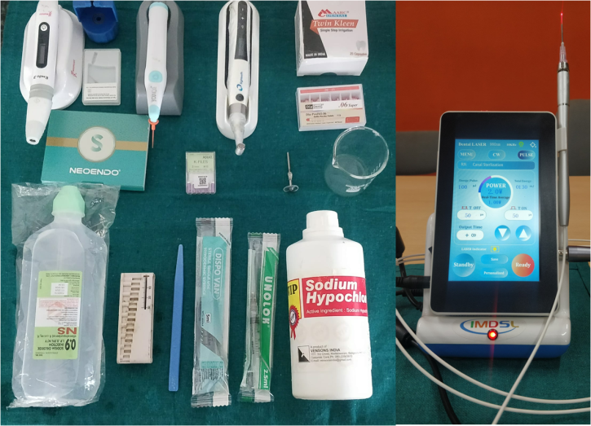

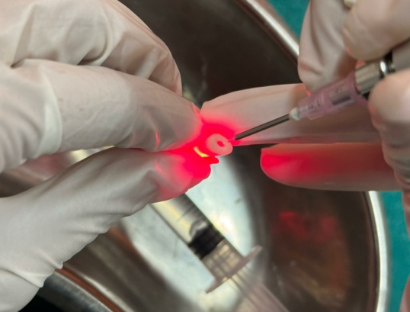 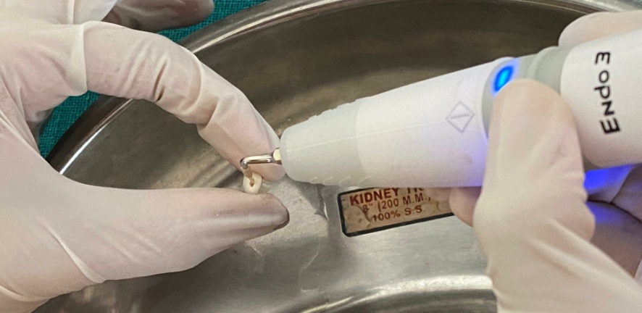

c) ultrasonic activation (fig3)

d) Laser activation (fig4)

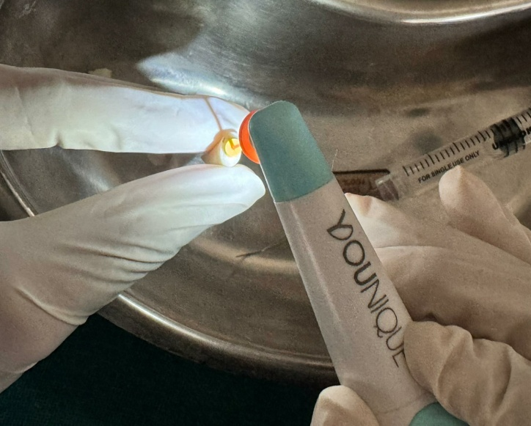 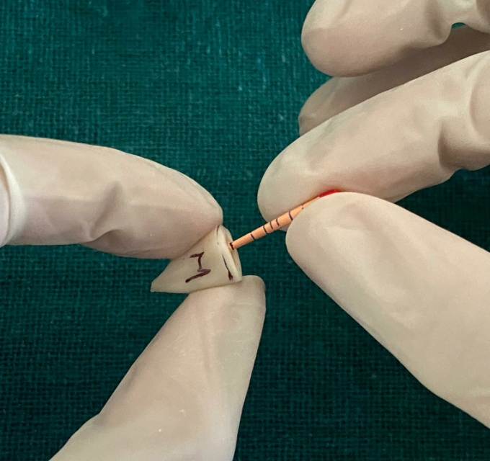

b) sonic activation( fig2)

a) manual dynamic agitation (fig1)

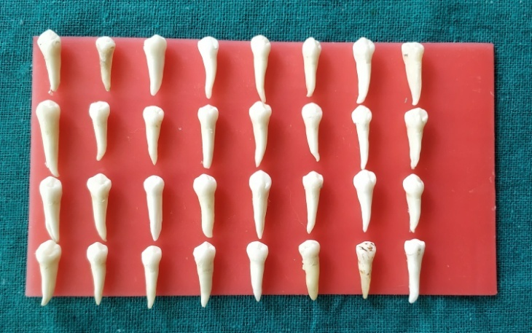 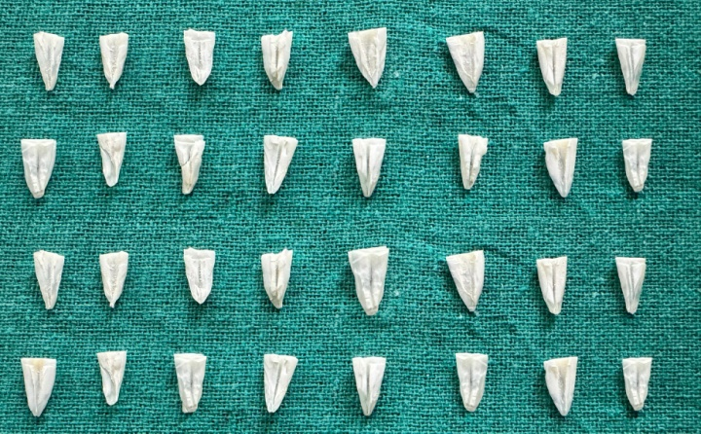

Samples after sectioning

Total samples

Sem images:

A)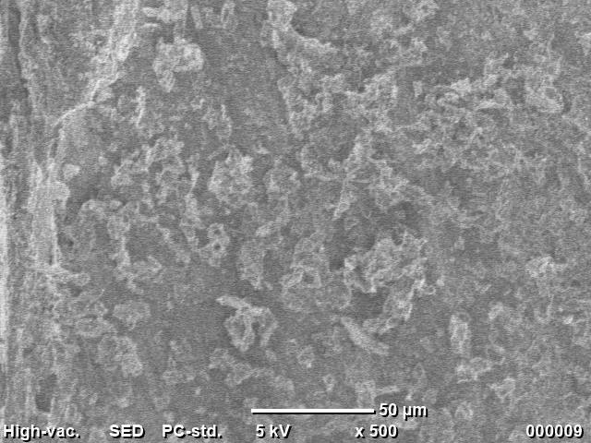 B) 

GROUP 1: A&B

C)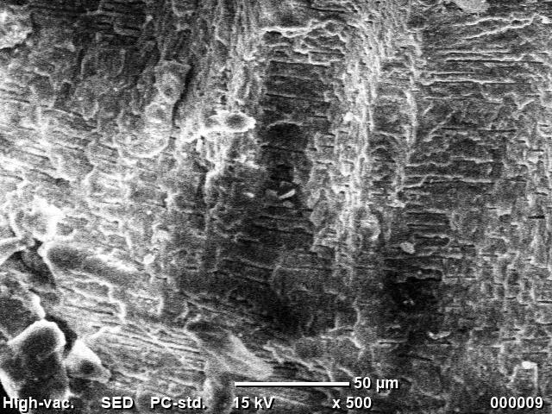 D)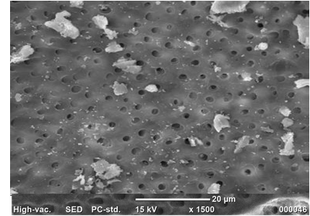

GROUP 2: C&D

E) 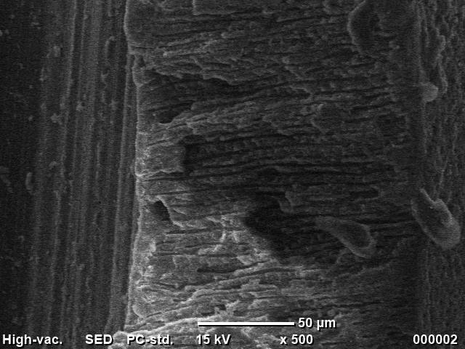 F) 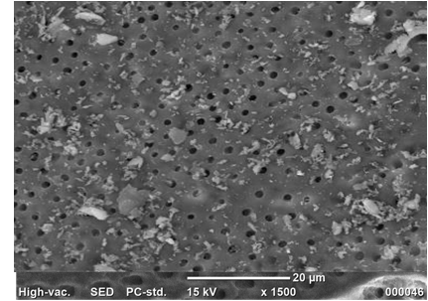

GROUP 3: E&F

G)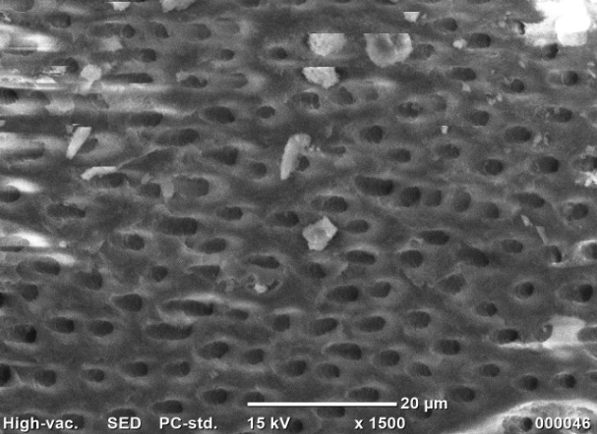 H) 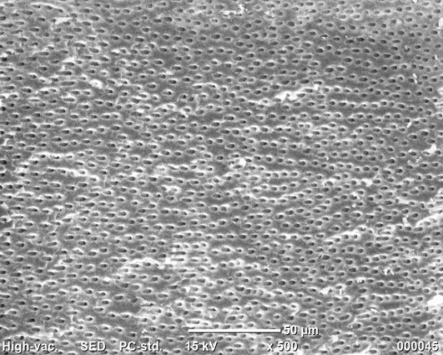

GROUP 4: G&H

TWIN KLEEN irrigant preparation:

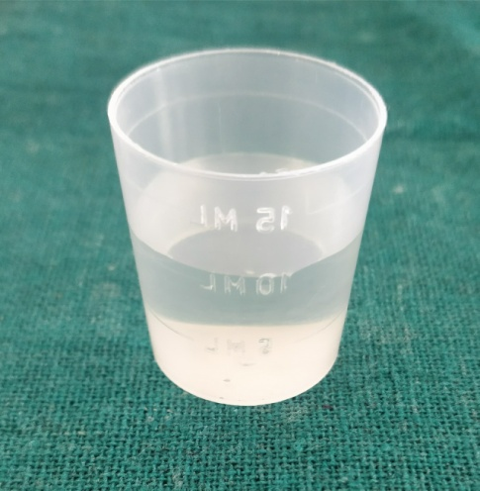 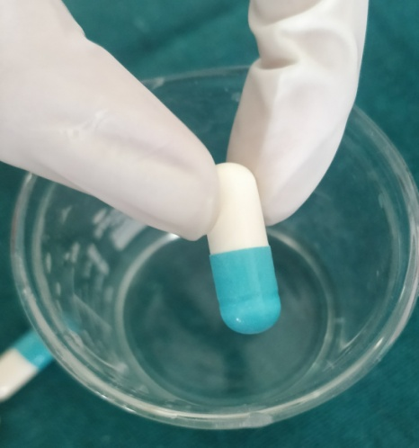 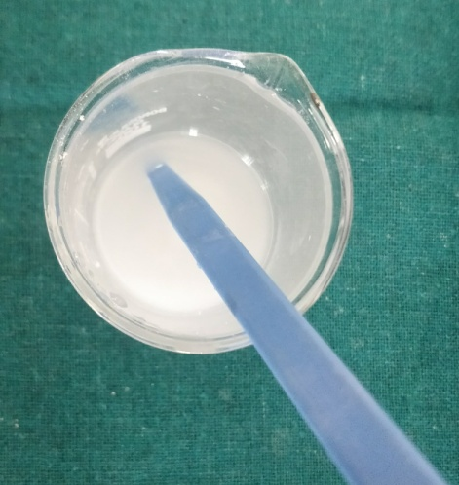

Stirred for 60 sec

2 capsules (0.45g each) of HEBP

10ml of 3% NaOCl