Case report

COMPLETE ROOT COVERAGE IN MANDIBULAR ANTERIOR RECESSION USING FREE GINGIVAL GRAFT: A CASE REPORT WITH CREEPING ATTACHMENT

ABSTRACT

Background: Achieving complete root coverage is challenging. Thus to resolve, we highlight the effective resolution of mandibular recession using free gingival graft; a case report showing creeping attachment and incremental adaptation to achieve complete root coverage.
Materials and Method: This case reveals about a 25 years old female patient who presented with gingival recession affecting the mandibular central incisor. Her predominant concerns were hypersensitivity and also the aesthetic enhancement. An extensive examination disclosed biofilm induced gingivitis within a reduced periodontium & mucogingival deformities. The gingival recession was classified as Cairo Recession Type 1. The treatment approach planned for an initial nonsurgical phase, succeeded by a surgical intervention utilizing a free gingival graft. This surgical procedure was to harvest the graft from the palatal mucosa and positioning it at the recipient site. Post-operative care & instructions were provided and given for a detailed follow-up schedule.
Result: After two weeks, the graft showed successful integration. By two months, the patient exhibited increased thickness of keratinized gingiva, with a characteristic tire-patch appearance, with a mild recession of 1 mm. After 12-month follow-up, the patient exhibited good periodontal health, characterized by creeping attachment and complete root coverage.
Conclusion: This success highlights the treatment plan's effectiveness in overcoming the hypersensitivity and also bringing back the aesthetics, while simultaneously promoting overall periodontal health. To conclude, factors which contributes to the successful achievement of creeping attachment include the recession's width, graft positioning, bone support, tooth alignment, patient hygiene practices, graft thickness, and root surface treatment.
Keywords
Creeping Attachment; Free Gingival Graft; Complete Root Coverage, nonsurgical phase

INTRODUCTION / AIM:
Gingival recession, defined as the movement of the gingival margin below the cementoenamel junction, offers a problem in periodontology.(1) Periodontal plastic surgery procedures for root coverage have been widely utilized in managing gingival recession. The primary indications cited in the literature include improving aesthetics, reducing dental hypersensitivity, and preventing both carious and non-carious cervical lesions. It was established in various literatures that there was a link between the inflammatory condition of marginal tissue and the amount of keratinized tissue, emphasizing the necessity of a minimum threshold of keratinized tissue for maintaining periodontal health (2). Based on this understanding, the preferred surgical approach was the free gingival graft. However, subsequent research on both animals and humans revealed that effective plaque control is the key factor in sustaining periodontal health, regardless of the width of keratinized tissue. Consequently, the primary indication for free gingival grafts shifted from increasing keratinized tissue to root coverage.
A free gingival graft (FGG) is a periodontal surgical procedure used to increase the width of attached gingiva, which is the firm, resilient part of the gingiva that is tightly bound to the underlying bone or tooth surface.(3) This procedure is often performed to address issues such as gingival recession, inadequate attached gingiva, or to improve the aesthetics and health of the gingiva. Creeping attachment is a fascinating phenomenon in periodontics where the gingival tissue gradually migrates in a coronal direction (towards the crown of the tooth) over a previously exposed root surface. This process can occur after periodontal surgical procedures, such as free gingival grafts, connective tissue grafts, or other root coverage techniques.(4) Complete root coverage (CRC) is a goal in periodontal therapy aimed at fully covering exposed root surfaces due to gingival recession.(4) Achieving CRC is important for both aesthetic and functional reasons, as it helps protect the root surface from decay, reduces sensitivity, and improves the overall appearance of the gingiva. Several techniques are used to achieve complete root coverage in which we have selected free gingival graft. Hence the aim of the present report is to document a case of isolated mandibular gingival recession management with creeping attachment following free gingival graft surgery.

CASE PRESENTATION:

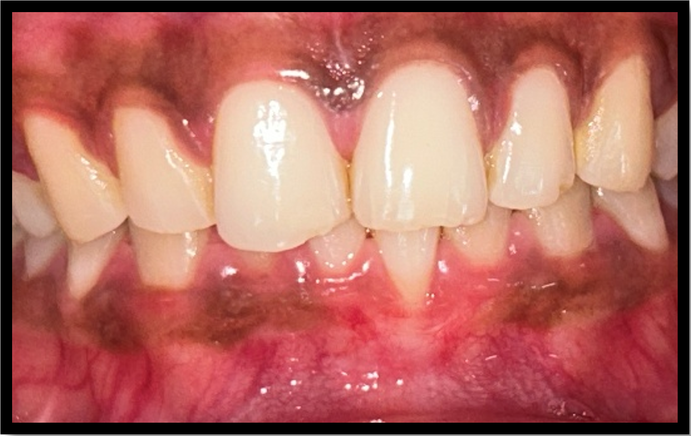
Fig 1: Pre-Op

A 28-year-old female patient came to the department of Periodontology with a chief complaint of gingival recession at the left mandibular central incisor and had concerns about hypersensitivity and aesthetic changes. She had no medical history and the patient is a non-smoker. She had previously undergone ultrasonic scaling before 2 months. On intraoral clinical examination, gingival recession of 3mm width and depth with insufficient width of attached gingiva in 31 was noted. No interdental clinical attachment loss detected. No attached gingiva seen apical to the defect. No tooth mobility detected. On radiographic examination, no interdental bone loss detected.
Based on clinical and radiographical examination, patient was diagnosed as mucogingival deformity with Cairo’s Recession Type 1 (RT 1) (5). Prognosis was found to be good. Hence, Free gingival graft surgery was planned to increase the width of attached gingiva and root coverage in 31 respectively. Phase 1 periodontal therapy was carried out which includes professional mechanical plaque removal followed by a subgingival root debridement using curettes under local anaesthesia. Patient was recalled after 4 weeks to assess oral hygiene status and gingival status. Oral hygiene maintenance and gingival status were found to be satisfactory. Phase II periodontal therapy (FGG) was carried out after 4 weeks of initial periodontal therapy.
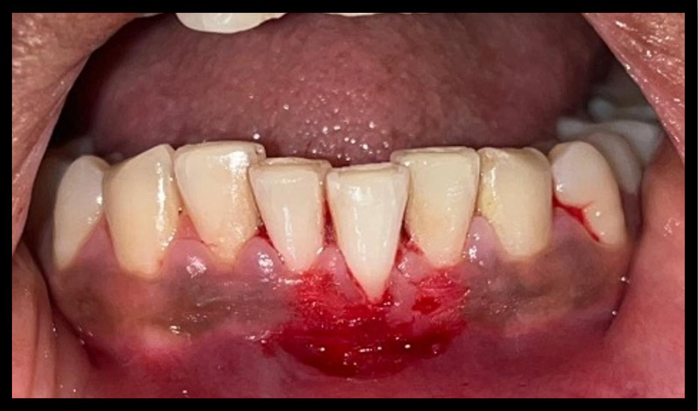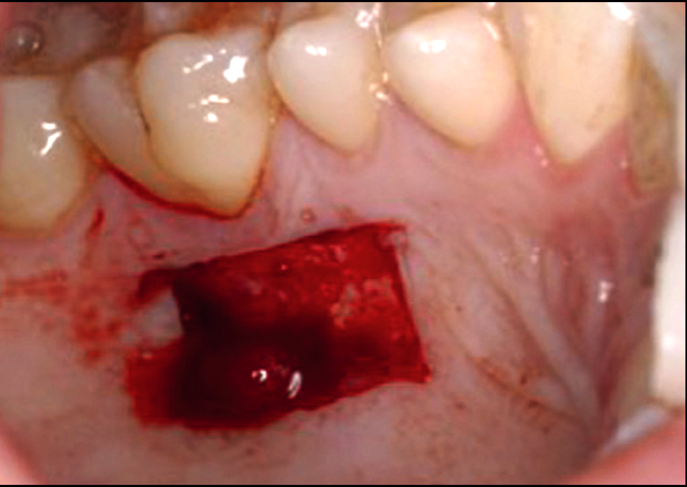
Fig 2: After De-epithelialization
Fig 3: Recipient site after graft harvesting

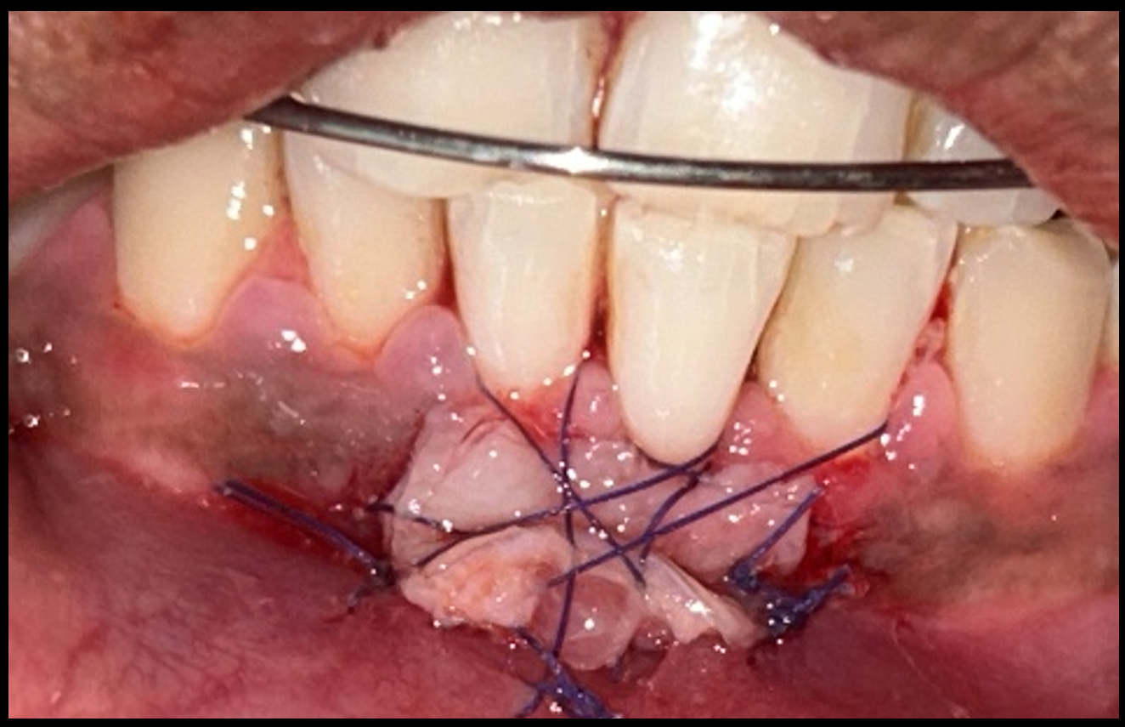
Fig 4: After Suturing

Recipient bed preparation:
After intraoral and extra oral antisepsis, the surgical site was anaesthetized with 2% lignocaine with adrenaline (Lignox 2%). Shallow vertical incision was made on buccal aspect of affected tooth, 31 extending 3mm mesially and distally and then shallow horizontal incisions were made on both sides using #15 scalpel. Thin partial thickness flap was removed from the butt joint, providing a smooth periosteal bed. Exposed root was planed with curettes followed by root conditioning with tetracycline and irrigated with saline. The recipient site was measured to harvest free gingival graft from palate.
Donor site preparation:
The measurement was outlined in the palate region from premolar to molar. Free gingival graft nearly 2 mm thickness, was harvested using #15 scalpel and soaked in saline. To promote wound healing at the palate site, a hem sponge was placed in donor site, and the palate was protected with a palatal stent, instructed the patient to wear it for 1 week after the surgery.
FGG stabilization:
The harvested free gingival graft was placed in the denuded root surface. Holbrook & Ochsenbein sutures of horizontal stretching, interdental concavity and circumferential suturing were done by anchoring the graft in recipient site to the periosteum using a 5.0 resorbable vicryl sutures and the graft stability was achieved.(7) Dead space was obliterated with moist gauze compression over the stabilized graft. Periodontal dressing was placed.
Post-operative care:
Post- operative instructions given to the patient was not to have mechanical trauma, not to brush, or not to give excessive lip pull in the surgical area. The patient was prescribed with Ketorolac 10 mg twice daily for 3 days, along with a 0.12% chlorhexidine mouthwash twice daily for 15 days after the surgery. Patient was educated regarding usage of palatal stents for donor site wound protection.

Recall and evaluation
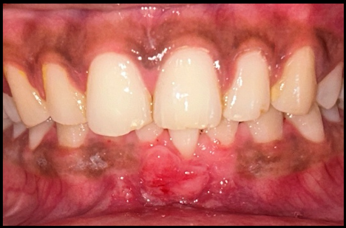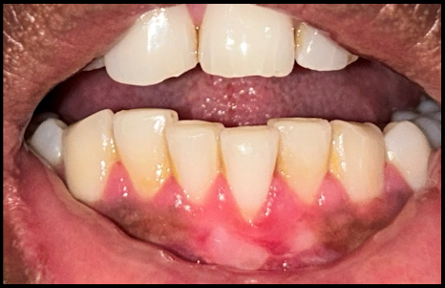
Fig 6: After 2 months
Fig 5: After 2 weeks

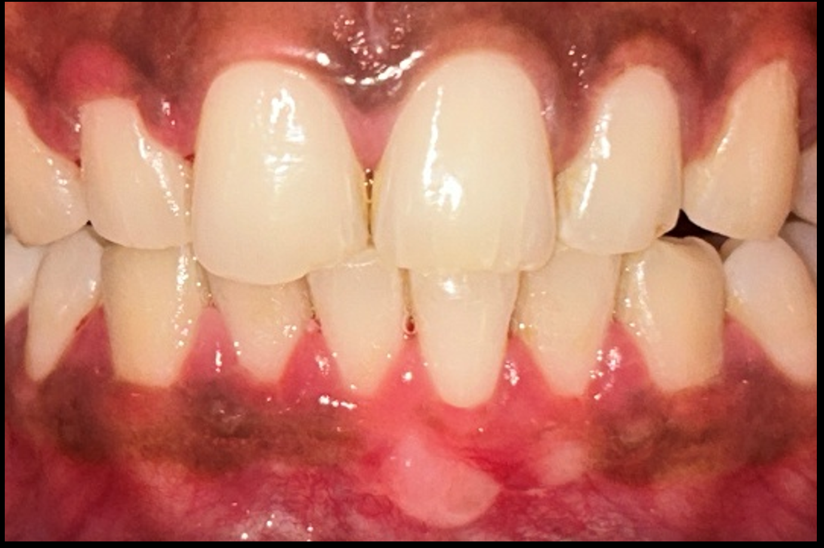
Fig7: After 12 months
Patient was recalled after 2 weeks for suture and periodontal dressing removal and also for wound healing assessment. Healing was found to be satisfactory, with good graft acceptance in the recipient site. Patient reinforced with oral hygiene instructions for the next 12 months. Mechanical plaque removal measures were instructed with soft tooth brush. After 2 months, patient presented with increased thickness of keratinized gingiva with a tire patch appearance and a mild recession of 1 mm was noted. After 12 months, patient had a creeping attachment of 1mm showing gradual coronal migration to the root surface. Complete root coverage was achieved. Signs of attach gingiva gain, suppressed bleeding on probing and reduced hypersensitivity was noted. Patient addressed with post-operative pain in the donor site for the following 1st week of surgery and the pain was gradually reduced at 21 days following surgery. The patient was completely satisfied with reduced hypersensitivity and the aesthetic outcome 12 months after surgery.

DISCUSSION
This case report presents the successful management of gingival recession in a 28-year-old female patient with concerns about hypersensitivity and aesthetics. The recession was classified as Cairo Recession Type 1 (RT1), with no interdental clinical attachment loss. (5) Given the patient’s good prognosis and the need for increased attached gingiva, a free gingival graft (FGG) was selected as the treatment modality.
The treatment plan followed a structured approach, beginning with a non-surgical phase that included professional mechanical plaque removal, subgingival debridement, and reinforcement of oral hygiene practices. This preparatory phase ensured optimal plaque control, which is crucial for the success of periodontal plastic surgery. The surgical phase involved harvesting a free gingival graft from the palatal mucosa and securing it at the recipient site, with meticulous post-operative care and follow-up over 12 months.
One of the key highlights of this case was the phenomenon of creeping attachment, wherein the gingival margin showed gradual coronal migration over the exposed root surface. After 12 months, a 1mm creeping attachment was observed, resulting in complete root coverage. This supports existing literature indicating that creeping attachment is influenced by several factors, including graft thickness, the presence of keratinized tissue, bone support, and patient compliance with oral hygiene. (6)
The free gingival graft effectively promoted root coverage while increasing the width and thickness of keratinized tissue. The presence of creeping attachment after 12 months demonstrates the biological potential of gingival tissues to migrate and integrate with the root surface over time (6). The coverage of the exposed root surface led to a significant reduction in hypersensitivity, improving the patient’s comfort. The increase in attached gingiva and the creeping attachment contributed to a more natural and harmonious gingival contour, enhancing the patient’s aesthetic concerns.
Previous studies have established that a critical amount of keratinized tissue is necessary for periodontal health, but plaque control remains the primary determinant of long-term stability (7). Traditionally, FGGs were used to increase the width of keratinized tissue, but their role has evolved toward achieving root coverage. Studies have also emphasized the importance of graft thickness and precise suturing techniques in ensuring graft survival and integration (8). In this case, the 2mm-thick palatal graft and careful stabilization techniques contributed to the optimal outcome.
Post-operative pain was a significant concern, particularly at the donor site, which is a common challenge with palatal grafts (9). The use of a hemosponge and palatal stent helped in reducing discomfort and protecting the healing tissue. Despite initial discomfort, the patient expressed high satisfaction with the aesthetic and functional improvements achieved at the 12-month follow-up.
There are still significant challenges in effectively treating gingival recession (10), While this case highlights the success of FGG with creeping attachment, further research is needed to understand the biological mechanisms underlying creeping attachment and to refine techniques that maximize predictable root coverage(11). Long-term studies comparing different grafting techniques and their impact on patient-reported outcomes would be valuable in optimizing treatment protocols for gingival recession (12).

CONCLUSION
The effective management of gingival recession in this case report demonstrates the efficacy of a treatment that uses a free gingival graft. Complete Root coverage with free gingival graft increases the thickness of keratinized gingiva and creeping attachment gave a positive outcome. Recession depth and width, graft thickness, tooth position, bone support, surgeon skills and patient oral hygiene were very important for this successful outcome. This case shows an importance of treatment planning and decision making of a mucogingival surgery for a clinician and also a "wait and see" approach for considering additional surgeries.

Consent
As per international standards or university standards, patient(s) written consent has been collected and preserved by the author(s).

Author(s) hereby declare that generative AI technologies such as Large Language Models, etc. have been used during the writing or editing to rephrase manuscripts. This explanation will include the name, version, model, and source of the generative AI technology and as well as all input prompts provided to the generative AI technology
Details of the AI usage are given below:
1. Chat GPT-4
2. Copilot 1.25042.146.0

REFERENCES

1. Kassab MM, Cohen RE. The etiology and prevalence of gingival recession. J Am Dent Assoc. 2003 Feb 1;134(2):220-5.
2. Lang NP, Loe H. The relationship between the width of keratinized gingiva and gingival health. J Periodontal 1972: 43:623-627.
3. Kassab MM, Cohen RE. Treatment of gingival recession. J Am Dent Assoc. 2002 Nov 1;133(11):1499-506.
4. Pereira Neto ARL, Passoni BB, de Souza Jr. JM, de Souza JGO, Benfatti CAM, Magini R de S, et al. Creeping Attachment Involving Dental Implants: Two Case Reports with a Two-Year Follow-up from an ongoing Clinical Study. Case Rep Dent.2014;2014(1):756908
5. Cairo F, Nieri M, Cincinelli S, Mervelt J, Pagliaro U. The interproximal clinical attachment level to classify gingival recessions and predict root coverage outcomes: an explorative and reliability study. J Clin Periodontol. 2011;38:661-666.
6. Matter J, Cimasoni G. Creeping attachment after free gingival grafts. Journal of Periodontology. 1976 Oct 1;47(10):574-9.
7. Schrott AR, Jimenez M, Hwang JW, Fiorellini J, Weber HP. Five-year evaluation of the influence of keratinized mucosa on peri-implant soft-tissue health and stability around implants supporting full-arch mandibular fixed prostheses. Clin Oral Implants Res. 2009 Oct;20(10):1170-7. doi: 10.1111/j.1600-0501.2009.01795.x. Epub 2009 Aug 30. PMID: 19719741; PMCID: PMC4928380.
8. Assimi S, Ismaili Z, Dghoughi S. Successful management of gingival recession with creeping attachment: A case report. Clinical Case Reports. 2024 May;12(5):e8952.
9. Arun, Ramya; Sevugan, Rajkumar. Creeping Attachment-aided Root Coverage with Free Gingival Graft in the Esthetic Zone. Journal of Interdisciplinary Dentistry 13(3):p 173-176, Sep–Dec 2023. | DOI: 10.4103/jid.jid_24_23

10. P D Miller Jr, Root coverage with the free gingival graft. Factors associated with incomplete coverage doi: 10.1902/jop.1987.58.10.674.

11. Deepalakshmi, D; Arunmozhi, Root coverage with free gingival auto grafts-a clinical study. DOI: 10.4103/0970-9290.29876

12. Luo, B., Xiao, J., Yan, F. et al. Changes in creeping attachment for soft tissue augmentation surgery. Clin Oral Invest 29, 191 (2025). https://doi.org/10.1007/s00784-025-06270-z

