Clinical Practice Article
The Art and Algorithm of Digital Smile Design: A Prosthodontic Case Series

ABSTRACT
Aim: This case series evaluates Digital Smile Design (DSD) in prosthodontics, highlighting its role in esthetic and functional rehabilitation. Digital tools improved diagnostic accuracy, treatment planning, and execution, enhancing predictability.
Presentation of Case: Three patients 20 year old male, 32 year old male and 45 year old male requiring partial prosthetic rehabilitation were included . In this case series The Dental CAD Exo-CAD was utilized to assess facial and dental harmony, generate digital mock-ups, and direct restorative procedures. Advanced tools such as intraoral scanners, 3D facial imaging, and CAD/CAM systems ensured precision in treatment execution. The cases presented diverse challenges, including tooth wear, malalignment, and missing teeth. The digital approach facilitated active patient involvement in smile design, leading to customized and satisfactory results. The patient satisfaction is enhanced after completion of the treatment course.
Discussion: The use of digital system provided a structured and efficient workflow for prosthodontic rehabilitation, enhancing collaboration among clinicians, dental technicians, and patients. Virtual previews minimized procedural errors and reduced clinical time while improving esthetic predictability. Despite initial challenges such as the learning curve and dependence on high-resolution imaging, the benefits—greater accuracy, patient engagement, and streamlined treatment—were significant.
Conclusion: Digital Smile Design is a transformative tool in prosthodontics, delivering patient-centered, reliable, and time-efficient smile rehabilitation. Its adoption in clinical practice improves both functional and cosmetic results, positioning it as a key advancement in contemporary dentistry. Despite the small clinical sample size, long-term follow-up is necessary to ensure long-term predictability

Introduction :
Digital Smile Design (DSD) merges digital technology and artistic principles for predictable aesthetics in prosthodontics [1]. This case series examines three clinically challenging scenarios where traditional treatment planning methods proved inadequate: first, a 20-year-old male with severe anterior tooth malalignment and compromised esthetics; second, a 32-year-old male with generalized spacing even after the orthodontic treatment; and third, a 45-year-old patient with severe midline diastema . Each case demonstrates unique applications of DSD in overcoming the limitations of conventional diagnostic wax-ups through its three key advantages: digital facial analysis, 3D smile simulation, and guided restorative execution [2].
The series highlights DSD's transformative role in complex prosthodontic management by: (1) facilitating interdisciplinary treatment planning through standardized digital workflows, (2) improving accuracy in outcome prediction compared to analog methods, and (3) enhancing patient engagement through visual treatment simulations [3]. Particular emphasis is placed on DSD's ability to quantify aesthetic parameters - including tooth proportions, gingival levels, and smile symmetry - while simultaneously addressing functional requirements [4].
These cases collectively demonstrate how digital workflows can reduce clinical time, improve laboratory communication, and ultimately deliver superior aesthetic results in challenging rehabilitations [5]. The findings underscore DSD's growing indispensability in contemporary prosthodontic practice.

Presentation of case :
Case Report 1: 20-Year-Old Male College Student with Missing and Malaligned Maxillary Anterior Teeth
A 20-year-old male college student with no significant medical history presented with missing and malaligned maxillary anterior teeth due to trauma, leading to compromised esthetics. The patient reported difficulty in chewing and dissatisfaction with his smile. Clinical examination revealed missing 22 and proclined 12, 11 with mild gingival discrepancies. Intraoral periapical (IOPA) radiographs confirmed the absence of periapical pathology, and Digital Smile Designing (DSD) was used to plan prosthetic rehabilitation, ensuring optimal tooth proportions and gingival harmony. Intentional root canal treatment was performed on 12, 11. The treatment involved a fixed partial denture (12-11-21-22-23 splinted 5-unit zirconia bridge), resulting in excellent immediate functional and esthetic outcomes.

Case Report 2: 32-Year-Old Male Lawyer with Generalized Spacing in Maxillary Anteriors
A 32-year-old male lawyer, previously treated with orthodontics, presented with persistent generalized spacing in his maxillary anterior teeth and poor esthetics. Despite prior orthodontic correction, the spacing remained, affecting his smile. Clinical examination revealed no active periodontal disease, and radiographic investigation ruled out periapical pathology. Digital Smile Designing (DSD) was employed to plan a 6-unit zirconia bridge (13-12-11-21-22-23), which successfully restored proper tooth proportions and smile aesthetics.

Case Report 3: 45-Year-Old Male Businessman with Severe Midline Diastema
A 45-year-old male businessman complained of a severe midline diastema in the maxillary arch, which affected his smile and self-confidence. Clinical and radiographic (IOPA) evaluation confirmed no underlying pathology. Digital Smile Designing (DSD) was used to plan diastema closure with a 6 unit zirconia bridge ( 13 to 23) initially but the treatment plan was changed to conservative by involving 4-unit zirconia bridge (12-11-21-22), achieving excellent symmetry and natural tooth morphology. The immediate post-treatment results met the patient's aesthetic expectations.

CASE REPORT-1 :
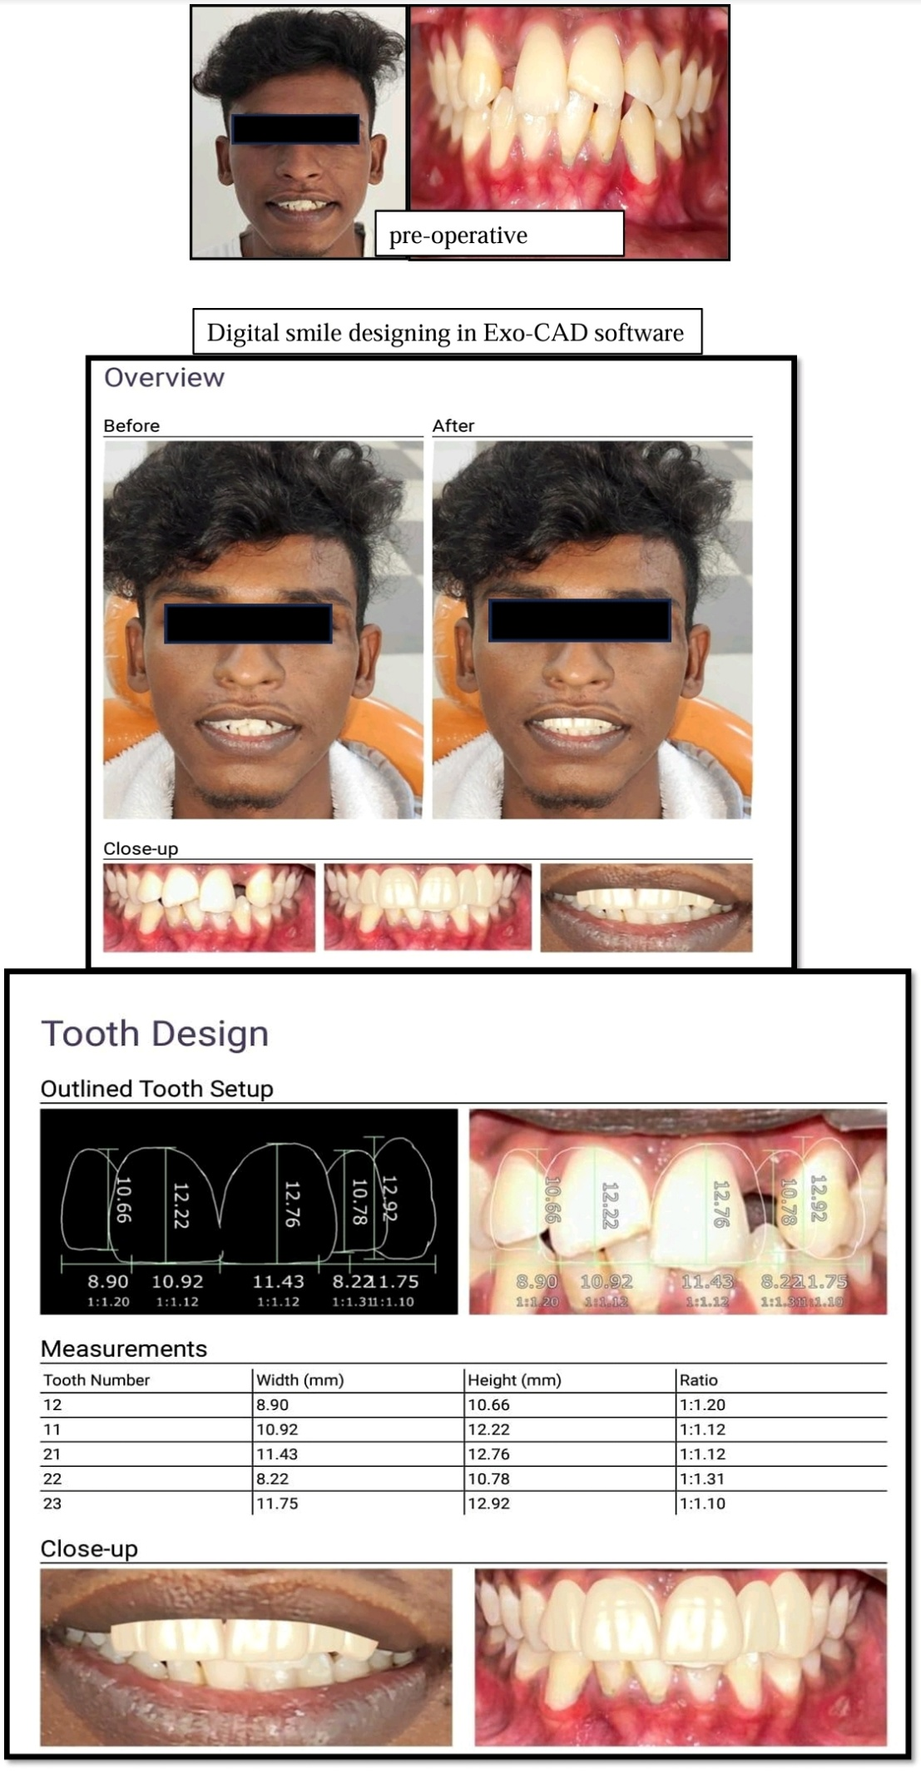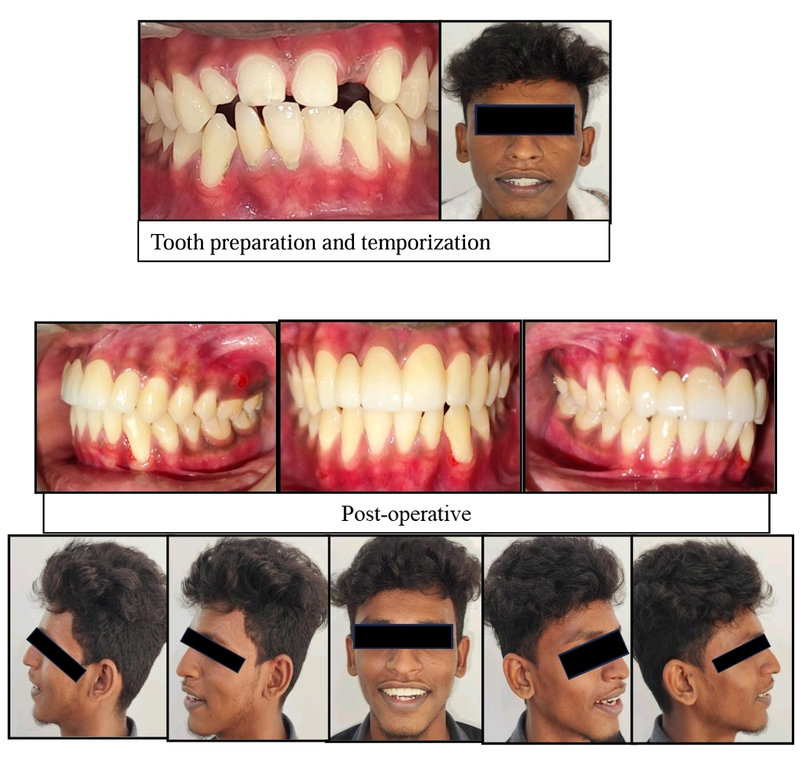

CASE REPORT-2 :

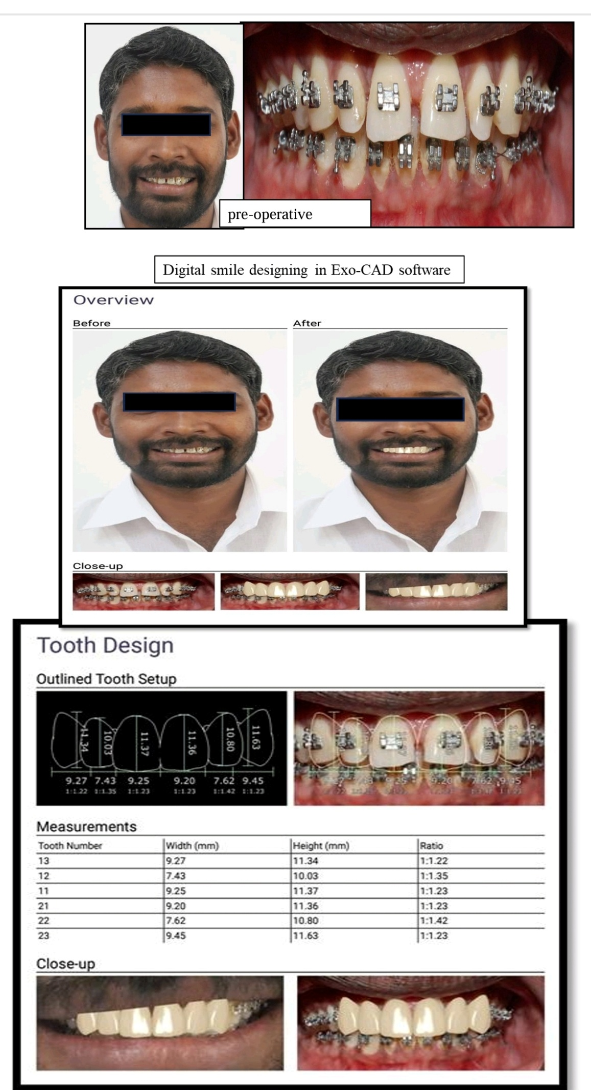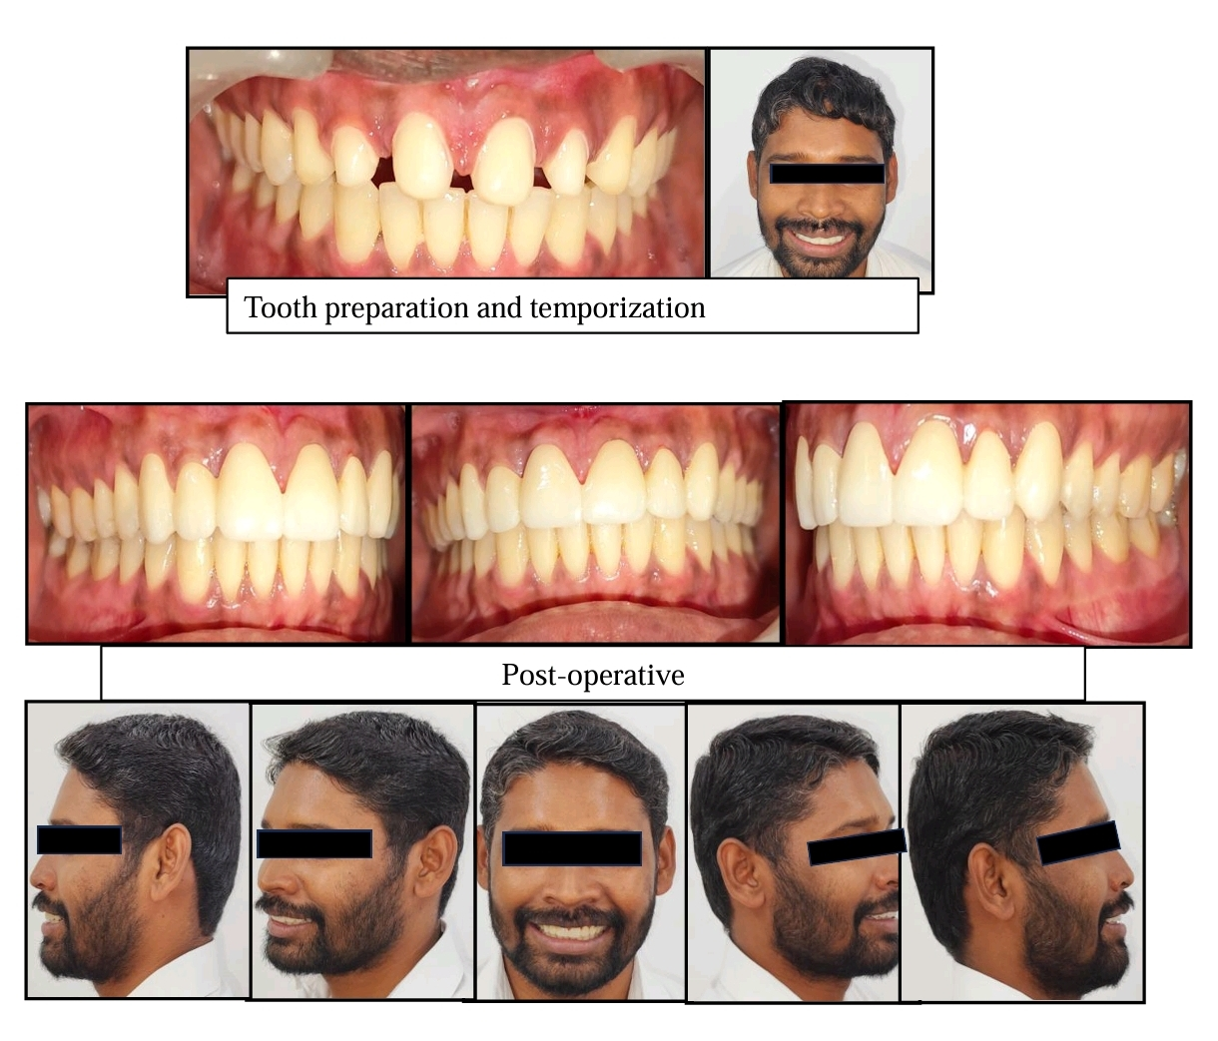

CASE REPORT-3:

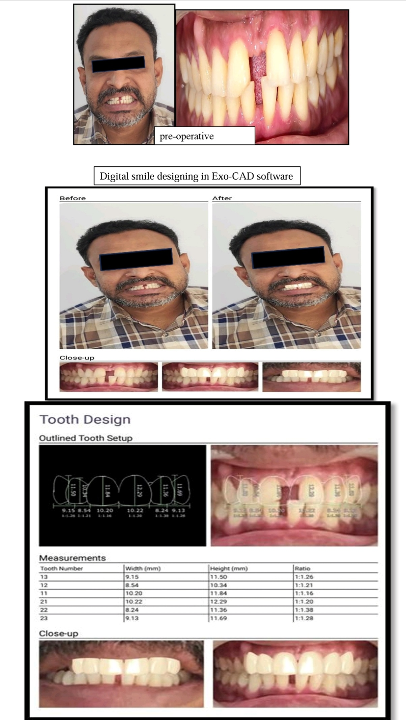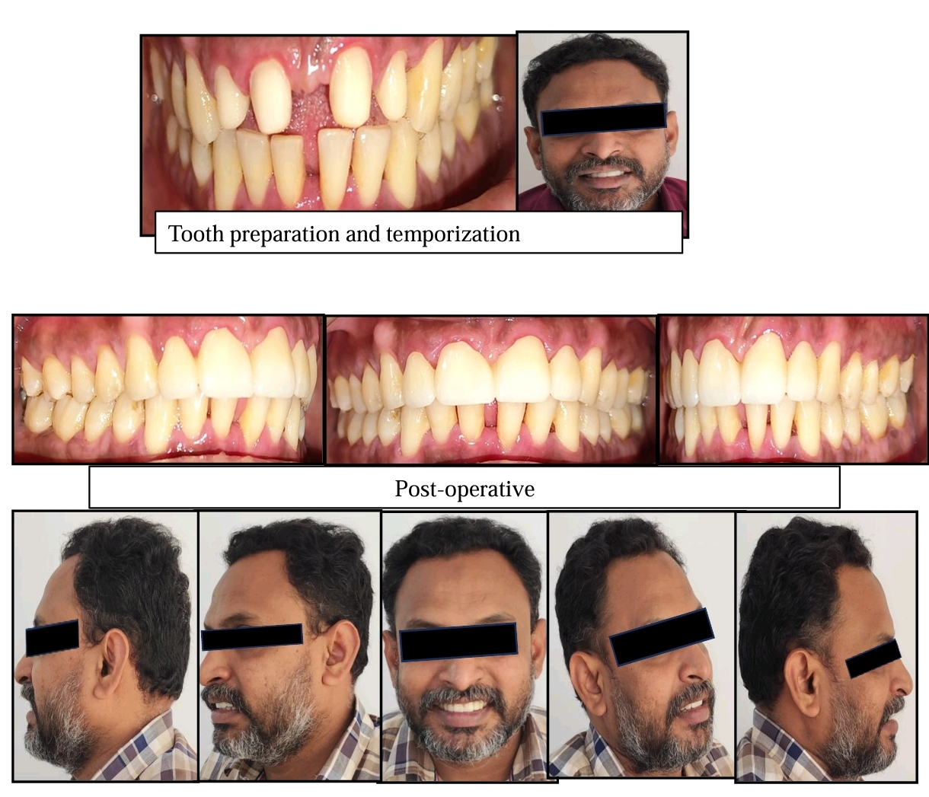

Discussion :

Digital Smile Design (DSD) has revolutionized aesthetic dentistry by combining advanced technology with patient-centered care. Thomas et al. [6] highlight how DSD enhances communication between clinicians and patients, ensuring predictable outcomes. Jafri et al. [7] emphasize its role in improving diagnosis and treatment planning through digital analysis. Agnini et al. [8] showcase the efficiency of a fully digital workflow, reducing treatment time. Bhave et al. [9] demonstrate DSD’s interdisciplinary benefits, integrating facial and dental aesthetics. Mir et al. [10] note its ability to boost patient confidence via previsualization. Liu et al. [11] stress the importance of 3D printing for precise outcomes, while Babaei et al. [12] compare patient satisfaction across DSD methods, finding high approval rates. Bhandari et al. [13] underline DSD’s conservative approach, preserving tooth structure while achieving aesthetic goals. Together, these studies affirm DSD as a transformative tool in modern dentistry, blending artistry, technology, and patient involvement for optimal results. This discussion analyzes three representative cases demonstrating DSD's clinical applications while addressing its inherent challenges.
Case 1: Traumatic Tooth Loss and Malposition. The 20-year-old patient presented with missing #22 and proclined #12-11 due to trauma. Treatment required intentional RCT of #12-11 to accommodate necessary tooth reduction and create parallel abutments for a 5-unit zirconia bridge (#12-23). DSD facilitated precise visualization of tooth positions and gingival architecture before preparation. Zirconia was selected for its strength and biocompatibility [5], particularly suitable given the patient's young age and occlusal demands. The digital workflow enhanced interdisciplinary communication, ensuring aesthetic expectations were met.
Case 2: Persistent Spacing Post-Orthodontics. The 32-year-old lawyer's generalized spacing persisted despite orthodontic treatment, highlighting limitations in addressing tooth size discrepancies[3]. A 6-unit zirconia bridge (#13-23) was chosen over more conservative options due to the extent of spacing and need for comprehensive recontouring. DSD's digital preview demonstrated proposed changes to incisal edge position and gingival display, significantly improving case acceptance. The technology enabled precise planning of tooth proportions critical for natural-looking results.
Case 3: Midline Diastema Management. The 45-year-old businessman's severe diastema required careful. evaluation of papilla condition and facial symmetry. A 4-unit zirconia bridge (#12-22) was preferred over orthodontics or composites due to the diastema width and patient's desire for definitive treatment. DSD ensured symmetrical proportions and natural emergence profiles, crucial for midline cases where minor asymmetries are noticeable [4]. Digital planning improved laboratory communication for optimal contour and texture matching.
Tooth preparation: The Abutments teeth were prepared to receive a full coverage restoration made of zirconia, with axial reduction of 1 to 1.5 mm and occlusal clearance of 2mm.
Material Considerations: Zirconia's selection across all cases reflects its unique combination of mechanical properties and aesthetic potential[5]. Modern translucent formulations provide natural-looking results while maintaining the strength needed for long-span anterior bridges. In all the three cases the FPD bridges were fabricated from densply zirconia block monolayered.
DSD Workflow Advantages: The DSD protocol enhanced treatment predictability through digital mock-ups[1], allowing patients to visualize outcomes before irreversible procedures. Exocad software utilizes the patient's scanned upper and lower STL files, aligning the retracted patient image with the STL data using common reference points. The smile image is then incorporated, and adjustments are made to the lip line and pupil points to match the patient's anatomy.
Next, helper lines appear to assist in orienting the facial midline, dental midline, and the plane of occlusion. Following this, the Smile Creator module is activated, allowing the user to select tooth morphology and customize the smile design. Adjustments can be made to the buccolingual, mesiodistal, and axial alignment of the teeth to achieve the desired aesthetic outcome.
Clinical Challenges and Limitations: The absence of follow-up visits prevented assessment of long-term outcomes, a common issue when patients are satisfied with initial results. Other limitations include: Irreversible tooth preparation committing patients to lifelong prosthetic maintenance, Significant cost of high-quality zirconia prostheses, Potential technical complications like veneer chipping in layered restorations, Wear characteristics against natural dentition requiring further study

Conclusion :
These cases demonstrate DSD's effectiveness in anterior aesthetic rehabilitation when combined with zirconia prosthetics. The digital workflow enhances treatment predictability through precise 3D planning and virtual smile simulations, while improving patient communication and case acceptance. However, clinicians must carefully consider the irreversible nature of tooth preparation and long-term maintenance requirements. The significant investment in high-quality zirconia prosthetics may also limit accessibility for some patients. Future advancements in ultra-translucent zirconia formulations and AI-assisted smile design promise to address current limitations while maintaining excellent outcomes. Emerging CAD/CAM technologies continue to streamline workflows from diagnosis to final delivery. Ultimately, successful treatment requires balancing technological innovation with fundamental biological principles, combining digital precision with clinical expertise. The synergy between advanced technology and prosthodontic artistry will continue to drive progress in aesthetic rehabilitation, offering improved solutions for patients with complex anterior restorations while maintaining emphasis on individualized care and evidence-based practice. This approach ensures optimal outcomes that meet both functional demands and aesthetic expectations.
Disclaimer (Artificial intelligence)
Option 1:
Author(s) hereby declare that NO generative AI technologies such as Large Language Models (ChatGPT, COPILOT, etc.) and text-to-image generators have been used during the writing or editing of this manuscript.

References :

1. Coachman C, Van Dooren E, Gürel G, Landsberg CJ, Calamita MA, Bichacho N. Smile design: From digital treatment planning to clinical reality. Inside Dentistry. 2017;13(2):98-110.
2. Gurel G. The science and art of porcelain laminate veneers. Berlin: Quintessence Publishing; 2016.
3. Spear FM, Kokich VG, Mathews DP. Interdisciplinary management of anterior dental esthetics. Journal of the American Dental Association. 2006;137(2):160-9.
4. Kokich VO, Kokich VG, Kiyak HA. Perceptions of dental professionals and laypersons to altered dental esthetics: Asymmetric and symmetric situations. American Journal of Orthodontics and Dentofacial Orthopedics. 2006;130(2):141-51.
5. Zhang Y, Lawn BR. Novel zirconia materials in dentistry. Journal of Dental Research. 2018;97(2):140-7.
6. Thomas PA, Krishnamoorthi D, Mohan J, Raju R, Rajajayam S, Venkatesan S. Digital smile design. Journal of Pharmacy and Bioallied Sciences. 2022 Jul 1;14(Suppl 1):S43-9.
7. Jafri Z, Ahmad N, Sawai M, Sultan N, Bhardwaj A. Digital Smile Design-An innovative tool in aesthetic dentistry. Journal of oral biology and craniofacial research. 2020 Apr 1;10(2):194-8.
8. Agnini A, Apponi R, Maffei S, Agnini A. Digital dental workflow for a smile makeover restoration. Int J Esthet Dent. 2020 Nov 30;15(4):374-89.
9. Bhave RP, Sabane AV, Kalsekar BG, Shah MA. TRANSFORMING SMILES: A CASE SERIES ON THE IMPLEMENTATION OF DIGITAL SMILE DESIGN.
10. Hassam Anjum Mir MI, Asif A, Ahmed AN, Ayub MM. Digital Smile Design: Case Series.
11. Liu J, Maihemaiti M, Ren L, Maimaiti M, Yang N, Wang Y, Wang M, Wang X, Fu Y, Wang Z. A comparative study of the use of digital technology in the anterior smile experience. BMC Oral Health. 2024 Apr 25;24(1):492.
12. Babaei M, Kazemian M, Barekatain M. A comparative analysis of patient satisfaction with various methods of digital smile design and simulation. Dental Research Journal. 2025 Mar 1;22(1):10.
13. Bhandari A, Tembhurne J, Gangurde A, Meena A. Miles Towards The Smile: A Case Series.

