The Charlson Comorbidity Index for Heart failure with reduced ejection fraction prognosis prediction

ABSTRACT
Aims:To assess the prognostic value of the Charlson comorbidity index (CCI) for predicting all-cause mortality in patients with heart failure with reduced ejection fraction (HRrEF) in a north African context.
Study design: prospective, single-center observational study.
Place and duration of study: conducted at the therapeutic heart failure unit, Ibn Rochd hospital, Casablanca, Morocco, from march to October 2022.
Methodology: we enrolled 188 adult patients diagnosed with HFrEF (left ventricular ejection fraction <40%). Comorbidities were recorded at admission and scored using the CCI. Patients were divided into two groups based on a cci cutoff of 5. The primary outcome was all-cause mortality tracked during follow-up. Survival differences were analyzed using Kaplan-Meier curves and statistical comparison tests.
Results:the average age was 63 ± 12 years, with a male-to-female ratio of 2:1. The mean cci score was 3.65 ± 1.45. Hypertension, diabetes, and chronic obstructive pulmonary disease were the most frequent comorbidities. During follow-up, 44 patients (23.4%) died. Mortality was significantly higher in patients with a cci score above 5 (P < 0.001). Mean survival was 6.02 months for the low cci group and 4.38 months for the high cci group.
Conclusion: The Charlson comorbidity index is a simple and effective tool to predict mortality risk in HFrEF patients. Its use can improve risk stratification and support tailored management, especially in settings with limited resources.
Keywords: Heart failure, Comorbidity, Charlson Comorbidity Index, Mortality, Risk assessment, Prognostic models, Observational studies
INTRODUCTION :
Heart failure with reduced ejection fraction is a major global health problem with high morbidity and mortality despite treatment advances. It affects over 64 million people worldwide, representing nearly half of all heart failure cases [1]. Risk stratification remains difficult due to patient heterogeneity [2,3].
Non-cardiac comorbidities significantly worsen prognosis in HFrEF. Patients often have multiple chronic diseases like hypertension, diabetes, or COPD that impact outcomes and limit therapies [4,5]. Evaluating these conditions individually may underestimate their combined effect.
The Charlson Comorbidity Index offers a simple, clinically based score summarizing 19 chronic conditions to predict mortality [6]. Its ease of use is valuable, especially in low-resource settings lacking advanced tools.
Recent studies link higher CCI scores to worse outcomes in heart failure, but most data come from Asia, with limited evidence in North Africa. Regional differences highlight the need to validate the CCI locally.
This study assesses the CCI’s prognostic value for all-cause mortality in Moroccan patients with HFrEF, hypothesizing that higher scores predict increased mortality and shorter survival, supporting its clinical use.

MATERIAL AND METHODS
Study Design and Setting
This prospective, single-center observational study was conducted at the therapeutic heart failure within the cardiology department at Ibn Rochd Hospital, Casablanca, Morocco. Data collection spanned an 8-month period from March 2022 to October 2022. The hospital serves a diverse urban and suburban population, providing a relevant clinical setting for assessing heart failure outcomes in a North African context.
Study Population

Eligible participants were adult patients (≥18 years) admitted with a confirmed diagnosis of HFrEF, defined as a left ventricular ejection fraction below 40% on echocardiography. Patients presenting with acute coronary syndromes, recent myocardial infarction (within the past 30 days), or other severe systemic illnesses that could confound the study outcomes were excluded. Informed consent was obtained from all participants prior to enrollment.

Data Collection
Upon admission, data were collected on patient demographics, clinical characteristics, and comorbidities.
Comorbidities were quantified using the Charlson Comorbidity Index, which assigns weighted scores (ranging from 1 to 6) to 19 predefined medical conditions, such as diabetes, chronic pulmonary disease, renal failure, or malignancies, based on their associated risk of mortality. The individual scores for each condition are summed to yield a total comorbidity score for each patient. This cumulative score reflects the overall burden of comorbid illness and has been shown to correlate with survival in patients with chronic conditions such as HFrEF.
Statistical Analysis
Data were analyzed using SPSS version 23.0. Patients were dichotomized into two groups based on their CCI score: low comorbidity burden (CCI ≤ 5) and high comorbidity burden (CCI > 5). Continuous variables were expressed as means ± standard deviations, and categorical variables as frequencies and percentages. Survival differences between groups were assessed using Kaplan-Meier survival analysis and compared with the Log-rank test. A p-value < 0.05 was considered statistically significant.

RESULTS

Patient characteristics

A total of 188 patients met inclusion criteria and were enrolled. The mean age of the cohort was 63 ± 12 years, with a predominance of male patients (male-to-female ratio approximately 2:1). corresponding to 125 men (66.5%) and 63 women (33.5%). The average CCI score was 3.65 ± 1.45, with a range of 1 to 8, indicating a variable but generally moderate comorbidity burden among participants.

Comorbidities

Hypertension was the most frequently observed comorbidity (33.5%), followed by diabetes mellitus (30.3%) and chronic obstructive pulmonary disease (11.7%). Each comorbidity was analyzed for its association with mortality risk; however, none reached statistical significance individually (hypertension p=0.42, diabetes p=0.89, COPD p=0.9), underscoring the importance of cumulative comorbidity assessment rather than isolated conditions.

Mortality and survival analysis

During the follow-up period, 44 patients (23.4%) died. Mortality was significantly higher in the high comorbidity group (CCI > 5) compared to the low comorbidity group (CCI ≤ 5), with a highly significant difference (p<0.001). The mean estimated survival time was 6.02 months (95% CI: 5.94–6.47) for patients with lower CCI scores, versus 4.38 months (95% CI: 3.27–5.50) for those with higher scores. Kaplan-Meier survival curves clearly depicted the survival disparity between groups, confirmed by the Log-rank test (p<0.001) (Figure-1). These findings demonstrate that a higher Charlson Comorbidity Index is strongly associated with increased mortality risk in patients with HFrEF.
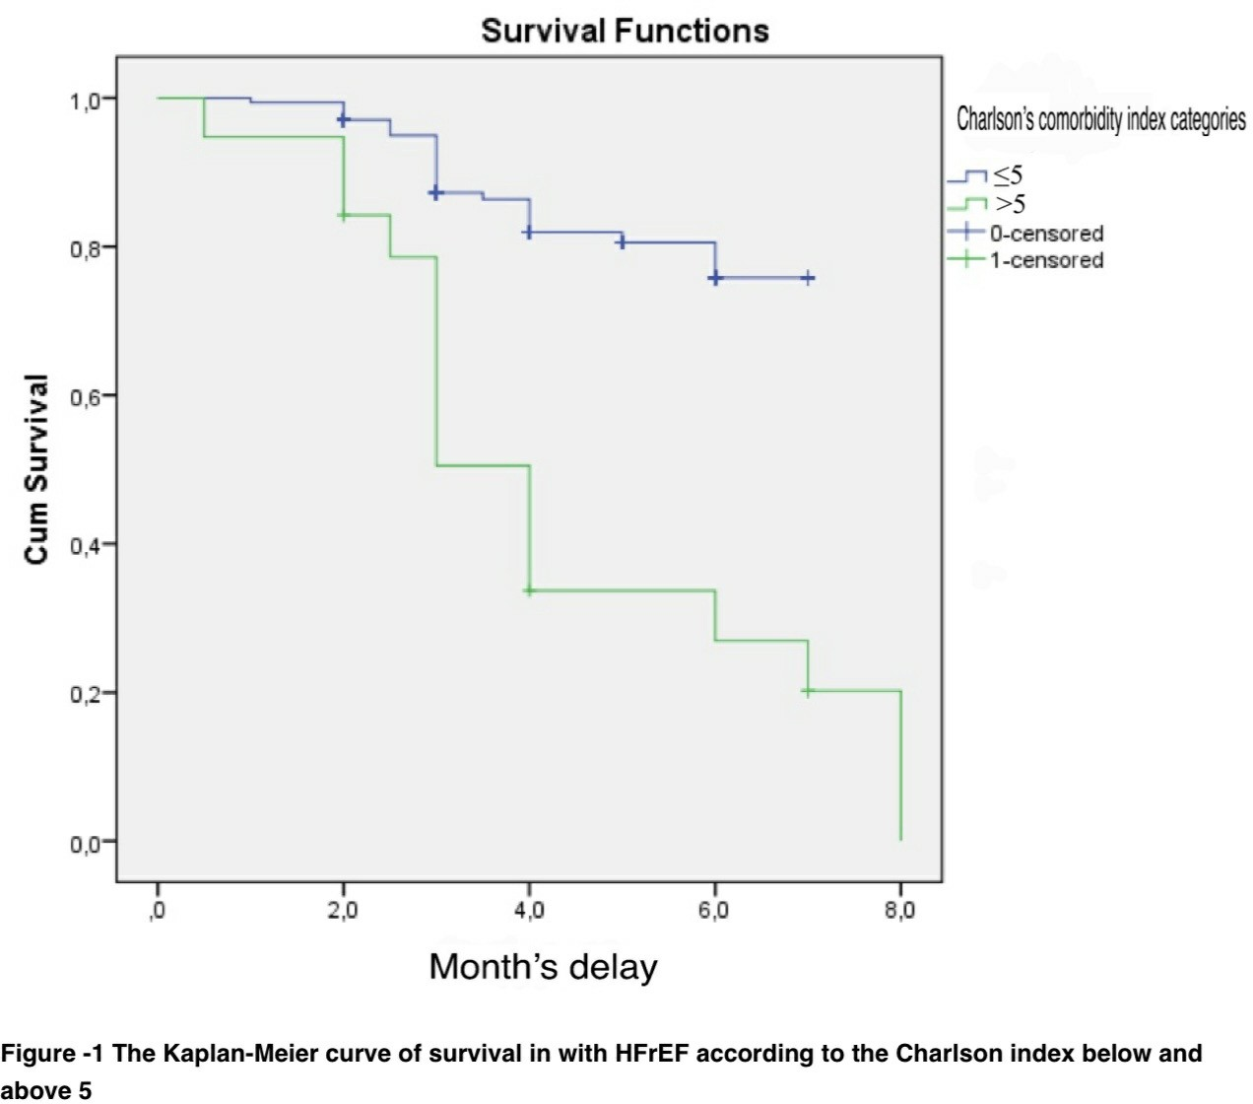

DISCUSSION
Our prospective observational study demonstrates that the Charlson Comorbidity Index is a strong and independent predictor of mortality in patients with HFrEF.
Patients with a CCI > 5 experienced significantly higher mortality and shorter survival compared to those with lower scores, supporting the use of this index as a simple yet powerful tool for risk stratification in heart failure care.
These findings align with prior analyses from large heart failure cohorts. For instance, data from the ASCEND-HF trial demonstrated that each one-point increase in the Charlson Comorbidity Index was associated with a significant increase in six-month mortality risk [7].
This demonstrates a clear dose-response relationship between comorbidity burden and adverse outcomes in heart failure. For instance, Formiga et al. reported that patients with a Charlson Comorbidity Index score greater than 2 had a significantly higher 1-year mortality rate compared to those with lower scores [8]. Our study reinforces these results by validating the prognostic value of the CCI within a North African context, where epidemiological profiles and healthcare infrastructures differ substantially from those typically studied.
Interestingly, despite the high prevalence of common comorbidities such as hypertension, diabetes mellitus, and COPD within our study, these conditions individually did not show a statistically significant association with mortality. This observation underscores the importance of assessing the cumulative burden of comorbidities rather than focusing solely on individual diseases. The Charlson Comorbidity Index effectively captures this cumulative burden, reflecting how multimorbidity contributes to a vulnerable physiological state characterized by systemic inflammation, neurohormonal dysregulation, diminished functional reserve, and reduced medication tolerance all factors associated with worse clinical outcomes [4,5].
This cumulative effect can amplify the risk beyond what any single comorbidity would predict.
One of the main strengths of the CCI is its simplicity and practicality. Unlike specialized biomarkers such as natriuretic peptides or advanced imaging modalities like cardiac MRI, which may not be readily accessible in many healthcare settings, the CCI can be calculated from basic clinical information obtained at admission. This makes it particularly valuable in resource-limited environments where diagnostic and monitoring tools may be scarce, yet the need for effective risk stratification remains critical. By incorporating the CCI into routine clinical assessment at admission, healthcare providers can quickly identify high-risk patients who may benefit from intensified monitoring, closer follow-up, early discharge planning, or more aggressive management of comorbidities and heart failure symptoms.
Moreover, the CCI should not be viewed as a stand-alone prognostic marker but rather as a complementary tool within a broader risk assessment framework. Previous studies suggest that combining the CCI with heart failure-specific parameters—such as natriuretic peptides (e.g., NT-proBNP), echocardiographic measures of left ventricular function, renal function markers, and assessments of functional capacity—can enhance prognostic accuracy and better inform personalized treatment plans [9]. Such multidimensional risk models can help clinicians prioritize patients for advanced therapies, including device implantation or referral for heart transplantation, and also guide timely discussions about palliative care when appropriate [10].
Despite these promising results, several limitations of our study should be acknowledged. The single-center design and relatively modest sample size may limit the generalizability of our findings to other populations and healthcare settings. Additionally, our follow-up period of six months was relatively short, restricting our ability to capture long-term outcomes and mortality trends. We also did not evaluate the impact of variations in treatment intensity, such as the use of beta-blockers, sacubitril/valsartan, or device therapies, which might independently influence mortality risk irrespective of comorbidity burden. Future studies incorporating these variables will be valuable in further refining the prognostic utility of the CCI.
Future research should also focus on integrating the CCI into electronic health record systems to enable real-time risk assessment and clinical decision support. Moreover, interventional studies targeting patients with high CCI scores are needed to determine whether tailored management strategies can reduce mortality and improve quality of life in this vulnerable subgroup. Importantly, validation of the CCI’s prognostic value in larger, multicenter cohorts across North Africa will be crucial to confirm its widespread applicability and to guide region-specific clinical guidelines.
In conclusion, our findings demonstrate that the Charlson Comorbidity Index is a valuable, simple, and accessible prognostic instrument in patients with HFrEF, independently associated with mortality risk in a Moroccan population. Given its predictive strength, ease of use, and applicability in diverse healthcare environments, particularly those constrained by limited resources, the CCI should be considered as an integral component of routine clinical evaluation and risk stratification in heart failure management.

CONCLUSION

This study underscores the critical importance of systematically assessing comorbidities in patients with HFrEF. The CCI has proven to be a valuable and practical tool for identifying patients at high risk of mortality, demonstrating a strong and independent association between higher CCI scores and increased risk of death.
Considering the high prevalence and complexity of multiple coexisting chronic conditions in this patient population, a thorough evaluation of comorbidity burden should be an integral part of routine clinical practice. Moreover, the significant impact of comorbidities on patient outcomes highlights the urgent need for comprehensive secondary cardiovascular prevention strategies tailored to individuals with elevated CCI scores. These strategies could include optimized medical therapy, vigilant monitoring, multidisciplinary care, and patient education to effectively manage both heart failure and associated comorbid conditions.
Future research should aim to further refine and validate the prognostic value of the CCI in diverse clinical settings and populations, especially in resource-limited environments. Additionally, it is essential to explore targeted interventions that can specifically address the heightened mortality risk linked to a high comorbidity burden. Ultimately, integrating comorbidity assessment tools like the CCI into personalized treatment plans may significantly improve survival and quality of life for patients living with HFrEF.

AcknowledgEments

The author thanks the heart failure unit team at Ibn Rochd Hospital for providing access to the database. This work was conducted independently, without any external funding or financial support.

CONSENT

All authors declare that written informed consent was obtained from the patients for publication of this study and any accompanying data.

ETHICAL APPROVAL
This study was approved by the Ethics Committee of Ibn Rochd Hospital, Casablanca. All patients provided informed consent prior to inclusion, in accordance with the principles of the Declaration of Helsinki.

Disclaimer (Artificial intelligence)

Author(s) hereby declare that generative AI technologies such as Large Language Models, etc. have been used during the writing or editing of manuscripts. This explanation will include the name, version, model, and source of the generative AI technology and as well as all input prompts provided to the generative AI technology
Details of the AI usage are given below:
1. Tool used: ChatGPT (OpenAI) — free online version
2. Purpose: Grammar and spelling correction, language refinement
3. Input prompts: Provided text and asked for corrections and improvements in English or grammar mistakes

REFERENCES:
- Savarese G, Lund LH. Global Public Health Burden of Heart Failure. Card Fail Rev. 2017 Apr;3(1):7-11.
- Bozkurt B, Coats AJS, Tsutsui H, et al. Universal Definition and Classification of Heart Failure: A Report of the Heart Failure Society of America, Heart Failure Association of the ESC, and Japanese Heart Failure Society. Eur J Heart Fail. 2021 Apr;23(4):352-380.
- Shah KS, Xu H, Matsouaka RA, et al. Heart Failure with Preserved, Borderline, and Reduced Ejection Fraction: 5-Year Outcomes. J Am Coll Cardiol. 2017 Sep 5;70(20):2476-2486.
- Tromp J, Tay WT, Ouwerkerk W, et al. Multimorbidity in patients with heart failure from 11 Asian regions: A prospective cohort study using the ASIAN-HF registry. PLoS Med. 2018 Mar 27;15(3):e1002541.
- Mentz RJ, O’Connor CM. Pathophysiology and Clinical Evaluation of Acute Heart Failure. Nat Rev Cardiol. 2016 Nov;13(11):676-687.
- Charlson ME, Pompei P, Ales KL, MacKenzie CR. A New Method of Classifying Prognostic Comorbidity in Longitudinal Studies: Development and Validation. J Chronic Dis. 1987;40(5):373-383.
- AS Bhatt, AP Ambrosy, A Dunning, et al. The burden of non-cardiac comorbidities and association with clinical outcomes in an acute heart failure trial – insights from ASCEND-HF Eur J Heart Fail, 22 (2020), pp. 1022-1031
- Formiga F, Moreno-Gonzalez R, Chivite D, et al. High comorbidity, measured by the Charlson Comorbidity Index, associates with higher 1-year mortality risks in elderly patients experiencing a first acute heart failure hospitalization. Aging Clin Exp Res. 2018;30(8):927–933.
- Sheng S, Xu F, Zhang Y, Hu L, Liang Y, Bai J, et al. Charlson Comorbidity Index is correlated with all-cause readmission within six months in patients with heart failure: a retrospective cohort study in China. BMC Cardiovasc Disord. 2023;23:271. doi:10.1186/s12872-023-03151-9.
- Chuzi, S., Saylor, M. A., Allen, L. A., Goldstein, N. E., Warraich, H. J., Kavalieratos, D., et al. (2025). Integration of palliative care into heart failure care: Consensus-based recommendations from the Heart Failure Society of America. Journal of Cardiac Failure, 31(3), 559–573. https://doi.org/10.1016/j.cardfail.2024.12.012

ABBREVIATIONS

HFrEF Heart failure with reduced ejection fraction
CCI Charlson Comorbidity Index
HF Heart Failure
COPD Chronic Obstructive Pulmonary Disease
DM Diabetes Mellitus
HBP High Blood Pressure
SPSS Statistical Package for the Social Sciences
CI Confidence Interval
SHFM Seattle Heart Failure Model
NT-probnp N-terminal pro B-type Natriuretic Peptide

