*Case report*

**From Transient Ischemic Attack to Acute Heart Failure: Unmasking Fabry Disease in a Young Woman with Hypertrophic Cardiomyopathy**

.

ABSTRACT

|  |
| --- |
| We report the case of a 20-year-old woman admitted to the cardiology intensive care unit for acute heart failure. Initial evaluations suggested hypertrophic cardiomyopathy (HCM), but cardiac magnetic resonance imaging (MRI) revealed diffuse myocardial fibrosis and features consistent with Fabry disease. Despite optimal medical therapy, her condition deteriorated, culminating in atrial fibrillation and death. This case underscores the importance of considering Fabry disease in young patients presenting with unexplained cardiomyopathy. |

**Keywords**: Fabry disease, Hypertrophic cardiomyopathy, Heart failure.

**Abbreviations**:   
MRI: magnetic resonance imaging  
HCM:hypertrophic cardiomyopathy  
LVEF: left ventricular ejection fraction  
RVEF: right ventricular ejection fraction  
LVH: Left ventricule hypertrophy  
ERT:Enzyme replacement therapy  
LGE:gadolinium enhancement

**Introduction**

Fabry disease is a rare X-linked lysosomal storage disorder caused by mutations in the *GLA* gene, which encodes the enzyme α-galactosidase A. Deficiency or absence of this enzyme leads to the progressive accumulation of globotriaosylceramide (Gb3) and related glycosphingolipids within lysosomes, affecting multiple organ systems, including the kidneys, nervous system, and heart. Cardiac involvement is particularly common in the later stages and is a major cause of morbidity and mortality in affected individuals.

In the heart, Gb3 accumulates within cardiomyocytes, conduction tissue, vascular endothelium, and valvular structures, leading to a range of manifestations including left ventricular hypertrophy (LVH), conduction abnormalities, arrhythmias, and eventually heart failure. The cardiac phenotype can closely resemble hypertrophic cardiomyopathy (HCM) or infiltrative disorders, which often results in misdiagnosis or delayed recognition—especially in female patients or those without a classic phenotype.

Early diagnosis of Fabry disease is critical, as enzyme replacement therapy (ERT) and pharmacological chaperone therapy are most effective when initiated before irreversible organ damage occurs. Cardiac magnetic resonance imaging (MRI), measurement of α-galactosidase A activity, and genetic testing are essential tools for timely identification.

Here, we present the case of a young female patient who developed acute heart failure due to previously undiagnosed hypertrophic cardiomyopathy, which was ultimately found to be the initial presentation of Fabry disease. This case underscores the importance of considering Fabry disease in the differential diagnosis of unexplained cardiac hypertrophy, particularly in young patients with rapidly progressive symptoms.

**Case Presentation**

A 20-year-old female, with medical history of a transient ischemic attack that was neglected by the patient 2 months ago, and she presented with acute dyspnea and fatigue. The illness began about 2 weeks prior with progressive dyspnea and lower limb edema, in an afebrile context with general health deterioration. Upon admission, the clinical examination found the patient to be orthopneic, without chest pain, but with exertional fatigue. Hemodynamically, she was stable with a blood pressure of 100/50 mmHg, heart rate of 110 bpm, respiratory rate of 40 breaths/min,On auscultation, pulmonary crackles were heard, suggesting pulmonary congestion with an oxygen saturation at 92% on room air, and temperature of 37.5°C.  
The ECG showed sinus tachycardia at 115 bpm ,a left ventricule hypertrophy and T wave inversion in the lateral and inferior leads. Chest X-ray: Demonstrated cardiomegaly with pulmonary congestion. Holter monitoring Detected episodes of paroxystic atrial fibrillation.

Transthoracic echocardiography showed an inferior and septal hypertrophy ( 17mm/18mm) with no anterior systolic motion of the mitral valve, no mitral valve abnormalities,and no obstruction. It also showed a dilated left and right ventricules with a severe biventricular dysfunction with an ejection fraction (LVEF) of 20% features suggestive of hypertrophic cardiomyopathy in an advanced stage.(figure 1 and 2 )

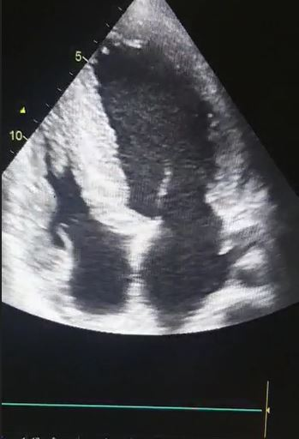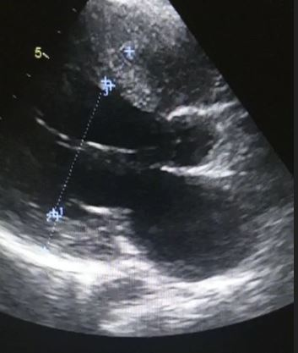  
**Figure 1 (left)** :transthoracic echocardiography at 4 cavity view showing the left ventricule dilatation   
**Figure 2 (right)**: septal thickness at 17mm and inferior wall thickness at 18mm

Cardiac MRI demonstrated Moderate hypertrophic cardiomyopathy at the stage of diffuse myocardial fibrosis of the left ventricle, with involvement of 80% of the myocardium, associated with right ventricular hypertrophy with moderate fibrosis, and right ventricular longitudinal dysfunction. LVEF: 13.3%, RVEF: 25%, with right ventricular dilation. Advanced Fabry disease is suspected due to the young age, moderate LV hypertrophy, predominance of dense intramyocardial fibrosis zones, involvement of the RV and papillary muscles. Enzymatic assays of alpha-galactosidase dosageconfirmed the diagnosis of Fabry disease.(figure 3)

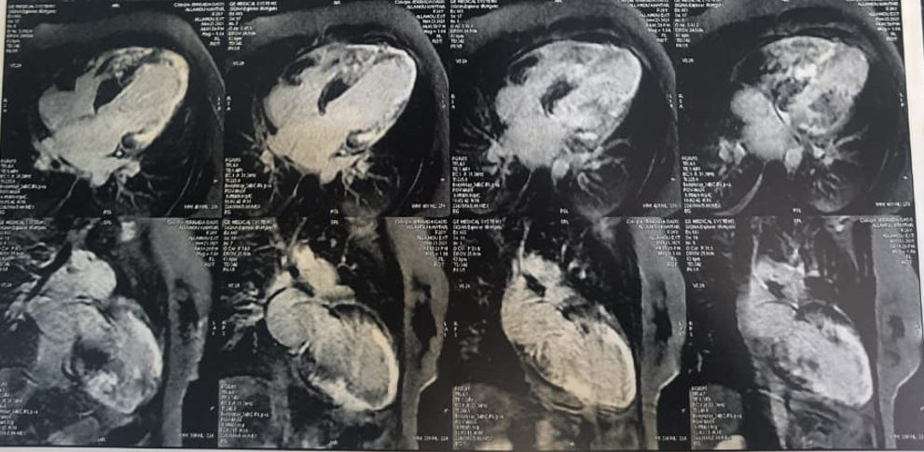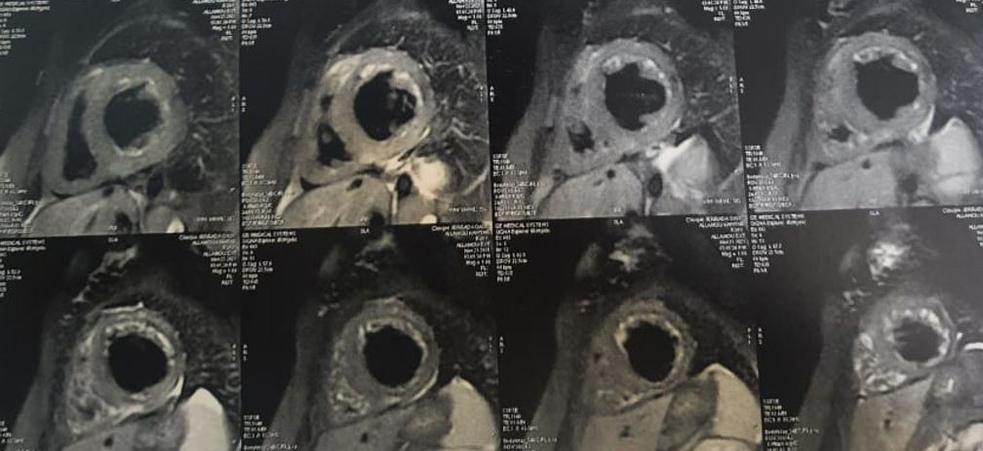

Figure 3: Cardiac MRI with Late gadolinium enhancement shows diffuse myocardial hypersignal in the hypertrophic walls, suggesting the presence of fibrosis."

The Laboratory tests showed a Hemoglobin: 10.4 g/dL ,Leukocytosis: 12,300/mm³,Platelets: 160,050/mm³ ,Impaired renal function: urea 0.51 g/L, creatinine 16.2 mg/L ,Inflammatory markers: CRP 131 mg/L, fibrinogen 5 g/l,Normal liver function .It also showed elevated brain natriuretic peptide indicating heart failure.

The patient was managed with intravenous diuretics and heart failure therapy but she rapidly developed atrial fibrillation, which worsened her clinical condition and she developed a cardiogenic choc with a ventricular fibrillation; and despite aggressive management she succumbed to her illness shortly thereafter.

**Discussion**

This case highlights the diagnostic challenge of fabry disease and the importance of the early diagnosis to avoid the dramatic death of young patients, particularly in female patients where the phenotype may be less typical and the diagnosis is often delayed. In Fabry disease, cardiac involvement can manifest as left ventricular hypertrophy (LVH), often concentric and accompanied by myocardial fibrosis, conduction abnormalities, and arrhythmias [1,2].

The presentation of our patient as a Hypertrophic cardiomyopathy at the stage of dilation and severe biventricular dysfunction is not that frequent with the Fabry disease.

In women, the presentation may be subtle due to X-chromosome inactivation, leading to heterogeneous clinical expression. This often results in delayed diagnosis until advanced stages when irreversible myocardial damage has occurred [3].

Cardiac magnetic resonance imaging (MRI) is a key modality in the diagnostic workup of Fabry cardiomyopathy, offering both anatomical and tissue characterization. Late gadolinium enhancement (LGE) commonly shows mid-wall fibrosis in the basal inferolateral wall, a hallmark pattern that may appear before systolic dysfunction [4,5].

Native T1 mapping is particularly useful, as early-stage Fabry disease presents with low native T1 values due to intracellular accumulation of glycosphingolipids (Gb3) in cardiomyocytes [6,7]. In advanced stages, T1 values may pseudo-normalize or increase as fibrosis develops, making interpretation more challenging [6,8].

T2 mapping can offer complementary information, especially in detecting myocardial edema or inflammation in patients with acute or advanced disease, though it is less specific [9].

These advanced MRI techniques improve the ability to differentiate Fabry cardiomyopathy from other hypertrophic phenotypes. When characteristic findings—such as inferolateral LGE and low native T1—are present, clinicians should proceed with confirmatory testing, including α-galactosidase A activity (especially in males) and GLA gene analysis (especially important in females, who may have normal enzyme levels). Early diagnosis is essential for initiating enzyme replacement or chaperone therapy, which can improve cardiac outcomes [10,11].

Enzyme replacement therapy (ERT) has been shown to reduce cardiac mass and delay disease progression, but it is most effective when initiated before extensive fibrosis has developed [12]. In our patient, diagnosis occurred at an advanced stage, highlighting the need for earlier clinical suspicion and intervention.

Atrial fibrillation is a recognized complication in Fabry disease, associated with poor prognosis and increased risk of thromboembolic events [13]. The arrhythmogenic substrate is likely due to progressive fibrosis, left atrial dilation, and autonomic dysfunction. Management of arrhythmias in Fabry patients should be proactive, and early initiation of anticoagulation and rhythm control may improve outcomes.

In the context of **Fabry cardiomyopathy**, **cardiac biomarkers** such as **high-sensitivity cardiac troponins (hs-cTn)** and **natriuretic peptides (BNP or NT-proBNP)** have emerged as important tools for **risk stratification** and **prognosis**. Persistently **elevated troponin levels** may reflect ongoing low-grade myocardial injury or inflammation and are frequently observed in patients with advanced cardiac involvement, even in the absence of acute coronary syndromes [14]. Similarly, **elevated natriuretic peptides** correlate with diastolic dysfunction, increased filling pressures, and overall **disease severity**. Both biomarkers have been shown to correlate with **extent of late gadolinium enhancement (LGE)** on cardiac MRI, left ventricular mass index, and functional capacity, making them useful for **monitoring progression** and predicting **adverse cardiovascular outcomes** [15,16].

This case also emphasizes the importance of multidisciplinary care. In young patients with unexplained heart failure and LVH, a high index of suspicion for metabolic or infiltrative diseases such as Fabry should be maintained. Early recognition and diagnosis not only improve outcomes but may also allow for family screening and genetic counseling.

**Conclusion**

In young patients presenting with unexplained cardiomyopathy and heart failure, Fabry disease should be considered as a differential diagnosis. Advanced imaging modalities and enzymatic assays are essential for accurate diagnosis, which is critical for timely initiation of disease-specific therapies. This case underscores the potentially fatal consequences of delayed diagnosis and the importance of multidisciplinary evaluation.

**Declarations**

Consent for publication: Written informed consent was obtained from the patients for publication of this case  
report and any accompanying images.

**Availability of data and material**: All data generated or analysed during this study are included in this  
published article.

Disclaimer (Artificial intelligence)

Option 1:

Author(s) hereby declare that NO generative AI technologies such as Large Language Models (ChatGPT, COPILOT, etc.) and text-to-image generators have been used during the writing or editing of this manuscript.

Option 2:

Author(s) hereby declare that generative AI technologies such as Large Language Models, etc. have been used during the writing or editing of manuscripts. This explanation will include the name, version, model, and source of the generative AI technology and as well as all input prompts provided to the generative AI technology

Details of the AI usage are given below:

1.

2.

3.

**References**

1. Linhart A, Elliott PM. The heart in Anderson-Fabry disease and other lysosomal storage disorders. Heart. 2007;93(4):528-535.
2. Nordin S, Kozor R, Bulluck H, et al. Cardiac Fabry disease with late gadolinium enhancement is a chronic inflammatory cardiomyopathy. J Am Coll Cardiol. 2016;68(15):1705-1707.
3. *Germain DP. Fabry disease. Orphanet J Rare Dis. 2010;5:30.*
4. Pica S, Sado DM, Maestrini V, et al. Reversibility of cardiac involvement in Anderson-Fabry disease with enzyme replacement therapy: insights from cardiovascular magnetic resonance. *Heart*. 2014;100(8):647-652. doi:10.1136/heartjnl-2013-304896
5. Moon JC, Sachdev B, Elkington AG, et al. Gadolinium enhanced cardiovascular magnetic resonance in Anderson–Fabry disease: evidence for a disease specific abnormality of the myocardium. *J Cardiovasc Magn Reson*. 2003;5(3):491–497. doi:10.1016/S1097-6647(03)00121-2
6. Sado DM, White SK, Piechnik SK, et al. Identification and assessment of Anderson–Fabry disease by cardiovascular magnetic resonance noncontrast myocardial T1 mapping. *Circ Cardiovasc Imaging*. 2013;6(3):392-398. doi:10.1161/CIRCIMAGING.112.000070
7. Nordin S, Kozor R, Medina-Menacho K, et al. Proposed stages of myocardial phenotype development in Fabry disease. *JACC Cardiovasc Imaging*. 2019;12(8 Pt 2):1673–1683. doi:10.1016/j.jcmg.2018.07.021
8. Pica S, Chamieh J, Karam N, et al. Myocardial native T1 mapping in patients with Anderson-Fabry disease: relationship to enzyme replacement therapy. *JACC Cardiovasc Imaging*. 2020;13(6):1325-1327. doi:10.1016/j.jcmg.2019.01.047
9. Sado DM, White SK, Fontana M, et al. T1 mapping for myocardial extracellular volume measurement by CMR: bolus only versus primed infusion technique. *JACC Cardiovasc Imaging*. 2013;6(9):955–962. doi:10.1016/j.jcmg.2013.01.016
10. Germain DP, Elliott PM, Falissard B, et al. The effect of enzyme replacement therapy on clinical outcomes in male patients with Fabry disease: a systematic literature review by a European panel of experts. *Mol Genet Metab*. 2019;126(3):224-235. doi:10.1016/j.ymgme.2018.12.007
11. Ortiz A, Germain DP, Desnick RJ, et al. Fabry disease revisited: management and treatment recommendations for adult patients. *Mol Genet Metab*. 2018;123(4):416-427. doi:10.1016/j.ymgme.2018.02.014
12. Weidemann F, Niemann M, Breunig F, et al. Long-term effects of enzyme replacement therapy on Fabry cardiomyopathy: evidence for a better outcome with early treatment. Circulation. 2009;119(4):524-529.
13. Patel MR, Cecchi F, Cizmarik M, et al. Cardiovascular events in patients with Fabry disease: natural history data from the Fabry Registry. J Am Coll Cardiol. 2011;57(9):1093-1099
14. Lenders M et al. Serum troponin T, a valuable biomarker in Fabry disease. Mol Genet Metab. 2016;119(3):312–317.
15. Weidemann F et al. BNP predicts disease severity in Fabry cardiomyopathy. J Am Soc Echocardiogr. 2013;26(7):766–773.
16. Krämer J et al. Usefulness of troponin and NT-proBNP to detect early myocardial damage in Fabry disease. Heart. 2013;99(9):689–695.