*Case report*

**Cardiac Sarcoidosis Leading to Restrictive Cardiomyopathy: A Case Report of Fatal Ventricular Fibrillation in a 45-year-old Male**

ABSTRACT

|  |
| --- |
| **Cardiac sarcoidosis is a rare but serious manifestation of systemic sarcoidosis, affecting the heart muscle and leading to significant morbidity and mortality. We report the case of a 45-year-old male with a decade-long history of systemic sarcoidosis, who was admitted with symptoms of global heart failure. Diagnostic evaluation included cardiac magnetic resonance imaging (MRI) and Holter monitoring, which revealed myocardial inflammation and arrhythmias. Despite medical management, his condition deteriorated, culminating in fatal ventricular fibrillation. This case underscores the challenges in diagnosing and managing cardiac sarcoidosis, the progression to restrictive cardiomyopathy, and the critical importance of early detection and risk stratification to prevent fatal arrhythmias.** |

**Keywords : Sarcoidosis, restrictive cardiomyopathy, Heart failure.**

**Abbreviations:**

MRI : Magnetic resonance imaging,

LVEF : left ventricular ejection fraction,

FDG PET :Fluorodésoxyglucose positron emission tomography,

LGE: Late gadolinium enhancement.

**Introduction**

Sarcoidosis is a systemic inflammatory disease characterized by the presence of non-caseating epithelioid and giant cell granulomas, predominantly affecting the lungs [7,8]. However, cardiac involvement remains rare, with a prevalence of 5 to 10% among patients with sarcoidosis. Its clinical presentation is polymorphic, typically manifesting as rhythm disturbances or cardiomyopathy with heart failure. Nevertheless, advances in imaging techniques such as cardiac MRI and ¹⁸FDG PET scans have improved diagnostic accuracy.

**Cardiac sarcoidosis** can affect any part of the heart, with the myocardium being the most frequently involved site. The cardiac manifestations vary widely, ranging from asymptomatic conduction abnormalities to severe **heart failure** and **life-threatening arrhythmias [9,10]**.  
In this report, we present a case of a 45-year-old male with a 10-year history of systemic sarcoidosis, progressing to **restrictive cardiomyopathy** and global heart failure, who ultimately died from **ventricular fibrillation**. This case illustrates the lethal potential of cardiac sarcoidosis and the challenges in managing this rare condition.

**Case Presentation**

We report the case of a 45-year-old male, a former smoker who quit 5 years ago, previously diagnosed with thoracic sarcoidosis (without documented evidence) and confirmed cardiac involvement on cardiac MRI.

The patient was admitted to the intensive care unit for global heart failure. The illness began about a month prior with progressive dyspnea and lower limb edema, in an afebrile context with general health deterioration. Upon admission, the clinical examination found the patient to be orthopneic, without chest pain, eupneic at rest, but with exertional fatigue. Hemodynamically, he was stable with a blood pressure of 100/50 mmHg, heart rate of 86 bpm, respiratory rate of 40 breaths/min, oxygen saturation at 94% on room air, and temperature of 37.5°C.  
The **ECG** showed sinus tachycardia at 115 bpm, a right bundle branch block (RBBB), and secondary repolarization abnormalities. *(Figure 1)*. **Chest X-ray**: Demonstrated cardiomegaly with pulmonary congestion.**Holter monitoring**: Detected non-sustained ventricular tachycardia (VT) episodes.

**Echocardiography** revealed features suggestive of restrictive cardiomyopathy with severe biventricular dysfunction. The left ventricle showed moderate hypertrophy and global hypokinesia with an ejection fraction (LVEF) of 20%. The right ventricle had impaired longitudinal systolic function. There was significant biatrial dilation, elevated right atrial pressures, and circumferential pericardial effusion. *(Figure 2)*

**Cardiac MRI** showed a normal-sized left ventricle with moderate systolic dysfunction and moderate septal hypertrophy. There was subepicardial late gadolinium enhancement in the septal and inferoapical regions, suggestive of a systemic disease such as sarcoidosis. The right ventricle was dilated with impaired function and biatrial dilation. *(Figure 3)*

**Coronary angiography** was also performed and was normal.  
**Abdominal ultrasound** revealed ascites, and thoracic ultrasound showed bilateral pleural effusion.

**Laboratory tests** showed a Hemoglobin: 11.4 g/dL (normal) ,Leukocytosis: 12,300/mm³ (neutrophil predominant) ,Platelets: 160,050/mm³ (normal),Impaired renal function: urea 0.51 g/L, creatinine 16.2 mg/L (estimated GFR 33 ml/min) ,Inflammatory markers: CRP 131 mg/L, fibrinogen 5 g/l,Normal protein electrophoresis ,Normal liver function .   
it also showed elevated **brain natriuretic peptide** indicating heart failure. An **endomyocardial biopsy** was not performed due to the high risk of complications.

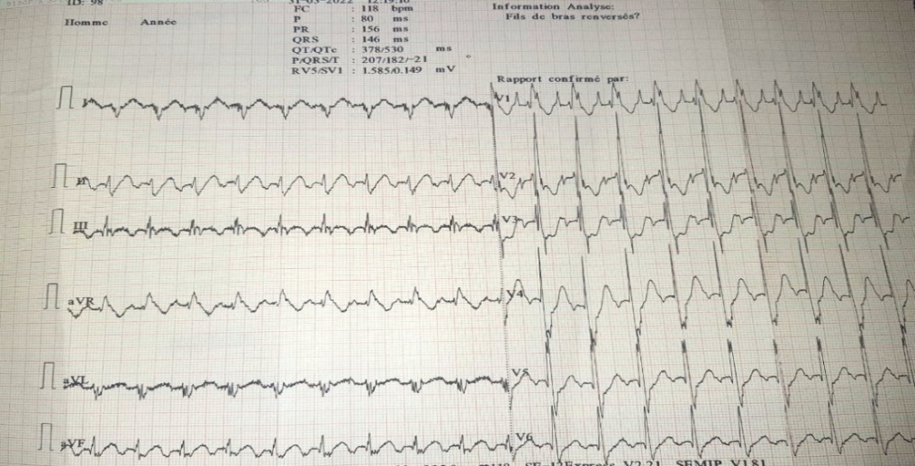

**Figure1 : electrocardiogram showing a right bundal block**

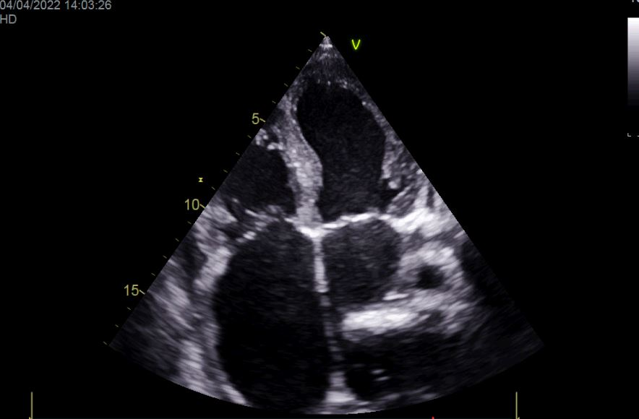

**Figure 2 : transthoracic echocardiography showing the important dilatation of both atriums and the septal moderate hypertrophy**

**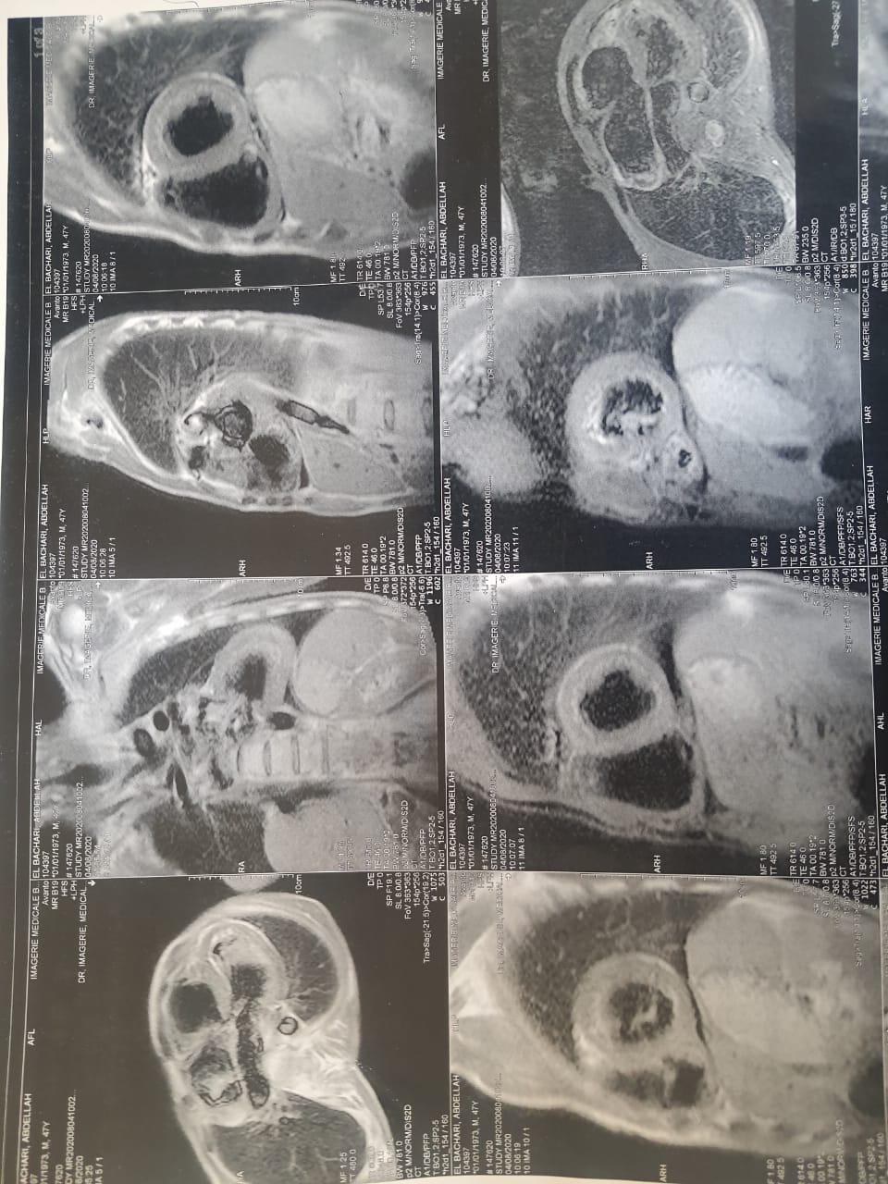  
Figure 3 : Cardiac MRI showing the gadolinium late enhancement in the septal and inferoapical regions**

The patient was diagnosed with **cardiac sarcoidosis**, leading to **restrictive cardiomyopathy** and **global heart failure**. The chronic sarcoid granulomatous infiltration had resulted in extensive myocardial fibrosis, severely compromising the heart's function.

The patient was managed with Intravenous diuretics for volume overload ACE inhibitors and beta-blockers to manage heart failure amiodarone to prevent further ventricular arrhythmias corticosteroid therapy was continued for sarcoidosis, with plans to increase the dose if the cardiac sarcoidosis worsened , a defibrillatorwas considered for secondary prevention of sudden cardiac death but could not be implanted due to the patient’s worsening condition.

Despite aggressive treatment, the patient’s condition deteriorated. Over the course of his hospitalization, he developed worsening **hypotension** and **tachyarrhythmias**, culminating in an episode of **ventricular fibrillation**. Resuscitation efforts were unsuccessful, and the patient died of sudden cardiac arrest.

**Discussion:**

Cardiac sarcoidosis is defined by heterogeneous infiltration of the myocardium by non-caseating epithelioid and giant cell granulomas. This infiltration leads to irreversible myocardial fibrosis due to local ischemic phenomena and the release of inflammatory mediators. [1]

The prevalence of cardiac involvement in sarcoidosis varies widely across studies, ranging from 2% to 75%, depending on the diagnostic criteria used. There is a slight female predominance. [2] This variability is largely due to differences in detection methods and the populations studied. Clinically, cardiac sarcoidosis may be asymptomatic and incidentally discovered through histological or imaging examinations. Alternatively, it may manifest as rhythm disturbances, conduction abnormalities, or heart failure. Notably, granulomatous infiltration tends to involve the free wall of the left ventricle, the interventricular septum, and the cardiac conduction pathways, frequently resulting in atrioventricular blocks. [3][4]  
  
The diagnosis of cardiac sarcoidosis relies on a combination of clinical assessment, electrocardiography, and imaging techniques. Cardiac magnetic resonance imaging (MRI) and ¹⁸FDG positron emission tomography (PET) have revolutionized the detection of inflammatory myocardial lesions, enabling more precise identification of affected areas. These imaging modalities are especially valuable for assessing inflammatory activity and the extent of myocardial fibrosis. [1]

Our case highlights the severe end of the spectrum, where longstanding granulomatous infiltration led to the development of restrictive cardiomyopathy, a condition characterized by impaired diastolic filling and progressive heart failure.

### **Diagnostic Criteria for Cardiac Sarcoidosis**

There are two ways to diagnose cardiac sarcoidosis:

#### 1. Histological Diagnosis Based on Myocardial Biopsy

The diagnosis is confirmed when non-caseating granulomas are found on histological analysis of myocardial tissue, and no other identifiable cause is present (especially infectious causes).

#### 2. Clinical Diagnosis: Cardiac Sarcoidosis Is Considered Probable If:

There is histological evidence of extracardiac sarcoidosis  
And at least one of the following conditions:

* Cardiomyopathy or conduction block that responds to corticosteroids or immunosuppressive therapy
* Unexplained reduction in left ventricular ejection fraction (LVEF < 40%)
* Unexplained sustained ventricular tachycardia (spontaneous or induced)
* Second-degree Mobitz II or third-degree atrioventricular (AV) block
* Abnormal cardiac uptake compatible with findings on a dedicated ¹⁸FDG PET scan
* Late gadolinium enhancement (LGE) on cardiac MRI with a compatible pattern
* Cardiac uptake with a compatible pattern on gallium scintigraphy

After reasonably excluding other cardiac causes.

Cardiac involvement accounts for **13% to 25%** of all sarcoidosis-related deaths. In Japan, this figure is significantly higher, reaching up to **58%**, highlighting the severity of this complication in certain populations. [5]

### **Prognostic Factors in Cardiac Sarcoidosis [6]**

* NYHA functional class
* Presence of clinical signs of heart failure
* Presence of sustained ventricular tachycardia (VT)
* Left ventricular end-diastolic diameter
* LVEF < 35%
* Presence and extent of late gadolinium enhancement (LGE) on cardiac MRI
* Presence of biventricular LGE (in both left and right ventricles)
* Extent and intensity of myocardial ¹⁸FDG uptake on cardiac PET

### **Therapeutic Strategies**

The treatment of cardiac sarcoidosis is not yet well standardized due to the lack of randomized controlled trials.  
Corticosteroids are generally the **cornerstone of therapy**, particularly in cases with AV block or mild to moderate left ventricular dysfunction. However, treatment response is variable, and the optimal duration of corticosteroid therapy remains unclear.

**Immunosuppressive agents**, such as methotrexate or synthetic antimalarials, are sometimes considered, though their efficacy is not firmly established. In refractory cases, **anti-TNF-α agents** have shown potential benefits.

Moreover, **risk stratification for arrhythmias** is crucial. Implantable cardioverter-defibrillators (ICDs) may be considered for patients at high risk of malignant ventricular arrhythmias.

### **Conclusion**

Cardiac sarcoidosis remains a serious and potentially life-threatening complication of systemic sarcoidosis. It requires heightened diagnostic vigilance and individualized therapeutic management.  
Advances in cardiac imaging have significantly improved the detection of myocardial involvement, but further studies are needed to optimize treatment strategies and improve the prognosis for affected patients.

**Declarations**

**Ethical Approval:**

**As per international standards or university standards written ethical approval has been collected and preserved by the author(s).**

**Consent :** Written informed consent was obtained from the patients for publication of this case report and any accompanying images.

**Availability of data and material:** All data generated or analysed during this study are included in this published article.

**Competing interests:** The authors declare that they have no competing interests.

Disclaimer (Artificial intelligence)

Option 1:

Author(s) hereby declare that NO generative AI technologies such as Large Language Models (ChatGPT, COPILOT, etc.) and text-to-image generators have been used during the writing or editing of this manuscript.

Option 2:

Author(s) hereby declare that generative AI technologies such as Large Language Models, etc. have been used during the writing or editing of manuscripts. This explanation will include the name, version, model, and source of the generative AI technology and as well as all input prompts provided to the generative AI technology

Details of the AI usage are given below:

1.

2.

3.

**Références**

[1] R. Blankstein*et al.*[Cardiac positron emissiontomographyenhancesprognosticassessments of patients with suspected cardiac sarcoidosis](https://www.sciencedirect.com/science/article/pii/S0735109713054557)J Am CollCardiol.

[2]ipek E, demirelli S, ermis S, incisarcoidosis and the heart: review of the literature. intractable rare dis res2015;4(4):170-80.

[[3][Venkata Satish Pendela](https://pubmed.ncbi.nlm.nih.gov/?term=Pendela+VS&cauthor_id=34113762) [1](https://pubmed.ncbi.nlm.nih.gov/34113762/#full-view-affiliation-1), [Pujitha Kudaravalli](https://pubmed.ncbi.nlm.nih.gov/?term=Kudaravalli+P&cauthor_id=34113762) [2](https://pubmed.ncbi.nlm.nih.gov/34113762/#full-view-affiliation-2), [Scott Feitell](https://pubmed.ncbi.nlm.nih.gov/?term=Feitell+S&cauthor_id=34113762) [3](https://pubmed.ncbi.nlm.nih.gov/34113762/#full-view-affiliation-3), [Vishal Parikh](https://pubmed.ncbi.nlm.nih.gov/?term=Parikh+V&cauthor_id=34113762) [3](https://pubmed.ncbi.nlm.nih.gov/34113762/#full-view-affiliation-3)Cardiac sarcoidosismasquerading as arrhythmogenic right ventricularcardiomyopathy](https://www.sciencedirect.com/science/article/pii/S1443950611010961) : a case report Eur Heart J Case Rep  doi: 10.1093/ehjcr/ytab072.

[4][Fabio Tavora](https://pubmed.ncbi.nlm.nih.gov/?term=Tavora+F&cauthor_id=19660614) [1](https://pubmed.ncbi.nlm.nih.gov/19660614/#full-view-affiliation-1), [Nathaniel Cresswell](https://pubmed.ncbi.nlm.nih.gov/?term=Cresswell+N&cauthor_id=19660614), [Ling Li](https://pubmed.ncbi.nlm.nih.gov/?term=Li+L&cauthor_id=19660614), [Mary Ripple](https://pubmed.ncbi.nlm.nih.gov/?term=Ripple+M&cauthor_id=19660614), [Carol Solomon](https://pubmed.ncbi.nlm.nih.gov/?term=Solomon+C&cauthor_id=19660614), [Allen Burke](https://pubmed.ncbi.nlm.nih.gov/?term=Burke+A&cauthor_id=19660614)[Comparison of necropsyfindings in patients with sarcoidosisdyingsuddenlyfrom cardiac sarcoidosis versus dyingsuddenlyfromother causes](https://www.sciencedirect.com/science/article/pii/S0002914909009242) Am J Cardiol 2009 Aug 15;104(4):571-7.doi: 10.1016/j.amjcard.2009.03.068. Epub 2009 Jun 18.

[5]HilarioNUNES(1,2) et coll.*, Service de pneumologie, Centre de référence des maladies pulmonaires rares (site constitutif) et Centre de compétences des maladies systémiques et auto-immunes rares, Hôpital Avicenne, AP-HP, Bobign.

[6] A.M. Freeman*et al.*[Predictors of cardiac sarcoidosis usingcommonlyavailable cardiac studies](https://www.sciencedirect.com/science/article/pii/S0002914913008230) Am J Cardiol (2013)

7. Rapezzi, C., Aimo, A., Barison, A., Emdin, M., Porcari, A., Linhart, A., ... & Sinagra, G. (2022). Restrictive cardiomyopathy: definition and diagnosis. European heart journal, 43(45), 4679-4693.

8. Nihoyannopoulos, P., & Dawson, D. (2009). Restrictive cardiomyopathies. European Journal of Echocardiography, 10(8), iii23-iii33.

9. Trivieri, M. G., Spagnolo, P., Birnie, D., Liu, P., Drake, W., Kovacic, J. C., ... & Judson, M. A. (2020). Challenges in cardiac and pulmonary sarcoidosis: JACC state-of-the-art review. Journal of the American College of Cardiology, 76(16), 1878-1901.

10. Pereira, N. L., Grogan, M., & Dec, G. W. (2018). Spectrum of restrictive and infiltrative cardiomyopathies: part 2 of a 2-part series. Journal of the American College of Cardiology, 71(10), 1149-1166.