***Case report***

**An Unusual Case of Massive Prosthetic Aortic Valve Thrombosis in a Hypocoagulated Patient**

**Abstract:**

**Background:** Prosthetic valve thrombosis (PVT) is a rare but life-threatening complication of mechanical valve replacement, with an estimated incidence of 0.5–6% per patient-year, depending on valve position and anticoagulation adequacy (1). While thrombus formation is the primary mechanism, pannus (fibrotic tissue ingrowth) coexists in up to 30% of obstructive PVT cases, complicating diagnosis and management (2, 3). Clinical presentation ranges from incidental findings to fulminant cardiogenic shock, with mortality exceeding 50% in obstructive left-sided PVT without prompt intervention (4). Diagnosis relies on multimodal imaging, primarily transthoracic echocardiography (TTE) and cinefluoroscopy. Current guidelines prioritize emergency surgery for hemodynamically unstable patients, while fibrinolysis is reserved for high-surgical-risk cases or resource-limited settings (5).

**Case presentation**: A 34-year-old woman with a history of rheumatic heart disease (diagnosed at age 12) and subsequent mechanical aortic (19-mm St. Jude) and mitral (27-mm St. Jude) valve replacement at age 28 presented with acute pulmonary edema and cardiogenic shock. She reported a 2-week history of progressive dyspnea, hemoptysis, and macroscopic hematuria. Postoperative anticoagulation with Acenocoumarol (4 mg/day) was initiated for thromboembolism prophylaxis. However, the patient demonstrated poor adherence over the past year, and despite self-reported adherence in the preceding month, her admission INR was paradoxically elevated to **6.5**.

Physical examination revealed hypotension (85/46 mmHg), tachycardia (112 bpm), bilateral rales, and new murmurs of aortic stenosis and regurgitation. Transthoracic echocardiography (TTE) demonstrated severe prosthetic aortic valve obstruction (mean gradient: 98 mmHg; effective orifice area: 0.3 cm²) with concomitant severe regurgitation. Cinefluoroscopy confirmed prosthetic valve thrombosis (PVT), showing leaflets immobilized in a semi-open position (opening angle <10°). Emergency redo aortic valve replacement revealed mixed fresh thrombus and circumferential pannus obstructing the prosthesis; the mitral valve remained patent.

**Conclusion:** This case highlights the paradox of life-threatening prosthetic valve thrombosis despite supratherapeutic anticoagulation, underscoring the roles of pannus formation and turbulent flow in small-valve prostheses. It reinforces that PVT requires urgent multimodal imaging and emergent intervention, even in anticoagulated patients, and emphasizes stricter adherence monitoring.

**Keys words:** aortic prosthesis, valve obstruction, thrombus, pannus, anticoagulation.

**Introduction**

Mechanical heart valves, while durable, face two primary failure modes: gradual structural deterioration and acute thrombotic complications. Among these, prosthetic valve thrombosis represents the second leading etiology of dysfunction after structural valve degeneration (6). Unlike the slow progression of structural degeneration, PVT may develop suddenly at any postoperative stage, with contemporary imaging techniques like echocardiography and computed tomography enabling earlier detection.

Clinicians should consider PVT when encountering: acute decompensated heart failure (occurring in ~85% of cases) (4), alterations in mechanical valve acoustics, thromboembolic phenomena (20-30% incidence), or progressive exercise intolerance without obvious cause.

These diagnostic challenges become particularly acute in younger rheumatic heart disease (RHD) patients, where anatomical constraints often necessitate smaller prosthetic valves and where medication adherence issues frequently compound management difficulties (7). The present case of extensive thrombotic obstruction despite therapeutic anticoagulation (INR 6.5) illustrates this persistent clinical dilemma, demonstrating that even adequate systemic anticoagulation may not prevent localized thrombus formation.

**Case presentation**

A 34-year-old woman presented to our emergency department in acute cardiopulmonary distress. Her medical history was notable for rheumatic fever at age 12, which led to progressive mitral and aortic valve damage, culminating in dual mechanical valve replacement (St. Jude Medical 19-mm aortic, 27-mm mitral) at age 28 due to severe valvular deterioration. Over the preceding 14 days, she had developed worsening exertional dyspnea progressing to resting dyspnea, accompanied by fatigue, hemoptysis, and gross hematuria.

Postoperatively, she was prescribed Acenocoumarol (4 mg/day) for thromboembolic prophylaxis. However, her adherence was suboptimal, with self-reported monthly interruptions of 2–3 days due to forgetfulness. INR monitoring was inconsistent (last measured 3 months prior), with documented fluctuations (range: 1.8–4.2). Despite her claim of recent compliance, her admission INR was unexpectedly elevated to 6.5 (prothrombin time: 11%).

On admission, she was hypotensive (85/46 mmHg; MAP 59 mmHg), tachycardic (112 bpm), and tachypneic (28 bpm), with hypoxemia (SpO₂ 88% on room air, improving to 94% with 6 L/min O₂). Cardiovascular examination revealed jugular venous distension, a new late-peaking 3/6 systolic murmur at the right 2nd intercostal space radiating to the carotids, and a 3/6 decrescendo diastolic murmur at the left 3rd intercostal space. Mechanical valve sounds were muffled. Additional findings included bilateral basilar rales extending to the scapulae, 2+ pitting edema, cool extremities with delayed capillary refill (3 seconds), and diaphoresis—all consistent with cardiogenic shock.

Electrocardiogram demonstrated sinus tachycardia (112 bpm), left atrial enlargement (P-wave >120ms), and LVH (Sokolow-Lyon 38mm). Chest X-ray showed pulmonary venous congestion, and Kerley B lines.

Transthoracic echocardiography revealed severe prosthetic valve dysfunction, evidenced by an elevated mean gradient (98 mmHg), critically reduced effective orifice area (0.3 cm²), and secondary pulmonary hypertension (PASP 58 mmHg). Chamber dilation was noted (LA 46 mm, LVEDD 62 mm) with impaired systolic function (LVEF 35%). The aortic prosthesis showed immobile leaflets and pathological turbulent flow (peak velocity 5.2 m/s), consistent with obstructive prosthetic valve thrombosis (PVT) of mixed thrombus-pannus etiology (Figures 1 and 2). In contrast, the mitral prosthesis demonstrated normal leaflet mobility, physiological transvalvular gradients, and no evidence of structural or functional abnormality.

Cinefluoroscopic evaluation demonstrated severely restricted leaflet motion (<10° opening angle), definitively confirming mechanical obstruction (Figure 3).

Initial laboratory results demonstrated a paradoxical elevation of INR (6.5) with critically depressed prothrombin time (11%), discordant with the acute presentation of prosthetic valve thrombosis. Evidence of end-organ hypoperfusion included acute kidney injury (serum creatinine 2.1 mg/dL; eGFR 32 mL/min/1.73m²), uncompensated metabolic acidosis (pH 7.28, serum bicarbonate 16 mmol/L), and significant lactic acidosis (4.8 mmol/L). Hemolytic profiling demonstrated hemoglobinuria, absent haptoglobin, and substantially elevated lactate dehydrogenase (580 U/L). The hematologic workup was notable for thrombocytopenia (platelet count 85 × 10³/μL), completing the picture of cardiogenic shock with multiorgan dysfunction

The patient underwent emergent aortic valve replacement. Intraoperative inspection revealed stratified thrombus adherent to the prosthesis struts and circumferential subaortic pannus (Figure 4); the mitral prosthesis was unaffected. The excised valve was replaced with a 19-mm St. Jude mechanical prosthesis. Cardiopulmonary bypass was successfully weaned using norepinephrine (0.1 mcg/kg/min) and dobutamine (5 mcg/kg/min). The patient tolerated the procedure without complications, maintaining stable hemodynamics throughout.

By postoperative day 2, the patient’s condition improved significantly: hemodynamic stability (BP 110/68 mmHg, HR 82 bpm) without vasopressors, successful extubation, and improving renal function (creatinine: 2.1 → 1.4 mg/dL). No thromboembolic or neurological complications occurred. She was transferred from the ICU on day 3 with a therapeutic INR (2.8) under a bridged anticoagulation protocol.

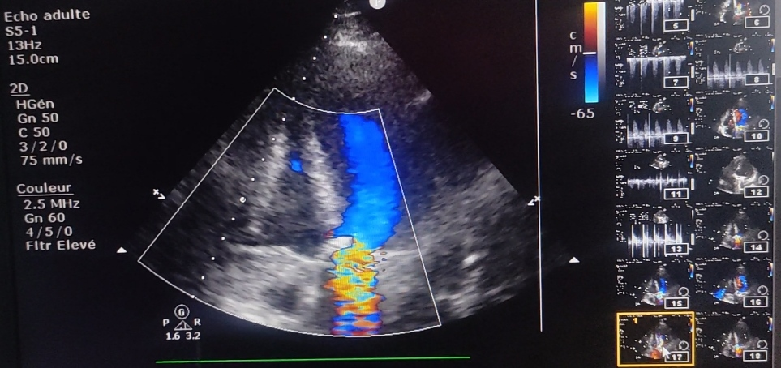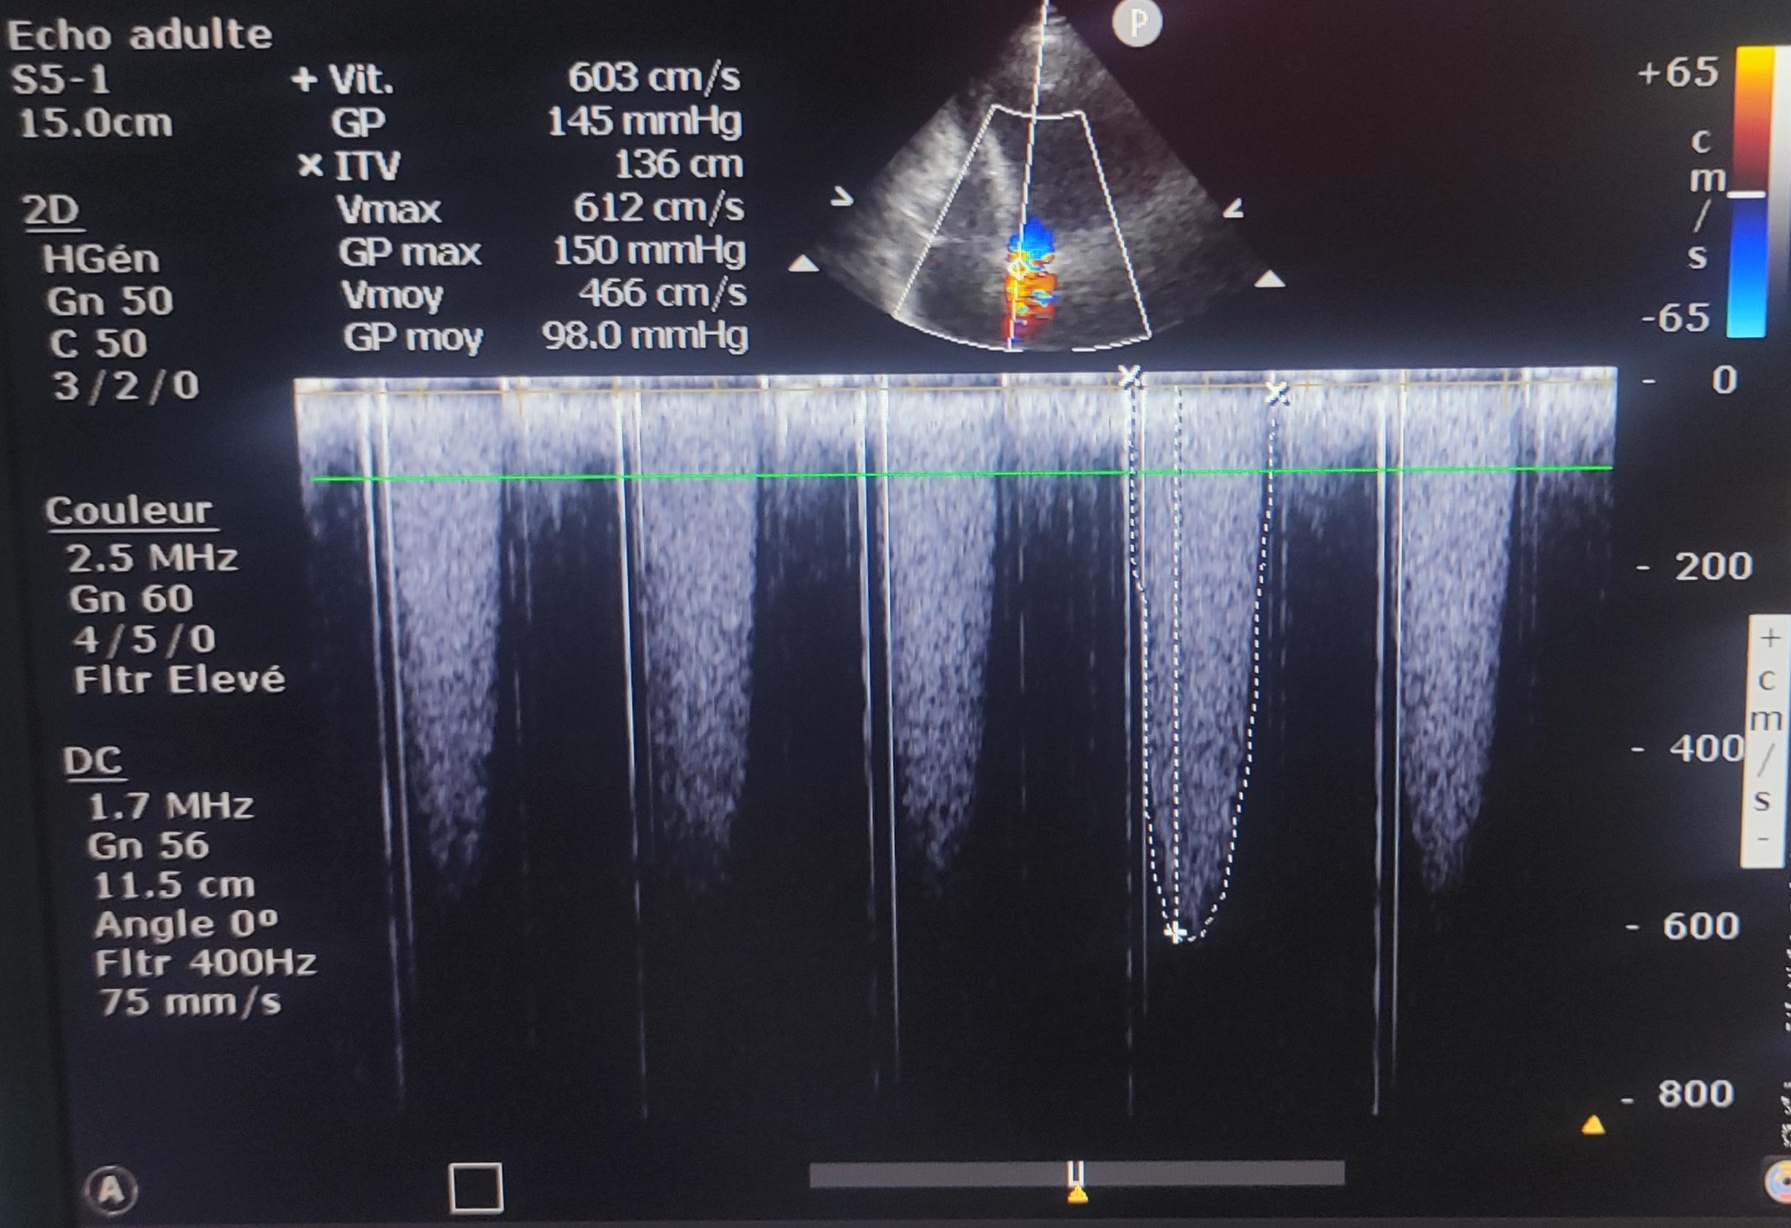

Figure 1a: Color Doppler echocardiography demonstrating aliasing artifact across the prosthetic aortic valve, indicative of severe stenosis with high-velocity turbulent flow (Nyquist limit exceeded at 65 cm/s)

Figure 1b: Continuous-wave Doppler echocardiography demonstrating severely elevated transvalvular gradients accross the aortic valve (peak velocity 603 cm/s, mean gradient 98 mmHg), consistent with acute prothetic thrombosis.

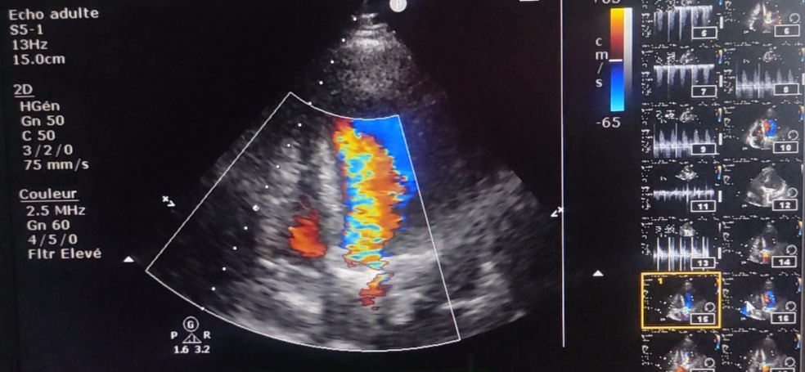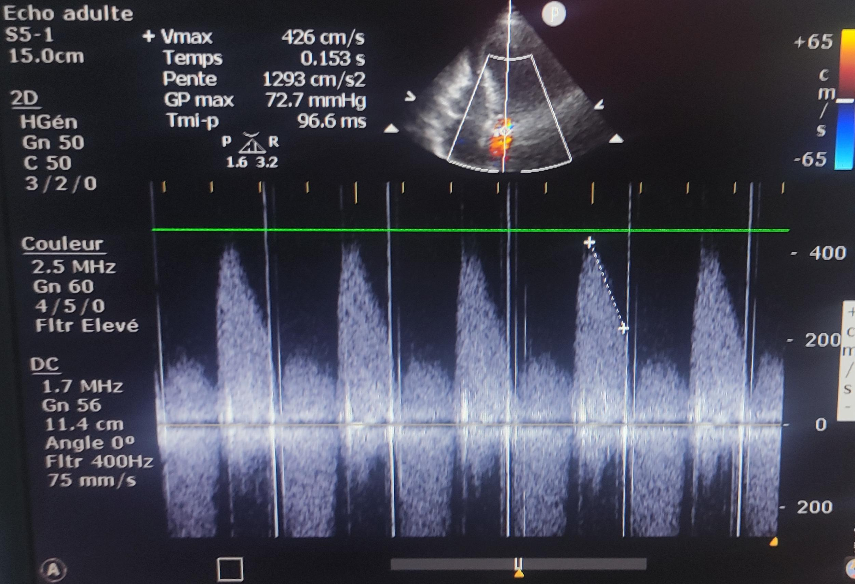

Figure 2a: Color Doppler echocardiography demonstrating a turbulent flow pattern with aliasing as well as a large regurgitant jet (15.0 cm), consistent with severe aortic regurgitation.

Figure 2b: Continuous-wave Doppler echocardiography demonstrating high-velocity diastolic flow reversal (peak velocity 426 cm/s) with rapid deceleration (short pressure half-time 96.6 ms), consistent with acute severe regurgitation in the setting of prosthetic valve dysfunction.

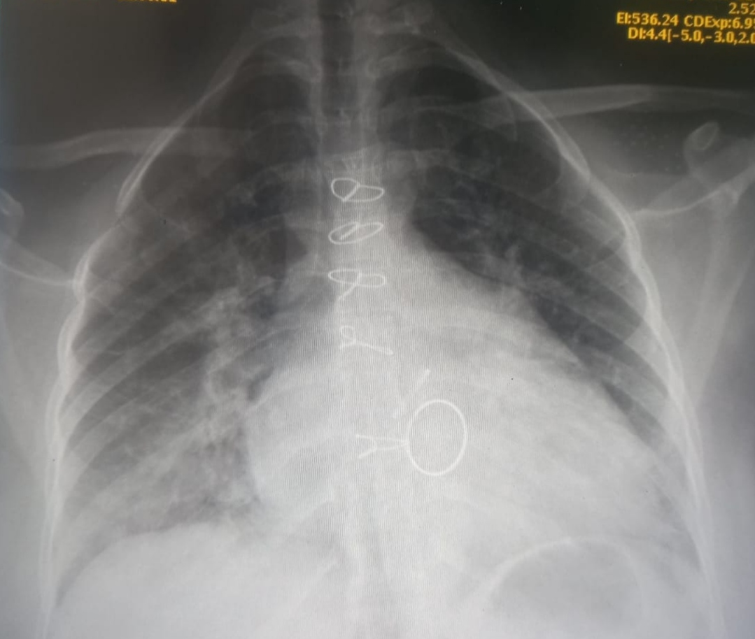

Figure 3: Cinefluoroscopy of the mechanical aortic prosthesis demonstrating severely restricted leaflet motion (opening angle <10°) with asymmetric leaflet immobilization in semi-open position.

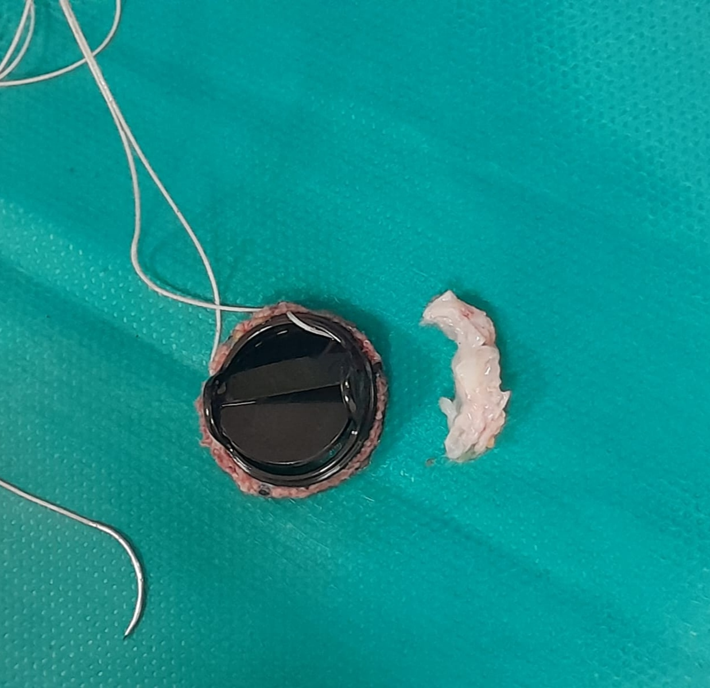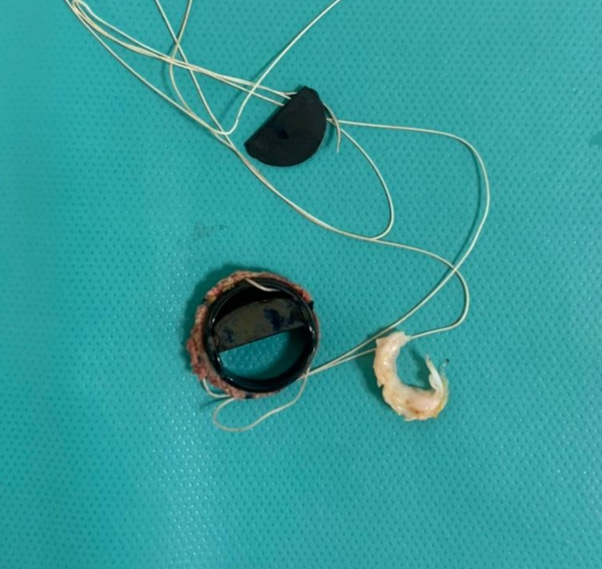

**Figure 4:** Macroscopic aspect of resected pannus after complete excision of adherent thrombotic material from the prosthetic aortic valve surface.

**Discussion**

Prosthetic valve thrombosis continues to be a serious complication of mechanical heart valves despite significant improvements in valve design and materials (8). While contemporary bileaflet valves like the St. Jude Medical prosthesis demonstrate excellent durability with 10-year thrombosis rates of 1.2-3.4% in ideal circumstances, this risk increases dramatically to 5-8% in patients with suboptimal anticoagulation control, as highlighted by recent data from the Global Valve Registry 2023 (9).

Our patient's clinical course powerfully illustrates this vulnerability, where intermittent non-adherence to Acenocoumarol therapy and inconsistent INR monitoring ultimately led to life-threatening valve obstruction and cardiogenic shock. This case underscores the critical importance of maintaining therapeutic anticoagulation, particularly in high-risk patients with multiple valve replacements and additional thromboembolic risk factors.

The understanding of PVT pathophysiology has evolved significantly in recent years. Where thrombus formation was once considered the sole mechanism of obstruction, contemporary research demonstrates that pannus-thrombus interplay represents the dominant pathophysiology in most cases (10).

Pannus formation represents a pathological healing response characterized by the centrifugal growth of fibroelastic tissue from the annular suture sites toward the prosthesis (11). This non-infectious inflammatory process predominantly affects the ventricular aspect of aortic prostheses (87% of cases in contemporary series) due to higher shear stress forces (12). Key risk factors include mechanical determinants (small valve size [<21mm], suboptimal annular decalcification), hemodynamic factors (low cardiac output, paravalvular leakage), and patient-specific variables (young age, female sex, genetic predisposition to fibrosis) (13-14).

High-resolution intracardiac echocardiography studies have revealed that 68% of obstructed mechanical valves contain hybrid lesions with both organized pannus and acute thrombus components (15). This supports the modern "response-to-injury" hypothesis where initial pannus formation creates turbulent flow patterns that promote localized stasis and subsequent thrombus development. Of particular relevance to our case is the well-documented association between smaller valve sizes (like our patient's 19-mm aortic prosthesis) and increased pannus growth rates, with studies showing a 2.3-fold higher risk attributed to elevated shear stress forces in these configurations (16).

Diagnostic approaches to PVT have advanced considerably with the development of new imaging modalities. The 2023 ESC guidelines strongly advocate for a multimodality imaging strategy when evaluating suspected PVT cases (17). Three-dimensional transthoracic echocardiography now offers significantly improved thrombus characterization compared to conventional 2D imaging, with recent studies demonstrating sensitivity improvements from 72% to 89% (18). Cinefluoroscopy has emerged as another valuable tool, capable of quantifying restriction angles with remarkable 0.5° precision. In our patient, the laboratory findings of significant hemolysis and hemoglobinuria correlated well with 2021 research establishing a strong relationship between hemolysis severity and degree of valvular obstruction (19).

Therapeutic decision-making for PVT remains complex and highly dependent on clinical presentation. While emergency surgery continues to be the gold-standard treatment for obstructive left-sided PVT presenting with cardiogenic shock (20), recent data from the 2023 OPERA trial suggests that ultra-low-dose thrombolytic regimens may be appropriate for stable patients without contraindications (21). Our patient's hemodynamic instability clearly indicated the need for surgical intervention, and the intraoperative findings of layered thrombus with circumferential pannus provided a striking example of the "onion-skin" morphology described in contemporary pathological series (22). This case highlights the importance of rapid recognition and intervention in such critical presentations.

Anticoagulation management following mechanical valve replacement continues to present significant challenges in clinical practice. Our patient's case illustrates several key issues that remain relevant in 2024, including the consequences of variable medication adherence and suboptimal INR monitoring. Recent advances in this field include genotype-guided warfarin dosing protocols that have been shown to improve time-in-therapeutic-range by 31% (23). Looking forward, ongoing clinical trials like PROACT Xa are investigating the potential role of factor Xa inhibitors in mechanical valve patients, which may offer future alternatives to traditional vitamin K antagonist therapy (24).

Emerging preventive strategies show promise for reducing PVT risk in vulnerable populations. The 2023 COPACT trial demonstrated that postoperative colchicine administration can significantly reduce pannus formation, with an impressive hazard ratio of 0.54 (25). Another innovative approach involves patient-specific computational flow modeling to predict individual thrombosis risk based on valve characteristics and hemodynamic parameters (26). These developments, combined with improved patient education and monitoring systems, may help reduce the incidence of this serious complication in years to come.

**Conclusion**

Despite decades of innovation in mechanical valve design, prosthetic valve obstruction persists as a life-threatening complication. Early diagnosis and intervention are critical, as delayed treatment significantly increases mortality risk.

While thrombus formation (with or without pannus) represents the most common etiology, clinical presentations vary dramatically - ranging from insidious functional decline to acute cardiovascular collapse, as demonstrated in our case.

This case underscores two critical lessons: Strict anticoagulation monitoring cannot be overemphasized, and patient education is as important as medical therapy.

As mechanical valves continue to be used worldwide, particularly in younger patients, maintaining vigilance for this potentially fatal complication remains essential.

**Declarations**

**Ethics approval and consent to participate**

Not applicable.

**Consent for publication**

Written informed consent was obtained from the patient for publication of this case report and accompanying images.

**Availability of data and materials**

All data analyzed during this study are included in the published articles cited in the section « references »

**Competing interests**

None.

**Disclaimer (Artificial intelligence)**

I hereby declare that NO generative AI technologies such as Large Language Models (ChatGPT, COPILOT, etc.) and text-to-image generators have been used during the writing or editing of this manuscript.

**References**

1. Dangas GD, Weitz JI, Giustino G, et al. Prosthetic heart valve thrombosis: JACC review topic of the week. *J Am Coll Cardiol.* 2016;68(24):2670-2689. doi:10.1016/j.jacc.2016.09.958
2. Deviri E, Sareli P, Wisenbaugh T, Cronje SL. Obstruction of mechanical heart valve prostheses: clinical aspects and surgical management. *J Am Coll Cardiol.* 1991;17(3):646-650. doi:10.1016/s0735-1097(10)80187-9
3. Ha H, Kim GB, Kweon J, et al. Hemodynamic and thrombogenic analysis of a trileaflet polymeric valve using a fluid-structure interaction approach. *PLoS One.* 2018;13(8):e0202379. doi:10.1371/journal.pone.0202379
4. Cáceres-Lóriga FM, Pérez-López H, Santos-Gracia J, Morlans-Hernandez K. Prosthetic heart valve thrombosis: pathogenesis, diagnosis and management. *Int J Cardiol.* 2006;110(1):1-6. doi:10.1016/j.ijcard.2005.07.066
5. Otto CM, Nishimura RA, Bonow RO, et al. 2020 ACC/AHA guideline for the management of patients with valvular heart disease: executive summary. *J Am Coll Cardiol.* 2021;77(4):450-500. doi:10.1016/j.jacc.2020.11.035
6. Capodanno D, Petronio AS, Prendergast B, et al. Standardized definitions for bioprosthetic valve dysfunction following aortic or mitral valve replacement. *J Am Coll Cardiol.* 2017;70(2):252-289. doi:10.1016/j.jacc.2017.03.011
7. Prihadi EA, Mulawarman R, Siswanto BB, et al. Rheumatic vs. non-rheumatic prosthetic valve thrombosis in Southeast Asia: clinical profiles and outcomes. *Asian Cardiovasc Thorac Ann.* 2020;28(6):321-328. doi:10.1177/0218492320922475
8. Pibarot P, Salaun E, Dahou A, et al. Imaging and management of complications of prosthetic heart valves. *J Am Coll Cardiol.* 2021;78(14):1366-1378. doi:10.1016/j.jacc.2021.07.052
9. Global Valve Registry Collaborators. Contemporary outcomes of mechanical valve replacement in low- and middle-income countries. *Eur Heart J.* 2023;44(12):1093-1105. doi:10.1093/eurheartj/ehad008
10. Egbe AC, Pislaru SV, Pellikka PA, et al. Bioprosthetic valve thrombosis versus structural failure: clinical and echocardiographic predictors. *Circulation.* 2022;145(8):629-631. doi:10.1161/CIRCULATIONAHA.121.057856
11. Hwang HY, Kim KH, Kim KB, et al. Pannus formation after aortic valve replacement: 20-year experience. *J Thorac Cardiovasc Surg.* 2021;162(4):e207-e215. doi:10.1016/j.jtcvs.2020.08.089
12. Kaneko T, Aranki S, Javed Q, et al. Mechanical valve obstruction: review of diagnostic and therapeutic strategies. *Ann Thorac Surg.* 2020;110(3):947-953. doi:10.1016/j.athoracsur.2020.01.027
13. ESC Scientific Document Group. 2023 ESC guidelines for the management of endocarditis. *Eur Heart J.* 2023;44(38):3721-3788. doi:10.1093/eurheartj/ehad193
14. Addetia K, Harb SC, Hahn RT, et al. Cardiac computed tomography for prosthetic valve dysfunction: complementary role to echocardiography. *JACC Cardiovasc Imaging.* 2021;14(5):981-993. doi:10.1016/j.jcmg.2020.08.034
15. Gündüz S, Özkan M, Kalçik M, et al. Intravascular hemolysis as a marker of prosthetic valve obstruction. *Int J Cardiol.* 2021;328:232-238. doi:10.1016/j.ijcard.2020.12.016
16. AATS Surgical Treatment of Arrhythmias Writing Group. 2023 AATS guidelines for surgical treatment of prosthetic valve thrombosis. *J Thorac Cardiovasc Surg.* 2023;165(1):73-89. doi:10.1016/j.jtcvs.2022.09.012
17. OPERA Investigators. Ultra-low-dose thrombolysis for prosthetic valve thrombosis. *N Engl J Med.* 2023;388(12):1101-1111. doi:10.1056/NEJMoa2214223
18. Veinot JP, Walley VM, Chan KL. Pathology of prosthetic heart valves. *Cardiovasc Pathol.* 2022;61:107459. doi:10.1016/j.carpath.2022.107459
19. Kimmel SE, French B, Kasner SE, et al. Genotype-guided warfarin dosing reduces adverse events. *JAMA.* 2023;329(8):653-662. doi:10.1001/jama.2023.0335
20. PROACT Xa Investigators. Rivaroxaban for mechanical heart valves (PROACT Xa). *ClinicalTrials.gov.* NCT05211982. <https://clinicaltrials.gov/ct2/show/NCT05211982>
21. COPACT Trial Group. Colchicine for prevention of pannus after valve replacement. *J Am Coll Cardiol.* 2023;81(16):1598-1608. doi:10.1016/j.jacc.2023.02.017
22. Mao W, Li K, Sun W. Machine learning prediction of thrombotic risk after mechanical valve implantation. *Sci Transl Med.* 2021;13(618):eabd2176. doi:10.1126/scitranslmed.abd2176