Case report

Acute Type A Aortic Dissection Revealing Undiagnosed Marfan Syndrome in a Young Patient: A Case Report

.
ABSTRACT

Aim & Background: Acute aortic dissection is a life-threatening cardiovascular emergency characterized by a tear in the aortic intima, allowing the entry of blood to the medial layer and the creation of a false lumen. In young patients, underlying connective tissue disorders such as Marfan syndrome are significant risk factors . The diagnosis should be suggested in the presence of suggestive skeletal features , ocular manifestations and cardiovascular abnormalities.
Case Description:
We report a case of a 41-year-old male with a history of a drained spontaneous pneumothorax and an operated retinal detachment, presenting with exertional dyspnea and retrosternal chest pain . Clinical examination showed a normal heart rate with an asymmetrical arterial blood pressure , a diastolic murmur in the aortic area , associated with signs of congestive left heart failure . Vascular auscultation also showed added carotid murmur and abdominal murmur. Femoral pulses were decreased without signs of peripheric hypoperfusion. There were no neurological signs. Transthoracic echocardiography revealed a Stanford type A aortic dissection extending from the ascending aorta to the abdominal aorta, accompanied by severe aortic regurgitation and non-previously diagnosed dilated cardiomyopathy with a severe left ventricular dysfunction (ejection fraction of 27%) and elevated left ventricular filling pressures. Clinical skeletal features ,history and the cardiovascular manifestations were suggestive of Marfan syndrome. The patient was initiated on beta-blocker and diuretic therapy and was sent for an emergency surgical repair .

Conclusion :
This case underscores the importance of considering genetic connective tissue disorders in young patients presenting with aortic dissection ,like Marfan syndrome in the presence of suggesting, ocular and cardiovascular manifestations. A prompt diagnosis can improve short-term prognosis and improves long-term prognosis by preventing other complications.
Clinical Significance:
Early recognition of Marfan syndrome in patients with suggestive clinical features is crucial for timely intervention ,improved outcomes in acute aortic dissection and a better long-term prognosis.
Keywords: Aortic dissection; Marfan syndrome; Connective tissue disorder; Cardiovascular emergency; Case report.

Keywords: Aortic dissection; Marfan syndrome; Connective tissue disorder; Cardiovascular emergency.

1. INTRODUCTION

Acute aortic dissection is a critical cardiovascular emergency characterized by a tear in the aortic intima, allowing blood to enter the medial layer and creating a false lumen. It is a lethal disease, responsible of high morbi-mortality. It requires prompt diagnosis and surgical intervention along with medical therapy to stabilize blood pressure and heart rate . [1,2]
While aortic dissection predominantly affects older individuals with a history of hypertension, younger patients with connective tissue disorders, notably Marfan syndrome, are at high risk of presenting this cardiovascular complication .
Marfan syndrome is a connective tissue disease, resulting of an autosomal dominant disorder affecting the fibrillin-1 gene, leading to major systemic manifestations including skeletal abnormalities ,ocular and cardiovascular manifestations.
Early diagnosis, meticulous echocardiographic follow-up and multidisciplinary assessment are essential to prevent complications and to improve prognosis . [3]

2. case PRESENTATION

A 41-year-old male, with a history of smoking, presented to the emergency department for a 20-day history of exertional dyspnea and recently onset retrosternal chest pain. His medical history was notable for a spontaneous pneumothorax , drained 9 years ago and a spontaneous bilateral retinal detachment 19 years ago. No etiological explorations were previously conducted for both pneumothorax and bilateral retinal detachment history.
Clinical examination of the patient found features suggestive of a connective tissue disorder: tall stature, long limbs , scoliosis, and joint hypermobility. Vital signs revealed a normal heart rhythm of 71 bpm and an asymmetrical blood pressure of 10/5 cmHg in the right arm and 12/6 cmHg in the left arm . Cardiac auscultation detected a diastolic murmur in the aortic area. Pulmonary auscultation found crackling in the bases as a congestive heart failure sign. There were no right heart congestive signs. Further examination found a bilateral carotid murmur, an abdominal murmur and a hardly precepted femoral pulses, without peripheric hypoperfusion signs.
Electrocardiogram showed a sinus rhythm with an electrical left ventricular hypertrophy and secondary repolarization abnormalities.
Urgent transthoracic echocardiography demonstrated a dilated initial aorta with an ascending aorta aneurysm diameter measuring 61mm , with an evidence of the dissection channel confirming a type Stanford A aortic dissection . A severe aortic regurgitation was found and a very dilated left ventricle with a telediastolic diameter of 70 mm in severe dysfunction and an ejection fraction of 27% . The evaluation also found high left ventricular filling pressures and an important pulmonary hypertension of 65 mmHg. The right ventricle was dilated, in dysfunction and the inferior vena cava was dilated and non compliant. ( Figures 1-3)
Supra sternal view and abdominal view showed the dissection extending to the abdominal aorta and supra-aortic arteries.
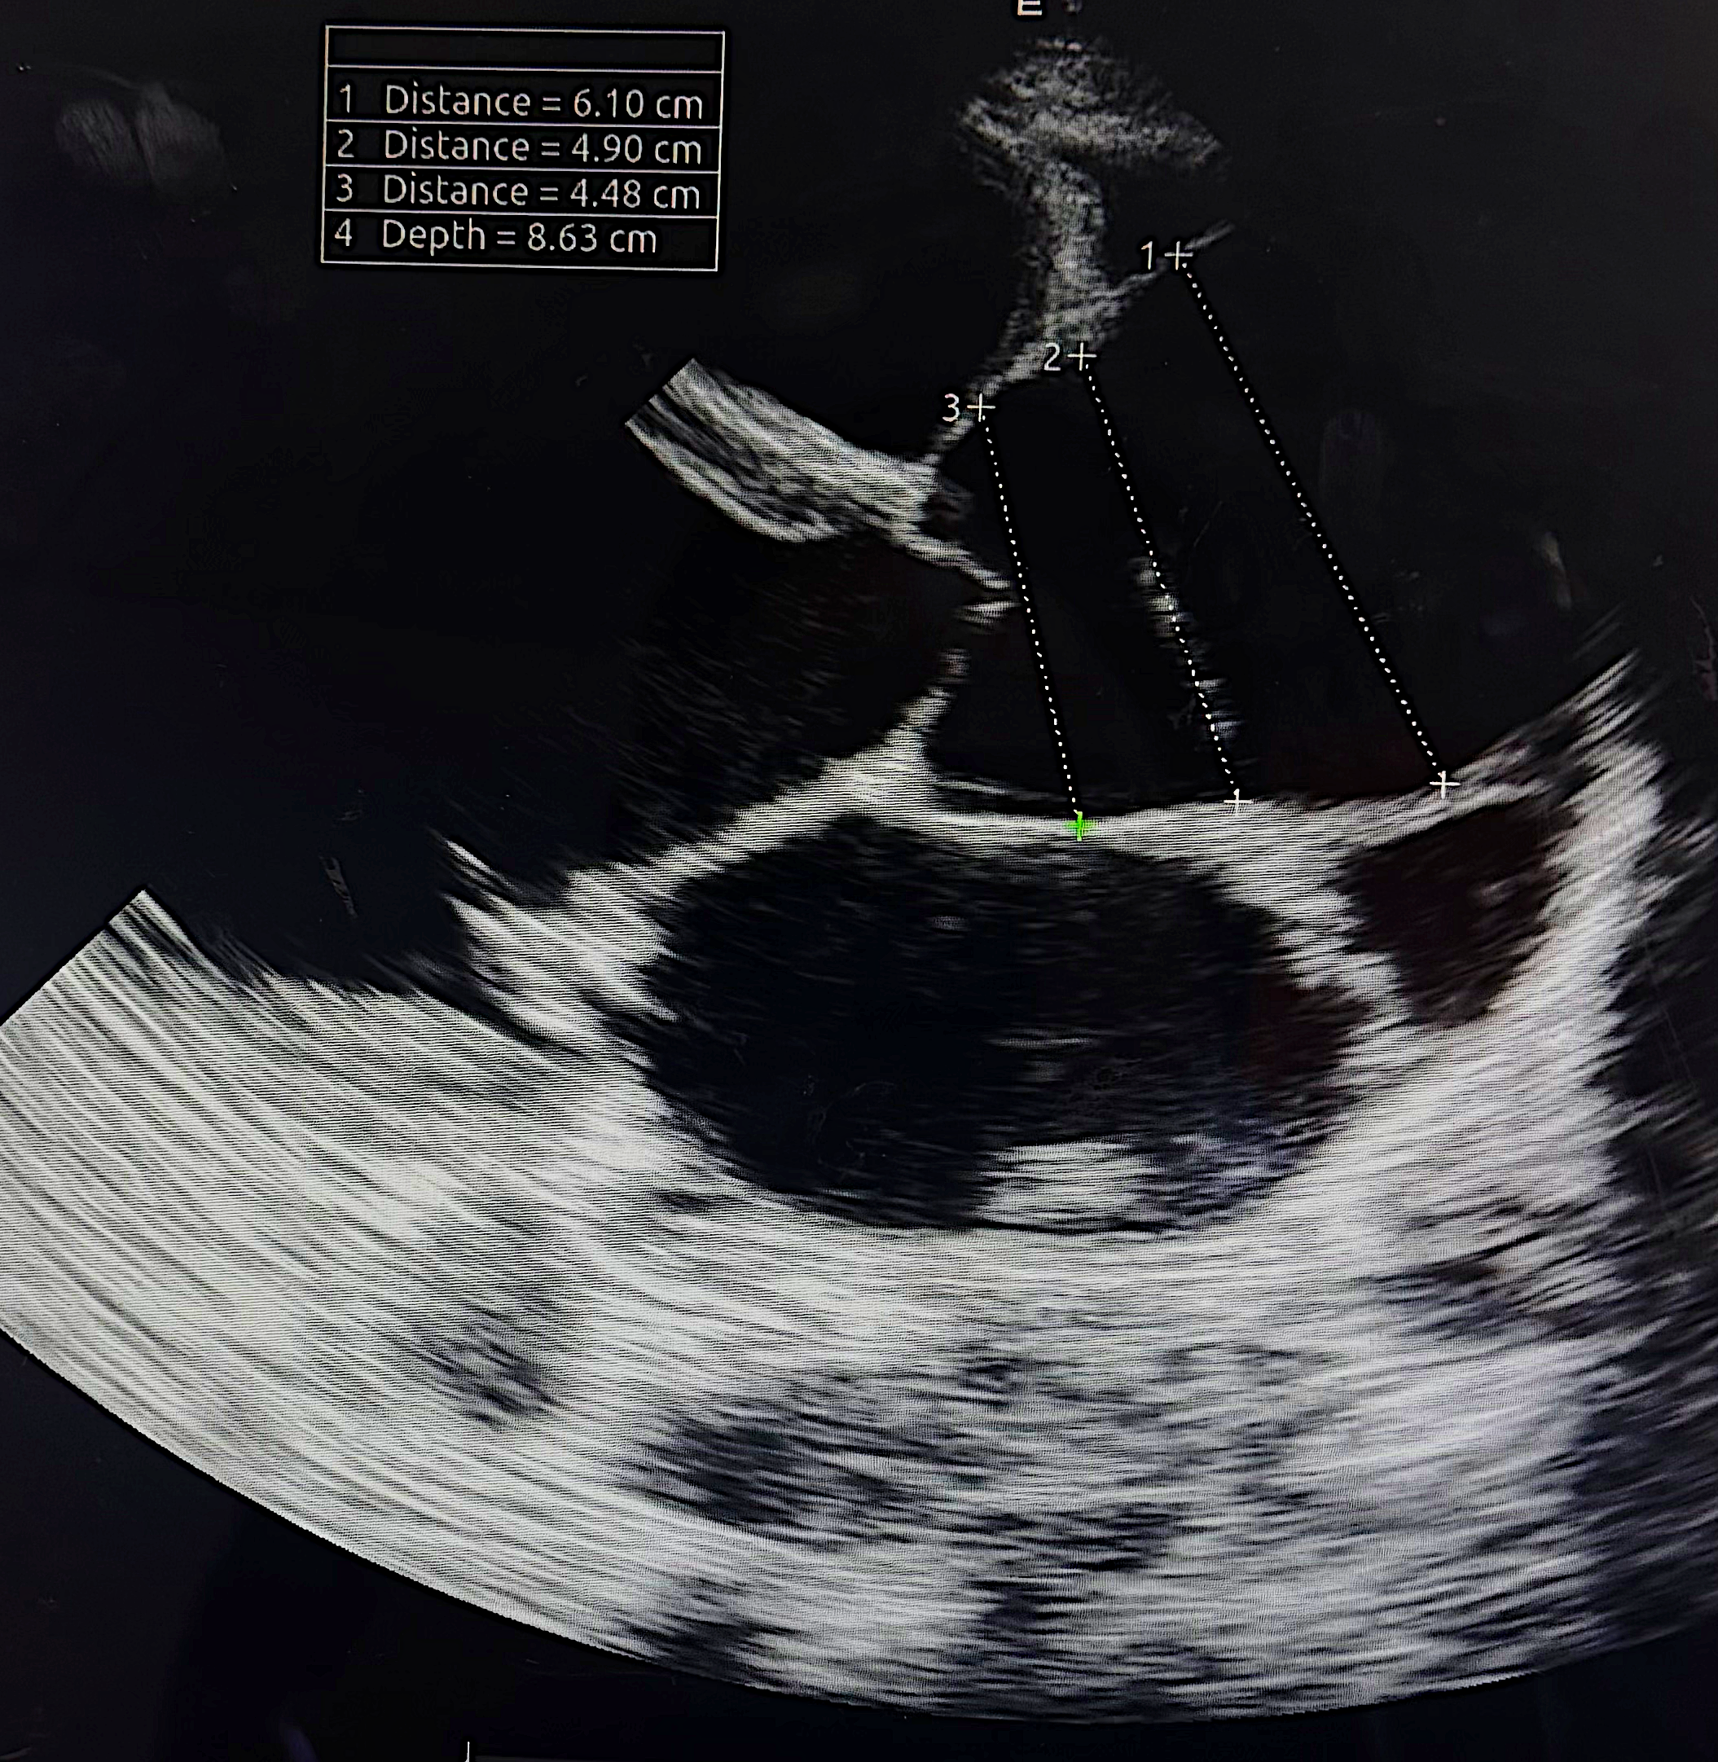
Figure 1 : Long axis parasternal view showing a dilated aorta in its initial segments : sinus, junction and ascending aorta.
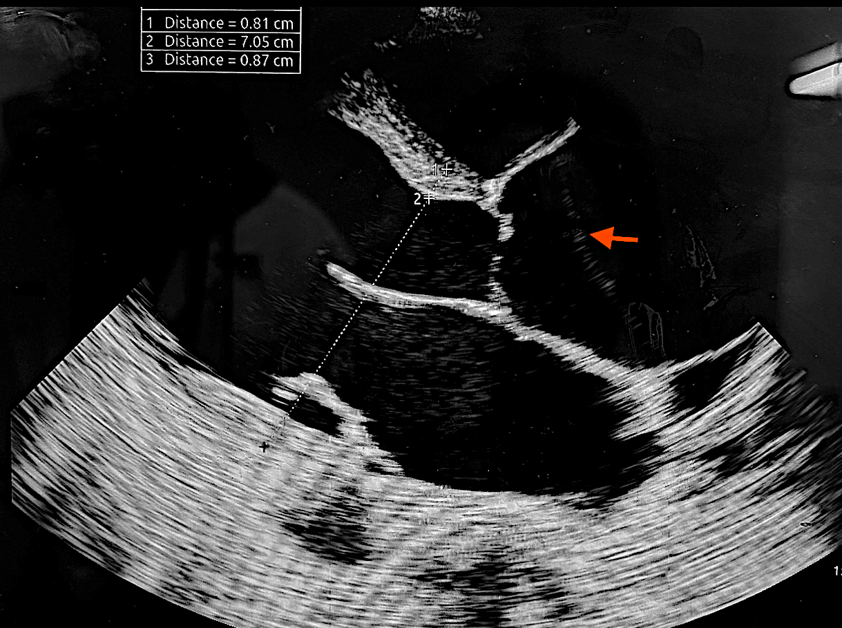
Figure 2 : Long axis parasternal view showing a type A aortic dissection and a dilated left ventricle and right ventricle .
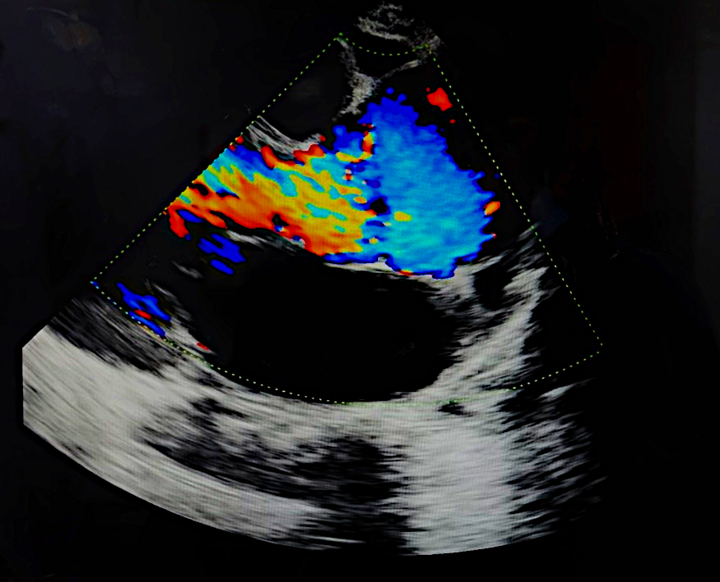
Figure 3: Long axis view showing aortic regurgitation
Heart surgery Team was informed for an urgent management along with an urgent computed tomography angiography that confirmed a Stanford type A aortic dissection extending from the ascending aorta to the abdominal aorta , carotid arteries and iliac arteries. (Figures 4 and 5)
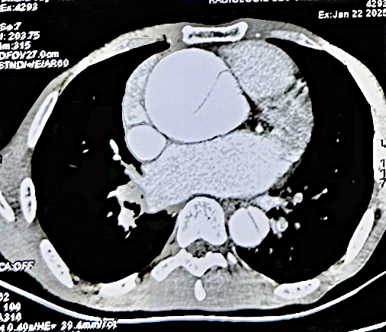
Figure 4 : Aortic CT scan showing an enlarged aortic aorta with extensive aortic dissection.
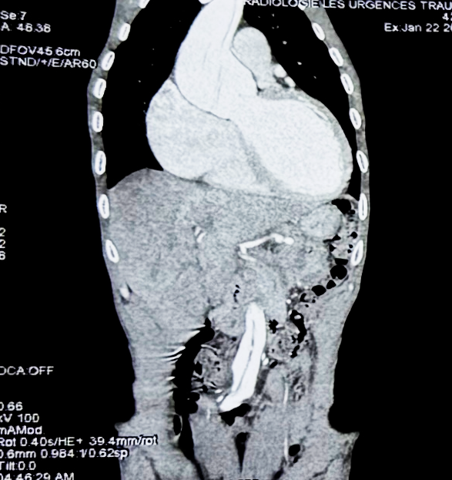
Figure 5 : Aortic CT scan showing the extension of the aortic dissection from the ascending aorta to the descending aorta
The patient’s age, the history of a previously drained spontaneous pneumothorax and treated bilateral retinal detachment in the young age, the clinical findings , are all suggestive of a connective tissue disorder. Imaging findings of a type A aortic dissection complicating an asymptomatic aortic aneurysm , the presence of a dilated cardiomyopathy with severe biventricular dysfunction, were highly suggestive of Marfan disease.
A beta-blocker therapy was initiated to manage heart rate and reduce aortic wall stress. Diuretics were established to treat the congestive heart failure. The patient was sent for an emergency surgical repair, with a poor prognosis due to the dissection’s extension.
Heart failure medications such as ACE inhibitors, mineralocorticoids are necessary for long-term management to improve survival.

3. discussion

Aortic dissection is a medical emergency with a high mortality rate if not promptly treated. In younger patients, connective tissue disorders like Marfan syndrome are significant predisposing factors due to the structural weakness of the aortic wall.
Marfan syndrome affects the fibrillin-1 gene, leading to systemic manifestations that increase the risk of aortic aneurysm and dissection. Limited life expectancy among affected individuals was primarily attributable to fatal aortic dissection. [4]
A study showed that younger patients had a dissection involving the supra-aortic vessels significantly more often than older patients and dissection extended significantly further downstream of the aorta. Younger patients showed significantly higher incidences of end-organ malperfusion correlating with dissection extension. [5]
The patient's history of spontaneous pneumothorax and retinal detachment, along with skeletal features, raised suspicion for Marfan syndrome. The diagnosis of Marfan syndrome is clinical, based on the revised Ghent criteria, which incorporate systemic features and family history. FBN1 testing, although not mandatory, has greater weight in the diagnostic assessment. Genetic testing can provide confirmation but was not available in this case .[6]
Management of type A aortic dissection involves urgent surgical intervention to prevent complications such as cardiac tamponade, aortic rupture, and death. [7] Postoperative medical therapy, including beta-blockers, ACE-inhibitors is essential to control blood pressure and reduce the risk of further aortic complications.[8]

In the past 30 years, research efforts have not only identified the genetic locus responsible but have begun to elucidate the molecular pathogenesis underlying this disorder, allowing for the development of seemingly rational therapeutic strategies for treating affected individuals. In spite of these advancements, the cardiovascular complications including mitral valve prolapse, aortic insufficiency, dilatation of the aortic root, and aortic dissection still remain as the most life-threatening clinical manifestations. [9]

Risk factors for aortic dissection in adults are as following: progressive aortic root dilatation and aortic root growth rate >5%/year or >2 mm/year, aortic dilatation >50 mm and family history of aortic dissection. [10]
In Marfan syndrome , annual imaging of the aorta is recommended, included echocardiography and computed tomography angiography or magnetic resonance angiography to assess the entirety of the aorta. In those patients with accelerated aortic root growth, current guidelines recommend the echocardiography twice a year or more frequent in with rapid growth phase in children.
In adults, prophylactic surgery is recommended for aortic root dilatation >4.5 cm or aortic diameter growth ≥0.5 cm/year. [3,11]

Functional imaging to understand the pathophysiological process in the aortic wall and four-dimensional imaging to assess the flow patterns and wall stress are currently being pursued. Biomarkers, such as vertebral artery tortuosity and the presence of branch aneurysms. [12,13]

The management of patients with aortic dissection remains complex, at times controversial, and is continuously evolving with the innovation of operative and endovascular techniques and devices.[14]

4. Conclusion

This case report highlights the importance of considering connective tissue disorders like Marfan syndrome in young patients presenting with aortic dissection in the presence of skeletal and ocular manifestations. Early recognition , an urgent TTE and an aortic CT scan confirming a type A acute aortic dissection and its extension indicates a prompt surgical intervention, necessary to improve patient’s outcomes.
Although the research progress the mortality remains important in type A aortic dissection and the prognosis is even more serious in extending aortic Stanford type A aortic dissection in patients with Marfan disease. Genetic testing and family screening are indicated to search for an unknown Marfan disease in the relatives . Aortic dissection is a rare but a life-threatening condition, a close follow-up, a medical therapy consisting on beta blockers and anti-hypertensive drugs is necessary even after surgical treatment.

5. CLINICAL SIGNIFICANCE

Recognizing the signs of Marfan syndrome in patients can lead to earlier diagnosis of this connective tissue pathology, and can prevent the aortic dissection , by close echocardiographic screening researching a dilated aorta , an aneurysm or other cardiac manifestations of the disease.
The presence of suggestive connective tissue disorder manifestations is a warning to eliminate an acute aortic dissection as the main etiology of chest pain. Urgent transthoracic echocardiography can confirm the diagnosis and indicates urgent appropriate surgical intervention and implementation of medical therapy to stabilize blood pressure, heart rate and prevent future cardiovascular events.

6. Declarations

Ethics Approval and Consent to Participate: Not applicable.

Patient Consent for Publication:
Written informed consent was obtained from the patient for publication of this case report and accompanying images.

Disclaimer (Artificial intelligence)

Author(s) hereby declare that NO generative AI technologies such as Large Language Models (ChatGPT, COPILOT, etc.) and text-to-image generators have been used during the writing or editing of this manuscript.

References

1 . Elsayed RS, Cohen RG, Fleischman F, Bowdish ME. Acute Type A Aortic Dissection. Cardiol Clin. 2017 Aug;35(3):331-345. doi: 10.1016/j.ccl.2017.03.004. Epub 2017 May 26. PMID: 28683905.

2. Nienaber CA, Clough RE, Sakalihasan N, Suzuki T, Gibbs R, Mussa F, Jenkins MP, Thompson MM, Evangelista A, Yeh JS, Cheshire N, Rosendahl U, Pepper J. Aortic dissection. Nat Rev Dis Primers. 2016 Jul 21;2:16053. doi: 10.1038/nrdp.2016.53. PMID: 27440162.

3. Stuart AG, Williams A. Marfan's syndrome and the heart. Arch Dis Child. 2007 Apr;92(4):351-6. doi: 10.1136/adc.2006.097469. PMID: 17376944; PMCID: PMC2083669.
4. Murdoch JL, Walker BA, Halpern BL, Kuzma JW, McKusick VA. Life expectancy and causes of death in Marfan syndrome. N Engl J Med 1972;286:804–808.

5. Okita Y. Aortic dissection is more violent in the young. Eur J Cardiothorac Surg. 2023 Jun 1;63(6):ezad209. doi: 10.1093/ejcts/ezad209. PMID: 37233032.

6. Loeys BL, Dietz HC, Braverman AC, Callewaert BL, De Backer J, Devereux RB, Hilhorst-Hofstee Y, Jondeau G, Faivre L, Milewicz DM, Pyeritz RE, Sponseller PD, Wordsworth P, De Paepe AM. The revised Ghent nosology for the Marfan syndrome. J Med Genet. 2010 Jul;47(7):476-85. doi: 10.1136/jmg.2009.072785. PMID: 20591885.

7. Zhu Y, Lingala B, Baiocchi M, Tao JJ, Toro Arana V, Khoo JW, Williams KM, Traboulsi AA, Hammond HC, Lee AM, Hiesinger W, Boyd J, Oyer PE, Stinson EB, Reitz BA, Mitchell RS, Miller DC, Fischbein MP, Woo YJ. Type A Aortic Dissection-Experience Over 5 Decades: JACC Historical Breakthroughs in Perspective. J Am Coll Cardiol. 2020 Oct 6;76(14):1703-1713. doi: 10.1016/j.jacc.2020.07.061. PMID: 33004136.

8. Coelho SG, Almeida AG. Marfan syndrome revisited: From genetics to the clinic. Rev Port Cardiol (Engl Ed). 2020 Apr;39(4):215-226. English, Portuguese. doi: 10.1016/j.repc.2019.09.008. Epub 2020 May 18. PMID: 32439107.

9. Zeigler SM, Sloan B, Jones JA. Pathophysiology and pathogenesis of Marfan syndrome. Adv Exp Med Biol. 2021;1348:185–206. doi:10.1007/978-3-030-80614-9_8. PMID: 34807420; PMCID: PMC8915437.

10. Ammash NM, Sundt TM, Connolly HM. Marfan syndrome-diagnosis and management. Curr Probl Cardiol. 2008;33:7–39. doi: 10.1016/j.cpcardiol.2007.10.001.

11. Böckler D, Meisenbacher K, Peters AS, Grond-Ginsbach C, Bischoff MS. Endovascular treatment of genetically linked aortic diseases. Gefasschirurgie. 2017;22(Suppl 1):1–7. doi: 10.1007/s00772-016-0221-z.

12. Morris SA, et al. Increased vertebral artery tortuosity index is associated with adverse outcomes in children and young adults with connective tissue disorders. Circulation. 2011;124(4):388–396.

13. Lopez-Sainz A, et al. Aortic branch aneurysms and vascular risk in patients with Marfan syndrome. J Am Coll Cardiol. 2021;77(24):3005–3012. doi:10.1016/j.jacc.2021.04.054.

14. Khaja MS, Williams DM. Aortic Dissection: Introduction. Tech Vasc Interv Radiol. 2021 Jun;24(2):100745. doi: 10.1016/j.tvir.2021.100745. Epub 2021 Jul 25. PMID: 34602274.

