Mechanical Support in Critical Coronary Syndromes: early Ventricular Assist Devices for LMCA Occlusion with Cardiogenic Shock

.
ABSTRACT

Acute occlusion of the Left main coronary artery (LMCA) is a rare but very serious angiographic finding with short-term life-threatening consequences. The clinical presentation is severe, with a high incidence of cardiogenic shock and sudden death. Treatment must be rapid and organized, and requires an angioplasty combined with hemodynamic support and the usual resuscitation resources.
We report the case of a 62-year-old patient admitted to our center after a resuscitated cardiac arrest, the post-resuscitation EKG revealed an ST segment elevation. The patient was rushed to the angiography room and we objectified a complete occlusion of the LMCA. Provisional stenting with mesh opening towards the circumflex with a good result, with rapid restoration of a TIMI III flow.
The persistence of shock with metabolic acidosis despite improvement in BP led to the use of hemodynamic support : Veno-Arterial extracorporeal membrane oxygenation (VA-ECMO) was rapidly initiated for circulatory support.
The patient stabilized under ECMO support and was gradually weaned off mechanical circulatory assistance. He made a full neurological recovery and was discharged home in stable condition.
This case highlights the importance of rapid recognition and a multidisciplinary approach, combining emergent PCI with mechanical circulatory support, in the management of catastrophic LMCA occlusion. The timely use of VA-ECMO can be life-saving by providing hemodynamic support and allowing successful revascularization in otherwise fatal presentations.

Keywords: Unprotected Left main coronary artery, cardiac arrest, VA-ECMO, PCI, acute coronary syndrome, cardiogenic shock.

1. INTRODUCTION
Acute unprotected left main coronary artery (ULMCA) occlusion is a rare yet catastrophic event, often resulting in sudden cardiac arrest or refractory cardiogenic shock. The LMCA supplies a substantial portion of the myocardium, including the left anterior descending and left circumflex arteries. Therefore, its acute occlusion leads to extensive myocardial ischemia, frequently culminating in fatal arrhythmias or hemodynamic collapse if not promptly addressed. The incidence of ULMCA occlusion in acute myocardial infarction (AMI) cases is estimated to be between 0.2% and 2.4%, underscoring its rarity and the associated high mortality rate, that approaches 90% when left untreated or when reperfusion is delayed [1] .​
Historically, coronary artery bypass grafting (CABG) has been the gold standard for revascularization in patients with ULMCA disease. However, in the setting of acute occlusion with associated cardiac arrest or profound shock, the urgency of intervention often precludes surgical options : our case . Percutaneous coronary intervention (PCI) has emerged as a viable alternative, especially with advancements in stent technology, interventional techniques and advanced mechanical circulatory support (MCS) modalities. Recent studies have demonstrated that PCI can be performed safely and effectively in selected patients with ULMCA lesions, even in the context of acute presentations [2].​
The concept of “ECMO-facilitated PCI” has gained traction in recent years, particularly in complex high-risk interventions (CHIP), including unprotected LMCA occlusions. Several case series and registry data suggest improved outcomes when VA-ECMO is deployed early in patients with ongoing ischemia and circulatory collapse [3]. This strategy serves as a critical tool in allowing time for myocardial recovery in patients who would otherwise succumb to circulatory collapse.
Despite these advancements, the management of ULMCA occlusion remains complex and requires a multidisciplinary approach. Early recognition, rapid initiation of VA-ECMO, and timely PCI are essential components of a successful outcome. This case report illustrates the critical role of this integrated strategy in salvaging patients with this life-threatening condition.
2. Presentation of Case
A 62-year-old previously healthy male with no known cardiac history apart from hypertension on treatment, collapsed at home with sudden cardiac arrest. Emergency medical services arrived and found the patient in ventricular fibrillation (VF). Advanced cardiac life support was initiated, including defibrillation, chest compressions, and intubation. Return of spontaneous circulation (ROSC) was achieved after 15 minutes.
Upon arrival at the emergency department, the patient remained hypotensive with persistent signs of cardiogenic shock (SBP 60 mmHg on high-dose vasopressors). Electrocardiogram showed diffuse ST-segment elevations in the anterior and lateral leads (Fig.1) . Emergency echocardiography revealed severe left ventricular dysfunction with global hypokinesia and Left Ventricular ejection fraction of 25% with no mechanical complications.
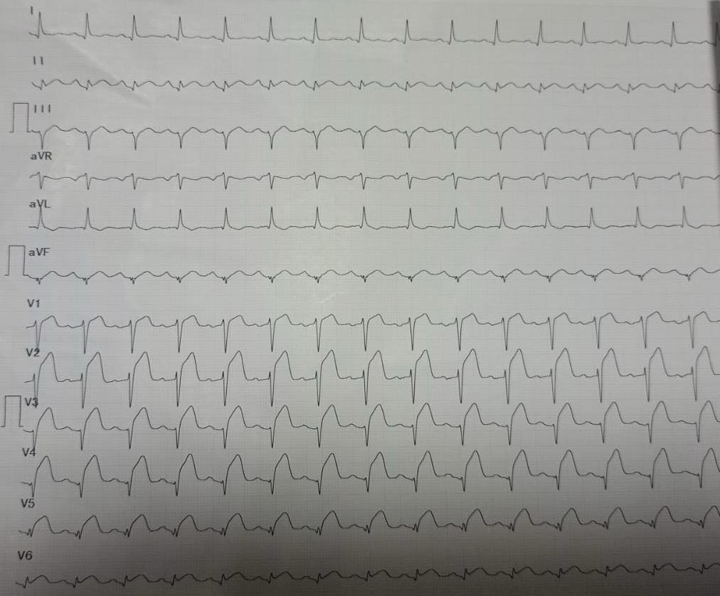
Fig. 1: The electrocardiogram of the patient after resuscitation
The patient was then rushed to the catheterization room for emergent coronary angiography that revealed a complete occlusion of the unprotected LMCA with no significant collateral flow (Fig.2).
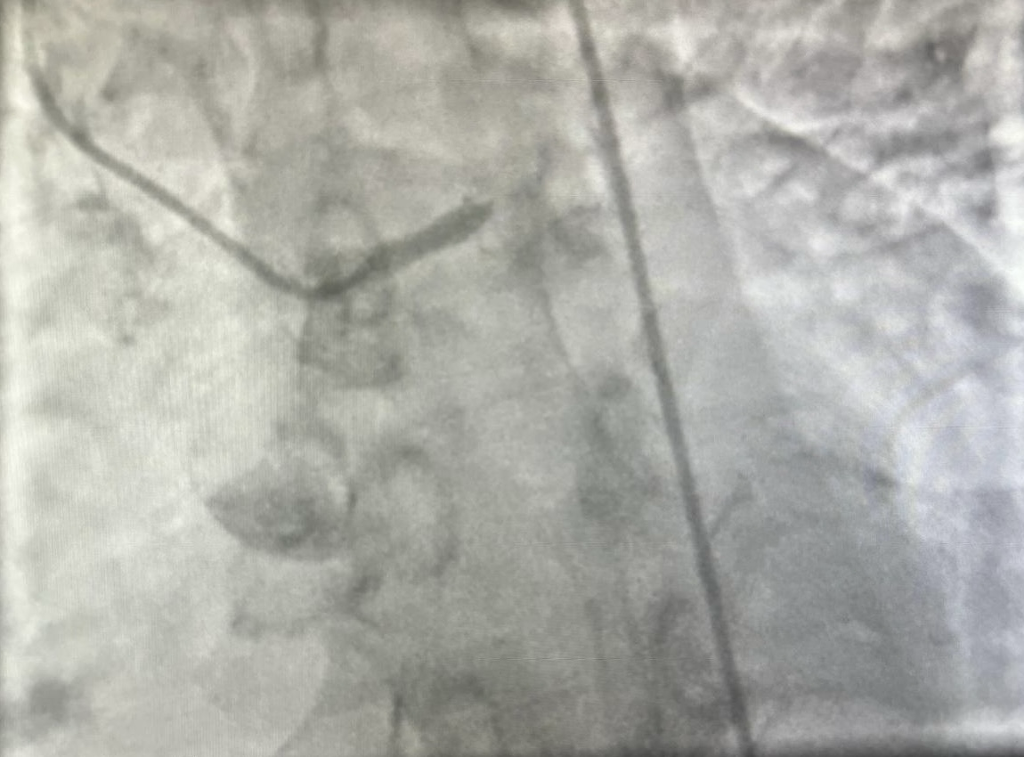
Fig. 2: Thrombotic acute occlusion of the distal left main coronary artery
Passage of the guide enabled recovery of a TIMI 3 flow and revealed a very tight stenosis from the distal left main to the proximal IVA (Fig.3).

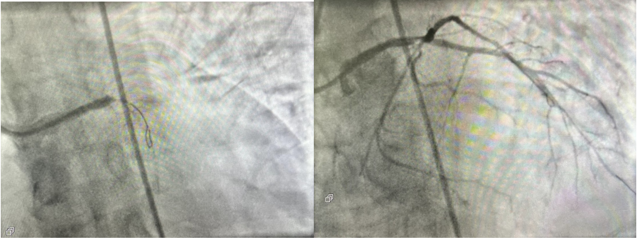
Fig. 3: TIMI3 flow recovery after guidewire passage.

Recanalization of the LM distal to the IVA with implantation of a DES 3.5 X 28 mm (Fig.4) with mesh opening towards the circumflex with a good result.
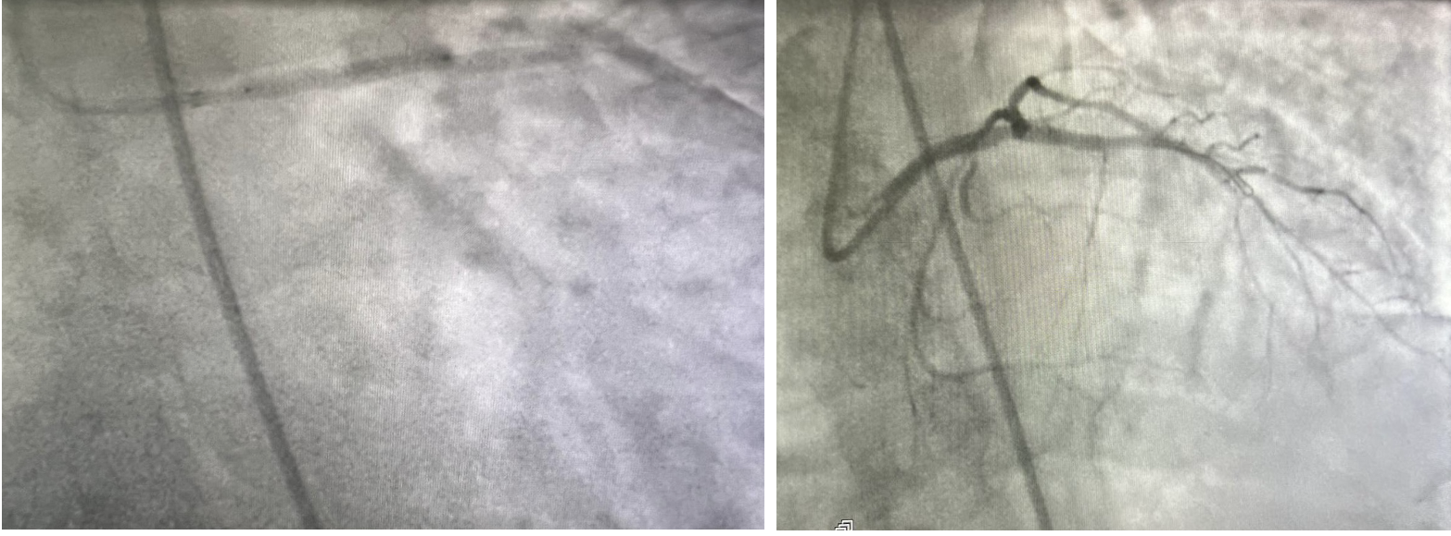
Fig. 4: Placement of a LM-IVA proximal stent and result.
The persistence of shock with metabolic acidosis despite improvement in blood pressure led to escalation to hemodynamic support. Circulatory assistance of the veno-arterial ECMO type was introduced via the femoral-femoral line (Fig.5).

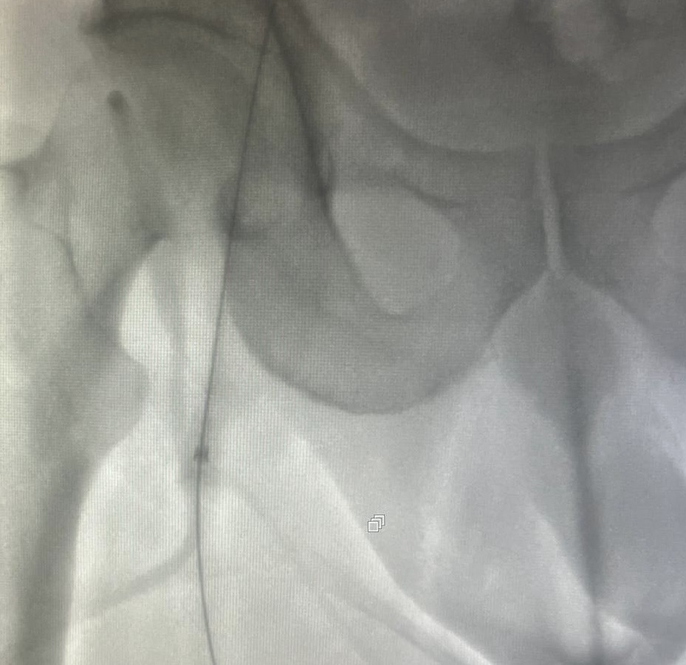
Fig. 5: Veno-arterial ECMO via the femoral-femoral route
The patient was transferred to the cardiac intensive care unit on ECMO and vasopressor support. Upon admission and during the acute phase of management, the patient demonstrated a constellation of laboratory abnormalities reflecting the profound myocardial injury, systemic hypoperfusion, and multi-organ stress associated the ULMCA occlusion complicated by cardiac arrest and cardiogenic shock :
- High-sensitivity troponin T was markedly elevated (>10,000 ng/L), confirming extensive myocardial necrosis consistent with an infarction involving the left main territory.
- NT-proBNP levels exceeded 20,000 pg/mL, indicating severe left ventricular dysfunction and volume overload.
- C-reactive protein (CRP) was significantly elevated, suggesting a systemic inflammatory response triggered by ischemia-reperfusion injury and ECMO-associated immune activation.
- Renal function deteriorated with a creatinine level of 2.3 mg/dL and elevated blood urea nitrogen, indicating acute kidney injury secondary to hypoperfusion.

Over the next 48 hours, myocardial contractility gradually improved. ECMO was weaned and decannulated on day 4. Neurological assessment revealed full recovery, and the patient was extubated without deficit. He was discharged home after 10 days with guideline-directed medical therapy and scheduled for cardiac rehabilitation.

3. discussion

ULMCA occlusion is a rare but highly lethal condition, accounting for approximately 0.2% to 2.4% of all AMI cases. The left main coronary artery supplies a substantial portion of the myocardium, including the left anterior descending and left circumflex arteries. Acute occlusion leads to extensive myocardial ischemia, often resulting in sudden cardiac arrest or refractory cardiogenic shock. Without prompt intervention, the mortality rate approaches 100% [4].
Poor prognostic factors include delayed diagnosis, transition to cardiogenic shock (which was the case in our patient), failure of revascularization, left-hand dominance and absence of collateral circulation.

Historically, CABG has been considered the gold standard for revascularization in left main coronary artery disease. However, in the setting of acute LMCA occlusion with cardiogenic shock or cardiac arrest, the urgency of revascularization precludes surgical delay. PCI has emerged as a feasible and increasingly utilized alternative, especially in unstable patients where time is critical. Studies such as the EXCEL and NOBLE trials have expanded the role of PCI in selected cases of LMCA disease, although these trials focused on stable patients and excluded those in shock or arrest [5].

In this case, the patient presented with out-of-hospital cardiac arrest due to acute ULMCA occlusion. Immediate resuscitation and stabilization were achieved through advanced cardiac life support and the initiation of veno-arterial extracorporeal membrane oxygenation (VA-ECMO), at the same time as emergent PCI. This approach underscores the critical importance of early recognition and aggressive management in such high-risk presentations.

The aim is to rapidly restore TIMI III flow. The technique of provisional stenting followed by a kissing balloon is the most commonly used, given its rapidity and feasibility. This was not the case for our patient, where provisional stenting was preferred, followed by diagonal mesh opening. With regard to antithrombotic therapy, the patient was treated with antigIIB-IIIA in view of the thrombotic burden associated with dual antiaggregation therapy.
Veno-arterial ECMO provides both cardiac and respiratory support, making it particularly valuable in cases of cardiac arrest or severe cardiogenic shock. It serves as a bridge to recovery or definitive therapy, allowing time for myocardial healing and stabilization. Recent studies have demonstrated that early initiation of VA-ECMO in patients with acute coronary syndromes complicated by cardiac arrest or shock is associated with improved survival outcomes [6] .​
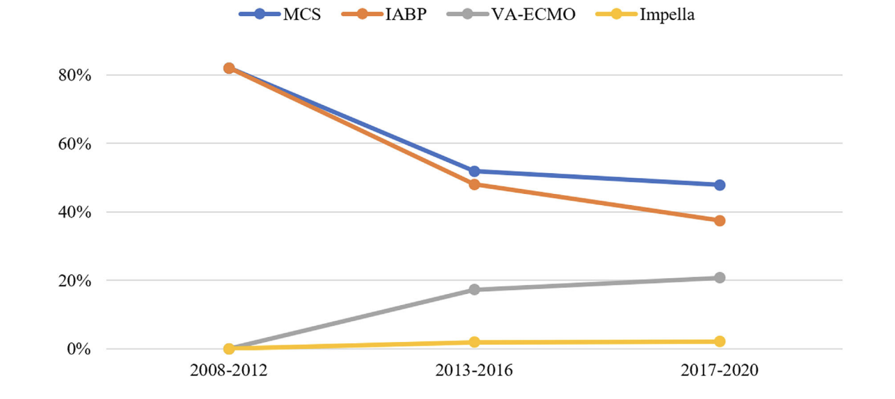
Fig. 6: Trends in mechanical circulatory support (MCS) use in the context of unprotected left main coronary artery occlusion/subtotal occlusion [7].
In the presented case, VA-ECMO was initiated at the same time as the PCI, providing essential circulatory support during the PCI procedure. This facilitated successful revascularization and contributed to the patient's favorable outcome. The integration of VA-ECMO with PCI represents a multidisciplinary approach that can significantly enhance survival in patients with ULMCA occlusion and associated cardiac arrest.
Managing ULMCA occlusion with associated cardiac arrest presents several challenges. Rapid identification and initiation of appropriate therapies are crucial. The decision to proceed with PCI in the setting of acute occlusion requires careful consideration of the patient's clinical status, anatomical suitability, and the availability of resources. Furthermore, the use of VA-ECMO necessitates expertise in its management and potential complications, such as bleeding, infection, and vascular injury. Close monitoring and a multidisciplinary approach are essential to optimize outcomes.​
the coordinated efforts of the emergency medical services, interventional cardiology team, and intensive care unit staff were instrumental in achieving a successful outcome in our case. The patient's rapid stabilization and subsequent recovery highlight the effectiveness of a comprehensive, team-based approach in managing this complex clinical scenario.
The emergence of “shock teams” and structured protocols in high-volume centers underscores the importance of rapid, team-based decision-making. At the same time, there is a growing need for individualized risk assessment tools to guide the use of ECMO and PCI in this critical population, as well as broader discussions around equitable access to these life-saving technologies globally. Future studies should focus on refining selection criteria, optimizing timing, and expanding access to ECMO-supported PCI in acute left main occlusion to improve outcomes.

4. Conclusion
Acute unprotected LMCA occlusion resulting in cardiac arrest is often fatal. Early initiation of VA-ECMO can provide critical hemodynamic support and allow for successful revascularization via PCI. A multidisciplinary team approach and rapid deployment of ECMO can dramatically improve survival and neurological outcomes in such critically ill patients.
Competing interests

Authors have declared that no competing interests exist.

Consent

As per international standards or university standards, patient written consent has been collected and preserved by the author.

References

- Dürig M, Arroyo D, Bedossa M, Commeau P, Fournier S, Müller O, Barragan P, Le Breton H, Puricel S, Cook S. Clinical outcomes after unprotected left main coronary artery occlusion: A retrospective multicentre cohort analysis. Catheter Cardiovasc Interv. 2023 Mar;101(4):679-686. doi: 10.1002/ccd.30585. Epub 2023 Feb 14. PMID: 36786485.
- Analysis of percutaneous coronary intervention outcomes in unprotected left main coronary artery lesions J Transcat Intervent.2022;30:eA20220033
- Thiele H, Ohman EM, de Waha-Thiele S, et al. Management of cardiogenic shock complicating myocardial infarction: An update 2020. Eur Heart J. 2020;41(20):2008–2020
- Neumann FJ, Sousa-Uva M, Ahlsson A, et al. 2018 ESC/EACTS Guidelines on myocardial revascularization. Eur Heart J. 2019;40(2):87–165
- Mäkikallio T, Holm NR, Lindsay M, et al. Percutaneous coronary angioplasty versus coronary artery bypass grafting in treatment of unprotected left main stenosis (NOBLE): a prospective, randomized, open-label, non-inferiority trial. Lancet. 2016;388(10061):2743–2752
- Beijk, M.A.M. et al. (2023). Clinical Outcomes after Percutaneous Coronary Intervention for Cardiogenic Shock Secondary to Total Occlusive Unprotected Left Main Coronary Artery Lesion-Related Acute Myocardial Infarction. Journal of Clinical Medicine, 12(4), 1311.
- Alexandre, J. et al. (2024). Twelve‐year trends in unprotected left main coronary artery occlusion: insights from a real‐world multicentre study. ESC Heart Failure.

ABBREVIATIONS
AMI : Acute myocardial infraction
CABG : coronary artery bypass grafting (CABG
LMCA : left main coronary artery
LCx : left circumflex
MCS : mechanical circulatory support (MCS)
PCI : Percutaneous coronary intervention (PCI)
VA-ECMO : Veno-arterial extracorporeal membrane oxygenation

