***Case report***

**A comparative study between Myopericarditis and ST-segment elevation myocardial infarction: a case report**

# Abstract

# Myopericarditis is an inflammatory disease affecting both the pericardial sac and the myocardium. Its presentation is typically similar to pericarditis syndrome, with myocardial involvement being more subtle or secondary in nature. Distinguishing between myopericarditis and myocardial infarction can be difficult, as the clinical, electrical and biological presentations of the two conditions can be similar. The study reports the case of a young patient who presented to the emergency department with acute chest pain. The electrocardiogram showed ST elevation in the septal and lateral leads with subtle reciprocal changes. The patient was initially mistakenly treated for coronary syndrome with ST-segment elevation, then diagnosed with myopericarditis on magnetic resonance imaging. Features such as young age, recent influenza-like illness, absence of cardiovascular risk factors and CRP/troponin ratio may point to myopericarditis rather than myocardial infarction. Early and accurate differentiation is essential to ensure optimal patient care and improve clinical outcomes. Cardiac magnetic resonance imaging (MRI) played a pivotal role in confirming the diagnosis.

**Keywords:** Myopericarditis; Myocardial infarction; Misdiagnosis; Medical reasoning

# Introduction

Myopericarditis is an inflammatory disease of the pericardial sac and myocardiocytes. The presentation of myopericarditis is mainly a pericarditic syndrome with minor myocardial involvement1. The pericarditis and acute myocarditis association is not uncommon since both underlying mechanisms is inflammation, sharing common aetiology agents, mainly cardiotropic viruses 2. Differentiating between myopericarditis and acute myocardial infarction (AMI) as the cause of an acute cardiac event can often be challenging on clinical grounds, as both conditions present with acute chest pain, electrocardiographic changes, and elevated troponin levels 3. The clinical manifestation of acute myocarditis varies with a broad spectrum of nonspecific symptoms ranging from asymptomatic courses to manifestations with signs of myocardial infarction and cardiogenic shock (Magalhães et al., 2021; Prepoudis et al., 2022). Changes in ECG are found in 93-100% of cases and include sinus tachycardia, sinus bradycardia, atrioventricular block, T wave inversion, ST-segment elevation, and pathological Q wave. Other diagnostic modalities include echocardiography and cardiac MRI which can clearly define the anatomical and physiological alteration in cardiac status. The prognosis of myocarditis is variable, the majority recover completely without any ill effects (Gohil & Agarwal, 2020).

We report the case of a 21-year-old man presenting with chest discomfort, electrocardiographic changes and elevated cardiac enzymes due to myopericarditis simulating acute myocardial infarction, highlighting this diagnosis challenge.

# Case presentation

A 21-year-old male who denied any cardiovascular risk factors presented to the emergency room with acute chest pain that started five hours prior to admission. The patient had no preceding viral or flu-like symptoms. On physical examination, vital signs were within normal limits, and heart sounds were clear, with no evidence of fever or pericardial friction rub. The electrocardiogram (Figure 1) showed ST-segment elevation in the septal and lateral leads and subtle reciprocal changes in inferior leads suggestive of an acute ST-segment elevation myocardial infarction (STEMI). Laboratory testing revealed significantly elevated cardiac biomarkers: troponin levels were 16,020 ng/l (Normal Range (NR): <34 ng/l), creatine kinase-MB (CK-MB) was 1,629 U/l (NR <200 U/l) and C-Reactive Protein (CRP) was 16 mg/l (NR < 5mg/l) with CRP/Troponin Ratio at 99.8. Despite these findings, transthoracic echocardiography (TTE) was unremarkable, showing no wall motion abnormalities or pericardial effusion. The presumptive diagnosis was a septal and lateral STEMI based on the typical electrocardiographic changes and ongoing chest discomfort, he was given dual antiplatelet therapy, and prehospital thrombolysis and underwent urgent coronary angiography. Coronary angiography (Figure 2) confirmed normal coronary arteries, ruling out obstructive coronary artery disease. Viral and autoimmune serology was negative. Cardiac MRI revealed an area of late contrast enhancement, consistent with myocardial inflammation and oedema (Figures 3 & 4) and a small pericardial effusion., further supporting the diagnosis of myopericarditis mimicking STEMI. The patient received a symptomatic treatment associated with non-steroidal anti-inflammatory drugs (NSAIDs) and colchicine for the pericarditis and was discharged with a good outcome.

# Discussion

Myopericarditis is the inflammation of both the myocardium and pericardium. The pericardium, a double-walled sac surrounding the heart, consists of a serous visceral layer and a fibrous parietal layer, with the pericardial cavity containing fluid between them. Pericarditis refers to inflammation of the pericardium, but since the serous visceral layer lies next to the myocardium, myocardial involvement often occurs as well. When pericardial inflammation is predominant, it is termed pericarditis, whereas myocarditis refers to predominant myocardial inflammation. "Myo- pericarditis" describes both, with "perimyocarditis" emphasizing more myocardial involvement 2. The clinical and paraclinical presentation of this condition can be difficult to distinguish in all aspects with an acute myocardial infarction, as this led to the creation of a new entity named acute coronary syndrome-like myopericarditis 4.

Symptomatic patients with myopericarditis may complain of chest pain with fatigue, decreased exercise capacity, and palpitations secondary to cardiac arrhythmias 2. This chest pain can be very different from typical pericarditis pain -worsening with deep inspiration 5- and may resemble ischemic pain simulating acute coronary syndrome as reported in myocarditis due to myocardial involvement, making it difficult to distinguish between the two entities 2.

A history of a febrile syndrome was reported in up to 50% of cases of myopericarditis, and only 21% in patients with simple acute pericarditis in a prospective study on viral or idiopathic myopericarditis, but not reported in our patient’s history. ECG changes are also common in acute pericarditis, reflecting some degree of myocardial involvement, because the pericardium is electrically silent, and they are predominantly represented with a diffuse ST elevation 6. However, in myopericarditis, several features may simulate an acute coronary syndrome with ST-segment elevation, such as a convex ST – elevation, with a localized distribution, associated with reciprocal changes, T waves inversion, new Q waves and also more frequent arrythmias 7. In fact, even echocardiography performed in patients with myopericarditis may demonstrate segmental wall motion abnormalities typical of AMI and not show the expected pattern of diffuse hypokinesis 8.

Enzymatic markers Troponin and CRP, are generally elevated in both AMI and in myopericarditis 2. However, the primary pathological process in patients with myopericarditis is inflammation, whatever the aetiology 2. Therefore, it is typically associated with high levels of CRP but with a proportionally smaller increase in the level of troponin released from damaged cardiomyocytes 9. Hence a CRP / troponin ratio may serve as an additional biomarker tool to use in clinical practice in order to evaluate the probability of myopericarditis 9. Although further evaluation is needed, a CRP/troponin ratio greater than 250 might suggest a likely diagnosis of myopericarditis, while a ratio exceeding 500 could reinforce the diagnosis as definite or highly probable.

Our patient’s case presentation combined features leading to a misdiagnosis for AMI, as there was no febrile syndrome or reported viral infection, acute chest pain with non-pericarditis features, ST elevation in localized territories (Septal and lateral) and a low CRP/Troponin ratio (99.8). The features that led us to the diagnosis of myopericarditis were the young age associated with the total absence of cardiovascular risk factors.

**Conclusion**

Distinguishing between acute myopericarditis and STEMI is paramount, as their management strategies and prognoses differ significantly. While AMI necessitates prompt revascularization and antithrombotic therapy to prevent adverse outcomes. The treatment of myopericarditis primarily involves NSAIDs or corticosteroids, combined with colchicine. Prognostically, myopericarditis generally follows a benign course with minimal long-term complications, contrasting with the more severe outcomes associated with AMI. Early and accurate differentiation remains critical for optimizing patient care and improving outcomes.

**Acknowledgements:** None.

**Conflicts of interest:** None to declare.

**Ethical approval**: Not applicable.

**Consent**: Written informed consent was obtained from the patient for publication of this case report and accompanying images. A copy of the written consent is available for review by the Editor-in-Chief of this journal on request.

**Guarantor:** Nabil Laktib

Disclaimer (Artificial intelligence)

Option 1:

Author(s) hereby declare that NO generative AI technologies such as Large Language Models (ChatGPT, COPILOT, etc.) and text-to-image generators have been used during the writing or editing of this manuscript.

Option 2:

Author(s) hereby declare that generative AI technologies such as Large Language Models, etc. have been used during the writing or editing of manuscripts. This explanation will include the name, version, model, and source of the generative AI technology and as well as all input prompts provided to the generative AI technology

Details of the AI usage are given below:

1.

2.

3.

# References

1. Manda YR, Baradhi KM. Myopericarditis. In: StatPearls. Treasure Island, FL: StatPearls Publishing; 2024.
2. Imazio M, Trinchero R. Myopericarditis: etiology, management, and prognosis. Int J Cardiol. 2008;127(1):17-26. doi:10.1016/j.ijcard.2007.10.053.
3. O’Donoghue ML, Morrow DA, Cannon CP, et al. Multimarker risk stratification in patients with acute myocardial infarction. JAHA. 2016;5(5). doi:10.1161/JAHA.115.002586.
4. Rozen G, Koifman E, Goitein O, et al. ACS-like acute myocarditis vs. acute myocardial infarction: continuous clinical challenge. Eur Heart J. 2013;34(suppl 1). doi:10.1093/eurheartj/eht309.P3870.
5. Tonini M, Melo DTPD, Fernandes F. Acute pericarditis. Rev Assoc Med Bras. 2015;61(2):184-190. doi:10.1590/1806-9282.61.02.184.
6. Spodick DH. Acute pericarditis: current concepts and practice. JAMA. 2003;289(9):1150. doi:10.1001/jama.289.9.1150.
7. Imazio M, Cecchi E, Demichelis B, et al. Myopericarditis versus viral or idiopathic acute pericarditis. Heart. 2008;94(4):498-501. doi:10.1136/hrt.2006.104067.
8. Leitman M, Tyomkin V, Peleg E, Copel L, Vered Z. Left ventricular function in acute inflammatory peri-myocardial diseases – new insights and long-term follow-up. Cardiovasc Ultrasound. 2012;10(1):42. doi:10.1186/1476-7120-10-42.
9. Meisel SR, Nashed H, Natour R, et al. Differentiation between myopericarditis and acute myocardial infarction on presentation in the emergency department using the admission C-reactive protein to troponin ratio. PLoS One. 2021;16(4). doi:10.1371/journal.pone.0248365.
10. Gohil, J. R., & Agarwal, T. S. (2020). Children with Myocarditis: Clinical Profile and Electrocardiographic Changes and Their Prognostic Significance: A Prospective Observational Study. Asian Journal of Pediatric Research, 4(1), 23–30. <https://doi.org/10.9734/ajpr/2020/v4i130142>
11. Magalhães, M. J. L., Gomes de Farias, L. D. P., Baptista, L. D. P. S., Sampaio, M. C., Guimarães, P. O., Baruzzi, A. C. A. D., ... & Furlan, V. (2021). Acute myocarditis associated with acute myocardial infarction. Radiology: Cardiothoracic Imaging, 3(1), e200469.
12. Prepoudis, A., Koechlin, L., Nestelberger, T., Boeddinghaus, J., Lopez-Ayala, P., Wussler, D., ... & APACE investigators. (2022). Incidence, clinical presentation, management, and outcome of acute pericarditis and myopericarditis. European Heart Journal Acute Cardiovascular Care, 11(2), 137-147.

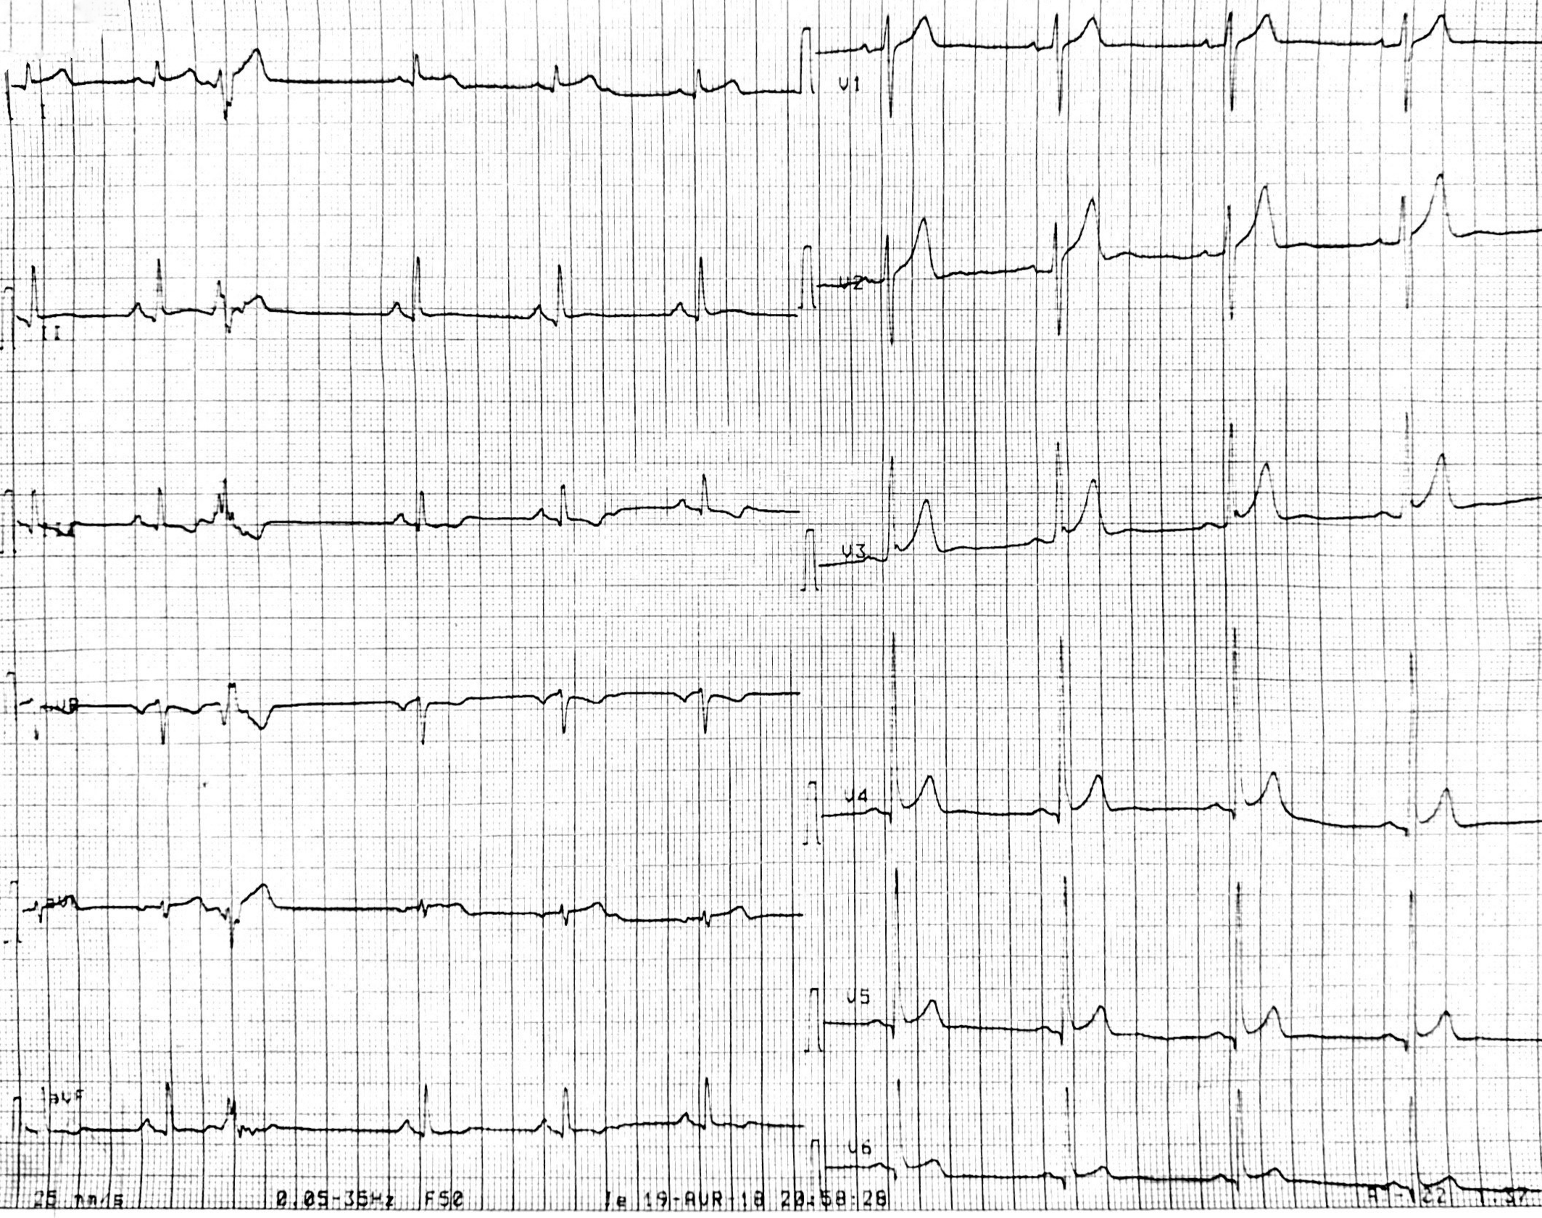

**Figure 1:** ECG showing a ST elevation in the septal and the lateral territories with subtle reciprocal changes in the inferior leads**.**

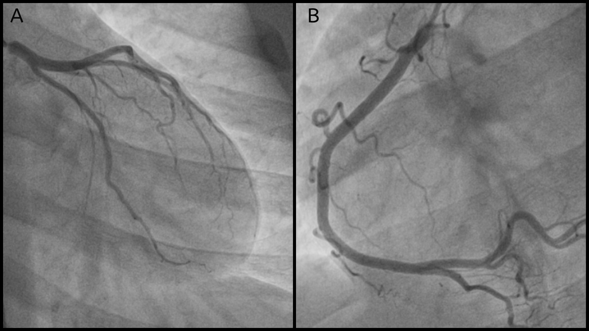

**Figure 2**: Coronary angiogram showing normal coronaries.  
A: Left anterior descending and circumflex coronary artery.

B: Right coronary artery.

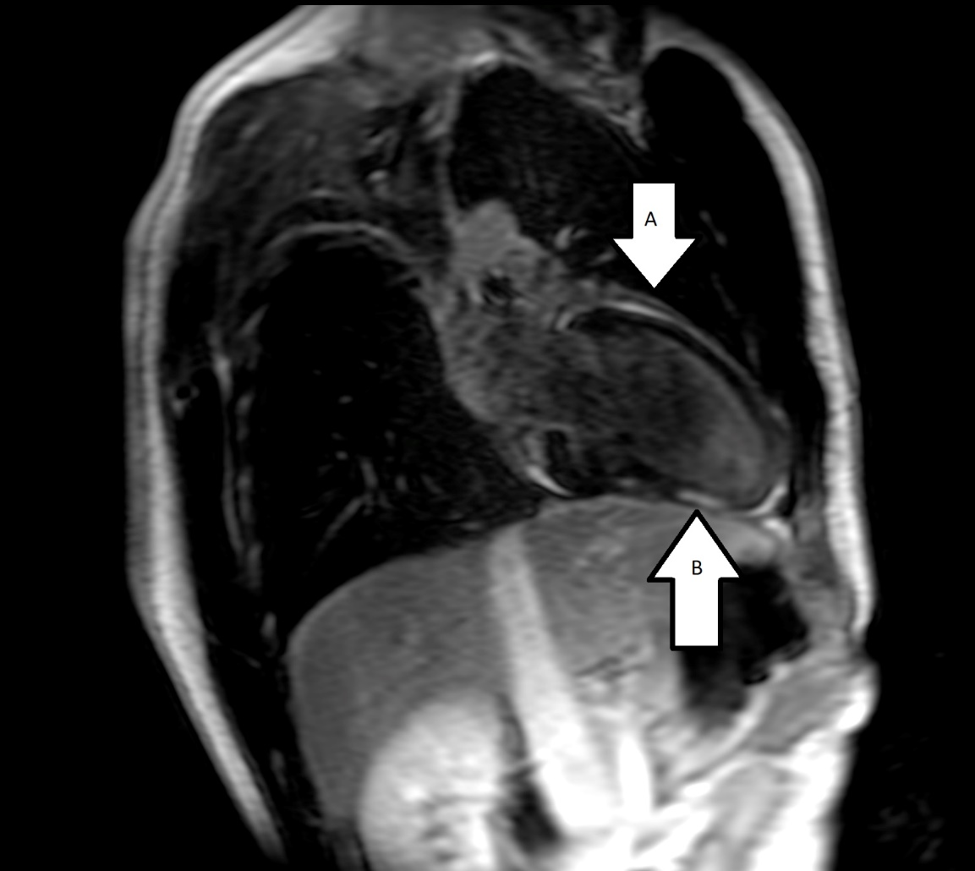

**Figure 3**: Cardiac magnetic resonance imaging showing signs of myopericarditis.  
A: Pericardial late gadolinium enhancement.

B: Inferior wall late gadolinium enhancement.

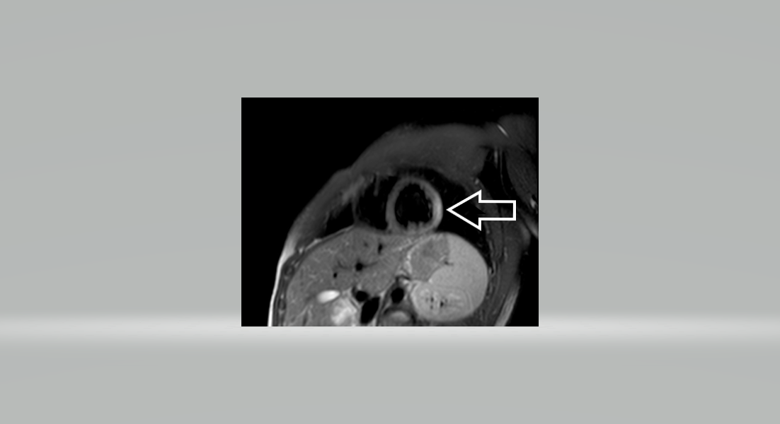

**Figure 4**: Cardiac magnetic resonance imaging showing myocardial oedema.