Case report

EFFECTIVENESS OF VACUUM-SUPPORTED AND LARVAL THERAPY ON PERSISTENT PRESSURE INJURIES IN DEBILITATED BED-BOUND PATIENT

ABSTRACT

Introduction: The management of pressure injuries (PIs) and immobility-related wounds poses significant clinical challenges, often requiring multimodal therapeutic interventions. This case report evaluates the integration of vacuum-assisted closure (VAC) therapy and larval debridement therapy (LDT) alongside systemic antibiotics and supportive care in a high-risk patient. Case: A 79-year-old bedridden male with advanced dementia, type 2 diabetes mellitus, and hypertension presented with a necrotic, infected sacral pressure injury. Conclusion: Following initial wound care and antibiotic therapy, sequential VAC and then LDT using (Lucilia sericata) were implemented, resulting in significant tissue granulation and infection resolution without complications. A ‘‘multidisciplinary approach’’ is crucial in managing complicated pressure injuries.

Keywords: vacuum therapy, larval therapy, pressure injuries, debilitated patients, Lucilia sericata.

1. INTRODUCTION:

Decubitus ulcers and hospital-acquired pressure injuries (HAPIs) represent persistent complications among bedridden patients, particularly those with multimorbidity and immunocompromised states [1]. The development of infectious pathogens and hospital-acquired infections is highly prevalent in such cases [2]. In addition to morbid diseases, extensive tissue loss, necrosis, and the growth of resistant pathogens make the situation more serious [3]. A multidisciplinary approach is very important in advanced stage injuries. We have seen positive effects of vacuum (VAC) and larval therapy (LDT) on wound healing time, along with basic support and antibiotic therapy. In this case, we thought that a single method would not be sufficient [4,5]. This report details the successful application of a combined VAC-LDT protocol in a high-risk patient, emphasizing the synergistic potential of these interventions.

2. CASE PRESENTATION:

A 79-year-old male with advanced dementia, hypertension, and type 2 diabetes mellitus was admitted following a severe pneumonia episode. The bedridden patient who had urinary and fecal incontinence, and was dependent on percutaneous endoscopic gastrostomy (PEG) feeding, exhibited non-cooperative behavior and cognitive disorientation.

During a 14-day intensive care unit (ICU) stay for pneumonia management, a Stage IV sacral pressure injury developed [Figure 1a-c]. Initial treatment included daily wound cleansing with topical epithelizing agents, systemic piperacillin-tazobactam, and repositioning protocols. Despite these measures, progressive necrosis and cavitation were observed at palliative care transfer [Figure 1c].

On admission to palliative care, inflammatory markers included leukocytosis (WBC: 7,600/μL) and elevated C-reactive protein (CRP: 209 mg/L). Wound cultures identified ESBL-producing Enterobacterales, prompting escalation to intravenous tazocin/sulbactam. Accordingly, the diagnosis of cavitated, infected, necrotic sacral defect was confirmed.

Surgical debridement was performed and necrotic tissues were removed [Figure 1d]. Then, VAC with washing was applied three session by 3-day intervals with additional debridement between each session [Figure 2a-c]. Continuous VAC was used and gradually increased from 80 to 120 mmHg. Due to persistant injury contamination, we thought that VAC with debridement alone would be insufficient. A protective colostomy was considered but we preferred LDT as an alternative treatment. We discontinued VAC and started LDT by using (Lucilia sericata). Yielding results within one month were quite satisfactory [Figure 3a-d]. Based on serial injury cultures taken during the treatment, systemic antibiotics were discontinued per the infection committee’s recommendation and enteral (by PEG) ciprofloxacin was started on the 15th day. By the day 30th of the treatment, the patient was able to be dressed with granulation tissue covered >90% of the wound surface [Figure 4]. The patient was discharged home with the control of periodic home care service. The patient was not notified of any complications or adverse events during routine visits from our home care team.

3. DISCUSSION:
A multidisciplinary approach is essential for managing decubitus ulcers and pressure injuries (PIs) [6]. In such cases, the situation is even more severe in comorbid, bedridden patients where clinical complexity is exacerbated by factors such as immunocompromise and polymicrobial infections. The growth of antibiotic-resistant pathogens complicates the situation [6,7]. This case underscores the critical role of staged biophysical therapies in managing complex PIs. While VAC therapy enhances angiogenesis and reduces edema, its efficacy is limited in biofilm-dominated infections [7,8]. VAC therapy was applied for a long time and was insufficient in cases that wounds close to the anal area where protective colostomies are frequently required [8,9]. In another direction, LDT is a highly effective and successful treatment in selected cases when meticulously managed, LDT complements mechanical debridement via proteolytic enzymes which target necrotic tissue while sparing viable matrix [10]. LDT was implemented alone or in combination after or with another treatments. While many protocols were applied and partial success was achieved [10,11], the sequential protocol here aligns with findings by Steenvoorde who reported a 40% reduction in healing time with combined VAC-LDT approaches [12]. In this case, VAC followed by LDT was implemented to expedite healing and avert clinical deterioration, guided by existing evidence. The patient’s favorable outcome—marked by robust granulation and infection resolution—supports the protocol’s efficacy. However, the absence of randomized controls precludes definitive causal inference, a limitation inherent to single-case reports.
4. CONCLUSION:
Complex pressure injuries in comorbid patients necessitate integrative strategies addressing microbial resistance, impaired tissue perfusion, and biofilm persistence. A multidisciplinary approach is critical for managing such complicated pressure injuries as isolated interventions often fail to address the multifactorial pathophysiology. In cases involving extensive necrosis or high-risk anatomical locations (e.g., perineal or sacral regions), the use of multimodal or concurrent interventions may be warranted. This case highlights the potential efficacy of combining staged mechanical debridement, vacuum-assisted closure (VAC) therapy, and larval debridement therapy (LDT) with tailored antibiotic regimens and supportive care. Sequential VAC followed by LDT may synergistically enhance outcomes: VAC optimizes the wound bed by reducing edema and promoting angiogenesis, while LDT selectively targets necrotic tissue and biofilms through enzymatic action. Adjunctive antibiotic therapy, guided by serial cultures and antimicrobial stewardship, further mitigates infection risks. We propose that this staged, multimodal protocol—emphasizing early debridement, biophysical therapies, and antimicrobial precision—could improve success rates in similarly high-risk populations. Future studies comparing combined VAC-LDT protocols to conventional therapies are needed to validate these observations.

5.Consent
As per international standards or university standards, patient(s) written consent has been collected and preserved by the author(s).

6. ACKNOWLEDGMENTS:
Funding: There is no specific funding related to this research.
Competing interests: The author declares that they have no competing interests.
Declaration of generative AI and AI-assisted technologies: The author declares that artificial intelligence and artificial intelligence products were not used in the article.
Availability of data and material: All data supporting the findings of this study are available within the paper and its Supplementary Information.

References

- Klein TM, Andrees V, Kirsten N, Protz K, Augustin M, Blome C. (2021) Social participation of people with chronic wounds: A systematic review. Int Wound J. 18(3):287-311. https://doi.org/10.1111/iwj.13533
- Sydnor ER, Perl TM. (2011) Hospital epidemiology and infection control in acute-care settings. Clin Microbiol Rev. 24(1):141-173. https://doi.org/10.1128/CMR.00027-10
- Hakkarainen TW, Kopari NM, Pham TN, Evans HL. (2014) Necrotizing soft tissue infections: review and current concepts in treatment, systems of care, and outcomes. Curr Probl Surg. 51(8):344-362. https://doi.org:10.1067/j.cpsurg.2014.06.001
- Cangel U, Sirekbasan S, Polat E. (2022) Comparison of Larval Therapy and Vacuum-Assisted Closure Therapy after Revascularization in Peripheral Artery Disease Patients with Ischemic Wounds. Evid Based Complement Alternat Med. 2022:8148298. Published 2022 Mar 29. https://doi.org/10.1155/2022/8148298
- Parizad N, Hajimohammadi K, Goli R. (2021) Surgical debridement, maggot therapy, negative pressure wound therapy, and silver foam dressing revive hope for patients with diabetic foot ulcer: A case report. Int J Surg Case Rep. 82:105931. https://doi.org/10.1016/j.ijscr.2021.105931
- Kandi LA, Rangel IC, Movtchan NV, Van Spronsen NR, Kruger EA. Comprehensive Management of Pressure Injury: A Review. Phys Med Rehabil Clin N Am. 2022 Nov;33(4):773-787. https://doi: 10.1016/j.pmr.2022.06.002
- Gomes F, Furtado GE, Henriques M, Sousa LB, Santos-Costa P, Bernardes R, Apóstolo J, Parreira P, Salgueiro O. (2022) A. The skin microbiome of infected pressure ulcers: A review and implications for health professionals. Eur J Clin Invest. Jan. 52(1):e13688. https://doi.org/10.1111/eci.13688
- Gabriel A, Shores J, Bernstein B, de Leon J, Kamepalli R, Wolvos T, Baharestani MM, Gupta S. (2009) A clinical review of infected wound treatment with Vacuum Assisted Closure (V.A.C.) therapy: experience and case series. Int Wound J. 6 Suppl 2(Suppl 2):1-25. https://doi.org/10.1111/j.1742-481X.2009.00628.x
- Li W, Zheng J. Negative Pressure Wound Therapy for Chronic Wounds. Ann Plast Surg. 2024 Aug 1;93(2S Suppl 1):S19-S26. https://doi: 10.1097/SAP.0000000000003891
- Mumford Z, Nigam Y. Maggots in Medicine: A Narrative Review Discussing the Barriers to Maggot Debridement Therapy and Its Utilisation in the Treatment of Chronic Wounds. J Clin Med. 2024 Nov 9;13(22):6746. https:// doi: 10.3390/jcm13226746
- Babamiri B, Nikkhah F, Faraji N, Goli R, Moghaddam NV, Rahimi K. (2023) Diabetic foot ulcer: Successful healing with combination therapy, including surgical debridement, maggot therapy, and negative pressure wound therapy. Int J Surg Case Rep. 110:108695. https://doi.org/10.1016/j.ijscr.2023.108695
- Steenvoorde P. (2008, January 9). Maggot Debridement Therapy in Surgery. Retrieved from https://hdl.handle.net/1887/12552

FIGURES:
Figure 1a, 1b, 1c, 1d: The condition of the patient in the intensive care unit and cavity formation.
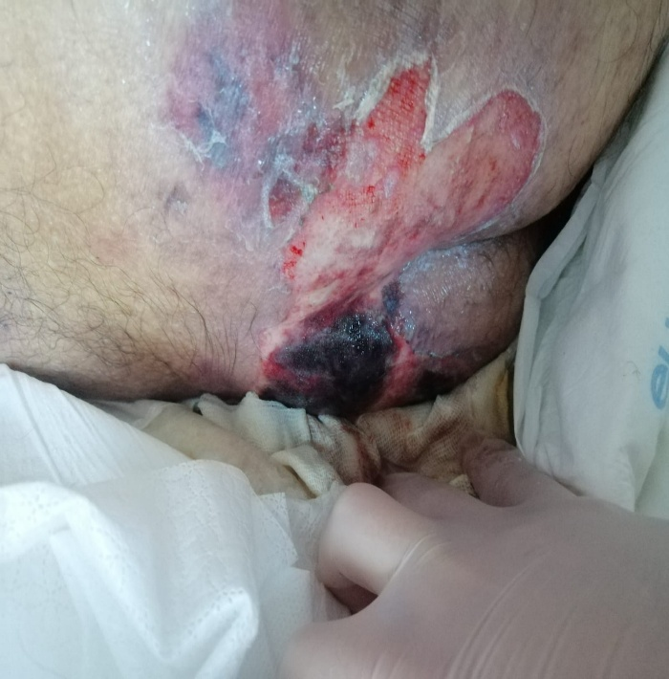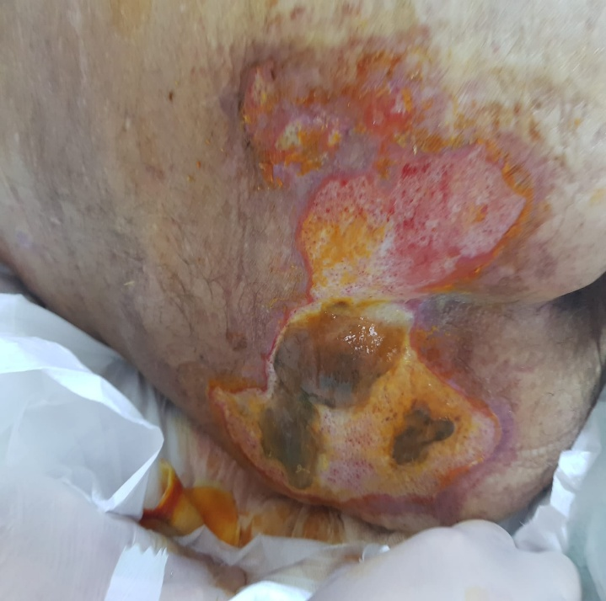
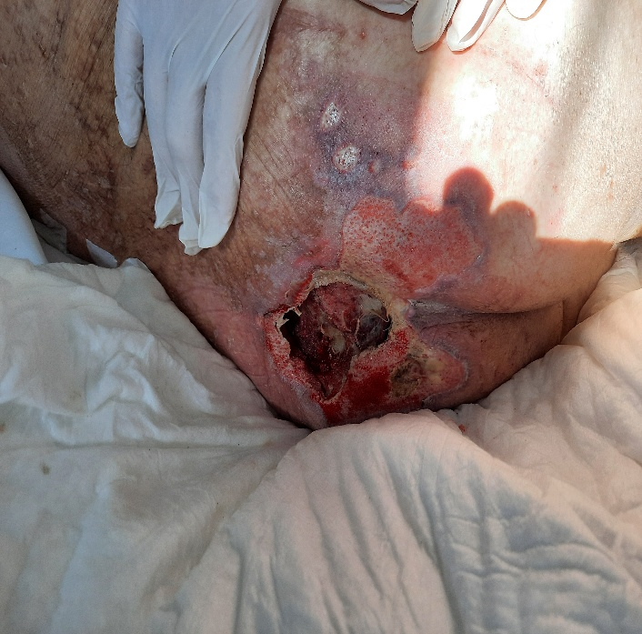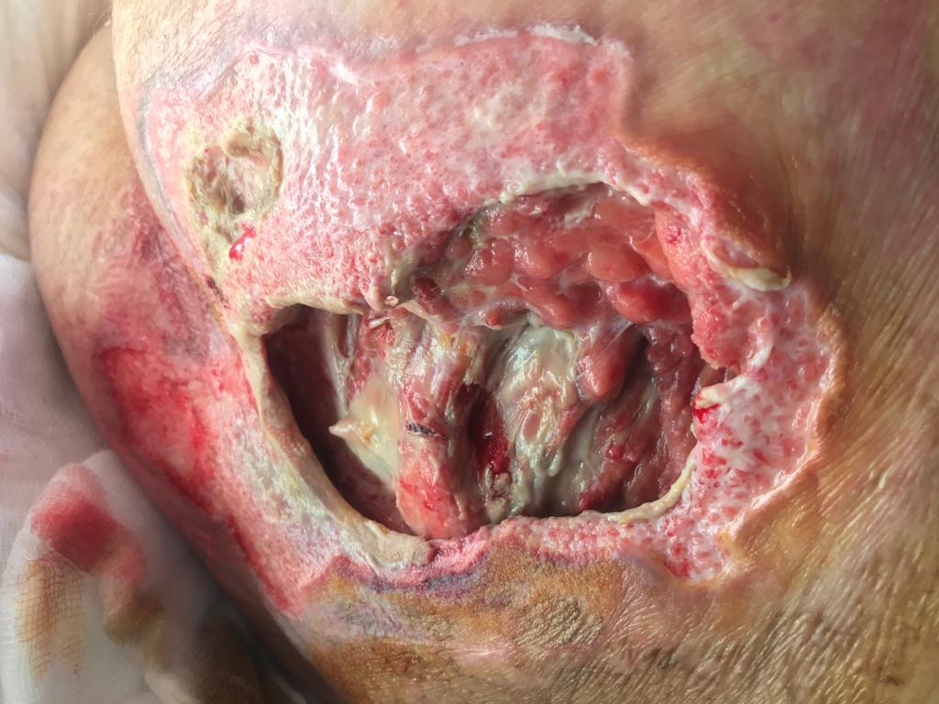
_______________________________________
Figure 2a, 2b, 2c: Vacuum therapy.

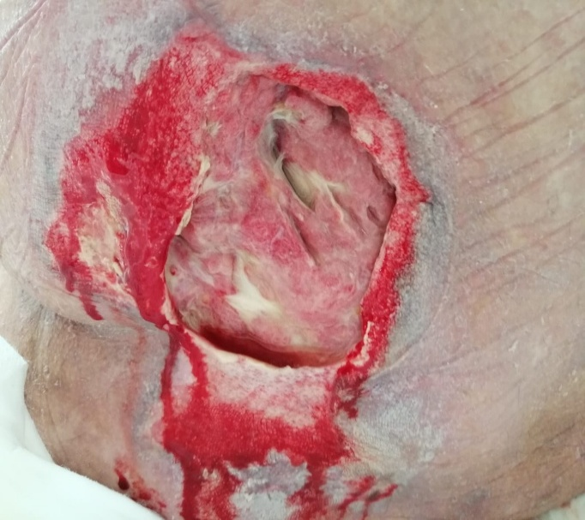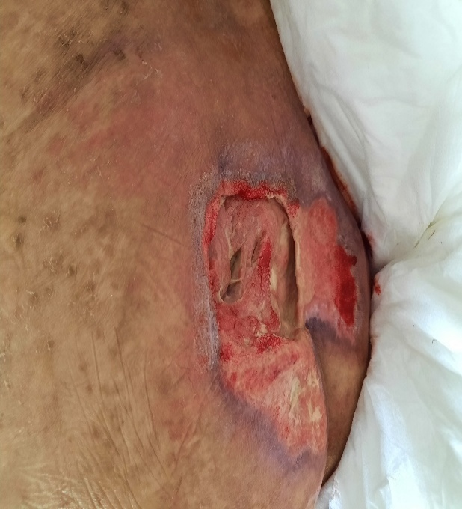
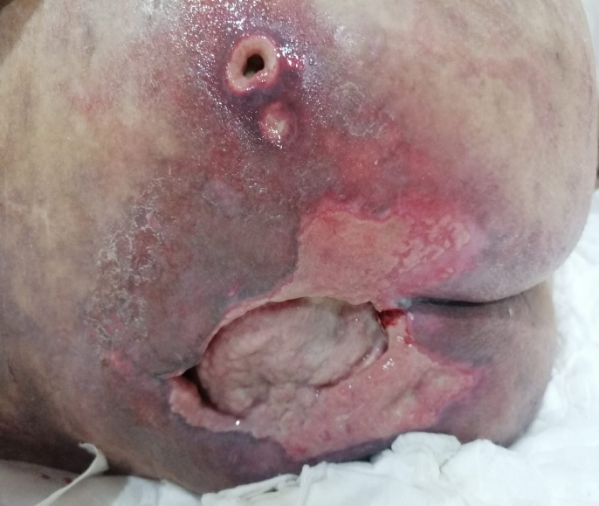
______________________________________
Figure 3(a-d): Larval treatment.
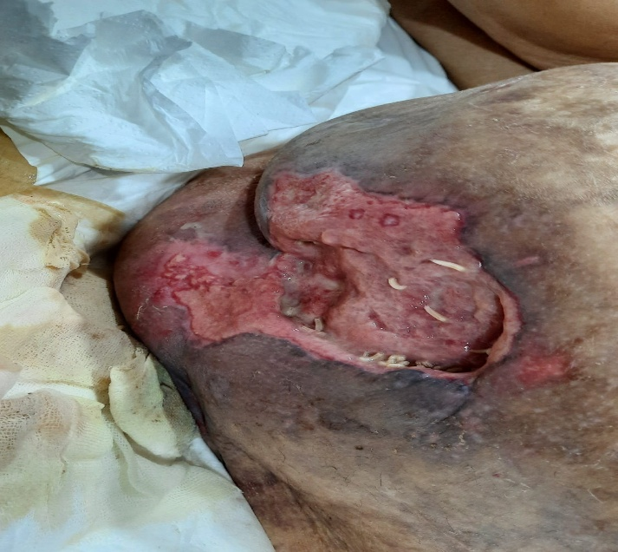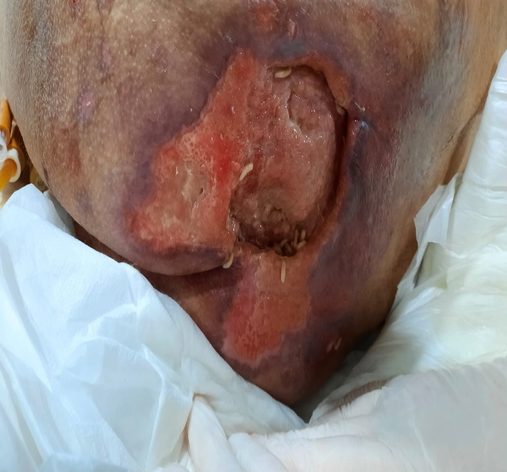
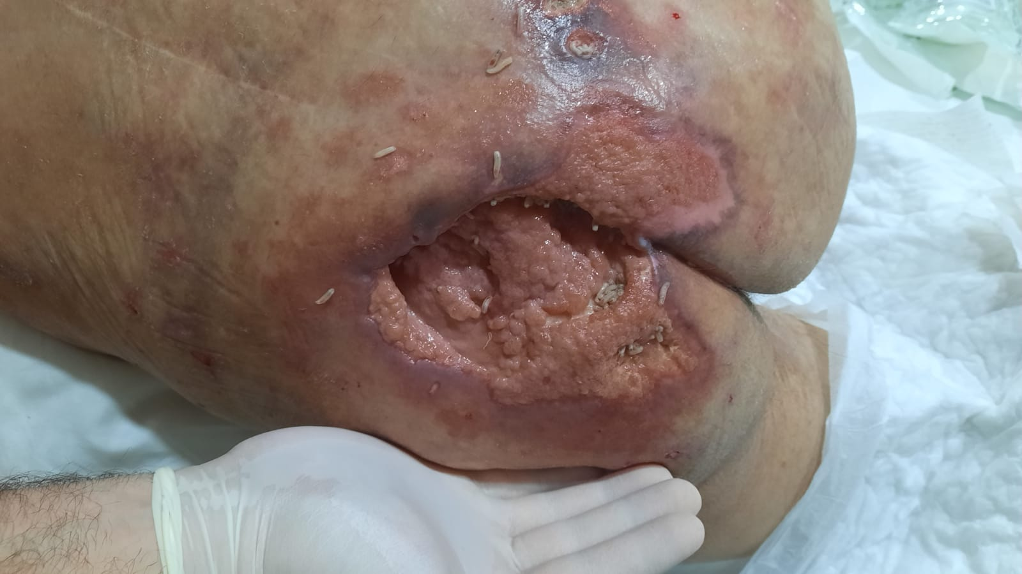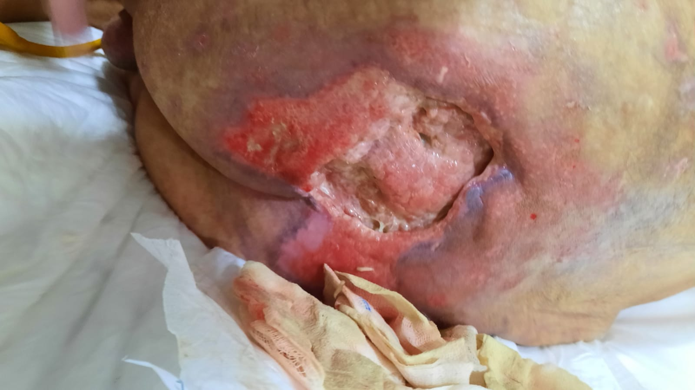
_____________________________________
Figure 4: The patient's current condition.
