Case report

A Rare Case of Pediatric Lipoblastoma: Diagnostic and Surgical Insights

ABSTRACT
Aims:
Lipoblastoma occurs mostly in young children and is extremely rare in adults, with most cases are found in children less than 3 years of age. It can present with a rapid growth rate, exerting pressure on surrounding structures or be slow growing and more difficult to detect.
Case presentation:
A 3 year old female was brought to OPD with complaints of a swelling over lower back on right side since 3 months.
A computed tomography of thorax was done that was suggestive of a well defined fat density lesion in intermuscular plane of posterior abdominal wall of right lumbar region. A core needle biopsy was suggestive of a lipomatous neoplasm. A final immunohistochemistry was suggestive of a benign adipocytic tumor.
A wide local excision incorporating the scar of biopsy was carried out. A gross margin of 1 cm was taken on all sides.
Discussion:
Lipoblastoma arise from abnormal proliferation of immature fat cells. Histologically there is an overlap between lipoblastoma and myxoid liposarcoma. Lipoblastomas appear as rapidly growing, localized well-circumscribed masses. Lipoblastomatosis is a more severe and diffuse form and has a higher recurrence rate due to infiltrative characteristics.
The treatment of choice consists of complete surgical resection with free margins to prevent recurrence. A more conservative approach in children with large invasive lesions or lesions in locations like the extremities that would lead to mutilating surgical excision has been described.
Conclusion:
Lipoblastoma is a poorly understood and uncommon soft tissue tumour in the infancy and early childhood.
KEYWORDS: myxoid liposarcoma, swelling, tomography, surgical excision
Introduction
Lipoblastoma is a rare, benign tumor of embryonic white fat that primarily affects infants and young children, typically under three years of age [1,2]. Though benign, these tumors may grow rapidly, raising concern for malignancy due to their size and invasive appearance. “Adipocytic tumours account for approximately 10% of soft tissue tumours in children and lipoblastomas are responsible for about 18–30% of these tumors. It has been estimated that 90% of lipoblastomas occur in children under the age of three years. Liposarcomas are extremely rare and account for less than 2% of all soft tissue malignancies in children with 90% of them occurring in the second decade of life”.² “They are a heterogeneous group of malignant neoplasms with variable risk of metastases and mortality depending on specific histology, underlying genetic alterations, and histological grade. While liposarcomas are also lipogenic tumours, they have a distinct genetic profile that distinguishes them from lipoblastomas”.[3]
They most commonly arise in the extremities or trunk, but cases involving the head, neck, and retroperitoneum have also been reported [4]. The condition exists in two histological forms: lipoblastoma, a localized, circumscribed lesion; and lipoblastomatosis, which is diffuse and infiltrative [5]. Accurate diagnosis is critical as clinical and radiological presentations often mimic those of malignant tumors like myxoid liposarcoma [6].
Preoperative diagnosis can be challenging, as radiologic features do not conclusively distinguish lipoblastoma from other lipomatous tumors [7]. Core biopsy and immunohistochemistry play a pivotal role in confirming the diagnosis. Complete surgical excision remains the mainstay of treatment, although infiltrative forms may necessitate close follow-up due to recurrence risk [8].
In this report, we present a rare case of lipoblastoma in a 3-year-old child, highlighting clinical features, imaging findings, histopathologic evaluation, surgical approach, and long-term management considerations.
Case Presentation
A 3-year-old female was presented to the outpatient department with a swelling over the right lower back that had been progressively increasing over three months. There was no history of trauma, fever, weight loss, or other systemic symptoms. On physical examination, the swelling was soft, non-tender, freely mobile along its long axis, and well-defined, with no overlying skin changes. No signs of infection or inflammation were present.
General systemic examination revealed no palpable axillary or inguinal lymphadenopathy, and vital signs were within normal limits. Given the age of the patient and rapid growth of the mass, further imaging was warranted.
A contrast-enhanced computed tomography (CECT) of the thorax, abdomen, and pelvis revealed a well-demarcated, fat-density lesion measuring approximately 11 x 8 x 7 cm within the intermuscular plane of the posterior abdominal wall in the right lumbar region. The imaging characteristics included homogenous fat attenuation without calcification or hemorrhage. The radiologist raised the possibility of a liposarcoma due to the lesion's size and infiltrative behavior.
To further delineate the nature of the lesion, a core needle biopsy was performed. Histopathological examination revealed a lipomatous tumor comprising mature adipocytes interspersed with immature lipoblasts within a myxoid stroma. There was no evidence of nuclear atypia or increased mitotic activity. Immunohistochemistry results supported the diagnosis of a benign adipocytic tumor.
Surgical management was planned. Under general anesthesia, a wide local excision was performed with 1 cm margins circumferentially, incorporating the scar of the previous biopsy. The tumor was completely excised, and the surgical defect in the posterior abdominal wall was reconstructed using a 15x15cm prolene mesh to reinforce the muscle layer and minimize the risk of a lumbar hernia. A vacuum drain was placed in the intermuscular plane and removed on the fifth postoperative day. The child was discharged on the sixth postoperative day without complications. Skin sutures were removed on postoperative day 10. The suture line healed with no complications.
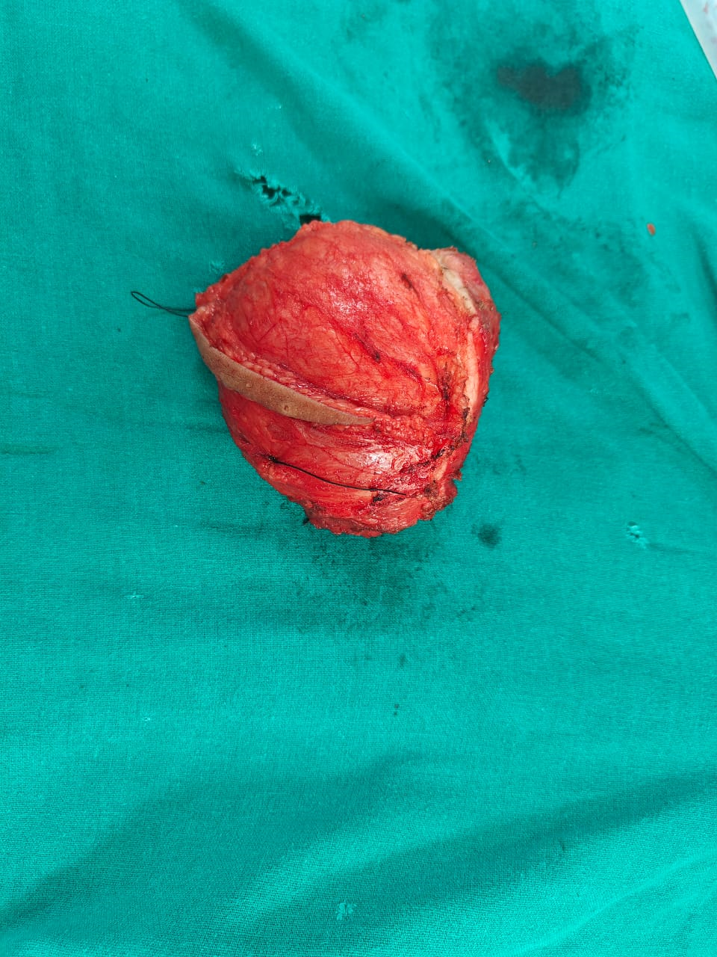
Fig 1 Removed tumor with adequate margins

Histopathological Findings
Gross pathological examination confirmed the mass measured 11 x 8 x 7 cm and had negative resection margins on all sides. Microscopic examination revealed lobulated adipose tissue with regions of myxoid change, spindle cells with scant cytoplasm, and numerous signet ring-like lipoblasts. There was evidence of local muscle invasion, but no vascular or perineural invasion. No necrosis or mitotic activity was identified, supporting the diagnosis of lipoblastoma.
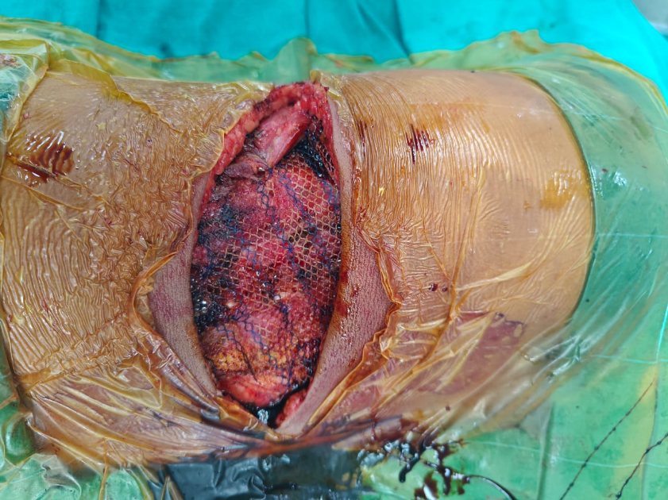

Fig 2: Mesh reconstruction to enforce muscle layer

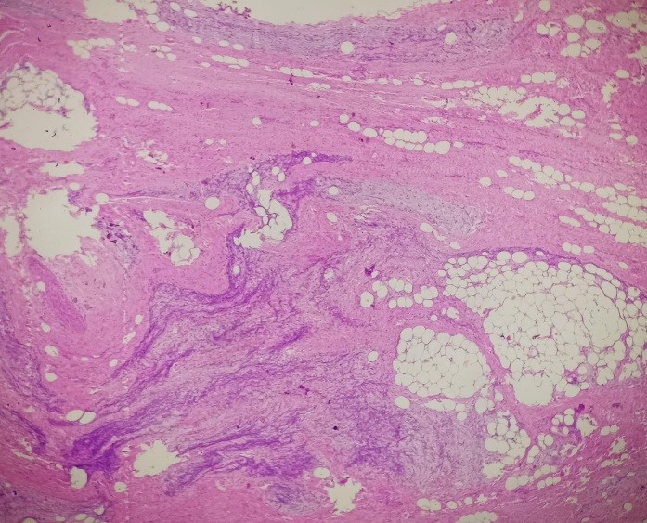
Fig 3: Myxoid areas with spindle cells and scant cytoplasm

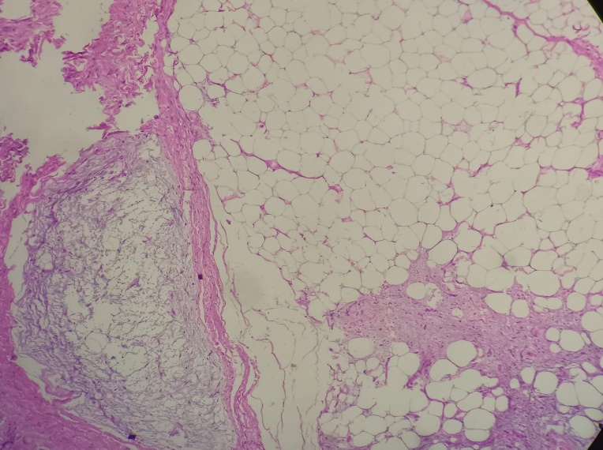
Fig 4: Lipoblastoma (signet ring lipoblasts)
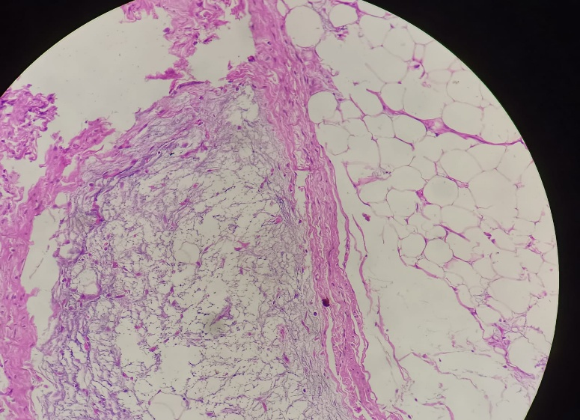
Fig 5: Sheets of adipocytes separated by fibrovascular septa with myxoid areas
Discussion
Lipoblastomas originate from immature adipose tissue and are distinguished from adult-type liposarcomas based on patient age, histologic features, and behavior [9]. “Lipoblastomas are of worldwide concern. They can be clinically and radiologically challenging to distinguish from other fat-containing soft tissue masses including hibernomas, lipomas and lipoma variants including spindle cell, pleomorphic lipoma and fibrolipoma, some of which are malignant.⁴ In addition, they are fast growing and may result in a mass effect resulting in bothersome symptoms or cosmetic problems without adverse symptoms. Moreover, complete resection of the tumours is crucial since incomplete resected tumours may regrow”.[10]
Lipoblastoma and lipoblastomatosis differ primarily in their growth patterns. The former is well-circumscribed and encapsulated, while the latter demonstrates infiltrative, multicentric growth and is more challenging to excise completely [3,5]. Despite their benign nature, both variants can grow rapidly and cause pressure effects on adjacent structures, warranting timely diagnosis and intervention.
The most critical differential diagnosis is myxoid liposarcoma, a malignant neoplasm typically seen in adults aged 40–60 years. It can mimic lipoblastoma radiologically and histologically due to the presence of lipoblasts and myxoid stroma. However, the absence of cellular atypia, mitotic figures, and specific genetic translocations such as FUS-DDIT3 in lipoblastoma helps differentiate it [9].
“Morphologically, lipoblastoma is primarily composed of primitive spindle mesenchymal cells and adipocytes at various stages of maturation. In particular, it contains lobules of mature adipocytes of different sizes divided by fiber septa, with a fine capillary network and mucinous stroma. In immunohistochemistry, lipoblasts are usually S-100-positive and P16-negative, while CD34 and desmin expression is usually observed in primitive mesenchymal cells; these properties serve as a useful diagnostic marker” [11,12]. “However, because lipoblastoma has its own characteristic genetic changes, fluorescence in situ hybridization (FISH) detection of PLAG1 fragmentation and rearrangement may be useful in diagnosis of lipoblastoma” [13,14].
The characteristic 'zoning phenomenon' seen in lipoblastomatosis—where immature mesenchymal cells and myxoid stroma predominate at the periphery of lobules—has been reported as a distinguishing histological hallmark [10]. Additional histopathologic features include absence of necrosis, absence of nuclear pleomorphism, and lack of mitotic activity [10,11].
“When a child presents with a painless enlarging mass, ultrasound is typically the first imaging modality employed. On ultrasound, lipoblastomas can appear as a well-defined hypoechoic mass with internal septations or they can have mixed-echogenicity and internal cystic spaces. Due to this variable appearance, ultrasound is thought to be not sensitive or specific enough to be diagnostically accurate for lipoblastoma. Although CT is often used in assessment of lipoblastomas, MRI is the preferred method of imaging due to its resolution in signal intensity but it still has some limitations.On MRI, lipoblastomas are often seen as solid encapsulated and lobulated masses with a heterogenous hyperintense signal in T1- and T2-weighted sequences”.[15] “Due to the varying content of adipose tissue in each lipoblastoma, some may appear as lipomas with increased hypointensity on fat-suppressed images, while those with less mature adipose tissue may appear more heterogenous”.[16] “Myxoid liposarcoma have a small adipose component and show low signal intensity on T1-weighted images along with high signal intensity foci”.[16,21]
“Although preoperative imaging is useful in assessing the extent of the tumor, it cannot differentiate between various adipose tissue tumors because there are no pathological imaging features associated with lipoblastoma”.[17]

Complete surgical excision with tumor-free margins remains the gold standard for treatment [8]. Incomplete excision is associated with recurrence, particularly in cases of lipoblastomatosis due to its infiltrative growth [18]. In situations where complete resection might lead to significant functional impairment or cosmetic deformity, especially in critical anatomical areas, a conservative approach with close radiological monitoring has been advocated [19].
Recurrence rates for lipoblastomatosis vary from 9% to 25%, with some reports indicating recurrence even after complete excision, necessitating long-term follow-up [20]. Surveillance strategies typically involve MRI or ultrasound at intervals of 6 to 12 months for at least 5 years postoperatively [19,20].
Our case reflects the typical clinical and histological features of lipoblastoma. The patient underwent successful surgical excision with no complications. Follow-up is ongoing with plans for regular clinical and radiological assessment every six months.
Conclusion
Lipoblastomatosis, although benign, poses significant diagnostic and therapeutic challenges due to its rapid growth, infiltrative nature, and resemblance to malignant adipocytic tumors. A multidisciplinary approach involving imaging, histopathology, and surgical expertise is essential for accurate diagnosis and effective management. Complete excision with clear margins remains the cornerstone of treatment. Long-term follow-up is critical due to the potential for recurrence, particularly in the infiltrative form. Early identification and intervention can prevent complications and improve outcomes in affected pediatric patients.
Consent
As per international standards, parental written consent has been collected and preserved by the author(s).
Disclaimer (Artificial intelligence)
Option 1:
Author(s) hereby declare that NO generative AI technologies such as Large Language Models (ChatGPT, COPILOT, etc.) and text-to-image generators have been used during the writing or editing of this manuscript.
Option 2:
Author(s) hereby declare that generative AI technologies such as Large Language Models, etc. have been used during the writing or editing of manuscripts. This explanation will include the name, version, model, and source of the generative AI technology and as well as all input prompts provided to the generative AI technology
Details of the AI usage are given below:
1.
2.
3.

References:
- MD Murphey, JF Carroll, DJ Flemming, TL Pope, FH Gannon, MJ Kransdorf From the archives of the AFIP: benign musculoskeletal lipomatous lesions Radiographics, 24 (5) (2004),pp. 1433-1466, 10.1148/rg.245045120
- J Hicks, A Dilley, D Patel, J Barrish, SH Zhu, M. Brandt Lipoblastoma and lipoblastomatosis in infancy and childhood: histopathologic, ultrastructural, and cytogenetic features Ultrastruct Pathol, 25 (4) (2001), pp. 321-333
- Putra J, Al-Ibraheemi A. Adipocytic tumors in Children: A contemporary review. Semin Diagn Pathol 2019; 36: 95–104
- AL Speer, DE Schofield, KS Wang, CE Shin, JE Stein, DB Shaul, et al. Contemporary management of lipoblastoma J Pediatr Surg, 43 (7) (2008), pp. 1295-1300
- S Abraham-Mendoza, R Padilla-Guevara, C Cortés-García, E Morales-Piñón, J García-Salazar, E Téllez-Bernal Lipoblastoma: case report and literature review Gaceta Mexicana de Oncología, 16 (2018), pp. 348-351
- HL George, PN Unnikrishnan, LA James, DC Perry, NK Garg, CE. Bruce Lipoblastoma–an unfamiliar but important diagnosis. A case series and literature review Acta Orthop Belg, 75 (4) (2009), pp. 533-536
- Séguier-Lipszyc, E., Baazov, A., Fichman, S. et al. Current management of lipoblastoma. Eur J Pediatr 177, 237–241 (2018). https://doi.org/10.1007/s00431-017-3059-9
- Jo VY, Fletcher CD. WHO classification of soft tissue tumours: an update based on the 2013 (4th) edition. Pathology. 2014; 46: 95-104
- Chung EB, Enzinger FM. Benign lipoblastomatosis. An analysis of 35 cases. Cancer 1973; 32: 482-92.
- Han JW, Kim H, Youn JK, et al. Analysis of clinical features of lipoblastoma in children. Pediatr Hematol Oncol 2017; 34: 212–220.
- Kubota F, Matsuyama A, Shibuya R, Nakamoto M, Hisaoka M. Desmin-positivity in spindle cells: Under-recognized immunophenotype of lipoblastoma. Pathol Int. 2013;63:353–357. doi: 10.1111/pin.12077.
- Abdul-Ghafar J, Ahmad Z, Tariq MU, Kayani N, Uddin N. Lipoblastoma: A clinicopathologic review of 23 cases from a major tertiary care center plus detailed review of literature. BMC Res Notes. 2018;11(42) doi: 10.1186/s13104-018-3153-8
- de Saint Aubain Somerhausen N, Coindre JM, Debiec-Rychter M, Delplace J, Sciot R. Lipoblastoma in adolescents and young adults: Report of six cases with fish analysis. Histopathology. 2008;52:294–298. doi: 10.1111/j.1365-2559.2007.02954.x.
- Creytens D. A contemporary review of myxoid adipocytic tumors. Semin Diagn Pathol. 2019;36:129–141. doi: 10.1053/j.semdp.2019.02.008.
- Lomoro P, Simonetti I, Nanni AL, et al. Imaging of head and neck lipoblastoma: case report and systematic review. J Ultrasound 2020.
- Sheybani EF, Eutsler EP, Navarro OM. Fat-containing soft-tissue masses in children. Pediatr Radiol 2016; 46: 1760–1773.
- McVay MR, Keller JE, Wagner CW, Jackson RJ, Smith SD (2006) Surgical management of lipoblastoma. J Ped Surg 41(6):1067– 1071. https://doi.org/10.1016/j.jpedsurg.2006.02.025
- Jung SM, Chang PY, Luo CC, Huang CS, Lai JY, Hsueh C (2005) Lipoblastoma/lipoblastomatosis: a clinicopathologic study of 16 cases in Taiwan. Pediatr Surg Int 21(10):809–812. https://doi.org/ 10.1007/s00383-005-1502-x
- Kok KYY, Telisinghe PU (2010) Lipoblastoma: clinical features, treatment, and outcome. World J Surg 34(7):1517–1522. https://doi. org/10.1007/s00268-010-0466-8
- Mentzel T, Calonje E, Fletcher CDM (1993) Lipoblastoma and lipoblastomatosis: a clinicopathological study of 14 cases. Histopathology 23(6):527–533. https://doi.org/10.1111/j.1365- 2559.1993.tb01238.x
- McRae, J. J., Hashmi, A., Radulescu, A., Carter, C. S., & Khan, F. A. (2021). Lipoblastomas and liposarcomas in paediatric patients: A case series. Journal of International Medical Research, 49(3), 0300060520981362.

