Case report

A Complication of EBUS-TBNA: Pneumomediastinum

ABSTRACT

Endobronchial ultrasound-guided transbronchial needle aspiration (EBUS-TBNA) is a minimally invasive diagnostic tool with low complication rates. Pneumomediastinum is a rare complication. Here, we report a 67-year-old woman who underwent EBUS-TBNA for investigation of suspected lung cancer. During EBUS-TBNA, the posterior tracheal wall collapsed suddenly, and the patient reported neck swelling, voice changes, and pain on swallowing. Examination revealed subcutaneous emphysema and imaging showed extensive pneumomediastinum. The patient was managed conservatively. A subsequent EBUS revealed granulomas, and the final diagnosis was tuberculosis. Although EBUS-TBNA is generally safe, rare complications like pneumomediastinum can occur. Symptoms such as neck swelling, and chest pain should prompt further evaluation. Chest X-rays may miss the diagnosis in up to 30% of cases, making CT imaging the investigation of choice. Conservative management is appropriate in haemodynamically stable patients. This case describes the identification and management of EBUS-induced mediastinum in a haemodynamically stable patient. We recommend suspecting pneumomediastinum in cases where the posterior tracheal wall collapses suddenly during EBUS-TBNA.

Keywords: Pneumomediastinum, EBUS-TBNA, tuberculosis, subcutaneous emphysema, conservative management.

1. INTRODUCTION

Endobronchial ultrasound-guided transbronchial needle aspiration (EBUS-TBNA) is a widely used, minimally invasive procedure for diagnosing and staging lung cancer and other intrathoracic conditions. It allows real-time ultrasound-guided sampling of mediastinal and hilar lymph nodes during bronchoscopy and has largely replaced surgical techniques like mediastinoscopy in many centers due to its safety and diagnostic accuracy (1).

EBUS-TBNA is widely considered a safe and minimally invasive procedure, with very low rates of adverse events. The most commonly reported complications include mild bleeding, fever, and transient hypoxia. Severe complications, such as pneumothorax, mediastinitis, and airway injuries, are rare but well documented. The overall safety profile of the procedure has made it the preferred method for staging non-small cell lung cancer, diagnosing sarcoidosis, and evaluating other conditions such as tuberculosis [1].

One of the serious complications of EBUS-TBNA is pneumomediastinum, defined as the presence of air in the mediastinal space. While the condition itself is rare, its occurrence post-EBUS has been reported sporadically in the literature. Pneumomediastinum can be associated with a range of non-specific symptoms, including neck swelling, chest pain, voice changes, and difficulty to swallow or dyscataposis. Despite its potential for causing significant clinical concern, pneumomediastinum remains underreported in the context of EBUS-TBNA. This makes the diagnosis of the condition challenging, as it requires a high index of suspicion and appropriate imaging to confirm its presence. The paucity of large-scale studies on this complication further complicates management protocols and outcomes for affected patients (2–5). Here, we report on a 67-year-old female patient who developed pneumomediastinum following EBUS-TBNA performed to evaluate a suspected lung mass, adding to the limited body of literature on EBUS-related pneumomediastinum.

2. Presentation of case

A 67-year-old lady presented to the respiratory clinic with breathlessness and a non-productive barking cough that had been present for approximately five months.
The patient was a lifelong non-smoker, and their past medical history included:
· Heart failure
· Ischaemic heart disease
· Hypertension
· Hypothyroidism
· Lumbar spinal stenosis
· Performance status between 0-1
A chest X-ray (Figure 1) revealed increased airspace opacification in the right mid-zone, prompting antibiotic treatment.
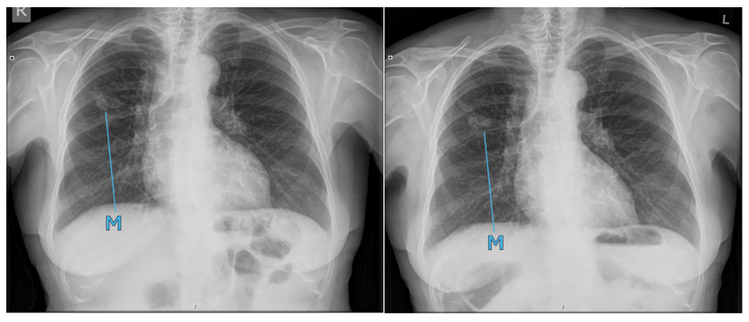
Figure 1: Initial chest x-ray showing a right upper lobe opacification (left) and repeat chest x-ray after 6 weeks (right). Key: M = Mass in the right upper lobe
A follow-up radiograph at six weeks demonstrated progressive focal opacification, warranting further evaluation with a CT scan (Figure 2). The CT scan revealed a substantial spiculated mass in the right upper lobe, which is highly indicative of primary lung cancer. This finding is further supported by the presence of ipsilateral lymphadenopathy. Endobronchial ultrasound showed a 4cm right upper lobe mass from the right main bronchus. Subsequent reports indicated that the biopsies taken for the purpose of cytological analysis were consistent with a diagnosis of non-necrotising epithelioid cell granulomas. Following a review of the evidence, it was decided that the EBUS-TBNA should be repeated after a period of two weeks in order to facilitate the sending of samples for tuberculosis bacteriology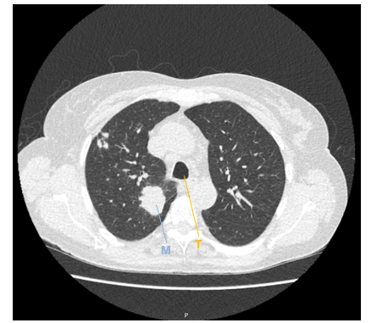
Figure 2: CT Image prior to EBUS showing a suspicious right mid zone lung mass. Key: T = Trachea, M = Mass in the right upper lobe
During the first procedure, the consultant had observed a sudden collapse of the posterior wall of the trachea (ballooning of the posterior tracheal wall into the lumen of the trachea) and the patient had reported chest pain. Following EBUS, the patient also reported a feeling that her voice had changed, pain on swallowing and swelling around their neck. Subcutaneous emphysema was identified on examination and on a post-EBUS chest x-ray (Figure 3).
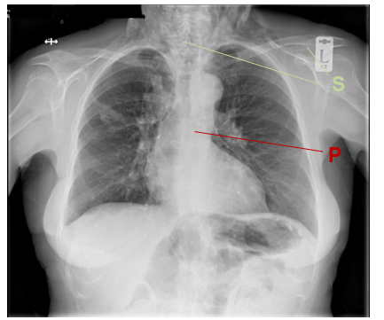
Figure 3: Post-EBUS chest x-ray showing subcutaneous emphysema in the soft tissues of the neck Key: S = Subcutaneous emphysema, P = Pneumomediastinum
The subsequent CT scan revealed extensive pneumomediastinum (Figure 4).
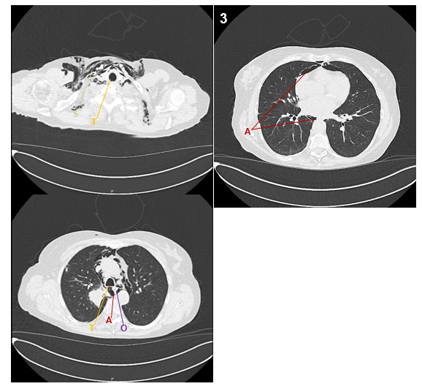
Figure 4: CT Images (labelled 1-3) post-EBUS showing subcutaneous emphysema (1) and air in the mediastinal space behind the posterior wall of the trachea (2) and around the heart (3). Key: T = Trachea, O = oesophagus, A = Air in the mediastinum S = Subcutaneous emphysema
The patient was admitted to a respiratory ward. She was haemodynamically stable and treated with prophylactic antibiotics for mediastinitis. The subcutaneous emphysema improved with conservative management and the patient was
discharged 3 days post-EBUS. She returned after 9 days for the repeat EBUS which was tolerated well.
The tuberculosis sample returned positive for acid-fast bacilli staining and the patient was referred to the tuberculosis clinic. The final diagnosis was necrotising granuloma with isolated tuberculosis, with no evidence of malignancy.

3. discussion

EBUS is a safe procedure due to very low rates of serious adverse events. Most complications tend to be non-serious, such as minor bleeding or mild hypoxia, which are typically self-limiting and resolve without intervention. However, more significant complications, such as pneumothorax, mediastinitis, and pneumomediastinum, though uncommon, do occur. Studies suggest that severe adverse events following EBUS-TBNA are reported in less than 1% of cases, with the majority being infective complications related to procedural infection or contamination (6). The incidence of pneumomediastinum following EBUS-TBNA remains low, and it is considered a rare complication of the procedure. Pneumomediastinum is reported to occur more frequently in younger individuals which may be due to the relative laxity of their mediastinal tissues, whereas in older adults, more fibrosed connective tissue may limit the migration of air (7). A large systematic review encompassing 16,181 EBUS procedures identified only 23 serious adverse events (0.14%) among which there were 2 instances of pneumothorax (1). Notably, no instances of pneumomediastinum were reported in this cohort. Despite its rarity, the presence of pneumomediastinum following EBUS-TBNA has been described in several case reports, with clinical presentations often including neck swelling, chest pain, dysphagia, and changes in voice. These symptoms are non-specific and can mimic other post-procedural complications, making timely recognition of pneumomediastinum a clinical challenge.
In our case, the patient underwent EBUS-TBNA after a CT scan was suggestive of lung cancer. The initial biopsy results showed granulomatous inflammation, and no malignancy was detected. A subsequent EBUS confirmed tuberculosis as the underlying cause, with a necrotising granuloma identified in the tissue samples. Granulomatous diseases, including tuberculosis, can be mistaken for malignancy on imaging studies, necessitating repeated sampling or the use of alternative diagnostic modalities to arrive at a definitive diagnosis.

After the initial EBUS, the patient began to exhibit signs of pneumomediastinum: neck swelling, chest pain, and voice changes. These symptoms are consistent with those described in previous case reports of EBUS-induced pneumomediastinum [3]. While initial chest X-rays were not diagnostic, showing only subcutaneous emphysema which was already identified through examination, a follow-up CT scan of the thorax confirmed the diagnosis of pneumomediastinum. CT scans are significantly more sensitive than chest X-rays in detecting pneumomediastinum, the latter of which can be normal in up to 30% of cases, and so CT is recommended as the imaging modality of choice when there is a suspicion of this complication following EBUS-TBNA (8,9).

The patient remained hemodynamically stable, which allowed for conservative management, including inpatient monitoring and the administration of prophylactic antibiotics to prevent mediastinitis. Despite its severity, pneumomediastinum in this case did not lead to any long-term complications and resolved with supportive care. Complications following EBUS are uncommon, and most serious adverse events reported are infective (6) though the relationship between pneumomediastinum and the development of intrathoracic infection needs to be studied further. A rare case documented the development of a broncho-mediastinal fistula leading to pneumomediastinum which required surgical repair (10).
Given the potential for misdiagnosis or delayed diagnosis of pneumomediastinum, clinicians must be vigilant for signs of this complication and consider follow-up imaging as appropriate. Future studies are needed to establish clear guidelines for the assessment and management of pneumomediastinum after EBUS-TBNA.

4. Conclusion

This case describes the rare complication of EBUS-induced pneumomediastinum, which was successfully managed in a hemodynamically stable patient. Early recognition and the use of CT scanning as the most sensitive imaging modality for diagnosing pneumomediastinum is crucial. Conservative inpatient management, including observation and supportive care, was effective in resolving both subcutaneous emphysema and the pneumomediastinum without the need for invasive intervention.
While the complication of pneumomediastinum is rare, it is essential for clinicians to be aware of its potential occurrence, especially in patients undergoing EBUS-TBNA.
Recommendations:
- Suspect pneumomediastinum when sudden collapse of the posterior tracheal wall occurs during EBUS-TBNA.
- Avoid going through the pleura or crossing the lung fissures when performing EBUS-TBNA, as this increases the risk of complications such as pneumomediastinum and pneumothorax.
- Conservative management is effective in treating pneumomediastinum and associated subcutaneous emphysema in hemodynamically stable patients.

Consent (where ever applicable)

All authors declare that written informed consent was obtained from the patient for publication of this case report and accompanying images. A copy of the written consent is available for review by the Editorial office/Chief Editor/Editorial Board members of this journal.

Ethical approval (where ever applicable)

Ethical approval was not required for this case report in accordance with local regulations.

Disclaimer (Artificial intelligence)

Author(s) hereby declare that NO generative AI technologies such as Large Language Models (ChatGPT, COPILOT, etc.) and text-to-image generators have been used during the writing or editing of this manuscript.

References

1. Von Bartheld MB, Van Breda A, Annema JT. Complication rate of endosonography (endobronchial and endoscopic ultrasound): a systematic review. Respiration [Internet]. 2014 [cited 2024 Oct 29];87(4):343–51. Available from: https://pubmed.ncbi.nlm.nih.gov/24434575/
2. Stanton A, Conroy K, Miller G. Pneumomediastinum following endobronchial ultrasound and transbronchial needle aspirate (EBUS-TBNA) sampling of mediastinal lymph nodes. BMJ Case Rep. 2021 Aug 2;14(8).
3. Shweihat Y, Perry JD, Munn N. Severe Pneumomediastinum Complicating EBUS-TBNA: To the Editor. J Bronchol Interv Pulmonol. 2015 Jul 23;22(3):e8–9.
4. Saha BK. Pneumomediastinum: A Rare Complication of Endobronchial Ultrasound Guided Fine Needle Aspiration. Prague Med Rep. 2022;123(1):43–7.
5. Marlow J, Brockbank L, Mohan K. Pneumomediastinum Post EBUS-TBNA in Interstitial Lung Disease. J Bronchology Interv Pulmonol [Internet]. 2018 Jul 1 [cited 2024 Oct 29];25(3):e32–3. Available from: https://pubmed.ncbi.nlm.nih.gov/29944592/
6. Asano F, Aoe M, Ohsaki Y, Okada Y, Sasada S, Sato S, et al. Complications associated with endobronchial ultrasound-guided transbronchial needle aspiration: a nationwide survey by the Japan Society for Respiratory Endoscopy. Respir Res [Internet]. 2013 May 10 [cited 2024 Oct 29];14(1):50. Available from: https://pmc.ncbi.nlm.nih.gov/articles/PMC3655828/
7. Kouritas VK, Papagiannopoulos K, Lazaridis G, Baka S, Mpoukovinas I, Karavasilis V, Lampaki S, Kioumis I, Pitsiou G, Papaiwannou A, Karavergou A, Kipourou M, Lada M, Organtzis J, Katsikogiannis N, Tsakiridis K, Zarogoulidis K, Zarogoulidis P. Pneumomediastinum. J Thorac Dis. 2015 Feb;7(Suppl 1):S44-9. doi: 10.3978/j.issn.2072-1439.2015.01.11. PMID: 25774307; PMCID: PMC4332083.
8. VK K, K P, G L, S B, I M, V K, et al. Pneumomediastinum. J Thorac Dis [Internet]. 2015 Jan 1 [cited 2024 Oct 29];7(Suppl 1):476–81. Available from: https://pubmed.ncbi.nlm.nih.gov/25774307/
9. Kara H, Uyar HG, Degirmenci S, Bayir A, Ak A, Oncel M. Dyspnoea and chest pain as the presenting symptoms of pneumomediastinum: two cases and a review of the literature. Cardiovasc J Afr [Internet]. 2015 Nov 1 [cited 2024 Oct 29];26(6):e1–4. Available from: https://pubmed.ncbi.nlm.nih.gov/26498134/
10. Bougioukas I, Seipelt R, Huwer H. Bronchial Fistula and Pneumomediastinum after EBUS-TBNA Following Mediastinoscopy. Thorac Cardiovasc Surg Rep. 2019 Jan;8(1):e11-e13. doi: 10.1055/s-0039-1688476. Epub 2019 May 6. PMID: 31065508; PMCID: PMC6502708

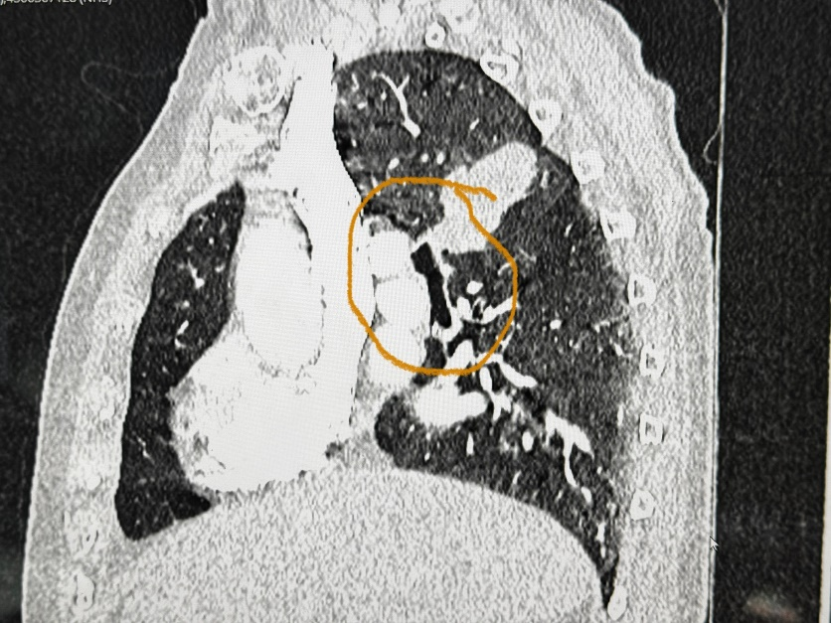.
Fig 5: CT image 1

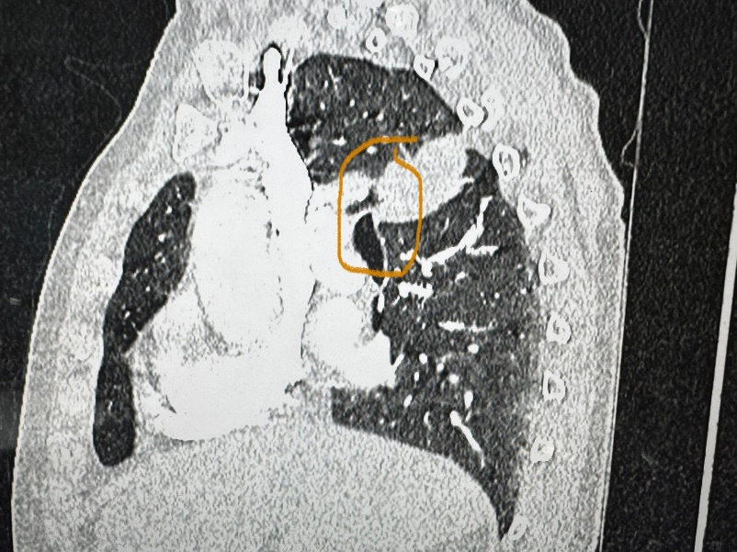

Fig 6: CT image 2

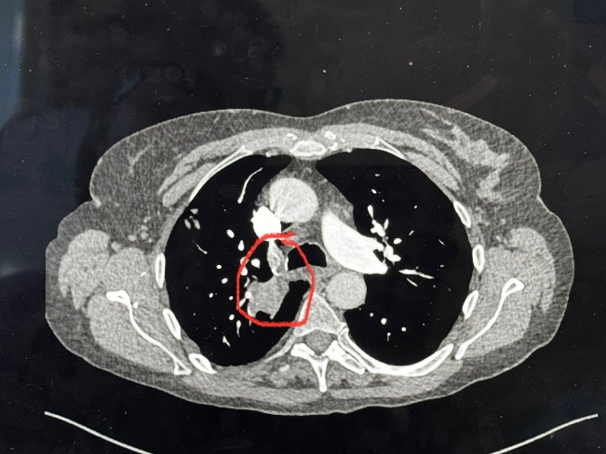

Fig 7: CT image 3

